|  |  |
| --- | --- |
| **Development of Chemistry Learning Media based on Joyful Learning with Snakes and Ladders Game on Stoichiometry material to Improve Student Learning Outcomes** | |
|  | |
| **Miftakhul Janah & Mitarlis\*** | |
|  | Department of Chemistry, Faculty of Mathematics and Natural Sciences, Surabaya State University, Jl. Ketintang, Ketintang, Kec. Gayungan, 60231 |
| \* | Corresponding Author e-mail*:* mitarlis@unesa.ac.id |

|  |  |  |
| --- | --- | --- |
| **Article History**  Received: dd-M-Year  Revised: dd-M-Year  Published: dd-M-Year  **Keywords**: Joyful learning, Snakes and Ladders Game, Stoichiometry, Learning Outcomes | **Abstract**  This research aims to obtain chemistry learning media based on joyful learning with the snakes and ladders game on stoichiometric material that is suitable for use to improve student learning outcomes based on the validity, practicality and effectiveness of the game. The research method used is the research development (R&D) method with the 4D model by Tigharajan which consists of 4 main stages, define, design, develop and disseminate. However, the development of Joyful Learing-based Chemistry Learning Media with the Snakes and Ladders game has only reached the development stage. The research was carried out at Surabaya State University and SMA Negeri 1 Menganti Gresik. Test the game media using the One Group Pretest-Posttest Design system. Validity is obtained from the assessment of the stoichiometric snake and ladder game media by the validator. Practicality is obtained from the results of observing student activities, observing the implementation of learning activities, and student response questionnaires. Effectiveness is obtained from student learning outcomes. The results of the research show that chemistry learning media based on joyful learning with the snakes and ladders game on stoichiometric material is suitable for improving student learning outcomes with a feasibility score of ≥ 4 in the feasible to very feasible category. The practicality of chemistry learning media based on joyful learning with the snakes and ladders game on stoichiometric material to improve student learning outcomes is said to be suitable for use in terms of the results of observations of student activities which obtained a percentage of 96.81%, the results of observations of learning implementation obtained a percentage of 93.98%, and Student responses obtained a percentage of 91.52%. Then, the effectiveness of chemistry learning media based on joyful learning with the snakes and ladders game on stoichiometry material to improve student learning outcomes which was developed in terms of pretest and posttest scores was declared effective. This is shown by the N-gain score of all students being in the medium to high category and meeting the KKM value, with an average N-gain value of 0.79 with high criteria. This shows that the stoichiometric snakes and ladders game is declared suitable for use as a chemistry learning medium based on joyful learning on stoichiometric material to improve student learning outcomes. | |
| **How to Cite:** First author., Second author., Third author, etc.. (20xx). The title. *Hydrogen: Jurnal Kependidikan Kimia*, vol(no). doi:https://doi.org/10.33394/hjkk.v10i2 | | |
| <https://doi.org/10.33394/hjkk>.xxxxx.xxxx | | This is an open-access article under the [CC-BY-SA License.](http://creativecommons.org/licenses/by/4.0/)  C:\Users\IKIP\Pictures\CC_BY-SA_3.0.png |

**INTRODUCTION**

Chemistry is a science that studies the properties and structure of substances, chemical changes and reactions, laws and principles of substance change, interrelated theories and concepts. One of the most important chemical disciplines is stoichiometry, which studies basic and abstract concepts such as relative atomic mass, relative molecular mass, Avogadro's constant, and the mole concept (Nilawati, 2016).

According to the Ministry of Education and Culture (2016), as shown by the results of the Trends in Mathematics and Science Study (TIMSS) and the International Program for International Student Assessment (PISA) in 2015, it shows that Indonesian students have low abilities or do not meet international standards in mathematics and science. This is proven by the achievements of Indonesian students in questions that have high cognitive characteristics.

Pre-research data shows that teachers at SMA Negeri 1 Menganti Gresik have used the independent curriculum. This curriculum provides educators with the opportunity to provide high-quality learning that suits students' needs and learning environment. The characteristics of this curriculum include a focus on important, relevant and in-depth material, as well as learning that can be adapted to the stage of achievement and development of students.

According to the results of interviews with chemistry teachers at SMA Negeri 1 Menganti Gresik, one of the challenges teachers face when teaching is trying to get students to focus when studying. Most students still have difficulty understanding calculation topics, especially stoichiometry. There is sufficient time to learn basic literacy and numeracy skills based on the characteristics of the independent curriculum. This allows the development of learning media to overcome problems faced by students in understanding stoichiometry material, which is related to calculations. Flexible learning in this research is possible through the use of fun learning strategies, which can be adapted to the students' achievements and their needs.

Chemistry material is considered difficult and uninteresting for some students. This is supported by pre-research data conducted at SMA Negeri 1 Menganti Gresik, where 86.111% of students stated that chemistry, especially stoichiometry, was very difficult to learn because the subject matter was broad and because students had to understand material concepts and understand chemical calculations. Apart from that, 47.222% of students said that chemistry subjects were not interesting because there were many learning activities. By using innovative and creative learning media, learning objectives can be achieved (Ningsih, 2021).

Rosmiati's research results at MAN Seragam Bagian Barat support this. Rosmiati (2022), said that students find it difficult to understand and study chemistry. This may be due to the fact that until now no complete solution has been found for learning chemistry. As a result, the idea has emerged that chemistry is such a difficult subject that some students dislike it or even hate it. This is supported by the results of interviews with chemistry teachers and questionnaires given to students during pre-research at MAN Seragam Bagian Barat. Based on their experience with chemistry lessons in high school, students face difficulties learning chemistry because they are less proficient in calculations and do not know how to study.

Learning media are learning tools used by educators to convey and clarify educators' messages to diverse students. Learning media must be appropriate to the characteristics of students. Learning media is something that can be used to convey messages so that it can attract students' attention, interests, thoughts and feelings in learning activities so that learning objectives can be achieved (Daryanto, 2010).

One of the benefits of using learning media in students' learning process is as follows: teaching will attract students' attention so that they are more motivated to learn; the lesson material will be clearer so that it is easier for students to understand; learning methods will be more varied and not only communicate verbally through the teacher's words, so that students are not bored and bored; and students will be involved in the learning process actively (Sudjana, 2009).

Learning media that is not innovative and interesting can cause students to become bored and reduce their motivation to learn, which can lead to poor learning outcomes. Therefore, there needs to be innovation and creativity in developing learning media to increase learning motivation and make learning easier for students. One way to overcome this is to use games. A pre-research at SMA Negeri 1 Menganti Gresik found that 41.667% of students considered games suitable as a medium for learning chemistry, and 94.444% of students thought games could help them understand the material.

Joyful learning can make learning activities not only more interesting but also less boring. Fun learning, also known as joyful learning, is a learning strategy that can provide students with the experience of learning while playing. Games are one medium that can be used to carry out this learning. Games have the potential to enhance students' learning experiences while learning. According to Pramita (2016), game media can train students to think, speak and communicate with other people in addition to reducing boredom.

Based on student questionnaire data in pre-research activities, as many as 44.444% of students at SMA Negeri 1 Menganti Gresik stated that learning about stoichiometry was not fun, according to the questionnaire they collected during pre-research activities. According to Lutfi's research (2021), students complained about online chemistry learning because they felt bored. Therefore, efforts are needed to make the teaching and learning process enjoyable. Data shows that many students face difficulties when studying chemistry. The results show that chemistry learning is not interesting in some schools, makes students bored and makes the class atmosphere passive. This condition causes boredom and irritation, which reduces students' interest and attention to lessons (Ristyanti and Bahria, 2016).

According to Zahro and Lutfi (2021), appropriate and enjoyable learning media for students is needed. Students will be happy and the learning atmosphere will be enjoyable if game media is used. Thus, to improve students' learning achievement, chemistry learning media based on joyful learning was created using the snakes and ladders game on stoichiometry material. It is hoped that this game media will provide students with a pleasant learning experience, because they will not only learn concepts but also be able to play. With this learning strategy, students have the opportunity to take an active part in the learning process. It is hoped that it can increase students' focus and understanding of the material, which means that students' learning outcomes will increase.

Data collected from student questionnaires during pre-research activities at SMA Negeri 1 Menganti Gresik, showed that as many as 94.444% of students agreed that in the learning process the stoichiometry material was used as learning media with the snakes and ladders game, because during the learning activities it had never been applied before. This conclusion is supported by comments from the chemistry teacher at SMA Negeri 1 Menganti Gresik, who agreed that learning media based on joyful learning with the snakes and ladders game should be developed for stoichiometry material, because it had never been developed before. In addition, it is hoped that the stoichiometric snakes and ladders game media will improve students' learning outcomes by increasing their motivation and increasing their focus on chemistry, especially stoichiometric material. Class 10 high school solution material was once used as material for the snakes and ladders game, but this was several years ago before the corona pandemic and has never been developed again since.

**METHOD**

The research design used is the research and development method. The research model used in this development research is a development research model with a 4D model adapted from Tiagarajan Sammel (1974). The 4D research model is a device development model developed by S. Thiagarajan, Dorothy S. Semmel, and Melvyn I. Semmel in 1974. The 4D development model consists of 4 main stages, namely definition, design, development Develop), and Dissemination (Desiminate). However, the development of Joyfull Learing-based Chemistry Learning Media with the Snakes and Ladders game has only reached the development stage, with the following research steps.

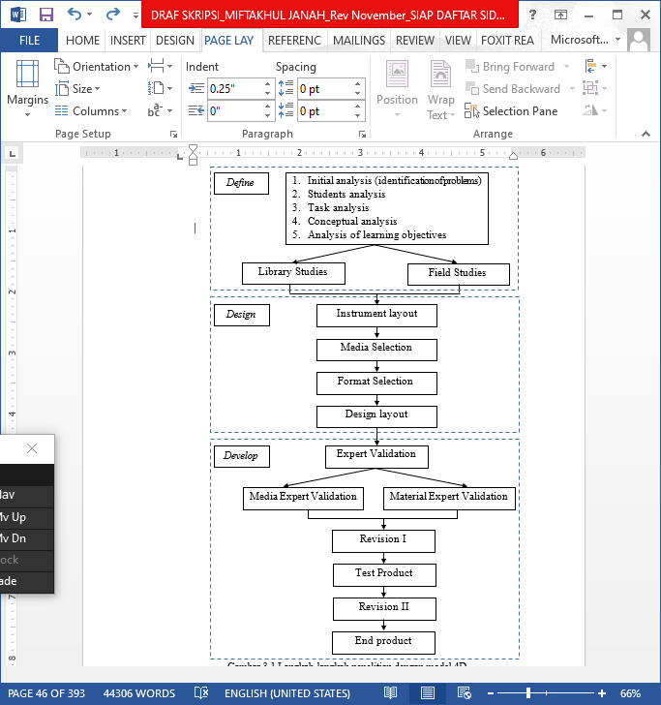

**Figure 1.** Research steps with 4D models

This research design was carried out using the One Group Pretest Posttest Design system, where students were given pretest questions before playing the game. After students take part in learning activities using the snake and ladder game media on stoichiometry material, students are given posttest questions. It is hoped that giving a pretest and posttest can provide more accurate research results because it can compare the conditions before and after treatment. This research design describes variable X and variable O, the relationship between the two is described as follows.

|  |
| --- |
| $$O_{1}…X{…O}_{2}$$ |

Keterangan:

O1 = pretest score (before the experimental group was given treatment)

O2 = posttest score (after the experimental group was given treatment)

X = treatment given (chemistry learning using learning media based on joyful learning with the snakes and ladders game on stoichiometry material)

(Sugiyono, 2014).

The data collection methods used in this research were questionnaires, observations and tests. The questionnaires used in this research were game media review questionnaires, game media validation questionnaires, and student response questionnaires. The results of this media review sheet are used to refine the learning media being developed. The media validation sheet is used to determine the validity of the chemistry learning media based on joyful learning with the snakes and ladders game that was developed. The results of this validation are in the form of a score, so that quantitative data analysis can be carried out to determine the validity of the learning media being developed.

**Table 1.** Game Media Validity Assessment Score

|  |  |
| --- | --- |
| Criteria | Score |
| Invalid | 1 |
| Not valid | 2 |
| Fairly valid | 3 |
| Valid | 4 |
| Very valid | 5 |

(Riduwan, 2014)

Next, the validation data in the form of ordinal data is analyzed by determining the score mode for each aspect or indicator with the condition that if the aspect assessed by the validator has a score mode ≥ 4, then that aspect is declared valid. If there are aspects that do not meet the valid requirements, then they must be corrected (revised) and validated again until they reach the specified criteria (Lutfi, 2021).

The student response questionnaire sheet is given after the game media has been tested on the students. Student response sheets are used to support the practicality of the media being developed. The percentage of student response questionnaire data is calculated using the following formula.

% response = $\frac{\sum{students answered “Yes”}}{\sum{all students}} ×100\%$

Then the results of the percentage of student responses are converted according to the student response categories based on the following table.

**Table 2.** Interpretation categories of student response questionnaire scores

|  |  |
| --- | --- |
| **Persentase (%)** | **Kriteria** |
| 0 – 20 | Very less |
| 21 – 40 | Not enough |
| 41 – 60 | Enough |
| 61 – 80 | Good |
| 81 – 100 | Very good |

(Riduwan, 2015).

Learning media is said to be practical if the percentage is ≥ 61% with good to very good criteria.

The observation method consists of two, namely observing student activities and implementing learning activities. The observation method is used to observe and record all student activities during the learning process using the learning media that has been developed. The percentage of student activity is calculated using the following formula.

% activity = $\frac{\sum{frequency of relevant activities}}{\sum{overall activity}} ×$ 100%

The percentage of student activity observation results is then interpreted according to the categories listed in the following table.

**Table 3.** Score Interpretation Categories

|  |  |
| --- | --- |
| **Percentage (%)** | **Criteria** |
| 0 – 20 | Very less |
| 21 – 40 | Not enough |
| 41 – 60 | Enough |
| 61 – 80 | Good |
| 81 – 100 | Very good |

(Riduwan, 2015)

The results of the analysis of this activity sheet are used to determine the practicality of the game being developed. Learning media is said to be practical if the percentage of relevant student activities is ≥ 61% with good to very good criteria.

Analysis of the results of the learning implementation observation sheet is used to provide an overview of the activities carried out by educators in managing learning during the trial of the media products being developed. To analyze the results of observational data on learning implementation during media trials, this was done by calculating the percentage of learning implementation. The percentage of learning implementation is calculated using the following formula.

% implementation of learning = $\frac{\sum{observed aspect scores}}{\sum{highest score}} ×$ 100%

The percentage of learning implementation observation results is then interpreted according to the categories listed in the following table.

**Table 4.** Score Interpretation Categories

|  |  |
| --- | --- |
| **Percentage (%)** | **Criteria** |
| 0 – 20 | Very less |
| 21 – 40 | Not enough |
| 41 – 60 | Enough |
| 61 – 80 | Good |
| 81 – 100 | Very good |

(Riduwan, 2015)

The results of the analysis of the learning implementation observation sheet are used to determine the practicality of the game being developed. Learning media is said to be practical if the percentage of relevant learning implementation results is ≥ 61% with good to very good criteria.

The test method used in this research is a pretest and posttest to measure improvements in student learning outcomes. The scores obtained by students on the pretest and posttest are calculated using the following formula.

Score = $\frac{number of correct answers}{total questions}×100$

Then it is analyzed using the N-gain score to see the increase in student learning outcomes, calculated using the following formula.

g = $\frac{posttest score – pretest score}{maximum score – pretest score}$

The calculation results obtained are then converted according to the score gain level criteria in the following table.

**Table 5.** N-Gain Score Category

|  |  |
| --- | --- |
| **Score** | **Criteria** |
| g $≥$ 0,7 | High |
| 0,7 $>$ g $≥$ 0,3 | Currently |
| g $<$ 0,3 | Low |

(Hake, 1998)

Learning media is said to be effective if student learning outcomes have increased, namely an N-gain value of 0.7 > g ≥ 0.3 with medium criteria or g ≥ 0.7 with high criteria.

**RESULTS AND DISCUSSION**

This section will describe the results along with a discussion of research into the development of fun chemistry learning media using the snakes and ladders game on stoichiometry material to improve student learning outcomes. The stoichiometric snakes and ladders game media is said to be feasible if three aspects are met, namely aspects of validity, practicality and effectiveness. The research method refers to the Thiagarajan 4D development model which is limited to the development stage. Following are the stages.

**Definition Stage (Define)**

At this stage the researcher collects information related to the product being developed to determine learning needs by analyzing the objectives and limitations of the material. The define stage includes initial analysis or problem identification, student analysis, task analysis, concept analysis or material analysis, and flow analysis of learning objectives. The use of media developed by researchers is aimed at state high school students in Gresik. The level of academic ability of students at this school is classified as medium, this is because the daily test scores of 58.333% of students are still below the KKM. At this stage students are required to be able to master stoichiometry material. The characteristics of this material are that students are able to explain molecular formulas and empirical formulas for compounds; determine the molecular formula and empirical formula of the compound; explain the relationship between moles and number of particles, mass, molarity, and volume; determine the limiting reagent, and determine the number of water molecules in the hydrate compound (crystal water).

**Design Stage (Design)**

The design stage aims to determine the type of learning media and design the structure based on several previous steps contained in the define stage. In this research, researchers developed learning media based on joyful learning with the snakes and ladders game. There are three steps in the design stage, namely selecting media that suits the characteristics of the material and the flow of learning objectives, selecting the format, and creating an initial design. At this stage, learning instruments and data collection are carried out. The learning tool instrument is in the form of a flow of learning objectives and teaching modules equipped with a Student Activity Sheet (LAPD) which is used as a guide in implementing learning activities. Meanwhile, the data collection instruments are in the form of a validation sheet which is used to assess the validity of the media, a learning implementation observation sheet, a student activity observation sheet and a learning implementation observation sheet aimed at observers who help during the learning activity, as well as a questionnaire of student responses to the learning media used.

The development of chemistry learning media based on joyful learning with the snakes and ladders game on stoichiometry material, aims to make students more enthusiastic and have no difficulty in studying stoichiometry material, so that student learning outcomes can improve. The initial design of the game media is produced at the design stage. Several stages in designing this media include compiling a game storyline (story board), collecting images, presenting material, compiling questions, and compiling an instruction book. This stage aims to ensure that the learning media developed is in accordance with the stages and components contained in the learning design. At this stage, initial designs were obtained in the form of game media designs, storyboards, stoichiometric material in game media, question cards, and a guidebook for the stoichiometric snakes and ladders game.

1. Stoichiometric Snakes and Ladders Game Media Design

This chemical snakes and ladders game media was designed based on an analysis of the need for interesting and educative learning media. This snakes and ladders media game can be played by two to six players, either individually or in groups. This chemical snakes and ladders game media is made from cardboard measuring 50 cm × 50 cm which can be opened and closed. This snakes and ladders game board consists of 100 boxes starting from number 1 which indicates the start of the game or start to number 100 which indicates the finish. This snakes and ladders game is equipped with two dice, six player pieces, teacher and student manuals, stoichiometry material, as well as three sets of snakes and ladders question cards.

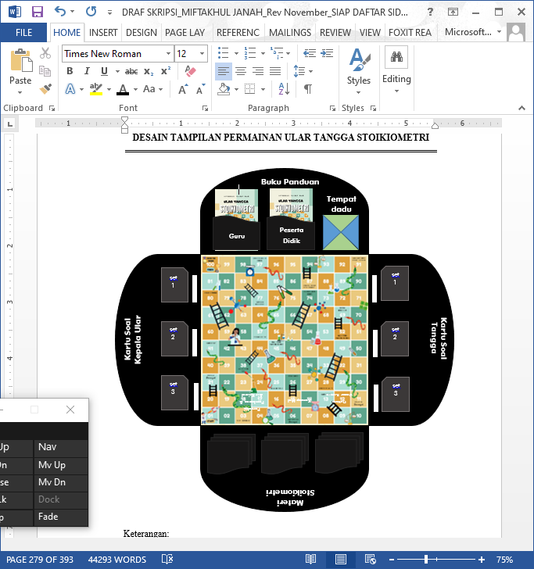

**Figure 2.** Media Game Snake Stairs Design

1. Stoichiometry Material in the Snakes and Ladders Game Media

The material used in this game media is stoichiometry grade 11 high school which includes calculating relative molecular mass, determining empirical formulas for compounds, the concept of moles, crystal water, and limiting reagents.

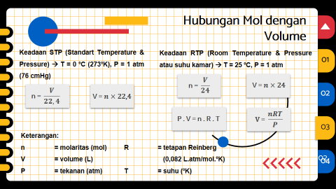 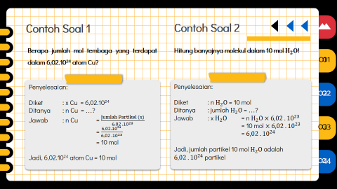

**Figure 3.** Display of material and examples of questions in the media game Stoichiometry Snakes and Ladders

1. Stoichiometry Snakes and Ladders Game Media Question Cards

The question cards in the stoichiometric snake and ladder game are divided into two types, namely snake and ladder question cards. These snake heads and ladders question cards are used as feedback in the stoichiometric snakes and ladders game. The snakes and ladders question cards in the stoichiometry snakes and ladders game contain questions related to stoichiometry material, including relative atomic mass and relative molecular mass, empirical formulas and molecular formulas for compounds, the concept of moles, limiting reagents, and crystal water.

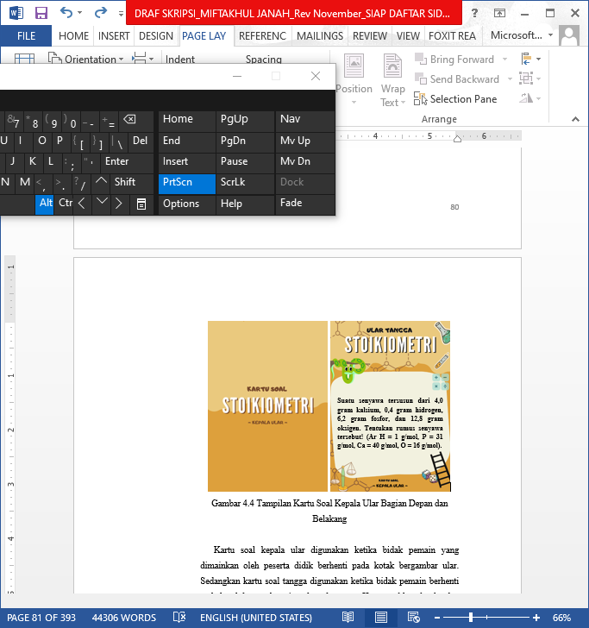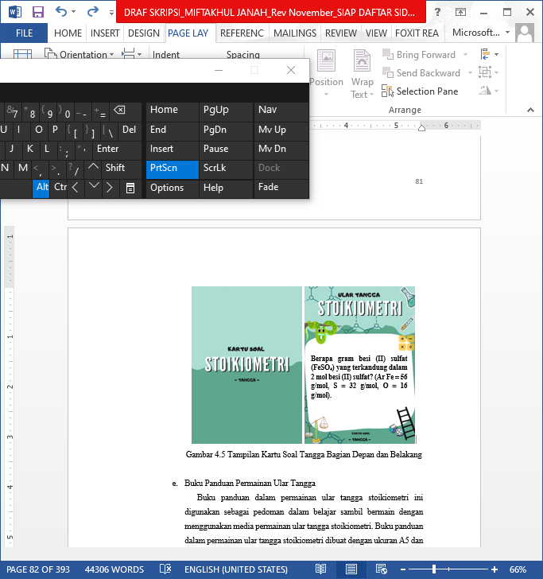

**Figure 4.** Display of Snakes and Ladders Question Cards in the Stoichiometric Snakes and Ladders Game Media

The snake head question card is used when the player's pawn played by the student stops on a box with a picture of a snake. Meanwhile, the ladder question card is used when the player's piece stops on the box with the bottom end of the ladder. The snake head and ladder question cards are used to determine the continuation of the snake and ladder game, where if students cannot answer the question on the snake question card correctly, then the player's pieces are required to go down to the box with the picture of the tip of the snake's tail. If the answer to the question is correct then the player's pawn remains in the previous box. Meanwhile, if students can answer the questions on the ladder question card correctly, then the player's pieces are allowed to rise to the top of the ladder. If the answer to the ladder card question is wrong, then the student's pawn is required to remain in the original box.

1. Snakes and Ladders Game Guidebook

This guidebook for the stoichiometric snakes and ladders game is used as a guide in learning while playing using the media of the stoichiometric snakes and ladders game. The guidebook for the stoichiometric snakes and ladders game is made in A5 size and there are two types, namely the student's guidebook and the teacher's guidebook. Both types of stoichiometric snakes and ladders game guidebooks have the same content, namely there is an introduction, content and conclusion. What differentiates between student and teacher guidebooks is the questions section and discussion of the snakes and ladders game card questions. The teacher's guidebook is accompanied by questions and discussion of the snake's head and ladder question cards, while the student's guidebook does not contain questions and discussion of the question cards.

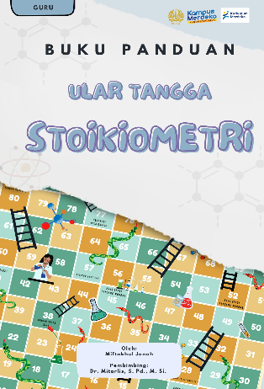 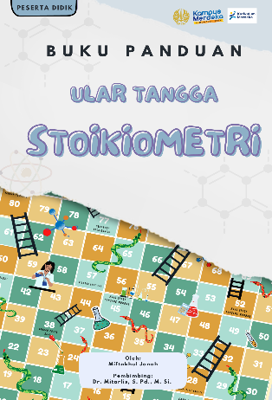 

**Figure 5.** External Cover Appearance Front and Back Book Guide Game Snake Staircase Stoichiometry

**Development Stage (Develop)**

The development stage is the stage to produce development products in the form of chemistry learning media based on joyful learning with snakes and ladders games on stoichiometric material to improve student learning outcomes. The development stage consists of three stages, namely review, validation and trial. At this development stage, a product will be produced that is ready to be presented to students after going through several stages, namely review by a chemistry lecturer which is then revised according to suggestions or input submitted by the reviewer, then validation from two chemistry lecturers and a high school chemistry teacher, and carry out trials.

**Review of Game Media**

The reviewer or material expert assesses the stoichiometric snakes and ladders game media as draft 1. The reviewer is a chemistry lecturer at Surabaya State University. The purpose of this review stage is to get suggestions or improvements from reviewers on how to improve the game media that has been developed to make it more perfect. The purpose of this review is to find out whether the game media that has been developed is feasible or still requires improvement. The game media draft is reviewed by the chemistry lecturer, then the game media draft that has been reviewed is revised according to the suggestions and input submitted by the reviewer. Suggestions and input are given based on appropriate content and construct criteria, including presentation, graphics and language.

**Validity of Game Media**

The validity of game media is reviewed based on the results of expert validation which is evaluated based on content and construct validity which includes aspects of content, presentation and language. The aim of this stage is to determine whether or not the chemistry learning media based on joyful learning with the snakes and ladders game is valid or not before the trial is carried out. Game media can be declared feasible if the score mode for each aspect is obtained with a value of ≥ 4 with valid to very valid criteria. In this step, the researcher gave the game media draft to three experts, namely two chemistry lecturers at Surabaya State University and one chemistry teacher at SMA Negeri 1 Menganti Gresik. The three experts who validate the game media being developed are called validators. The following validation results based on content validity criteria and the construct of the learning media developed are presented in Table 6.

**Table 6.** Validation Results of Stoichiometric Snakes and Ladders Game Media

|  |  |  |
| --- | --- | --- |
| Criteria Aspect | Validity Score Mode | Criteria |
| Contents | 4 | Valid |
| Presentation | 4 | Valid |
| Language | 5 | Very Valid |

Based on the assessment of the content and construct validity criteria for chemistry learning media based on joyful learning with the snakes and ladders game which includes content validity, presentation and language, it is known that the stoichiometric snakes and ladders game media has met the valid to very valid criteria and is ready to be tested on students . This can be proven by obtaining a score of ≥ 4 on each eligibility criterion in the feasible to very feasible category.

**Trials**

After being validated, the next step was to try out the game media on 32 students in class XI 2 SMA Negeri 1 Menganti Gresik. The trial was carried out through group activities, with each group consisting of 5 to 6 students, so that in one class there were 6 groups. The selection of group members is carried out heterogeneously based on the academic abilities and gender of the students. The data obtained from the trial stage were observations of student activities, observations of the implementation of learning activities, pretest and posttest results of student learning outcomes on stoichiometry material, as well as data from student response questionnaires.

**Observation of Student Activities**

When observing student activities, the observer observes the activities listed on the student activity observation sheet, whether they are carried out or not. The following are the results of observations of student activities which are presented in Table 7.

**Table 7.** Observation Results of Student Activities

|  |  |  |  |
| --- | --- | --- | --- |
| No. | Meeting | Percentage of Student Activities (%) | |
| Relevant | Irrelevant |
| 1 | Meeting 1 | 96,82 | 3,18 |
| 2 | Meeting 2 | 96,80 | 3,20 |
| Rata-rata | | 96,81 | 3,19 |

Based on Table 7, the results of observations of student activities that have been presented show that during the trial activities using chemistry learning media based on joyful learning with the snakes and ladders game on stoichiometry material, the average of the first and second meetings was 96.81% and the activity irrelevant from the average of the first and second meetings of 3.19%. This shows that students are very enthusiastic and happy during learning activities using chemistry learning media based on joyful learning with the snakes and ladders game on stoichiometry material. During the trial activities, students were very active in participating in learning activities. Based on the results of student observations made during the first and second meetings, it can be concluded that the stoichiometric snakes and ladders game is a practical chemistry learning medium where an average relevant activity score of ≥ 61% was obtained at the first and second meetings, namely 96.81%.

**Observation of the Implementation of Learning Activities**

Data from observations of the implementation of learning activities are used to provide an overview of the activities carried out during the trial. The observation sheet provided is filled in by the observers. Each observer observes and provides an assessment of the activities carried out during the trial activities according to the aspects presented on the learning implementation observation sheet.

**Table 8.** Observation Results of Implementation of Learning Activities

| No. | Observed Aspects | Persentase Hasil Observasi (%) | | | Category |
| --- | --- | --- | --- | --- | --- |
| Pertemuan 1 | Pertemuan 2 | Rata-rata |
| 1 | Introduction | 80 | 80 | 80 | Very Practical |
| 2 | Phase 1. Conveying goals and organizing students | 94,67 | 91,11 | 92,89 | Very Practical |
| 3 | Phase 2. Demonstrate knowledge or skills | 98,33 | 98,33 | 98,33 | Very Practical |
| 4 | Phase 3. Guiding training | 100 | 100 | 100 | Very Practical |
| 5 | Phase 4. Check understanding and provide feedback | 97,78 | 97,78 | 97,78 | Very Practical |
| 6 | Phase 5. Provide opportunities for advanced training and implementation | 100 | 100 | 100 | Very Practical |
| 7 | Closing | 88,89 | 88,89 | 88,89 | Very Practical |
| Average | | 94,24 | 93,73 | 93,98 | Very Practical |

The results of observations of the implementation of learning activities using chemistry learning media based on joyful learning with the snake and ladder game on stoichimetry material obtained an average percentage of learning implementation at the first meeting of 94.24% and the second meeting of 93.73%. Based on observations of learning implementation at the first and second meetings, the average percentage of learning implementation was 93.98% in the very practical category. This shows that the implementation of learning activities during the trial using chemistry learning media based on joyful learning with the snake and ladder game on stoichimetry material, was carried out very well and was in accordance with the learning syntax that had been designed in the teaching module. Based on the results of observations of the implementation of learning at the first and second meetings, it can be said that the stoichiometric snakes and ladders game media was practically used as a chemistry learning medium where a percentage of ≥ 61% was obtained in the practical to very practical category.

**Pretest and Posttest Results of Student Learning Results on Stoichiometric Material**

Students are given pretest and posttest questions in the form of essay questions on stoichiometric material as learning outcomes during trials using chemistry learning media based on joyful learning with the snakes and ladders game on stoichimetric material. The questions given consist of 10 essay questions and are done for 20 minutes. The questions given are in accordance with the material being taught and are similar to the questions on the stoichiometric snakes and ladders game media question card. The results of the pretest and posttest on stoichiometry material were then analyzed using the N-gain score to determine the increase in student learning outcomes after using chemistry learning media based on joyful learning with the snakes and ladders game. The results of the analysis of improving learning outcomes are presented in the following table.

**Table 9.** Data on Improvement of Student Learning Outcomes

| No. | Name | Pretest Score | Posttest Score | Improvement (N-gain) | Criteria |
| --- | --- | --- | --- | --- | --- |
| 1 | ADS | 20 | 80 | 0.75 | High |
| 2 | AB | 37 | 87 | 0.79 | High |
| 3 | AO | 11 | 78 | 0.75 | High |
| 4 | AS | 38 | 88 | 0.81 | High |
| 5 | BP | 22 | 82 | 0.77 | High |
| 6 | DDP | 40 | 90 | 0.83 | High |
| 7 | EPE | 51 | 95 | 0.90 | High |
| 8 | ELNA | 20 | 80 | 0.75 | High |
| 9 | FRA | 23 | 83 | 0.78 | High |
| 10 | GA | 42 | 92 | 0.86 | High |
| 11 | IA | 30 | 80 | 0.71 | High |
| 12 | KN | 30 | 80 | 0.71 | High |
| 13 | KAM | 35 | 85 | 0.77 | High |
| 14 | MH | 30 | 90 | 0.86 | High |
| 15 | MI | 20 | 85 | 0.81 | High |
| 16 | MWN | 11 | 78 | 0.75 | High |
| 17 | MSRA | 12 | 80 | 0.77 | High |
| 18 | MAR | 12 | 80 | 0.77 | High |
| 19 | MP | 12 | 82 | 0.68 | Medium |
| 20 | MHR | 30 | 88 | 0.83 | High |
| 21 | NM | 35 | 95 | 0.92 | High |
| 22 | NP | 60 | 96 | 0.90 | High |
| 23 | NPA | 30 | 85 | 0.79 | High |
| 24 | PNA | 30 | 87 | 0.81 | High |
| 25 | RAW | 41 | 91 | 0.85 | High |
| 26 | RA | 25 | 85 | 0.80 | High |
| 27 | SAM | 5 | 75 | 0.74 | High |
| 28 | SLN | 31 | 81 | 0.72 | High |
| 29 | SNA | 40 | 90 | 0.83 | High |
| 30 | TAAM | 12 | 84 | 0.82 | High |
| 31 | TVA | 12 | 80 | 0.77 | High |
| 32 | ZPA | 11 | 78 | 0.75 | High |
| Rata-rata | | 28,81 | 84,69 | 0.79 | High |

**Table 10.** Analysis Result of N-gain Score

|  |  |  |  |  |  |
| --- | --- | --- | --- | --- | --- |
| **Descriptive Statistics** | | | | | |
|  | N | Minimum | Maximum | Mean | Std. Deviation |
| Ngain\_skor | 32 | .68 | .92 | .7931 | .05713 |
| Ngain\_Persen | 32 | 68.18 | 92.31 | 79.3122 | 5.71310 |
| Valid N (listwise) | 32 |  |  |  |  |

Based on Table 9 and Table 10, it can be seen that there has been an increase in student learning outcomes with an average n-gain value of 0.79 in the high category. All students individually experienced an increase in learning outcomes by 21% in the medium category and 79% in the high category. This shows that chemistry learning media based on joyful learning with the snakes and ladders game can effectively improve student learning outcomes in stoichiometry material.

**Student Response**

The student response questionnaire was obtained from a questionnaire containing 22 statements, which contained positive and negative statements regarding the game media that had been given, with the answer options being "Yes" and "No". This response questionnaire was distributed to students after learning activities using chemistry learning media based on joyful learning with the stoichiometric snake and ladder game. The statements presented are classified into five aspects, namely interest in games as a learning media, novelty of the game, usefulness of the game, ease of use of the game, and linguistics. The results of the students' responses can be seen in Table 11 as follows.

**Table 11.** Results of Student Responses

| No. | Aspect | Percentage (%) | Category |
| --- | --- | --- | --- |
| 1 | Interest in games as a learning media | 91,96 | Very Practical |
| 2 | Newness of the game | 96,875 | Very Practical |
| 3 | The usefulness of the game | 81,25 | Very Practical |
| 4 | Ease of use game | 87,5 | Very Practical |
| 5 | Language | 100 | Very Practical |
| Average | | 91,52 | Very Practical |

Based on Table 10 it can be seen that each aspect fulfills the very practical category by obtaining an average percentage of 91.52%. This shows that the game media given to students gets a positive response, so it is hoped that learning will be meaningful, enjoyable, and can improve student learning outcomes in stoichiometry material. This is supported by analysis of student response data which shows that ≥ 61% of responses are positive so that the stoichiometric snake and ladder game media is declared practical for use in chemistry learning activities.

**CONCLUSION**

Based on the results and discussion related to chemistry learning media based on joyful learning with snakes and ladders games on stoichiometric material to improve student learning outcomes, it can be said to be suitable as a chemistry learning media, with the following details.

1. The validity results of chemistry learning media based on joyful learning with the snake and ladder game on stoichiometric material to improve student learning outcomes can be said to be suitable for use in terms of content, linguistic, presentation and graphic criteria. Consecutively, the criteria were adequate to very adequate with a score of ≥ 4. This result was supported by an n-gain score of 0.79, which indicated that chemistry learning media based on joyful learning with the snakes and ladders game on stoichiometry material could improve student learning outcomes. said to be suitable for use during learning activities.
2. The practical results of chemistry learning media based on joyful learning with the snakes and ladders game on stoichiometry material to improve student learning outcomes are said to be suitable for use in terms of the results of observations of student activities which obtained a percentage of 96.81%, the results of observations of learning implementation obtained a percentage of 93.98 %, and student responses obtained a percentage of 91.52%. This shows that chemistry learning media based on joyful learning with snakes and ladders games on stoichiometry material to improve student learning outcomes can be said to be practically used during learning activities.
3. The results of the effectiveness of chemistry learning media based on joyful learning with the snake and ladder game on stoichiometry material to improve student learning outcomes which were developed in terms of pretest and posttest scores were declared effective. This is shown by the N-gain score of all students being in the medium to high category and meeting the KKM value, with an average N-gain value of 0.79 with high criteria. This shows that chemistry learning media based on joyful learning with the snake and ladder game on stoichiometry material to improve student learning outcomes can be said to be effectively used during learning activities.

**RECOMMENDATIONS**

Based on the results obtained from this development research, several suggestions can be written as follows.

1. In carrying out the trial, data was obtained that the stoichiometric snakes and ladders game media was only given one game media in one class which was divided into 6 groups with a total of 32 students. For further research it would be more optimal if each group was given one each. The media game is stoichiometric snakes and ladders and one of the group members is given the responsibility to determine the course of the game based on the teacher's guidebook.

2. Further research needs to be carried out by applying the stoichiometric snakes and ladders game media to other classes that receive chemistry lessons in order to obtain broader data regarding the advantages and disadvantages of this media.

3. During the learning activities, data was obtained that the majority of students had cellphones and more often played games via gadgets. For further research, it would be more optimal if the stoichiometric snakes and ladders game media was developed using digital or ICT-based media.

**ACKNOWLEDGEMENTS**

Thank you to the supervisor and chemistry lecturer at Surabaya State University who have guided in conducting this research. Thank you to the school principal and chemistry teacher at SMAN 1 Menganti Gresik who have agreed to provide time and space for this research, as well as students in class XI 2 at SMAN 1 Menganti Gresik who have agreed to be the subject of alimited trial in this study.

**BIBLIOGRAPHY**

Daryanto. 2010. *Media Pembelajaran.* Bandung: PT Sarana Tutorial Nurani Sejahtera.

Hake, R.R. 1998. Interactive-Engagement Versus Traditinal Methods: A Six-Thousand- Student Survey of Mechanics Test Data for Introductory Physic Courses. *American*

*Journal Physic*. Vol. 66, Hal 66-74.

Kemdikbud. 2016. *Peringkat dan Capaian PISA Indonesia Mengalami Peningkatan.* http://www.kemdikbud.go.id, Kemendikbud.

Lutfi, Ahmad, Nur Qurrotur Aini, Nurul Amalia, Putri Amiratul Umah, Maissy Diana Rukmana. 2021. Gamifikasi untuk Pendidikan Pembelajaran Kimia yang Menyenangkan Pada Masa Pandemi Covid 19. *Jurnal Pendidikan Kimia Indonesia*. Vol. 5 No. 2 Hal. 99-101

Nilawati, Nilawati, Putri Arum, Subandi, dan Yudhi Utomo. 2016. Keefektifan Pembelajaran Interkoneksi Multipel Representasi dalam Mengurangi Kesalahan Konsep Siswa Pada Materi Stoikiometri. *Jurnal Pendidikan*. Hal 2076-2082.

Ningsih, Silvia P, Amilda, dan Etrie Jayanti. 2021. Desain Permainan Ular Tangga dalam Pembelajaran Kimia. *Orbital: Jurnal Pendidikan Kimia*. Hal 49-66.

Pramita, Amilia dan Rudiana Agustini. 2016. Pengembangan Media Permainan Ular Tangga Pada Materi Senyawa Hidrokarbon Kelas XI SMA untuk Meningkatkan Pemahaman Konsep Siswa. *UNESA Journal of Chemical Education*. Hal 336-344.

Riduwan. 2015. Skala Pengukuran Variabel-Variabel Penelitian. Bandung: ALFABETA.

Ristiyani, E., & Bahriah, E., S. 2016. Analisis Kesulitan Belajar Kimia Peserta didik di SMAN X Kota Tangerang Selatan. *Jurnal Penelitian Dan Pembelajaran IPA*, Vol. 2 Hal 18–29.

Rosmiati. 2022. Pembelajaran Kimia yang Menyenangkan di Madrasah. *Uniqbu Journal of Exact Science (UJES)*. Vol. 3 Hal. 18-23.

Sudjana, Nana. 2009. *Penilaian Hasil Proses Belajar Mengajar.* Bandung: Remaja Rosdakarya.

Zahro, N. M., & Lutfi, A. 2021. Students’ Well-Being and Game Implementation in Learning Chemistry in Merdeka Belajar Era. Jurnal Pendidikan Kimia Indonesia, Vol. 5 Hal. 34 – 43.