|  |  |
| --- | --- |
| **Development of E-Supplement Biomordant from Several Species of Ferns (*Pteridophyta*) as A Teaching Material for Green Chemistry Course** | |
|  | |
| **Weni Hariyanti1, Masriani2\*, Risya Sasri3, Ajuk Sapar4, Erlina5** | |
| **1**  **2** | Chemistry Education Study Program, Faculty of Teacher Training and Education, Tanjungpura University, Pontianak, Indonesia  Chemistry Study Program, Faculty of Mathematics and Natural Sciences, Tanjungpura University, Pontianak |
| \* | Corresponding Author e-mail*:* [*masriani@fkip.untan.ac.id*](mailto:masriani@fkip.untan.ac.id) |

|  |  |  |
| --- | --- | --- |
| **Article History**  Received: dd-M-Year  Revised: dd-M-Year  Published: dd-M-Year  **Keywords**: Development; E-supplement; Biomordant; *Pteridophyta*; Green chemistry | **Abstract**  The purpose of this study was to determine the feasibility of Green Chemistry E-Supplement with material Biomordant from Several Species of Ferns (*Pteridophyta*). The method used in this research is Research and Development (R&D). The e-supplement teaching material development model used is ADDIE. The subject of this research is Green Chemistry E-Supplement with material Biomordant from Several Species of Ferns (*Pteridophyta*). The data collection techniques used were direct communication and measurement techniques. The research instrument used was a feasibility assessment sheet and data analysis using a Likert scale. The feasibility of e-supplement was assessed by two validators. The final results of the feasibility assessment in the aspects of material, media, and language obtained a percentage of 98%. So, it can be concluded that the Green Chemistry E-Supplement with material Biomordant from Several Species of Ferns (*Pteridophyta*) is very feasible. | |
| **How to Cite:** First author., Second author., Third author, etc., (20xx). The title. *Hydrogen: Jurnal Kependidikan Kimia*, vol(no). doi:https://doi.org/10.33394/hjkk.v10i2 | | |
| <https://doi.org/10.33394/hjkk>.xxxxx.xxxx | | This is an open-access article under the [CC-BY-SA License.](http://creativecommons.org/licenses/by/4.0/)  C:\Users\IKIP\Pictures\CC_BY-SA_3.0.png |

**INTRODUCTION**

Learning refers to a series of programs arranged by educators with the aim of teaching individuals or groups through various efforts, strategies, methods, and approaches to achieve planned goals (Akrom & Istiq’faroh, 2021). The learning process is divided into two main activities, namely learning activities and teaching activities. In learning activities, there is a lot of emphasis on students as active individuals in an effort to gain insight and knowledge in learning activities. Meanwhile, teaching activities emphasize a lot on educators as people who try to convey insights and knowledge in learning activities. In learning activities, educators and students need facilities or tools such as teaching material (Arif & Rukmi, 2020).

Teaching material are one of the main tools in learning activities. The teaching material contain learning materials that are designed in such a way as to have interesting and systematic elements to achieve several expected competencies. As one of the main tools in learning activities, teaching material can be used as a measuring tool for the success of a learning activity. In a learning activity, teaching material can be said to be the main aspect in the learning process in the classroom. The use of teaching material can help educators and students in learning activities. One type of teaching material that can be utilized in learning activities is supplementary books (Arif & Rukmi, 2020). According to Sothayapetch et al., (2013) books play an important role in the learning process.

Minister of National Education Number 2 of 2008 article 6 (2) states that in addition to textbooks, educators can use educators' guidebooks, enrichment books, and reference books in the learning process. According to Abdillah et al., (2020) companion books or student supplement books are learning resources that can be used as a complement that can increase students' understanding of the subject matter. Supplement books are books that can enrich and improve mastery of science and technology, skills, and shape the personalities of students, educators, education managers, and other communities. This type of book is not solely intended for students but can also be used by other parties or society in general. Supplement books are needed to increase learners' creativity and knowledge. In learning, many sources are needed so that learners' knowledge develops, not only the cognitive aspects but also the application and application (Rizki et al., 2016).

Ferns (Pteridophyta) are plants that are easily found in West Kalimantan. Some ferns can be used as natural dyes (Andries et al., 2022). According to Lestariningsih et al., (2021) ferns or ferns have leaf dyes that can be used as natural dyes for textile products through the ecoprint technique. Based on previous research, some of the fern species contain secondary metabolites including tannins, this was explained by Swandi & Salmi, (2023) that the methanol extract of resam fern leaves *(Gleichenia linearis*) contains tannin compounds. Furthermore, in the research of Shah et al., (2014) the extract of uban fern leaves *(Nephrolepis biserrata*) in methanol solvent found tannin compounds, besides that in the leaves of dayak ferns (*Blechnum orientale*) also found tannin compounds (Lai et al., 2010).

Lestari et al., (2020) explained that tannin compounds can have potential as a mordant material in natural coloring. In addition, tannins can also be used as textile dyes in fabrics (Hong, 2018). Tannin that act as mordant have a tendency to color, so they can strengthen the overall color of the fabric. The use of natural mordant (biomordant) is done to prevent the impact caused by metal mordants where the metal is ecologically dangerous considering the residue is discharged directly into the environment (Adu et al., 2022). According to (Permatasari & Lestari, 2023) synthetic waste (chemicals) from textile dyeing is one of the problems still faced by society and the fashion industry today. The increased use of synthetic dyes produces hazardous chemical waste, the waste is difficult to decompose in final disposal which has an impact on environmental damage and public health.

One of the elective courses in the Chemistry Education Study Program, Faculty of Teacher Training and Education, Tanjungpura University is Green Chemistry. The Green Chemistry course focuses on thinking about chemistry to save the environment and the health of living things from the use of hazardous chemicals. In the Green Chemistry course, based on 12 principles which are important steps towards environmental conservation and sustainable development. Based on the results of interviews with lecturers teaching Green Chemistry courses regarding the teaching material used that currently students do not have Green Chemistry course e-supplement books, so that learning does not only focus on certain teaching material sources, so that varied learning resources are needed such as e-supplement that can deepen student understanding. With the development of Green Chemistry E-Supplement with material Biomordant from Several Species of Ferns (*Pteridophyta*), this can increase students insight and knowledge in preventing the negative effects of hazardous chemicals and can foster student interest and motivation in learning.

**METHOD**

The method used in this research is Research and Development (R&D). The e-supplement teaching material development model used uses ADDIE. The ADDIE model development research type is the steps or process to develop and produce a new product. In addition, the ADDIE model development research aims to improve existing products (Arif & Rukmi, 2020). The reason for using the ADDIE development model is because it is simple and easy to learn and its structure is systematic (Muliani et al., 2019). The ADDIE development model has five stages including Analysis, Design, Development, Implementation, and Evaluation (Cahyadi, 2019). However, in this study, the implementation stage was not carried out because the development in this study was only to determine the feasibility level of the e-supplement. The flow of the ADDIE model stages according to Branch, (2009), can be seen in Figure 1.

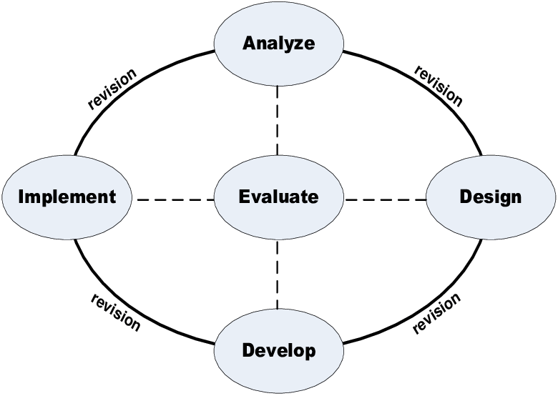

Figure 1. Steps of the ADDIE Model

The first stage is the analysis stage. The analysis stage carried out is problem analysis and needs analysis. At this stage, direct interviews were conducted with lecturers teaching Green Chemistry courses regarding teaching material used in Green Chemistry courses. The second stage is the design stage. The design stage is carried out by making a media design in the form of a storyboard, determining the format of the e-supplement that will be made both the writing format and the content/material format, then compiling a feasibility assessment sheet (Ersando et al., 2022). The third stage is the development stage. The development stage is carried out to realize the product that has been designed and assess the feasibility of the product (Kurnia et al., 2022). The product that will be produced from this research is additional teaching material in the form of Green Chemistry E-Supplement with material Biomordant from Several Species of Ferns (*Pteridophyta*). The product that has been produced is then validated by testing its feasibility based on material, media, and language aspects. The feasibility of the product was assessed by two validators. The last stage carried out is evaluation. The evaluation stage is carried out at each stage of analysis, design, to development. The evaluation carried out at this stage is formative evaluation. In this evaluation, improvements (revisions) are made at each stage including analysis, design, and development (Nukila et al., 2022).

Data collection techniques in this study used direct communication techniques and measurement techniques. Direct communication techniques by conducting direct interviews with lecturers teaching Green Chemistry courses. The measurement technique was carried out by two validators by filling in the feasibility assessment sheet of the e-supplement that had been designed. The research instrument used was a feasibility assessment sheet. Instruments are used to collect data needed to assess products (Puspasari & Suryaningsih, 2019). The data analysis used is a Likert scale (1-4). After obtaining the assessment data, the data was then interpreted with certain criteria (Table 1).

Table 1. Criteria for interpretation of feasibility assessment scores

|  |  |
| --- | --- |
| **Assessment Score** | **Criteria** |
| 76%< X ≤ 100% | Very worthy |
| 51% < X ≤ 75% | Worthy |
| 26% < X ≤ 50% | Not worthy |
| 0%< X ≤ 25% | Very unworthy |

(Nurdiana et al., 2023)

The formula used to calculate the percentage of product feasibility is as follows.

$$\text{P=}\frac{\text{f}}{\text{N}}\text{×100\%}$$

Description:

P : percentage of feasibility

f : score obtained from the validator

N : maximum score

(Hidayat et al., 2022)

**RESULTS AND DISCUSSION**

Product development is carried out using the ADDIE model. In this study, the ADDIE model used was evaluating the analysis, design, and development sections. The implementation stage has not been applied in this study. The stages carried out in the ADDIE model include the following.

***Analysis stage***

The analysis stage carried out is problem analysis and needs analysis. At this stage, direct interviews were conducted with lecturers teaching Green Chemistry courses regarding teaching material used in Green Chemistry courses. The results of the analysis show that students do not have complementary books (e-supplement) in Green Chemistry courses, complementary teaching material are needed to increase student creativity and knowledge. So that learning does not only focus on certain teaching material sources, it is necessary to have varied learning resources such as e-supplement that can deepen student understanding.

***Design stage***

The design stage is carried out by making media designs in the form of storyboards, determining the format of e-supplement, namely the writing format and content/material format, and compiling feasibility assessment sheets. The preparation of the feasibility assessment sheet was carried out by compiling aspects and assessment indicators that would be given to the validator lecturer to determine the feasibility of the developed e-supplement.

***Development Stage***

The development stage in this study includes the development of e-supplement products and product feasibility test assessments. At this stage the validator provides criticism and suggestions which are then used as input and further revisions are made (Saski & Sudarwanto, 2021). The software used in making this e-supplement is *Canva*. Making e-supplement is tailored to the learning objectives. The selection of images, colors, words and sentences is also adjusted to the characteristics of the material, so that students can easily understand the content of the e-supplement teaching material information. Green Chemistry E-Supplement Product with material Biomordant from Several Species of Ferns (*Pteridophyta*) can be seen in Figure 2.

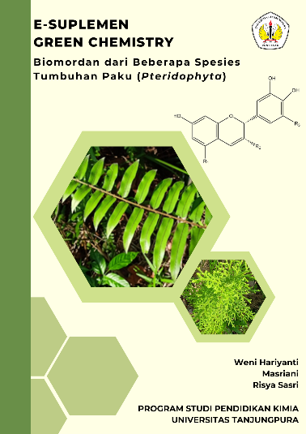 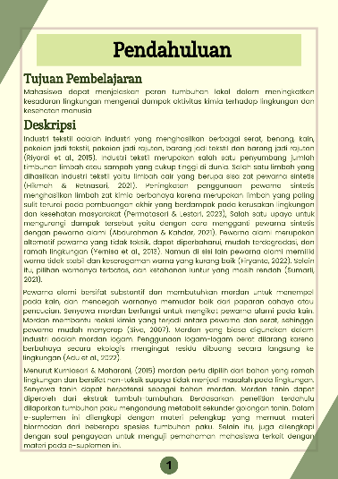 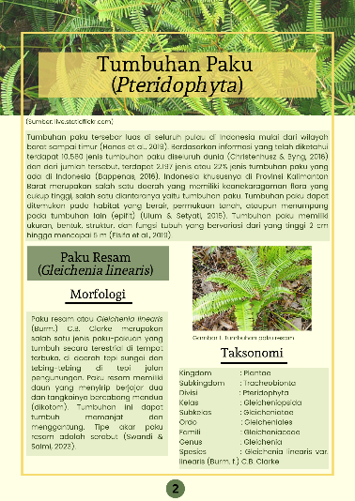

(c)

(b)

(a)

Figure 2. Display of Green Chemistry e-supplement. a) display of the e-supplement cover; b) display of the e-supplement introduction section; c) display of the e-supplement material content

After making the product, the next stage is feasibility assessment and improvement. Feasibility assessment is carried out based on material, media and language aspects. The purpose of the feasibility assessment is to determine or measure the level of feasibility of the media that has been developed based on percentage criteria. The feasibility assessment of material, media, and language aspects was carried out by 2 validators. The results of the feasibility assessment of the three aspects obtained very feasible results with a percentage of 98% with very feasible criteria. Data on the results of the feasibility assessment of material, media, and language from the two validators can be seen in Table 2 below.

Table 2. Data from the assessment of the feasibility of material, media, and language from the two validators

|  |  |  |  |
| --- | --- | --- | --- |
| **Aspects** | **Number Statements** | **Assessment Score Validator 1** | **Assessment Score Validator 2** |
| Material | 1 | 4 | 4 |
| 2 | 4 | 4 |
| 3 | 4 | 4 |
| 4 | 4 | 4 |
| 5 | 4 | 4 |
| Media | 6 | 4 | 4 |
| 7 | 4 | 3 |
| 8 | 4 | 4 |
| 9 | 4 | 3 |
| Language | 10 | 4 | 4 |
| 11 | 4 | 4 |
| 12 | 4 | 4 |
| 13 | 4 | 4 |
| **Total score** | | 52 | 50 |
| **Presentase** | | 100% | 96% |
| **Average Percentage** | | 98% (Very worthy) | |

Based on the evaluation from the validator, there are several indicators in the e-supplement that need to be improved in all three aspects, namely:

1. Material Aspect

In the material aspect, the material presentation indicator in the e-supplement needs to be improved by adding some sub-material content, namely about tannin compounds and biomordant reactions in binding with cellulose fibers and dyes. The addition of the content of the sub-material is done to help and clarify concepts that are difficult to understand in e-supplement. By providing a more detailed explanation, students will more easily understand the content of the learning material. According to Rahdiyanta, (2015), the presentation of the material must be complete and in accordance with the learning outcomes. Some of the revised e-supplement results on the material aspect can be seen in Figure 3 below.

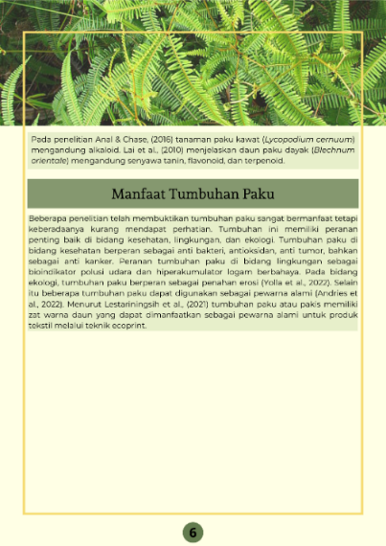 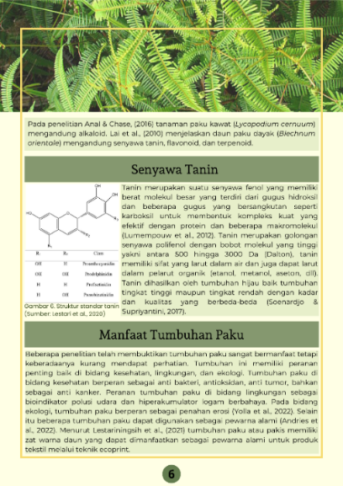

After revision

Before revision

(a)

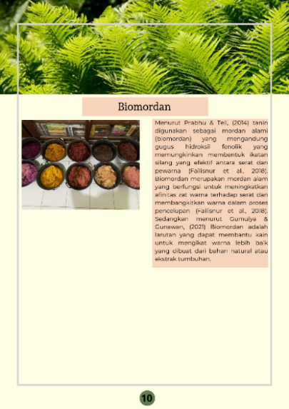 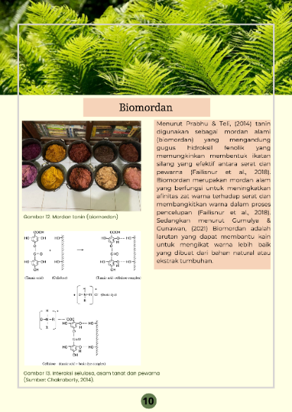

After revision

Before revision

(b)

Figure 3. Revision of e-supplement on material aspect. a) revision of material on tannin compounds; b) revision of material on biomordant reaction

1. Media Aspect

In the media aspect, the visual display indicator of teaching material in e-supplement needs to be added to each picture and table. On images (which are not personal documentation) it is necessary to include the source to provide legality and disclosure of information about the images used in the e-supplement. In addition, the layout of the writing on the types of mordants needs to be improved by making the sentence into one sentence. Some of the revised e-supplement results on the media aspect can be seen in Figure 4 below.

**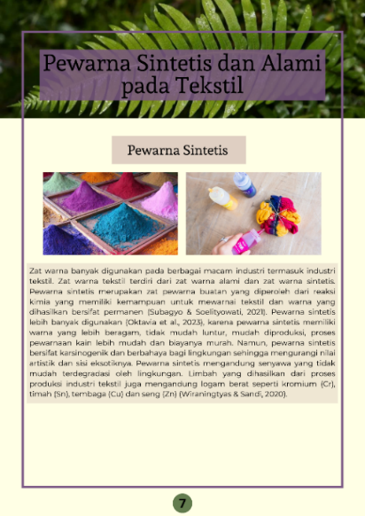** **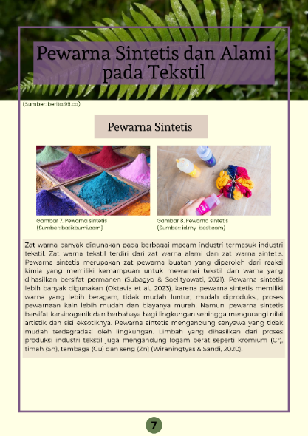**

After revision

Before revision

(a)

**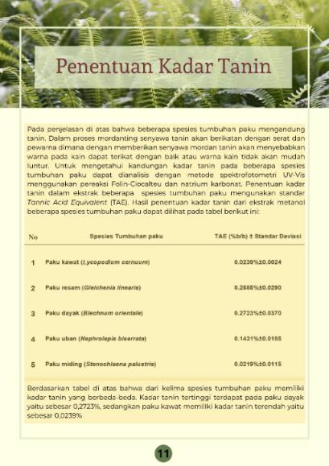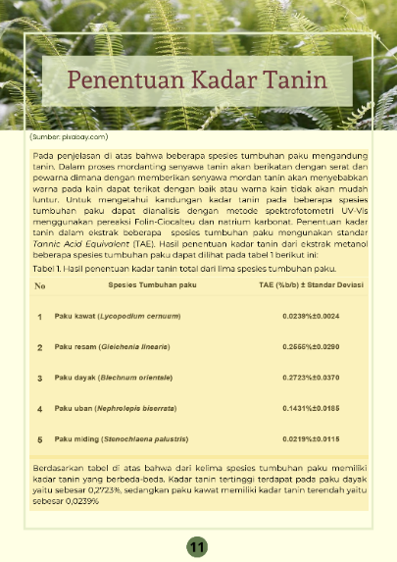**

After revision

Before revision

(b)

**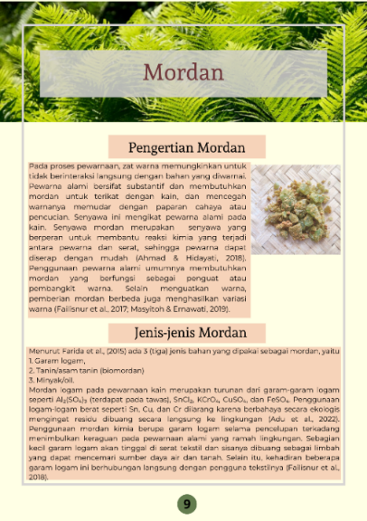 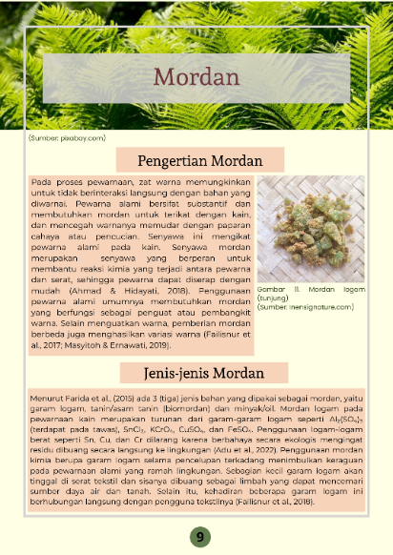**

(c)

After revision

Before revision

Figure 4. Revision of e-supplement on media aspect. a) revision of captions and sources on each picture; b) revision of table captions; c) revision of text layout

1. Language Aspect

In the language aspect, the straightforward indicator in the e-supplement needs to be improved on sentences that are less effective. According to Dina, (2015), effective sentences are correct and clear sentences that can be understood by others correctly. Some of the revised e-supplement on the language aspect can be seen in Figure 5 below.

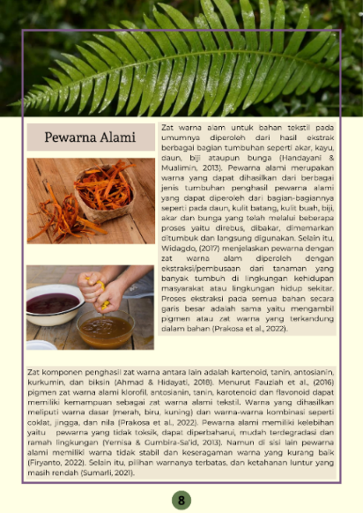 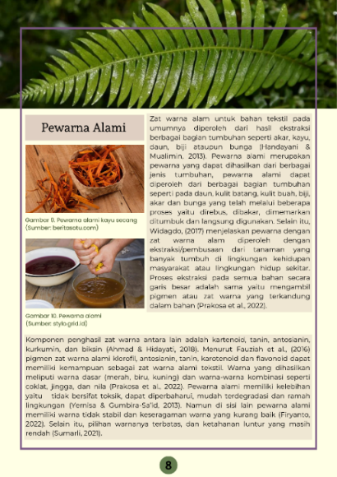

After revision

Before revision

Figure 5. Revised e-supplement on the language aspect of the effective sentence section

Based on the various aspects that have been described based on the feasibility assessment from the validator, the Green Chemistry E-Supplement with material Biomordant from Several Species of Ferns (*Pteridophyta*) are very feasible. This is in line with the research of Reski et al., (2016) regarding the development of local wisdom-based textbook supplement that get an assessment score of 84.58% which is included in the decent category with a good predicate. Then in the research of Sofia et al., (2022) the development of biology supplement books received an assessment score from experts with a percentage of 91.25% with a very feasible category. This Green Chemistry e-supplement has advantages and disadvantages, the advantages given to this e-supplement are that it is more practical to use because it can be accessed easily via smartphone devices and computers. In addition, it is also equipped with questions so that it can train students' level of understanding. The weakness in this e-supplement is that it is only a simple text that contains sentences and images, not complete with audio visuals or others.

**CONCLUSION**

Green Chemistry e-supplement are declared feasible to use as complementary/supportive teaching material from the point of view of expert validators. The average percentage obtained from the two validators was 98% with very feasible criteria so that the e-supplement could be used in learning.

**RECOMMENDATIONS**

It is hoped that the Green Chemistry e-supplement from this research can be given to students as a complementary/supporting teaching material in learning Green Chemistry courses.

**ACKNOWLEDGEMENTS**

The researcher's gratitude to Tanjungpura University for providing research funds through DIPA Faculty of Teacher Training and Education 2023.

**BIBLIOGRAPHY**

Abdillah, A. F., Degeng, I. N. S., & Husna, A. (2020). Pengembangan Buku Suplemen dengan Teknologi 3d Augmented Reality sebagai Bahan Belajar Tematik untuk Siswa Kelas 4 SD. *JINOTEP (Jurnal Inovasi Dan Teknologi Pembelajaran)*, *6*(2), 111–118. https://doi.org/10.17977/um031v6i22020p111

Adu, R. E. Y., Tea, M. T. D., & Bouk, Y. (2022). Ekstraksi Tanin dari Limbah Kulit Biji Asam dan Penggunaannya sebagai Biomordan pada Pewarnaan Tenun Timor Secara Alami. *Jurnal Riset Kimia*, *13*(2), 178–187. https://doi.org/10.25077/jrk.v13i2.509

Akrom, N., & Istiq’faroh, N. (2021). Pengembangan Buku Suplemen IPS Tema “Indahnya Kebersamaan” Berbasis Kearifan Lokal Sidoarjo untuk Siswa Kelas IV Sekolah Dasar. *Jurnal Pendidikan*, *4*(2), 19–24.

Andries, A. E., Koneri, R., & Maabuat, P. V. (2022). Inventarisasi Tumbuhan Paku Di Ruang Terbuka Hijau Kampus Universitas Sam Ratulangi Manado, Sulawesi Utara. *Jurnal Bios Logos*, *12*(2), 140–148. https://doi.org/10.35799/jbl.v12i2.42343

Arif, M. H., & Rukmi, A. S. (2020). Pengembangan Buku Suplemen untuk Keterampilan Menulis Deskripsi Siswa Kelas IV Sekolah Dasar. *JPGSD*, *8*(5), 1033–1043. https://ejournal.unesa.ac.id/index.php/jurnal-penelitian-pgsd/article/view/36680/32683

Branch, R. M. (2009). Instructional Design: The ADDIE Approach. In *Encyclopedia of volutionary Psychological Science*. https://doi.org/10.1007/978-3-319-19650-3\_2438

Cahyadi, R. A. H. (2019). Pengembangan Bahan Ajar Berbasis Addie Model. *Halaqa: Islamic Education Journal*, *3*(1), 35–42. https://doi.org/10.21070/halaqa.v3i1.2124

Dina, R. (2015). Penggunaan Kalimat Efektif dalam Karya Ilmiah Siswa: Aplikasi Semantik Studi Kasus Siswa Kelas XI SMK Negeri 2 Lembah Gumanti. *Jurnal Penelitian Bahasa Dan Sastra Indonesia*, *1*(2), 167–173.

Ersando, E., Muharini, R., Lestari, I., Putra Sartika, R., & Rasmawan, R. (2022). Pengembangan E-Modul Pemisahan Senyawa Fenolik dari Fraksi Simpur Air dengan Teknik Kromatografi Lapis Tipis (KLT) Preparatif sebagai Sumber Belajar Kimia Bahan Alam. *Kependidikan Kimia*, *10*(2), 2656–3061. http://ojs.undikma.ac.id/index.php/hydrogen/

Hidayat, R. K., Sahidu, H., & Gunada, I. W. (2022). Pengembangan Perangkat Pembelajaran Berbasis Inkuiri Terbimbing Terintegritas dengan Karakter untuk Meningkatkan Pemahaman Konsep Fisika Peserta Didik. *Jurnal Ilmiah Profesi Pendidikan*, *7*(2), 285–291. https://doi.org/10.29303/jipp.v7i2.462

Hong, K. H. (2018). Effects of Tannin Mordanting on Coloring And Functionalities of Wool Fabrics Dyed with Spent Coffee Grounds. *Fashion and Textiles*, *5*(33), 1–11. https://doi.org/10.1186/s40691-018-0151-3

Kurnia, M. R. A., Haryanto, H., Sanova, A., & Dewi, C. A. (2022). Studi Respon Siswa Terhadap Pengembangan Multimedia Interaktif Berbasis Chemo-Entrepreneurship Berbentuk Aplikasi Android. *Hydrogen: Jurnal Kependidikan Kimia*, *10*(1), 10. https://doi.org/10.33394/hjkk.v10i1.4954

Lai, H. Y., Lim, Y. Y., & Kim, K. H. (2010). *Blechnum Orientale* Linn - a Fern with Potential as Antioxidant, Anticancer and Antibacterial Agent. *BMC Complementary and Alternative Medicine*, *10*(15), 1–8. https://doi.org/10.1186/1472-6882-10-15

Lestari, D. W., Atika, V., Satria, Y., Fitriani, A., & Susanto, T. (2020). Aplikasi Mordan Tanin pada Pewarnaan Kain Batik Katun Menggunakan Warna Alam Tingi (Ceriops tagal). *Jurnal Rekayasa Proses*, *14*(2), 128–136. https://doi.org/10.22146/jrekpros.57891

Lestariningsih, S. P., Riyono, J. N., & Siswoyo, A. (2021). Pemanfaatan Pakis sebagai Motif Alami pada Kain (Ecoprint) untuk Pengembangan Ekonomi Kreatif di Desa Rasau Jaya Umum, Kabupaten Kubu Raya. *Prosiding SNAPP : Sosial Humaniora, Pertanian, Kesehatan Dan Teknologi*, *1*(1), 518–526.

Muliani, M., Khaeruman, K., & Dewi, C. A. (2019). Pengembangan Perangkat Pembelajaran Predict Observe Explain (Poe) Berorientasi Green Chemistry untuk Menumbuhkan Sikap Ilmiah Siswa pada Materi Asam Basa. *Hydrogen: Jurnal Kependidikan Kimia*, *7*(1), 37. https://doi.org/10.33394/hjkk.v7i1.1654

Nukila, M., Muharini, R., Sartika, R. P., Hairida, H., & Lestari, I. (2022). Pengembangan E-Suplemen Berbasis Multirepresentasi pada Materi Hidrokarbon. *Edukatif : Jurnal Ilmu Pendidikan*, *4*(4), 5970–5987. https://doi.org/10.31004/edukatif.v4i4.3071

Nurdiana, N., Dwiyanti, S., Pritasari, O. K., & Wilujeng, B. Y. (2023). Pengembangan Media Pembelajaran Berbasis Website Kompetensi Dasar Gizi untuk Kecantikan di SMK Labschool Unesa 1 Surabaya. *Jurnal Tata Rias*, *12*(2), 186–194.

Permatasari, K. A. N., & Lestari, N. P. E. B. (2023). Pemanfaatan Pewarna Alam Dalam Menghasilkan Karya Fesyen (Studi Kasus Produk Busana Casual Pria Dan Wanita). *Jurnal Da Moda*, *4*(2), 53–64. https://jurnal.std-bali.ac.id/index.php/damoda

Puspasari, R., & Suryaningsih, T. (2019). Pengembangan Buku Ajar Kompilasi Teori Graf dengan Model Addie. *Journal of Medives : Journal of Mathematics Education IKIP Veteran Semarang*, *3*(1), 137. https://doi.org/10.31331/medivesveteran.v3i1.702

Rahdiyanta, D. (2015). Teknik Penyusunan Modul. Yogyakarta: Direktorat P2TK.

Reski, R., Hairida, H., & Masriani, M. (2016). Pengembangan Suplemen Buku Ajar Berbasis Kearifan Lokal pada Materi Biosintesis Eikosanoid. *Neliti.Com*, *5*(3), 1–13. https://www.neliti.com/publications/191800/pengembangan-suplemen-buku-ajar-berbasis-kearifan-lokal-pada-materi-biosintesis

Rizki, M., Irwandi, D., & Bahriah, E. S. (2016). Pengembangan Buku Suplemen Kimia Berbasis Sains Teknologi Masyarakat pada Materi Kimia Polimer. *JTK (Jurnal Tadris Kimiya)*, *1*(2), 47–57. https://doi.org/10.15575/jta.v1i2.1241

Saski, N. H., & Sudarwanto, T. (2021). Kelayakan Media Pembelajaran Market Learning Berbasis Digital pada Mata Kuliah Strategi Pemasaran. *Jurnal Pendidikan Tata Niaga (JPTN)*, *9*(1), 1118–1124.

Shah, M. D., Yong, Y. S., & Iqbal, M. (2014). Phytochemical Investigation and Free Radical Scavenging Activities of Essential Oil, Methanol Extract and Methanol Fractions of *Nephrolepis biserrata*. *International Journal of Pharmacy and Pharmaceutical Sciences*, *6*(9), 269–277.

Sofia, E., Muharini, R., Lestari, I., Sahputra, R., & Ulfah, M. (2022). Electronic-Supplement Kimiapedia dengan Pendekatan Literasi Sains pada Materi Hidrokarbon di SMA Negeri 10 Pontianak. *Jurnal Kependidikan Kimia*, *10*(2), 73–88.

Sothayapetch, P., Lavonen, J., & Juuti, K. (2013). An Analysis of Science Textbooks for Grade 6: The Electric Circuit Lesson. *Eurasia Journal of Mathematics, Science and Technology Education*, *9*(1), 59–72. https://doi.org/10.12973/eurasia.2013.916a

Swandi, M. K., & Salmi, S. (2023). Ekstrak Daun Paku Resam (*Gleichenia linearis* (Burm.) C.B. Clarke) Berpotensi sebagai Tanaman Obat Berdasarkan Profil Fitokimia dan Kadar Total Fenol. *BERKALA SAINSTEK*, *11*(2), 96–105. https://doi.org/10.19184/bst.v11i2.34875