|  |  |
| --- | --- |
| **CYTOTOXIC ACTIVITY OF GUDE LEAVES (*Cajanus cajan*) USING THE *Brine Shrimp Lethality Test* (BSLT) METHOD** | |
|  | |
| **Andi Emelda1, Hasnaeni2\*, Amanda Ulfa3** | |
|  | 1,,3Department of Pharmacy, Faculty of Pharmacy, Universitas Muslim Indonesia, Jl. Urip Sumoharjo Km 05 Makassar, Indonesia 90231  2\* Master of Pharmacy, Postgraduate Program Universitas Muslim Indonesia |
|  | \*Corresponding Author : [hasnaeni.hasnaeni@umi.ac.id](mailto:hasnaeni.hasnaeni@umi.ac.id) |

|  |  |  |
| --- | --- | --- |
| **Article History**  Received: dd-M-Year  Revised: dd-M-Year  Published: dd-M-Year  **Keywords**: Toxicity Test, Gude Leaves, Artemia Salina Leach, *Brine Shrimp Lethality Test* (BSLT). | **Abstract**  Gude Leaves (*Cajanus cajan*) are a traditional medicinal plant for treating diarrhea. The ingredients contained in Gude leaves are flavonoids, such as kajanol, quarcetin and luteolin and also contain other secondary metabolites, tannins, saponins, alkaloids, terpenoids and phenols. Scientifically, Gude leaves have antimalarial, antidiabetic, anthelmintic, antioxidant, antibacterial and anticancer activity. This research aims to determine the toxicity of gude leaves (*C. cajan*) using the *Brine Shrimp Lethality Test* (BSLT) method. This research began by carrying out two extraction methods, namely maceration and UAE (*Ultrasonic Assisted Extraction*) on samples of gude leaves using 70% ethanol solvent. Then a phytochemical screening was carried out which showed that samples of gude leaves contained alkaloids, flavonoids, steroids, saponins and tannins. Experimentation the toxicity of gude leaf extract using maceration and UAE methods on *Artemia Salina* Leach larvae, each divided into 5 test groups, namely 4 treatment groups (concentrations of 250 ppm, 500 ppm, 750 ppm and 1000 ppm) and 1 positive control group (*sea water* ). Each concentration was made in 3 vials into which 10 *Artemia Salina* Leach larvae were placed after treatment for 24 hours. The research results can be seen through probit analysis by calculating the LC50 value. The LC50 value of gude leaf extract using the maceration method was 242.52 and the result of gude leaf extract using the UAE method was 394.16 (*Toxic*). | |
| **How to Cite:** Emelda, A., Hasnaeni & Ulfa, A.(2024). Cytotoxic activity Of Gude Leaves (*Cajanus cajan*) Using The *Brine Shrimp Lethality Test* (BSLT) Method. *Hydrogen: Jurnal Kependidikan Kimia*, vol 12(1). doi:https://doi.org/10.33394/hjkk.v10i2 | | |
| <https://doi.org/10.33394/hjkk>.xxxxx.xxxx | | This is an open-access article under the [CC-BY-SA License.](http://creativecommons.org/licenses/by/4.0/)  C:\Users\IKIP\Pictures\CC_BY-SA_3.0.png |

**INTRODUCTION**

Plants are one of the important natural resources. Because plants are a place for the synthesis of organic compounds produce groups of compounds with a variety of structures.With research into new compounds on plants that have not yet been studied widely researched, potentially finding compounds that can be used as the development of medicinal plants in the field of phytotherapy (Copriady,2016).

Cancer is the main cause of death throughout the world (Ministry of Health of the Republic of Indonesia, 2015), with prevalence which is higher in women than men. Breast cancer is a type the most common cancer in women, accounting for approximately 43.3% of all new cases and 12.9% of all cancer deaths. Wrong one method of treating breast cancer is chemotherapy, which involves the use of special drugs to kill the cells cancer. However, chemotherapy can cause side effects such as anemia, thrombocytopenia, leukopenia, nausea and vomiting.

As an alternative treatment, plants such as Gude leaves (*Cajanus cajan*) has been developed for medicinal use anti cancer. Gude leaves contain various flavonoids such as kajanol, quarcetin and luteolin (Rahayu and Roosmarinto, 2017). Study shows that many plants are used in medicine Traditional medicine can be used as an alternative for various treatments diseases, including cancer (Maintang, 2014); (Maukar *et al*., 2013). The progression of various diseases including cancer can be controlled by flavonoid intake. Cytotoxicity on cancer cells was demonstrated due to Flavonoid compounds are specific and only affect cancer cells without affects normal cells. Cytotoxicity test of apigenin and luteolin compounds (flavonoids, namely flavones) have the ability to regulate macrophage function in the elimination of cancer cells and plays a role in inhibiting cells (Feng, *et al*., 1016) (Zhou, *et al*., 2019). Gude leaves have also been used for a long time in traditional medicine in various countries, shows potential its therapeutic value (Maintang, 2014).

Gude are native to Indonesia, India, Myanmar, and Pakistan. However, now it has spread to various countries with tropical climates. For growth, this plant needs a lot of sunlight. The seeds can be used as a food source, including in Java The middle is usually made from tempeh and soy sauce. Meanwhile, the fruit young can be eaten as fresh vegetables. Fresh fruit contains vitamin A and B complex. Every 100 g of dry seeds contains 14-30 g of protein, 1-9 g fat, 36-65 g carbohydrates, 5-9.4 fiber, as well as average energy content 4 1,450 kJ/100 g. In addition, this plant has the ability to increases soil fertility, fixes large amounts of nitrogen, and plays a role in controlling weeds (Suhayono, 2011).

Gude leaves (*Cajanus cajan*) are often found in the region Soppeng Regency. This plant is a cultivated plant by the fruit is a source of family income. Besides that, people also empirically believe and often use it Gude leaves as a traditional medicine to treat disorders diarrhea. The parts of the plant used for diarrhea are the leaves, where the chemical content contained in Gude leaves is flavonoids, saponins, and polyphenols (Dalimartha, 1999: 66).

Previous research conducted by Wempi Budiana *et al*., 2018 through the antioxidant activity of Kratok Nut Skin Extract (Phaseolus Lunatus) and Gude Fruit Skin (*C. cajan*) with DDPH Method and Determination of Total Flavonoid and Phenol Levels, The results obtained were that the highest antioxidants in the extract were found in ethanol extract of Gude fruit skin with the result (LC50, namely 22.07 μg/mL which is a very strong antioxidant. On Results determination of total phenol content ± the highest results were found in the ethanol 70% Gude extract, namely 9.837 ± 0.7818 mg GAE/100mg extract. The results of determining the highest total flavonoid content found in the extract 70% ethanol Gude, namely 2.394 ± 0.1626 mg QE/100 mg extract.

Toxicity testing is an initial screening to determine the effects undesirable from a medicinal plant. United States of Food and Drugs 5 Administration (FDA) states that toxicity testing is a test that carried out on a compound that has potential as a drug or toxic to animals (Sasmito *et al*. 2015, 235).

The Brine Shrimp Lethality Test (BSLT) method is a method using test animals, namely Artemia salina Leach larvae. Brine Method Shrimp Lethality Test (BSLT) is a test to determine the presence of activity pharmacology of a natural extract. This method has several advantages, namely, fast, cheap, relatively few samples required and simple. BSLT is used as a preliminary test before proceed to the next test stage for certain pharmacological activities. By using the BSLT method the limits will also be known safety of use for medicinal purposes (Susilowati 2017, 2).

**METHOD (12pt)**

**Apparatus**

The tools used in this research consist of a set glassware, horn spoon, water bath, pH meter, micropipette and tip, a set of reflux tools, a set of rotary evaporators, a set of tools hatching larvae eggs, sitting scales, analytical scales, vials, tools light (incandescent lamp), aerator, Whatman paper, aluminum foil, jar, Erlenmeyer, and Sonicator.

**Materials**

The materials used in this research are sea water, extracts Gude leaf ethanol, 96% ethanol, yeast extract, shrimp larvae (Artemia salina Leach), HCl 2N, Dragendorf's reagent, Mayer's reagent, Mg powder 0.1 g, concentrated HCl, acetic anhydrous, H₂SO₄, distilled water, FeCl₃.

**Sample Collection and Processing**

The Gude leaves that have been collected are then washed clean, then dried in the open air protected from direct sunlight. After drying, the leaves are crushed to obtain simplicia powder (Shaleh, 2016: 36).

**Extraction methods**

1. Extract Gude Leaves by Meceration

A total of 100 g of gude leaf simplicia powder put into a meseration container then add 70% ethanol solvent until completely submerged (± 2 cm above the sample surface). Stored in a protected place from direct sunlight while stirring occasionally. After 1 x 24 hours filtered. Separate between filtrate and waste. Furthermore in the same way the dregs are extracted again with 70% ethanol solvent. This is done 3 times. The filtrate 25 then obtained in a rotary evaporator and evaporated until obtained thick ethanol extract. After that, the ethanol extract was released Ethanolize by adding water to the extract evaporated. The extract obtained was weighed using analytical scales (Shaleh, 2016: 36-37).

1. Extract Gude Leaves using (UAE) *Ultrasonic Assisted Extraction* method

A total of 100 g of gude leaf simplicia powder Placed in an Erlenmeyer flask and solvent added as much as 1000 mL. Covered with aluminum foil, then put into a sonicator, extracted for 20 minutes at a temperature of 40ºC and a wave frequency of 20 kHz. Next, let it sit for 90 minutes and filter with batiste. The residue resulting from the first sonication is extracted again with 500 mL of solvent with the same treatment. Continuous resonication was carried out until the filtrate colored become constant with the addition of 150 mL solvent (Farida, 2016).

**Phytochemical Screening**

1. Alkaloid Test

Gude extract that has been dissolved is then added into a test tube as much as 2 mL, then add 5 drops HCL 2N. Then 3-5 drops of Dragendroff's reagent are added, then the results are positive if a precipitate forms in the solution orange.

1. Flavonoid Test

Gude extract that has been dissolved is then added into a test tube as much as 2 mL, then add 0.1 g Mg. Then add 2 drops of concentrated HCL again, then positive result if the solution forms orange, red, yellow and green.

1. Steroid/Triterpenoid Test

Gude extract that has been dissolved is then added into a test tube as much as 2 mL, add Libermen Bouchard 3-5 drops, then the results are positive steroids if a blue or green color forms and if the results are positive triterpenoids form a red or purple color.

1. Saponin Test

A total of 10 mL of experimental solution was obtained from identification of the flavonoid group is put into the tube the reaction was then shaken for 10 minutes vertically and let stand for 10 minutes. Adding 1 drop of concentrated HCl will stable foam is formed.

1. Tannin Test

Gude extract that has been dissolved is then added into a test tube as much as 2 mL, then add FeCL3 3-5 drops, then the result is positive for tannin pyrogallol if 27 blackish green in color and positive results for catechol tannins if green color.

1. Thin Layer Chromatography

Phytochemical tests using TLC were carried out on groups compounds that are positive from the results of the phytochemical test. Identify with TLC uses GF254 silica plate. Each plate with size 1x7 cm. Extract the thick sample by extraction method meseration and extraction of UAE, then spotted at a distance of ± 1 cm from the bottom edge of the plate with a capillary tube then dried. Then the plate was eluted with a solvent mixture n-hexane : ethyl acetate (7:3) Spot stain obtained on plates after drying (Suhaenah & Nuryanti, 2017

**Experimentation using the Brine Shrimp Lethality Test (BSLT) Method**

1. Larvae Preparation

Artemia salina Leach eggs were weighed as ± 50 mg then put into a hatching vessel with a divider so it has two sides of space, namely the open side and the open side closed (dark). The hatching vessel is filled with pre-filled sea water filtered with Whatman paper then put in an aerator and illuminated with incandescent lamps. After 24 hours, the eggs are ready hatch into nauplii moved to another place, and 24 hours then the nauplii are given a yeast suspension as an ingredient food and can be used as test animals (Handayani *et al*., 2019).

1. Preparation of Stock Solution

The stock solution used is prepared by: weighed 50 mg of dissolved ethanol extract of Gude leaves in 2 mL seawater. If the sample is insoluble or difficult to dissolve, then 0.1-50 μg of 1% *dimethyl sulfoxide* (DMSO) was added or just 2 drops and add sea water to the volume reaches 50 mL to obtain the stock solution concentration 1000 ppm (Handayani *et al*., 2019).

1. Making Test Solutions

The test solution for the ethanol extract of gude leaves was made in concentrations of 250 ppm, 500 ppm, 750 ppm, and 1000 ppm. For Make a concentration of 250 ppm, pipette 1.25 mL of solution stock, then increase the volume to 5 mL. For Make a concentration of 500 ppm, pipette 2.5 mL of solution stock, then increase the volume to 5 mL. For make a concentration of 750 ppm, pipette 3.75 mL of solution stock, then increase the volume to 5 mL. For Make a concentration of 1000 ppm, pipette 5 mL of solution stock, then increase the volume to 5 mL (Handayani *et al*., 2019, 361).

1. Toxicity Testing

Toxicity tests were carried out on each group Sample extracts were divided into 5 test groups, namely 4 29 treatment groups (concentration 250 ppm, 500 ppm, 750 ppm, and 1000 ppm) and 1 control or comparison group (sea water). Each sample extract concentration was made in 3 vials. Next, 10 individuals were added to each solution concentration Artemia salina Leach larvae into the vial. Control entered 5 mL seawater without test solution. Then, observations were made for 24 hours on the death of Artemia salina Leach larvae The number of dead larvae from each vial was counted and then continued with probit analysis to determine the LC50 value (Handayani *et al*., 2019, 361).

**RESULTS AND DISCUSSION**

The Gude leaf plant (*Cajanus cajan*) is a type of legume that has the potential to be a food source. Gude contain quite high levels of protein, carbohydrates, fat and vitamins (Andriana, 2014). Gude (*C. cajan*) are also a type of legume found in lowland areas. In Indonesia, Gude can be found in Sumatra, Java, Bali, NTT, NTB, Maluku and South Sulawesi (Renaldi, A., 2022). The people of Soppeng district use gude leaves as a traditional medicinal plant to treat diarrhea. The ingredients contained in Gude pea leaves are flavonoids, such as kajanol, quarcetin and luteolin and also contain other secondary metabolites, tannins, saponins, alkaloids, terpenoids and phenols. Scientifically, gude leaves have antimalarial, antidiabetic, anthelmintic, antioxidant, antibacterial and anticancer activity (Sahu *et al*., 2014) (Rahayu and Roosmarinto, 2017). A plant can be used as an anticancer if the plant has cytotoxic activity (Parlin *et al*., 2022). Compounds that have cytotoxic activity such as flavonoids. Flavonoids are specific for cancer cells without affecting normal cells. In gude there are flavonoid compounds (apigen and luteolin) which have the ability to regulate macrophage function in eliminating cancer cells and play a role in inhibiting cells (Feng, *et al*., 1016) (Zhou, et al., 2019). Toxicity testing can be done in vitro or in vivo. One of the in vitro tests is the Brine Shrimp Lethality Test (BSLT) namely the method used to determine toxic ability against cells (cytotoxic) from a compound produced by the extract plants using Artemia salina Leach (Nastiti *et al*., 2017).

Samples of Gude (*C. cajan*) leaves used in This research was obtained from Tikkao Village, Lalabata Rilau Village, Lalabata District, Soppeng Regency, South Sulawesi Province. Before extraction, the sample is dried in order to: reduces water content, stops enzymatic reactions and prevents the occurrence of a decrease in quality or damage and so that it is not easy damaged and can be stored for a long time (Ariani *et al*., 2022). Process Extraction is carried out using 2 methods, namely maceration and UAE (Ultrasonic Assisted Extraction). The maceration method is done by soaking simplification in a closed container using 70% ethanol solvent was carried out stirring every 8 hours at room temperature (Endah, 2017). The UAE method is a modified maceration method where Extraction is assisted by the use of ultrasonics (frequency waves high) (Sarker, S,D., *et al*. 2006: 32). 70% ethanol solvent is one of the solvents which is often used because it can attract active compounds both compounds polar and non-polar that exist in these leaf plants. Extraction results evaporated with a Rotary Vacuum Evaporator then after that filtered and then evaporated using a Rotary Vacuum The evaporator then calculates the percent yield obtained. Calculation results of percent soaking of 70% ethanol extract of gude leaves (*C. cajan*) can be seen in table 1.

Table 1. Results of soaking 70% ethanol extract of Gude leaves *(Cajanus cajan)*

|  |  |  |  |
| --- | --- | --- | --- |
| Extraction Method | Simple Weight  (Grams) | Extract Weight  (Grams) | Extract Yield (%) (w/w) |
| Maceration 70% ethanol extract of Gude leaves  *(Cajanus cajan)* | 100 | 0,943 | 0,943 |
| UAE 70% ethanol extract of Gude leaves *(Cajanus cajan)* | 100 | 0,746 | 0,746 |

Based on the results of calculations for the extraction of Gude leaves (*C. cajan*) in the table above obtained the percent soaking for maceration method was 0.943% and for the UAE method it was obtained percent yield is 0.746%. Soaking is a comparison the weight of the extract produced with the weight of simplicia as the raw material, The higher the soaking value produced indicates the value of the extract people are getting more and more (Syamsul *et al*., 2020). Purpose of calculation soaking of extracts obtained from a material to its initial weight simple ingredients and to find out the number of bioactive compounds contained in the extracted material (Gitlemen & Kleberger, 2014). 33 The extract obtained was subjected to phyochemical identification/screening. Test results Phytochemical screening can be seen in table 2.

Table 2. Phytochemical screening test results of Gude leaves *(Cajanus cajan)*

|  |  |  |  |
| --- | --- | --- | --- |
| No | Screening Test | Result | Information |
| 1. | Sample in reaction tube + Dragendrof reagent | An orange color forms.  (+) Alkaloids | The appearance of the Dragendorf stain. A positive reaction is indicated by the presence of a brown, orange-brown (orange) stain. (Yuda *et al*, 2017). |
| 2. | Sample in reaction tube + Mg reagent + concentrated HCl | A green color is formed.  (+) Flavonoids | Flavonoid testing resulted in the formation of a green color, this indicates the presence of flavonoid compounds in the sample. (Ketut Linda Puspa Yani & Nastiti, 2023). |
| 3. | Sample in test tube + Libermen Bouchard Peragent | A blackish green color forms  (+) Steroids | Using the Liberman-Buchard reagent stain. A positive reaction to steroids is indicated by a blackish green stain. (Yuda *et al*, 2017). |
| 4. | Sample in a reaction tube + Concentrated HCL and warm Aquadest reaction | A stable foam is formed.  (+) Saponin | Saponin is obtained as a result of forming stable foam. Saponins are non-polar because they have hydrophobic groups, namely aglycones. (Agustina *et al*., 2017). |
| 5. | Sample in reaction tube + FeCl3 reagent | A green (+) tannin color is formed | Tannin testing resulted in a blackish green color which indicates tannin in the sample (Wahid & Safwan, 2020). |

The identification test using TLC on Gude leaf extract using the mobile phase n-Hexane: Ethyl acetate (7: 3) can be seen in figures 1 and 2.

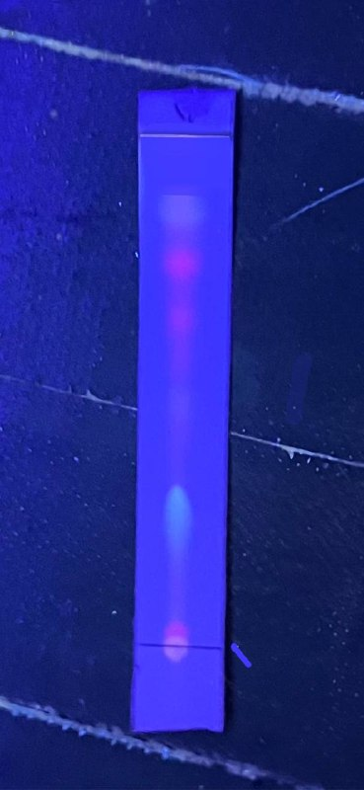 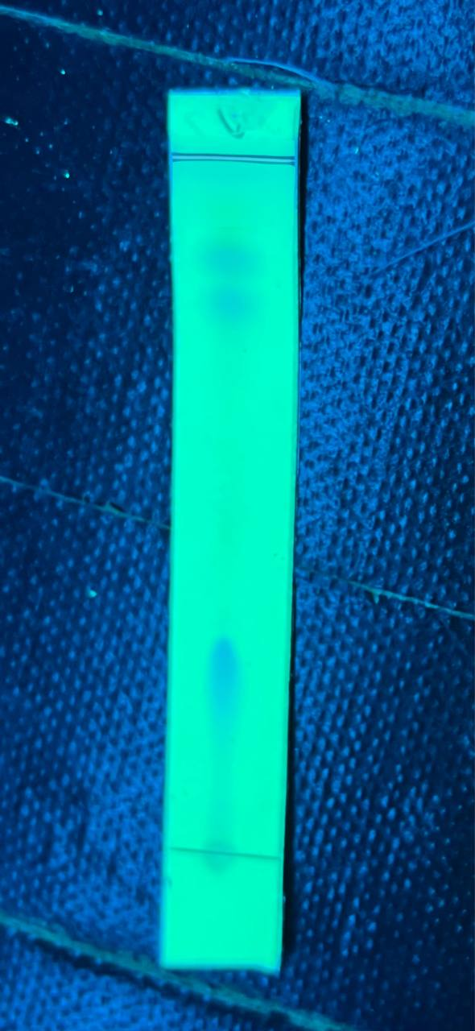

A B

**Figure 1.** Thin Layer Chromatogram of Gude Leaf Extract Extracted by the UAE Method

**Note :**

A : UV 366 nm

B : UV 254 nm

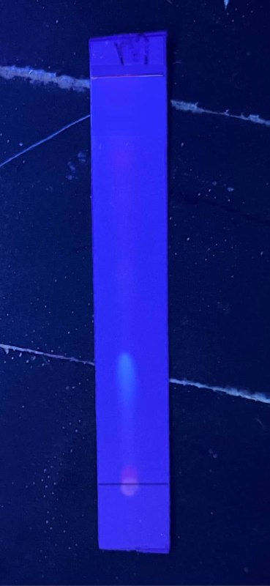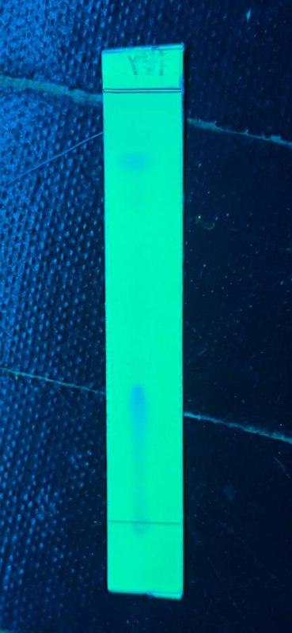

A B

**Figure 2**. Thin Layer Chromatogram of Gude Leaf Extract Extracted by the Maceration Method

**Note :**

A : UV 366 nm

B : UV 254 nm

Figures 1 and 2 show the results of thin layer chromatography (TLC) from samples of Gude leaves. In image 1 using the UAE method there are visible stains at UV 366 nm showing reddish fluorescence, as well as in image 2 using the maceration method. According to (Rahayu *et al*., 2023) The stain results visible at UV 366 nm show a reddish fluorescence indicating that it contains flavonoids. This proves pictures 1. And 2. Positive for flavonoids.

Samples of 70% ethanol extract of Gude leaves (*Cajanus cajan*) were then tested for their toxic effects on *Arthemia Salina* Leach. *Arthemia Salina* L has high sensitivity to changes in environmental conditions and chemical contamination in the environment so that it can be used as an initial parameter for changes in environmental conditions (Marliza & Oktaviani, 2021). The ability of 70% ethanol extract of Gude leaves to kill *Arthemia Salina* Leach larvae can be seen by testing the toxicity of 70% ethanol extract of Gude leaves using the *Brine Shrimp Lethality Test* (BSLT). The results of toxicity testing using the maceration and UAE extraction methods on Gude leaves can be seen in tables 3 and 4.

Table 3. Death of *Artemia salina* L. larvae using the maceration extraction

|  |  |  |  |  |  |  |
| --- | --- | --- | --- | --- | --- | --- |
| **Replication test samples** | | **The number of dead shrimp larvae per series of test sample solution concentrations** | | | | |
| **250**  **ppm** | **500**  **ppm** | **750**  **ppm** | **1000**  **ppm** | **Control** |
| **Gude Extract** | 1 | 2 | 6 | 7 | 8 | 0 |
| 2 | 2 | 5 | 6 | 8 | 0 |
| 3 | 3 | 6 | 8 | 8 | 0 |
| **Total deaths** | | 7 | 17 | 21 | 24 | - |
| **% Death** | | 23,333% | 56,666% | 70% | 80% | - |
| **Probit Value** | | 4, 26 | 5, 15 | 5, 52 | 5, 84 | - |

Table 4. Death of Artemia salina L. larvae using the UAE extraction method

|  |  |  |  |  |  |  |
| --- | --- | --- | --- | --- | --- | --- |
| **Replication test samples** | | **The number of dead shrimp larvae per series of test sample solution concentrations** | | | | |
| **250**  **ppm** | **500**  **ppm** | **750**  **ppm** | **1000**  **ppm** | **Control** |
| **Bean Leaf Extract Gude** | 1 | 3 | 6 | 7 | 9 | 0 |
| 2 | 3 | 6 | 8 | 7 | 0 |
| 3 | 4 | 6 | 7 | 8 | 0 |
| **Total deaths** | | 10 | 18 | 22 | 24 | - |
| **% Death** | | 33,333% | 60% | 73,333% | 80% | - |
| **Probit Value** | | 4, 56 | 5, 25 | 5, 61 | 5, 84 | - |

The results of observations of the toxicity test of Gude leaf extract show that all concentration series caused death in larvae except for the control group which contained sea water. A concentration of 1000 ppm caused the highest average larval death, while a concentration of 250 ppm caused the lowest larval death. Different concentrations in each test vial had different numbers of larval deaths, this shows that each concentration level has a different effect on larval death. The higher the concentration of extract used, the higher the total number of larval deaths. This is in accordance with the theory in research (Parlin *et al*., 2022) which states that the higher the extract concentration, the greater the number of larvae that die.

Figure 3. Log concentration and probit value from the extraction method Maceration of Gude leaf extract.

Figure 4. Log concentration vs probit value of the UAE method for Gude leaf extract.

The y value can be determined by graphing a linear regression equation from the data that has been obtained to calculate the LC50 value. The graphs can be seen in figures 1 and 2. Based on the figure above, figure 1 shows that the linear regression equation produced by the maceration method is y = 2.6079x – 1.9609 where the R value = 0.9949. Figure 2 uses the UAE extraction method, namely y = 2.1383x – 0.5503 where the R value = 0.998. This R value is almost close to 1, which indicates that there is a strong relationship between increasing the concentration of Gude leaf extract and the number of deaths of Artemia salina Leach larvae which is directly proportional. Next, this data is used to determine the LC50 value.

Determination of the Lethal Concentration 50 (LC50) value in Gude leaf extract was carried out using probit analysis. The sample extract is said to be toxic if the LC50 obtained is <1000 ppm (Arianta *et al*., 2022). The toxicity level of an extract is if the LC50 is 0-100 µg/mL, then the sample is very toxic. If the LC50 is 500-1000 µg/mL then the sample is toxic. Meanwhile, if LC50 is >- 1000 µg/mL then the sample is non-toxic. The level of toxicity can indicate its potential activity as an anticancer, where the smaller the LC50 value, the more toxic a compound is and has the potential to act as an anticancer (Meyer *et al*., 1982). Based on the LC50 value obtained in tables 3 and 4. Showing the results of probit analysis, the LC50 value of Gude leaf extract is for table 3 using the maceration extraction method, obtain ing a value of 466.726 µg/mL < 1000 ppm and for table 4 using the extraction method UAE obtained a value of 394.165 µg/mL < 1000 ppm, which means that both maceration and UAE extraction methods show that Gude leaf extract is toxic and the extract can cause 50% death of *Arthemia Salina* L larvae.

**CONCLUSION**

1. Gude leaf extract (*Cajanus cajan*) is toxic to *Artemia salina* Leach larvae.
2. Lethal Concentration 50% (LC₅₀) Gude leaf extract (*C. cajan*) is 466.72 µg/mL for the maceration extraction method is included in the toxic category.
3. Lethal Concentration 50% (LC₅₀) Gude leaf extract (*C. cajan*) is for the UAE 394 extraction method, 16 µg/mL is included in the toxic category.

**RECOMMENDATIONS**

It is recommended to determine the levels of compounds in Gude (*Cajanus cajan*).

**BIBLIOGRAPHY**

Aji, A., Bahri, S., & Tantalia, T. 2018. Pengaruh Waktu Ekstraksi dan Konsentrasi HCl Untuk Pembuatan Pektin Dari Kulit Jeruk Bali (*Citrus maxima*). *Jurnal Teknologi Kimia Unimal*, *6*(1), 33.

Ariani, N., Musiam, S., Niah, R., & Febrianti, D. R. 2022. Pengaruh metode pengeringan terhadap kadar flavonoid ekstrak etanolik kulit buah alpukat (Persea americana Mill.) dengan spektrofotometri. 9(1), 40–47.

Atdjas., C., 2011 Pengaruh salinitas terhadap waktu penetasan Artemia. Proposal penelitian. Fakultas Perikanan dan Ilmu Kelautan Joint program pppptk-seamolec. Universitas Padjajaran.

BPOM. 2014. Pedoman Uji Toksisitas Nonklinis Secara In Vivo. *Badan Pengawas Obat Dan Makanan Republik Indonesia*.

Capelo-Martine, J. L. 2009. Ultrasound in Chemistry Analitical Application.

Wiley-VCH Verlag GmbH & Co. KgaA Portugal. 33 (4): 1003-1010

Constantin, M., & Mioara, D. 2011. Artemia salina. 2(4), 119–122.

Copriady, J; Miharty; Herdini,; Gallokatekin: 2006. Senyawa Flavonoid lainya dari Kulit Batang Rengas (*Gluta renghas Linn*.)”. *Jurnal Natur Indonesia.*, 4, 1, 1–6.

Dalimartha, S. 2008. Atlas Tumbuhan Obat Indonesia. PT Pustaka Pembangunan Swadaya Nusantara. Jakarta.

Endah, S. R. N. 2017. Pembuatan Ekstrak Etanol dan Penapisan Fitokimia Ekstrak Etanol Kulit Batang Sintok (*Cinnamomun sintoc Bl.*). *Jurnal Hexagro*, *1*(2), 29–35.

Farida, Y. 2016. Kandungan Flavonoid The Putih (Camelia sinensis L.) Dengan Metode Ekstraksi Ultrasonic Assisted Extraktion (UAE) Dengan Variasi Suhu Dan Waktu. Skripsi. Universitas Pakuan. Bogor.

Feng, X.; Weng, D.; Zhou, F.; Owen, Y. D.; Qin, H.; Zhao, J.; WenYu; Huang, Y.; Chen, J.; Fu, H.; Yang, N.; Chen, D.; Li, J.; Tan, R.; Shen, P., 2016. Activation of PPARγ by a Natural Flavonoid Modulator, Apigenin Ameliorates Obesity-Related Inflammation Via Regulation of Macrophage Polarization. EBioMedicine., 9, 61–76

Gitleman, L., & Kleberger, J. (2014). Paper knowledge. Toward A Medi History Of Documents, 10(1), 76–83.

Handayani, V., Najib, A., Syarif, R. A., Mahmud, A., Hamidu, L., & Ahmad, A. R. 2019. Uji Toksisitas Ekstrak Etanol Terpurifikasi Biji Mahoni (*Switenia mahagoni*). *Jurnal Fitofarmaka Indonesia*, *6*(2), 360–362.

Harryana. E *et al*. 2013. Daun Ampuh Basmi Berbagai Penyakit. Jogjakarta: NusaCreativa.

Hassan, E.M., Matloub, A.A., Aboutabl, M.E., Ibrahim, N.A., Mohamed, S.M., 2016. Assessment of anti-inflammatory, antinociceptive, immunomodulatory, and antioxidant activities of *Cajanus cajan L.* seeds cultivated in Egypt and its phytochemical composition. Pharm. Biol. 54, 1380–1391.

Kandran, A. A. S., Gelgel, K. T. P., Pertiwi, N. W. L., Anthara, M. S., Dharmayuda, A. A. G. O., & Anggraeni, L. D. 2013. Toksisitas Ekstrak Daun Sirih Merah pada Tikus Putih Penderita Diabetes Melitus (*Toxicity Of Red Betel Extract In Diabetic White Rat* ). *Jurnal Veteriner*, *14*(4), 527–533.

Kementerian Agama Republik Indonesia., 2018., *‘Waqaf dan Ibtida’ Qur’an Suara Agung.,* Cetakan 1.,PT. Suara Agung., Jakarta: Halim Publishing dan Distributing., Hal : 591.

Kementerian Kesehatan Republik Indonesia, 2015, Pusat Data & Informasi Kementrian Kesehatan Indonesia: STOP KANKER, Kementrian Kesehatan RI, Jakarta.

Lestari, D., Kartika, R., & Marliana, E. 2019. Uji Brine Shrimp Lethality Test (BSLT) Umbi Bawang Tiwai (*Eleutherine bulbosa (Mill.) Urb*) dan Uji Toksisitas Akut Fraksi Aktif. *Jurnal Riset Kefarmasian Indonesia*, *1*(1), 1–10.

Maintang, Hanifa, A.P. and Agustin R., 2014, Potensi Kacang Gude Sebagai Diversifikasi Pangan, Prosiding Seminar Hasil Penelitian Tanaman Aneka Kacang dan Umbi, 917-924.

Marliza, H., & Oktaviani, D. (2021). Uji sitotoksik ekstrak etanol daun kemunu (Colacasia gigantea Hook.F) dengan metode brine shrimp lethality test (BSLT). Bencoolen Journal Of Pharmacy, 1(1), 38–45

Maukar A.M., Runtuwene M.R.J. and Pontoh J., 2013, Analisis Kandungan Fitokimia dari Uji 13 Toksisitas Ekstrak Metanol Daun Soyogik (Sauraula bracteosa) dengan Menggunakan Metode Maserasi, Jurnal Ilmiah Sains, 13 (2), 98-101.

Meyer, B.N., Ferrigni, N.R., Putnam, J.E.,Jacobsen, L.B., Nichols, D.E, and McLaughlin, J.L., 1982, Brine Shrimp: A Convenient General Bioassay for Active Plant Constituents, Planta Medica, 45(05), 31-34.

Medina-Torres, *et al*. Ultrasound Assisted Extraction for the Recovery of Phenolic Compounds from Vegetable Sources, Agronomy, 2017, 7:47.

Najib, A. 2018. Ekstraksi Senyawa Bahan Alam. Dalam *Ekstraksi Senyawa Bahan Alam* (1 ed., Issue August 2018). Deepublish.

Nastiti *et al.* 2017 . Skrining fitokimia dan uji toksisitas pada daun terap (Artocarpus elasticus) dengan metode brine shrimp lethality test (BSLT). Prosiding Seminar Nasional Kimia, 60, 69–73.

Nursal, Wulandari, S., & Rio, B. S. 2016. Uji Toksisitas Ekstrak Kulit Batang Rengas *( Gluta Renghas* ) Terhadap Larva Udang *Artemia salina*. *Jurnal Biogenesis*, *13*(1), 11–18.

Parlin, D. A., Nasution, M. P., Nasution, H. M., Daulay, A. S., Farmasi, P. S.,Farmasi, F., Muslim, U., Umn, N., Korespondensi, A., Nasution, M. P., Farmasi, P. S., Farmasi, F., Muslim, U., Al-Washliyah, N. U. M. N., Garu, J., & No, I. I. (2022). Skrining Fitokimia Dan Uji Sitotoksisitas Ekstrak Etanol Daun Matoa (Pometia pinnata) Dengan Metode BSLT Phytochemical 2(1), 38–48.

Pineiro, Z., R. F. Guerrero, M. I. FernandezMartin, E. Cantos-Villar, and M. Palma. 2013. Ultrasound-Assisted Extraction of Stilbenoids from Grape Stems. Journal of Agricultural and Food Chemistry. 59 (21): 11683-11689.

Purwandari, R., Subagiyo, S., & Wibowo, T. 2018. Uji Aktivitas Antioksidan Ekstrak Daun Jambu Biji. *Walisongo Journal of Chemistry*, *1*(2), 66.

Rahayu M. and Roosmarinto, 2017, Kajian Aktivitas Antikanker Ekstrak Duan Gude *(Cajanus cajan)* terhadap Sel Kanker Kolon Secara In Vitro, Jurnal Teknologi Laboratorium, 6 (1), 1-8.

Renaldi, A. 2022. “PENGARUH PERENDAMAN, FERMENTASI DAN PERKECAMBAHAN TERHADAP KANDUNGAN SENYAWA ANTI-GIZI ASAM FITAT PADA TEPUNG KACANG GUDE *(Cajanus Cajan).* S.Si Skripsi. Fakultas Pertanian. Universitas Hasanuddin.

Rofiqoh, A. D. 2015. Skripsi Uji Toksisitas Subkronik Ekstrak Air Daun Katuk (*Sauropus androgynous*) Terhadap Kadar Bilirubin Serum dan Histologi Hepar Tikus (*Rattus norvegicus*) Betina.

Sahu, M., Verma, D., Harris, K.K., 2014. Phytochemical Analysis of The Leaf, Stem and Seed Extracts of *Cajanus cajan L* (dicotyledoneae: fabaceae). World J. Pharm. Pharm. Sci. 3, 41.

Sarker, S. D., Latif, Z., & Gray, A. I. 2006. Natural Products Isolation $2^{nd}$. Humana Press, New Jersey.

Setiasih, I. S., Hanidah, I.-I., Wira, D. W., Rialita, T., & Sumanti, D. M. 2016. Uji Toksisitas Kubis Bunga Diolah Minimal (KBDM) Hasil Ozonasi. *Jurnal Penelitian Pangan (Indonesian Journal of Food Research)*, *1*(1), 22–26.

Shaleh, M, Ulfah. 2016. Uji Efek Antidiare Ekstrak Etanol Daun Kacang Gude. S.Si Skripsi. Fakultas Kedokteran dan Ilmu Kesehatan. Universitas Islam Alauddin Makassar. Makassar.

Suhaenah, A., Nuryanti, S. 2017. Skrining Fitokimia Ekstrak Jamur Kucing (*Agaricus bisporus*). *Jurnal Fitofarmaka Indonesia*, 4(1), 199–204.

Suhayono, U. 2011. Petunjuk Praktis Penggunaan pupuk Organik Secara Efektif dan Efisien. Penebar Swadaya. Jakarta.

Surya, A. 2018. Toksitas Ekstrak Metanol Kulit Jengkol *(Pithecellobium Jiringa)* dengan Metode *Brine Shrimp Lethality Test* terhadap Larva Udang (*Artemia Salina*). *Jurnal Rekayasa Sistem Industri (JRSI)*, *3*(2), 149–153.

Syaikh Abdurrahman Bin Nashir As-Sa’di., 2023., *Tafsir As Sa’di.,* <https://tafsirweb.com/12524-surat-at-tariq-ayat-12.html> ., Diakses Tanggal., 4 Oktober 2023.

Syamsul, E. S., Amanda, N. A., & Lestari, D. 2020. Perbandingan ekstrak Lamur aquilaria malaccensis dengan metode maserasi dan refluks. Jurnal Riset Kefarmasian Indonesia, 2(2), 97–104.

Tanbiyaskur, T., Yulisman, Y., & Yonarta, D. 2019. Uji LC50 Ekstrak Akar Tuba dan Pengaruhnya Terhadap Status Kesehatan Ikan Nila (*Oreochromis niloticus*). *Journal of Aquaculture and Fish Health*, *8*(3), 129.

Tefu, M,O.F.I & Sabat, D.R. 2022. Tanaman Obat Tradisional : Dokumentasi Pemanfaatan Tanaman Obat Masyarakat Suku Dawan (Amanuban) Kabupaten Timor Tengah Selatan. Deepublish. Yogyakarta.

Utami, R. S. 2019. Aktivitas Sitotoksik Ekstrak Metanol Daun Kacang Gude *(Cajanus cajan)* Terhadap Sel Kanker MCF-7 dan T47D. Master Tesis. Fakultas Farmasi. Universitas Muhammadiyah Surakarta. Surakarta.

Wibowo, S. 2013. *Artemia untuk Pakan Ikan dan Udang*. Penebar Swadaya.

Yudissanta A. and Madu R., 2012, Analisis Pemakaian Kemoterapi pada Kasus Kanker Payudara dengan Menggunakan Metode Regresi Logistik Multinominal (Studi Kasus Pasien di Rumah Sakit “X” Surabaya), Jurnal Sains dan Seni ITS, 1 (1), 1-6.

Zhou, Q.; Xu, H.; Yu, W.; Li, E.; Wang, M., 2019. Anti-inflammatory effect of an apigenin-maillard reaction product in macrophages and macrophage-endothelial cocultures. Oxidative Medicine and Cellular Longevity.