**ANTIOXIDANT ACTIVITY OF AVOCADO FOLIUM (*Persea americana* M.)**

|  |  |
| --- | --- |
| **Fahriya Wusurwut1, Hasnaeni2*, Risda waris3** | |
|  | 1,3Prodi Farmasi,Fakultas Farmasi, Universitas Muslim Indonesia, Makassar, Sulawesi Selatan  2*Program study Magister Farmasi, Fakultas Farmasi, Universitas Muslim Indonesia, Makassar, Sulawesi Selatan  **\*Co-author : [hasnaeni.hasnaeni@umi.ac.id](mailto:hasnaeni.hasnaeni@umi.ac.id)** |

|  |  |
| --- | --- |
| **Article History**  Diterima: dd-M-Tahun  Direvisi: dd-M-Tahun  Diterbitkan: dd-M-Tahun  **Keywords**: Avocado folium extract, DPPH, (*2,2-dihphenyl-1-picrylhdrazil),* | **Abstract**  Free radicals can be formed through normal cell metabolism events, malnutrition and as a result of responses to external influences such as pollution and ultraviolet rays. Free radicals can cause premature aging, therefore antioxidants are needed to prevent premature aging. Avocado folium (*Persea americana* M.) contain secondary metabolite compounds, namely alkaloids, saponins, tannins, glycosides and flavonoids in the form of quercetin, where flavonoid compounds can act as antioxidants. This study aims to determine the antioxidant activity of avocado leaf extract (*P. americana* M), using the (*2,2-dihphenyl-1-picrylhdrazil)* (DPPH) method. DPPH method with a UV-Vis spectrophotometer at a wavelength of 514 nm. The antioxidant activity of ethanol extract of avocado folium in this test is 112.410 µg / mL. The results of this study show that avocado folium extract has moderate antioxidant activity. |

**INTRODUCTION**

Free radicals are molecules in orbit the outer shell has one or more electrons in pairs, they are very unstable and very reactive so it can cause damage to cell components such as DNA, lipids, proteins and carbohydrate. This damage can also occur causes various biological disorders such as atherosclerosis, cancer, diabetes and disease other degenerative (Harmanto, 2002). Free radicals can be formed through normal cell metabolism events, malnutrition and as a result of responses to external influences such as pollution and ultraviolet rays. Free radicals in the body through ultraviolet (UV) radiation. The strength of ultraviolet rays emitted by the sun can cause various skin problems, such as redness, pigmentation, and even cause premature aging and cancer in the long term. Exposure to pesticides or food and drinks containing pesticides or other substances can trigger the production of free radicals in the body (Tapan, E. 2005). Free radicals are very unstable and very reactive so that they can cause damage to cell components such as DNA, lipids, proteins, and carbohydrates. This damage can cause various biological disorders such as atherosclerosis, cancer, and degenerative diseases such as diabetes, tissue inflammation, immune disorders, myocardial infarction (Adrianta Agus ketut, 2020).

Antioxidants can reduce or deactivate free radical attacks and reactive oxygen species (ROS) (Hamsidar, H. 2022; Lu et al., 2010). This can inhibit cell damage and is also able to protect the body against damage caused by reactive oxygen compounds that cause various degenerative diseases, antioxidants react in the body and are an important parameter for monitoring body health (Salimi, K Yuszda 2021).

Antioxidant activity is to react with relatively stable reactive free radicals, antioxidants stabilize free radicals by completing the lack of electrons from free radicals. There are two antioxidants, namely enzymatic antioxidants and non-enzymatic antioxidants. Enzymatic antioxidants can be produced in the human body and can be divided into primary or secondary antioxidants superoxide (SOD), glutathione peroxidase (Gpx) and catalase (CAT), while those included in secondary antioxidants are glutathione reductase (GR) and glucose-6 phosphate dehydrogenase (G6PDH) (Misra et al, 2014). Antioxidants function to prevent cancer and tumors, narrowing of blood vessels, premature aging and others. In the food industry, antioxidants can be used to prevent oxidation that can cause damage, such as rancidity, changes in color and aroma, and other physical damage. Antioxidants can also inhibit oxidation reactions by binding free radicals and highly reactive molecules so that cell damage can be prevented. Oxidation reactions with free radicals often occur in protein molecules, nucleic acids, lipids and polysaccharides (Sayuti, K et al, 2015).

Avocado is one of the plants found in tropical and subtropical climates. This plant is widely found in Indonesia. Some avocado plants are widely used as fresh food and cosmetics. Another part that can be used is the folium for traditional medicine, which contain active substances that have the potential to be antioxidants. Some compounds that have been identified in avocado folium are flavonoids, saponins, and tannins. Flavonoids are secondary metabolites found in various plants that contain medicinal properties. Flavonoids are phenolic compounds that are rich in hydroxyl groups and have antioxidant properties. The antioxidant effect on plants can be caused by phenolic compounds containing flavonoids. Saponins are surfactant compounds produced by steroids that bind sugar or triterpene groups, which have beneficial biological effects, namely lowering blood cholesterol and anticancer, and can increase the body's immune system (Erik Tapan 2005).

**METHODS**

**Materials**

Micro pipette (Dragonlab), Capillary pipette, porcelain dish, TLC plate, Rotary vacuum evaporator (IKA HB10 basic), UV-Vis spectrophotometer, analytical balance (Phaus), vial, water bath, DPPH (*2,2-dihphenyl-1-picrylhdrazil*), Aquadest

**Sample Collection and Extraction**

Avocado leaves (Persea americana M) that have been collected are washed using clean water and then wet sorting is carried out. Avocado leaves are dried by drying them in the sun covered with a black cloth so that they are not exposed to direct sunlight, the dried simplicia is weighed and cut into small pieces (± 0.5 -1cm) (Triswanto, Rizki Permatasari 2015).

Dried avocado leaf simplicia was weighed as much as 400 grams, extracted by maceration method. Simplicia was put into a maceration container and soaked with 2 liters of 96% ethanol solvent. Simplicia was soaked for 3 days and stirred occasionally. The macerate was separated by filtration or filtered using filter paper or gauze. Remaceration was carried out for 2 times then the macerate was collected. The macerate was evaporated using a rotary vacuum evaporator at a temperature of 40 ℃ and a pressure of 100 mBar until a thick extract was obtained (Hasnaeni., Aminah, 2019; Setat, T., Permatasari, R. 2015).

**Phytochemical Screening**

* **Thin Layer Chromatography (TLC)**

Ethanol extract of avocado folium and quercetin standard dissolved in 96% ethanol. The extract was spotted on the TLC plate. The plate was then eluted with the appropriate eluent and then sprayed with DPPH. The spots that appeared were observed (Handayani, et al 2014).

* **Alkaloid test**

Identification of alkaloid compounds using 2 reagents, namely Mayer and Dragendorf. The sample was weighed as much as 0.1 grams dissolved in ethanol, added 2 drops of 2 N sulfuric acid (H2SO4), added with 3 drops of Mayer reagent and Dragendorf reagent for each tube, positive alkaloids with the formation of a yellowish white precipitate (Mayer) and a red to orange precipitate (Dragendrop),

* **Flavonoid test**

The extract was weighed as much as 0.1 mg, dissolved in 5 mL of 96% ethanol. 2 mL of sample, added 0.1 grams of magnesium powder and added 10 drops of concentrated HCL from the side of the tube and shaken slowly. If a yellow or orange color is formed, it is positive indicating the presence of flavonoids but if a yellow or orange color is formed it indicates the presence of flavones, chalcones, and aurones.

* **Saponin test**

Weighed as much as 0.1 grams of sample, put into a test tube, added 5 mL of hot water, cooled then shaken vigorously for 10 seconds. Positive results are indicated by the formation of stable foam for no less than 1 minute.

* **Tanin test**

The sample was weighed as much as 0.1 grams and put into a test tube, dissolved with 2 mL of distilled water, then heated on a water heater and cooled, after cooling, 3 drops of 3% FeCl3 solution were added, a positive result was a blue-green to blackish color.

(Hanani, 2017).

**Antioxidant Activity Test Using the DPPH (2,2-*diphenyl-1-picrylhdrazil*) method. (Mikhael & Soenghardjo).**

**a. Preparation of DPPH (1,1-diphenyl-2-2picrylhydrazil) solution**

3 mg DPPH was dissolved with 100 mL ethanol p.a measuring flask (30 ppm), then 2 mL of the solution was pipetted into the vial and incubated for 30 minutes. The maximum absorption wavelength of the DPPH solution using a UV-Vis spectrophotometer (wavelength 400-800 nm).

b. **Preparation of sample solution.**

A sample solution concentration of 10,000 ppm. Weigh 100 mg of extract then dissolve it with 10 mL of ethanol P.a, make a series of concentrations of 100 ppm, 200 ppm, 300 ppm, 400 ppm, 500 ppm in 5 mL.

**c. Preparation of standard solution**

Standard quercetin solution with a concentration of 1000 ppm. Pipette 1 mL of 1000 ppm quercetin solution made into 100 ppm quercetin solution, 100 ppm quercetin solution made with concentration variations of 1 ppm, 2 ppm, 3 ppm, 4 ppm, 5 ppm.

d. **Measurement of antioxidant activity of quercetin and avocado leaf extract (*Persea americana* M.)**

Each series of concentrations of the standard solution (1 ppm, 2 ppm, 3 ppm, 4 ppm, 5 ppm) and samples (100 ppm, 200 ppm, 300 ppm, 400 ppm, 500 ppm) were pipetted as much as 1 mL into a vial and added 3 mL of DPPH solution.Incubated for 30 minutes in a dark room. The absorbance was measured by UV-Vis spectrophotometry at a wavelength of 514 nm. The results of the determination of sample antioxidants were compared with the quercetin standard.

Antioxidant analysis in avocado leaves was carried out by calculating IC50 using the linear regression equation y = bx + a.

The percentage of DPPH radical scavenging is calculated using the equation (Ridho et al 2013) :

% inhibition = (A control - A sample) / (A control ) x 100%

A control = absorbance of control

A sample = absorbance of sample

**RESULTS AND DISCUSSION**

The sample used in this research was avocado folium obtained from Southeast Maluku Regency (Maluku Province). The avocado plant is a type of tropical plant that is easy to care for because it does not require intensive care and has high drought tolerance. Avocado folium are known to contain alkaloid compounds, tannins, saponins, flavonoids, The chemical compounds contained in avocado leaves can play an active role in lowering cholesterol levels, protecting cells from DNA damage by cleaning cells from free radicals which cause several chronic and degenerative diseases such as (atherosclerosis, hypertension, cancer, stroke, coronary heart disease and premature aging) (Anggorowati, D., et al. 2016)

This research aims to determine the secondary metabolites contained in the extract and the antioxidant potential of the IC50 value in avocado leaf extract using the DPPH free radical reduction method. Avocado folium extract *(Persea americana* M.) was then extracted using the maceration method using 96% ethanol solvent. The results obtained from extraction can be seen in table 1. The extract results obtained were then carried out by a phytochemical screening test using the tube method or color test, namely alkaloid, flavonoid, tannin and saponin compounds, can be seen in Table 2

From the extraction results, the percentage of ethanol extract soaked in % can be seen in the following table:

Table 1. Powder and % yield of avocado leaf ethanol extract *(Persea americana* M.*).*

|  |  |  |  |
| --- | --- | --- | --- |
| **Sample** | **Simple weight (g)** | **Extract weight**  **(g)** | **Extract yield (%)(b/b)** |
| **Extract**  **avocado folium** | 400 | 61,03 | 15,257 |

In table 1 it is explained that the weight of avocado folium powder is 400 grams and when extracted, the weight of avocado folium extract is 61.03 grams. The percentage yeald of avocado folium extract is 15.257(%)(w/w)

Table 2 Identification of the chemical content of avocado leaves. *(Persea americana* M)

|  |  |  |  |  |
| --- | --- | --- | --- | --- |
| **Compound** | **Reagents and Observation Results** | **Previous color** | **Color after.** | **Library** |
| Alkaloids | Mayer (-) | Green | Red | Mayer agent (+)  gives a yellowish whiteprecipitate.(NI putu diah paramita, NI kadek yunita sari 2023) |
|  | Dragendroft(+) | Green | Orange precipitate | Dragendroft reagent (+) gives a ginger precipitate (NI putu diah paramita, NI kadek yunita sari 2023) |
| **Flavonoids** | Flavonoids(+) | Green | Orange | Flavonoids(+)  If it is orange it is a result of reduction by hydrochloric acid and magnesium (Putri, N.D, et al., 2023) |
| **Tannin** | Tannin (+) | Green | Blackish green | FeCl3(+) Gives a blackish green color (Halimu, rizkito, rieny & lukman 2017). |
| **Saponins** | Saponins (+) | Green | Foam/froth is formed | Saponin(+)  stable foam is formed (Putri, N.D., 2023) |

(+) = Positive; (-) = Negative

In table 2, the identification of chemical compounds from the ethanol extract of avocado folium shows that the presence of alkaloids, flavonoids, tannins, saponins

Identification using TLC to determine free antiradical activity using DPPH on avocado folium ethanol extract with quercetin as a standard. This method is easy, simple, fast and sensitive and only a small sample is used. The ethanol extract of avocado folium and quercetin which have been dissolved in 96% ethanol are then spotted on a marked TLC plate after which it is eluted using the liquid solvent n-Hexane : Ethyl acetate (9:1), After the plate has eluted, it is then sprayed with DPPH. Spots that change color to yellow indicate the presence of anti-free radical activity. Antioxidant activity occurs due to the reaction of diphenyl picri hydrazyl molecules with hydrogen atoms from antioxidants to form diphenyl picri hydrazyl compounds, which can be seen changing the color of DPPH from purple to yellow (Handayani, Roskiana A, Sudir., 2014). In the results of this test, the ethanol extract changes color to yellow, which indicates antioxidant activity.

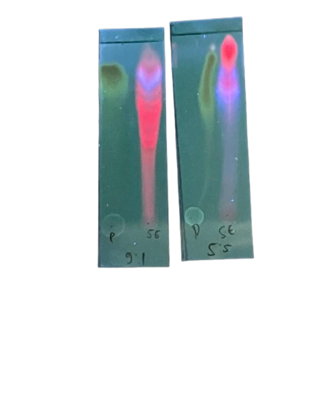 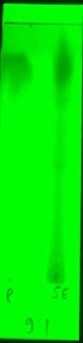 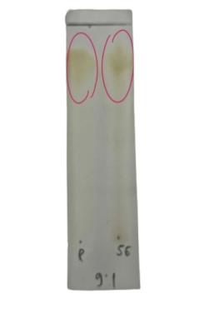

B

**A**

**C**

**E**

E

**E**

P : Standard quercetin,

E : sample of avocado folium ethanol extract

A : UV 254 nm

B : UV 366 nm

C : After being sprayed with DPPH

Eluent : n-Hexan : Etyl acetat (9:1)

P

P

P

(a) (b) (c)

**Antioxidant activity using the DPPH Method**

The antioxidant of avocado folium ethanol extract was carried out using a quantitative test using the DPPH radical immersion method with UV-Vis spectrophotometry. The antioxidant activity test method with DPPH (*2,2-diphenyl-1-picryhydrazyl*) was chosen because this method is simple, easy, fast and sensitive and only requires a small sample to evaluate the antioxidant activity of natural compounds so it is widely used to test the ability of compounds to act as electron donors. Quercetin was used as a positive control because it was proven to have antioxidant activity. Quercetin contains an OH group. The OH group is able to stabilize free radicals through the H atom transfer mechanism or electron transfer from this group (Adawiyah & Rizki 2018).

One of the parameters used is IC50. IC50 is the concentration of the sample solution required to inhibit 50% of DPPH free radicals. The lower the IC50 value, the stronger the antioxidant is in neutralizing free radicals or the stronger the antioxidant activity. Data from measurements of absorbance and percentage of inhibition as well as IC50 from the standard and avocado folium extract (Maryam, 2015).

Table 3. Percentage of inhibition and IC50 value of the Quercetin comparator

|  |  |  |  |  |
| --- | --- | --- | --- | --- |
| **Concentration (ppm)** | **Absorbance**  **DPPH** | **Sample absorbance** | **Inhibition (%)** | **IC50**  **(µg/mL)** |
| 1 | 0,937 | 0,689 | 26,467 |  |
| 2 | 0,937 | 0,551 | 41,195 |  |
| 3 | 0,937 | 0,476 | 49,199 | 33,862µg/mL |
| 4 | 0,937 | 0,426 | 54,533 |  |
| 5 | 0,937 | 0,354 | 62,219 |  |

Table 4. Inhibition percentage and IC50 value from ethanol extract of avocado leaves (*Persea americana* M.)

|  |  |  |  |  |
| --- | --- | --- | --- | --- |
| **Concentration (ppm)** | **Absorbance**  **DPPH** | **Sample absorbance** | **Inhibition (%)** | **IC50**  **(µg/mL)** |
| 100 | 0,937 | 0,254 | 72,892 |  |
| 200 | 0,937 | 0,200 | 78,655 |  |
| 300 | 0,937 | 0,190 | 79,722 | 112,410µg/mL |
| 400 | 0,937 | 0,147 | 84,311 |  |
| 500 | 0,937 | 0,101 | 89,221 |  |

Graphs 1 and 2 are graphs of the relationship between the concentration and percentage of inhibition of the comparison quercetin and avocado folium ethanol extract.

Figure 1. Graph of the relationship between the comparison concentration of Quersetinn and % Inhibition

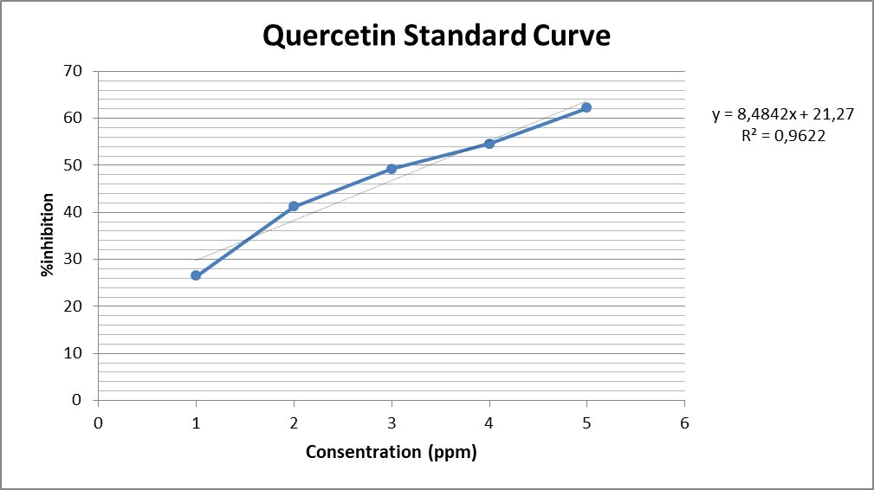

Figure 2. Graph of the relationship between avocado leaf extract concentration and %inhibition

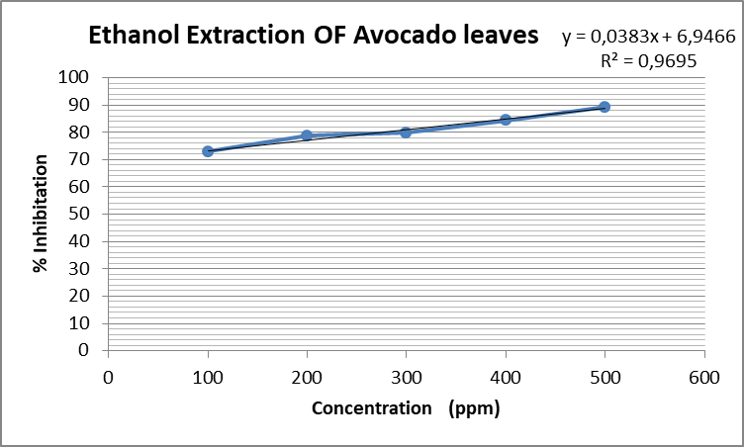

The graph of the relationship between concentration and percentage of inhibition, a linear regression equation can be created between concentration (ppm) as the x-axis and antioxidant activity value (%) as the y-axis, so that from this equation the IC50 value can be determined. The linear regression results from avocado leaf extract are y= 0.0383x + 6.9466. with an R2 value = 0.9695 while the value of the quercetin linear regression is y = 8.4842x + 21.27 with a value R2=0.9622

The average R2 value is used as a predictor value that has a coefficient of determination value approaching +1 (positive). The R2 value shows that there is a significant relationship between concentration variations and % inhibition. The values ​​of R2=0.9695 and R2=0.9622 in the ethanol extract of avocado leaves and quercetin mean that the independent variable has an influence of 96% on the dependent variable of 4%. In the linear regression graph, the average R squared (R2) value obtained in the standard of quercetin and avocado leaf ethanol extract has a coefficient of determination value approaching to +1 (positive), so the ability for antioxidant activity is higher. This research proves that the ethanol extract of avocado leaves contains secondary metabolites which act as antioxidants (Ranggaini, D., et al. 2024).

The antioxidant activity of a compound can be classified based on the IC50 value. If the IC50 value of an extract is <50µg/mL then the antioxidant activity is in the very strong category, the IC50 value is between 50-100µg/mL meaning the antioxidant activity is in the strong category, the IC50 value is between 100-150µg/mL meaning the antioxidant activity is in the medium category, the IC50 value is between 150-200µg/mL means the antioxidant activity is in the weak category, whereas if the IC50 value is >200µg/mL then the antioxidant activity very weak category (Bahriul et al 2014).

Data in tables 3 and 4 avocado leaf ethanol extract has moderate antioxidant activity because it has an IC50 value of 112.410 µg/mL which means it is between 100-150 µg/mL. The quercetin standard has an IC50 value of 33.862 µg/mL and is a very strong antioxidant because it has an IC50 value of <50 µg/mL

Natural antioxidants can be found in plants. One of the compounds that can act as a natural antioxidant is flavonoids which are polar. Results of phytochemical screening of avocado plants (*Persea americana* M). shows that avocado folium contain flavonoids. Based on the research results, it is known that avocado leaf ethanol extract has antioxidant properties. Thus, avocado leaf ethanol extract contains compounds that can reduce free radicals. Compounds that have antioxidant activity such as flavonoids generally have polar OH groups [18]. The hydroxyl group contained in flavonoid compounds can donate hydrogen atoms to free radicals, so that flavonoid compounds have the potential to be antioxidants (Ridho et al, 2013).

**CONCLUSION**

In this study, it was concluded that the ethanol extract of avocado folium (*Persea americana* M) has moderate antioxidant activity with an IC50 value of 112.410µg/mL.

**SUGGESTION**

Further research can be carried out on the antioxidant activity of ethanol extract of avocado folium (*Persea americana* M.) using other methods

**BIBLIOGRAPHY**

Adawiyah, R., & Rizki, M, I. 2018. Aktivitas antioksidan ekstrak etanol akar Kalakai (*Stenochlaena palustris Bedd*) asal Kalimantan Tengah. Jurnal Pharmascience, 5(1).

Adrianta Agus Ketut, (2020). "Program Studi Sarjana Farmasi, Fakultas Farmasi Universitas Mahasaraswati Denpasar Jl. Kamboja No. 11 A. Denpasar Bali" American Journal of Tropical Medicine and Hygiene, 6 (1), 33-39

Agustina, W., Nurhamidah, N., & Handayani, D. 2017. ‘Skrining fitokimiadan antioksidan beberapa fraksi dari kulit batang jarak (*Ricinus communis* L.)’ Alotrop, 1(2) American Journal of Tropical Medicine and Hygiene, 6 (1), 33-39.

Anggorowati, D. Priandini., G., Thufail, Puspita sari. 2016. Potensi daun alpukat (persea americana M.) sebagai minuman teh herbal yang kaya antioksidan. Industri Inovatif, 6(1), 1-7.

Arviani setyanigrum , windi atmaka sri Raharjo. 2018. Karakterisasi dan uji stabilitas digestif nanoemulsi β-caroten yang dibuat dengan metode emulsifikasi spontan Surakarta. Unversitas sebelas maret

Bahriul, P., Rahman, N., & Diah, A, W, M. 2014. Uji aktivitas antioksidan ekstrak daun salam (Syzygium Polyanthum) dengan menggunanakan 1*,1-Difenil-2-Pikrilhidrazil.* Jurnal Akademika Kimia, 3(3), 143-149

Halimu, Bay, R., Sulistijowati, R., Mile, L. 2020. Identifikasi Kandungan Tanin pada Sonneratia Alba Identification of tannin content in Sonneratia Alba. The NIKe Journal 5.4

Hamsidar, H., Ain Nur, T., Farmita, H., Nuzuk Fika, R., Anggun Putri, I.S. 2022. Skrining Fitokimia dan Uji Aktivitas Antioksidan Kulit Batang Matoa (Pometia pinnata) Dengan Metode 1,1-Diphenyl-2 picrylhidrazyl (DPPH). Indonesian Journal of Pharmaceutical Education (e-Journal), 2 (1).

Hanani , F. (2017). Analisis fitokimia (T.V.D.Had). Jakarta:EGC

Handayani V., Roskiana A., Sudir M. 2014. Uji Aktivitas Antioksidan Ekstrak Metanol Bunga dan Daun Patikala (*Etlingera elatior* (Jack) R.M. sm) menggunakan Metode DPPH. Pharm Sci. Re. ISSN : 2470 234

Hasnaeni., Aminah, 2019. Antioxidant Activity and Phytochemical Profile of Beta-beta (*Lunasia amar*a Blanco) Wood Extract. Galenika Journal of Pharmacy. 5(1): 101– 107

Harmanto, N. 2002. Sehat dengan Ramuan Tradisional Mahkota dewa, Cetakan empat, Tangerang, PT. Agromedia Pustaka, Jakarta.

Lamberkabel, J.S.A. 2011. Mengenal Jenis-Jenis Lebah Madu, Produk-Produk Dan Cara Budidayanya. Jurnal Ilmu Pengetahuan dan Teknologi, Volume 9 (1): 70-77

Maryam, S., Baits, M. and Nadia, A. 2015. Pengukuran Aktivitas Antioksidan Ekstrak Etanol Daun Kelor *(Moringa oleifera Lam*.) Menggunakan Metode FRAP (*Ferric Reducing Antioxidant Power*). Jurnal Fitofarmaka Indonesia.

Mikhael, G., & Soegihardjo. 2013. Uji Aktivitas Antioksidan Menggunakan Radikal 1,1-Difenil-2- Pikrilhidrazil dan Penetapan Kandungan Fenolik Total Fraksi Etil Asetat Ekstrak Etanol Buah Anggur Bali (*Vitis vinifera* L.). Jurnal Farmasi Sains Dan Komunitas, 10(2), 109-120.

Misra, A., Srivastava, S., & Srivastava, M. 2014. Evaluation of anti diarrheal potential of Moringa oleifera (Lam.) leaves. Journal of Pharmacognosy and Phytochemistry, 2(5), 43-46. Pendidikan dan Sosial Indonesia Maju (YPSIM) Banten, 2021

Putri .N. D, Sari .N.K.Y ,Permatasari .A. A putri permatasari. 2023. Skrining Fitokimia Ekstrak Etanol Daun Alpukat (*Persea americana* M.)dan Rimpang Jahe Merah *(Zingiber officinale Rosc var. rubrum*) vol 2 No 3 Hal 3

Ranggaini D., Johni H., Michelle .A. T. 2024. Aktivitas antioksidan dengan metode DPPH dan ABTS terhadap ekstrak etanol daun (*Amaranthus hybridus* L). JKGT VOL. 6, NO.1

Ridho, E., Sari, R., & Wahdaningsih, S. 2013. Uji aktivitas antioksidanekstrak metanol buah lakum *(Cayratia trifolia*) dengan metode DPPH *(2, 2-Difenil-1-Pikrilhidrazil*). Jurnal Mahasiswa FarmasiFakultas Kedokteran UNTAN, 1(1).

Salamah, N., dan Nurushoimah. 2014. Uji Aktivitas Antioksidan Ekstrak Etanol HerbaPegagan (*Centella asiatica* (L.) Urb.) dengan Menggunakan Metode *β-carotene,* Jurnal Farmasi.

Sayuti, K., Yenrina, R. 2015. Antioksidan Alami dan Sintetik. Andalas Univesity Press: Padang.

Sentat, T., Permatasari, R. 2015. Uji Aktivitas Ekstrak Etanol Daun Alpukat *(Persea americana* M.) Terhadap Penyembuhan Luka Bakar Pada Punggung Mencit Putih Jantan (*Mus musculus*). Jurnal Ilmiah Manuntung, 1(2), 100-106. Universitas Mahasaraswati Denpasar Jl. Kamboja No. 11 A. Denpasar Bali.

Tapan, E. 2005. Kanker, antioksidan & Terapi komplementer. Jakarta : Elex media kompitindo