|  |  |
| --- | --- |
| **Scientific Skills Through Guided Inquiry: A Case Study of Briquette Production from Corncob and Coffe Grounds** | |
|  | |
| **Egita Widiastuti1, Neneng Windayani2, Yulia Sukmawardani2, Risa Rahmawati1** | |
| **1**  **2** | Chemistry Education Study Program, UIN Sunan Gunung Djati Bandung, Indonesia  Magister of science education study program, Postgraduate UIN Sunan Gunung Djati Bandung |
| \* | Corresponding Author e-mail*:* [*nenengwinda.ftk@uinsgd.ac.id*](mailto:nenengwinda.ftk@uinsgd.ac.id) |

|  |  |  |
| --- | --- | --- |
| **Article History**  Received: dd-M-Year  Revised: dd-M-Year  Published: dd-M-Year  **Keywords**: Guided inquiry, briquettes, corncob, coffee grounds, scientific skills | **Abstract**  This study aims to develop students' scientific performance with the help of guided inquiry-based learner worksheets (LKPD) in improving students' scientific performance in the practice of making briquettes from corncob waste and coffee grounds. The issue of low utilization of agricultural waste and lack of integration of real context in chemistry learning. The method used was pre-experimental with a One-Shot Case Study design, involving three groups of students in class XI Industrial Chemical Engineering. The assessment focused on the six stages of guided inquiry: observation, formulating problems, making hypotheses, conducting experiments, analyzing data, and drawing conclusions. The results showed that student activity reached 90.3 while scientific performance showed excellent results with scores between 83-91.7. This finding indicates that applying of LKPD in making corn stover and coffee grounds briquettes with a guided inquiry learning model is effectively develops students' scientific skills. | |
| **How to Cite:** Widiastuti, E., Windayani, N., Sukmawardani, Y., Rahmawati, R. (2025). Scientific Skills Through Guided Inquiry: A Case Study Of Briquette Production From Corncob And Coffee Grounds. *Hydrogen: Jurnal Kependidikan Kimia*, vol(no). doi:https://doi.org/10.33394/hjkk.v10i2 | | |
| <https://doi.org/10.33394/hjkk>.xxxxx.xxxx | | This is an open-access article under the [CC-BY-SA License.](http://creativecommons.org/licenses/by/4.0/)  C:\Users\IKIP\Pictures\CC_BY-SA_3.0.png |

**INTRODUCTION**

Indonesia is one of the countries that has enormous renewable energy potential, but its utilization is still not optimal. Meanwhile, energy demand is increasing every year, along with the increase in human activities (Arake, 2017). Indonesia ranks 5th in global coffee consumption, along with the rapid growth of coffee shops. This condition produces much coffee grounds waste; about 90% of coffee grounds are not utilized. Coffee grounds can be used as an environmentally friendly briquette-making material to reduce this waste. Based on data from the Central Statistics Agency (BPS), Indonesia produces 5.7 million tons of corncob waste yearly. However, most of the waste has not been optimally utilized. It tends to be thrown away or burned, which can cause environmental pollution and impact greenhouse gas emissions and global warming (Pratama, 2023). However, corncobs have the potential to be processed into products that have economic value. Severalh studies have shown that corncob waste can be used as a base material for making flour that is low in calories, rich in fiber, and high in protein, which is beneficial for helath and can also improve the community’s economic welfare. In addition, corncobs can also be processed into charcoal briquettes as an environmentally friendly alternative fuel. Corn waste is a lignocellulosic waste from the agricultural sector that contains main components such as cellulose, hemicellulose, and lignin. Its chemical composition comprises about 23.3% lignin, 44.9 cellulose, and 31.8% hemicellulose. In addition, corncobs also have a high calorific value (Suherman dkk., 2022).

Integrating environmental issues such as agricultural waste management into teaching and learning activities is crucial in education. One method that is considered effective is the guided inquiry learning model, which invites students to actively engage in problem investigation through observation, data collection, and scientific performance-based problem formulation. Applying the guided inquiry learning model can improve students' higher-order thinking skills, such as critical thinking and conceptual understanding (Azizah dkk., 2019).

One of the practical learning to improve students' understanding and concept discovery is the guided inquiry learning mode (Wahyuni & Witarsa, 2023). The guided inquiry model can also improve students' ability to solve problems in chemistry (Ischak dkk., 2020). Learners' activities are focused on discussion and sharing opinions guided by leading questions given by the educator. The questions will guide learners in understanding the problem to be solved, formulating hypotheses, collecting data, analyzing data, and making conclusions (Puspitasari dkk., 2019). Using the Guided Inquiry approach, students are directed to be directly involved in the scientific work process, which allows them not to understand chemical material more deeply and improve their' critical thinking and metacognitive skills (Pahriah dkk., 2024).

Practicum usually focuses on applying module content without fully developing students' scientific performance. For this reason, supporting media such as Worksheets are needed (Afriani dkk., 2024). Learning should emphasize more on practice both in the laboratory and in the community which refers to the ability of scientific performance. Thus the importance of scientific performance in classroom learning activities emphasizes scientific performance (Pradianti dkk., 2017). Therefore, it is necessary to develop guided inquiry-based LK to support student practicum with simple procedures in the laboratory so that it has the opportunity to build student knowledge (Sulaeman et al., 2021).

Previous research shows that using guided inquiry-based worksheets in chemistry learning can improve students' concept understanding and science process skills. However, most studies are still limited to conceptual topics and have not explored their application in the context of real problem-solving-based practicum. On the other hand, the issue of processing organic waste such as corn stover and coffee grounds as alternative energy materials is still not widely utilized in chemistry learning in schools. This innovation not only gives students practical experience in applying chemistry concepts but also develops students' scientific skills, such as critical thinking, problem-solving, and working scientifically in practicum.

**METHOD**

This research uses a quantitative approach. The pre-experiment method was use with the One Shot Case Study design. This research uses guided inquiry-based worksheets that apply to students. This study involved three groups from class XI majoring in Industrial Chemical Engineering. The research focused on Waste Management subjects, excellent waste treatment materials. The design used was a one-shot case study, involving only one experimental class, without a comparison class and an initial test. This research is about applying LK to corn stovers and coffee grounds for briquette making. The research procedure can be seen in Figure 1.

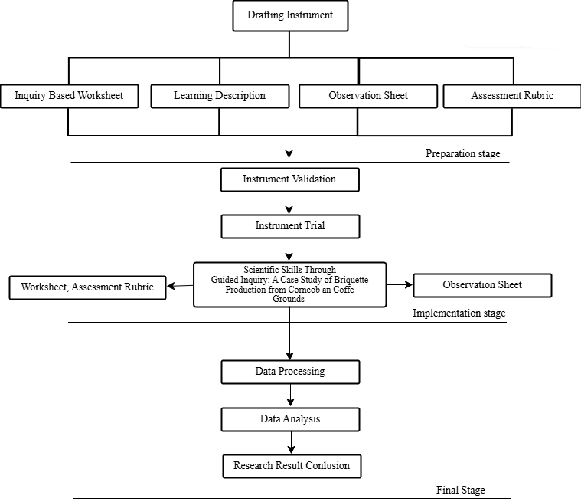

Figure 1. Research Procedure

This study provides treatment by applying guided inquiry-based worksheets in organic waste utilization activities, especially corncob waste and coffee grounds for briquette making. Data collection techniques in this study were in the form of validation sheets from chemical education expert lecturers to determine the validation of the applied Learner Worksheets, student activity observation assessment sheets, and scientific performance assessment sheets for the application of guided inquiry-based worksheets implemented. The data obtained in this study were calculated using the formula :

$$\% Assesment=\frac{score obtained}{total assessment score} × 100\%$$

Then, the data is interpreted into the average learning outcome category, as seen in Table 1.

Table 1. Categories of average learning outcomesa say

|  |  |
| --- | --- |
| **Average Score** | **Description** |
| 80-100 | Very Good |
| 66-79 | Good |
| 56-65 | Sufficient |
| 40-55  30-39 | Insufficient  Fail |

**RESULTS AND DISCUSSION**

Data analysis on the results of this study is divided into two parts, which include student activity on the application of guided inquiry-based worksheets and student scientific performance on LK. The implementation of this paper begins with preliminary activities that aim to build apperception and increase student motivation before entering the learning process. Furthermore, the core activities are carried out, where students carry out practicum on making briquettes from corn stover and coffee grounds, ans completing the LK designed with guided inquiry stages. Student activities during learning using guided inquiry-based worksheets refer to the learning design that has been prepared previously, where each stage has been adjusted to the indicators and stages of scientific performance to facilitate the implementation of research. A recapitulation of the value of the results of observing student activity at each stage of the guided inquiry-based worksheet is given in Table 2.

Table 2. Recapitulation of Student Activity Data Processing Results

|  |  |  |  |  |  |  |  |  |
| --- | --- | --- | --- | --- | --- | --- | --- | --- |
| **Group** | **Student Activity (%) at Each Stage of Guided Inquiry Learning** | | | | | | **Average** | **Interpretation** |
| **1** | **2** | **3** | **4** | **5** | **6** |  |  |
| 1 | 100 | 75 | 75 | 100 | 91,6 | 93,8 | 89,2 | Very Good |
| 2 | 100 | 100 | 100 | 100 | 91,6 | 93,8 | 97,6 | Very Good |
| 3 | 75 | 75 | 75 | 100 | 91,6 | 87,5 | 84 | Very Good |
| **Average** | 91,7 | 83,3 | 83,3 | 100 | 92 | 91,7 |  | Very Good |

Based on the data presented in the table, it can be seen that students' activities at each stage of guided inquiry-based learning show very good results. Overall, the average learner activity from all stages and groups was 90.3%, which shows that this guided inquiry-based learning model successfully created an active and participatory learning atmosphere. The high level of learner activity in each learning stage reflects that this approach can encourage students' overall involvement in the learning process, both in discussion, experimentation, and reflection. ***Making Observations***

In the early stages of learning, students observe the waste materials that will be used and the problems presented in the discourse. Students' activities in making observations can be seen in Figure 2.

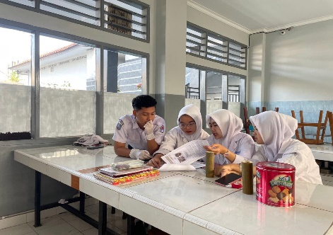

Figure 2. Activity Observation

After observing students' activities, the observation data is presented in more detail in Table 3

Table 3. Average results at the observation stage

|  |  |  |  |  |
| --- | --- | --- | --- | --- |
| **Group** |  | **Score obtained**  **(Maximum 4)** | **Score** | **Interpretation** |
| 1 |  | 4 | 100 | Very Good |
| 2 |  | 4 | 100 | Very Good |
| 3 |  | 3 | 75 | Good |
| **Average** | | | 91,7 | Very Good |

Based on the assessment results contained in the table, an overview of the achievement of students' scientific performance in guided inquiry-based learning activities at one of the implementation stages, namely making observations, shows that groups 1 and 2 can carry out all stages of learning optimally, both in aspects of understanding concepts, involvement in group discussions, and in conveying the results of thinking logically and scientifically. This is by the findings of Naini dkk., (2024) which states that learning using guided inquiry-based worksheets at the stage of making observations can improve scientific performance skills because the guided inquiry model reflects the scientific method.

In contrast, group 3 scored three, equivalent to a 75 and is in the good category. This suggests that although this group has performed quite well,some shortcomings still there are still some shortcomings that need to be improved, such as problem analysis, or group members' participation in the discussion process. This imbalance of achievement between groups suggests the importance of evaluating the group work process, including how the teacher monitors and provides feedback during the activity.

***Formulating the Problem***

At the stage of formulating the problem, the researcher guided the participants of class XI in identifying the problem through discussion. Providing students with an understanding of the problems related to the large amount of corn stover waste and coffee grounds that have not been managed optimally can encourage their interest in understanding the issue and formulating the right solution. Students' activities in formulating the problem can be seen in Figure 3.

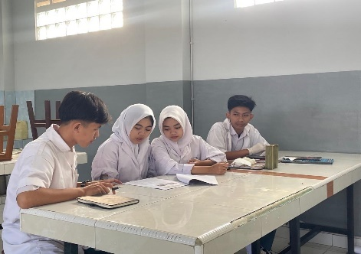

Figure 3. Problem Formulation Activity

Next, the researcher directed the participants to formulate questions related to the topic of the experiment. In this second stage, students are asked to formulate two problem questions related to the discourse that has been delivered. This is in line with research conducted by Mulyani dkk., (2015) which states that guided inquiry emphasizes scientific problem-solving through a process of in-depth investigation to find answers to problems that have been formulated. The results of the guided inquiry-based worksheet in stage 2 of formulating the problem are shown in Table 4.

Table 4. Average results at the stage of formulating the problem

|  |  |  |  |  |
| --- | --- | --- | --- | --- |
| **Group** |  | **Score obtained (Maximum 4)** | **Score** | **Interpretation** |
| 1 |  | 3 | 75 | Good |
| 2 |  | 4 | 100 | Very Good |
| 3 |  | 3 | 75 | Good |
| **Average** | | | 83,3 | Very Good |

The level of participant involvement in the problem formulation stage reached 83.3, which is classified as very good based on Table 4. However, only one group had all its members actively participating in identifying problems and formulating questions. In contrast, in the other two groups, only two to three members from each group were involved in the discussion. The ability to formulate problems is one of the important aspects of developing scientific performance. This result is by what was stated by Widodo et al., (2023) who stated that the learning approach used is quite effective in encouraging students to identify and formulate problems appropriately and can encourage students to actively participate in problem identification and formulation. The more relevant the problem presented in waste management issues, the greater the opportunity for students to identify and solve problems effectively.

***Creating a Hypothesis***

Practitioners are directed to search for appropriate literature to formulate temporary answers to research questions. Hypothesis formulation is one of the stages in the scientific method that serves as a direction in the research process. Without a hypothesis, research can lose focus and the goals to be achieved (Halim dkk., 2022). Students' activities in formulating problems can be seen in Figure 4.

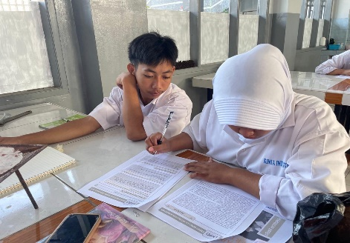

Figure 4. Hypothesis Generation Activity

The results of the guided inquiry-based worksheet in stage 3 of hypothesis generation are shown in Table 5.

Table 5. Average results at the stage of making a hypothesis

|  |  |  |  |  |
| --- | --- | --- | --- | --- |
| **Group** |  | **Score obtained (Maximum 20)** | **Score** | **Interpretation** |
| 1 |  | 18 | 90 | Very Good |
| 2 |  | 17 | 85 | Very Good |
| 3 |  | 19 | 95 | Very Good |
| **Average** | | | 90 | Very Good |

The average score of the three groups is 90, which indicates that most students have demonstrated excellent mastery of the material or skills assessed. This indicates a successful learning process consistently in improving students' scientific understanding and performance between groups. The results align with research conducted by Liandari dkk., (2017) which shows that the science process skills approach through the practicum method can develop students' scientific performance in formulating and testing hypotheses. The stages of making hypotheses can help students think scientifically and solve problems using the scientific method.

***Conducting an Experiment***

At this stage, students begin to carry out practical activities that have been previously designed. Laboratory experiments involve students in the inquiry process, where they play an active role by asking questions, making conjectures, making observations, organizing data, and explaining the patterns found (Adrianus Nasar, 2019). Student activities in conducting experiments can be seen in Figure 5.

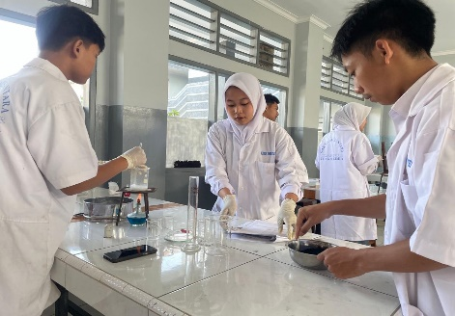

Figure 5. Activity Conduct an Experiment

As a crucial part of the scientific working process, this stage allows students to apply their theoretical understanding through real experiments. Thus, this stage reflects how students understand the concepts they have learned and their readiness to carry out group practicum activities. Based on the results at the stage of conducting experiments, it is shown in Table 6.

Table 6. Average results at the stage of conducting experiments

|  |  |  |  |  |  |  |  |  |
| --- | --- | --- | --- | --- | --- | --- | --- | --- |
| **Group** | **Stages (Scores earned)** | | | | | **Total Score (Maximum 20)** | **Score** | **Interpretation** |
| **1** | **2** | **3** | **4** | **5** |  |  |  |
| 1 | 4 | 4 | 3 | 3 | 3 | 17 | 85 | Very Good |
| 2 | 4 | 3 | 3 | 3 | 4 | 17 | 85 | Very Good |
| 3 | 4 | 4 | 4 | 3 | 3 | 18 | 90 | Very Good |
| **Average** | | |  |  |  |  | 87 | Very Good |

Implementing experimental activities at the guided inquiry stage significantly improves science process skills, scientific performance, and student learning outcomes (Fitriyani, 2017). This shows that participants can follow the stages of conducting experiments systematically and in under established procedures. The achievement of this score reflects a good understanding of the instructions and responsibilities of each group member. These results are in line with the views of Chintya dll., (2023) who states that the score obtained through the practicum illustrates students' level of understanding in experimenting.

***Analyzing Data***

In this process, students receive lessons from the researcher's explanation and discover the essence of the material they are learning. One important activity in this process is analyzing the data that has been obtained. Table 7 shows the average results at this stage of data analysis. Table 7. Average results at the stage of analyzing data.

|  |  |  |  |  |
| --- | --- | --- | --- | --- |
| **Group** |  | **Score obtained (Maximum 4)** | **Score** | **Interpretation** |
| 1 |  | 3 | 75 | Good |
| 2 |  | Good | 75 | Good |
| 3 |  | Good | 100 | Good |
| **Average** | | | 83 | Very Good |

Table 7 shows two groups scored 75 in the good category, while one group achieved a perfect 100 with an excellent interpretation. The overall average was 83, which falls into the excellent category. These results reflect that most students can process and interpret experimental data correctly. Howover, some groups still need improvement in understanding the meaning of the data in depth. This shows that analyzing data in the guided inquiry learning model can improve students' science process skills, which are part of the scientific performance (Sufriyah, 2024).

***Drawing Conclusions***

From the researcher's observation, each group representative could present the experiment's results well. The conclusion-making stage in this model helps improve students' science process skills, which is an important component of scientific performance in science learning (Pradianti et al., 2017). Figure 6 shows the students' activities during presenting the results.

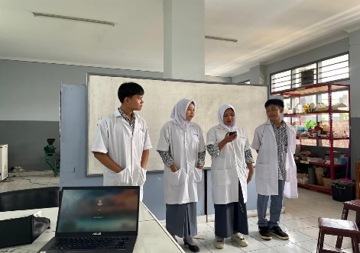

Figure 6. Activity Drawing Conclusions

The results of students' assessment of guided inquiry-based learning at stage 6, namely making conclusions, are shown in Table 8.

Table 8. Average results at the stage of making conclusions

|  |  |  |  |  |  |  |  |
| --- | --- | --- | --- | --- | --- | --- | --- |
| **Group** |  | **Stages (Scores earned)** | | | **Total score (Maximum 12** | **Score** | **Interpretation** |
|  | **1** | **2** | **3** |  |  |  |
| 1 |  | 4 | 3 | 3 | 10 | 83,3 | Very Good |
| 2 |  | 4 | 3 | 3 | 11 | 83,3 | Very Good |
| 3 |  | 4 | 4 | 3 | 10 | 91,6 | Very Good |
| **Average** | | | | | | 88,3 | Very Good |

The ability to conclude is one of the important indicators in developing scientific performance, as it involves analysis and evaluation. This achievement shows that the applied learning strategy is able to encourages students to think reflectively and critically about the information they obtain. Presentations were made using posters. The results of students' posters can be seen in Figure 7.

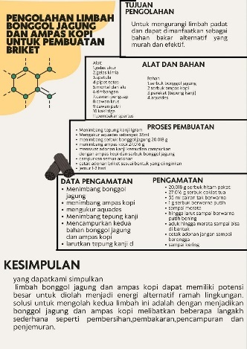

Figure 7. Student poster results

Poster-based scientific presentation methods can improve students' activity and speaking skills. This skill is part of scientific performance that is important in science learning (Sari, 2017).

The average score obtained by each group in each stage showed a positive consistency, with an outstanding interpretation category. The results indicated that the guided inquiry model allows students to explore diverse solving-problems strategies to improve of their critical thinking skills and scientific performance. Through activities such as formulating hypotheses, designing experiments, and drawing conclusions, students showed improvement in their scientific performance (Chengere dkk., 2025)

Worksheets designed with guided inquiry stages show that core activities quite well. This can be seen from the results of students' scientific performance at each stage of the LK, which is in by the predetermined time. In addition, students were seen actively discussing during learning with their group members, and the practicum implementation went smoothly. Therefore, guided inquiry-based learning is highly recommended to be widely applied in science education to encourage the achievement of 21st-century competencies (Alake-Tuenter et al., 2015).

**CONCLUSION**

The application of guided inquiry-based student worksheets in making briquettes from corncob waste and coffee grounds is proven to be able to improve student activity and scientific performance at all stages of learning. The average student activity reached 90.3%, while scientific performance showed excellent results, with scores between 83 and 91.7 at each stage of the inquiry. This approach is effective in developing critical thinking skills and environmental awareness. This model deserves to be applied more widely in contextual chemistry learning.

**RECOMMENDATIONS**

The guided inquiry learning model is recommended to be applied in chemistry learning because it is proven effective in improving students' scientific performance. The development of real context-based LKPD and teacher training must also be improved. Further research is recommended to test the effectiveness of this model more widely.

**ACKNOWLEDGEMENTS**

The thank you is primarily addressed to research funders or donors. A word of gratitude can also be conveyed to those who assist in the implementation of the research.

**BIBLIOGRAPHY**

Adrianus Nasar. (2019). Keefektifan Pembelajaran Sains Melalui Eksperimen Laboratorium Dalam Meningkatkan Pemahaman Dan Penerapan Konsep Serta Kinerja Ilmiah Peserta Didik. *Sustainability (Switzerland)*, *11*(1), 1–14.

Afriani, R., Rahmatullah, S., & Sukmawardani, Y. (2024). Development of Worksheets Based on Guided Inquiry on the Production of Hand Sanitizer from Mahonony Seed Extract (Swietenia mahagoni). *KnE Social Sciences*, *2024*, 236–247. https://doi.org/10.18502/kss.v9i8.15553

Alake-Tuenter, E., Biemans, H. J. A., Tobi, H., Wals, A. E. J., Oosterheert, I., & Mulder, M. (2015). Inquiry-Based Science Education Competencies of Primary School Teachers: A literature study and critical review of the American National Science Education Standards. *International Journal of Science Education*, *34*(17), 2609–2640. https://doi.org/10.1080/09500693.2012.669076

Azizah, A. N., Prayitno, B. A., & Nurmiyati. (2019). Penerapan Model Guided Inquiry Learning untuk Meningkatkan Kemampuan Berpikir Tingkat Tinggi Siswa Sma. *Bio-Pedagogi: Jurnal Pembelajaran Biologi*, *8*(1), 39–43. Retrieved from http://eprints.unm.ac.id/16346/1/Artikel.pdf

Chengere, A. M., Bono, B. D., Zinabu, S. A., & Jilo, K. W. (2025). Enhancing secondary school students’ science process skills through guided inquiry-based laboratory activities in biology. *PLoS ONE*, *20*(4 April), 1–18. https://doi.org/10.1371/journal.pone.0320692

Chintya, F., Siswaningsih, W., & Nahadi. (2023). Pengembangan Instrumen Penilaian Kinerja Siswa SMA pada Praktikum Identifikasi Jenis Protein dalam Bahan Makanan. *Jurnal Riset Dan Praktik Pendidikan Kimia*, *11*(2), 39–49.

Firmansyah Ully Pratama. (2023). Pemanfaatan Bonggol Jagung Sebagai Bahan Campuran Pembuatan Paving block Porous. *Jurnal Agricultural Biosystem Engineering*, *2*, 346.

Fitriyani, R. (2017). Pengaruh Model Inkuiri Terbimbing Terhadap Keterampilan Proses Sains Pada Materi Kelarutan Dan Hasil Kali Kelarutan. *Jurnal Inovasi Pendidikan Kimia*, *11*(2).

Halim Simatupang, Aryeni, D. P. (2022). Peningkatan Kemampuan Literasi Sains Mahasiswa Melalui Penerapan Model Problem Solving Laboratory Pada Matakuliah Praktikum Biologi Sistem. *Jurnal Pelita Pendidikan*, *26*(4), 1–37.

Ischak, N. I., Odja, E. A., La Kilo, J., & La Kilo, A. (2020). Pengaruh Keterampilan Proses Sains Melalui Model Inkuiri Terbimbing terhadap Hasil Belajar Siswa pada Materi Larutan Asam Basa. *Hydrogen: Jurnal Kependidikan Kimia*, *8*(2), 58. https://doi.org/10.33394/hjkk.v8i2.2748

Khoiroh, I. U., Nugroho, S. A., Rosdiana, E., Asmono, S. L., Novenda, I. L., & Pujiastuti. (2024). Karakteristik Dan Uji Hedonik Sabun Berbahan Limbah Ampas Kopi. *Jurnal Biosense*, *7*(1), 189.

Lailiyatus Sufriyah. (2024). Analisis Keterampilan Proses Sains Siswa Pada Model Pembelajaran Inkuiri Terbimbing Materi Bioteknologi. *Program Studi Tadris Biologi*.

Liandari, E., Siahaan, P., Kaniawati, I., & Isnaini, I. (2017). Upaya Meningkatkan Kemampuan Merumuskan Dan Menguji Hipotesis Melalui Pendekatan Keterampilan Proses Sains Dengan Metode Praktikum. *WaPFi (Wahana Pendidikan Fisika)*, *2*(1), 50–55. https://doi.org/10.17509/wapfi.v2i1.4904

Mulyani, N. K. S., Karyasa, I. W., & Suardana, I. N. (2015). Kinerja Ilmiah Siswa yang Dibelajarkan dengan Model Project Based Learning dan Model Pembelajaran Inkuiri Terbimbing. *E- Journal Program Pascasarjana Universitas Pendidikan Ganesha*, *5*(1), 1–12.

Naini, Y., Maulina, H., Sukmawardani, Y., & Rahmatullah, S. (2024). Penerapan Lks Berbasis Inkuiri Terbimbing Dalam Pemanfaatan Limbah Ampas Tebu Sebagai Adsorben Fe. *QUANTUM: Jurnal Inovasi Pendidikan Sains*, *15*(2), 239–247.

Pahriah, Putu Budi Adnyana, I Putu Wisna Ariawan, I. G. A. W. (2024). Effectiveness of the Constructivist Approach (Guided Inquiry) in Chemistry Learning: A Systematic Review. *Hydrogen: Jurnal Kependidikan Kimia*, *12*(October), 59.

Pradianti, D., Wasis, W., & Agustini, R. (2017). Pengembangan Perangkat Pembelajaran Fisika Model Inkuiri Terbimbing Untuk Melatihkan Kinerja Ilmiah Siswa. *JPPS (Jurnal Penelitian Pendidikan Sains)*, *4*(2), 672. https://doi.org/10.26740/jpps.v4n2.p672-680

Puspitasari, D. R., Mustaji, & Rusmawati, R. D. (2019). Model Pembelajaran Inkuiri Terbimbing Berpengaruh Terhadap Pemahaman dan Penemuan Konsep dalam Pembelajaran PPKn. *Jipp*, *3*(1), 96–107.

Sari, D. P. (2017). Penerapan Metode Presentasi Ilmiah Berbasis Poster untuk Meningkatkan Keterampilan Berbicara Siswa Kelas V Sekolah Dasar. *Antologi UPI*, *5*(1), 280–289.

Sitti Rahma Arake. (2017). *Uji Kalor Briket Limbah Tongkol Jagung Dan Sekam Padi Dengan Proses Karbonisasi*. *Universitas Hasanuddin Makassar*.

Suherman, M., Hidayanti, N. S., Utami, L. N., Firdaus, F. R., & Rabbani, M. H. A. (2022). Pemanfaatan Olahan Limbah Bonggol Jagung sebagai Salah Satu Solusi Peningkatan Perekonomian di Desa Tambaksari. *Jurnal Kreativitas Pengabdian Kepada Masyarakat (PKM)*, *5*(12), 4353–4361. https://doi.org/10.33024/jkpm.v5i12.7971

Sulaeman, A., Zenab, C., Sukmawardani, Y., Kimia, P., Keguruan, T., Sunan, U., … No, J. S. (2021). Logam Besi Dalam Air Sumur Menggunakan Limbah Kertas Dengan Modifikasi Asam Sitrat Development Of Guided Inquiry Based Worksheets Biosorpsion Of Iron Metal In Well Water Using Paper Waste With Modification Of Citric Acid. *Gunung Djati Conference Series*, *2*, 360.

Wahyuni, R., & Witarsa, R. (2023). Penerapan Metode Inkuiri untuk Mengembangkan Kemampuan Berpikir Kreatif Siswa Sekolah Dasar. *Journal of Education Research*, *4*(1), 203–209. https://doi.org/10.37985/jer.v4i1.148

Widodo, J., Judijanto, L., Halim, A., Rachman, A., Sutarto, S., & Santosa, T. A. (2023). Does the Guided Inquiry Model Improve Student’s Problem Solving Thinking Ability? Meta-Analysis. *Jurnal Penelitian Pendidikan IPA*, *9*(SpecialIssue), 37–45. https://doi.org/10.29303/jppipa.v9ispecialissue.6253