Metadata Scopus Database and Google Scholar Visualization

Scopus database and google scholar visualization is shown in the following figure :

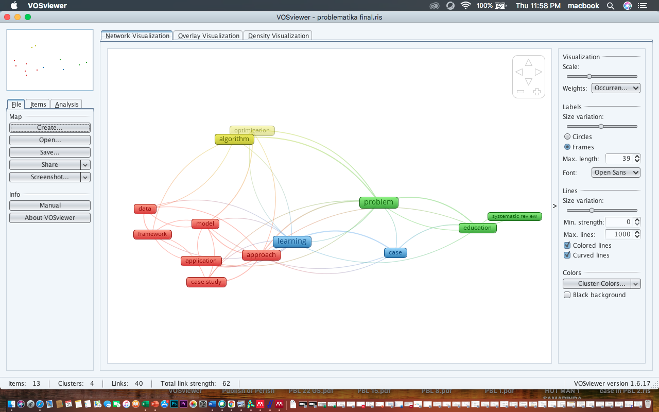

Figure 1. Scopus Database Network Visualization

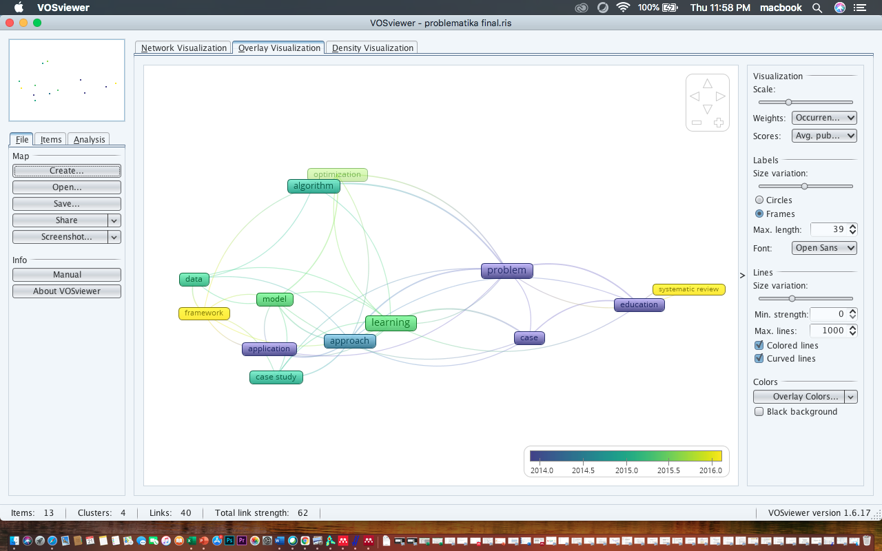

Figure 2. Overlay Visualization of Scopus Database

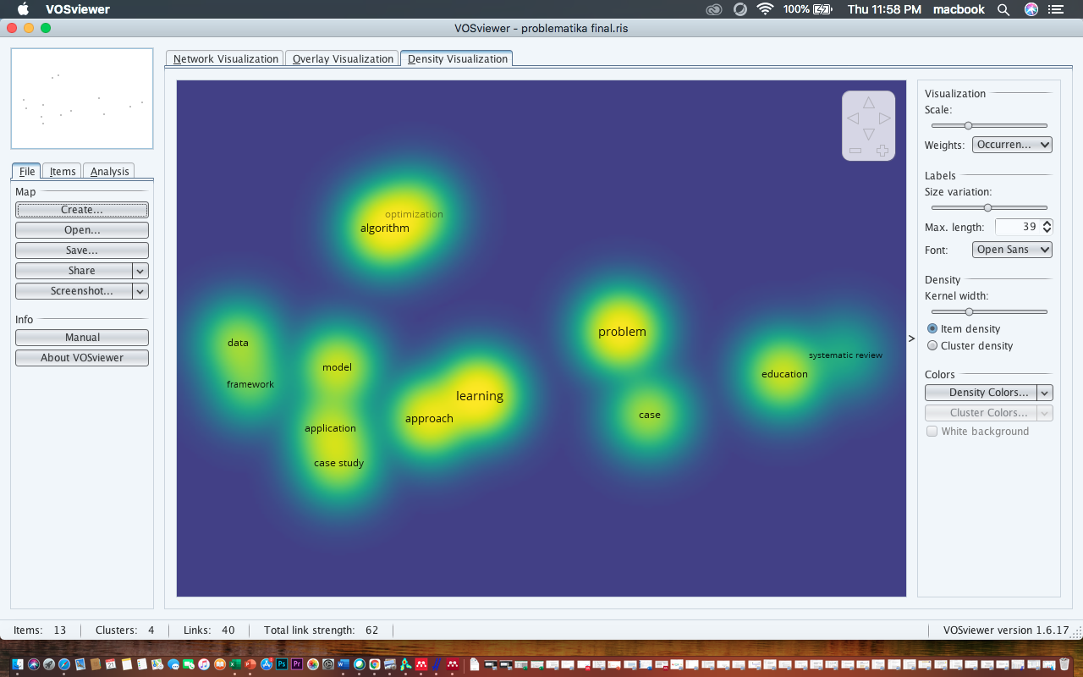

Figure 3. Density Visualization of Scopus Database

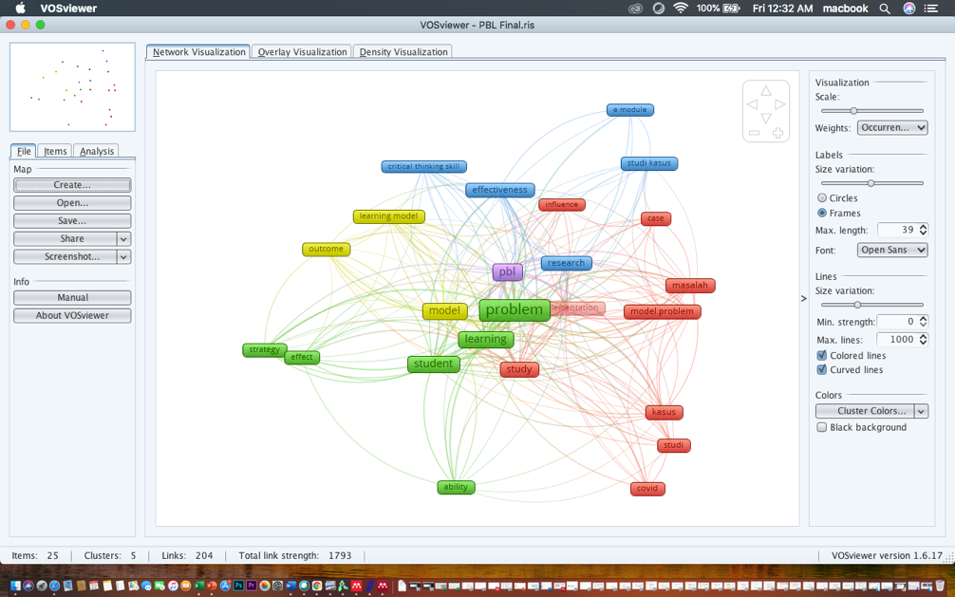  
Figure 4. Google Scholar Database Network Visualization

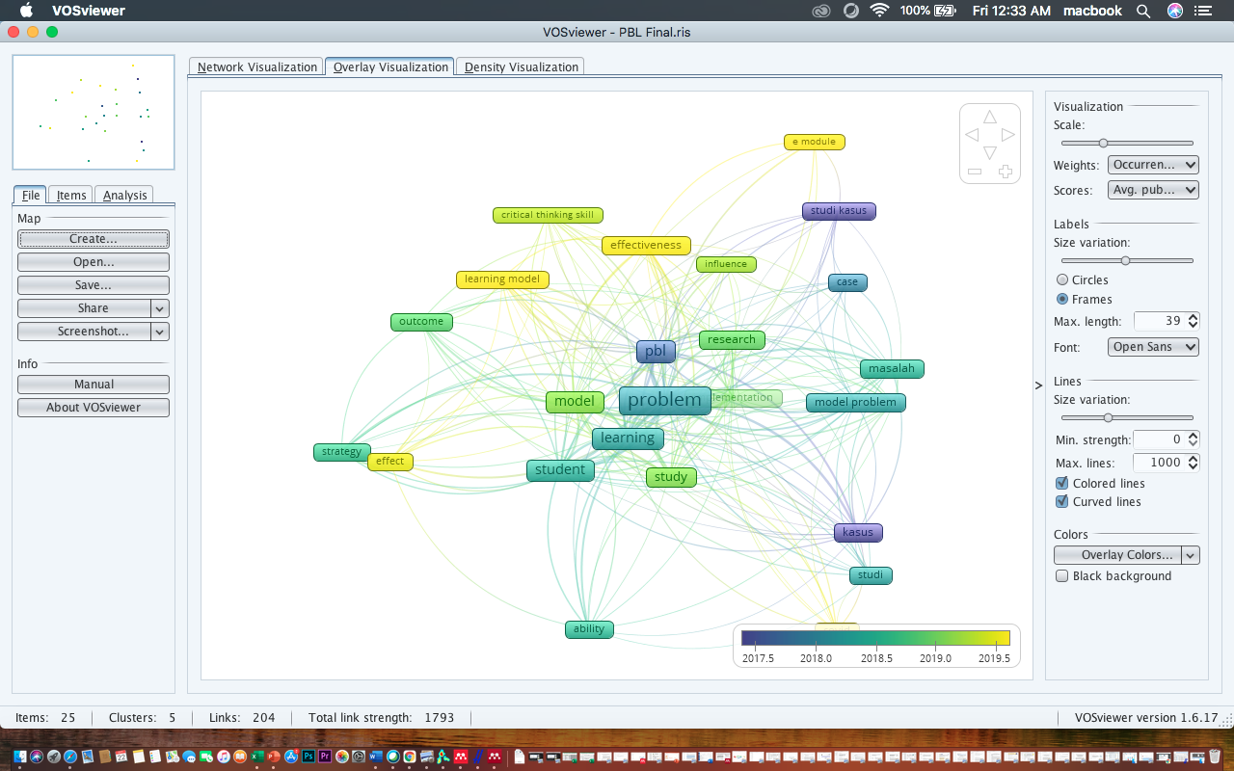

Figure 5. Overlay Visualization of google scholar database

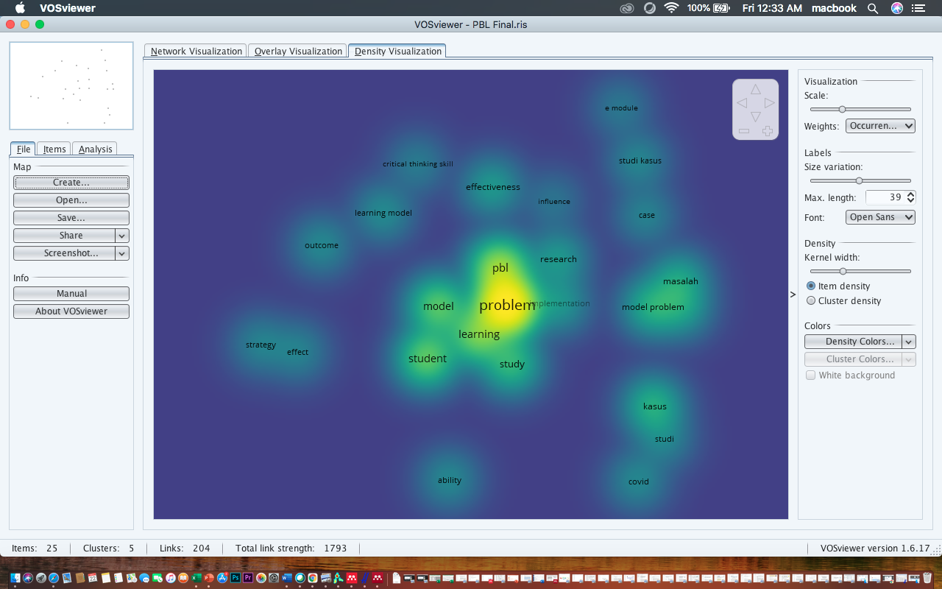

Figure 6. Density Visualization of Google Scholar database