|  |  |
| --- | --- |
| **DEVELOPMENT OF DISCOVERY LEARNING-BASED STUDENT WORKSHEETS (LKPD) ON CHEMICAL EQUILIBRIUM MATERIAL** | |
|  | |
| **Nita Februanti1\*, Rachmat Sahputra 2, Rody Putra Sartika3** | |
| **1** | Department of Chemistry Education, Faculty of Mathematics and Natural Sciences,  Tanjungpura University of Education, Jl. Prof. Dr. H. Nawawi, Indonesia 78124 |
| \* | Corresponding Author e-mail*:* nitafebruanti14@gmail.com |

|  |  |  |
| --- | --- | --- |
| **Article History**  Received: dd-M-Year  Revised: dd-M-Year  Published: dd-M-Year  **Keywords**: development, LKPD, discovery learning | **Abstract (10 pt)**  This study aims to produce discovery learning-based worksheets on chemical equilibrium material through expert judgment. The method in this study is Research & Development (R&D) with a Four-D development model which is limited to the Develop stage, based on a feasibility test. The subject of this research is student worksheets (LKPD) based on discovery learning on chemical equilibrium material for class XI students of SMA Negeri 1 Kuala Mandor B. Data collection techniques used are measurement techniques and direct communication techniques. The data collection tool is in the form of a LKPD feasibility assessment sheet. The feasibility test was carried out based on the material aspect, namely 92% with a very feasible category, the language aspect was 95.2% with a very feasible category and the design aspect was 95% with a very feasible category. Thus, it can be concluded that the worksheets based on discovery learning on chemical equilibrium materials developed are feasible. for use in learning. | |
| **How to Cite:** Nita Februanti., Rachmat Sahputra., Rody Putra Sartika,. Development of Discovery Learning-Based Student Worksheet (LKPD) on Chemical Equilibrium Material. *Hydrogen: Jurnal Kependidikan Kimia*, vol(no). doi:https://doi.org/10.33394/hjkk.v10i2 | | |
| <https://doi.org/10.33394/hjkk>.xxxxx.xxxx | | This is an open-access article under the [CC-BY-SA License.](http://creativecommons.org/licenses/by/4.0/)  C:\Users\IKIP\Pictures\CC_BY-SA_3.0.png |

**INTRODUCTION (12pt)**

Chemistry is the study of the nature of substances and how they react with other substances (Chang, 2005). Based on the Ministry of Education and Culture (2013), one of the objectives of chemistry is to apply chemical concepts to solve problems in everyday life and technology. Chemistry consists of concepts that are calculational or theoretical in nature. Most science concepts such as chemistry are mostly abstract and highly theoretical topics (Sunyono, 2013). This abstract nature can cause students to have difficulty in understanding chemistry subject matter at school and are less interested in learning it.

Based on the results of interviews with chemistry teachers at SMA Negeri 1 Kuala Mandor B, the learning and teaching process at school has used the 2013 curriculum with cooperative learning methods, question and answer, group discussions but learning is still teacher-centered. The low level of understanding of concepts so that students are less actively involved in learning activities. In addition, the teaching materials used by teachers in learning are only in the form of power points, chemistry books and LKPDs made by the teacher himself. However, learning is still not optimal because students still have difficulty understanding concepts in learning chemistry. The LKPD used in class only contains material questions that have not used learning models in the 2013 curriculum. The LKPD has not led students to understand concepts that can provide learning experiences for students to learn actively learn independently. This results in a lack of curiosity of students in learning, so that it can make students only memorize the concepts given but do not understand the meaning of the concepts taught. In line with Elfina's research (2020) which states that a good LKPD must have several components or elements to be feasible and can be used as a medium in learning that can provide new colors for students in increasing their critical thinking skills. In addition, the LKPD used at school does not have basic competencies and clear learning objectives and the lack of completeness of other components in the LKPD. The lack of completeness of the components in the LKPD makes the LKPD less effective. Because according to Prastwo (2014) there are six main components that need to be considered in preparing a good LKPD, namely: title, basic competencies, learning instructions, work steps, supporting information and assessment.

According to the teacher, the understanding of concepts in students in chemistry subjects, especially chemical equilibrium material is still low, it can be seen from the percentage of completeness of the daily test scores of students on average below the minimum completeness criteria (KKM), especially in chemical equilibrium material, which is 15% lower than the other two materials such as reaction rate 25% and acid base 35%. Chemical equilibrium material requires a good understanding because the material includes prerequisite material to understand the next chemical learning material (Sugandi, 2015).

Based on the results of the explanation above, the solution that needs to be done in solving the problems that exist in the school needs to be developed student work sheets (LKPD) that can make it easier for students to be active and easy to understand chemical equilibrium material. According to Prastwo (2011) LKPD is a printed teaching material in the form of sheets of paper containing material, summaries, and instructions for implementing learning tasks that must be done by students, which refers to the basic competencies that must be achieved. The use of student worksheets (LKPD) is one of the alternatives to improve students' concept understanding and learning activities. The presentation of LKPD can be developed with various kinds of innovations. There are various innovations that can be applied, one of which is combining with the right learning model.

The use of learning models can help students obtain information, ideas, skills values, ways of thinking and understanding that they express (Daryanto, 2017). According to Pristiyono (2021), one of the learning models that can make students actively involved in the learning process is the discovery learning model because this model can provide learning opportunities, where the model requires students to be able to find a concept for themselves in learning. Besides, a good learning model must provide learning opportunities for students. In line with Made's research (2018) which says that discovery learning-based student worksheets (LKS) have a better effect on learning outcomes in chemistry learning. Another study, namely, Amorita (2021) based on the results of research on the discovery learning model assisted by audio visual media can increase the activeness and learning outcomes of science as seen from the average activeness of each cycle, which is 26%. Through discovery learning, students also usually learn to think analytically and try to solve the problems they face themselves.

According to Hosnan (2014) discovery learning is a mode that applies a way of learning to be active with the process of finding and investigating the concept itself, the understanding obtained will be more durable in memory. According to Prasetyo (2021) the discovery learning learning model has characteristics, namely: (1) centered on students, (2) explore and solve problems to form, combine and announce knowledge, (3) the process of combining new knowledge and previous knowledge.

Based on Annisa's research (2016), it is stated that the LKS on collision material with the discovery learning model is declared suitable for use, this is evidenced by the percentage of very high validity, namely in the aspect of content suitability of 77.69%, in the construction aspect of 86.84% and the readability aspect of 80.67%. According to Wati's research (2017) states that LKPD on macromolecular material with a discovery learning model is declared valid and feasible based on the assessment of experts and can be applied to learning through a validation process stated to fulfill the aspects of content feasibility, presentation language, and graphics with a percentage of feasibility of 89.1%, 90.5%, and 91.6% respectively.

Based on the description above, researchers feel the need to develop discovery learning-based student worksheets (LKPD) on the subject matter of chemical equilibrium at SMA Negeri 1 Kuala Mandor B. Researchers hope that this LKPD will be useful for the general public as a learning resource, especially increasing the active spirit of learning of students and helping learning and teaching activities at school.

**METHOD (12pt)**

In this study, the method used by researchers is research and development with the 4D model developed by S. Thiangrajan, Drothy S. Sammel, and Melvyn I. Sammel (1974: 5). Sammel (1974: 5). The model is one of the models of device development in learning. There are stages in the 4D model, namely: define, design, develop and disseminate. The stages used in this study were limited to the develop stage because the product development in this study was only to determine the feasibility of the learner worksheet.

At the define stage, (1) front-end analysis aims to analyze the basic problems in developing learning devices in the form of discovery learning-based LKPD on chemical equilibrium material; (2) analysis of students to determine the academic ability of students; (3) concept analysis to determine the concept of material studied at the school; (4) analysis of learning objectives to make detailed learning objectives clearly according to the indicators expected through discovery learning-based learning activities.

The design stage is carried out (1) selecting the media to be developed according to the problems found in the school; (2) making LKPD design as an initial design; (3) making reference tests according to the indicators that have been set.

The develop stage aims to produce valid media, by validating the feasibility of the media made based on the opinions of experts. In this study, validation was carried out by language, material and design experts. The experts in this study amounted to three experts each. Feasibility validation uses an assessment instrument that has been validated.

Data collection techniques in this study are measurement techniques and direct communication techniques. The measurement technique referred to in this study is the feasibility assessment by experts (material, language and design) on discovery learning-based LKPD. The direct communication technique was carried out through interviews with teachers of SMA Negeri 1 Kuala Mando B.

The data collection tool used is the feasibility assessment of discovery learning-based LKPD. In this study, the feasibility assessment was assessed by experts in their fields so that the resulting LKPD was suitable for use. The assessment conducted by experts is used as a reference for revision and improvement. In this study the experts consisted of material, design and language experts, each of which amounted to 3 people. The feasibility assessment sheet follows the standards of teaching materials from BNSP which are adjusted to the needs of researchers. The feasibility assessment was then analyzed with the validity analysis formula.

P = $\frac{\sum{X}}{\sum{Xi}}$ x 100 %

|  |  |
| --- | --- |
| Keterangan |  |
| P = | Percent score gain |
| ∑X = | Total score for each statement |
| ∑Xi = | Sum of the highest scores |
| Furthermore, calculate the average percentage of feasibility of LKPD with the following formula. | |

V = $\frac{\sum{P}}{n}$

|  |  |
| --- | --- |
| Keterangan |  |
| V = | Percent average eligibility |
| ∑P = | Total average percent value of each aspect |
| n = | Number of aspects assessed |

The LKPD eligibility criteria that researchers use according to (Riduwan, 2017), in table 1.

**Tabel 1. Kriteria tingkat kelayakan LKPD berbasis *discovery learning***

|  |  |  |
| --- | --- | --- |
| No | Interval (%) | Kategori |
| 1 | 81-100 | Very feasible |
| 2 | 61-80 | Worth |
| 3 | 41-60 | Decent enough |
| 4 | 21-40 | Not worth it |
| 5 | 0-20 | Very unfeasible |

**RESULTS AND DISCUSSION (12pt)**

The development carried out in this study produced discovery learning-based student worksheets (LKPD) on chemical equilibrium material which was carried out through several stages in accordance with the 4D (four D) medel research. there are 4 stages in the 4D development model, namely: define (defining), design (designing), develop (developing) and dessiminate (disseminating). In this study, researchers were limited to the develop stage because the product development in this study was only to determine the quality of the product The feasibility of the learner worksheet. The development of this LKPD is assessed based on the assessment of material experts, design experts, and language experts.

At the define stage or defining is done to determine and define the learning requirements in the LKPD to be developed by analyzing learning objectives based on the limitations of the material to be developed. The define stage has several steps that must be taken starting from front end analysis, learner analysis, concept analysis and formulation of learning objectives. At the front end analysis is done to find out how the learning process takes place by interviewing one of the chemistry teachers at SMA Negeri 1 Kuala Mandor B. Based on the results of the interview, it is known that in the learning process students are classified as less active in learning. In addition, the teaching materials used in learning are only in the form of textbooks, power points and sometimes also use LKPD made by the teacher. The LKPD only contains a collection of material and questions, without any learning model in the LKPD. This resulted in low learning outcomes, especially in chemical equilibrium material. After the front end analysis was carried out, then continued to analyze the students.

Learner analysis was carried out by interviewing several students. This analysis is carried out to determine the academic ability of students, learning motivation and previous learning experience. Based on the results of the interview, it is known that in the learning process students still have difficulty in understanding the material studied, especially material that emphasizes understanding concepts and calculations. In addition, students like learning chemistry by doing experiments because students can explore and find and understand the concept of learning that is done. This is in accordance with Bruner's theory which suggests that students learn actively to build concepts and principles. Based on this, students want learning that can provide opportunities for students to explore the material independently.

The next analysis is concept analysis by determining what concepts will be presented in the LKPD to be developed which is a reference for the achievement of student learning outcomes. To present these concepts, it is necessary to analyze the core competencies and basic competencies used at the school in accordance with Permendikbud No. 24 of 2016. The next analysis is to formulate learning objectives based on the material studied as a basis for determining the content components in the LKPD to be developed.

The next stage of development is design or design by organizing or designing the media to be developed. According to Agus (2017) this stage aims to design the developed media. This design is done by compiling an initial draft of the LKPD to be made. The LKPD to be developed is based on discovery learning on chemical equilibrium material. In designing LKPD, it needs to be done well because LKPD can help students in understanding learning. According to Putri (2020) states that a good LKPD device design can motivate students to be actively involved in learning. There are several steps in this design, the first step is to compile the competency standards and basic competencies used at the school. Then determine the design of the LKPD to be made, divided into the introduction, content and cover. The introduction page consists of a title page (cover), LKPD identity, preface, table of contents, instructions for using LKPD and concept map. The content page consists of core competencies, basic competencies, indicators, learning objectives, learning activities that contain the stages of the discovery learning model and practice questions. On the closing page contains a bibliography. Before the LKPD is validated by experts, researchers first consulted the initial design to the supervisor in order to get suggestions and input so that the LKPD to be developed is better. In order for participants the activities carried out by students in the developed LKPD can be seen in table 2.

**Table 2: Activities in the LKPD**

|  |  |  |
| --- | --- | --- |
| **No** | **Expected Indicators** | **Activities in LKPD to Achieve Indicators** |
| 1 | Analyzing reversible reactions and irreversible reactions based on experiments | Learners work on LKPD based on the steps in discovery learning, namely (1) stimulus by identifying two events in everyday life such as the event of burning paper and the formation of coral reefs where burnt paper cannot return to its original form while coral reefs can return to their original form or can react continuously. It is hoped that students can distinguish between continuous reactions and continuous reactions. (2) problem identification by making questions that will be solved in the next step. (3) data collection by searching for various relevant materials or theories both from books and the internet. (4) data processing through 2 experiments, the first reacting CaCO3 solids with HCl solution, the second experiment reacting Pb(NO3)2 solution with KI solution and KNO3 solution. (5) verification through presentation and discussion to ensure the correctness of the concept obtained. (6) Students' conclusions summarize the learning outcomes obtained in accordance with the learning objectives on the LKPD. |
| 2 | Analyze the equilibrium formula based on the experiment | After getting the data from the experiment, students are asked to analyze the graph through follow-up questions that direct students in analyzing the experiment table and analyzing the equilibrium formula. |
| 3 | Analyze the data from the experiment to determine the price of the equilibrium constant. | After students know the equilibrium formula, then determine the price of the equilibrium constant based on experimental data guided by follow-up questions. |
| 4 | Presenting the results of data processing in the form of a table of observation results to determine the price of equilibrium stability | After the students conduct the experiment, they continue by processing the experimental data in the form of a table and determining the price of the equilibrium constant accompanied by follow-up questions. |

The last stage of development in this study is develop or development. At this stage, researchers have produced discovery learning-based student worksheets (LKPD) on chemical equilibrium material after conducting feasibility / validation tests and declared feasible for use. Validation is carried out by experts in accordance with their respective fields of expertise consisting of 3 material experts, 3 design experts and 3 language experts, with a total of 9 experts. Validity is a measure that shows the level of validity of a test (Lestari, 2020). The instrument used uses a Likert scale. A recapitulation of the results of the feasibility assessment by experts can be seen in table 3.

**Table 3. Results of Feasibility Assessment Of Discovery Learning-Based LKPD**

|  |  |  |  |
| --- | --- | --- | --- |
| **No** | **Aspects assessed** | **Percent (%)** | **Category** |
| 1 | Material | 92 | Very feasible |
| 2 | Design | 95 | Very feasible |
| 3 | Language | 95,2 | Very feasible |
|  | **Average** | **94,1** | **Very feasible** |

Based on the results of the experts' assessment in each aspect of feasibility, the average score is 94.1% with a very feasible category, which means that the LKPD developed by researchers is feasible and valid for use in the learning process because all experts have said it is valid. This opinion is in line with the results of Yunita's research (2018) which states that the module is said if all experts who validate the product say it is valid.

The results obtained are in line with the results of Izzatunnisa's research (2019) which states that LKPD is said to be feasible to use with an average percentage of LKPD assessment aspects of 89.33% and included in the criteria very feasible to use. According to his research (Lestari, 2020) said that based on the results of the validity assessment of discovery learning-based LKPD seen from an average of 1.00 with very high criteria valid and can be used as one of the teaching materials to assist students in carrying out the learning process and can do practicum independently without having to be guided by the teacher.

Based on the acquisition of the feasibility value that has been done LKPD is feasible and good for use, but product revisions are still carried out in accordance with the suggestions and input of experts. This revision needs to be done so that the LKPD developed is valid and suitable for use in the learning process. It can be said to be feasible because it includes the suitability of the content with KI and KD, that in this LKPD has included discovery learning steps. According to Syah (2008) there are several step procedures in discovery learning that are carried out in teaching and learning activities in general, namely: stimulus, problem identification, data collection, data processing, verification and drawing conclusions.

The designed LKPD was validated by material expert validation, linguistic expert validation and media expert validation. During the validation process that has been carried out, there are several improvements based on the validator's suggestions and comments as consideration for making revisions.

The results of the validation of the material aspect containing content and presentation obtained a percentage of feasibility of 92% with a very feasible category. From the results of this validation that the LKPD developed is included in the criteria very feasible to use in the learning process. There are three aspects assessed in the validation of the material, namely the aspect of the suitability of the material with the Basic Competencies (KD) categorized as very valid because the material contained in the LKPD is in accordance with the basic competencies and objectives to be achieved in line with the opinion of Rahmawati (2020) that an LKPD developed must be in accordance with the concepts and theories based on the basic competencies in the applicable curriculum so that it is clear the learning objectives to be achieved by students. The second aspect, namely the concepts presented in the LKPD in accordance with the concepts and definitions that apply in the field of chemistry, especially in chemical equilibrium material, is categorized as very valid, meaning that the concepts and definitions in the LKPD developed are in accordance with the definitions that apply in chemistry. According to Mahendra (2022) said that in the development of LKPD the concepts and definitions regarding learning materials must be in accordance with the field because otherwise it will cause confusion in students. The last aspect, namely the content of LKPD material in accordance with the discovery learning model, is categorized as valid because the steps in the LKPD developed are in accordance with the model in discovery learning and the events exemplified are in everyday life. In line with the opinion of Novita (2020), it is said that a good LKPD must follow the steps in the learning model contained in the teaching material.

There are several suggestions for improvement from experts so that revisions need to be made. Revisions were made based on suggestions and input from experts. The following are the results of LKPD improvements. In the concept map section, the validator suggested adding components to the concept map, because according to the validator the concept map presented before the revision was very minimalist. The purpose of adding components from the concept map is so that students understand the sequence of the material. In addition, in the stimulus, the validator suggested making a stimulus that can make students interested in reading and writing learning by discovering the problems in the stimulus themselves. The revised concept maps can be seen in figures 1 and 2.

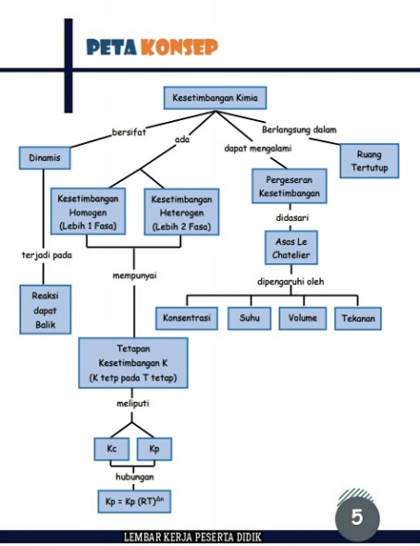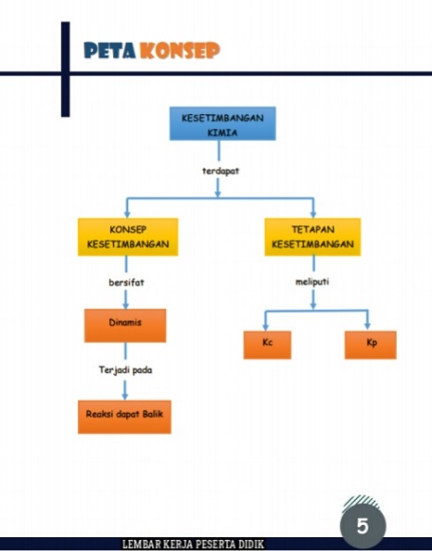

(a) (b)

**Figure 1: Concept map display (a) before revision and (b) after revision**

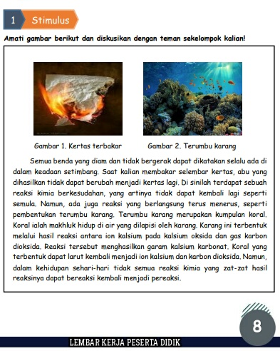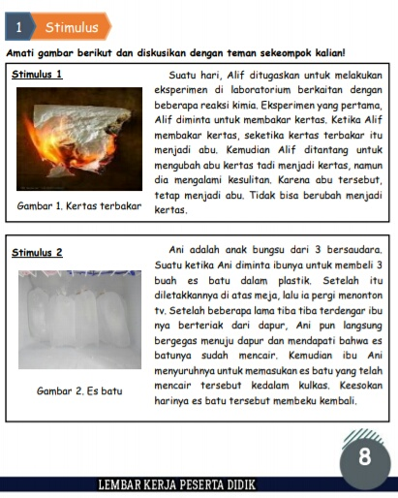

(a) (b)

**Figure 2: Stimulus (a) before revision and (b) after revision**

The results of the validation of the linguistic aspects of content and presentation validated by 3 experts obtained an average percentage of feasibility of 95.2% with a very feasible category. From the results of this validation that the LKPD developed is included in the criteria very feasible to use in the learning process. There are several aspects assessed in language validation, namely in the aspects of straightforward, communicative and dialogical categorized as valid because the language used is clear, not convoluted, communicative and according to the rules. Furthermore, the aspect of suitability for the cognitive development of readers is categorized as valid, meaning that the LKPD developed is in accordance with the development of readers which will make it easier for students to understand the material. The last aspect, namely the suitability of language rules, is categorized as valid, meaning that the language and layout in the LKPD are in accordance with language rules. In line with the statement of Yerimadesi (2016) which says that language is said to be valid if the sentences in teaching materials are clear, easy to understand and do not cause confusion so that they are easily understood by students.

There are several suggestions for improvement from experts so that revisions need to be made. Revisions were made based on suggestions and input from experts. In the preface section, the validator suggested changing the word "preface" to "preface". This was done on the grounds that if written with "preface" it is intended to be a greeting from the printer to the author, while "preface" is a greeting from the author to the reader. In addition, there is a wrong word writing, namely for foreign words that are not tilted. The results of the revision of the language in the preface can be seen in Figure 3.

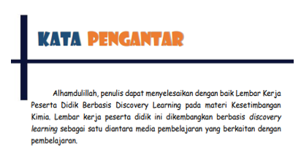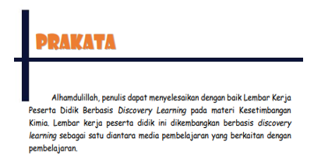

(a) (b)

**Figure 3: Preface (a) before revision and (b) after revision**

The results of the validation of the design aspects validated by 3 experts obtained an average percentage of feasibility of 95% with a very feasible category. From the results of this validation that the LKPD developed is included in the criteria very feasible to use in the learning process. There are several aspects that are assessed in design validation, namely the use of letters, layouts and illustrations or images categorized as very valid, meaning that the use of letters, the harmony of image layouts and illustrations in LKPD can be understood properly because of the placement of good layouts and clarity in illustrations can clarify information. Based on BNSP (2016) states that good images and illustrations can convey messages effectively to students.

There are some suggestions for improvement from experts so that revisions need to be made. Revisions were made based on suggestions and input from experts. On the cover, the validator suggested improving the size of the title writing of the cover, reducing the size of the writing "Class XI" and moving the writing of the author's name. this was done on the grounds that the cover was more attractive. The revised results of the LKPD cover design can be seen in Figure 4.

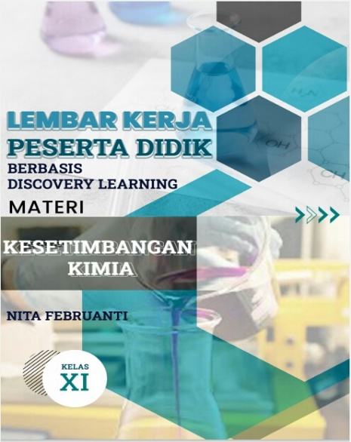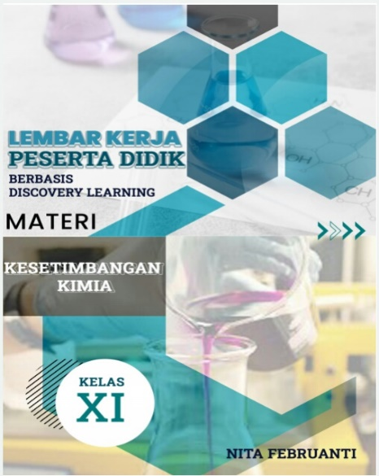

(a) (b)

**Figure 4: Cover view (a) before revision and (b) after revision**

Based on the explanation above, the LKPD developed by researchers can be said to be suitable for use seen from the results of the validation that has been done. The LKPD developed is categorized as very feasible after the feasibility test on 3 aspects obtained at 92% on the feasibility of the material, 95.2% on the feasibility of language and 95% on the feasibility of design. It can be seen that the results obtained are good, but there are still some suggestions from experts to make revisions that will make the LKPD even better. In line with Wardianti's research (2018) which says that the teaching materials developed can be said to be valid if all experts who validate have stated that they are valid. another opinion by Hala (2015) states that the requirements for teaching materials are said to be valid if they meet the criteria for validity based on a strong theoretical study that is consistent.

**CONCLUSION (12pt)**

Based on the results of the study, it can be concluded that the discovery learning-based student worksheet (LKPD) on chemical equilibrium material is very feasible to use in the learning process. The developed LKPD is categorized as very feasible based on the feasibility test on 3 aspects of material feasibility, language and design sequentially obtaining a percentage of 92%, 95.2% and 95%.

Suggestions for further researchers can develop discovery learning LKPD to the next stage such as by testing the effectiveness of LKPD and can disseminate teaching materials to students.

**ACKNOWLEDGEMENTS (12pt)**

The thank you is primarily addressed to research funders or donors. A word of gratitude can also be conveyed to those who assist in the implementation of the research.

**BIBLIOGRAPHY (12pt)**

Amorita, Lysa. 2021. *Model Discovery Learning Berbantuan Media Audio Visual untuk Meningkatkan Keaktifan dan Hasil Belajar IPA Siswa Sekolah Dasar*. Edukatif : Jurnal Ilmu Pendidikan Volume 3 Nomor 3 Tahun 2021 Halm 770 -776.

Annisa, Dira. 2016. *Pengembangan LKS pada Materi Teori Tumbukan Berbasis Discovery Learning.* Jurnal Pendidikan dan Pembelajaran Kimia, Vol. 5, No.1 Edisi April 2016, 128-139.

Ariani, Desi. 2020. *Pengembangan Lembar Kerja Peserta Didik (LKPD) Berbasis Discovery Learning Pada Materi Kalor di SMP.* [Skripsi]: Universitas Islam Negeri Ar-Raniry Darussalam-Banda Aceh.

Badan Standar Nasional Pendidikan (BNSP). 2006. Standar Penilaian Bahan Ajar.

Chang, Raymond. 2005. *Konsep-konsep Inti Edisi 3 Jilid 1*. Jakarta: Erlangga.

Elfina, Sisra. 2020. *Pengembangan lembar kerja peserta didik (LKPD) Berbasis Problem Based Learning (PBL) dalam meningkatkan kemampuan berfikir kritis siswa pada mata pelajaran sosiologi di SMA negeri 1 payakumbuh*. Jurnal Sikola: Jurnal kajian pendidikan dan pembelajaran, Vol. 2 No. 1 September 2020.

Daryanto dan Karim. 2017. *Pembelajaran Abad 21*. Yogyakarta: Gava Media.

Hala, Yusminah. 2015. *Pengembangan perangkat pembelajaran biologi berbasis pendekatan saintifik pada konsep ekosistem bagi siswa sekolah menengah pertama. Journal of educational science and tecnology*, Volume 1 Nomor 3 Desember 2015 hal 85-96.

Hosnan, M. 2014. *Pendekatan Saintifik dan Kontekstual dalam Pembelajaran Abad 21: Kunci Sukses Implementasi Kurikulum 2013*. Jakarta: Ghalia Indonesia.

Izzatunnisa. 2019. *Pengembangan Lkpd Berbasis Pembelajaran Penemuan Untuk Meningkatkan Kemampuan Literasi Sains Peserta Didik pada Materi Kimia SMA.* J. Pijar MIPA, Vol.14 No. 2. 2019: 49 – 54.

Lestari, Anggun. 2021. *Pengembangan Lembar Kerja Peserta Didik (LKPD) Berbasis Discoveli Learning pada Materi Asam Basa*. Jurnal Zara, Vol. 9 No. 2(2021), halaman 117-124.

Lia, M. U. 2014. *Pembelajaran Kesetimbangan Kimia Menggunakan Model Discovery Learning Dalam Meningkatkan Sensitivitas Siswa. Lampung*: Universitas Lampung.

Made, Ni. 2018. *Pengaruh Penerapan Model Pembelajaran Discovery Learning Berbantuan Lembar Kerja Siswa (Lks) Terhadap Hasil Belajar Kimia Pada Materi Reaksi Oksidasi Dan Reduksi Siswa Kelas X Mia Sman 8 Mataram.* [Jurnal Skripsi]: Universitas Mataram.

Peraturan Mentri Pendidikan dan Kebudayaan (Permendikbud) Republik Indonesia Nomor 69 Tahun 2013.

Permendikbud Nomor 59 Tahun 2014 tentang Kurikulum 2013 Sekolah MenengahAtas/Madrasah Aliyah.

Prasetyo, Apri Dwi. *Peningkatan Hasil Belajar Koognitif Melalui Model Discovery Learningtema Perkembangan Teknologi pada Siswa Sekolah Dasar*. Edukatif : Jurnal Ilmu Pendidikan Volume 3 Nomor 4 Tahun 2021 Halm 1830 -1837.

Prastowo, Andi. 2014. *Pengembangan Bahan Ajar Tematik: Tinjauan Teoretis dan Praktik. (Edisi Pertama)*. Jakarta: Prenadamedia Group.

Pristiyono, Edi. *Pengembangan Lembar Kerja Peserta Didik (LKPD) Berbasis Discovery Learning Untuk Melatih Kemampuan Berfikir Tingkat Tinggi Peserta Didik SMA*. Edukatif : Jurnal Ilmu Pendidikan Volume 3 Nomor 6 Tahun 2021 Halm 5265 -5275.

Riduwan. 2017. *Dasar-dasar Statistika*. Bandung: Alfabeta.

Syah, M. 2008. *Psikologi Pendidikan.* Bandung: PT. Remaja Rosdakary.

Wardianti, Yunita. 2018. *Validitas Modul Biologi Berbasis Kearifan Lokal*. Bioedusains: Jurnal Pendidikan Biologi dan Sains Volume 1, Nomor 2, Desember 2018 2598-7453.

Wati, Desri. 2017. *Pengembangan Lembar Kegiatan Peserta Didik (LKPD) Berbasis Discovery Learning pada Pokok Bahasan Makromolekul*: Universitas Riau.

Yesimedesi. 2016. *Pengembangan Modul Kesetimbangan Kimia Berbasis Pendekatan Saintifik Untuk Kelas XI SMA/MA.* Jurnal: *Journal of Sainstek* Vol 8(1):85-97.