**Enhancing Critical Thinking through Ethnoscience-Integrated Problem-Based Learning: A Comparative Study in Secondary Education**

**Yusuf Sarkingobir1* & Abdulaziz Bello2**

1 Department of Environmental Education, Shehu Shagari University of Education Sokoto, NIGERIA

2 State College of Basic and Remedial Studies Sokoto, NIGERIA

*Corresponding author e-mail: [superoxidedismutase594@gmail.com](mailto:superoxidedismutase594@gmail.com)

|  |  |
| --- | --- |
| **Article Info** | **Abstract** |
| **Article History**  Received:  Revised:  Published:  **Keywords**  Problem-based learning;  Ethnoscience;  Critical thinking skills;  Experimental study | This study investigates the impact of integrating ethnoscience with problem-based learning (PBL) on the enhancement of critical thinking skills among secondary school students. Employing a nonequivalent control group design with purposive sampling, the research involved 66 students from a Nigerian secondary school, divided into experimental (n=31) and control (n=35) groups. The experimental group engaged in a PBL curriculum enriched with ethnoscience, while the control group received traditional expository teaching. The study aimed to bridge the gap in current educational practices by incorporating cultural relevance into science education, thus making learning more meaningful and directly applicable to students' lives. Results indicated a significant improvement in the critical thinking abilities of the experimental group, as evidenced by their pretest and posttest scores, compared to the control group. The findings underscore the effectiveness of the ethnoscience-integrated PBL approach in fostering higher-order thinking skills, suggesting a notable advancement over conventional teaching methods. This research contributes to the educational literature by demonstrating the benefits of combining ethnoscience and PBL, advocating for a shift towards more dynamic, student-centered, and culturally relevant teaching strategies. The study highlights the importance of contextual learning experiences and suggests further exploration across various disciplines and educational levels to validate the approach's effectiveness and applicability. |
| https://doi.org/xxxxxxxx  Copyright*©* 2024, xxx & xxx  This is an open-access article under the [CC-BY-SA License](http://creativecommons.org/licenses/by-sa/4.0/).  Creative Commons License |
| **How to Cite** | xxx (2024). xxx. *International Journal of Ethnoscience and Technology in Education*, *1*(1), xx. https://doi.org/xxxxxxxx |

# 

# INTRODUCTION

Education today goes beyond the simple acquisition of textbook knowledge, placing a strong emphasis on the development of comprehensive cognitive skills among students. This approach is particularly pertinent as we navigate the complexities and challenges of the 21st century. Critical thinking, as highlighted by researchers like Salvetti et al. (2023) and Altun and Yildirim (2023), emerges as a fundamental skill that students must master to succeed in this dynamic era. The global curriculum reflects this need, emphasizing the vital role of critical thinking in both the academic and eventual professional success of students. This focus underscores the importance of not just acquiring knowledge, but also developing the ability to critically evaluate and apply this knowledge effectively.

However, the process of nurturing critical thinkers is intricate and demands a strategic educational framework. It is widely recognized that critical thinking skills do not develop overnight; they require careful cultivation through specific educational practices (Aliyu et al., 2023; Bilad, Doyan, et al., 2022). Unfortunately, current science education often overlooks the critical component of socio-cultural context, leading to a gap in students' ability to apply scientific concepts in real-life situations. This disconnect stems from a teaching paradigm that fails to integrate science with everyday life and cultural values, as noted by Zidny et al. (2020). Such oversight can hinder the relevance and impact of science education, making it imperative to weave local wisdom and cultural insights into the curriculum to enhance learning outcomes.

The importance of integrating socio-scientific and cultural contexts into science education cannot be overstated. According to Sjöström et al. (2016), a contemporary science education should acknowledge and incorporate diverse socio-scientific issues and cultural knowledge, termed "indigenous knowledge" by Zidny et al. (2020). This approach allows students to connect their personal and communal knowledge bases with scientific concepts, fostering a more holistic understanding of science. By comparing and contrasting their beliefs, values, and experiences with modern scientific ideas, students can achieve a deeper comprehension and appreciation of science. This method not only makes science more accessible but also more relevant to students' lives, encouraging a more engaged and enthusiastic approach to learning.

However, the challenge remains in effectively integrating these principles into science education. The current educational system, which often neglects pre-existing cultural beliefs, may inadvertently reduce students' interest in science and negatively impact their understanding and attitudes towards scientific learning (Alshammari et al., 2015). The disconnection between cultural relevance and scientific education has been shown to adversely affect students' critical thinking skills (Prayogi et al., 2022). It is, therefore, crucial to adopt teaching strategies that bridge this gap, ensuring that science education is both culturally relevant and conducive to developing critical thinking skills.

To this end, problem-based learning (PBL) emerges as a powerful pedagogical model that can address these challenges. PBL places students at the center of the learning process, engaging them in active problem-solving and collaborative learning. This model fosters a deep engagement with real-world problems, encouraging students to apply their knowledge in practical contexts (Pozuelo-Muñoz et al., 2023; Smith et al., 2022; Marcinauskas et al., 2024). Such an approach not only enhances students' critical thinking abilities but also ensures that learning is meaningful and directly applicable to their lives. By embracing PBL and other dynamic educational models, educators can cultivate a generation of critical thinkers who are well-equipped to navigate the challenges of the 21st century.

Despite efforts to merge PBL with ethnosciences, there's a paucity of in-depth research on its impact on students' critical thinking skills. Thus, further investigation is warranted to understand the actual effects of this educational model on the development of students' critical thinking abilities. This research aims to bridge the existing knowledge gap and provide deeper insights into how the integrated PBL and ethnosciences model influences students' critical thinking skills. The findings of this study are expected to contribute to the development of more effective learning strategies for enhancing students' critical thinking skills in the contemporary educational era. Specifically, the research questions are as follows:

1. What is the impact of the integrated problem-based learning and ethnosciences model on students' critical thinking skills?
2. How do the critical thinking skills of students taught through the integrated problem-based learning and ethnosciences model compare with those taught through traditional expository teaching methods?

# METHODS

The research adopted a nonequivalent control group design, employing two groups: a control group and an experimental group selected through non-probability, purposive sampling. This sampling method involves choosing participants based on specific characteristics or qualities known in advance, aiming for targeted insights. Both groups were exposed to the same learning materials but underwent different learning treatments, as outlined in the Table 1.

**Table 1.** Research Design

|  |  |  |  |
| --- | --- | --- | --- |
| **Kelompok** | **Pretest** | **Treatment** | **Posttest** |
| Experimental | O₁ | X | O₂ |
| Control | O₁ | Y | O₂ |

The experimental group engaged with a problem-based learning (PBL) model integrated with ethnosciences (X), whereas the control group experienced traditional expository teaching (Y). A pretest (O1) was administered to both groups before the treatment, and a posttest (O2) followed the treatment.

**Sample and Ethical Consideration**

The study was conducted in a secondary school in Nigeria, involving sixty-six students divided into an experimental group (n = 31) and a control group (n = 35). Demographically, participants were aged between 15 to 16 years, with a relatively balanced gender distribution. However, the study did not consider the demographic backgrounds of the sample as influencing variables.

Ethical approval was obtained from the relevant ethics committee and educational institution, ensuring all activities adhered to ethical standards. Participant anonymity and data confidentiality were prioritized, with minimized psychological risks and clarified voluntary participation, allowing students to withdraw at any time without consequences.

**Procedure**

The research commenced with purposive sampling of students, dividing them into experimental and control groups. Before implementing the learning methods, both groups took a pretest assessing their initial critical thinking skills, measuring abilities in analysis, inference, evaluation, and decision-making. Subsequently, each group received specific treatments over two months, with educational content focusing on physics science subjects. After the intervention period, a posttest assessed the change in students' critical thinking skills resulting from the different educational treatments. The instruments for pretests and posttests were previously validated and adapted to a critical thinking scoring scale. Research findings were then analyzed to draw conclusions.

**Instruments and Analysis**

Students' critical thinking skills were measured using a test instrument featuring indicators for analysis, inference, evaluation, and decision-making. This instrument, already validated, was deemed suitable for collecting critical thinking data as pretests and posttests. The critical thinking scoring system was adapted from the Ennis-Weir Critical Thinking Essay Test, with a modified scoring scale. The critical thinking criteria ranged from non-critical to highly critical (Aliyu et al., 2023). Data on students' critical thinking skills were analyzed descriptively and statistically. Descriptive data analysis focused on average critical thinking scores and improvements from pretest to posttest. Score improvements were calculated using Hake's (1999) formula.

# RESULTS AND DISCUSSION

A study was conducted with the objective of examining the impact of an integrated problem-based learning model with ethnosciences on students' critical thinking skills. The analysis of the experimental class's descriptive results, focusing on the average scores of critical thinking and the normalized gain (n-gain) for each indicator, is detailed in Table 2 and Figure 1. This approach aimed to provide a comprehensive understanding of how the innovative teaching method influences the development of critical thinking abilities among students.

**Table 2.** Results of descriptive analysis of the critical thinking skills of the experimental group

|  |  |  |  |  |  |  |  |  |  |
| --- | --- | --- | --- | --- | --- | --- | --- | --- | --- |
| **Indicator** | **N** | **Pretest** | | | **Posttest** | | | **n-gain** | **Criteria** |
| **Min** | **Max** | **Mean (SD)** | **Min** | **Max** | **Mean (SD)** |
| Analysis | 31 | 0.00 | 3.00 | 1.77 (±0.85)  (Quite Critical) | 1.50 | 3.00 | 2.39 (±0.84)  (Critical) | 0.48 | Moderate |
| Inference | 31 | 0.00 | 2.50 | 0.68 (±0.65)  (Less Critical) | 1.50 | 3.00 | 2.34 (±0.85)  (Critical) | 0.72 | High |
| Evaluate | 31 | 0.00 | 1.50 | 0.05 (±0.46)  (Not Critical) | 1.50 | 3.00 | 2.33 (±080)  (Critical) | 0.73 | High |
| Decision- making | 31 | 0.00 | 1.50 | 0.72 (±0.45)  (Less Critical) | 1.50 | 3.00 | 2.39 (±0.86)  (Critical) | 0.78 | High |

The results presented in Table 2 and Figure 1 illustrates the impact of an integrated problem-based learning model with ethnosciences on the critical thinking skills of students in an experimental group. The table reports on four critical thinking indicators: Analysis, Inference, Evaluate, and Decision-making, with each indicator assessed among 31 students through pretest and posttest scores, alongside calculated normalized gains (n-gain).

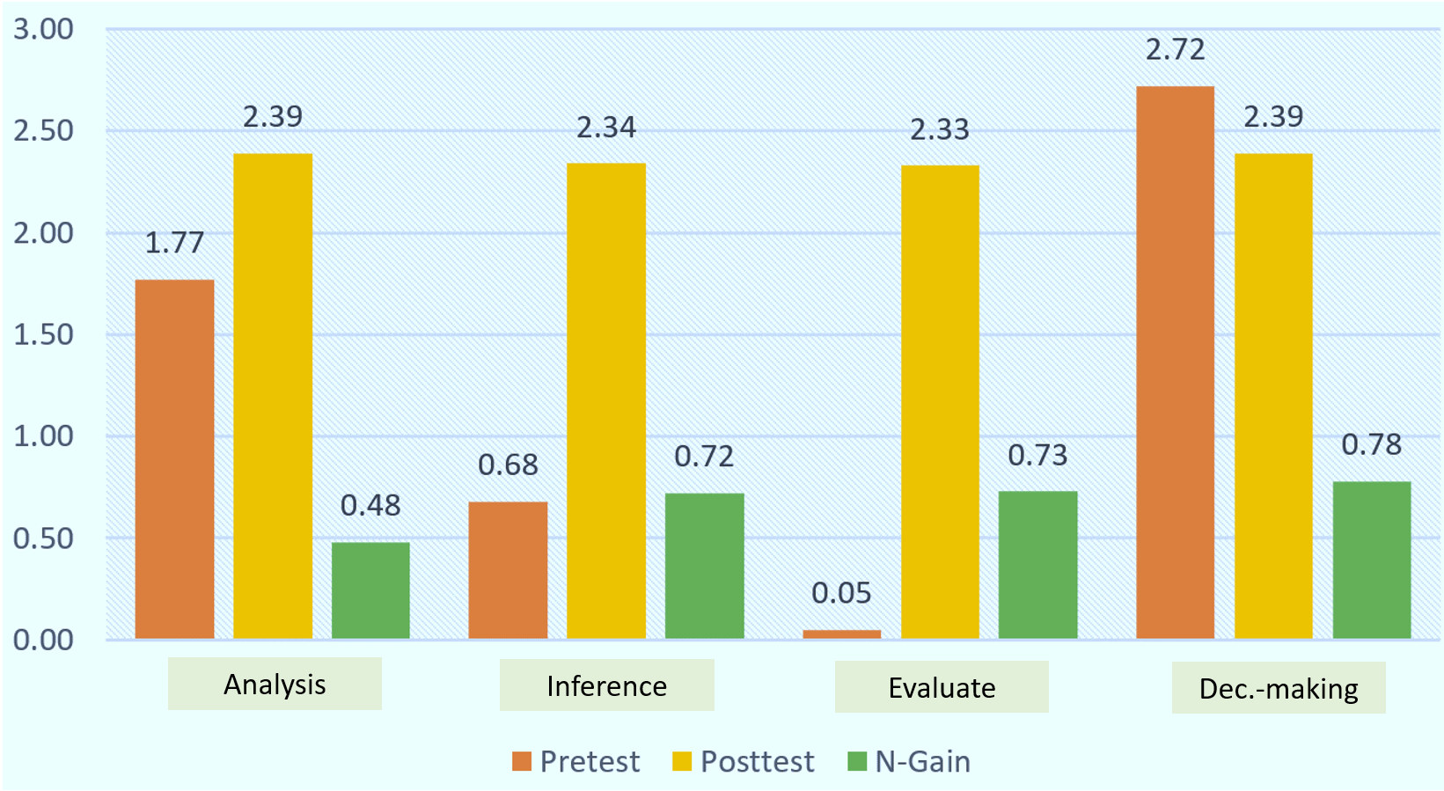

**Figure 1.** Visualization of the results of descriptive analysis of the critical thinking skills of the experimental group

For the Evaluate indicator, initial scores were significantly low, ranging from 0.00 to 1.50 with a mean of merely 0.05 (±0.46), classified as Not Critical. After the intervention, scores significantly increased to a range of 1.50 to 3.00 with an average of 2.33 (±0.80), reaching a Critical status and an n-gain of 0.73, reflecting a high level of improvement. Lastly, the Decision-making scores also demonstrated a substantial increase from a pretest range of 0.00 to 1.50 and a mean of 0.72 (±0.45), deemed Less Critical, to a posttest range of 1.50 to 3.00 and an average of 2.39 (±0.86), categorized as Critical, with the highest n-gain of 0.78, indicating a high level of enhancement in students' critical thinking ability. Next, the results of the descriptive analysis of the control class based on the parameters of the average critical thinking score and n-gain for each indicator are presented in Table 3 and Figure 2.

**Table 3.** Results of descriptive analysis of the critical thinking skills of the control group

| **Indicator** | **N** | **Pretest** | | | **Posttest** | | | **n-gain** | **Criteria** |
| --- | --- | --- | --- | --- | --- | --- | --- | --- | --- |
| **Min** | **Max** | **Mean (SD)** | **Min** | **Max** | **Mean (SD)** |
| Analysis | 35 | 0.00 | 3.00 | 1.48(±0.85)  (Quite Critical) | 1.00 | 2.50 | 1.86(±0.45)  (Quite Critical) | 0.48 | Moderate |
| Inference | 35 | 0.00 | 2.00 | 0.63(±0.55)  (Less Critical) | 0.00 | 2.50 | 1.62(±0.46)  (Quite Critical) | 0.54 | Moderate |
| Evaluate | 35 | 0.00 | 2.00 | 1.07(±0.57)  (Less Critical) | 0.50 | 2.00 | 1.42(±0.68)  (Quite Critical) | 0.30 | Moderate |
| Decision- making | 35 | 0.00 | 1.50 | 0.65(±0.58)  (Not Critical) | 0.00 | 2.00 | 1.14(±0.58)  (Quite Critical) | 0.22 | Low |

Table 3 and Figure 2 reveals the outcomes of the descriptive analysis for the control group, which was subjected to traditional expository teaching methods, in terms of their critical thinking skills. The analysis encompassed four indicators: Analysis, Inference, Evaluate, and Decision-making, with assessments conducted among 35 students through pretest and posttest scores, along with the computed normalized gains (n-gain). For the Analysis indicator, initial scores varied from 0.00 to 3.00, with an average of 1.48 (±0.85), qualifying as Quite Critical. Following the intervention, scores increased to a range between 1.00 to 2.50 with an average of 1.86 (±0.45), remaining in the Quite Critical category, and an n-gain of 0.48, indicating moderate improvement. In the case of Inference, the pretest scores ranged from 0.00 to 2.00, averaging 0.63 (±0.55), considered Less Critical, which then improved to a range of 0.00 to 2.50 with an average of 1.62 (±0.46), moving up to Quite Critical with a moderate n-gain of 0.54.

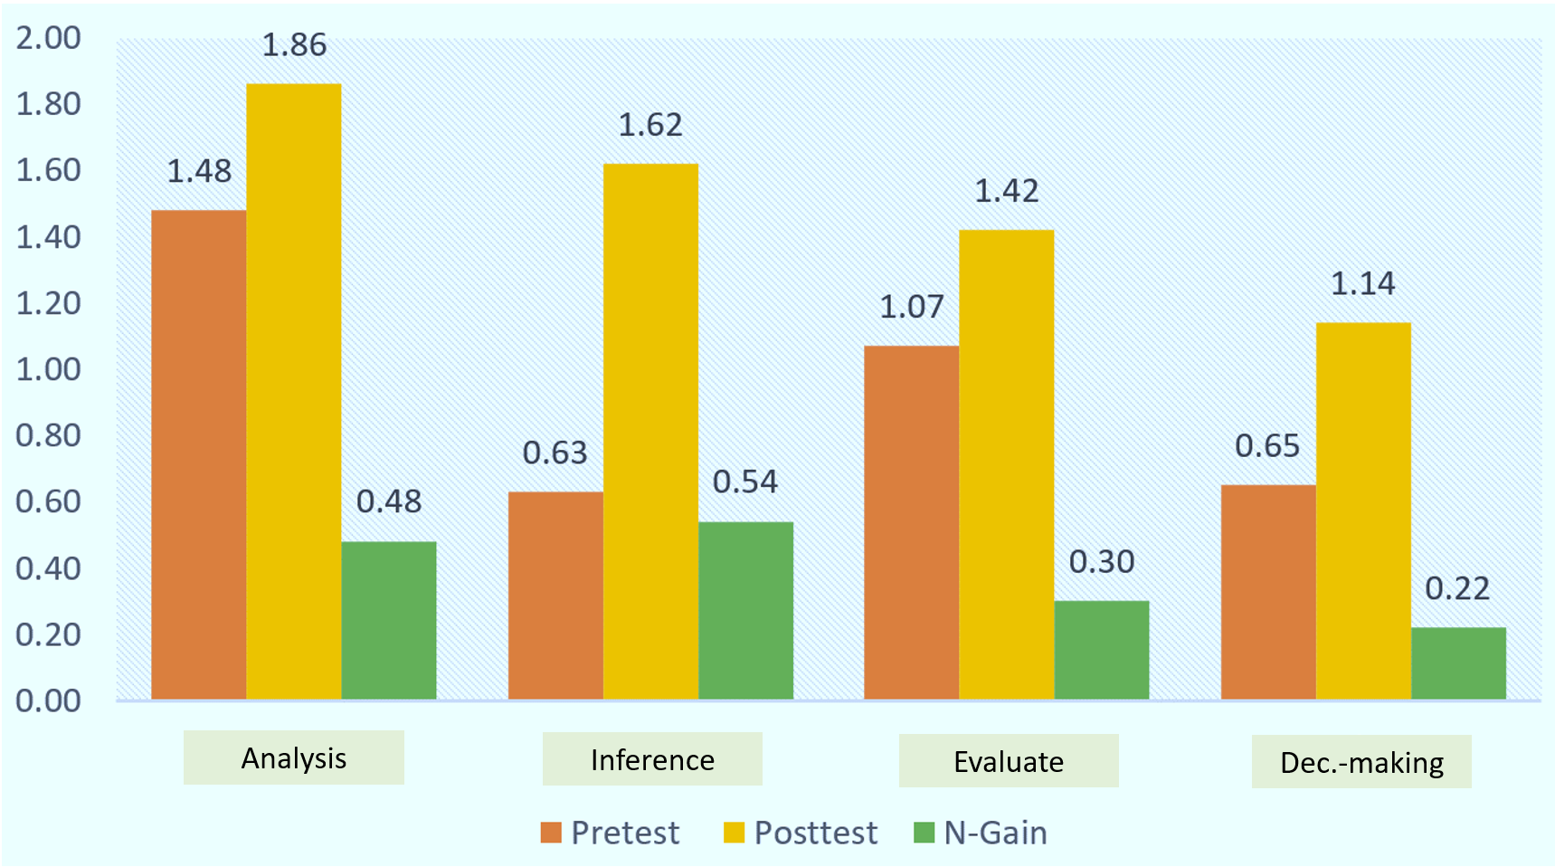

**Figure 2.** Visualization of the results of descriptive analysis of the critical thinking skills of the control group

On the Evaluate indicator, the control group began with scores ranging from 0.00 to 2.00, with a mean of 1.07 (±0.57), labeled as Less Critical. After the intervention, these scores modestly increased to between 0.50 and 2.00 with an average of 1.42 (±0.68), achieving a Quite Critical status, accompanied by an n-gain of 0.30, which is considered moderate. The Decision-making scores showed a pretest range from 0.00 to 1.50 with an average of 0.65 (±0.58), categorized as Not Critical. The posttest scores observed a slight increase to a range of 0.00 to 2.00 with an average of 1.14 (±0.58), elevating to Quite Critical, yet with a low n-gain of 0.22. These findings demonstrate the control group's moderate enhancement in critical thinking skills across most indicators, highlighting a less significant improvement compared to the experimental group, especially in decision-making capabilities. This underlines the potential added value of integrating problem-based learning with ethnosciences in promoting more substantial growth in critical thinking skills. Furthermore, the results of descriptive analysis based on the average total score of classical critical thinking in the experimental and control groups are presented in Table 4.

**Table 4.** The results of the descriptive analysis are based on the average total score of classical critical thinking in the experimental and control groups

|  |  |  |  |  |  |  |  |  |  |
| --- | --- | --- | --- | --- | --- | --- | --- | --- | --- |
| **Group** | **N** | **Pretest** | | | **Posttest** | | | **n-gain** | **Criteria** |
| **Min** | **Max** | **Mean** | **Min** | **Max** | **Mean** |
| Experimental | 31 | 3.00 | 9.00 | 6.55 | 15.00 | 23.00 | 18.68 | 0.70 | Moderate |
| Control | 35 | 5.00 | 11.00 | 7.66 | 10.00 | 15.00 | 12.11 | 0.27 | Low |

Table 4 provides a comparative overview of the average total scores for classical critical thinking skills between the experimental and control groups, both before and after the intervention, alongside the calculated normalized gains (n-gain). In the experimental group, which utilized an integrated problem-based learning approach with ethnosciences, the pretest scores ranged from 3.00 to 9.00, with an average score of 6.55. Post-intervention, this group showed a significant improvement in their critical thinking scores, with the range expanding to 15.00 to 23.00 and the average score increasing to 18.68. This substantial increase resulted in a normalized gain of 0.70, which is categorized as moderate. This indicates a notable enhancement in the critical thinking abilities of students exposed to the innovative teaching methodology, reflecting the effectiveness of combining problem-based learning with ethnosciences in fostering critical thinking skills.

Conversely, the control group, which was taught using traditional expository methods, started with pretest scores between 5.00 to 11.00, averaging at 7.66. After the intervention, their posttest scores ranged from 10.00 to 15.00, with an average increase to 12.11. The normalized gain for the control group was calculated at 0.27, indicating a low level of improvement in critical thinking skills. This contrast between the experimental and control groups' outcomes highlights the relative efficacy of the problem-based learning model integrated with ethnosciences. The experimental group's students not only achieved higher average scores but also demonstrated a greater increase in their ability to think critically, underscoring the potential of innovative educational strategies to significantly enhance critical thinking skills compared to more traditional teaching approaches. Furthermore, differences in students' critical thinking skills scores between classes were tested statistically, preceded by normality and homogeneity tests. The results of the normality and homogeneity tests are presented in Table 5.

**Table 5.** Normality and homogeneity test results

|  |  |  |  |  |  |  |  |
| --- | --- | --- | --- | --- | --- | --- | --- |
| **Group** | **Score** | **N** | **Normality** | | | **Homogeneity** | |
| **Mean** | **SD** | **Sig.** | **Levine test** | **Sig.** |
| Experimental | Pre-test | 31 | 6.65 | 2.027 | 0.217 | 8.196 | 0.066 |
| Post-test | 31 | 18.68 |
| Control | Pre-test | 35 | 7.66 | 1.272 | 0.311 |  |  |
| Post-test | 35 | 12.11 |

The results from Table 5, showing the normality and homogeneity tests for critical thinking scores of students in both experimental and control groups, indicate that the data meets the necessary assumptions for subsequent statistical analysis. For the experimental group's pre-test scores, with a mean of 6.65 and a standard deviation of 2.027, the normality test returned a significance value of 0.217, suggesting a normal distribution. Similarly, the control group's pre-test scores, with a mean of 7.66 and a standard deviation of 1.272, showed a normality significance value of 0.311, further confirming normal distribution. The Levine test for homogeneity yielded a significance value of 0.066, indicating homogeneous variances across groups. These results validate the data's adherence to the prerequisites for statistical comparison, setting the stage for analyzing differences in critical thinking improvements between the experimental and control groups. Based on these results, a paired sample t-test was carried out (p < 0.05), the results are presented in Table 6.

**Table 6.** Paired sample t-test results (p < 0.05)

|  |  |  |  |  |  |  |  |
| --- | --- | --- | --- | --- | --- | --- | --- |
| **Pair** | **Group** | **N** | **Mean** | **SD** | **t** | **df** | **p** |
| Pair 1 | Exp. (pretest) | 31 | -12.129 | 2.125 | -31.778 | 30 | 0.000 |
| Exp. (posttest) | 31 |
| Pair 2 | Cont. (pretest) | 35 | -4.343 | 1.679 | -15.299 | 34 | 0.000 |
| Cont. (posttest) | 35 |

The statistical analysis presented in Table 6, utilizing the paired sample t-test, assesses the impact of educational interventions on two distinct groups: the experimental and the control groups, with the analysis predicated on a significance threshold of p < 0.05. The experimental group, denoted as Pair 1, underwent a pretest and posttest evaluation, revealing a marked improvement in their scores from -12.129 in the pretest to -31.778 in the posttest, yielding a statistically significant p-value of 0.000. This substantial shift underscores the experimental group's considerable progress post-intervention. Meanwhile, the control group, or Pair 2, also demonstrated significant growth from their pretest to posttest scores, moving from -4.343 to -15.299 with a p-value of 0.000. Although the control group saw noteworthy improvements, their advancements were not as pronounced as those observed in the experimental group. This difference validates the hypothesis that the problem-based learning model, when integrated with ethnosciences, significantly bolsters students' critical thinking capabilities, casting traditional expository teaching methods as less effective in fostering these essential skills.

This comparative analysis not only validates the effectiveness of the problem-based learning approach integrated with ethnosciences but also highlights the limitations of conventional teaching strategies in nurturing critical thinking among students. The experimental group's significant leap in performance post-intervention, as opposed to the more modest gains seen in the control group, speaks volumes about the added value of innovative teaching methodologies. By affirming the research hypothesis, the study emphasizes the substantial influence that a problem-based learning framework, enriched with ethnoscientific knowledge, has on the critical thinking development of students. This revelation underscores the necessity for educational practices to evolve beyond traditional methods to cultivate the analytical and evaluative skills that students need in an increasingly complex world.

The recent study illuminates the profound effect that integrating ethnoscience into a problem-based learning (PBL) framework has on enhancing students' critical thinking capabilities. PBL, recognized for its student-centric approach, stimulates active participation, teamwork, and problem-solving initiatives (Aliyu et al., 2023). Meanwhile, ethnoscience enriches the curriculum by embedding cultural knowledge, thereby amplifying the relevance of the context in which learning occurs (Koirala, 2023). The synergy of these methodologies is designed to create an all-encompassing educational setting that not only imparts specialized knowledge across various subjects but also advances the critical thinking skills of students, aligning perfectly with the objectives of this investigation.

A critical element underscored by this study is the enriched learning experience brought about by the integration of ethnoscience, affirming the principle that learning achieves its greatest impact when conducted within contexts that resonate with the learners' own cultural backgrounds. By weaving ethnoscience with PBL, the curriculum's cultural relevance is significantly enhanced, bridging theoretical concepts with their practical applications in the real world, deeply rooted in students' cultural heritage. This method not only facilitates a deeper comprehension of the material but also significantly contributes to the cultivation of critical thinking skills among students. Such an approach has been corroborated by preceding studies, which have highlighted the success of combining PBL with ethnoscience in elevating critical thinking skills across different educational settings (Prayogi et al., 2022).

In conclusion, this investigation adds to the accumulating evidence that supports the dynamic and effective nature of integrating ethnoscience with problem-based learning. This blend not only addresses the need for subject-specific knowledge but also fosters essential skills vital for thriving in a range of academic and professional settings. The findings advocate for a shift towards educational strategies that are not just focused on content delivery but are also aimed at developing comprehensive skill sets, including critical thinking, which are indispensable in navigating the complexities of the modern world. Through such integrated educational frameworks, students are better prepared to face the challenges of an ever-evolving global landscape, underscoring the importance of innovative teaching methods in today's diverse educational ecosystem.

# CONCLUSION

This study's findings significantly contribute to the existing literature by demonstrating the positive impact of integrating ethnoscience with a problem-based learning (PBL) approach on enhancing students' critical thinking skills. The PBL model, renowned for its focus on student-centered learning, active engagement, and problem-solving, was further enriched by incorporating ethnoscience, which adds cultural knowledge into the learning, thereby increasing its contextual relevance. This unique blend not only promoted subject-specific knowledge but also significantly improved students' critical thinking abilities. The empirical evidence, highlighted by the substantial improvements in the experimental group's critical thinking scores compared to the control group, underscores the effectiveness of this innovative teaching method. It reaffirms the hypothesis that integrating problem-based learning with ethnoscience is more effective in fostering critical thinking skills than traditional expository teaching methods.

Moreover, the study illuminates the importance of contextual learning experiences facilitated by the integration of ethnoscience. This approach, which aligns learning with students' cultural backgrounds, not only deepens their understanding but also significantly enhances their critical thinking capabilities. The comparison of pretest and posttest scores within the experimental group reveals a noteworthy advancement in critical thinking, demonstrating the added value of this pedagogical strategy. These findings advocate for a paradigm shift in educational practices towards more dynamic and culturally relevant teaching methods, highlighting the necessity for educational strategies that not only focus on content knowledge but also prioritize the development of critical thinking and other essential skills for success in diverse academic and professional environments.

# Author Contributions

The authors have sufficiently contributed to the study, and have read and agreed to the published version of the manuscript.

# Funding

This research received no external funding.

# Acknowledgment

The authors wish to express their sincere gratitude to all participants and educators who contributed their time and insights to this study, making this research possible. Special thanks are extended to the school administration for their cooperation and support in facilitating the research process.

# Conflict of interests

The authors declare no conflict of interest.

# REFERENCES

Aliyu, H., Ebikabowei, M., & Kola, A. J. (2023). Problem-Based Learning in Remote Learning Scenario Utilizing Climate Change Virtual Reality Video in Mobile Application to Train Critical Thinking. *International Journal of Essential Competencies in Education*, *2*(2), 144–159. <https://doi.org/10.36312/ijece.v2i2.1612>

Alshammari, A. S., Mansour, N., & Skinner, N. (2015). The Socio-Cultural Contexts of Science Curriculum Reform in the State of Kuwait. In N. Mansour & S. Al-Shamrani (Eds.), *Science Education in the Arab Gulf States* (pp. 205–223). SensePublishers. <https://doi.org/10.1007/978-94-6300-049-9_11>

Altun, E., & Yildirim, N. (2023). What does critical thinking mean? Examination of pre-service teachers’ cognitive structures and definitions for critical thinking. *Thinking Skills and Creativity*, *49*, 101367. <https://doi.org/10.1016/j.tsc.2023.101367>

Biazus, M. de O., & Mahtari, S. (2022). The Impact of Project-Based Learning (PjBL) Model on Secondary Students’ Creative Thinking Skills. *International Journal of Essential Competencies in Education*, *1*(1), 38–48. <https://doi.org/10.36312/ijece.v1i1.752>

Bilad, M. R., Anwar, K., & Hayati, S. (2022). Nurturing Prospective STEM Teachers’ Critical Thinking Skill through Virtual Simulation-Assisted Remote Inquiry in Fourier Transform Courses. *International Journal of Essential Competencies in Education*, *1*(1), 1–10. <https://doi.org/10.36312/ijece.v1i1.728>

Bilad, M. R., Doyan, A., & Susilawati, S. (2022). Analyzing STEM Students’ Critical Thinking Performance: Literacy Study on the Polymer Film Fabrication Process Irradiated with Gamma Rays. *International Journal of Essential Competencies in Education*, *1*(2), 49–60. <https://doi.org/10.36312/ijece.v1i2.782>

Botha, L. R. (2012). Using expansive learning to include indigenous knowledge. *International Journal of Inclusive Education*, *16*(1), 57–70. <https://doi.org/10.1080/13603110903560093>

De Beer, J., & Whitlock, E. (2009). Indigenous Knowledge in the Life Sciences Classroom: Put on Your de Bono Hats! *The American Biology Teacher*, *71*(4), 209–216. <https://doi.org/10.2307/27669414>

Hake, R., R. (1999). *Analyzing change/gain scores*. Indiana University: Woodland Hills, CA - USA.

Koirala, K. P. (2023). Ethno science practice as Indigenous wisdom: Challenges to braiding with Western-based school science curriculum. *Diaspora, Indigenous, and Minority Education*, *17*(4), 270–282. <https://doi.org/10.1080/15595692.2022.2138321>

Lithoxoidou, A., & Georgiadou, T. (2023). Critical Thinking in Teacher Education: Course Design and Teaching Practicum. *Education Sciences*, *13*(8), 837. <https://doi.org/10.3390/educsci13080837>

Marcinauskas, L., Iljinas, A., Čyvienė, J., & Stankus, V. (2024). Problem-Based Learning versus Traditional Learning in Physics Education for Engineering Program Students. *Education Sciences*, *14*(2), 154. <https://doi.org/10.3390/educsci14020154>

Pozuelo-Muñoz, J., Calvo-Zueco, E., Sánchez-Sánchez, E., & Cascarosa-Salillas, E. (2023). Science Skills Development through Problem-Based Learning in Secondary Education. *Education Sciences*, *13*(11), 1096. <https://doi.org/10.3390/educsci13111096>

Prayogi, S., Ahzan, S., Indriaturrahmi, I., & Rokhmat, J. (2022). Opportunities to Stimulate the Critical Thinking Performance of Preservice Science Teachers Through the Ethno-Inquiry Model in an E-Learning Platform. *International Journal of Learning, Teaching and Educational Research*, *21*(9), 134–153. <https://www.ijlter.org/index.php/ijlter/article/view/5818>

Salvetti, F., Rijal, K., Owusu-Darko, I., & Prayogi, S. (2023). Surmounting Obstacles in STEM Education: An In-depth Analysis of Literature Paving the Way for Proficient Pedagogy in STEM Learning. *International Journal of Essential Competencies in Education*, *2*(2), 177–196. <https://doi.org/10.36312/ijece.v2i2.1614>

Sjöström, J., Eilks, I., & Zuin, V. G. (2016). Towards Eco-reflexive Science Education: A Critical Reflection About Educational Implications of Green Chemistry. *Science & Education*, *25*(3–4), 321–341. <https://doi.org/10.1007/s11191-016-9818-6>

Smith, K., Maynard, N., Berry, A., Stephenson, T., Spiteri, T., Corrigan, D., Mansfield, J., Ellerton, P., & Smith, T. (2022). Principles of Problem-Based Learning (PBL) in STEM Education: Using Expert Wisdom and Research to Frame Educational Practice. *Education Sciences*, *12*(10), Article 10. <https://doi.org/10.3390/educsci12100728>

Snively, G., & Corsiglia, J. (2001). Discovering indigenous science: Implications for science education. *Science Education*, *85*(1), 6–34. <https://doi.org/10.1002/1098-237X(200101)85>

Ssemugenyi, F. (2023). Teaching and learning methods compared: A pedagogical evaluation of problem-based learning (PBL) and lecture methods in developing learners’ cognitive abilities. *Cogent Education*, *10*(1), 2187943. <https://doi.org/10.1080/2331186X.2023.2187943>

Suhirman, S., & Ghazali, I. (2022). Exploring Students’ Critical Thinking and Curiosity: A Study on Problem-Based Learning with Character Development and Naturalist Intelligence. *International Journal of Essential Competencies in Education*, *1*(2), 95–107. <https://doi.org/10.36312/ijece.v1i2.1317>

Zidny, R., Sjöström, J., & Eilks, I. (2020). A Multi-Perspective Reflection on How Indigenous Knowledge and Related Ideas Can Improve Science Education for Sustainability. *Science & Education*, *29*(1), 145–185. <https://doi.org/10.1007/s11191-019-00100-x>