Development of PBL-Based LKPD to Enhance Students' Mathematical Literacy Skills)

**Ismayawati1, Sri Yuliyanti2, Eliska Juliangkary3**

1,2,3 Department of Mathematics Education, Faculty of Science, Technology, and Teaching, Mandalika University of Education.

*Corresponding author e-mail: [eliskajuliangkary@undikma.ac.id](mailto:eliskajuliangkary@undikma.ac.id)

***Abstract:*** *This study aims to develop and evaluate Problem-Based Learning (PBL)-based student worksheets (LKPD) on polynomial material for 11th-grade high school students. The development model used is the 4-D model, consisting of four stages: Define, Design, Develop, and Disseminate. However, in this study, the model was modified to 3-D due to time and budget constraints. The research findings indicate that the developed LKPD meets the criteria of validity, practicality, and effectiveness. According to the validators' assessments, the LKPD is valid with a score of 80% from content experts and 90% from media experts. The validation covers content accuracy, coverage appropriateness, instructional material accuracy, language, simplicity, integration, balance, form, color, and PBL components. The practicality test conducted with a small group showed highly positive results, with a score of 97% from teachers and an average score of 3.4 or 97% from students. These findings indicate that the PBL-based LKPD is easy to understand, provides knowledge, and increases students' motivation and interest in learning. This study reinforces the theory that valid, practical, and effective teaching materials can enhance the quality of teaching and learning outcomes. The findings provide a basis for further development of PBL-based teaching materials in other subjects and educational levels, emphasizing the importance of using attractive media and formats such as Canva in material design. Overall, this study contributes to the mathematics education literature by providing innovative teaching tools that educators can use to improve students' mathematical literacy.*

***Keywords****: Problem-Based Learning (PBL), student worksheets (LKPD), polynomials, mathematical literacy, mathematics education.*

**INTRODUCTION**

Background of the Study

Education is a fundamental aspect of human life. It can be said that wherever people live, there is knowledge. Education is essential and necessary for life, enabling humans to adapt to themselves, their surroundings, and the broader environment. Through education, students gain the knowledge they need (Sari et al., 2013). The Indonesian Education System.

Law No. 20 of 2003 defines education as a conscious and planned effort to create a learning environment that allows students to actively develop their potential to possess spiritual strength, self-control, personality, intelligence, noble character, and the skills needed by themselves and society (Pristiwanti et al., 2022). Among various subjects, mathematics holds a crucial role in enhancing students' abilities.

Mathematics is a mandatory subject at all levels of education. The National Education Ministry Regulation (Permendiknas) of 2006 states that mathematics should be taught to all students starting from elementary school to equip them with the ability to think critically, logically, systematically, solve problems, collaborate, innovate, and work in teams (Wati et al., 2022). The aim of mathematics education in schools is not only to improve students' calculation skills but also to enhance their problem-solving logic and critical reasoning abilities. These skills are integral to what is known as mathematical literacy. Individuals with high mathematical literacy are not only proficient in mathematics but are also capable of applying it to solve everyday problems. This aligns with the goals of mathematics education set by the National Department of Education in 2006, which include five competencies: mathematical problem solving, mathematical communication, mathematical reasoning, mathematical connection, and mathematical representation. Students need a combination of these competencies to utilize mathematics in daily life. Mathematical literacy encompasses these five abilities (Amelia et al., 2022).

**Main Research Problem and General Solution**

Despite the significant role of mathematics in education, results from the PISA OECD surveys in 2015 and 2018 indicate that Indonesian students' mathematical literacy levels are significantly low. In 2015, Indonesian students scored 387 compared to the average score of 490, and this score dropped to 379 in 2018. Similarly, the TIMSS results in 2016 showed an average score of 395 for Indonesia, placing it below other Southeast Asian countries such as Vietnam (Ate & Lede, 2022). These results highlight the difficulties students face in mathematical literacy, which involves the ability to apply mathematical knowledge to solve real-world problems.

Several factors contribute to the low mathematical literacy among Indonesian students, including suboptimal development of critical thinking skills in mathematics, the lack of habitual reflective reading and application of skills in problem-solving, and a tendency towards mechanistic responses rather than significant reasoning in their answers. Although mathematics is taught, it has not yet become a means for students to practice critical thinking. Students tend to accept information without deep understanding, which inhibits their intellectual agility in learning mathematics (Wibowo et al., 2022). Observations at SMAN 1 Lingsar revealed that students' mathematical literacy remains low. This is due to both student-related factors, such as their inability to formulate given problems, errors in applying concepts, and difficulties in interpreting solutions, and teacher-related factors, including insufficient emphasis on literacy-related problem-solving and a lack of use of supportive learning tools like student worksheets (Effendi et al., 2021).

**Specific Solution from the Scientific Literature**

One potential strategy to enhance students' mathematical literacy is the development and implementation of innovative learning tools, such as Problem-Based Learning (PBL) worksheets. PBL is a teaching model that uses contextual problems as a medium for students to develop problem-solving skills, critical thinking, and conceptual knowledge (Wati et al., 2022). Wina Sanjaya describes three main features of PBL: it involves a series of learning activities that emphasize active student engagement, it is directed towards solving problems, and it uses scientific thinking approaches (Trinanda et al., 2024). Research has demonstrated the effectiveness of PBL in enhancing students' mathematical literacy by fostering active learning and higher-order thinking skills.

Several studies have explored the effectiveness of different educational frameworks in developing student worksheets. (Erita et al., 2022) developed worksheets based on Realistic Mathematics Education (RME) to improve students' mathematical reasoning abilities, demonstrating the practicality and validity of such materials. Similarly, (Marpaung et al., 2024) found that worksheets designed with a realistic mathematics learning approach significantly improved students' problem-solving skills and self-efficacy. These studies underscore the importance of context-rich educational tools in promoting mathematical literacy.

Setiyani et al., (2023) focused on worksheets based on the Predict, Observe, and Explain (POE) approach to enhance students' mathematical representation abilities, highlighting the value of inquiry-based learning and higher-order thinking. Additionally, (Trinanda et al., 2024) emphasized the effectiveness of RME-based worksheets in improving students' mathematical literacy skills, showing their superiority over traditional teaching methods. These findings suggest that integrating innovative teaching models into student worksheets can significantly enhance mathematical literacy.

**Specific Literature Review That Finally Led to Research Gaps**

The existing literature reveals a growing interest in developing student worksheets based on various educational approaches to enhance mathematical literacy. Studies by (Erita et al., 2022) and (Marpaung et al., 2024) demonstrated the effectiveness of RME-based worksheets in improving students' mathematical reasoning and problem-solving skills. (Setiyani et al., 2023) and (Trinanda et al., 2024) further validated the use of inquiry-based and RME-based worksheets in promoting higher-order thinking and mathematical literacy.

However, despite these advancements, there remains a significant gap in the literature regarding the use of PBL-based worksheets specifically designed to improve mathematical literacy among Indonesian high school students. While PBL has been recognized for its potential to foster critical thinking and problem-solving, research on its application in developing mathematical literacy-specific worksheets for high school mathematics curricula, particularly for complex topics like polynomials, is limited.

**Objective, Statement of Novelty, or Justification of the Hypothesis, and the Scope of the Study**

This study aims to develop and evaluate PBL-based student worksheets to enhance the mathematical literacy skills of Grade XI science students at SMAN 1 Lingsar. The primary hypothesis is that the use of PBL-based worksheets will significantly improve students' mathematical literacy on polynomial topics. Additionally, the study hypothesizes that these worksheets will be effective, valid, and practical in a classroom context.

The novelty of this research lies in its focus on creating PBL-based worksheets tailored to improving mathematical literacy among high school students, addressing a critical gap in the existing literature. By integrating PBL principles into the worksheet design, this study aims to provide an innovative educational tool that actively engages students in the learning process, thereby enhancing their ability to apply mathematical concepts to solve real-world problems.

The scope of this research includes the development, validation, and practical implementation of PBL-based worksheets within the context of high school education. This involves a systematic evaluation of the effectiveness of these worksheets in enhancing mathematical literacy, guided by educational theory and empirical research findings. This study contributes to the field of mathematics education by offering a new approach to improving mathematical literacy through PBL-based instructional materials.

**METHOD**

## Research Design

One type of research that can be conducted to produce new products, such as learning innovations, and to test product effectiveness, is Research and Development (R&D) (Nusantara et al., 2023). The development model used for the Problem-Based Learning (PBL) student worksheets (LKPD) is the 4-D model proposed by (Santi et al., 2022), which consists of four stages: Define, Design, Develop, and Disseminate. However, in this study, the 4-D model is modified to a 3-D model (Define, Design, and Develop) due to time and budget constraints.

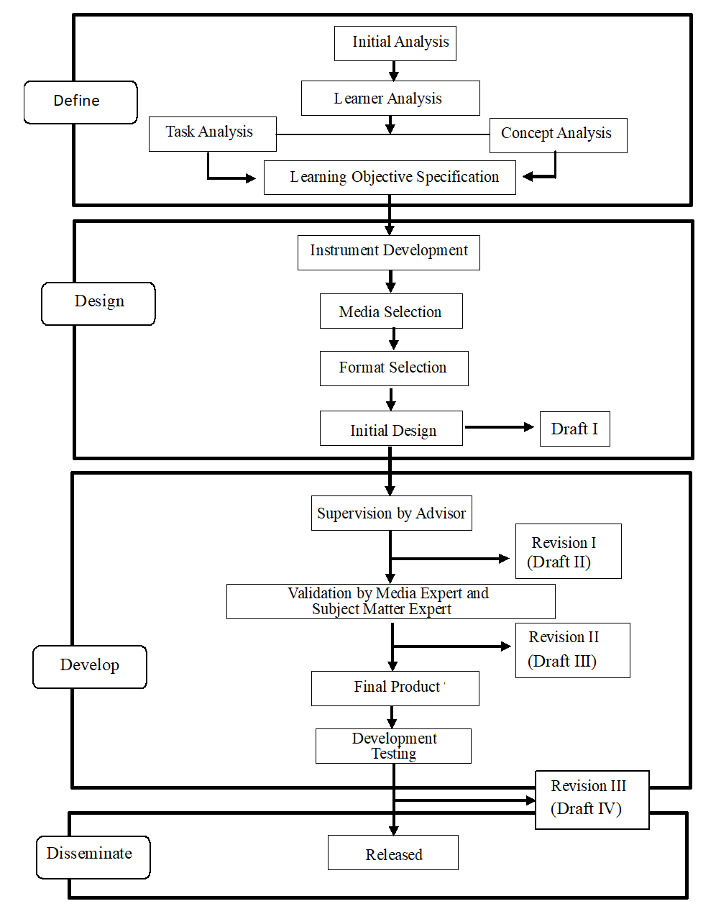

**Figure 1.** Diagram of the Steps in the Development Research of LKPD

**Materials Top of Form**

**Bottom of Form**

The primary material used in this research is the Problem-Based Learning (PBL) Student Worksheets (LKPD). Additional materials include validation sheets for validators, questionnaires to measure the practicality and validity of the LKPD, and test questions designed to assess students' mathematical literacy skills. These materials are crucial for the development and evaluation of the LKPD, ensuring that the worksheets are both effective and practical for use in educational settings (Sugiyono, 2011: 333).

**Sample Preparation**

The sample preparation in this study involves several critical stages to ensure a thorough and systematic approach. Initially, a preliminary analysis is conducted to gather comprehensive information about mathematics learning activities at SMAN 1 Lingsar. This step is essential to identify the fundamental problems in mathematics learning, which serve as the basis for developing the LKPD. Following this, a student analysis is performed to examine the characteristics of the students, including their mathematical literacy skills. This analysis is pivotal in determining the appropriate learning model tailored to the students' needs.

Subsequently, a task analysis is undertaken to review the content and competencies required to be achieved in the learning process. The preparation of the LKPD is guided by the Core Competencies (KI) and Basic Competencies (KD) of the 2013 Curriculum, ensuring alignment with national educational standards. A concept analysis is also conducted to identify the essential concepts that students need to master through the learning process using the developed LKPD. This stage includes analyzing other relevant concepts that support the learning objectives.

An analysis of learning objectives is performed to define the specific learning goals that align with the studied material. These objectives are then integrated into the LKPD content, ensuring that the worksheets are designed to meet the targeted educational outcomes (Santi et al., 2022).

**Design Experimental Set-up**

The experimental setup begins with the preparation of the Problem-Based Learning (PBL) student worksheets (LKPD) tailored to the class XI material. The development stage of the LKPD involves several steps:

1. LKPD Validation: The designed LKPD is reviewed and discussed with several experts. Validation is conducted by completing validation sheets until a valid and feasible LKPD is obtained.
2. LKPD Revision: If any parts need improvement based on the validator's assessment, revisions are made. The revised LKPD is then returned to the validators for further discussion until it is deemed suitable for trial.
3. Product Trial: The validated LKPD is tested at SMAN 1 Lingsar with class XI students for the 2023/2024 academic year to assess its practicality. The trial aims to determine the effectiveness and ease of use of the PBL-based LKPD.

**Parameters**

The parameters measured in this study include the validity and practicality of the LKPD as well as students' mathematical literacy skills.

1. LKPD Validity: Assessed using validation sheets that cover content, language, and presentation aspects. Validation is conducted by two validators, and the results are analyzed by calculating the average score given by the validators.

The formula in English is written as:



The criteria are as follows:

If , $0<\overline{X}≤1$ then it is categorized as strongly disagree

If , $1<\overline{X}≤2$ then it is categorized as disagree

If , $2<\overline{X}≤3$ then it is categorized as agree

If , $3<\overline{X}≤4$ then it is categorized as strongly agree

1. LKPD Practicality: Measured using practicality questionnaires given to teachers and students. The questionnaire uses a four-point scale: 1) strongly disagree, 2) disagree, 3) agree, 4) strongly agree. Data is analyzed using the classification in Table 1.

**Table 1.** Practicality Categories of LKPD

|  |  |  |
| --- | --- | --- |
| **No.** | **Score** | **Category** |
| 1 | $$0<\overline{X}≤40\%$$ | Very Impractical |
| 2 | $$40<\overline{X}≤60\%$$ | Impractical |
| 3 | $$60<\overline{X}≤80\%$$ | Practical |
| 4 | $$80<\overline{X}≤100\%$$ | Very Practical |

1. Mathematical Literacy Skills: Assessed using test questions included in the LKPD aimed at evaluating students' mathematical literacy.

**Statistical Analysis**

Statistical analysis in this study is conducted to evaluate the validity and practicality of the LKPD as well as the mathematical literacy skills of students. Validity data is analyzed by calculating the average score from the validators to determine the level of validity of the LKPD. Practicality data is analyzed using descriptive analysis, which involves calculating percentages to determine the practicality category of the LKPD based on responses from teachers and students.

For the analysis of mathematical literacy skills, students' test results are quantitatively analyzed to assess the improvement in mathematical literacy skills after using the PBL-based LKPD. The results of this analysis are used to evaluate the effectiveness of the LKPD in enhancing students' mathematical literacy skills.

The instruments used include validation sheets, practicality questionnaires, and test questions. The validation sheet contains assessments of the content, language, and presentation of the LKPD, evaluated by two validators. The practicality questionnaire is given to teachers and students to measure the ease and effectiveness of using the LKPD. The test questions are used to measure students' mathematical literacy skills before and after using the PBL-based LKPD.

**RESULT AND DISCUSSION**

**Development Results of Problem-Based Learning (PBL) Student Worksheets (LKPD) on Polynomial Material for Class XI High School**

The development of Problem-Based Learning (PBL) Student Worksheets (LKPD) on polynomial material for class XI high school utilized the 4-D model developed by (Santi et al., 2022). This model comprises four main stages: Define, Design, Develop, and Disseminate. However, due to time and budget constraints, the Disseminate stage was not carried out in this study, modifying the 4-D model into a 3-D model that only includes the Define, Design, and Develop stages.

In the Define stage, several analyses were conducted to determine the teaching materials to be developed. These analyses included preliminary-final analysis, task analysis, material analysis, and learning objectives analysis. The preliminary-final analysis aimed to collect information about field learning activities and identify basic problems in mathematics learning. Task analysis examined the content and competencies that must be achieved in the learning process, while material analysis and learning objectives analysis helped identify key concepts and formulate specific learning objectives.

The Design stage involved selecting media, choosing a format, and designing the initial LKPD. The selected media was printed teaching materials in the form of PBL-based LKPD on polynomial material, with designs using Canva and material sources from textbooks and the internet. The LKPD format was designed to support an effective learning process, with modules and learning outcomes designed based on learning achievement indicators. The content of this LKPD included solving polynomial problems, arranged to help students understand polynomial concepts through a PBL approach.

The initial pages of the LKPD include a cover page (Figure 2), which provides a visually appealing introduction to the material.

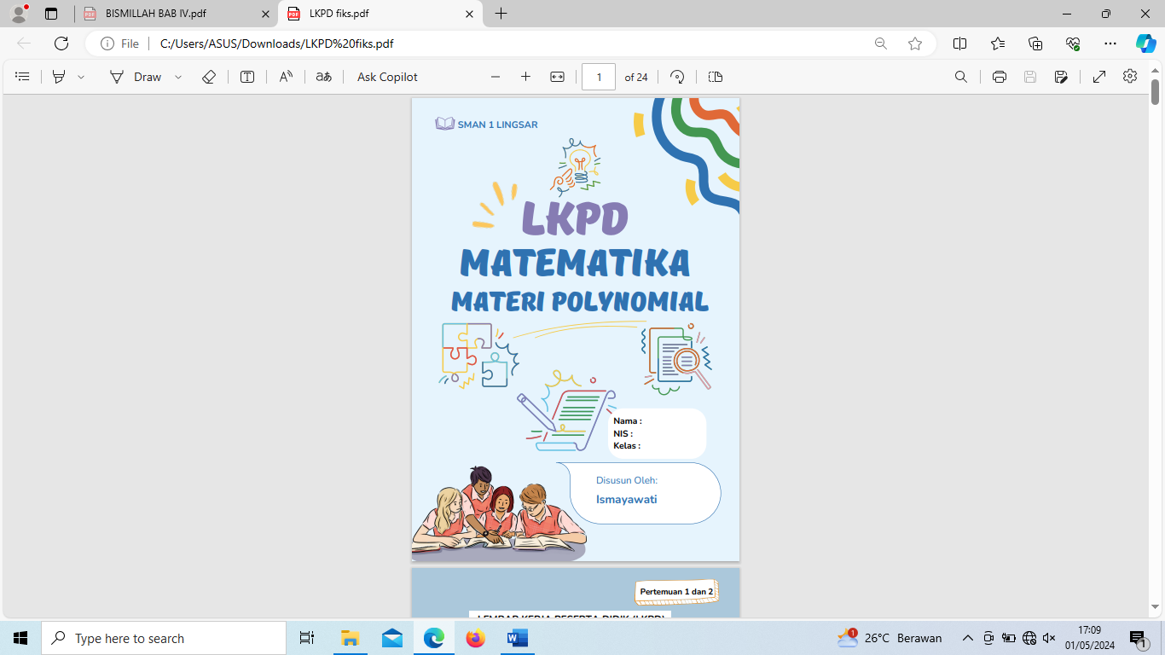

**Figure 2.** Cover Page

Following the cover page, there is a Learning Instructions page (Figure 3). This section guides students on how to use the LKPD effectively, ensuring they can navigate through the materials and activities smoothly.

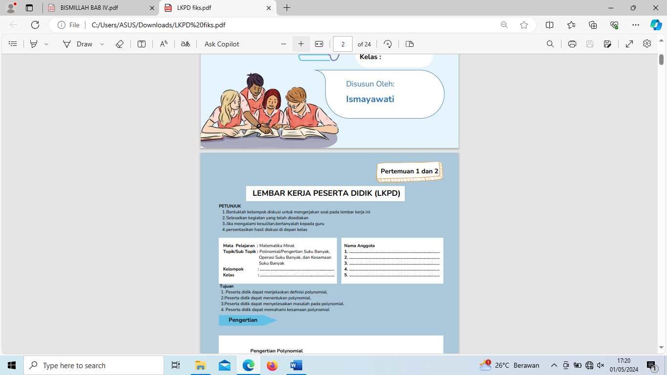

**Figure 3.** Learning Instructions Page

Next is the Competencies to be Achieved page (Figure 4). This section outlines the specific competencies that students are expected to achieve through the use of the LKPD, aligning with the educational standards and learning objectives.

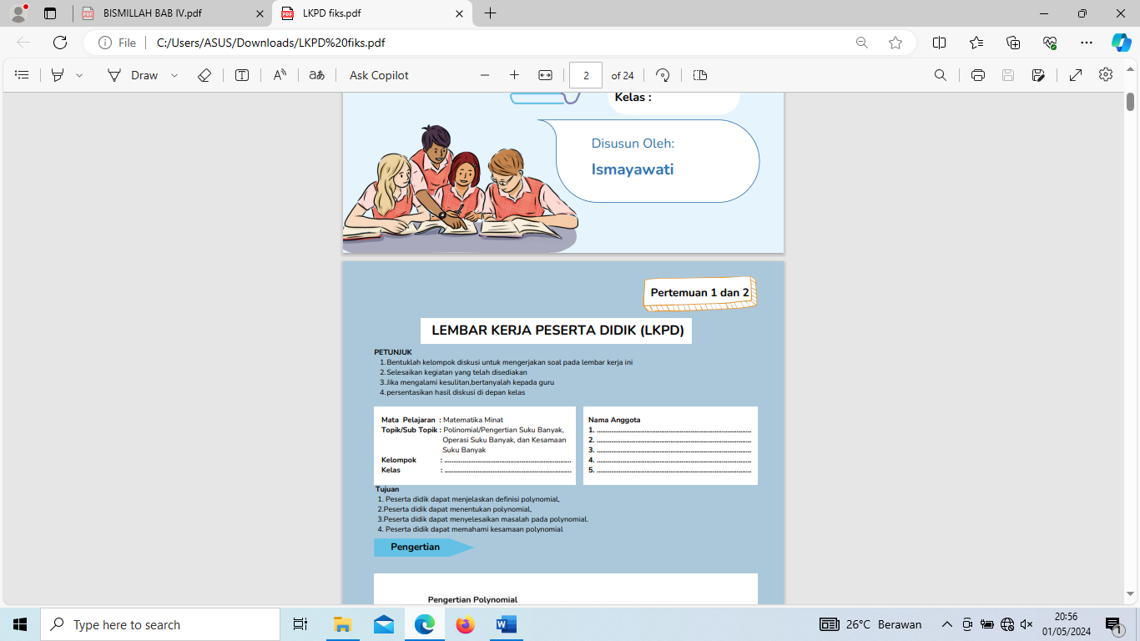

**Figure 4.** Competencies to be Achieved Page

The main content of the LKPD is presented in the Material page (Figure 5). This section covers the polynomial material comprehensively, using clear explanations and examples to facilitate student understanding.

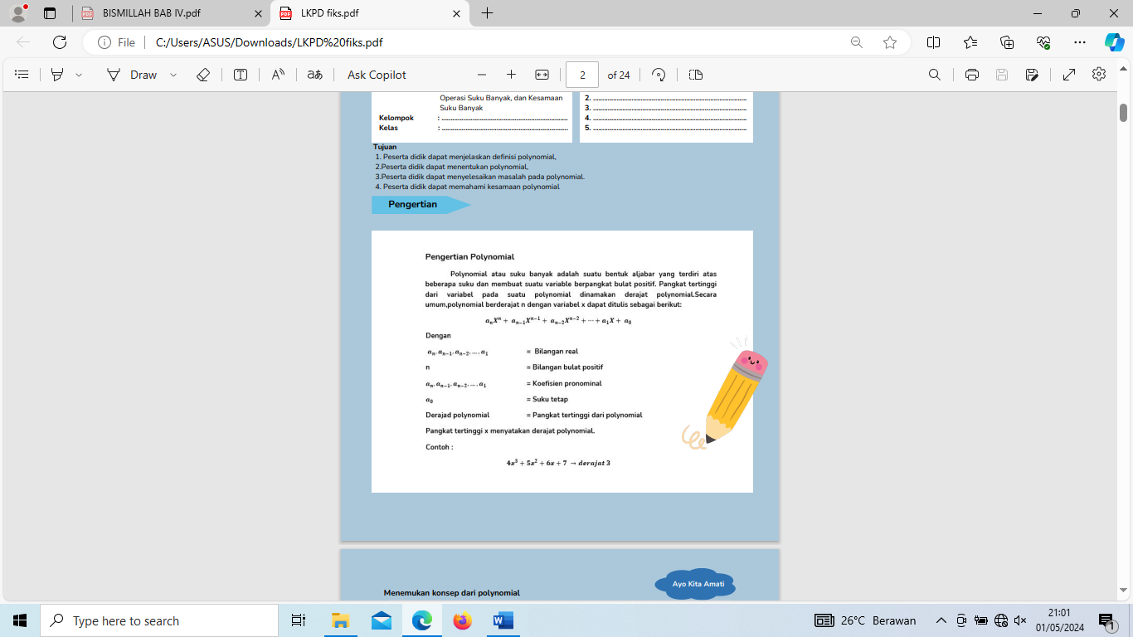

**Figure 5.** Material Page

Finally, the Learning Activities page (Figure 6) includes various activities designed to engage students in problem-solving and critical thinking. These activities are structured to reinforce the concepts covered in the material section and to apply the PBL approach effectively.

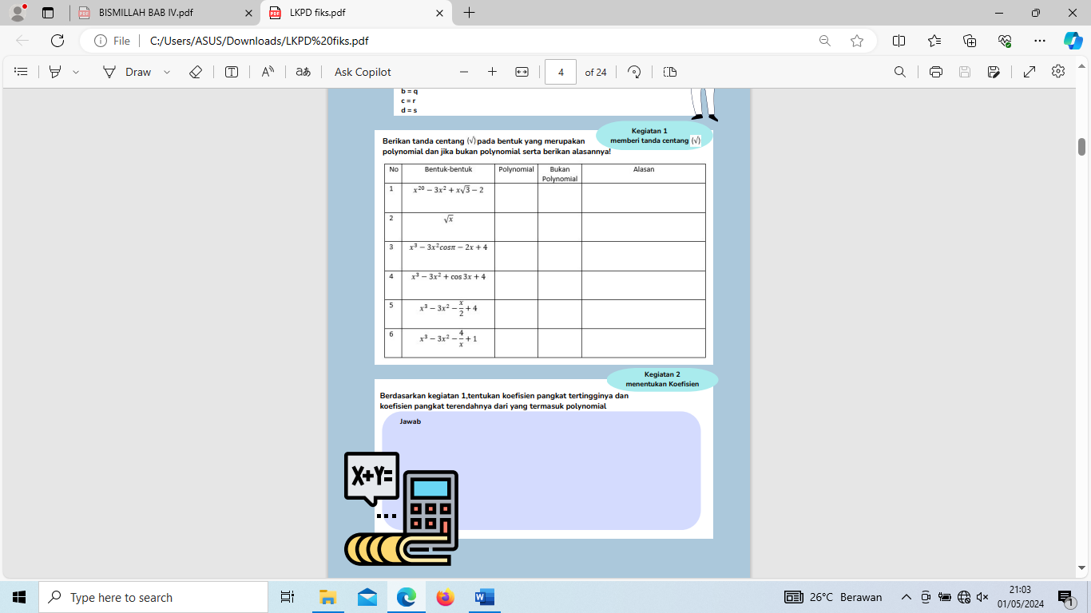

**Figure 6.** Learning Activities Page

**Importance of Findings and Scientific and Practical Implications**

The findings of this study have important implications both scientifically and practically. Scientifically, the development of PBL-based LKPD on polynomial material demonstrates that this approach is not only valid and practical but also effective in enhancing students' mathematical literacy. This is consistent with the theory proposed by Nieveen (1999) that teaching materials considered practical by educators and students, and aligned with the researcher's plan, can be deemed successful. The use of the modified 4-D model into 3-D in this context underscores the model's flexibility and sustainability in various educational settings.

Practically, the developed PBL-based LKPD can serve as an effective tool in mathematics learning for class XI. The conducted trials indicated that this LKPD is easy to use and understand by students, and it aligns with the established learning plans. The success of the trials without requiring revisions shows that this LKPD is ready for broader implementation in other schools, with the potential to enhance the overall quality of mathematics learning.

Furthermore, these findings provide a foundation for further development of PBL-based teaching materials in other subjects and different educational levels. This approach can help facilitate more interactive and meaningful learning, thereby improving students' overall learning outcomes. This study also highlights the importance of using engaging media and formats, such as Canva, in designing teaching materials to increase students' interest and engagement in the learning process.

In conclusion, the development of this PBL-based LKPD not only enriches the literature on innovative approaches in mathematics education but also provides a practical tool that educators can use to enhance students' mathematical literacy. These findings support the use of the 4-D (with modifications) approach as an effective framework for developing teaching materials and show great potential for wider application in various educational contexts.

**Description of Findings**

The research results show that the PBL-based LKPD on polynomial material for class XI high school meets the criteria of validity, practicality, and effectiveness. Based on the evaluation by the validator team, this LKPD was deemed valid with a score of 80% from the subject matter expert and 90% from the media expert. This validation covered aspects of content accuracy, coverage precision, teaching material thoroughness, language, simplicity, integration, balance, form, color, and PBL components. This indicates that the LKPD has good content quality and presentation that meet learning needs.

The practicality trial conducted with a small group showed very positive results. The questionnaire given to mathematics educators received a score of 97%, indicating that this LKPD is highly practical and easy to use in learning. Responses from students were also very positive, with an average score of 3.4 or 97%, showing that this LKPD is easy to understand, provides knowledge, and increases students' motivation and interest in learning.

**Comparison and Contrast with Literature Data**

The development results of this PBL-based LKPD align with previous research showing the effectiveness of the 4-D model in various educational contexts. For instance, (Fahreza et al., 2022) used the 4-D model in developing E-Comic learning media for elementary school mathematics, demonstrating that this approach can produce practical and valid teaching materials. Similarly, (Erdisna et al., 2022) applied the 4-D model in developing a digital entrepreneurship learning model for millennials in higher education, emphasizing the model's flexibility and relevance in contemporary education.

Moreover, research by (Erita et al., 2022) on developing Problem Solving-based LKPD for Optics material in class XI showed that teaching materials developed with similar methods could significantly improve students' understanding and skills. Research by (Marpaung et al., 2024) also supports these findings, where the use of LKPD with a realistic mathematics education approach improved students' problem-solving abilities and self-efficacy. (Setiyani et al., 2023) and (Trinanda et al., 2024) emphasized the importance of innovative teaching materials such as POE and RME-based LKPD to enhance students' mathematical representation skills and literacy.

This research adds evidence that the PBL approach in developing LKPD can enhance students' mathematical literacy, consistent with previous research findings showing the effectiveness of innovative approaches in mathematics education. The modified 4-D model into 3-D also proved to be practical and effective in producing teaching materials that can be implemented in the field without significant revisions.

**Importance of Findings and Scientific and Practical Implications**

The findings of this research have important implications both scientifically and practically. Scientifically, this research reinforces the theory that valid, practical, and effective teaching materials can improve the quality of learning and student outcomes. This is consistent with the theory proposed by Nieveen (1999), stating that an educational product is considered good if it meets the criteria of validity, practicality, and effectiveness. Thus, the development of this PBL-based LKPD is not only valid and practical but also effective in enhancing students' mathematical literacy.

Practically, the developed PBL-based LKPD can be used as an effective learning tool in class XI high school. The conducted trials showed that this LKPD is easy to use and understand by students and aligns with the established learning plans. The success of the trials without requiring revisions indicates that this LKPD is ready for broader implementation in other schools, with the potential to enhance the overall quality of mathematics learning.

Furthermore, these findings provide a foundation for further development of PBL-based teaching materials in other subjects and different educational levels. This approach can help facilitate more interactive and meaningful learning, thereby improving students' overall learning outcomes. This study also highlights the importance of using engaging media and formats, such as Canva, in designing teaching materials to increase students' interest and engagement in the learning process.

In conclusion, the development of this PBL-based LKPD not only enriches the literature on innovative approaches in mathematics education but also provides a practical tool that educators can use to enhance students' mathematical literacy. These findings support the use of the 4-D (with modifications) approach as an effective framework for developing teaching materials and show great potential for wider application in various educational contexts.

**CONCLUSION AND SUGGESTIONS**

This study aimed to develop and evaluate Problem-Based Learning (PBL)-based Student Worksheets (LKPD) on polynomial material for class XI high school students. The findings indicate that the developed LKPD meets the criteria of validity, practicality, and effectiveness. Validation scores were 80% from content experts and 90% from media experts, covering aspects such as content accuracy, language, simplicity, integration, and PBL components.

The practicality trial, involving a small group of students and mathematics educators, showed very positive results. Educators gave a score of 97%, and student responses averaged at 97%, indicating that the LKPD is easy to understand, provides substantial knowledge, and increases student motivation and interest in learning.

These results support the theory that valid, practical, and effective teaching materials enhance the quality of learning and student outcomes. Scientifically, this study demonstrates that PBL-based LKPD is an effective tool for improving students' mathematical literacy. Practically, the developed worksheets are ready for broader implementation in other schools, showing potential for improving mathematics education quality.

Furthermore, this research emphasizes the importance of engaging media and formats, like Canva, in designing teaching materials to boost student interest and engagement. Overall, the development of this PBL-based LKPD enriches the literature on innovative mathematics education approaches and provides a practical tool for educators to enhance students' mathematical literacy.

**REFERENCES**

Amelia, I., Syamsuri, S., Santosa, C. A. H. F., & Fatah, A. (2022). Meta analisis: pengaruh model pembelajaran terhadap kemampuan literasi matematis siswa. Jurnal Cendekia : Jurnal Pendidikan Matematika, 6(2), 1720–1730. https://doi.org/10.31004/cendekia.v6i2.1410

Ate, D., & Lede, Y. K. (2022). Analisis Kemampuan Siswa Kelas VIII dalam Menyelesaikan Soal Literasi Numerasi. Jurnal Cendikia : Jurnal Pendidikan Matematika, 06(01), 472–483.

Effendi, R., Herpratiwi, H., & Sutiarso, S. (2021). Pengembangan LKPD matematika berbasis problem based learning di sekolah dasar. Jurnal Basicedu, 5(2), 920–929. https://doi.org/10.31004/basicedu.v5i2.846

Erdisna, E., Ridwan, M., & Syahputra, H. (2022). Developing Digital Entrepreneurship Learning Model: 4-D Competencies-Based for Millennial Generation in Higher Education. Utamax : Journal of Ultimate Research and Trends in Education, 4(2), 84–100. https://doi.org/10.31849/utamax.v4i2.10081

Erita, S., Utami, E. S. D., & Ningsih, F. (2022). Realistic Mathematic Education-Based Student Worksheet to Improve Students’ Mathematical Reasoning on Circle Material. Indonesian Journal of Science and Mathematics Education, 5(2), 210–223. https://doi.org/10.24042/ijsme.v5i2.11249

Fahreza, V., Sumilat, J. M., Anggraheni, D., Wayansari, C., & Leonard, L. (2022). The Development of E-Comic Learning Media for Elementary School Mathematics

Learning. Formatif: Jurnal Ilmiah Pendidikan MIPA, 12(2), 223–236. https://doi.org/10.30998/formatif.v12i2.14238

Marpaung, I., Arnita, A., & Fauzi, K. M. A. (2024). Development of Student Worksheets Based on a Realistic Mathematics Learning Approach to Improve Problem Solving Ability and Self-Efficacy. https://doi.org/10.4108/eai.2-11-2023.2343263

Nieveen,N.(1999).Design Approaches and Tools in Education and Training:Prototyping to Reach Product Quality.Springer-Science+Bussines Media,B.V

Nusantara, D. A., Pendidikan, J., Vol, B., & Arrahmaniyah, O. S. (2023). Research And Development ( R & D ) Penelitian Yang Inovatif Dalam Pendidikan. 1(1).

Pristiwanti, D., Badariah, B., Hidayat, S., & Dewi, R. S. (2022). Pengertian pendidikan. Jurnal Pendidikan Dan Konseling, 4(6), 7911–7915.

Sadulloh.(2014).PEDAGOGIK (Ilmu Mendidik).Bandung:Alfabeta,cv

Santi, I., Hutapea, N. M., & Murni, A. (2022). Pengembangan perangkat pembelajaran matematika model Problem based learning (PBL) untuk memfasilitasi kemampuan pemecahan masalah matematis peserta didik kelas x jurusan Otomotif SMK. Jurnal Cendekia : Jurnal Pendidikan Matematika, 6(2), 1584–1602. https://doi.org/10.31004/cendekia.v6i2.1178

Sari, L. S., Studi, P., Matematika, P., Sarjanawiyata, U., & Yogyakarta, T. (2013). Pengaruh pendekatan saintifik terhadap prestasi belajar matematika ditinjau dari keaktifan siswa. 2007, 814–820.

Setiyani, E. N., Baharin, Z. H. Z., & Jesse, S. N. (2023). Development of POE-Based Student Worksheets (Predict, Observe, And Explain) for Students’ Mathematical Representation Abilities. Journal of Educational Technology and Learning Creativity, 1(2), 78–87. https://doi.org/10.37251/jetlc.v1i2.792

Trinanda, B., Sari, N., Sukmaningthias, N., & Simarmata, R. H. (2024). Mathematical Literacy Skills By Using Realistic Mathematics Education-Based Worksheets. Prima: Jurnal Pendidikan Matematika, 8(1), 206. https://doi.org/10.31000/prima.v8i1.7210

Wati, I. M., Nofriyadi, R., & Karmelia, N. A. (2022). Efektivitas pembelajaran pbl dan saintifik rme terhadap peningkatan kemampuan literasi matematika siswa. Prosiding Seminar Nasional Pendidikan Matematika IV (Sandika IV), 4(1), 229–237.

Wibowo, A. I., Muhtarom, & Harun, L. (2022). Efektivitas Model Pembelajaran Problem Based Learning ( PBL ) Dan Discovery Learning Terhadap Kemampuan Numerasi Siswa Kelas VII SMP Islam Sultan Agung 1 Semarang. Jurnal Matematika Dan Pendidikan Matematika, 4(6), 539–548.