**AHLI MATERI**

|  |  |  |  |  |  |  |  |
| --- | --- | --- | --- | --- | --- | --- | --- |
| **Aspek** | **No** | **Validator**  **1** | **Validator**  **2** | **Validator**  **3** | **Jumlah skor setiap aspek** | **Jumlah skor yang diperoleh** | **Skor maksimal** |
| Kelayakan Isi | 1 | 4 | 5 | 5 | 14 | 101 | 120 |
| 2 | 5 | 5 | 4 | 14 |
| 3 | 5 | 4 | 4 | 13 |
| 4 | 4 | 4 | 4 | 12 |
| 5 | 4 | 4 | 4 | 12 |
| 6 | 4 | 4 | 4 | 12 |
| 7 | 4 | 4 | 4 | 12 |
| 8 | 3 | 5 | 4 | 12 |
| Kelayakan Penyajian | 9 | 4 | 5 | 4 | 14 | 113 | 135 |
| 10 | 4 | 5 | 4 | 13 |
| 11 | 4 | 4 | 4 | 12 |
| 12 | 4 | 4 | 4 | 12 |
| 13 | 4 | 4 | 4 | 12 |
| 14 | 4 | 5 | 4 | 13 |
| 15 | 4 | 5 | 4 | 13 |
| 16 | 3 | 5 | 4 | 12 |
| 17 | 3 | 5 | 4 | 12 |
| Pemecahan Masalah (*Problem Solving*) | 18 | 4 | 5 | 4 | 13 | 79 | 90 |
| 19 | 5 | 5 | 4 | 14 |
| 20 | 4 | 5 | 4 | 13 |
| 21 | 4 | 5 | 4 | 13 |
| 22 | 4 | 5 | 4 | 13 |
| 23 | 4 | 5 | 4 | 13 |

|  |  |  |  |  |
| --- | --- | --- | --- | --- |
| **Aspek** | **Jumlah skor yang diperoleh** | **Skor maksimal** | **Persentase** | **Kategori** |
| Kelayakan Isi | 101 | 120 | 84,16% | Sangat Baik |
| Kelayakan Penyajian | 113 | 135 | 83,7% | Sangat Baik |
| Pemecahan Masalah (*Problem Solving*) | 79 | 90 | 87,7% | Sangat Baik |
| Persentase rata-rata | | | 85,18% | Sangat Baik |

**AHLI MEDIA**

|  |  |  |  |  |  |  |  |
| --- | --- | --- | --- | --- | --- | --- | --- |
| **Aspek** | **No** | **Validator**  **1** | **Validator**  **2** | **Validator**  **3** | **Jumlah skor setiap aspek** | **Jumlah skor yang diperoleh** | **Skor maksimal** |
| Kelayakan Kegrafikan | 1 | 5 | 4 | 5 | 14 | 139 | 165 |
| 2 | 4 | 4 | 4 | 12 |
| 3 | 4 | 4 | 4 | 12 |
| 4 | 4 | 4 | 4 | 12 |
| 5 | 4 | 3 | 5 | 12 |
| 6 | 4 | 4 | 4 | 12 |
| 7 | 4 | 4 | 5 | 13 |
| 8 | 4 | 4 | 4 | 12 |
| 9 | 5 | 4 | 5 | 14 |
| 10 | 4 | 5 | 5 | 14 |
| 11 | 4 | 4 | 4 | 12 |
| Kelayakan Media Elektronik | 12 | 4 | 5 | 5 | 14 | 53 | 60 |
| 13 | 4 | 5 | 5 | 14 |
| 14 | 4 | 4 | 5 | 13 |
| 15 | 4 | 4 | 4 | 12 |

|  |  |  |  |  |
| --- | --- | --- | --- | --- |
| **Aspek** | **Jumlah skor yang diperoleh** | **Skor maksimal** | **Persentase** | **Kategori** |
| Kelayakan Kegrafikan | 139 | 165 | 84,24% | Sangat Baik |
| Kelayakan Media Elektronik | 53 | 60 | 88,33% | Sangat Baik |
| Persentase rata-rata | | | 86,28% | Sangat Baik |

**ANGKET RESPON GURU**

|  |  |  |  |  |  |  |
| --- | --- | --- | --- | --- | --- | --- |
| **Aspek** | **No** | **Jumlah skor setiap aspek** | **Jumlah skor yang diperoleh** | **Skor maksimal** | **Persentase** | **Kategori** |
| Aspek Tampilan | 1 | 5 | 20 | 20 | 100% | Sangat Baik |
| 2 | 5 |
| 3 | 5 |
| 10 | 5 |
| Aspek Kegunaan | 4 | 4 | 4 | 5 | 80% | Sangat Baik |
| Aspek Isi Materi dan Kurikulum | 6 | 5 | 20 | 20 | 100% | Sangat Baik |
| 7 | 5 |
| 8 | 5 |
| 9 | 5 |
| Aspek Penyajian | 5 | 5 | 28 | 30 | 93,3% | Sangat Baik |
| 11 | 5 |
| 12 | 4 |
| 13 | 4 |
| 14 | 5 |
| 15 | 5 |
| Persentase rata - rata | | | | | 93,32% | Sangat Baik |

|  |  |  |  |  |
| --- | --- | --- | --- | --- |
| **Aspek** | **Jumlah skor yang diperoleh** | **Skor maksimal** | **Persentase** | **Kategori** |
| Tampilan | 20 | 20 | 100% | Sangat Baik |
| Kegunaan | 4 | 5 | 80% | Sangat Baik |
| Isi Materi dan Kurikulum | 20 | 20 | 100% | Sangat Baik |
| Penyajian | 28 | 30 | 93,3% | Sangat Baik |
| Persentase rata-rata | | | 93,32% | Sangat Baik |

**ANGKET RESPON PESERTA DIDIK**

|  |  |  |  |  |  |  |  |  |  |
| --- | --- | --- | --- | --- | --- | --- | --- | --- | --- |
| **No** | **Skor** | **No** | **Skor** | **No** | **Skor** | **No** | **Skor** | **No** | **Skor** |
| 1. | 162 | 6. | 156 | 11. | 156 | 16 | 164 | 21. | 166 |
| 2. | 150 | 7. | 165 | 12. | 162 | 17. | 159 | 22. | 166 |
| 3. | 163 | 8. | 164 | 13. | 157 | 18. | 158 | 23. | 165 |
| 4. | 167 | 9. | 158 | 14. | 161 | 19 | 161 | 24. | 162 |
| 5. | 165 | 10. | 154 | 15. | 155 | 20. | 156 | 25. | 165 |

|  |  |  |  |  |
| --- | --- | --- | --- | --- |
| **Aspek** | **Jumlah skor yang diperoleh** | **Skor maksimal** | **Persentase** | **Kategori** |
| Tampilan | 1.450 | 1.575 | 92,06% | Sangat Baik |
| Penyajian Materi | 1.426 | 1.575 | 90,53% | Sangat Baik |
| Manfaat | 1.141 | 1.225 | 93,14% | Sangat Baik |
| Persentase rata – rata | | | 91,91% | Sangat Baik |

**HASIL TES EVALUASI SISWA**

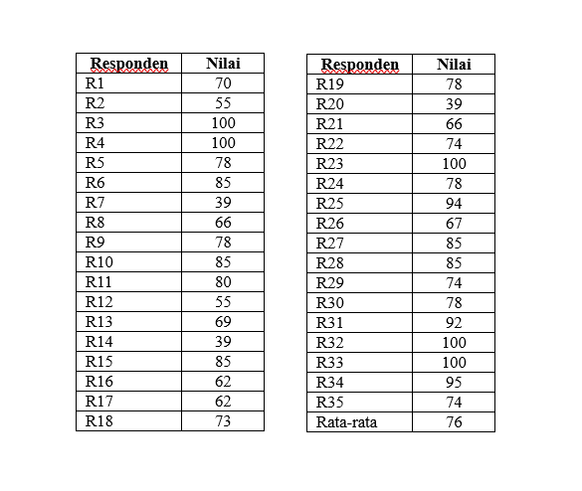

Persentase ketuntasan = $\frac{T}{N}$ x 100%

= $\frac{30}{35}$ x 100%

= 0,857 x 100%

= 85,7%