**CRITICAL THINKING OF JUNIOR HIGH SCHOOL STUDENTS IN USING DICTIONARY SPEECH ASSISTANT**

**Senowarsito1, Agnesia Stefanny Susanto2, Sukma Nur Ardini3**

1,2,3 English Language Education Study Program, Faculty of Languagesand Arts Education Universitas PGRI Semarang, Semarang City, Indonesia

Corresponding Author Email: [senowarsito@upgris.ac.id](mailto:senowarsito@upgris.ac.id)

| ***Article Info*** | **Abstract** |
| --- | --- |
| ***Article History***  *Received:*  *Revised:*  *Published:*  *……………………………….*  ***Keywords***  *critical thinking;*  *dictionary speech assistant; EFL learners; Junior High School* | *Dictionary speech assistant, particularly in language acquisition, provides both benefits and obstacles in directing students' outputs towards learning objectives. In the current study, the researchers investigated the use of dictionary speech assistant as learning aids to help students enhancing their pronunciation ability in English language acquisition as well as explored how was the flow of thinking when the students revised their pronunciation. An explanatory sequential mixed-method design was utilised to collect quantitative and qualitative data. The data gained from pre-test, post-test, and documentation of dictionary speech assistant by pronouncing single words and phrases/sentences which were collected from 34 students of SMA N 6 Semarang. Then, they were analyzed using SPSS program quantitatively and descriptive qualitative. The quantitative result outlined that there was significant difference on students’ pronunciation skill with t-test value was higher than t-table (9.117 > 2.035). The qualitative findings obtained that the students’ critical thinking in imitating the tool made them able to gain a significant improvement. Overall, the result showed that dictionary speech assistant effectively improves the students’ pronunciation ability. The main factor affecting this improvement was the students’ interest in teaching learning process involving Dictionary Speech Assistant. The researchers concluded that dictionary speech assistant is beneficial for students in learning pronunciation.* |
|  |  |
| **How to cite :**Last name (2024). Title. JOLLT Journal of Languages and Language Teaching, Volume(Issue), pp. Page-Page. DOI: [Insert DOI here if available] | |

**INTRODUCTION**

Learning is a fundamental part of life. Throughout the learning process, the instructor must successfully instruct the children. It is considered that teaching students how to reflect on their own learning process can help them learn more effectively (Liaw, 2007). Speaking is a crucial part of the language acquisition process. To guarantee that the information is transmitted to the audience, students must acquire English skills such as speaking and generating words correctly (Kholis, 2021). According to Bafadal and Muslimin (2020), speaking is an oral communication in which participants must negotiate meaning within a limited set of ideas, feelings, and facts, as well as establish who is to what, to whom, and about what. However, many students have difficulty pronouncing words. According to Aratusa (2019), students learning English as a foreign language find it difficult to enunciate an English sound, especially when the instructor is not a native speaker, and failing to properly pronounce an English sound might lead to a misunderstanding of meaning. Furthermore, as Samad and Ismail (2020) mentioned, there are several accents or dialects in Indonesia based on area. The bulk of Indonesian students' pronunciation will be impacted by their dialect, making it difficult for them to properly speak their foreign language. Some of them struggle with pronunciation owing to influences from their mother tongue, place of birth, and wider culture. As we all know, pronunciation is increasingly important in communication. Pronunciation is the process of generating sounds from words in order to communicate with people and convey meaning. Pronunciation features including intonation, vocal point, and pausing are "discourse signals" that help listeners understand the flow of the speech (Tussa'adah, 2018). As a result, communicating without pronunciation is insufficient to avoid misinterpretation and misunderstanding.

Globalisation has resulted in extensive cultural, political, economic, technological, scientific, and information interaction, which is frequently mediated by translators and interpreters. As a result, there is a greater demand for well-trained linguists who can effectively communicate a message from one language to another, whether written or spoken (Simon et al., 2015). Over decades, the innovator discovered a technology in language learning. This technology is used to help students learn a second or foreign language. Nowadays, technology is widely used in people's lives for a variety of reasons, including virtual interaction, product and service transfer, business transactions, commercial occupations, and even education (Kholis, 2021). It is time for the educational industry to properly adapt to changing teaching and learning practices.

Examples of educational technology include LMS (Learning Management System), Google Apps for Education, and AI (Artificial Intelligence). AI is defined as a machine, computer, or computer system that mimics human cognitive abilities such as learning and problem solving (Pokrivcakova, 2019).One of the example of AI in English learning is called ELSA SPEAK. The acronym ELSA stands for English Language Speech Assistant. This innovation allowed students to analyse their language error correction and receive direct feedback from ASR (Automatic Speech Recognition), which has the potential to provide students with additional motivation and opportunities to engage in spoken conversation in the target language. Dictionary Speech Assistant was combined with the RLR (Record, Listen, Revise) method to help students improve their pronunciation skills. This method was linked to an AI system that would allow students to replay their recording of the words and repair it if errors occurred. It emphasises the concept that AI has the potential to be equally revolutionary for society. AI is set to fundamentally alter how we work, live, and interact with the world. Technology has had an impact on how we engage with language and communication, including pronunciation (Senowarsito & Ardini, 2023).

On the other hand, critical thinking is an essential skill for students to develop in academic language (Connolly, 2000; Davidson, 1998; Davidson & Dunham, 1997). Theorists and educators have presented a range of definitions for critical thinking. At least three educators in the field of second language acquisition (SLA) have characterised the critical thinking abilities required for academic/professional employment (Pally, 2000). English for Academic Purposes (EAP) emphasises students' ability to achieve English language competency in cause and effect, description, classification, and differentiation, particularly for comparison and contrast.

While critical thinking is necessary in L2 classrooms, EFL learners may also engage in it. In reality, EFL students typically arrive in L2 classes with a diverse set of critical thinking abilities gained in their first language. Many students are capable of and require critical thinking in their second language. Since higher-order thinking abilities are becoming increasingly important for success in a knowledge-based society, it is the role of EFL teachers to help their students develop critical thinking skills while studying English.

Since language development and thinking are inextricably linked, and the teaching of higher-order thinking abilities should be an essential component of an L2 curriculum, this study was conceived and carried out to investigate the possibility of boosting critical thinking skills in an EFL classroom. Taking into account the previous context, the aims of this study were to investigate the use of dictionary speech assistant as learning aids to help students enhancing their pronunciation ability in English language acquisition as well as explore how was the flow of thinking when the students revised their pronunciation.

**LITERATURE REVIEW**

**2.1 Mobile-Assisted Language Learning**

Mobile learning, also known as M-learning, began as an extension of e-learning using mobile computational devices such as personal digital assistants (PDAs) and mobile phones. It was identified as a subset of distant learning, alongside e-learning (Cakmak, 2019). In other words, mobile learning is the use of mobile technology to improve the learning process, which includes delivering digitalized information to wireless phones that are linked to work and education. M-learning is currently accessible on a variety of mobile devices, including PDAs, mobile phones, small tablets, MP3/MP4 players, e-book readers, integrated circuit recorders, gaming consoles, digital dictionaries, voice recorders, and so on.

With the advancement of mobile devices and the availability of internet and telecommunication technologies, there has been a growing interest in participating in language learning in a more flexible setting. This approach is known as mobile-assisted language learning (MALL). MALL evolved from Computer-Assisted Language Learning (CALL) and Mobile Learning (Cakmak 2019). Language learning via mobile devices may be more real, relevant, and contextual when two strategies are used in conjunction.According to Naninggia (2017), mobile learning has three purposes in the classroom learning process: supplements, complements, and substitutes.

**2.2 Dictionary Menu as Speech Assistant**

The ELSA Speak Application offers more lessons and subjects for users to practice pronunciation, beginning with English words, phrases, and sentences. An interactive dictionary is one of the features of the ELSA Speak Application that will assist users in pronouncing the word or phrase they are looking for (Anggraini, 2022). To try this feature, opens the ELSA Speak program, then select Dictionary under Discover. In order to begin the recording, locate a blue microphone and click. Ask the students to read the sentences after that. Then click "See My Score" to view the outcomes. The instructional materials utilized in the teaching and learning process should be in line with contemporary forms of learning as worldwide enters the industrial revolution. Students can practice speaking as though they have listened to the audio straight immediately by clicking the microphone button in ELSA Speak. This program is very useful for all students and is easy to use, which can help us learn how to pronounce words in English. It also features intriguing components that may awaken students' curiosity about what they are learning.

**2.3 Critical Thinking**

Critical thinking is used in all types of knowledge, and it also requires learners to form real bonds in order to gain knowledge via reflection and deep thought (Saleh, 2019). The concept of critical thinking was introduced by John Dewey, who dubbed it "reflective thinking". Reflective thinking is defined as the process of turning a subject over in one's thoughts and giving it meaningful, sequential consideration. According to Shalova (2015), critical thinking encompasses a broad range of cognitive talents (thinking strategies) employed in a variety of academic activities. Thinking critically entails demonstrating interest and employing research procedures that include asking questions, conducting a systematic search for answers, defining a certain point of view on the problem, and being able to defend this perspective using logic and evidence.

**RESEARCH METHOD**

This research utilised an explanatory sequential mixed-method approach, combining quantitative and qualitative approaches. According to Creswell (2012), a mixed-method research design involves combining quantitative and qualitative approaches in a single or series of studies to better understand a research subject. The researchers employed an explanatory sequential design, which could be utilised to collect both quantitative and qualitative data in support of the experimental design. According to Fraenkel and Wallen (2012), the primary purpose of an explanatory sequential design is to collect quantitative data, which will then be followed by qualitative data to fine-tune the conclusions drawn from the quantitative data. In an explanatory sequential mixed method design, researchers collect quantitative data first, then qualitative data to support the quantitative data conclusions. Furthermore, Creswell & Creswell (2018) stated how the researchers' interpretation of this mixed approach led them to interpret the findings in the study's discussion section, which were quantitative in the first phase and qualitative in the second phase.

In this study, the population was the the eighth grade students in SMP N 6 Semarang. The number of students was 272 students. Creswell (2012) defines a sample as a subset of a larger population to be analysed for general conclusions. There was only one group chosen as a sample, class VIII H. The class consists of 34 students. The instruments were divided into single words and phrase/sentence test which were done through pre-test, post-test and documentation taken from the dictionary speech assistant of the students. The researchers analyzed the pronunciation test of single words to determine the students' pronunciation abilities of dictionary as a speech assistant. The analysis was performed by using SPSS 27. After the required data was collected, the researcher analyzed the data to obtain the mean pre-test and post-test scores. The phrase/sentence test was analyzed using qualitative design which was based on students’ critical thinking.

**RESEARCH FINDINGS AND DISCUSSION**

The objectives of this study were to investigate the use of dictionary speech assistant as learning aids to help students enhancing their pronunciation ability in English language acquisition as well as explore how was the flow of thinking when the students revised their pronunciation. Therefore, the researchers displayed two results; the quantitative data and then followed by the qualitative ones.

The quantitative data were obtained from pre-test result of students’ pronunciation test before using dictionary speech assistant, after that the post-test result of students’ pronunciation after using dictionary speech assistant. At last was the significant difference to give evidence about the hypothesis acceptance. The following are the qualitative results and the explanation.

Table 1. The description of students’ pre-test

|  |  |  |  |  |  |
| --- | --- | --- | --- | --- | --- |
| Assessed Components | | | | Total Obtained Score | Total Final Score |
| Fluency | Accuracy | Intonation | Stressing |
| 3.2 | 3.0 | 2.8 | 2.2 | 11.2 | 56 |

In Table 1, the researchers delivered the pre-test to the students before presenting them with any materials or therapy. It was designed to measure the pupils' capacity to grasp pronunciation before they received treatment. This exam assesses multiple components, including fluency, correctness, intonation, and emphasising. The highest pre-test score is 95, while the lowest score is 15. The pre-test result is produced by calculating the students' scores before utilising Dictionary Speech Assistant. It is calculated using the total score, the percentage of students' scores, and the mean of the pretest. The sum of the students' pre-test scores is 1904, calculated from 34 students. The percentage of students that took the pre-test was 56%, indicating that this group of students performed badly.

Table 2. The description of students’ post-test

|  |  |  |  |  |  |
| --- | --- | --- | --- | --- | --- |
| Assessed Components | | | | Total Obtained Score | Total Final Score |
| Fluency | Accuracy | Intonation | Stressing |
| 4.8 | 4.2 | 4.0 | 3.6 | 16.6 | 82.8 |

During this stage, the AI provided the students with useful corrections for mispronounced words and phrases. Afterward, the researcher administered a post-test to assess the students' skills following the treatment. A post-test was also administered to assess the pupils' pronunciation ability achievement. In addition, students were given a traditional pronunciation teaching evaluation using a paper-based pronunciation exam that was tailored to the current topics throughout teaching and learning. The post-test score is shown in Table 2. According to Table 2, the highest post-test score is 98, while the lowest is 62. The post-test result was calculated from the students' scores after utilising Dictionary Speech Assistant. It was determined with the post-test total score, student score percentage, and post-test mean. The total post-test score obtained from 34 students was 2818. The students' score percentage is 82.8%, suggesting that the category of their post-test results after utilising Dictionary Speech Assistant is good.

The second data were the qualitative findings. It was obtained from the documentation taken from the process of the students when they were doing the recording of post-test. The data were in the form of screenshots which then analyzed their critical thinking, as follows.

Figure 1. The process when student explore their critical thinking to be able to achieve excellent score

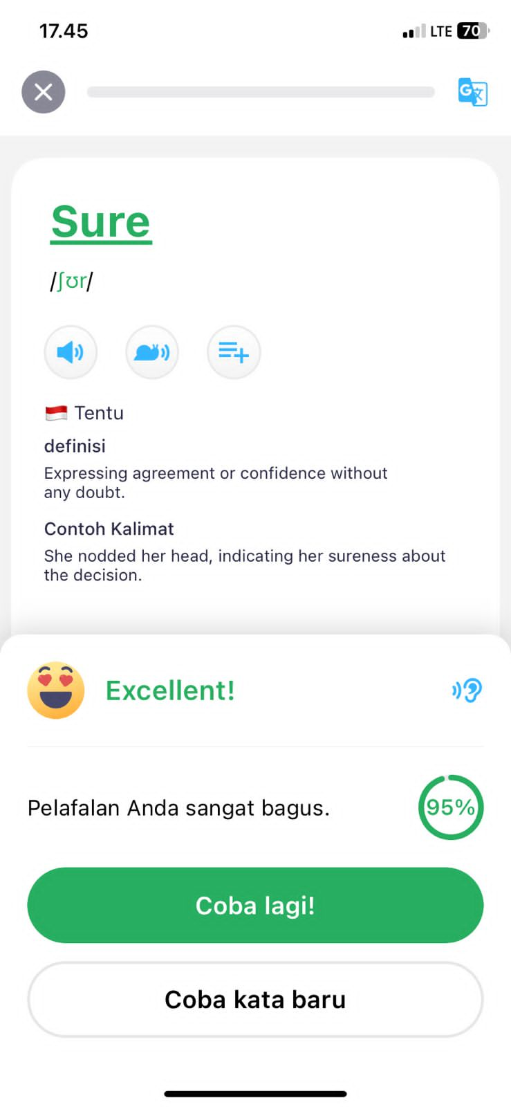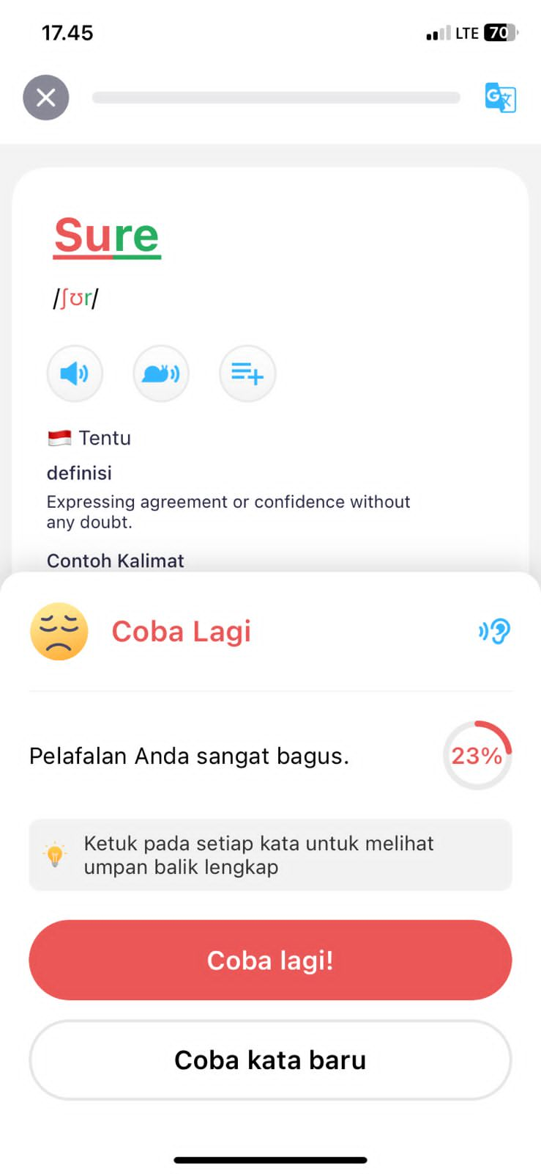

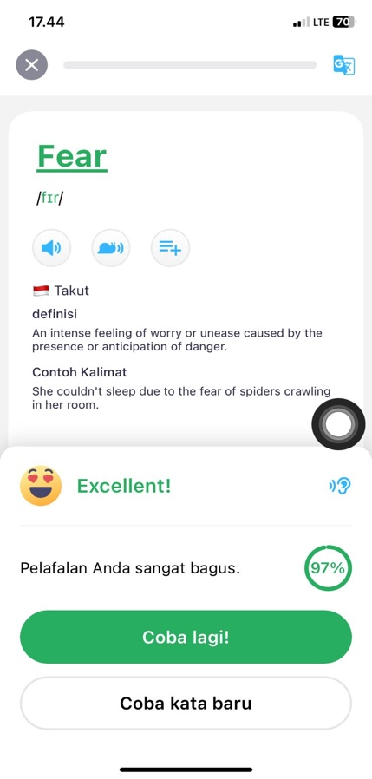

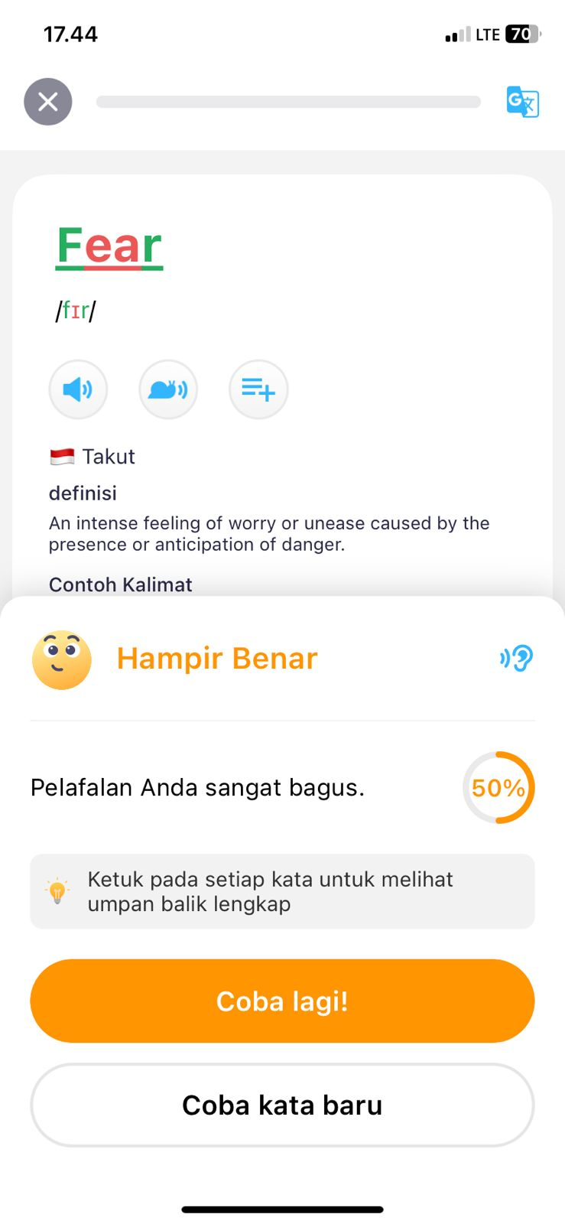

**Discussion**

Pre-test and post-test critical thinking result was done through ELSA application by pronouncing single word and phrases/sentences. The result presents that in the pre-test, most of the students had troubles in pronouncing /ʊə/ and /eɪ/ sounds. It made their score of pre-test was only 70. For examples, in the word ‘fear’ the students pronounced as /fɪr/ which has correct pronunciation /fɪə/. Additionally, in the word ‘sure’, the students pronounced /ʃər/ which has correct pronunciation /ʃʊə/. ‘

However, the students had improvements in the post-test in pronouncing /aʊ/, /ʊə/ and /əʊ/ sounds. Although the respondent still had trouble especially on pronounced /eɪ/ sound. The mean score of student’s post-tests was 96. It indicates that the student’s score was improved 20% after using Dictionary Speech Assistant.

According to those results, it is indicated that the students’ critical thinking of using Dictionary Speech Assistant is this application is instructional and beneficial to improve pronunciation ability. It is also agreed that Dictionary Speech Assistant could improve their learning performance. Besides that, the students liked Dictionary Speech Assistant because it was excellent and interactive learning media. It is because this feature was assisted by AI to detect mispronounced and gave auto correction and feedback of their pronunciation.

Additionally, Dictionary also creates the students to have a new ambience of learning which supports them in improving their learning capacity. This statement also supported by the research from Samad & Ismail (2020) that the features of ELSA Speak Application successful to encourage students’ to involved effectively in pronunciation learning. The combination of technology in the teaching and learning process was a principal in the attempt to improve students’ performance and the effectiveness of teaching pronunciation. By giving the students quizzes through Dictionary Speech Assistant, the researcher would be able to know students’ understanding so that the researcher knew the parts the students could not fully understand.

Another advantages, the ASR system that associated in Dictionary Speech Assistant provided direct feedback to the student’s mistake on pronunciation. Kholis (2021) was pointed this benefit on his research, Automatic Speech Recognition (ASR) to teach pronunciation. It proved that ASR investigated how students heard, voiced, uttered, vocalized, and reiterated English words orally. It means Dictionary Speech Assisted was suitable for  learners in the beginner or intermediate level who needs guidance in learning pronunciation.

**CONCLUSION**

The aims of this study were to find out the results of students’ critical thinking in pronunciation before and after applying Dictionary Speech Assistance. According to the results that have been presented previously, the scores result before applying Dictionary Speech Assistant was found that the score percentage was 56% which means the category of student grades before applying Dictionary Speech Assistant was poor. On the other hand, the score result of students’ score percentage was 82.8% which means the category of student grades after applying Dictionary Speech Assistant was good. Moreover, the results of students’ critical thinking skills revealed that the majority of students responded positively. There are improvements in the post-test. The students tried to fix their error pronunciation to get correct pronunciation. In contrast, the majority of students believed that Dictionary Speech Assistant creates a new environment to help students improve their pronunciation skills. Dictionary Speech Assistant is a new and challenging assessment tool for students that incorporates technology into their learning. These findings may have consequences for the development of 21st-century abilities, which should be integrated in pronunciation competency as soon as feasible. As a result, instructors and students will perceive pronunciation as a tough and intriguing topic, rather than one to be overlooked and undervalued.

**REFERENCES**

Anggraini, (2022). Improving students’ pronunciation skill using ELSA Speak application. *Journal of English Language and Pedagogy*.

Aratusa, Z.C. (2019). Using accent reduction software to improve English beginners’ pronunciation. *188 (Eltlt 2018),* 112-116.

Bafadal, M.F. & Muslimin. (2020). The an analysis of students’ speaking ability on specific purpose learning. *Linguistic and English Language Teaching Journal.* ISSN: 2614-8633.

Cakmak, F. (2019). *Mobile learning and mobile assisted language learning in focus*. Language and Technology Book. Dergi Park Academic.

Connolly, M. (2000). What we think we know about critical thinking. *CELE Journal*, *8*, 120-134.

Creswell, J. (2012). Educational Research: Planning, Conducting, and Evaluating Quantitative and Qualitative Research. <http://nuir.nkumbauniversity.ac.ug/handle/20.500.12383/985>

Creswell, W. J. and, & Creswell, D. J. (2018). Research Design: Qualitative, Quantitative, and Mixed Methods Approaches, 5th Edition: by John W.

Creswell and J. David Creswell, Los Angeles, CA: SAGE, 2018, $38.34, 304pp., ISBN: 978-1506386706: *Journal of Electronic Resources in Medical Libraries*: Vol 19, No 1-2. https://www.tandfonline.com/doi/full/10.1080/15424065.2022.2046231

Davidson, B. (1998). A case for critical thinking in the English language classroom. *TESOL Quarterly*, 32, 119-123.

Davidson, B., & Dunham, R. (1997). Assessing EFL student progress in critical thinking with the Ennis-Weir Critical Thinking Essay Test. *JALT Journal*, 19(1), 43-57.

Edmons, W.A., & Kennedy, T.D. (2016). *An applied guide to research* designs*: Quantitative, qualitative, and mixed methods.* Sage Publications.

Fraenkel, J. R., & Wallen, N. E. (2012). How to Design and Evaluate Research in Education.

Kholis, A. (2021). Elsa Speak App: Automatic Speech Recognition (ASR) for supplementing English pronunciation skills. Pedagogy: *Journal of English Language Teaching*. ISSN 2580-1473.

Liaw, M. L. (2007). Content-based reading and writing for critical thinking skills in an EFL context. *English Teaching and learning*, *31*(2), 45-87.

Naninggia R. (2017). *Attitudes toward using mobile devices in language learning among English Education Department students at Muhammadiyah University of Purwokerto*. (Doctoral dissertation). Universitas Muhammadiyah Purwokerto.

Pally, M. (2000). *Sustained Content Teaching in Academic ESL/EFL: A Practical Approach*. Houghton Mifflin Company, 222 Berkeley Street, Boston, MA 02116-3764.

Pokricakova, S. (2019). Preparing teachers for the application of AI-*powered* technologies in foreign language education*. Journal of Language and Cultural Education,* 7(3), 135-153.

Saleh, S. E. (2019). Critical thinking as a 21st century skill: Conceptions, implementation and challenges in the efl classroom. *European Journal of Foreign Language Teaching, 4*(1), 1–16. doi: 10. 5281/zenodo.2542838

Samad, I.S., & Ismail, I. (2020). ELSA Speak application as a *supporting* media in enhancing students’ pronunciation skill. *Majesty Journal*. 2(2), 1-7.

Senowarsito, S. & Ardini, S.N. (2023). The Use of Artificial Intelligence to Promote Autonomous Pronunciation Learning: Segmental and Suprasegmental Features Perspective. *Indonesian Journal of English Language Teaching and Applied Linguistics*, 8(2), 133-147.

Shalova, N. S. (2015). Critical thinking as a tool for teaching listening in the English classroom at the universities. *Journal of the National Technical University of Ukraine “KPI”: Philology and Educational Studies*, *6*, 100-104.

Simon, S. K. (2015). Strategies for improving the English pronunciation of the 1st year "Translation-interpreting" students. *Procedia - Social and Behavioral Sciences*, 2157-2160.

Tussa’adah, N. (2018). *The correlation between students’ pronunciation mastery and their speaking ability at the first semester of the eleventh grade of SMA N 1 Adung Pekurun Kotabumi North Lampung in the academic year of 2017/2018*. (Doctoral dissertation). UIN Raden Intan Lampung.