**The Correlation Between Undergraduate-Students’ Reading Interest**

**and Their Reading Comprehension**

**1Dewi Fatima Nur Alfatihah, 2Peptia Asrining Tyas**

Faculty of Cultural Studies, Universitas Brawijaya, Indonesia

Co. Author Email: dewifatima@student.ub.ac.id

| ***Article Info*** | **Abstract** |
| --- | --- |
| ***Article History***  *Received:*  *Revised:*  *Published:* | *As an academic component, undergraduate-students have an obligation to read, so that it is driven by the academic life of lectures which require students to have reading comprehension skills. In addition, students' reading interest is also an important factor for students in their reading comprehension. Therefore, this study aims to investigate the correlation of students' reading interest and reading comprehension in higher education levels. This study was conducted through a quantitative approach and correlation study as the method. The population of this research is about 140 students of EFL semester 4 who are active in the English language education study program of Universitas Brawijaya. By using simple random sampling technique, there were 41 students from 4th semester involved as participants in this research. This study was conducted by distributing questionnaires to students who were respondents and reading comprehension tests, after which they were input and analyzed through the SPSS program. The findings of this study indicate that there is a correlation between interest and reading comprehension, with Pearson's product moment (r-value) showing a weak positive correlation.* |
| ***Keywords***  *correlation;*  *reading;*  *students’ interest; comprehension* |
| ***How to cite:*** | |

**INTRODUCTION**

In the education context, processes and ways of learning are closely related (Ama, 2021). One way of learning that is usually done by students is by reading. In learning English, reading is an activity to get information that has an important role as input for students. This idea is supported by Suharti (2012) who states that reading skills are important for obtaining information and mastering the environment. Through reading activities, readers gain new information, knowledge, and ideas by participating in it activities. Reading activities have become one of the literacies needed to face the challenges of the 21st century. This is not an exaggeration, considering that reading is the basic literacy needed in shaping global competencies (Widodo, Indraswati, & Sobri, 2019). When compared to sight or hearing, reading is more challenging. Reading involves the capacity to comprehend a sequence of phrases and then interpret them without assistance from others, and not everyone has the patience to do so (Sudarsana, 2014). In addition, understanding reading comprehension is important since it helps students to learn and develop new knowledge and information in order to attain academic achievement.

Many psychological factors play a role in reading activities, one of them is interest. As a psychological aspect, interest plays an important role in encouraging someone to do work without coercion. As mentioned by Meity & Ramdhani (2015), interest motivates people to participate in activities and directs them to pay attention and give their time to do these activities. Further, Rahim in Musafiri (2016) argued that reading interest is defined as a significant desire to read followed by reading efforts. Someone who has interest in reading will demonstrate this by his willingness to learn the points of reading material and then read it on his own motivation or with external encouragement. Hidi (2001) discovered that students' knowledge structure was connected with deep understanding, memory of important ideas, and higher levels of cognitive organization. Students' reading interest is important to be grown as a source of strong motivation which is closely related to reading comprehension.

In fact, Indonesia is one of the countries with the lowest reading interest in the world. This condition can be seen from several survey results. One of them is a survey and assessment conducted in 2019 by the *Organization for Economic Co-operation and Development* (OECD). Based on the findings from the *Program for International Students Assessment* (PISA), it was found that Indonesian people's literacy rate and reading interest are quite low. The statistics of the 2019 Indonesian people's reading interest survey were ranked 62 out of 70 countries, or were in the bottom 10 countries. This may be a result of the impact of ever-faster technology advancements. In this era of technological development, people prefer things that are fast and instant. Siswati (2010) also explained in her research article that since reading requires a certain concentration that cannot be combined with other activities, various types of entertainment like the use of social media that do not use book media are becoming increasingly attractive to the public along with technological advances. It may be a problem where people's low reading interest can affect the quality of their reading comprehension.

Discussing the problem of reading interest in Indonesia, undergraduate students are a part of the community whose interest in reading is supposed to increase. This is because every college student needs reading skills and comprehension to get the most out of reading resources like books, journals, and other sources that support lecture and academic material (Reflinda, 2017). Other than that, according to Wibawanto (2016), being a student means being ready to be involved in any changes in the environment. One of the change activities can be done by reading the phenomena that are around it and pouring it into written form. It means that being a student must be able to enrich knowledge not only for the purpose of academic activities, but also for the purpose of social change. Siregar stated in a scientific article published by Siswati (2010) that undergraduate students who are a part of the academic component have an obligation to read. It is undeniable that the situation and environmental conditions of the academic community, namely at the university level, require students to deepen their reading and expand their thinking. For students, reading interest not only affects academic success but also how students can channel critical thoughts and solutions that can help in social life in the future. As stated by Supriyono (1998), increasing interest in reading has many benefits. Some of the benefits of reading are increasing self-development, fulfilling intellectual demands, fulfilling the interests of life, increasing interest in certain fields, and knowing the truth. Therefore, further research is needed to investigate further the correlation between students' interest in reading and reading comprehension, especially at the higher education level.

In several studies, the relationship between reading interest and understanding is still an interesting topic to be studied, since those previous studies have different relationship results. Rumaniah (2018) in her study found that there is no relationship between students’ reading interest and reading comprehension. In her research, she argued that there were other factors that further encouraged students' reading comprehension, such as motivation. In contrast to the research findings conducted by Fitria et.al (2019) which focuses on middle school students as research subjects. It was found that there was a significant relationship between students' reading interest and their reading comprehension. Fitria argued that reading interest is one of factors which affects reading comprehension. Students who have a deeper interest in reading have more information and are able to understand the text better. In line with the research conducted by Despita (2020), she found that there is a high correlation between students' reading interest and reading comprehension, which is necessary for second semester students of STIA SATYA NEGARA Palembang. She claimed that if students are interested in reading, their ability to comprehend the text will be great.

Considering different findings on the previous studies and the background previously, the researcher is curious to find out the relationship between students’ reading interest and reading comprehension. In short, this study was conducted to investigate the correlation between students' reading interest and their reading comprehension.

**RESEARCH METHOD**

**Research Design**

The researcher took a quantitative approach in this study. The quantitative method is used to collect numerical data using a variety of research instruments (Cresswell 2012). The method of this research is the correlational method. It is a research method that examines and investigates the relationship between two variables or more (independent variable and dependent variable), without any activity affecting each variable. It is supported by the theory of Cresswell (2012), correlational research is a type of quantitative research in which researchers use the statistical process of correlational analysis to determine the relationship between two or more variables. Therefore, the main focus of current research is to explore the relationship between 2 variables; reading interest as independent variable and reading comprehension as dependent variable.

**Sampling & Participants**

The population of this study was 140 EFL of 4th semester active students at the English Education study program, Universitas Brawijaya - Malang in the academic year 2021/2022. In this study, the researcher used a simple random sampling technique as the sampling technique. A simple random sample is a sample selected from a population in such a way that every individual in the population has an equal chance of being selected (Fraenkel et. al, 2012; Ary et. al, 2010). The 4th semester students or the students of English language education batch 2020 were selected as participants of this research because they meet the research criteria such as currently taking the Critical Reading course and having passed the Reading Comprehension course in the previous semester. Researchers determine students who take Critical Reading courses in this semester because Critical Reading courses are the highest and last level class of reading skills in the English Language Education Study Program. While conducting the research, the researcher was able to collect 41 responses from around 140 active students. The minimum valid sample size for the correlational research, according to Fraenkel and Wallen (2012), is no less than 30. Therefore, because the 41 participants who had been involved were more than 30, the researcher used their responses for this research.

**Instruments**

The data were collected by the questionnaire items and reading tests which are distributed to students. The questionnaire is used to get the information about the students' reading interest. Other than that, a test is used to investigate the students' reading comprehension, the researcher distributes the reading test in order to get the students’ score. The reading interest questionnaires used in this study to get the information of students reading interest were adapted from research questionnaires by Noortyani (2015) and Putro & Lee (2017). Both questionnaires were chosen to be adapted because it has several indicators that are appropriate and in accordance with the background of the research being studied. The instrument that is used by the writer is a questionnaire that consists of 28 items; each of the items used a Likert scale that has five choices.  This questionnaire was scored using the Likert scale, which is one of the rating scale scaling techniques. The items from the reading interest questionnaire consist of several indicators, including students' personal interest, situation and students' reading activity, and the benefits from interest in reading. The researcher distributes the questionnaire to the sample in order to get the information about the students reading interest. The questionnaire was distributed through the google form. The process of filling questionnaires took 20 minutes. After the data was collected, the data were analyzed to obtain the result.

Meanwhile, to get information about students' reading comprehension, the researcher used a reading comprehension test that was adapted by Longman’s TOEFL Preparation Test (2003) and Baron Practice Exercise for TOEFL (2007). The reading comprehension test is an objective test in the form of multiple-choice types. The test consists of 35 items with four alternative answers (a, b, c, dan d). The questions provided have several indicators, such as finding the main idea, the purpose of the text, understanding vocabulary, finding the conclusion of the text, and finding the detailed information of the text. The reading comprehension test was distributed through the google form. The test process takes about 55 minutes. The two instruments used were distributed asynchronously with the assistance of lecturers in charge of Critical Reading courses and several students from the class of 2020.

Before the researcher analyzes the correlation test and several other tests, the researcher must test the validity and reliability of the items and questions that have been distributed to participants. To assess the validity of the reading interest questionnaire and reading comprehension test, the writer distributed 28 items of reading interest questionnaire and 35 questions of reading comprehension test to all of the students in the research sample (N = 41), and then only the valid data was analyzed. To analyze the data, the researcher utilized the SPSS 25.0 program. The writer compared the r- value to the r-table at a significant level of 5%, which is 0.308 (N=41). To get a valid item subject, the r value of each item must be higher than the table r. If the value of r is less than r table, then it is possible to conclude that these elements are not strongly related to the overall score and should be corrected or eliminated.

According to the results of the analysis, there are 26 valid items and 2 invalid items of the reading interest questionnaire. For invalid items are numbers 20 and 23. These items were ruled invalid because their scores were less than 0.308. Meanwhile, for the reading comprehension test of the 35 questions tested, the researcher got 26 valid questions and 9 invalid questions. Meanwhile, for the reading comprehension test, of the 35 questions tested, there were 25 valid questions and 10 invalid questions. For invalid items are numbers 2, 8, 14, 16,18, 23, 24, 27, 32, and 34.

Furthermore, regarding the reliability test of the reading interest questionnaire and reading comprehension test, the researcher also used the SPSS 25.0 program to find out whether the questionnaire and the test was reliable or not.

**Table. 1**

**Reliability of Reading Interest Questionnaire**

|  | |
| --- | --- |
| Cronbach's Alpha | N of Items |
| .920 | 28 |

From the table above, it can be seen the value of Cronbach’s alpha is .920. It can be concluded that the reading interest questionnaire is very high reliable level.

**Table. 2**

**Reliability of Reading Comprehension Test**

|  | |
| --- | --- |
| Cronbach's Alpha | N of Items |
| .724 | 35 |

From the table above, it can be seen the value of Cronbach’s alpha is .724. It can be concluded that the reading comprehension test is high reliable. Therefore, based on the results of the reliability test of the two instruments, it can be said that the two instruments are reliable

**Data Analysis**

In this quantitative study, the researcher analyzed the data descriptively. It also used SPSS software to calculate the validity, the reliability, the descriptive statistics, the normality, the linearity and the correlation between two variables. The results of the questionnaire and reading test scores were also divided into several interval classes, such as for the interval class the reading interest questionnaire divided it into 5 classes based on the theory from Ridhuwan (2011), namely very high, high, moderate, low and very low. Meanwhile, the reading test is divided into 7 interval classes based on the theory of Sugiyono (2010), namely excellent, very good, good, average, fair, poor, and very poor. The analysis of correlation between students’ reading interest and reading comprehension used SPSS version 25. After that, the researcher interpreting the result of the data analysis, the researchers used the standard of Pearson correlation category as in the table below by Sugiyono (2017):

**Table. 3**

***Pearson Correlation Category***

| **Product Moment (r)** | **Interpretation** |
| --- | --- |
| 0,00 – 0,199 | No correlation |
| 0,20 – 0,399 | Weak correlation |
| 0,40 – 0,599 | Medium correlation |
| 0,60 – 0,799 | Strong correlation |
| 0,80 – 1,00 | Perfect correlation |

According to Anshori and Iswati (2019:44), the hypothesis is formulated to describe the causal relationship between the two variables studied. There were two hypotheses in this study:

1. Ho, there is no significant relationship between students’ reading interest and achievement on reading comprehension (r value < r table)
2. H1, there is a significant relationship between the higher the students' reading interest and the higher reading comprehension (r value > r table).

One standard level of significance for decision making in hypothesis testing is 5% or 0.05, then Ho is accepted or Ha is rejected, if the significance is > 0.05 and Ho is rejected or Ha is accepted if the significance is < 0.05. As seen in the table below:

**Table. 4**

**Category of Significant Correlation**

| Criteria | Category |
| --- | --- |
| If r < 0,05 | Significant |
| If r > 0,05 | No Significant |

**RESEARCH FINDINGS AND DISCUSSION**

**Research Findings**

In the section, the researcher is divided into 2 sub sections; results and discussion. In the result section, the data collected and analyzed by the researcher, will be summarized and explained through the relevant data. In this section, the findings regarding correlation analysis relate to the relationship between students’ interest and reading comprehension. Whereas, in the discussion section, the researcher will describe the findings obtained from the specific analysis.

**Students’ Reading Interest**

In this study, students’ reading interest in reading activity is as an independent variable (X). The following table describes the result of students’ reading interest in reading activity after accumulated. The total score of 41 students’ is 3736, that consists of reading interest minimum score was 65 and the maximum score was 120. Reading interest’s mean score was 91,12 and the standard deviation was 14,118. While the classes are divided into 5 criteria they are, very high, high, moderate, low, and very low in the class interval of Students’ Reading Interest. Here is the total score students’ reading interest as accumulation score from rate:

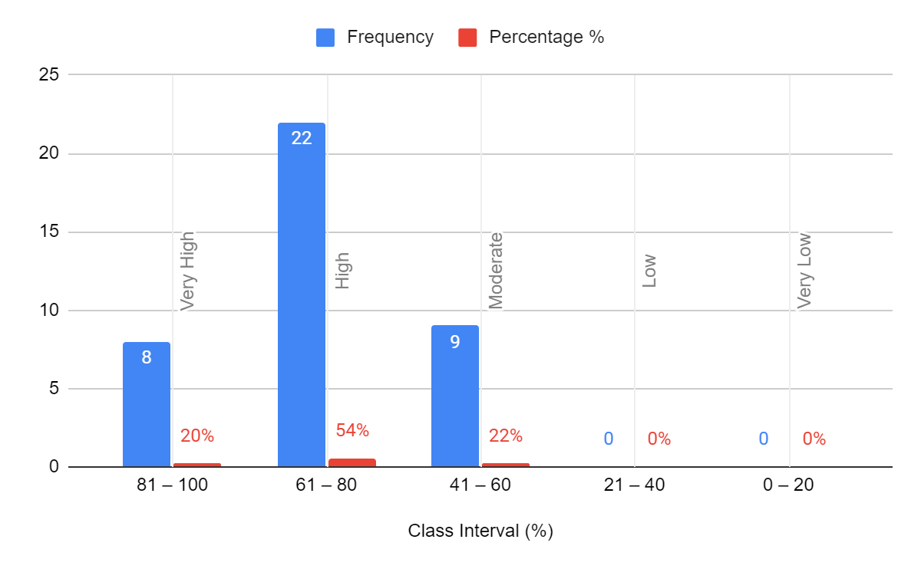

**Figure. 1 The Distribution Frequency of Students’ Reading Interest**

These reading interests have three dimensions which are certain students’ personal interest, situation and students’ reading activity, and the benefits from interest in reading. Those dimensions were expanded into 26 items which were provided in the questionnaire. The responses varied in option ''Strongly agree”, “Agree”, “Doubt about me”. “Disagree”, and “Strongly disagree”.

The dimension of students’ personal interest is divided into 8 items. The result of the questionnaire showed that the highest mean score belongs to number 4 (Mean = 4,0244). It means that most students do a reading activity for their own satisfaction. The lowest mean score belongs to number 8 (Mean = 2,5854). In item number 8, if students have the options between reading or other activities (such as watching TV or playing), they will choose reading. Based on the low average of these items, it can be interpreted that on average, students are still attached to other media that are more entertaining than reading books.

The dimension of the situation and students’ reading activity is divided into 12 items. The result of the questionnaire found out that the highest mean score belongs to number 12 (Mean = 4,1463). It means that students always connect their reading material with what they already know. The lowest mean score belongs to number 20 (Mean = 2,7805). It means that students’ do not make some special time for their reading activity.

The dimension of the benefits from interest in reading is divided into 5 items. The result of the questionnaire found out that the highest mean score belongs to number 26 (Mean = 4,3171). It means that although in some previous dimensions the average student does not place reading as an interest, they indirectly feel the benefits of reading. The lowest mean score belongs to number 22 and 23 (Mean = 3,2439). Despite having a low average in this dimension, students feel that reading affects their academic activities, especially in reading subjects. Although there are several factors and things other than reading interest that provide benefits in academic activities.

**Students’ Reading Comprehension**

In this study, students’ reading comprehension is the dependent variable (Y). To know students' score, the researcher conducted a reading online test for the students. The total score of 41 students’ is 2840. The reading comprehension minimum score was 32 and the maximum score was 96. Reading comprehension’s mean score was 66,83 and the standard deviation was 17.156. While the classes of criteria are, very high, high, moderate, low, and very low in the class interval of Students’ Reading Interest. Here is the graphic score reading comprehension as accumulation score from rate:

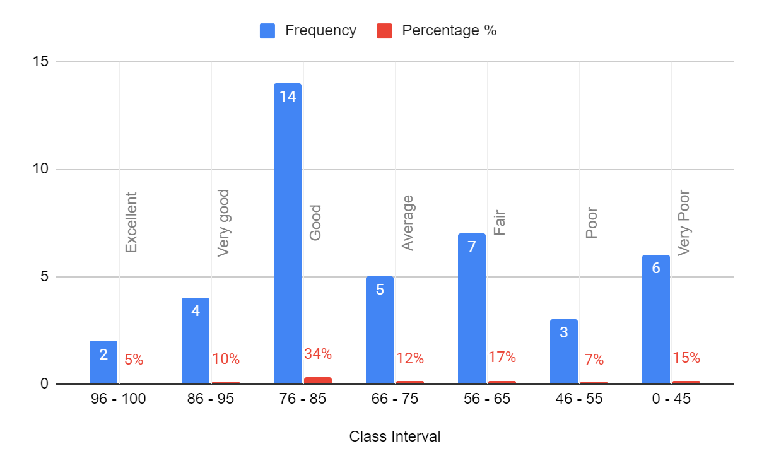

**Figure. 2 The Distribution Frequency of Students’ Reading Comprehension**

It can be seen from figure 2 that 5% had an excellent reading comprehension, 10% had a very good reading comprehension, 34% had good reading comprehension, 12% had average reading comprehension, 17% had fair reading comprehension, 7% had poor reading comprehension, and 15% had very poor reading comprehension achievement. Based on the figure above, it can see that the majority of students have good reading comprehension.

**The Result of Normality Test and Linearity Test**

During normality testing and linearity testing of the two existing data variables, normal and linear results were obtained as follows:

**Table. 7**

**The result of normality test**

|  | Kolmogorov- Smirnov | Significant | Type of Distribution |
| --- | --- | --- | --- |
| Students’ Reading Interest | .081 | .200 (sig. > 0,05) | Normal |
| Students’ Reading Comprehension | .137 | .051 (sig. > 0,05) | Normal |

**Table. 8**

**The result of linearity test**

| Variable | F value | Significant (Deviation from Linearity) |  |
| --- | --- | --- | --- |
| Students’ Reading Interest – Students’ Reading Comprehension | .919 | .600 | Linier |

Based on the results of the normality test that has been carried out by researchers after the required data has been collected, it was found that the significance value of the students' reading interest data is 0.200 and the significance value of the students' reading comprehension data is .051. The two variable values indicate that the result is more than 0.05 which is the minimum number of data that can be called normal. Thus, with a significance value of .200 for students' reading interest (X) and .051 for residual reading comprehension, the results show a normal distribution. Therefore, the data can be used for further analysis. Furthermore, the results of linearity calculation analysis above, the calculated F value is .919 < F table is 2.21. Other than that, if we view from the probability value, it is known that the probability in Deviation from Linearity is .600 > 0.05, then there is a significant linear relationship between the independent variable (X) and the dependent variable (Y). Therefore, it can be seen that the results of the relationship between students' reading interest and reading comprehension have a linear relationship.

**The Correlation Between Students’ Reading Interest and Students’ Reading Comprehension**

In this study, both of students’ reading interest and reading comprehension are correlated by using SPSS. The following is the computation result of the two variables.

| **Table. 9**  **Correlations** | | | |
| --- | --- | --- | --- |
|  | | Students' Reading Interest | Students' Reading Comprehension |
| Students' Reading Interest | Pearson Correlation | 1 | .356* |
| Sig. (2-tailed) |  | .022 |
| N | 41 | 41 |
| Students' Reading Comprehension | Pearson Correlation | .356* | 1 |
| Sig. (2-tailed) | .022 |  |
| N | 41 | 41 |
| *. Correlation is significant at the 0.05 level (2-tailed). | | | |

Based on the result, it is shown that the correlation coefficient is .022, meaning that there is a significant relationship between reading interest and reading comprehension. The r-value (.356) indicates that its relationship’s strength belongs to weak correlation according to the Sugiyono (2012). The r-value of the Pearson correlation is positive, it means that If the independent variable (X) increases, the dependent variable (Y) increases as well; the greater undergraduate students' reading interest in reading activities, the higher their reading comprehension score.

The writer had previously presented two hypotheses; null hypothesis (H0) and the alternative hypothesis (H1). Whereas, null hypothesis (H0) stated that there is no correlation between undergraduate-students’ reading interest and their reading comprehension. The alternative hypothesis (H1) stated that there is a correlation between undergraduate students’ reading interest and their reading comprehension. From hypothesis testing of the research, it was found that undergraduate students’ reading interest has a significant correlation to students’ reading comprehension. The correlation coefficient between reading interest (x) and reading comprehension (y) is (r) = .356 with a significance of .022. Based on those results of *r-value* and *p-value*, there was a positive although it has low or weak correlation between undergraduate students’ reading interest and reading comprehension. It shows that for students who want to be good in reading comprehension activities, reading interest plays an important role.

**Discussion**

The results of the current investigation reveal a similar perspective in previous studies regarding the relationship between students' reading interest and reading comprehension (Rumaniah, 2018; Restiana, Purwanti & Dahnilsyah, 2019). Therefore, in this study the author only focuses on elaborating the relationship between reading interest and reading comprehension for undergraduate students. Based on the analysis of the results of the study, it showed that the reading interest of undergraduate students was in the medium to high level, with a total of 54% of students participating in this study being in the high category, according to the Ridhuwan (2011).

The researcher found out that internal factors from the students themselves became one of the factors driving interest in reading, from the finding the average students answered that they liked reading because they were happy or their pleasure. It proves that students' interest in reading a text can be based on one aspect, namely personal pleasure. There are 4 aspects in reading interest; pleasure, attention, willingness, and consciousness, all of which need individuals pursuing opportunities and reading sources (Skinner, 1984; Wilhelm, 2016).

Furthermore, regarding the results of the reading comprehension data analysis that has been obtained, the reading test results show that more than half of the sample has a good to high enough test score. When viewed from the percentage score of the questionnaire and reading test results that have been obtained in the finding section, it can be seen that the majority of the scores of the two research variables are quite high. However, there were some participants who got reading test results that were not comparable to the results of their questionnaire answers. However, this can be evidence that, despite its weakness, there is still a positive correlation between reading interest and reading comprehension. The result of this weak correlation could be due to the influence of the presence of technology and other activities that can distract more from reading books, such as watching entertainment programs from television, playing social media and others. As the researcher found through the questionnaire, on average most of the students chose to disagree on the statement items regarding choosing reading activities over other activities as entertainment.

In addition, based on the results of the correlation analysis, the current study has the same significance as the results of research conducted by Fitria (2019) and Despita (2020). Their study mentioned that it has a significant correlation between students' reading interest and reading comprehension. However, despite having similar correlation results with previous studies, there is one difference between previous research and current research, namely the results of the Pearson Product Correlation. From the results of previous studies, it was found that the category of the Pearson correlation is a strong correlation. Meanwhile, in the current study, it was found that the correlation bonds tend to be weak. Even though the correlations are weak, the result indicates that students who had the least interest in reading also had the lowest reading comprehension (Kirby et.al, 2011). Other than that, the weak correlation between reading interest and reading comprehension can also be caused by the number of sample data results (N=41) obtained which are less than the actual sample size.

Data analysis revealed that there is a substantial relationship between undergraduate students' reading interest and reading comprehension. It can be concluded that to improve reading comprehension, teachers or lecturers must first focus on increasing students' reading interest. According to the findings of research by Schraw, Flowerday, & Lehman (2001). In terms of situational interest the teacher can do many things in the classroom to increase interest. In this case, the teacher can implement activities that promote reading interest in the classroom, such as assigning reading material or reading on topics that students are interested in. It is in line with the research conducted by Guthrie et.al (2006), the tasks that include reading activities given by the teacher in improving situational interest can increase long-term intrinsic motivation and reading comprehension. This is supported by the student response that with an average of 3,073, if given a reading assignment, students will be pleased to do it.

**CONCLUSION**

Based on the finding and discussion above, the researcher concluded that in this research the null hypothesis (Ho) was rejected and the alternative hypothesis (H1) was accepted. It means that there is correlation between students’ reading interest and students' reading comprehension of English Language Education study program, Universitas Brawijaya. Other than that, the result of the Pearson Product Correlation also shows that the correlation between students’ reading interest and students' reading comprehension of English language education study program, Universitas Brawijaya is in the category of low or weak correlation. It can be implied that, although the two variables have a significant correlation, the nature of the relationship tends to be weak. Therefore, it can be possible that the correlation between students' reading interest and students' reading comprehension does not have a strong influence, because it is caused by other factors that occur in learning activities.

The limitation of this study lies in the lack of data obtained from the research sample. Although the implementation is quite in accordance with the theory used, it can affect the results of the study. After conducting research on the correlation between reading interest and students' reading comprehension, the researcher suggests several points that can be made for future research, such as expanding the number of samples required in the study, so that research can be more specific, then increasing supporting literature, so that discussion material is wider.

**ACKNOWLEDGEMENT**

First, the writer would like to thank God Almighty, Allah SWT. Then the researcher also thanked Mrs. Peptia Asrining Tyas, thanks to her, the direction, and input for the process of making this article were very meaningful. I also thank my family, the people around me for their moral support and always encouraging me. I also do not forget to thank my friends who always share knowledge to develop this research, and also not to forget, I would like to say to all those who have helped the process of this research, such as the lecturer in Critical Reading course and also my class of 2020 friends who are willing to be participants in this research.Thanks again for everything.

**REFERENCES**

Al Musafiri, M. R. (2016). Pengaruh Minat Baca Mahasiswa Terhadap Hasil Belajar Pada Mahasiswa Jurusan Bimbingan Konseling Islam IAI Darussalam Blokagung. *Jurnal Darussalam: Jurnal Pendidikan, Komunikasi dan Pemikiran Hukum Islam*, *7*(2), 466-478. <https://doi.org/10.30739/darussalam.v7i2.22>

Ama, R. G. T. (2021). Minat Baca Siswa Ditinjau Dari Persepsi Keterlibatan Orangtua Dalam Pendidikan. *Edunesia: Jurnal Ilmiah Pendidikan*, *2*(1), 219-229. https://doi.org/10.51276/edu.v2i1.122

Anshori, M., & Iswati, S. (2019). *Metodologi penelitian kuantitatif: edisi 1.* Airlangga University Press.

Ary, D., Jacobs, L. C., Irvine, C. K. S., & Walker, D. (2010). *Introduction to research in education*. Cengage Learning.

Creswell, J. W. (2012). Educational research: planning, conducting, and evaluating quantitative and qualitative research (4th ed.). Pearson.

Despita, D. (2020). The Correlation among Students’ Reading Interest, Reading Comprehension, and Their Intralingual Translation Achievement. *Lectura: Jurnal Pendidikan*, *11*(1), 47-59.

Fitria, W. (2019). Reading Interest and Reading Comprehension: A Correlational Study. *Journal Educative: Journal of Educational Studies*, *4*(1), 95.

Fraenkel, J. R., Wallen, N. E., & Hyun, H. H. (2012). *How to design and evaluate research in education* (Vol. 7, p. 429). New York: McGraw-hill.

Guthrie, J. T., Wigfield, A., Humenick, N. M., Perencevich, K. C., Taboada, A., & Barbosa, P. (2006). Influences of stimulating tasks on reading motivation and comprehension. *The Journal of Educational Research*, *99*(4), 232-246. <https://doi.org/10.3200/JOER.99.4.232-246>

Hidi, S. (2001). Interest, reading, and learning: Theoretical and practical considerations. *Educational Psychology Review*, 13 (3), 191-209. https://doi.org/10.1023/A:1016667621114

Kirby, J. R., Ball, A., Geier, B. K., Parrila, R., & Wade‐Woolley, L. (2011). The development of reading interest and its relation to reading ability. *Journal of Research in Reading*, *34*(3), 263-280. <https://doi.org/10.1111/j.1467-9817.2010.01439.x>

Meity, I. H,& Ramdani, I. (2015). *Pendidikan Anak Usia Dini.* Jakarta Timur: Luxima Metro Media.

Putro, N. H. P. S., & Lee, J. (2017). Reading interest in a digital age. *Reading Psychology*, 38(8), 778-807. <https://doi.org/10.1080/02702711.2017.1341966>

Reflinda, R. R. (2017). The Effect of learning strategy and reading interest to the reading understanding ability of students of IAIN Bukit Tinggi. *International Journal on Language, Research and Education Studies*, *1*(2), 226-239.

Riduwan. (2012). *Metode & Teknik Menyusun Proposal PENELITIAN.* Bandung: Alfabeta

Rumainah, R. (2018). Undergraduate Students’ Reading Interest and Reading Comprehension Achievement In A State Islamic University. *Ta'dib: Jurnal Pendidikan Islam*, *23*(1), 54-64.

Schraw, G., Flowerday, T., & Lehman, S.   (2001). Increasing situational interest in the classroom. *Educational Psychological Review*, 13(3), 211–224. <https://doi.or/10.1023/A:1016619705184>

Skinner, B.F. (1984). The Evolution of Behavior. Journal: Harvard University.

Sudarsana, U. (2014). *Pembinaan minat baca.* Jakarta: Gramedia.

Sugiyono. (2010). Metode penelitian Kuantitatife, Kualitatif dan R&D. Bandung: Alfabeta.

Sugiyono. (2017). Metode Penelitian Kuantitatif, Kualitatif, dan R&D. Bandung: Alfabeta.

Siswati, S. (2012). Minat membaca pada mahasiswa (studi deskriptif pada mahasiswa fakultas psikologi UNDIP semester I). *Jurnal Psikologi*, *8*(2), 124-134. <https://doi.org/10.14710/jpu.8.2.124-134>

Taherdoost, H. (2016). Sampling methods in research methodology: how to choose a sampling technique for research. *International Journal of Academic Research in Management (IJARM)*, 20-23. [http://dx.doi.org/10.2139/ssrn.3205035](https://dx.doi.org/10.2139/ssrn.3205035)

Widodo, A., Husniati, H., Indraswati, D., Rahmatih, A. N., & Novitasari, S. (2020). Prestasi belajar mahasiswa PGSD pada mata kuliah pengantar pendidikan ditinjau dari segi minat baca. *Jurnal Bidang Pendidikan Dasar*, 4(1), 26–36. <https://doi.org/https://doi.org/10.21067/jbpd.v4i1.3808>

Wilhelm, J. D. (2016). *" You Gotta be the Book": Teaching Engaged and Reflective Reading with Adolescents*. Teachers College Press.