THE IMPACT OF MOBILE-ASSISTED HYBRID DYNAMIC ASSESSMENT ON ARABIC LANGUAGE LEANERS’

READING COMPREHENSION PERFORMANCE

**1Musti’ah, 2Dayat**

1Islamic Religion Lecture, Faculty of Social Education, IKIP PGRI Pontianak, Indonesia

2English Lecturer, Faculty of Language and Art education, IKIP PGRI Pontianak, Indonesia

Co. Author Email: mustiahdyt@gmail.com

|  |  |
| --- | --- |
| ***Article Info*** | **Abstract** |
| ***Article History***  *Received:*  *Revised:*  *Published:* | *This study mainly aimed to explore the quantitative and qualitative impact of mobile-assisted hybrid dynamic assessment (MAHDA) on Islamic religious Education (IRE) learners’ Arabic reading comprehension (ARC). This recent study employed a sequential explanatory mixed-methods design and involved twenty participants assigned into experimental and control groups. All groups received pre-and post-tests to compare the intervention. The experimental group was mediated through the MAHDA procedure for two months and the control group received conventional instruction. The interview with the participants was also conducted to assess the learners’ perception of the mediation strategies of MAHDA. The pre- and post-test were analyzed by t-test and the transcribed interviews were thematically analyzed. Quantitatively, the results showed a meaningful distinction between the two groups. The qualitative findings revealed that the participants felt satisfied with the MAHDA in improving the learners’ ARC abilities and social interaction.* |
| ***Keywords***  *dynamic assessment;*  *Arabic reading*  *comprehension;*  *mobile-assisted language learning;*  *cognitive development.* |
| ***How to cite:*** | |

**INTRODUCTION**

Dynamic assessment (DA) has been globally applied in language assessment to improve learners' cognitive development. DA is rooted in Vygotsky's sociocultural theory (SCT) with the concept of the zone of proximal development (ZPD) in which the interaction between assessor or more competent learners are met to improve learners’ cognitive (Poehner 2008a; Poehner 2008b; Poehner and Lantolf 2013). With this in mind, the learners can make use of these activities for future learning and instruction (Yang & Qian 2019).

Currently, DA has been embedded with mobile technology to more effective DA in language teaching classes. There have been some research studies that have shown the effectiveness of mobile-based DA (MDA) in assisting learners’ learning potential in the context of English language assessment (Andujar 2020; Ebadi and Bashir 2020). Andujar implemented MDA through mobile instant messaging (MIM) (WhatsApp application) to enhance grammar and vocabulary skills. In his study, the experimental and control groups received the traditional assessment (pre-and post-test). The data were collected and analyzed from open-ended dialogue with the learners to assist the learning and identify the pedagogical MDA. During the DA session, the mediation moves applied the implicit-to-most explicit prompts. The findings indicated that MDA was effective in improving the performance and the potential learning of L2 development. On the other hand, another study also showed that text-based meditation and WhatsApp helped learners to better compose academic writing skills. Although several studies concerned with the effectiveness of MDA in English Language reading comprehension in particular (Kazemi, Bagheri, and Rassaei 2020; Suherman 2020), there is still little information about the role of MDA in improving Arabic reading comprehension (ARC). This study aimed at the extent of MDA in developing Islamic religious education (IRE) learners’ reading comprehension skills.

After reviewing reputable journals, a little information about the implementation of MDA research in the context of ARC. Therefore, this research was conducted to investigate HDA in different forms of mediation, namely, human interaction through technological devices. Arab. previous research applied these two approaches in the context of English academic writing (eg., Rad 2021), but the effectiveness of mobile-based HDA requires further investigation in a different context. With reason, this recent study fulfilled the gaps to prove the effectiveness of the current HDA.

Generally speaking, reading is a complex process and there is no consensus as to which theory is most efficient at explaining it (Yang & Qian, 2019). It also happens to Arabic reading since Arabic reading involves various components and skills; for example, word recognition, syntactic parsing, use of background knowledge, and special reading skills or strategies (Yang and Qian 2019). More specifically, Arabic reading refers to two dimensions, *al-qira'ah al-jahriyyah* and *al-qirā'ah ash-shāmitah* (Munip, 2017) and Qasim & Fadl, 2014).

*Al-qirā'ah al-jahriyyah* is the lower level of reading to respond to the orthographic (writing or symbols) language Arabic by identifying or pronouncing it. On the other hand, al-*qirā'ah ash-shāmitah* is the higher-level skill to understand the meaning of written texts. This research focuses on investigating learners’ ability to understand Arabic texts since this skill is still viewed as a challenging skill for most IRE learners when the researcher first visited and pre-observed the research site. Therefore, the research question of this study is: What are the impacts of MAHDA on learners’ Arabic reading comprehension?

Furthermore, this recent research is expected to contribute to lecturers of Arabic language courses in utilizing mobile-based HDA (MAHDA) in developing ARC (*fahmūl maqrū’*) abilities. In addition, this research can also make a complementary contribution for learners to develop their ability to understand Arabic texts.

**RESEARCH METHOD**

**Research Design**

This study followed a sequential explanatory mixed-method design in which the researchers collected quantitative and qualitative data sources. With this in mind, the researchers highlighted quantitative findings through a more in-depth analysis of qualitative data (Riazi, 2016). The mixed method used in this present research was the Quan➔Qual design in which two types of data were gathered sequentially.

**Research Subject**

The recent research involved 20 learners from five classes at an Islamic university in Pontianak assigned randomly into the control (Group C) and experimental (Group E) groups. All participants voluntarily joined the research project after the researcher distributed research invitations and negotiations. They were invited to participate in research to gain the benefits of the present research. Therefore, the roles of researchers were not only to collect data for research purposes but to provide brief directions within the learning session. As a result, the learners gained new knowledge or insight about *fahmūl maqrū.*

All groups (Group C and Group E) were assigned to approve that they honestly completed the online pre-test individually and without any other technology assistance, for instance browsing the internet for gaining the answer.

**Instruments**

Quantitatively, the pre-and post-test consisting of 25 questions of ARC within 50 minutes was carried out. Also, the result of the pre-test was used to determine the homogeneity of the participants of each group. Since the results of each group were higher than α (sig > 0.05), the two groups were considered homogeneous (see Figure 1). Also, the results of pre-and post-test of the control and experimental group were compared. In mediation session, the mediation group discussion was carried out through social chat (WhatsApp) and recorded. Qualitatively, the data were gained through semi-structured interviews with the experimental group after completing the post-test. Eight guiding questions were interrogated in Bahasa Indonesia to avoid miscomprehending. Semi-structured interviews were employed to gain more elaboration (Mackey and Gass 2015) through an exploratory way (Dornyei 2007). The interviewer-interviewee voices were recorded and transcribed verbatim

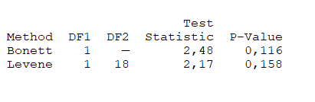

Figure 1. The homogeneity of the samples

This activity was used to measure the current ARC proficiency level. In the teaching session, Group E was assigned to involve in group WhatsApp created by the researchers and discussed each question of the pre-test. The roles of researchers were to facilitate and provide some prompts or hints when they were not able to answer the questions. The activities took three sessions (two months) and Group C received traditional class (face-to-face classrooms) without mediation. Lastly, all learners returned to take the post-test. Interviews with individuals of experimental group were conducted in this sessin.

**Data Analysis**

To analyze the data, quantitative and qualitative procedures were involved. The quantitative data were statistically conducted through Minitab version 17. To find the comparison of the pre-and post-test of each group, a paired-sample t-test was calculated. For the analysis of the significant differences between two groups (C and E) regarding the pre-and post-test, an independent-sample t-test was also employed. Further, the transcribed data from semi-structured interviews were analyzed thematically.

**RESEARCH FINDINGS AND DISCUSSION**

**Research Findings**

***Quantitative Results***

The researcher calculated a paired-sample t-test to compare the difference pre- and post-test of each group. The t-test result for Group C proved that there was no significant distinction between pre-and post-test (sig > 0.05) as shown in Figure 2.

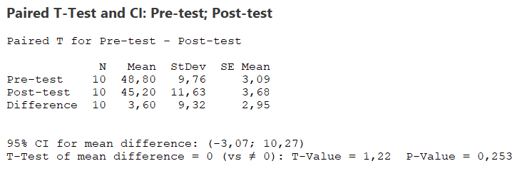

Figure 2. The result of the paired-sample t-test for Group C

Figure 3 shows that the mean of pre-and post-tests were significantly different (sig < 0.05). This result reveals that Group E performed better in their post-test.

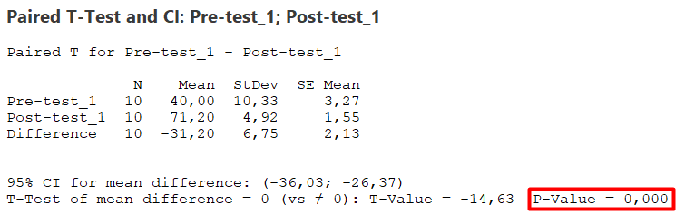

Figure 3. The result of the paired-sample t-test for Group E

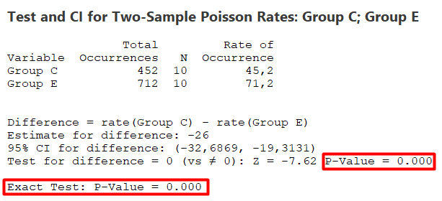In addition to comparing the means of post-test for two groups (C and E), Figure 4 indicated that there was a meaningful difference between the two groups (sig < 0.05) and it can be concluded dynamic assessment was effective to be implemented in this recent research context.

Figure 4. The result of the independent sample t-test for Groups

***Qualitative Findings***

This section explores the PAI learners’ perspectives on the learning experience during the MAHDA session. In this case, ten participants from the experimental group volunteered to be interviewed. After analyzing the interview transcripts, three themes emerge through thematic analysis, positive aspects, negative aspects, and suggestions from the implementation of MAHDA. Each theme and its code were explained by providing excerpts from the interview data. Anonymously, pseudonyms were employed for the learners ranging from E1 to E10. The findings indicated that the participants had positive attitudes toward the MAHDA experience. The excerpts are provided as follows:

|  |  |  |
| --- | --- | --- |
| *E1* | *:* | *I preferred this dynamic method because I could ask the lecturer in the group when something was difficult to understand.* |
| *E2* | *:* | *The provision of group discussion made me easier to understand.* |
| *E3* | *:* | *With Discussion of this assessment method, we could share our ideas or experiences with others.* |
| *E4* | *:* | *When there were incorrect answers, mediation from lecturers and peers was provided.* |
| *E6* | *:* | *With Discussion, a lot of knowledge could be obtained from other people.* |
| *E7* | *:* | *The dynamic assessment provided discussions in which the problems could be resolved more easily, establish harmony, strengthen cooperation, get used to respecting other opinions, and gain new understanding from them.* |
| *E8* | *:* | *The dynamic assessment method did not only complete the test but also discussed the test. With this in mind, the wrong answers were discussed together.* |
| *E9* | *:* | *With discussions, we could share ideas, opinions, and suggestions, and when we did not understand, we could ask the solution in the group.* |
| *E10* | *:* | *I preferred dynamic assessment because I received more knowledge and experience.* |

Further, eight out of ten learners reported that the mediation that had been most beneficial to the development of the ARC area was the ability to find the meaning of Arabic words (as E1, E2, E3, E4, E6, E8, E9, and E10), main idea (E5 leaner), and all aspects (E7).

On the other hand, the negative aspects of implementing MAHDA were recorded. One learner said that the impact of MAHDA on cognitive development was not so significant. Based on the chat record, this learner had a problem with the internet connection. With this in mind, communication became hampered. Here is the excerpt:

*E5: The impact of this assessment method was not so significant. I was late in receiving information or intervention because of a poor internet connection.*

Lastly, the learner proposed an idea for improving the intervention through virtual or face-to-face meetings since she thought that she would get more knowledge.

*E7: In my opinion, this dynamic assessment method should not only be implemented via WhatsApp chat but also the Google Meet application or face-to-face class since it allowed me to attain more new insights.*

**Discussion**

This study aimed to explore the impact of MAHDA on ARC on the IRE learners by adopting two DA approaches. We adopted a sequential explanation mixed methods approach to collect and analyze the data. The quantitative results of this study indicated that there was a significant difference between the experimental and control groups in the development of ARC abilities. In particular, MAHDA was more effective in improving the learners' ARC abilities as indicated by the difference between the pre-test and post-test average scores of the experimental group (t-test results). These results could be related to learning media, for instance, the WhatsApp application. The learners said they had no previous experience with MAHDA. By using this social media and others, they shared messages and multimedia content with others. It is in line with Dehghan et al. (2017) who say WhatsApp is an entertaining device and not for education.

Moreover, these qualitative findings strengthen Ebadi and Bashir's (2020) study on mobile learning had a positive impact on the learners’ writing proficiency. Conversely, this study contradicts Ma and Yodkamlue’s (2019) research result which showed there was no significant difference between pre-and post-results through mobile learning.

Based on the IRE learners’ perspectives on the mediation, MAHDA had also positive and negative impacts as the previous study by Ebadi and Bashir (2020). Most of the learners indicated that MAHDA was efficient, convenient, and caused less social pressure. This also corroborates Ma and Yodkamlue (2019)’s study on mobile learning.

**CONCLUSION**

This research highlights the importance of how discussion-based mediation via mobile devices can contribute to better learner performance. It is suggested that IRE lecturers use web resources and face-to-face classes as tools and mediation strategies framed through MAHDA in teaching ARC in both individual and group formats to enhance their learners' ARC abilities and uncover their level of ZPD. Further research might explore the effects of different proficiency levels, gender, and learning styles of different learners in the MAHDA context. This research has important implications for Arabic language lecturers specifically regarding the cellular potential for foreign language teaching. One of the implications of this research is to promote the use of mobile learning within a cellular-mediated MAHDA framework to teach various features of Arabic including reading comprehension of Arabic.

The second important implication of this research is also for lecturers to consider and evaluate various feedback or mediation as a measure of development and assessment. For assessment purposes, as part of MAHDA, lecturers can evaluate student interventions or feedback to gain further insight into students' developing abilities. Tests and mediation procedures in the form of reciprocity can be prepared for individual and group assessment for classroom and online teaching to track the progress of Arabic language learners in IRE study programs.

One of the important limitations of this research is what has been suggested by student participants for IRE lecturers to use web resources and face-to-face classes as mediation tools and strategies framed through MAHDA in teaching ARC in individual and group formats to improve their students' ARC abilities and reveal their ZPD level. Therefore, further research needs to be done to utilize face-to-face to explore the effects of this strategy. In addition, future MAHDA research examines the development in terms of each individual, gender, and the different learning styles of different students and different language skills.

**ACKNOWLEDGEMENT**

I would like to thank IKIP PGRI Pontianak for funding the research project.

**REFERENCES**

Andujar, A. (2020). Mobile-mediated dynamic assessment: A new perspective for second language development. *ReCALL*, 1–17.

Dehghan, F., Rezvani, R., & Fazeli, S. (2017). Social networks and their effectiveness in learning foreign language vocabulary: A comparative study using WhatsApp. *CALL-EJ, 18*(2), 1–13.

Dornyei, Z. (2007). *Research methods in applied linguistics: Quantitative, qualitative, and mixed methodologies*. Oxford University Press.

Ebadi, S. & Saba Bashir, S. (2020). An exploration into EFL learners’ writing skills via mobile-based dynamic assessment. *Education and Information Technologies*.

Kazemi, A., Bagheri, M.S., & Ehsan Rassaei, E. (2020). Dynamic assessment in English classrooms: Fostering learners’ reading comprehension and motivation. *Cogent Psychology, 7* (1), 1-10.

Ma, X., & Yodkamlue, B. (2019). The effects of using a self-developed Mobile app on vocabulary learning and retention among EFL learners. *PASAA*, 58, 166–205.

Mackey, A., & Gass, S. M. (2015). *Second language research: Methodology and design*. Routledge.

Munip, A. (2017). *Penilaian pembelajaran bahasa Arab*. Yogyakarta: Fakultas Ilmu Tarbiyah dan Keguruan, Universitas Islam Negeri (UIN) Sunan Kalijaga Yogyakarta.

Poehner, M. E. & James P Lantolf, J.P. (2013). Bringing the ZPD into the equation: Capturing L2 development during Computerized Dynamic Assessment (C-DA). *Language Teaching Research*, *17*(3) 323 –342.

Poehner, M. E. (2008a). *Dynamic assessment: A Vygotskian approach to understanding and promoting L2 development*. Springer Science & Business Media.

Poehner, M. E. (2008b). Dynamic Assessment and the Problem of Validity in the L2 Classroom. In *CALPER Working Paper Series* (Issue 10).

Qasim, Y. I. & Fadl, F. H. (2014). ‘Qiyāsu al-Adāi fī Ikhtibārātun al-Fahmu wa al-Qirāatu fī al-lugati al-‘Arabīyati laday Ṭalābi Kullīyati al-Ādābi – Jami’ati al-Hadīdati', *Majallatu al-Darāsāti al-Ijtiā’īyati,* 40, 257-294.

Rad, H.S. (2021). Exploring Use of Mobile-mediated hybrid dynamic assessment in improving EFL learners' descriptive writing skills. *Computer Assisted Language Learning Electronic Journal,* *22* (1), 111-132.

Riazi, A. M. (2016). *The Routledge encyclopedia of research methods in applied linguistics*. Routledge.

Suherman, A. (2020). The effects of dynamic assessment on reading skill performance: A study of Indonesian EFL learners. *Metathesis: Journal of English Language Literature and Teaching, 4* (2), 151-162.

Yang, Y. & Qian, D.D. (2019): Promoting L2 English learners’ reading proficiency through computerized dynamic assessment, *Computer Assisted Language Learning*.