**Efforts to Achieve Independence of Vocational School Students through Entrepreneurship Class: Making Virgin Coconut Oil (VCO) by Bakti Karya Parigi Vocational School Students**

**Hikmah Maulani1, Nur Muthmainah2, Tatang3, Nalahuddin Saleh4, Shofa Musthofa Khalid5**

1345 Pendidikan Bahasa Arab, Fakultas Pendidikan Bahasa dan Sastra, Universitas Pendidikan Indonesia

2Pendidikan Bahasa Jerman, Fakultas Pendidikan Bahasa dan Sastra, Universitas Pendidikan Indonesia

\*Correspinding Author Email : [hikmahmaulani@upi.edu](mailto:hikmahmaulani@upi.edu)

|  |  |
| --- | --- |
| **Abstract (English)**  In implementing the Profil Pelajar Pancasila, students are developed to form individuals who are creative, innovative, independent and able to contribute and interact with the environment as well as society. In terms of its program elements, Bakti Karya Parigi Vocational School initiated a program of independence and creativity in a multicultural class environment with the Niti Sajati program. Niti Sajati's motto is live nature, live culture was formed as a forum for students' independent aspirations in collaboration with educators and the community through creativity, one of which is making Virgin Coconut Oil (VCO) made from coconuts produced by schools and the community. The selling value of this VCO innovation is expected to generate economic value that is beneficial not only for students and schools but also for the community. Bakti Karya Vocational School is a multimedia vocational school, with this provision, students can learn to manage marketing through multimedia. In learning practices at universities, these innovations can become treasures for entrepreneurship courses. So in this case, researchers need to take steps to strengthen the selling value of VCO products made by Bakti Karya Vocational School students so that they become processed products that can compete in the public market, both domestic and foreign.  Keywords: Independence, Niti Sajati, Entrepreneur, Virgin Coconut Oil (VCO) | **Article History**  Received: …..J  Reviewed: ……  Published:……..  **Key Words**  content, formatting, article. |
| **Abstrak (Indonesia)**  **(Times New Roman 10, spasi 1, spacing  before 10 pt, after 2 pt)**  Dalam implementasi profil pelajar pancasila, siswa dikembangkan membentuk pribadi yang kreatif, inovatif, mandiri dan mampu berkontribusi dan interaksi dengan lingkungan juga masyarakat. Dalam elemen programnya, SMK Bakti Karya Parigi menginisiasi program kemandirian dan kreativitas dalam wadah kelas multikultural dengan program Niti Sajati. Niti Sajati sendiri bermotto live nature, live culture dibentuk sebagai wadah aspirasi kemandirian siswa yang berkolaborasi dengan pendidik dan masyarakat melalui kreativitas, salah satunya membuat Virgin Coconut Oil (VCO) dengan berbahan dasar kelapa hasil bumi sekolah dan masyarakat. Nilai jual dari inovasi VCO ini diharapkan dapat menghasilkan nilai ekonomi yang bermanfaat bukan hanya untuk siswa dan sekolah melainkan juga masyarakat. SMK Bakti Karya merupakan sekolah berkejuruan multimedia, dengan bekal ini, siswa dapat belajar mengelola pemasaran melalui multimedia. Dalam praktik pembelajaran di Universitas, inovasi tersebut dapat menjadi khazanah bagi mata kuliah kewirausahaan. Maka dalam hal ini, peneliti perlu melakukan upaya langkah penguatan nilai jual produk VCO yang dibuat oleh siswa SMK Bakti Karya sehingga menjadi produk olahan yang dapat bersaing di pasar masyarakat baik dalam atau luar negeri.  Kata kunci : Kemandirian, Niti Sajati, Wirausaha, Virgin Coconut Oil (VCO) | **Sejarah Artikel**  Diterima: …..  Direview: …..  Disetujui: ……. 7  **Kata Kunci**  Kemandirian, Niti Sajati, Wirausaha, Virgin Coconut Oil (VCO). |

**How to Cite:** First author., Second author., &amp; Third author. (20xx). The title. Jurnal Pengabdian UNDIKMA, vol(no). doi:https://doi.org/10.33394/jp.vxxyyi

|  |  |
| --- | --- |
| C:\Users\IKIP\Pictures\1200px-DOI_logo.svg.png https://doi.org/10.33394/jp.vxxyyi | This is an open-access article under the [CC-BY-SA License.](http://creativecommons.org/licenses/by/4.0/) |

C:\Users\IKIP\Pictures\CC_BY-SA_3.0.png

**Introduction**

Increase business productivity in Pembangunan Jangka Panjang Nasional (PJPN 2005-2025) there is a need for business empowerment aimed at developing science and technology-based and globally competitive businesses. The strategy for empowering small businesses is directed at developing innovation and technology competencies so that they play a greater role in economic growth (Sukirman, 2020). In connection with these conditions, education is the most strategic sector in national development, because through education knowledge, skills and attitudes can be provided. Education that is suitable for facing the challenges of globalization is education that is oriented towards the industrial world with a learning approach and is supported by an appropriate curriculum (Astuti SMKN & Sukardi, 2013).

Furthermore, the rapid pace of the world economy demands a rapid pace of innovation as well. This is without exception from strengthening the selling value of a business product. Changes that occur in the business world are a natural thing because throughout the history of marketing, the market has been in a state of flux, so companies must move with the market, namely by changing the marketing system in accordance with changing situations and conditions of consumers (Hutabarat, 2017).

With the innovations made, it is possible to create new markets for the products produced. So that it will be able to increase the selling value and in the end will increase the income of business actors (Dewi, Santi Riana, 2019).

The innovation referred to in the presentation of the paragraph above is not limited to gaps in circles, meaning that both the general public and even school students are required to be independent in their work and in the economy. In implementing the Pancasila student profile, students are developed to form individuals who are creative, innovative, independent and able to contribute and interact with the environment as well as society.

In terms of its program elements, Bakti Karya Parigi Vocational School initiated a program of independence and creativity in a multicultural class environment with the Niti Sajati program. Niti Sajati's motto is live nature, live culture was formed as a forum for students' independent aspirations in collaboration with educators and the community through creativity, one of which is making shibori cloth made from environmentally friendly materials.

The Multicultural Class is a program that was initiated as a forum for the introduction of cultural tolerance for students from various regions, ethnicities, races and religions in Indonesia who are affiliated at Bakti Karya Parigi Vocational School. Bakti Karya Vocational School is a Multimedia vocational school with the concept of diversity-friendly, environmentally friendly and open to the public. We believe that education can be built on mutual cooperation.

The Darma Bakti Karya Foundation is a non-governmental organization initiated by a number of activists who care about developing culture and encouraging a new civilization that is more humane and sustainable. This foundation focuses on the liberating education movement, pro-ecological activities, community self-reliance, promotion of culture and technology development for a sustainable life. Since 2016, the Darma Bakti Karya Foundation has managed the Bakti Karya Parigi Vocational School, designed the Multicultural Class program and initiated Kampung Nusantara as a learning ecosystem in accordance with the ideals of the foundation.

In addition to the Bakti Karya Parigi Vocational School, this foundation also oversees the Kemuning Kindergarten, TPQ Cinta Allah and the Hidayatul Irpan Ecology Student Islamic Boarding School. As a non-governmental organization, the Darma Bakti Karya Foundation is ready to collaborate with various parties to realize ideas that are in harmony with the constitution and common sense. We are supported by public funds in the form of crowdfunding and other funding sources that are free from corruption, environmental destruction and human rights violations.

Every activity related to education must produce an output. In the same way, implementing character education in a multicultural environment will create students with independent character. Educators teach multicultural education through teaching and learning activities in forming "Independent" characters. Independence is an attitude and behavior that is not easily dependent on others in completing tasks (Amrullah A, 2017).

In the development of independent foundations and schools in fostering students, it has implications for student innovation in forming entrepreneurial creativity, one of which is the production of Virgin Coconut Oil (VCO) through the idea of an entrepreneurial class program called Niti Sajati.

Service approach through efforts to strengthen selling points. This is based on the analysis that the price of goods is something that is very important, meaning that if the price of goods is too expensive it can cause the goods to become less salable, and conversely if it is sold too cheap, the profits will decrease (Neisia, 2018). In the context of Community Service, the researcher observes a problem where assistance is needed to strengthen the selling value of the marketing of shibori cloth products so that they have high selling value and are of high quality so as to help students and schools' income. Strengthening assistance is emphasized on marketing training through multimedia (using social media) and also collaboration with companies/tourism in Pangandaran Regency. Training on how to sell draing / online, as well as how packaging is more attractive to target users or buyers.

**Method**

**Participant**

Researchers took steps to go directly into the field to provide assistance, the reason is that apart from being easy to observe, it is also easy to provide assistance. On the other hand, even though it is already in the post-pandemic phase of Covid-19, of course, we still maintain health protocols.

**Location**

The location we chose to conduct the Community Service Program (PkM) was the Multicultural Class of SMK Bakti Karya Parigi Pangandaran, West Java.

**Stages**

*Observation*

Observations made are not just observations, but with systematic recording of the objects being studied. As this method is used by researchers to determine the characteristics of social and religious character values in students.

*Interview*

The interviews carried out were direct meetings and dialogues conducted by the research team with students with the aim of exchanging information so that it became a conclusion. In the interview, the researcher determined the interview schedule for the interviewees and asked questions using the 5W+1H pattern (what, when, why, where, who, and how).

*Assistance through teaching*

Assistance is carried out using a semi-seminar model that presents speakers from experts on entrepreneurship with the target of students and the aim of educating students.

*Assistance through teachers*

Assistance is carried out using the Focus Group Discussion model with teachers at the school involving a team of researchers and experts on entrepreneurship.

*Direct assistance to students and the community*

Direct assistance in the form of being involved in the daily activities of students from elements of religious and social activities and even student independence in entrepreneurship programs and professional classes.

The flow of the method or road map for the implementation of this community service can be illustrated as follows in Figure 1:

Figure 1. PkM activity road map

**Results of Service and Discussion**

***Patterns of Independence for Multicultural Class Students at Bakti Karya Parigi Vocational School***

The results of the mentoring found that students' educational experiences could be obtained from various environments, not only within the school environment but through the community and family. Community and cultural environment can provide entrepreneurial experience when the environment becomes the center of entrepreneurship. As with families, parents who are entrepreneurs or not entrepreneurs will provide experience to their children. Entrepreneurial motivation is not enough just to be equipped with entrepreneurial knowledge or education. There must be provision of skills regarding what fields will be used as a business or become the focus of entrepreneurship. Vocational High School is an education that provides certain vocational knowledge and skills to its students. This knowledge and skills can not only be used to find work in industry/companies, but are also expected to be used as provisions for independence by opening their own business.

Furthermore, assistance is carried out to realize student readiness in soft skills and hard skills. This is based on the 2015-2019 Ministry of Education and Culture Strategic Plan, the target to be achieved in the Smart Indonesia Program through the implementation of the 12 Year Compulsory Education (Ministry of Education and Culture, 2015-2019) one of which is to increase the readiness of secondary education students to enter the world of work/business world or continue their education higher level, where students are expected to be prepared to enter the world after school. This readiness can be formed before or even during students studying at SMK. In addition, one of the strategic goals of improving the quality and relevance of character-oriented learning is to increase the relevance of vocational education by increasing theoretical and practical entrepreneurial skills. Many factors influence the process of establishing entrepreneurship readiness, one of which is entrepreneurship learning. In general it can be said that to become an entrepreneur requires entrepreneurial readiness which includes Self Readiness, Entrepreneurial Personality, and Skills. is a personal/individual trait that must be built to become an entrepreneur, and skills are the ability to do something related to entrepreneurial activities (Putra et al., 2018).

Bakti Karya Parigi Vocational School performs its duties well. This school realizes that the school is one of the institutions that organizes the teaching and learning process in guiding, fostering and developing student achievement to realize educational goals. The process of teaching and learning that takes place in schools is the linkage of various educational components to achieve a good goal, one of which is to increase students' creativity and innovation in solving the problems they face as well as increasing good attitudes and student behavior. Education that is directed at forming attitudes and behaviors that have creative and innovative abilities and is beneficial to the wider community is through entrepreneurship education. With the existence of entrepreneurship learning in schools, it is hoped that it can increase students' interest in entrepreneurship. But in increasing students' interest in entrepreneurship there are many factors that can influence, one of which is student learning outcomes (Yulianto et al., n.d.). This was reinforced by the provision of assistance by the research team to both the school and students.

***Selection of Virgin Coconut Oil (VCO) as Student Entrepreneurship Content***

Technological developments and consumer preferences that have accommodated environmental and health issues have encouraged the coconut industry to grow more diverse and deep (Dwi Sutanto et al., 2021).

Virgin Coconut Oil (VCO) is no stranger to the world of traditional medicine. This coconut product is known for its many benefits. Virgin coconut oil (VCO) is coconut oil which contains medium chain fatty acids (MCFA) which are easily broken down by the body in very high amounts. Besides that, VCO also contains antioxidants such as tocopherols and beta-carotene which are very high (Dwi Sutanto et al., 2021).

The coconut tree (Cocos nucifera), also referred to as the "tree of life", belongs to the 'Arecaceae' family. It is one of the most important plants, used for limitless applications worldwide. It is the only known species in the genus Cocos to have a tall stem, growing up to 30m tall, with pinnate leaves 4–6m long, and 60–90 cm long; Broken old leaves go clean, leaving a smooth trunk. There are several different varieties of coconut, including tall and dwarf. It is common, called "tall", its varieties are Ceylon, India, Jamaica, Malay, Java and Laguna. Malay, green, orange and Fijian are some of the "dwarf" varieties. Tall varieties are generally cultivated for commercial purposes. They are slow to mature and only produce flowers 6-10 years after planting. The life span of tall varieties is about 60-100 years. Coconut trees are perfect for the humid tropical coastal climate; it can tolerate poor sandy soil and exposure to salt water. The three largest coconut producing countries are Indonesia (3.1 million hectares), the Philippines (2.7 million hectares) and India (1.5 million hectares) (Srivastava et al., 2018).

Through this data, Indonesia is one of the largest coconut producers, the existence of coconuts is not difficult to find. Indonesia is a rich country with plantation products. One type of plantation product that exists in Indonesia and has the most potential is coconut trees. Coconut tree (Cocos nucifera L.) is a plant that is beneficial to human life. Almost all parts of the coconut tree can be used to meet needs. The most important parts of the coconut tree are water and coconut meat. Coconut meat is one part of the coconut that is often used by the community and industry (Pramitha & Wibawa, 2021).

VCO is pre-processed in the form of coconut milk. Coconut milk is an oil and water emulsion stabilized by protein. To recover the oil from the coconut milk, the protein bonds are broken using heat in a double-walled kettle, known as a VCO burner, by slow heating to coagulate the proteins and release the oil. Separation of class A oils from protein residues (kalkam) by filtering the mixture through a muslin cloth (Srivastava et al., 2018).

The ease of making it without the need for expensive special tools is an opportunity to introduce VCO production to students.

***Entrepreneurial Assistance for Marketing Virgin Coconut Oil (VCO) Products for Multicultural Class Students at Bakti Karya Parigi Vocational School***

Broadly speaking, the implementation flow is: First, a needs analysis in discussing the product marketing concept. The discussion was carried out in the form of focused discussions (FGD) which highlighted the need for training to strengthen the value of jaul products. The focused discussion also discussed the urgency of strengthening the jaul value of the product. In this focused discussion involved a number of resource persons who are experts in the field of entrepreneurship. Second, preparation of training tools for entrepreneurship mentoring. Third, the implementation of activities is the core of the community service program that will be carried out. At this stage the implementing team publishes community service activities to recruit training participants who meet the requirements, compile a rundown of activities, carry out activities, and collect the data needed for writing articles. Fourth, evaluation of training activities is carried out by distributing satisfaction questionnaires to participants, monitoring students and teachers after training, and giving rewards to the best participants. And fifth, activity publication and reporting consists of the stages of preparing activity reports, compiling activity results in the form of scientific articles, and disseminating activity results in the form of seminars.

**Tool materials**

Virgin coconut oil (VCO) aka virgin coconut oil is believed to have more benefits because its quality is considered higher than regular coconut oil. The benefits of virgin coconut oil certainly come from the nutrients it contains. In one tablespoon of virgin coconut oil, there are 13 grams of total fat. As many as 11 grams come from saturated fat. The type of saturated fat found in virgin coconut oil is lauric acid or lauric acid.

**Tools**

1. Blender
2. Transparent plastic jar with a diameter of 30 cm
3. Basin 2
4. Coconut grated machine
5. Coconut milk filter
6. Filter paper
7. Clear plastic hose
8. VCO bottle size 250 ml
9. Spoon

**Raw material**

1. Old ripe coconut tree 10 grains
2. Finished VCO/clear cooking oil 1 L
3. Water 6 L

**Making process**

1. Coconut is grated and added 6 liters of water to be squeezed.
2. Put coconut milk in a jar and let it settle for 25 minutes, forming 2 layers.
3. The top layer is thick coconut milk and the bottom layer is water. Take out the water with a hose.
4. Mix the top layer of thick coconut milk with VCO as a lure, stir until smooth.
5. Store at room temperature for 8 hours to become 3 layers; the top of the oil, the middle blondo and the bottom of the water (sometimes the oil is in the middle and the blondo is on top).
6. Take out the water with a hose.
7. Prepare a filter, mineral water bottles, filter paper, cotton and ziolite stones.
8. Take the oil with a spoon, put it in a colander. The clear VCO results are like mineral water, packed directly into bottles, sealed and labeled.

**Sale and Marketing**

In sales activities, Virgin Coconut Oil (VCO) is packaged in bottles. As in the following figure 2:

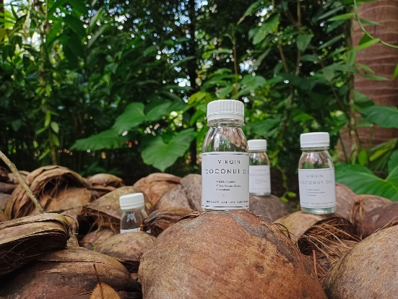

figure 2. Bottled Virgin Coconut Oil products.

The selling price of Virgin Coconut Oil (VCO) with selected ingredients using community-sourced ingredients, namely coconut which is the result of processing community gardens around the school has a selling value of around IDR 15.000 - 25.000 per bottle. Furthermore, as a creative innovation, VCO is packaged in attractive packaging. Prices that adjust, in other words, are pocket-friendly, are the main attraction for buyers.

In addition, sales are made through the use of technology and social media. Through the multimedia department, SMK Bakti Karya is considered successful in baiting student motivation and creativity in sales. Together with the entrepreneurship program under the Niti Sajati program, students create a sales link affiliated with the school's website, namely at <https://www.sbk.sch.id/niti-sajati/> . The following figure 3 describes a website that contains sales content.

**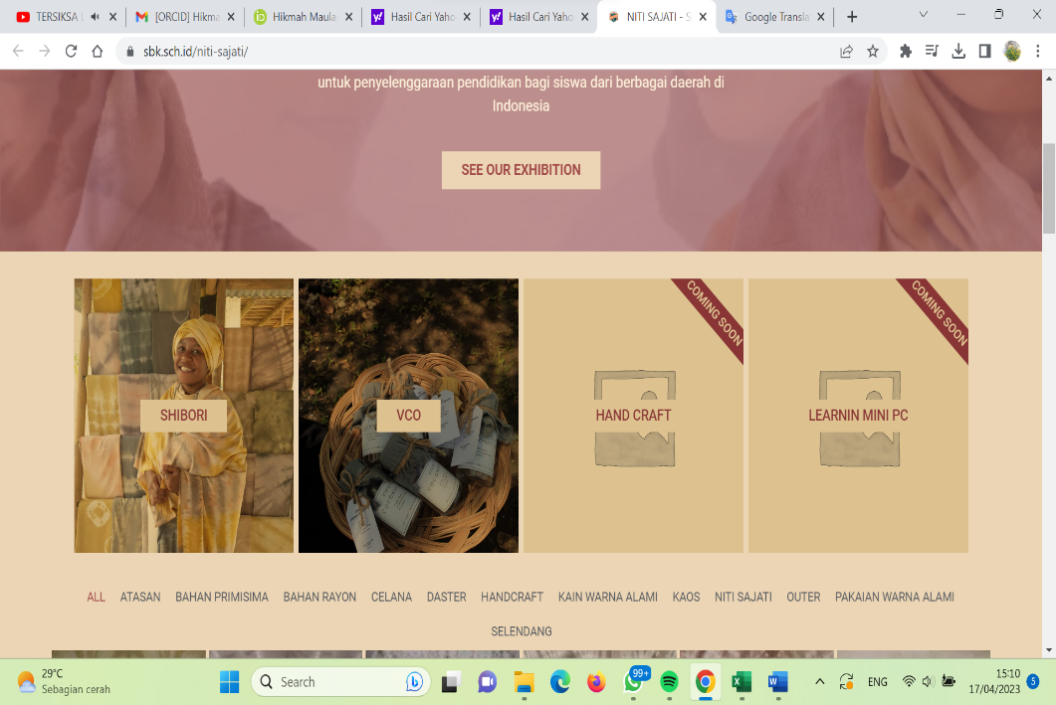**

Figure 3. Sales Website

The price of goods is something that is very important, meaning that if the price of goods is too expensive, it will cause the goods to sell less, and vice versa, if you sell too cheap, profits will decrease. (Neisia, 2018). In the context of community service, researchers see a problem where assistance is needed in strengthening the selling value of Virgin Coconut Oil (VCO) product marketing so that it can have high selling value and quality so that it can help students and school income. Strengthening mentoring is emphasized on marketing training through multimedia (using social media) and also collaboration with companies/tourism in Pangandaran Regency. Training on how to sell draining/online, as well as how to make packaging more attractive to target users or buyers.

Entrepreneurship can be seen as an incubator of product and market renewal, it is also considered as a catalyst for technological growth, for example Japan is becoming a developed country in Asia, because it sponsors entrepreneurial activities. Japan has 2% medium entrepreneurs and 20% small entrepreneurs. So one-fifth of Japan's population are entrepreneurs. In Indonesia, the characteristics of entrepreneurs in starting entrepreneurship are still negative feelings about taking the risk of failure, and lack of confidence in their own strengths. The problems of the Indonesian nation are so complex. Currently, one of the toughest challenges for the Indonesian nation is how to prepare a strong generation to be able to compete in the global era. One of the problems of the Indonesian nation is unemployment which is increasing, because job opportunities are getting narrower and the national economy is also less exciting. This is evident from the fact that there are still many labor demonstrations demanding an increase in the UMR (regional minimum wage) and that companies do not lay off workers (termination of employment) (Afandi, n.d.).

Interest in Entrepreneurship is important to offer to students so that a new orientation appears besides becoming an employee after completing their studies. The problem is, the interest in entrepreneurship is not something that just appears in a person, but something that changes. While the industrial revolution is developing rapidly, on the other hand the low interest in entrepreneurship is still a serious concern for various parties: the government, the world of education, the industrial world, and society (Akmal et al., 2020).

**Conclusion**

Entrepreneurship is something that is no longer taboo to be introduced to school children or students. Entrepreneurship training for students can be adopted when they have graduated and returned to society. In the context of entrepreneurship, the use of raw material commodities in the community is right on target, in addition to encouraging student motivation and creativity. The collaboration that exists between students and the community gives rise to new uses in the social aspect. In this service, the utilization of coconut commodities which are commonly found in community plantations is then processed into Virgin Coconut Oil (VCO) as an alternative in the utilization of processed coconut. In addition, the concept of selling is also a focus that must be provided to students. Utilization of technology and social media that are not far from student life, facilitate access to marketing so that products are not only marketed in the surrounding community but also further introduced to the world outside of school.

**Recommendation**

The suggestions given based on the results of this community service activity are that it is necessary to collaborate with several related parties, one of which is the registration of drug and food supervisors (BPOM) and carry out further activities for BPOM assistance..

**Acknowledgment**

The dedication team would like to thank the Universitas Pendidikan Indonesia for sponsoring this service activity, Arabic Language Education and German Language Education Study Programs, and Bakti Karya Parigi Vocational School for establishing good collaboration..

**References**

Afandi, R. (n.d.). *PENANAMAN JIWA KEWIRAUSAHAAN PADA SISWA SEKOLAH DASAR*.

Akmal, F., Purnomo, A., & Salam, R. (2020). *PENGARUH PENDIDIKAN KEWIRAUSAHAAN TERHADAP MINAT BERWIRAUSAHA SISWA SMP ALAM AR-RIDHO SEMARANG*. http://journal.unnes.ac.id/sju/index.php/SOSIOLIUM

Amrullah A, dan Z. A. (2017). *Pedoman Pendidikan Budaya dan Karakter Bangsa*. Gava Media.

Astuti SMKN, S., & Sukardi, T. (2013). *FAKTOR-FAKTOR YANG MEMPENGARUHI KEMANDIRIAN UNTUK BERWIRAUSAHA PADA SISWA SMK FACTORS INFLUENCE THE AUTONOMY FOR ENTREPRENEURE IN STUDENT’S SMK* (Vol. 3).

Dewi, Santi Riana, dkk. (2019). Kaibon Abhinaya. *Jurnal Pengabdian Masyarakat*, *1*(1).

Dwi Sutanto, T. D., Ratnawati, D., & HP, A. M. (2021). Pembuatan Virgin Coconut Oil (VCO) Dengan Metode Enzimatis Dan Fermentasi. *Indonesian Journal of Community Empowerment and Service (ICOMES)*, *1*(1), 6–9. https://doi.org/10.33369/icomes.v1i1.18978

Hutabarat, E. (2017). Analisis Strategi Pemasaran Dalam Meningkatkan Penjualan Motor Suzuki Satria Fu Pada Pt. Sunindo Varia Motor Gemilang Medan. *Jurnal Ilmiah Methonomi*, *3*(1), 112–121.

Neisia, T. C. (2018). *Pengaruh Harga Terhadap Penjualan Produk Motor Yamaha Mio Pada PT. Hasjrat Abadi Outlet Karombasan Manado*. *6*(3), 35–43.

Pramitha, D. A. I., & Wibawa, A. A. C. (2021). Pemanfaatan Virgin Coconut Oil (VCO) dalam Kehidupan Sehari-Hari di Desa Cemagi Badung Bali. *Jurnal Pengabdian UNDIKMA*, *2*(1), 24. https://doi.org/10.33394/jpu.v2i1.3743

Putra, R., Pratomo, K., Mulyadi, H., & Utama, D. H. (2018). PENGARUH PEMBELAJARAN KEWIRAUSAHAAN TERHADAP KESIAPAN BERWIRAUSAHA SISWA KELAS XII PASTRY SEKOLAH MENENGAH KEJURUAN NEGERI 9 BANDUNG. In *Journal of Business Management Education |* (Vol. 3, Issue 2).

Srivastava, Y., Semwal, A. D., & Sharma, G. K. (2018). Virgin Coconut Oil as Functional Oil. In *Therapeutic, Probiotic, and Unconventional Foods*. Elsevier Inc. https://doi.org/10.1016/B978-0-12-814625-5.00015-7

Sukirman, dkk. (2020). Analisis Kemandirian Usaha Mahasiswa melalui Inovasi Produk, Pemanfaatan Teknologi Informasi dan Minat Berwirausaha. *JBTI: Jurnal Bisnis: Teori Dan Implementasi*, *11*(1), 73–82.

Yulianto, A., Buwono, S., & Genjik Program Studi Pendidikan Ekonomi FKIP Untan, B. S. (n.d.). *PENGARUH HASIL BELAJAR PELAJARAN KEWIRAUSAHAAN TERHADAP MINAT BERWIRAUSAHA SISWA SMK PANCA BAKTI SUNGAI RAYA*.