DEVELOPMENT OF LEARNING MODULES FOR ENTREPRENEURSHIP COURSES TO TRAIN THE INDEPENDENCE OF AGRICULTURAL PRODUCT TECHNOLOGY STUDY PROGRAM STUDENTS

Arfiati Ulfa Utami¹, Bagus Setyawan²,
Rosiana Ulfa³
Agricultural Product Technology, Faculty of Agriculture, PGRI University Banyuwangi
Corresponding Author e-mail: arfiatiuniba@gmail.com

Abstract:  This research aims to produce a learning module for entrepreneurship courses to train student independence. The module was prepared in the form of a printed module. This module was created as an educational tool for entrepreneurship classes in the Faculty of Agriculture's Agricultural Product Technology Study Program, PGRI Banyuwangi University. The technique employed in developing this module is the ADDIE development model, this model is used because the development stages are simpler and the time used is not too long. The study's findings are in the form of an entrepreneurship learning module to determine the feasibility of using this module, trials have been carried out including individual trials and group trials. The individual trial involved 3 students, while the group involved 9 students. In this study, it was found that the confirmation from material experts was 92.5% and the media expert validation was 87.5% so that it could be categorized as very good. It is also carried out limited and group trials with the aim of seeing the feasibility of the products developed. The restricted trial's outcomes were as follows an average of 89.58%, meaning that the average can be categorized as excellent and the results of the group trial obtained an average of 90.26% so that the developed module is categorized as feasible and can train student independence. | Article History  Received: 2  Revised:  Published:.. 2017  Key Words :  learning module, training independence, ADDIE
How to Cite: First author., Second author., &amp; Third author. (20xx). The title. Jurnal Paedagogy: Jurnal Penelitian dan Pengembangan Pendidikan, vol(no). doi:https://doi.org/10.33394/jp.vxxyyi
Introduction
Learning is a process of increasing student knowledge that is preceded by the interaction of response and stimulus (Nahar, 2016). The learning process will be successful if students' knowledge and skills can increase according to the learning outcomes that have been set (Mansur, 2017). Students during the learning process in Higher Education either in theory or practicum can master skills and fields of knowledge (Kemdikbud, 2014). In higher education, instructional activities can take place both within and outside of the classroom. A good learning process must be planned well by the lecturer, in the form of planning learning tools. Learning tools include Lecture Event Units (SAP), Semester Implementation Plans (RPS), Learning Modules, Textbooks, and Learning Media. Before beginning any learning activity, instructors need to arrange the necessary learning resources. Learning instruments are apparatuses or hardware to carry out a handle that permits teachers and understudies to carry out learning exercises. Learning instruments gotten to be a direct for speakers in carrying out learning both within the classroom outside the classroom or within the research facility. One of the tools developed by researchers is a learning module.
Modules are educating materials that are efficiently planned based on a certain educational modules and bundled within the frame of the littlest learning units and permit autonomous ponder in a certain unit of time (Rahmi, 2021). Modules are learning instruments in printed shape that are efficiently orchestrated, contain learning materials, strategies, learning destinations based on essential competencies or markers of competency accomplishment, enlightening for self-learning exercises (self directions), and give openings for understudies to test themselves through works out displayed within the module (Basri, 2015). Learning module according to Smaldino (Smaldino, Lowther, & Russel, 2011) is a complete teaching unit and is designed to be used by learning without the presence of a teacher or lecturer. This means that The smallest teaching unit that can be used is the learning module contains complete material and is deliberately designed for students to use without the presence of a lecturer. The learning module created by the researchers for entrepreneurship courses.
A foundational course worth three credits in the Agricultural Product Technology Study Program is entrepreneurship. The achievements of the entrepreneurship course include Acing the hypothetical concepts, strategies and expository apparatuses of administration capacities (arranging, actualizing, coordinating, checking, assessing, and controlling) and organizational capacities (promoting, human assets, operations, and back) in different sorts of organizations. Able to contribute to the preparation of organizational strategic plans in translating strategic plans into organizational operational plans at the functional level. Have an understanding of the basic theory of entrepreneurship and the ability to analyze the theory of entrepreneurship theory and have the ability to create creative and innovative ideas. Business enterprise courses educate how to gotten to be an business visionary who includes a trade thought or thought into a trade field and by understanding the circumstances and conditions that happen around can create fruitful business visionaries and can make occupations for others. The course is additionally an usage of different speculations instructed in business enterprise so that understudies are anticipated to ended up modern business visionaries who have thoughts and usage of modern commerce areas that can development the economy of people, companies, religions and nations.
Based on the description above, researchers developed a learning module for entrepreneurship courses to train student independence in the Agricultural Product Technology Study Program. It is expected that students are able to realize independence as a provision to face the challenges and developmental tasks in adulthood. Independent students are able to try to solve their own problems so that they do not immediately ask for help from others, are not swayed by the information received, both orally and in writing, are able to use which values are important and the right maan.

Research Method
This study is focused on development (Research and Development). The development research method is a method used to produce certain products. The device developed is a printed module for entrepreneurship courses. The ADDIE model is the development model employed. This paradigm comprises Analysis, Design, Development, Implementation, and Evaluation, as implied by its name. ADDIE learning system design model with its components can be described in the diagram below
Examination
Needs Examination and SLOs

Create
Goal Setting, Materials and Evaluation

Progress
Module Development, Product Validation and Revision

Execution
Small-scale trial, large-scale trial and post-test

Student response questionnaire
Evaluation

Figure 1. ADDIE Development Model

- Stage of Analysis
The analysis stage is a process to define what students want to learn, namely conducting a needs analysis. The output we will produce is in the form of student characteristics, identification of needs and task analysis in accordance with learning outcomes.
- Stage of Design
This stage is the design stage in making learning modules in entrepreneurship courses. Before developing this stage includes setting goals in accordance with learning outcomes, determining material and evaluation.
- Development Stage
The development stage is the stage in making modules, validating and revising modules. The module draft was then validated by 2 teams, namely material expert validators and design/media expert validators.
- Implementation Stage
This stage is the implementation stage by conducting small trials and large trials. Small trials were conducted involving 3 students, while large trials were conducted involving 10 students.
- Evaluation Stage
The evaluation stage is the end of the addie development model. This stage is done by giving a questionnaire to students to see the response/response about the learning module developed.

There are two kinds of research data that are classified based on their nature, specifically, quantitative and qualitative data. Qualitative information as comments and recommendations, comments on the modules developed. Although quantitative data is the form of data from observation sheets given to material expert validators, media/design experts. Quantitative data is also obtained from the results of the module trial questionnaire on a small scale and medium scale.
The types of instruments used to obtain data in accordance with the problem are as follows: a) Validation Sheet The validation sheet is used to validate the developed module. This validation sheet is given to material expert validators, design/media expert validators. Material experts and educational practitioners/study field teachers provide an assessment of the Aspects of content feasibility, presentation feasibility, and language feasibility. Media/design expert validators provide an assessment module's dimensions, design of the module cover, module content design. b) Respondent Questionnaire Questionnaires are used to obtain quantitative data. This questionnaire was given to students to find out how students responded to the developed module. students were requested to evaluate the display's elements, material presentation aspects and language aspects.
Both qualitative and quantitative analysis were used as data analysis methodologies in this study. 1) Qualitative analysis in this study is an analysis used to analyze qualitative data such as input and suggestions from material expert validators and media/design experts. 2) Quantitative analysis is used to examine validation sheet data filled in by material expert validators, media/design expert validators and respondents. From the inquire about instrument information, at that point by looking at the weight of each chosen reaction to each articulation, at that point calculating the normal score of the evaluation comes about for each component of the learning gadget utilizing the equation. Material expert validators, design experts and respondents fill out the validation sheet according to the criteria in Table 1 below

Table 1. Validation Sheet Item Assessment Criteria
Category | Score
Very good | 4
Good | 3
Less | 2
Very Less | 1

The formula used to calculate the percentage each subject as follows:
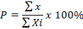
Description:
P = Percentage sought
X = Total Score
Xi = Maximum Score

To give meaning and make decisions from the calculation scores that have been obtained above, the scores can be interpreted with a range as in the table below

Table 2. Points for the Respondent Questionnaire Awards
Percentage | Standards
85- 100% | Very good
69 - 84% | Good
53 - 68% | Simply
37 - 52% | Less
21 - 36% | Very Less
(Ekayana, 2019)

Result and Discussion
Based on the Higher Education Curriculum in accordance with KKNI, entrepreneurship courses are core courses in the Agricultural Product Technology Study Program with a weight of 3 credits. The curriculum is a guide in preparing a learning module, because in the curriculum there are several important rules to consider which include learning outcomes, Competency standards, fundamental competences, indicators, learning goals, resources, exercises, and assessment. The finished module is prepared, followed by a concept map and then checking the outline, font size, font type, space composition, color, image, color on the material and the completeness of the material content, it is all done so that the module is compiled with minimal errors and makes it attractive to students to learn it.
Entrepreneurship Module

Introduction to Entrepreneurship

Entrepreneurial Financial Principles

Entrepreneurial Attitude and Profile

Entrepreneurship
Young

Creativity and Innovation

Productivity
Business

Business Planning and Ethics

Plan
Marketing

Business Opportunity Analysis

Evaluation

Figure 2. Concept Map of Entrepreneurship Course Material
The next step is to print the module that has been validated and corrected, then the module is printed with a predetermined size as shown below.

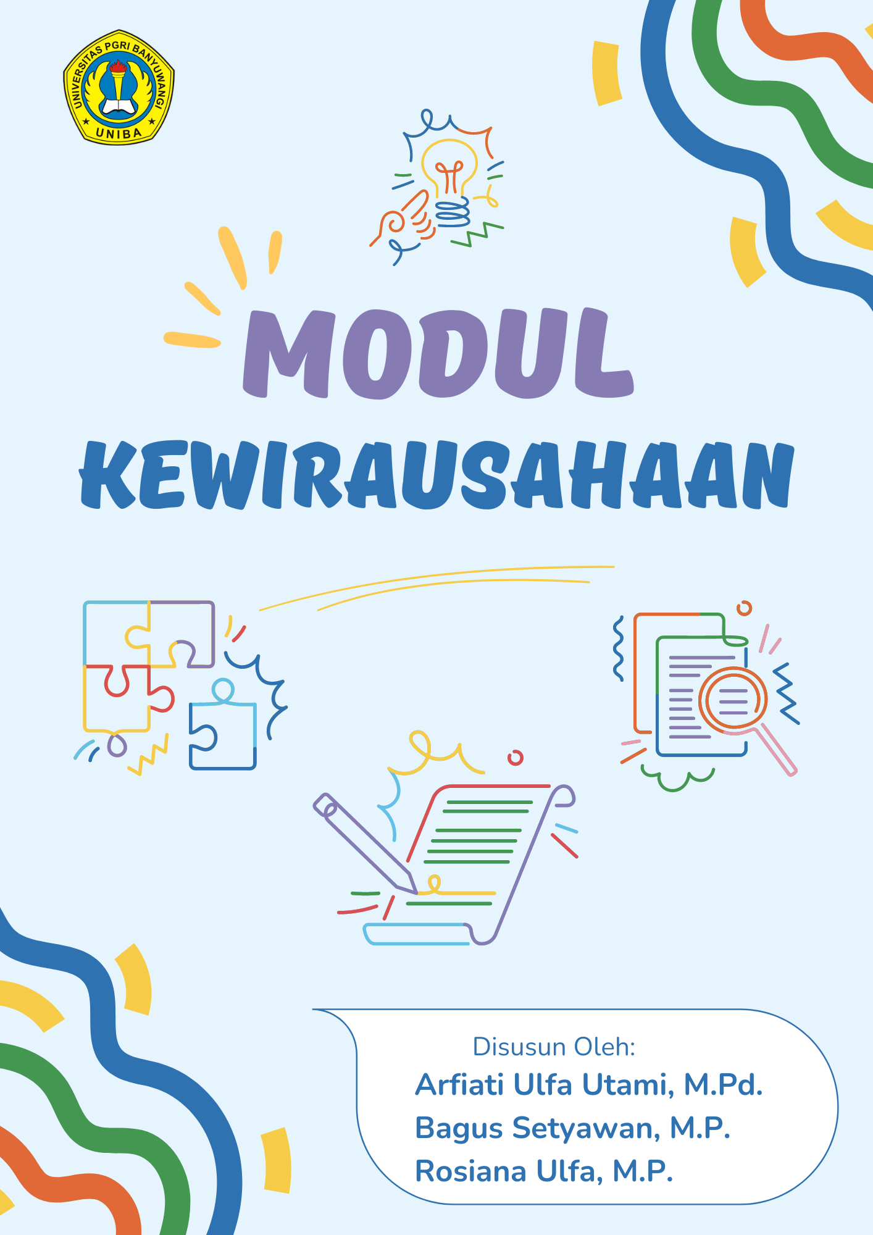
Figure 3. Entrepreneurship Module Design

Experts in materials and design were involved in the product validation process. Material and design experts involve a lecturer who has competence related to the content and design of the module. The validation results are as follows

Table 3. Material Expert Validation Results
No. | Content and Language Appropriateness | Score
No. | Content and Language Appropriateness | 4 | 3 | 2 | 1
1 | Suitability of material with learning outcomes | √
2 | Correctness of concept |  | √
3 | Contextuality of the material presented | √
4 | The material is easy to understand | √
5 | Ability to stimulate critical thinking | √
6 | Ability to stimulate creative thinking |  | √
7 | Ability to train independent learning | √
8 | Correct use of Indonesian spelling | √
9 | Correct use of sentences and terms | √
10 | Appropriateness of language use with cognitive development |  | √
Total |  | 37
Percentage (%) |  | 92,5
Based on Table 3 above, this total value is converted to the respondent's questionnaire score criteria guidelines, so that the percentage of material expert validation is 92.5% and can be categorized as very good so that it does not need to be revised.

Table 4. Media Expert Validation Results
No. | Presentation and Graphic Design | Score
No. | Presentation and Graphic Design | 4 | 3 | 2 | 1
1 | Presentation of material creates a pleasant atmosphere |  | √
2 | Presentation of material is equipped with pictures |  | √
3 | Presentation of material provides opportunities to carry out tasks independently | √
4 | Presentation of figures and tables | √
5 | Summary presentation |  | √
6 | Presentation of glossary and bibliography |  | √
7 | Conformity between text and image | √
8 | Readability of writing | √
9 | Image size and color are clear | √
10 | Attractiveness of the cover |  | √
Total |  | 35
Percentage (%) |  | 87,5

Total value is converted to respondent's questionnaire score criteria guidelines, so that the percentage of media expert validation is 87.5% and can be categorized as very good so that it does not need to be revised. Then individual and group trials were conducted. The results of individual trials of module products are packaged in the form of printed media and neatly bound to increase student attractiveness. This trial involved 3 students from the Agricultural Product Technology Study Program. The particular trial's outcomes are displayed in Table 5 below.
Table 5. Individual/Limited Test Results
No. | Test Criteria | Score
No. | Test Criteria | 4 | 3 | 2 | 1 | 4 | 3 | 2 | 1 | 4 | 3 | 2 | 1
1. | Essentially clear | √ |  |  |  |  | √ |  |  |  | √
2. | Interesting and meaningful modules | √ |  |  |  |  | √ |  |  | √
3. | Relevant and contextual |  | √ |  |  | √ |  |  |  |  | √
4. | Sustainable | √ |  |  |  | √ |  |  |  | √
Total |  | 15 |  |  |  | 14 |  |  |  | 14
Percentage (%) |  | 93,7 |  |  |  | 87,5 |  |  |  | 87,5
Average (%) |  | 89,58

The results of the individual trial in Table 5 above obtained an average of 89.58%, meaning that the average can be categorized as very good. While Table 6 below displays the group trial's outcomes.
Table 6. Group Test Results
No. | Test Criteria | Score
No. | Test Criteria | 4 | 3 | 4 | 3 | 4 | 3 | 2 | 4 | 3 | 4 | 3 | 4 | 3 | 4 | 3 | 4 | 3 | 4 | 3
1 | Essentially clear | √ |  |  | √ | √ |  |  | √ |  |  | √ | √ |  | √ |  | √ |  |  | √
2 | Interesting and meaningful modules |  | √ | √ |  |  | √ |  | √ |  | √ |  | √ |  | √ |  |  | √ |  | √
3 | Relevant and contextual |  | √ | √ |  |  | √ |  | √ |  | √ |  |  | √ | √ |  | √ |  | √
4 | Sustainable | √ |  |  | √ |  |  | √ | √ |  |  | √ | √ |  | √ |  | √ |  | √
Total |  | 14 |  | 14 |  | 12 |  |  | 16 |  | 14 |  | 15 |  | 16 |  | 15 |  | 14
Percentage (%) |  | 87,5 |  | 87,5 |  | 75 |  |  | 100 |  | 87,5 |  | 93,7 |  | 100 |  | 93,7 |  | 87,5
Average (%) |  | 90,26

Based on Table 6 above is the result of a group trial involving 9 students, so an average of 90.26% was obtained. Based on the score criteria table, the average score can be categorized as very good. As stated by (Ibrahim & Purwatiningsih, 2017) The learning process's goals while employing modules include; 1) Making information more understandable and straightforward to avoid overly verbose; 2) Overcoming time constraints both lecturers and students. Overcoming the time constraints of both lecturers and students; 3) increase student motivation and passion for learning; 4) develop students' ability to interact directly with the environment and other learning resources; 5) allow students to study independently according to their abilities and interests; 6) allow students to measure or evaluate their own learning objectives. Thus, it may be said that the purpose of compiling the module is so that students can master the competencies to be achieved in learning activities as much as possible.
In preparing teaching modules, the ability and creativity of a teacher is needed. This is because the teaching module is one of the teaching tools that is crucial for classroom's educational process to be successful. This teaching module aims as a direction or benchmark for the process of learning that will thereafter take place in the classroom, so that creative thinking is needed from a teacher to manage the class so that the learning process becomes interesting and fun. However, there are still quite a number of teachers who still do not understand how to prepare teaching modules in the independent curriculum (Salsabilla, 2023).
According to Smaldino (Smaldino et al., 2011) the advantages of learning modules are; 1) The content can be finished by students at their own pace of study; 2) Module is an integrated learning package; 3) Validated, modules are tested and validated before being distributed, with a large enough number of enthusiasts, vendors can invest in curriculum research and development. Besides having advantages, modules also have disadvantages, including (Ibrahim & Purwatiningsih, 2017); 1) The material contains a verbal high element; 2) requires readers to focus intently and try hard to understand the content; 3) The presentation is fixed and cannot be altered; 4) Not all kinds of knowledge can be explained through modules; 5) Module preparation is more difficult when compared to electronic learning materials; 6) Paper-based materials are very vulnerable. Based on the advantages and disadvantages of modules above, it can be concluded that modules have high validity, with modules students can determine their own learning speed and modules are also easy to carry everywhere and can be studied according to the material needed. However, modules require a long time for the development process, besides the printing costs are also quite large.
Learning independence is the attitude of students with a desire to learn that is driven by their own desires. The existence of learning activities based on their own will, their own choice and their own responsibility. Independent learning certainly has its own criteria in terms of influencing learning independence. A contributing aspect to students' interest in learning independence is the availability of modules or e-modules as instructional materials. Independence has several indicators that cause the desire to learn independently, including: self-confidence, motivation, initiative, and responsibility. One of the main characteristics in learning biology is the need for independent learning as a means of support. In research conducted by Kismiati (2020), one solution in increasing students' learning independence is to enrich them by utilizing e-modules as teaching materials with attractive designs to grab kids' interest and direct them toward learning (Saparuddin, 2022).
Based on several references that have been analyzed, the use of modules can increase students gaining self-reliance. The findings of the research that was done demonstrate this by Kismiati (2020) who found an increase in learning independence with an average score of 80.83 within the modest range. The results showed that there was learning independence students after implementing an enrichment program using E-modules. The same thing is also in accordance with study carried out by Linda, et al (2021) The increase in student learning independence after using emodules is from 75.00% to 87.92% in the medium to high category. This increase is due to the e-module making students enthusiastic in learning and independent because the material presented is very interesting and the presentation is in the form of images and animations that have been presented.

Conclusion
Considering the findings of the previously described research, the entrepreneurship learning module is the right solution in increasing student independence. This module is used as a reference in entrepreneurship courses in the Study Program for Agricultural Product Technology. According to his research, the material expert approval was 92,5% and the confirmation of media experts was 87.5% so that it could be categorized as very good. It is also carried out limited and group trials with the aim of seeing the feasibility of the products developed. The small trial's outcomes showed an average of 89.58%, meaning that the average can be categorized as excellent and the group trial's outcomes obtained average of 90.26% so that the developed module is categorized as feasible and can train student independence.

References
Baasri, H. (2015). New Paradigm ofLearning System. Bandung: Faithful Library.
Ekayana, A A Gede. Ratna R A. 2019. Development of Internet of Things Course Learning Modules. Jurnal of Technology and Vocational Education Vol.16 No.2 July 2019 ISSN 2541-0652
Ibrahim, N, & Purwatiningsih, H. (2017). Open and distance education perspectives: Theoretical and Application Studies. (Richardus Eko Indrajit, Ed.) (1st ed.). Yogyakarta: Graha Ilmu.
Ministry of Education and Culture. 2014. Regulation of the Minister of Education and Culture Number 49 of 2014 concerning National Higher Education Standards. Jakarta: Ministry of Education and Culture
Kismiati D A. 2020. Implementation of E-Modules for Enrichment of Isolationand Caracterization of Bacteria in Increasing Learning Independence of High School Student. Alveoli: Journal of Biology Education. 1: 1-10
Linda R, et all. 2021. Increasing the Independence and Learning Outcomes of Learners Through the Implementation of Interactive E-Modules of Conected Type Integrated Science on Energy Material in Junior High School / MTs. Indonesian Journal of Science Education. 9: 191-200.
Mansur, N. 2017. Achievement of Learning Outcomes in View of Student Learning Attitudes. Lantanida Journal, 3(2), 107-115.
Nahar, N. 2016. Application of Behavioristic Learning Theory in the Learning Process. NUSANTARA: Journal of Social Sciences, 1(1). Retrieved from http://jurnal.um tapsel.ac.id/index.php/nusantara/article/view/9 4
Rahmi, E. Ibrahim N. Dwi K. 2021. Development of Online Modules for Open and Distance Learning Systems to Improve Learning Quality in the Educational Technology Study Program. Junal Visipena Vol. 12, No. 1 June 2021. ISSN 2502-6860
Salsabilla I, Erisya, Juanda. 2023. Analysis of Teaching Modules Based on the Independent Curriculum. Indonesian Journal of Literacy and Learning Vol. 3 No. 1, 33-41
Saparuddin. 2022. The Use of E-Modules as a Solution to Increase Motivation and Learning Independence of Learners. Proceedings of the National Seminar on Biology FMIPA UNM.
Smaldino, S. E., Lowther, D. L., & Russel, J. D. (2011). Instructional Technology & Media For Learning: Learning Technology and Media for Learning. Jakarta: Kencana Prenada Media Group.

