PRIMARY STUDENTS' PERCEPTION LEVEL OF FOOD IN THE SCHOOL ENVIRONMENT OF BANYUWANGI STATE 2 TUKANG KAYU
PRIMARY SCHOOL

Arfiati Ulfa Utami¹, Agnes Juniarti Chastelyna², Bagus Setyawan³,
Yuvita Lira Vesti Arista⁴, Rosiana Ulfa⁵
Agricultural Product Technology, Faculty of Agriculture, PGRI University Banyuwangi
Corresponding Author e-mail: arfiatiuniba@gmail.com

Abstract: The importance of elementary school students understanding healthy food is very important because this will have an impact on students' health and the school environment. This research aims to measure the extent of students' perceptions of snacks in the school environment at SD Negeri 2 Tukang Kayu Banyuwangi. This research uses a survey method. The subjects in this research were 50 class V students of SD Negeri 2 Carpenter Banyuwangi. The research instrument is in the form of a questionnaire or questionnaire. The analysis used is descriptive qualitative. The results of student perceptions showed that 72% of students could understand healthy snacks in the school environment. | Article History  Received: 2  Revised:  Published:.. 2017  Key Words :  Student perceptions, snack foods, school environment
How to Cite: First author., Second author., &amp; Third author. (20xx). The title. Jurnal Paedagogy: Jurnal Penelitian dan Pengembangan Pendidikan, vol(no). doi:https://doi.org/10.33394/jp.vxxyyi
Introduction
Food is the intake of living creatures as a source of energy to carry out activities. Snack food is food that is bought and sold. The school environment is a place where students carry out activities to obtain learning directly or indirectly involving a number of students. The school environment has a big influence on the level of cleanliness of a child's diet. Students' access to snacks in the school environment is very easy, even if the child has brought provisions from home. Snacks that children generally like are snacks that are attractive in terms of color and taste. In fact, most of these snacks contain many dangerous chemicals and cannot be separated from biological contamination (Khomsan, 2010). The impact of unhealthy food causes various factors, one of which causes various diseases. Problems with food generally occur due to unclean processing and presentation, resulting in a lot of contamination (Srikandi in Zentalian (2014). Diseases that occur due to unhealthy behavior cause health problems such as cancer, poisoning, and impaired growth and development in school age students ( Syarifuddin, 2022).
According to BPOM in 2016, school snacks currently available in school environments are increasingly diverse, from traditional snacks to modern snacks, which ultimately attracts students to buy and consume these snacks and has a negative effect on the health of school children. The school period is a golden period or growth and development period, so it requires intake and nutrition to support the growth and development process. The snacks offered in schools are increasingly diverse. This development can encourage the habit of consuming snacks among school children, especially during recess. Conditions in the field are that there are still many children who do not have the habit of consuming healthy snacks (Anto, 2017). Food safety for school children's snacks requires serious attention. One form of effort to address the problem of food consumed by students in schools throughout Indonesia is by monitoring children's snacks. The dominant cause of cases of children being poisoned at school is food sold by snack vendors that is not hygienic and meets hygiene and health standards. Weak supervision of snacks has an adverse impact on one's health in the future (Aini, 2019).
Selection of snack foods is a manifestation of behavior. The factors that influence the formation of behavior are internal and external factors. Factors that influence food choices are divided into three groups, namely food-related factors, personal factors related to food choice decision making, and socio-economic factors (Gusani in Utami, & Waladani, 2017).

Research Method
This research is included in quantitative descriptive research with survey methods. The research was carried out at SD Negeri 2 Tukang Kayu Banyuwangi with a total of 50 students as respondents. The data collection technique uses a questionnaire by giving written questions to respondents.

Result and Discussion
The Students' perceptions of snacks at SD Negeri 2 Carpenter School were determined by researchers conducting a survey by asking several questions to students through a questionnaire that had been made by researchers for respondents, namely fifth grade elementary school students, who then answered honestly. There are 15 indicators which include
1. Clean and closed snacks are foods that are safe to eat
2. Fruit and vegetables can be eaten raw without having to wash them first
3. The snacks smell rancid and rotten and are not safe to eat
4. Snacks that smell rancid can still be eaten
5. Snacks using bright colors are safer to consume
6. Snacks using artificial sweeteners are healthy
7. Packaged snacks are kept clean
8. Wrapped snacks are safer to eat
9. Snack packaging that has been damaged can be eaten
10. Snacks that are past their expiration date are dangerous
11. Food contains lots of nutrients that are good for health
12. Hands should be washed before touching food
13. Foods that contain lots of preservatives are not good
14. Students are encouraged to bring their own food from home
15. Don't forget to read the nutritional content of each food

The results of research related to students' perceptions of healthy food can be obtained as follows
1. In indicator 1, the image results below are obtained
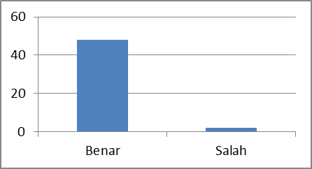
Correct
Wrong
Figure 1. Results of indicator 1

Based on the picture above, the correct results were 48 and the wrong results were 2 out of a total of 50 students. Student perceptions in indicator 1 can be stated that students are able to understand healthy food and are able to choose safe food in the school environment.

2. In indicator 2, the image results below are obtained
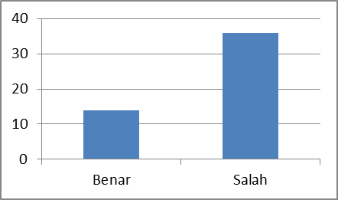
Correct
Wrong
Figure 2. Results of indicator 2

Based on the picture above, the correct results were 14 and 36 incorrect out of 50 elementary school students. Student perceptions in indicator 2 can be stated that students are actually able to differentiate between types of vegetables or fruit that need to be washed first.

3. In indicator 3, the image results below are obtained
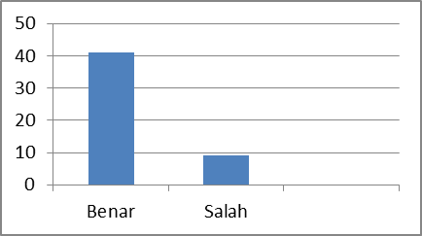
Wrong
Correct
Figure 3. Results of indicator 3

Based on the picture above, the correct results were obtained, namely 41 correct and 9 wrong out of 50 students. Indicator 3 is food that smells or is rotten and is not safe to eat. Students were able to answer this statement correctly by 41.

4. In indicator 4, the image results below are obtained
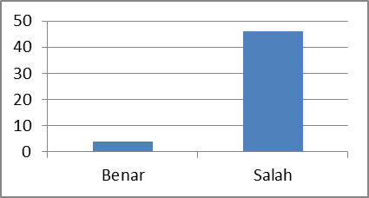
Wrong
Correct
Figure 4. Results of indicator 4

Based on the image above, the results obtained were 4 in the correct category and 46 in the incorrect category. Indicator 4 includes food that smells rancid and can still be eaten. Students still cannot understand food related to rancid odors.

5. In indicator 5, the image results below are obtained
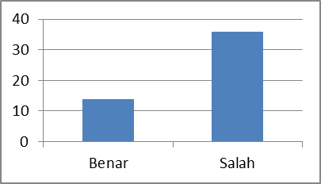
Wrong
Correct
Figure 5. Results of indicator 5

Based on the picture above, the perception results obtained were 14 correct and 36 incorrect from 50 students on the indicator that food that uses various dyes in bright, striking colors is safer to consume. Food coloring is an additive used to improve the appearance of fresh and processed foods. Many foods have striking colors, like snacks at school.

6. In indicator 6, the image results below are obtained
Wrong
Correct
Figure 6. Results of indicator 6

In indicator 6, drinks that use artificial sweeteners are healthy. Students answered 11 correct and 39 incorrect. Elementary students can already answer that sweet snacks are not good for health.

7. In indicator 7, the image results below are obtained
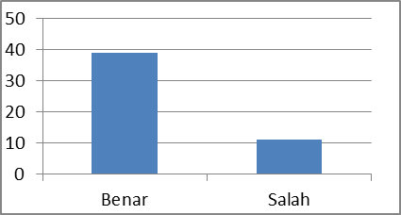
Correct
Wrong
Figure 7. Results of indicator 7

In indicator 7, namely food that is packaged is guaranteed to be clean, namely 39 correct and 11 incorrect from 50 students. Packaged snacks are kept more clean, this indicator means students are able to choose the correct answer.

8. In indicator 8, the image results below are obtained
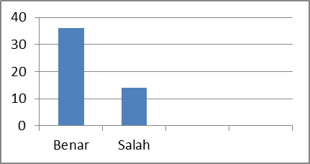
Correct
Wrong
Figure 8. Results of indicator 8

In indicator 8, the food that is wrapped is more guaranteed to be clean. A total of 36 students answered correctly and 14 students answered incorrectly on the indicator that packaged snacks are safer for consumption. Students were able to understand the importance of food safety.

9. In indicator 9, the image results below are obtained
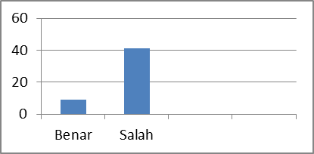
Correct
Wrong
Figure 9. Results of indicator 9

In indicator 9, namely food whose packaging has been damaged can still be eaten, and student perception is that 9 students answered food correctly and 41 students answered incorrectly. This means that students are able to answer the statement correctly.

10. In indicator 10, the image results below are obtained
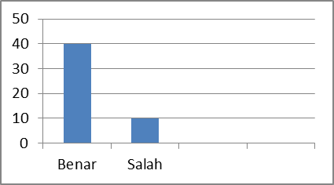
Correct
Wrong
Figure 10. Results of indicator 10

In Figure 10 above there is an indicator, namely that food past its expiration date is dangerous with the perception of 40 students who answered correctly and 10 students who answered incorrectly.

11. In indicator 11, the image results below are obtained
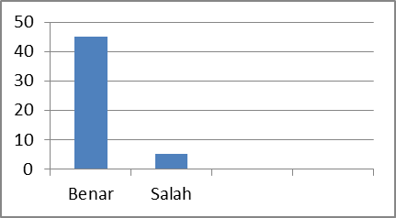
Correct
Wrong
Figure 11. Results of indicator 11

In Figure 11 above there are indicators, namely food that contains nutrients that are good for health with a perception result of 45 correct answers and 5 wrong answers.

12. In indicator 12, the image results below are obtained
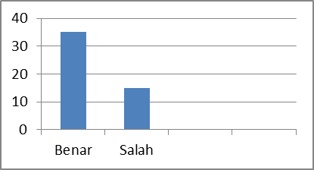
Correct
Wrong
Figure 12. Result of indicators 12

In figure 12 above there is an indicator that washing hands before eating can prevent disease. The perception results include 35 students' correct answers and 15 students' wrong answers.

13. In indicator 13, the image results below are obtained
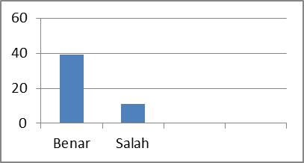
Correct
Wrong
Figure 13. Results of indicator 13

In Figure 13 above, the perception results obtained were 39 students with correct answers and 11 students with incorrect answers out of 50 elementary school students on the indicator that food with too many flavorings and preservatives is not good for health.

14. In indicator 14, the image results below are obtained
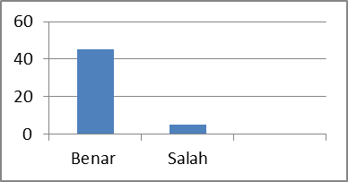
Wrong
Correct
Figure 14. Results of indicator 14

In Figure 14 above, the perception results showed that 45 students had correct answers and 15 wrong answers out of 50 students with indicators that breakfast and bringing lunch were healthier than school snacks. Most of the students were able to answer correctly because many students brought supplies.

15. In indicator 15, the image results below are obtained
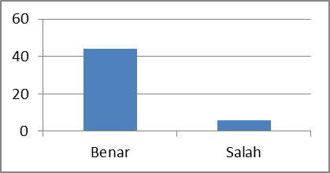
Wrong
Correct
Figure 15. Results of indicator 15

In the picture above, the perception results show that 44 students answered correctly and 6 students answered incorrectly out of 50 students on the indicator that every time you buy packaged food you need to read the nutritional content. The negative aspect of snack foods is that if consumed excessively it can cause excess energy intake. A study in the United States shows that children consume more than a third of their daily calorie needs from fast food and soft drinks, thus contributing to increasing intake beyond needs and causing obesity (Safriana, 2012). Another problem with snack foods is related to their safety level. Misuse of dangerous chemicals or inappropriate addition of food additives by food producers is an example of the low level of knowledge of producers regarding the safety of the snacks they produce. Producers' ignorance regarding this abuse and poor hygienic practices are the main factors causing the snack food problem (BPOM, 2007).
According to Extraordinary Events (KLB) of food poisoning collected by the Directorate of Food Safety Surveillance and Counseling of BPOM RI throughout Indonesia in 2008-2010, it shows that 17.26 – 25.15% of cases occurred in school environments with the highest group being elementary school students. Food additives (BTP) in school snacks have exceeded safe limits as well as microbiological contamination. Based on sampling of school children's snacks carried out in 6 provincial capitals (Jakarta, Serang, Bandung, Semarang, Yogyakarta and Surabaya), 72.08% were found to be positive for containing dangerous substances (Rifka, 2015).

Conclusion
Based on the results of research on elementary school students' perceptions of snacks around the school environment at SD Negeri 2 Tukang Kayu which was included in quantitative research using a survey method using a questionnaire as a measuring tool for conducting data, it was found that the instrument was valid and reliable for measuring students' perceptions about snacks. around the school, the students' perception results show that 72% understand about healthy and hygienic food so that it is suitable for consumption.

References
Aini, Siti Qorrotu. 2019. Snacking Behavior in Elementary School Children. R&D Journal: Research, Development and Science and Technology Information Media. Vol XV No 2 December 2019 Pages 133-146 htpp://ejurnal-litbang.patikab.go.id.
Anto, Sudarman, S., Yetti, E.R., & Manggabarani, S. 2017. The Effect of Counseling to Modify the Lifestyle on Prevention of Obesity in Adolescents. Journal of Public Health
Republic of Indonesia Food and Drug Supervisory Agency. 2007. School Children's Snacks. Integrated Food Safety System.
National Agency of Drug and Food Control. 2012. Commitment and Independence of the School Community to Succeed the National Food Action BPOM R1 VOL 1 Jakarta.
Directorate of Food Safety Surveillance and Counseling, Deputy for Food Safety and Hazardous Supervision, BPOM RI. 2012. Food Safety in School Canteens. Jakarta: BPPOM RI.
Rifka, T. 2015. The Relationship between Knowledge and Attitudes Regarding Safe Snacks and the Behavior of Choosing Snack Foods in Class V Students of Cipayung State Elementary School. Depok: University of Indonesia.
Safriana. 2012. Snack Choosing Behavior among Elementary School Students at SDN Garot, Darul Imarah District, Aceh Besar Regency. Jakarta: FKM UI.
Syarifuddin, Surya et al. 2022. Healthy Snack Education for School Age Children. Journal of Progressive Community Service SELAPARANG. Volume 6, Number 1 March 2022 e-ISSN: 2614-526
Utami, W., & Waladani, B. 2018. Introduction to Healthy Snacks and Dangerous Snacks at SDN 2 Kalibeji, Sempor District. URECOL Proceedings. Purwokerto: Muhamadiyah University Purwokerto.

