Ethical Statement

Hereby, I consciously assure that for the manuscript “Determinant of Sustainable Entrepreneurial Intention: Mediating Role of Entrepreneurial Self-Efficacy” the following is fulfilled:

1) This material is the authors' own original work, which has not been previously published elsewhere.

2) The paper is not currently being considered for publication elsewhere.

3) The paper reflects the authors' own research and analysis in a truthful and complete manner.

4) The paper properly credits the meaningful contributions of co-authors and co-researchers.

5) The results are appropriately placed in the context of prior and existing research.

6) All sources used are properly disclosed (correct citation). Literally copying of text must be indicated as such by using quotation marks and giving proper reference.

7) All authors have been personally and actively involved in substantial work leading to the paper, and will take public responsibility for its content.

I agree with the above statements and declare that this submission follows the Jurnal Kependidikan: Jurnal Hasil Penelitian dan Kajian Kepustakaan di bidang Pendidikan, Pengajaran, dan Pembelajaran as outlined in the Guide for Authors and in the Ethical Statement.

Date: 27th February 2024

Corresponding author’s signature:
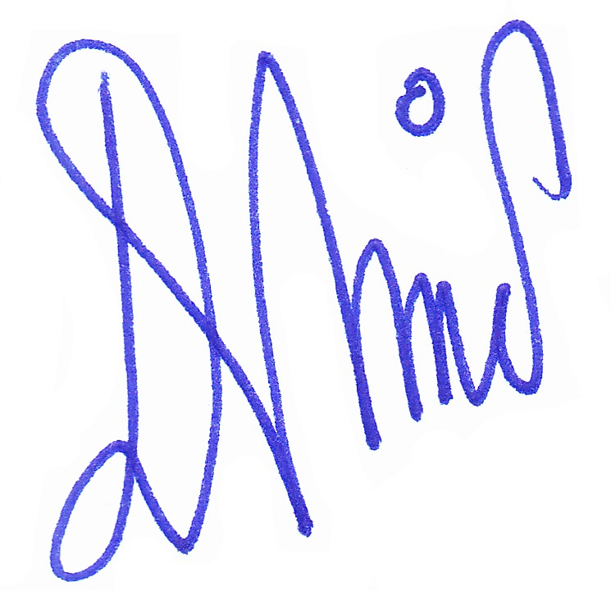

Dr. Dewi Kusuma Wardani, M.Si.

