Filsafat

*by* [Muhsinpd38@guru.sd.belajar.id](mailto:Muhsinpd38@guru.sd.belajar.id) 1

**Submission date:** 04-May-2024 06:57AM (UTC+0000)

**Submission ID:** 2370585315

**File name:** artikel_teks_inggris.docx (87.45K)

**Word count:** 5951

**Character count:** 36613

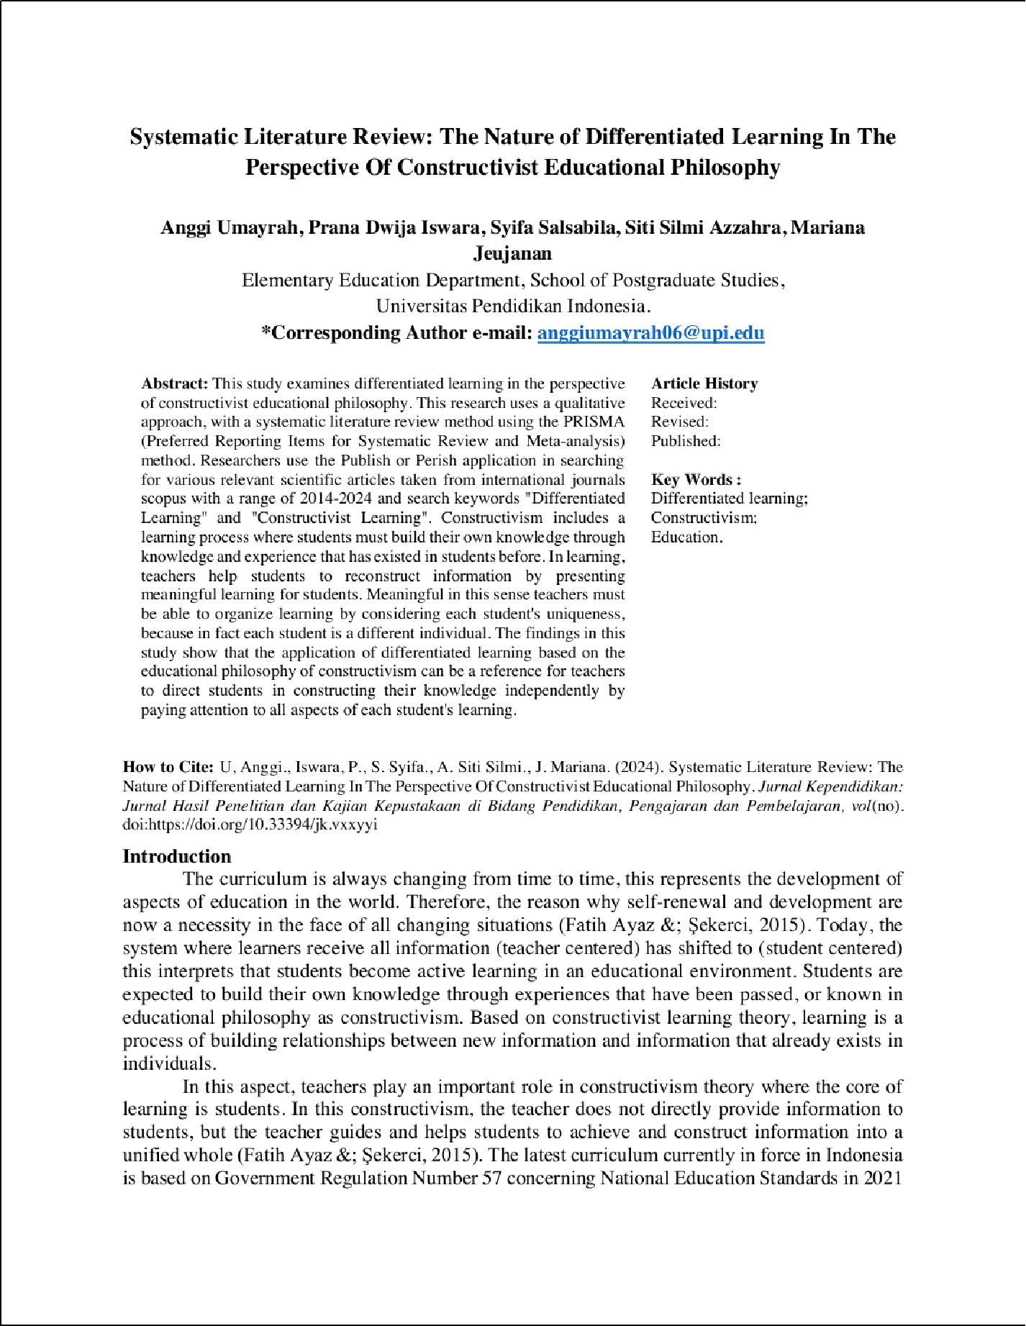

5

20

15

31

6

6

37

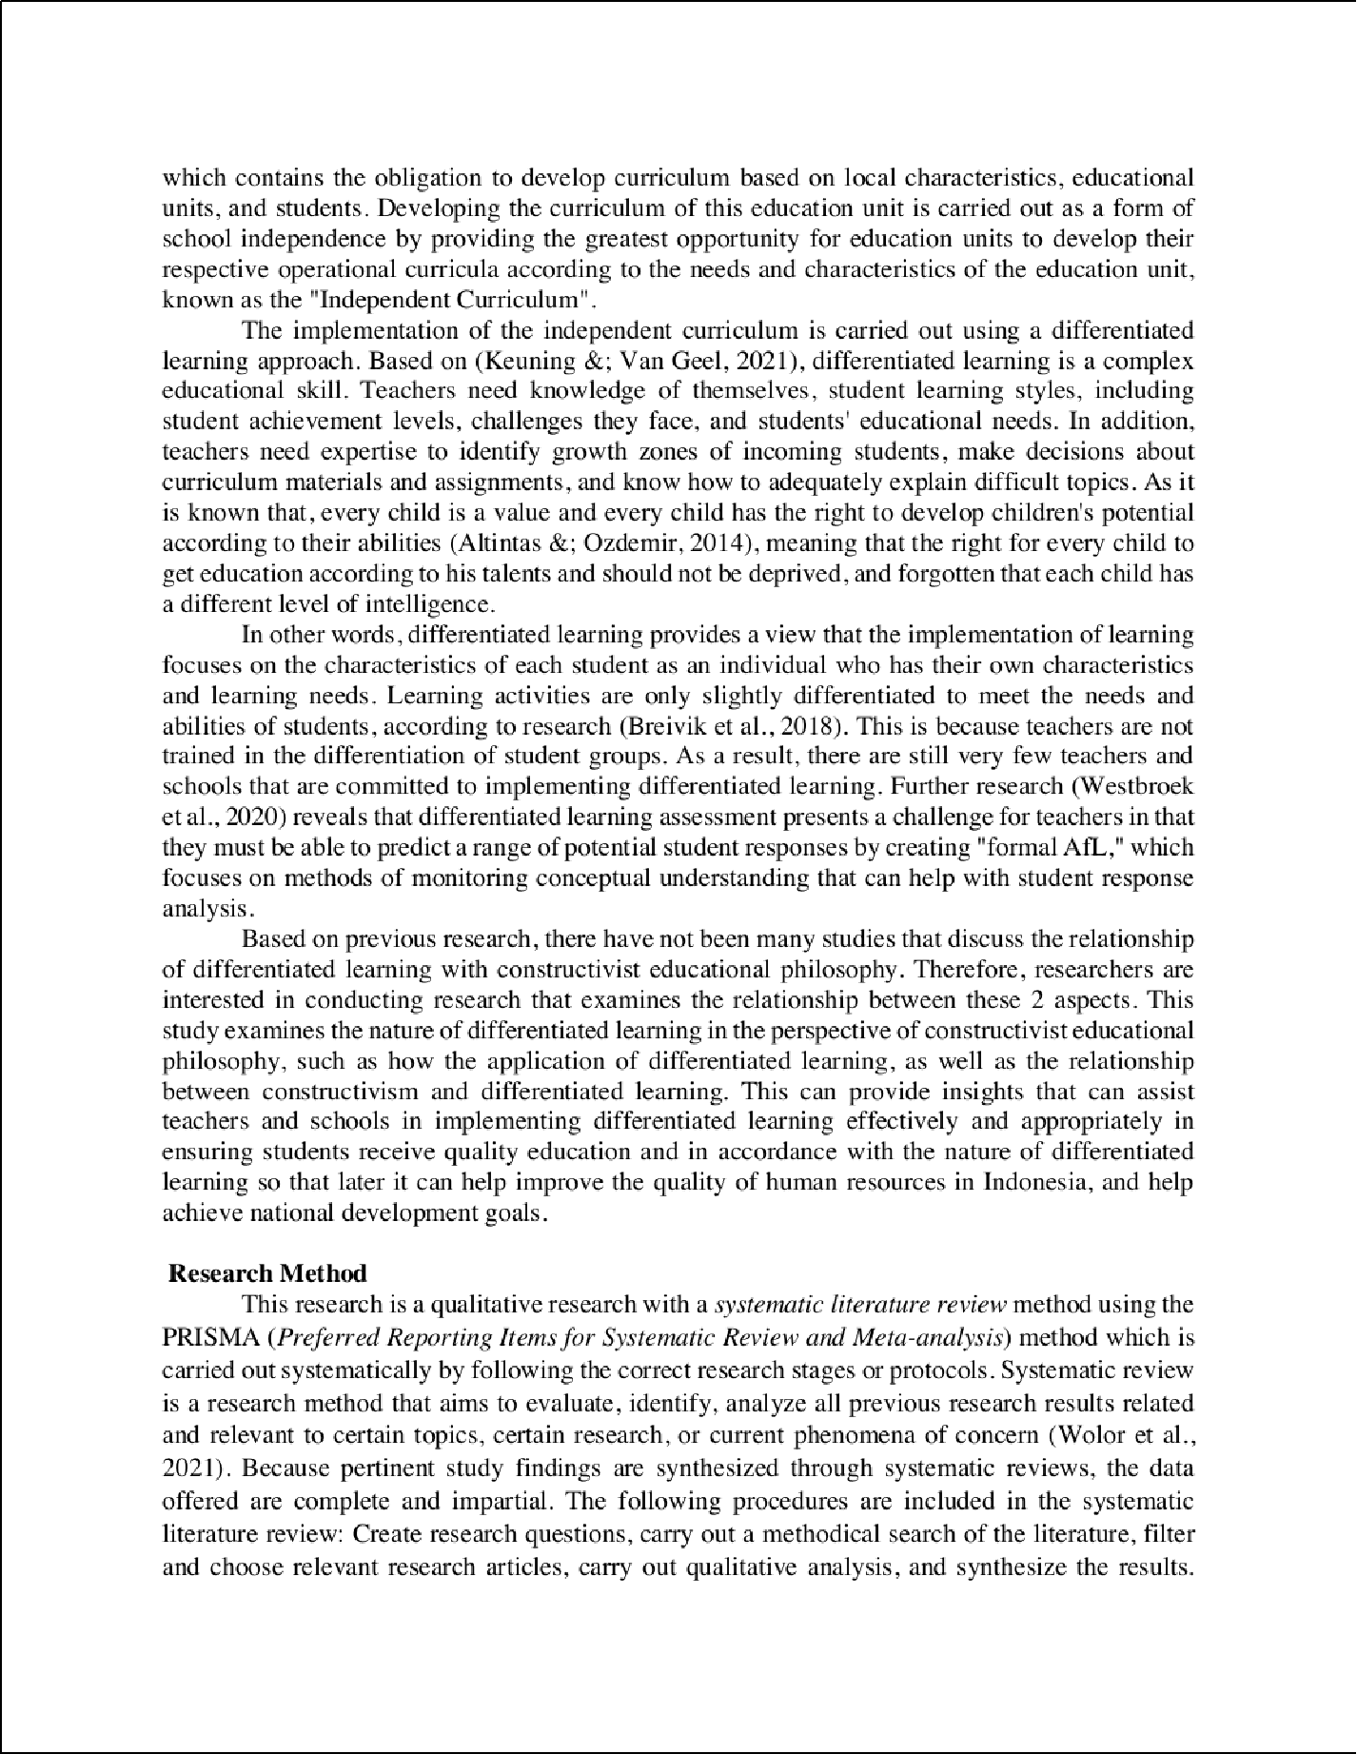

45

26

17

13

41

13

5

6

2

23

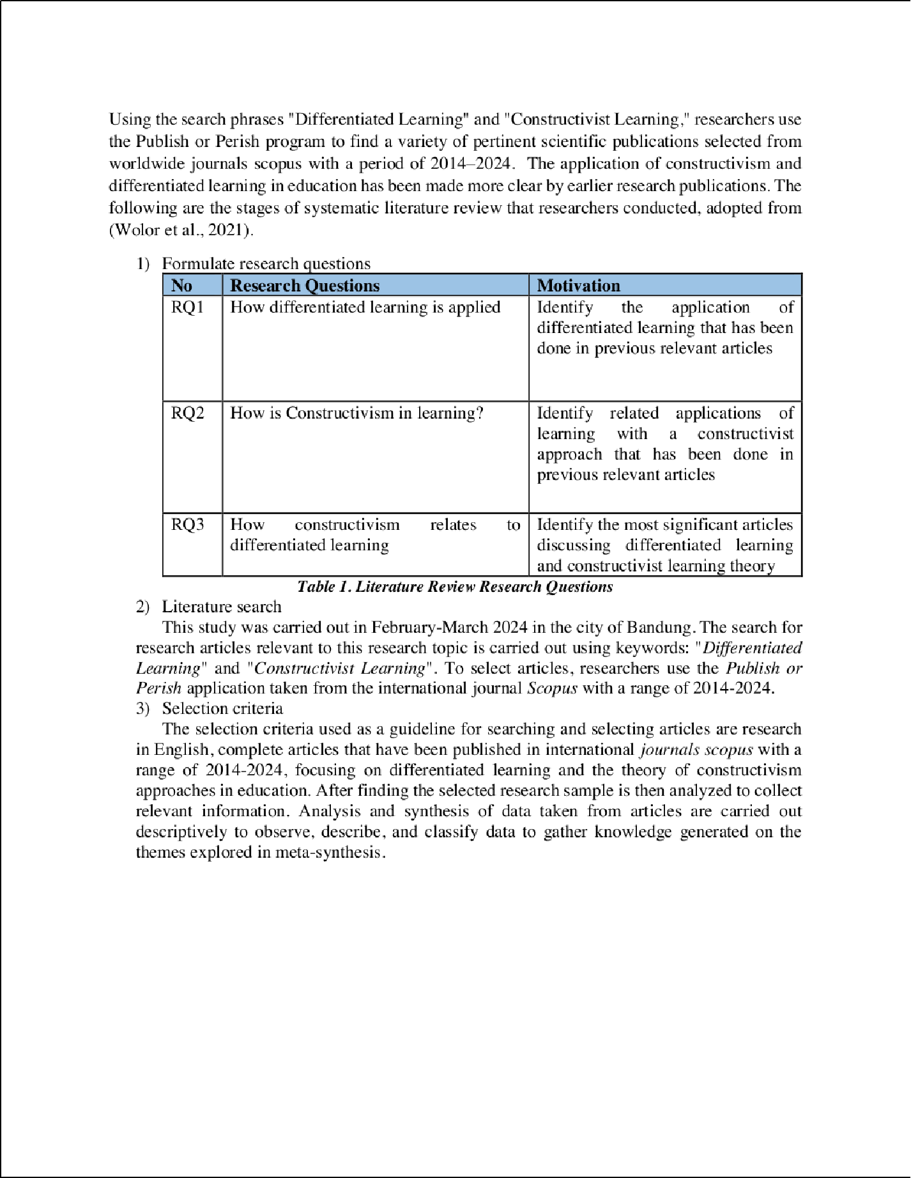

2

2

10

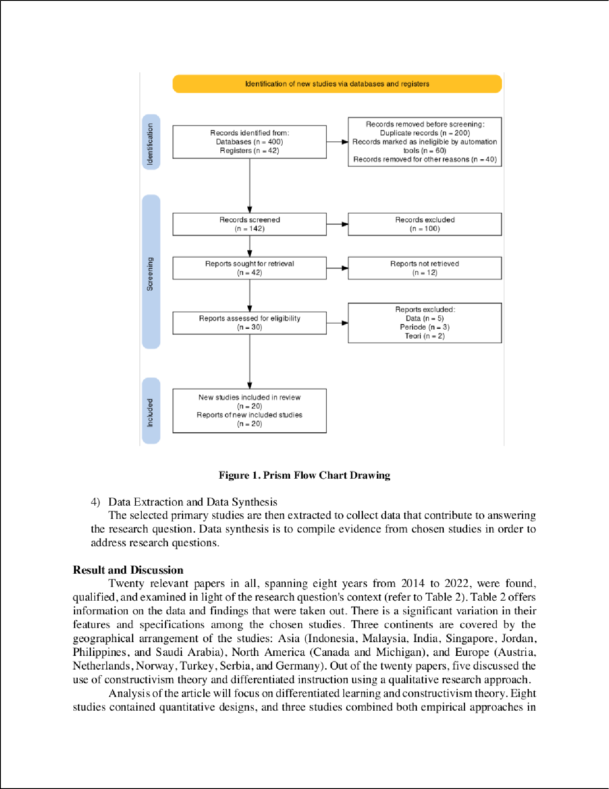

2

2

8

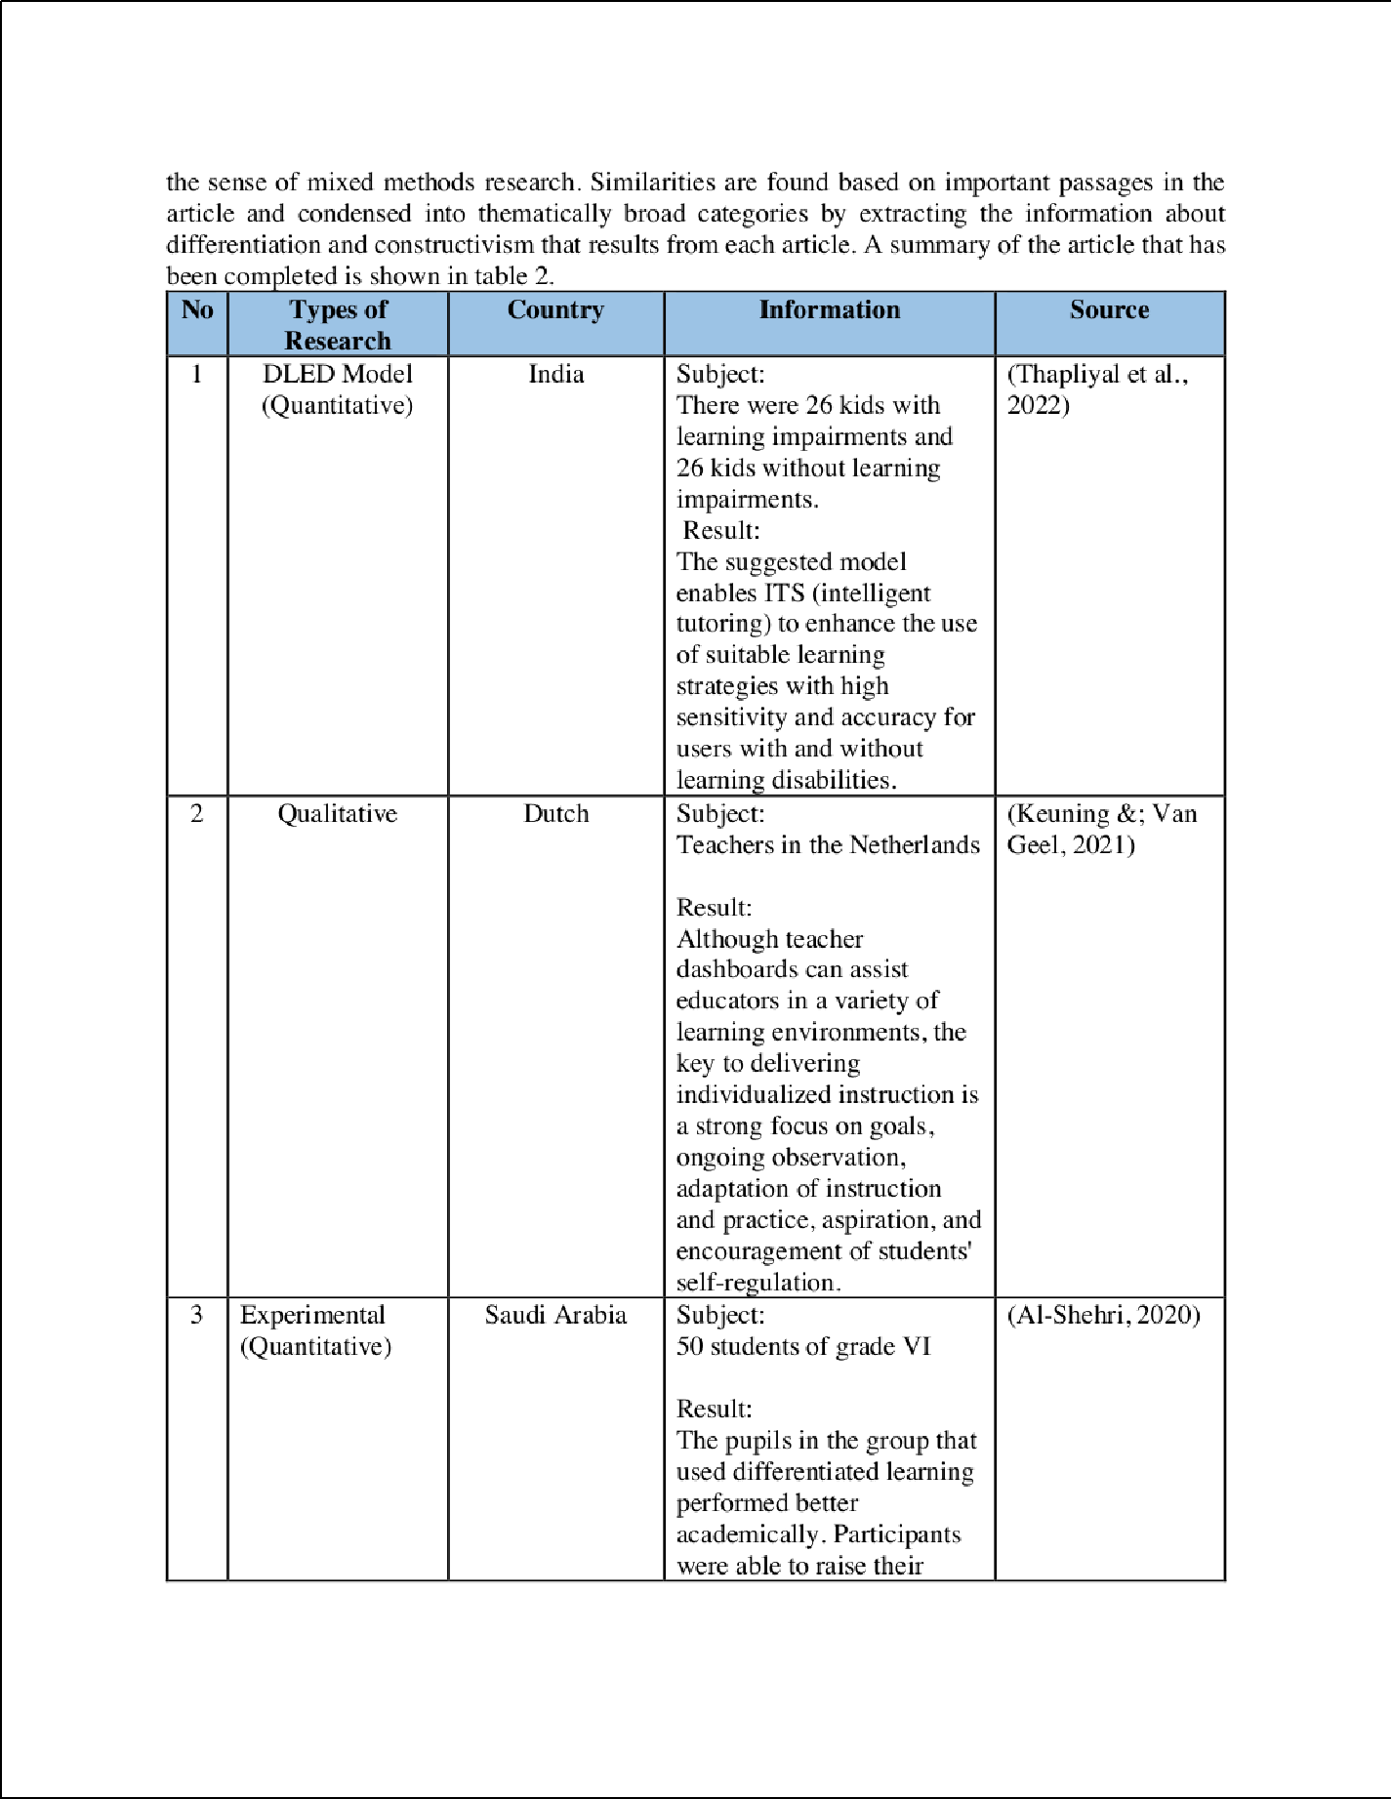

8

8

7

|  |  |  |  |
| --- | --- | --- | --- |
|  | |  | |
|  | | | |
|  | |  |  |
|  |
|  |  | | |

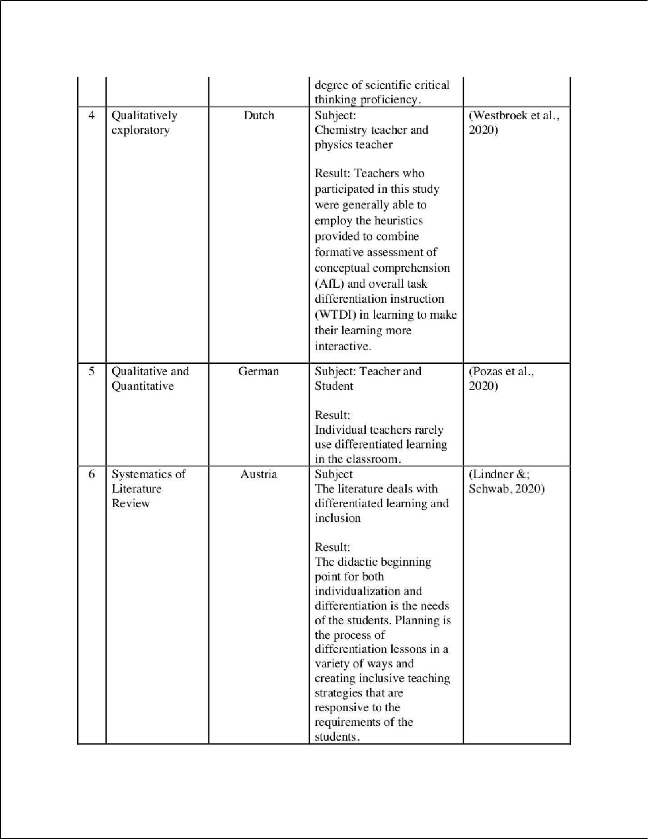

39

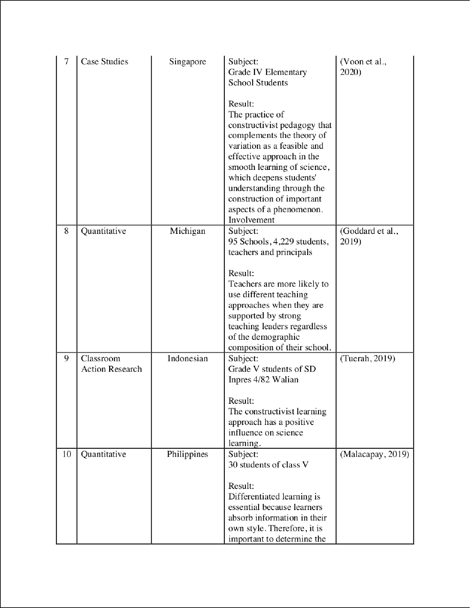

35

24

11

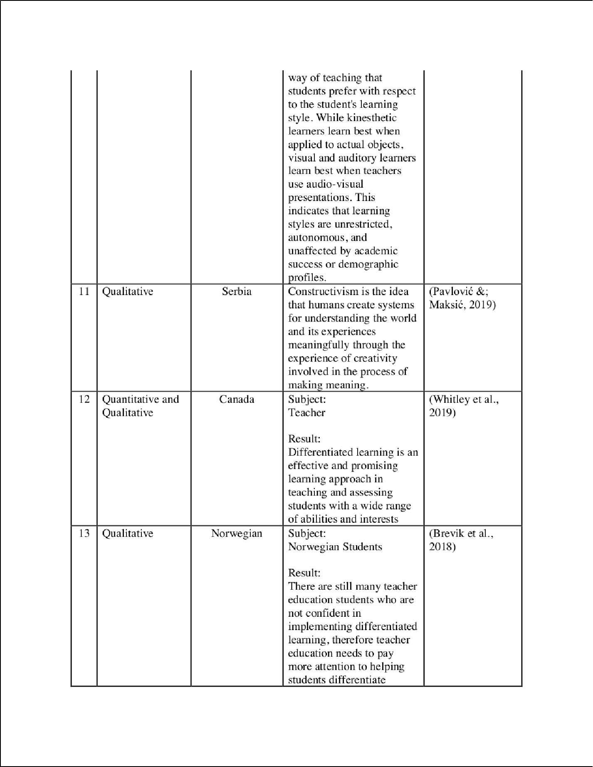

19

|  |  |  |  |  |  |  |
| --- | --- | --- | --- | --- | --- | --- |
|  | | |  | |  | |
|  | | | | | |  |
|  | |  | | | |  |
|  | | | | | | |
|  | | | |  | | |
|  |  | | |  | | |

9

|  |  |  |  |  |  |  |  |
| --- | --- | --- | --- | --- | --- | --- | --- |
|  | | | | | |  | |
|  |  |  | | | |  | |
|  |  | | |  | | | |
|  | | | | |  | | |
|  | | |  |  | | |  |
|  | | | | | |  |

4

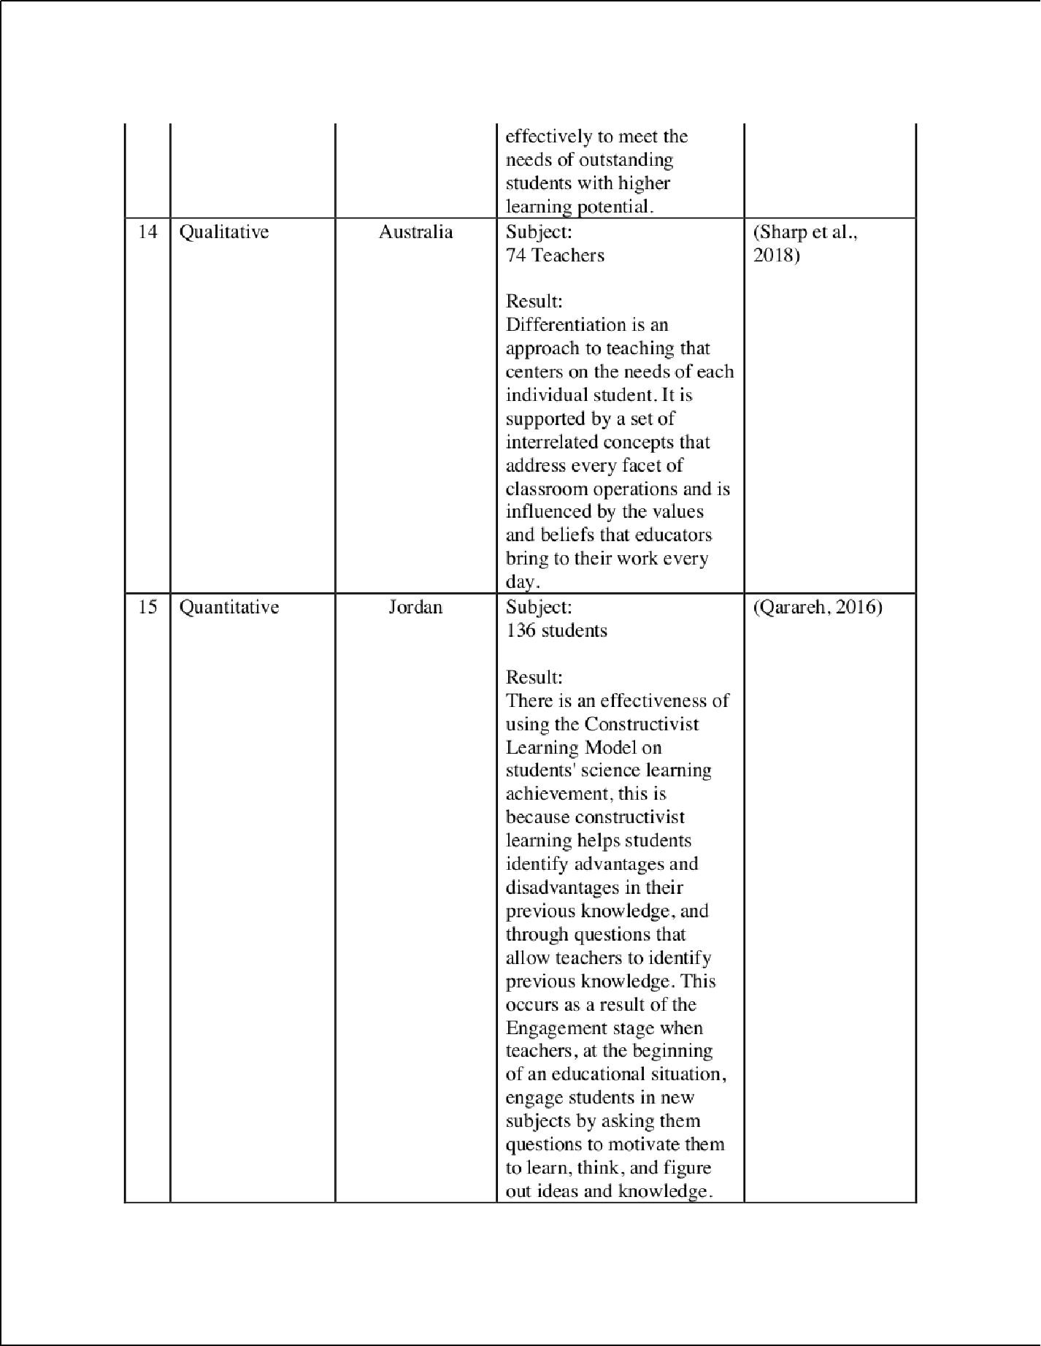

4

28

27

|  |  |  |  |  |  |  |
| --- | --- | --- | --- | --- | --- | --- |
|  | | |  | | | |
|  |  | | | | |  |
|  | | | | |  |
|  | |  | | |
|  | | | |  |

3

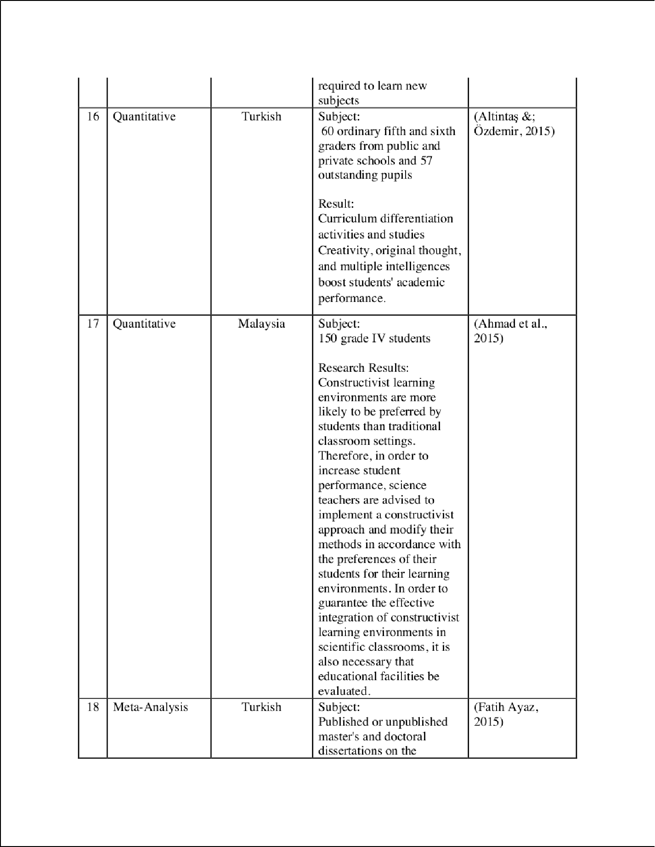

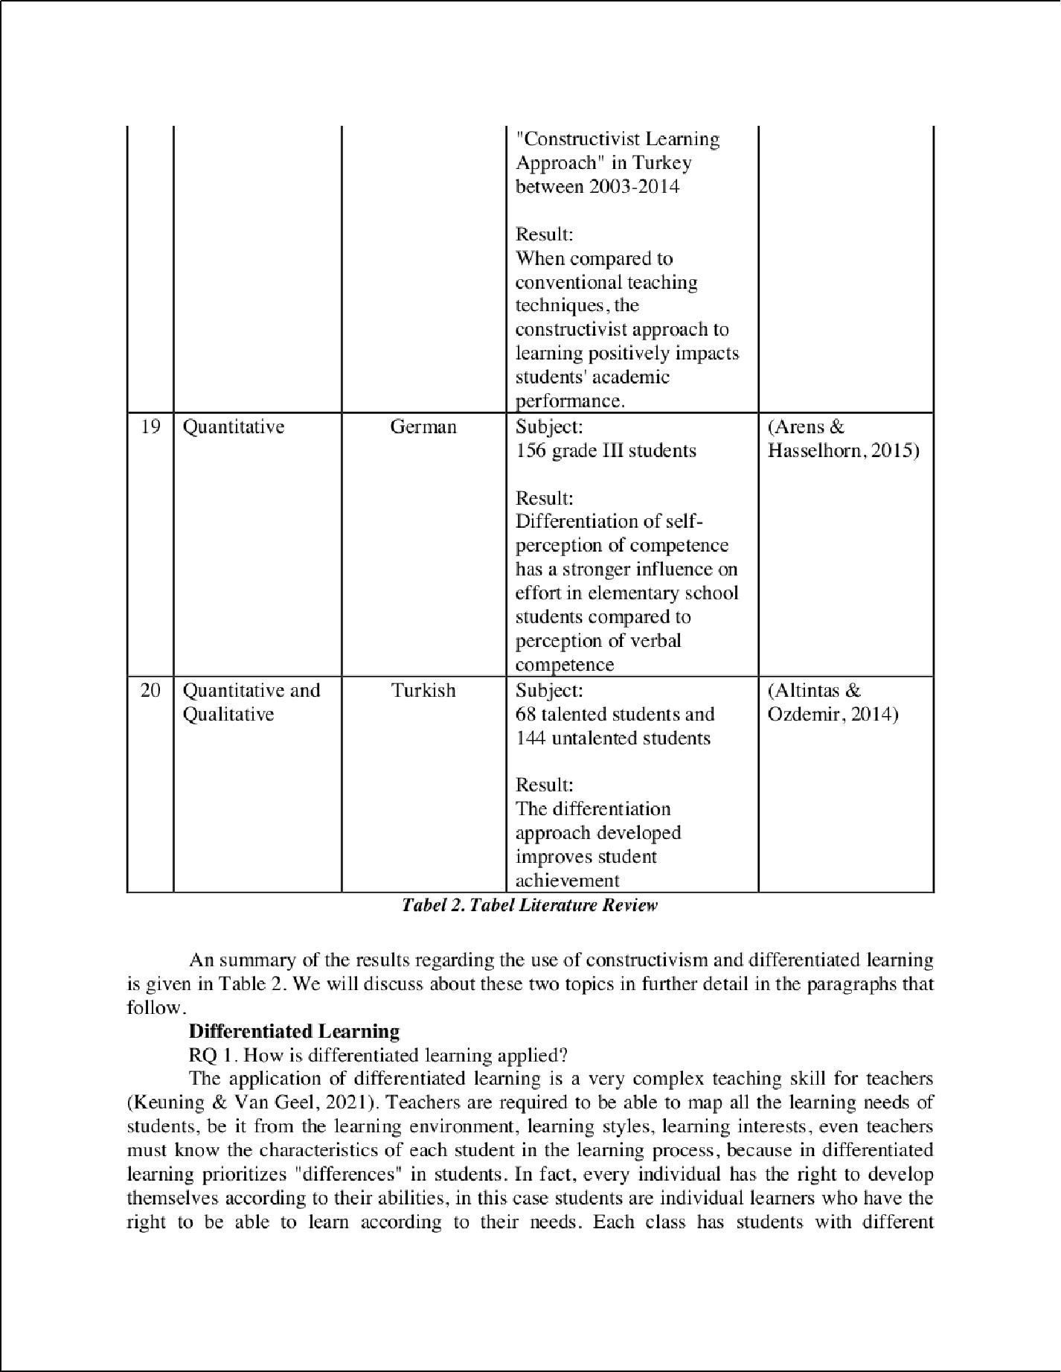

36

5

14

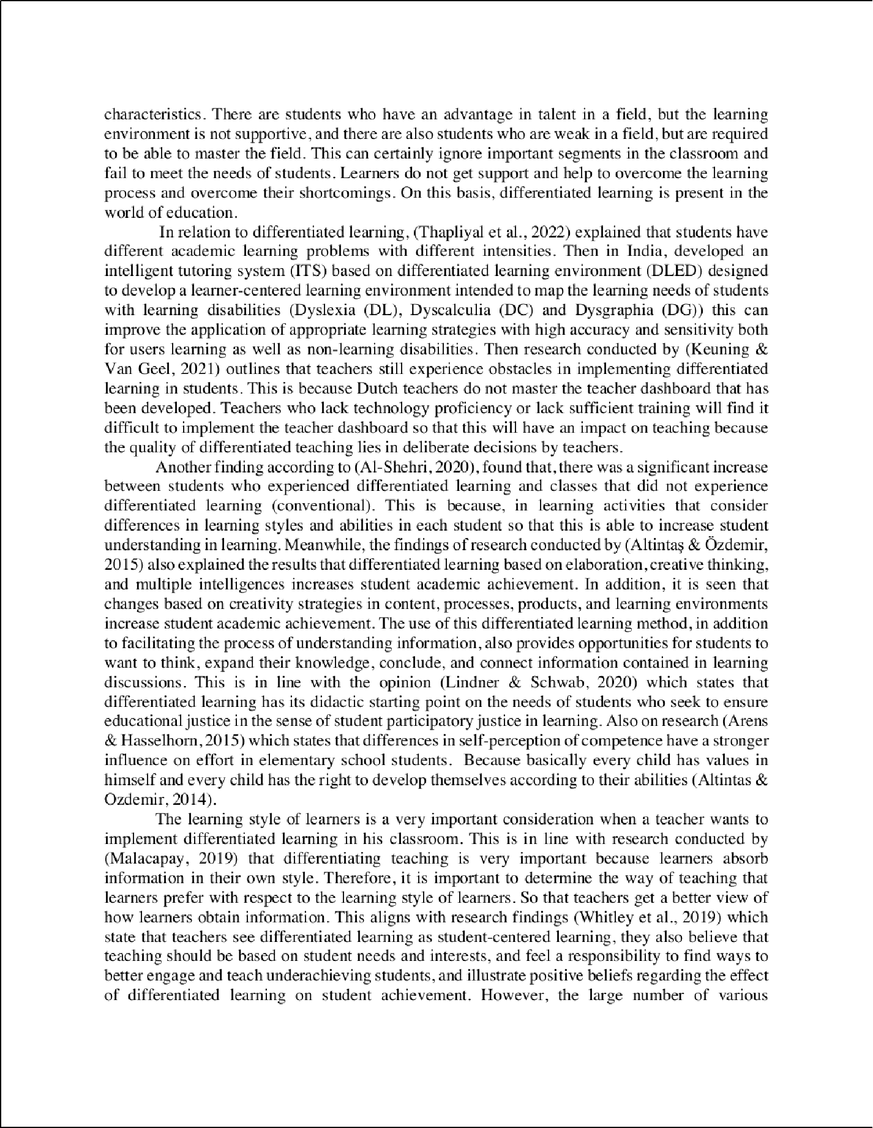

29

16

7

44

43

7

7

12

16

8

30

9 9

5

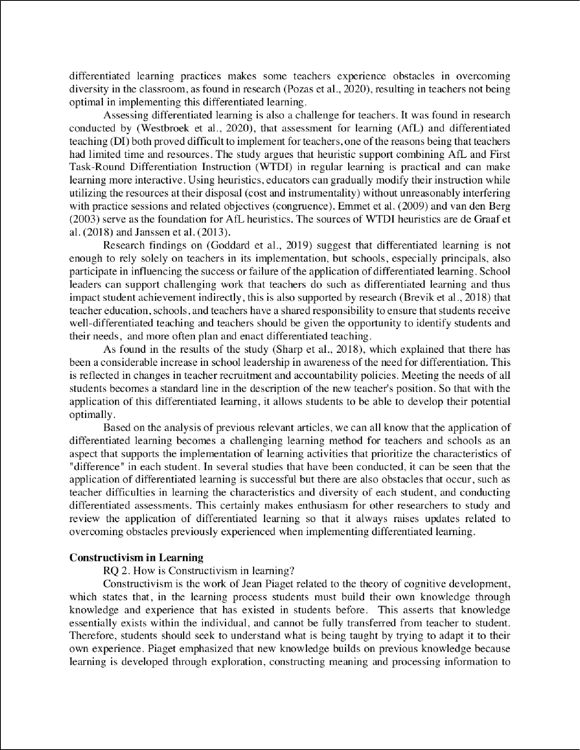

4

4

17

14

5

1

1

1

18

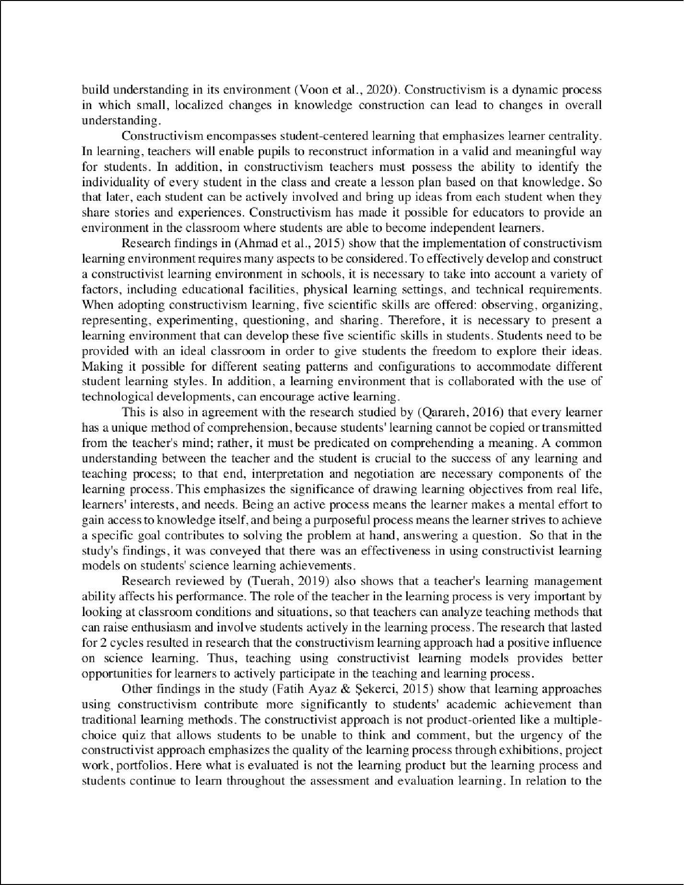

1

1

1

22

1

1

33

1

38

3

3

3

11

11

3

34

46

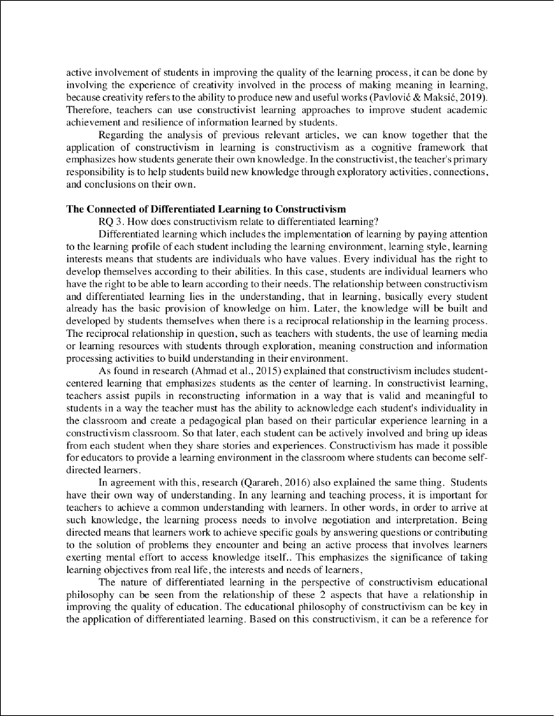

25

42

14

1

40

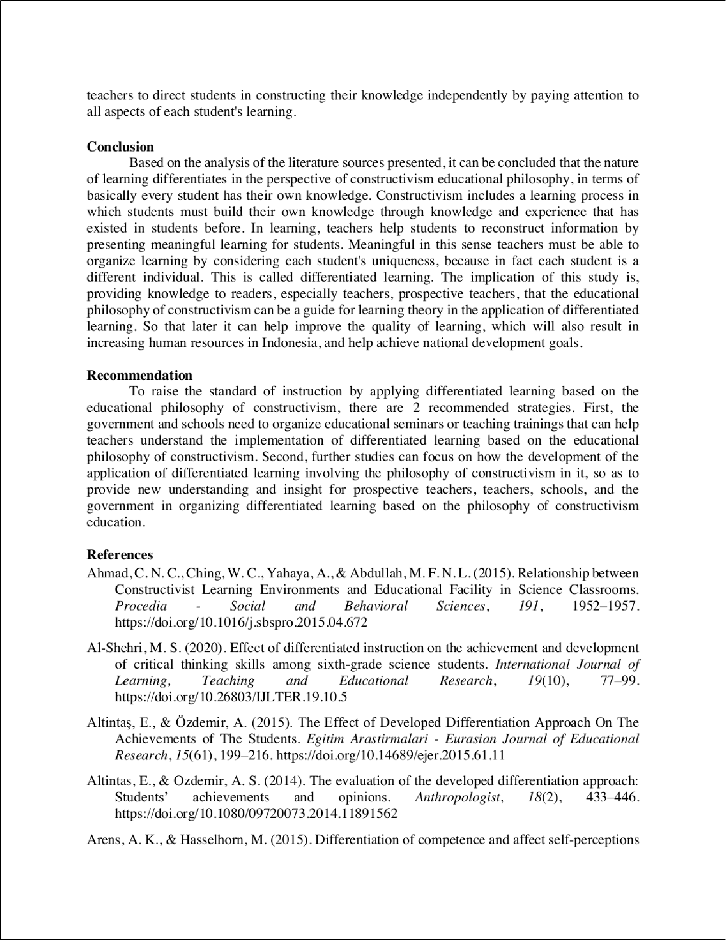

21

32

13

13

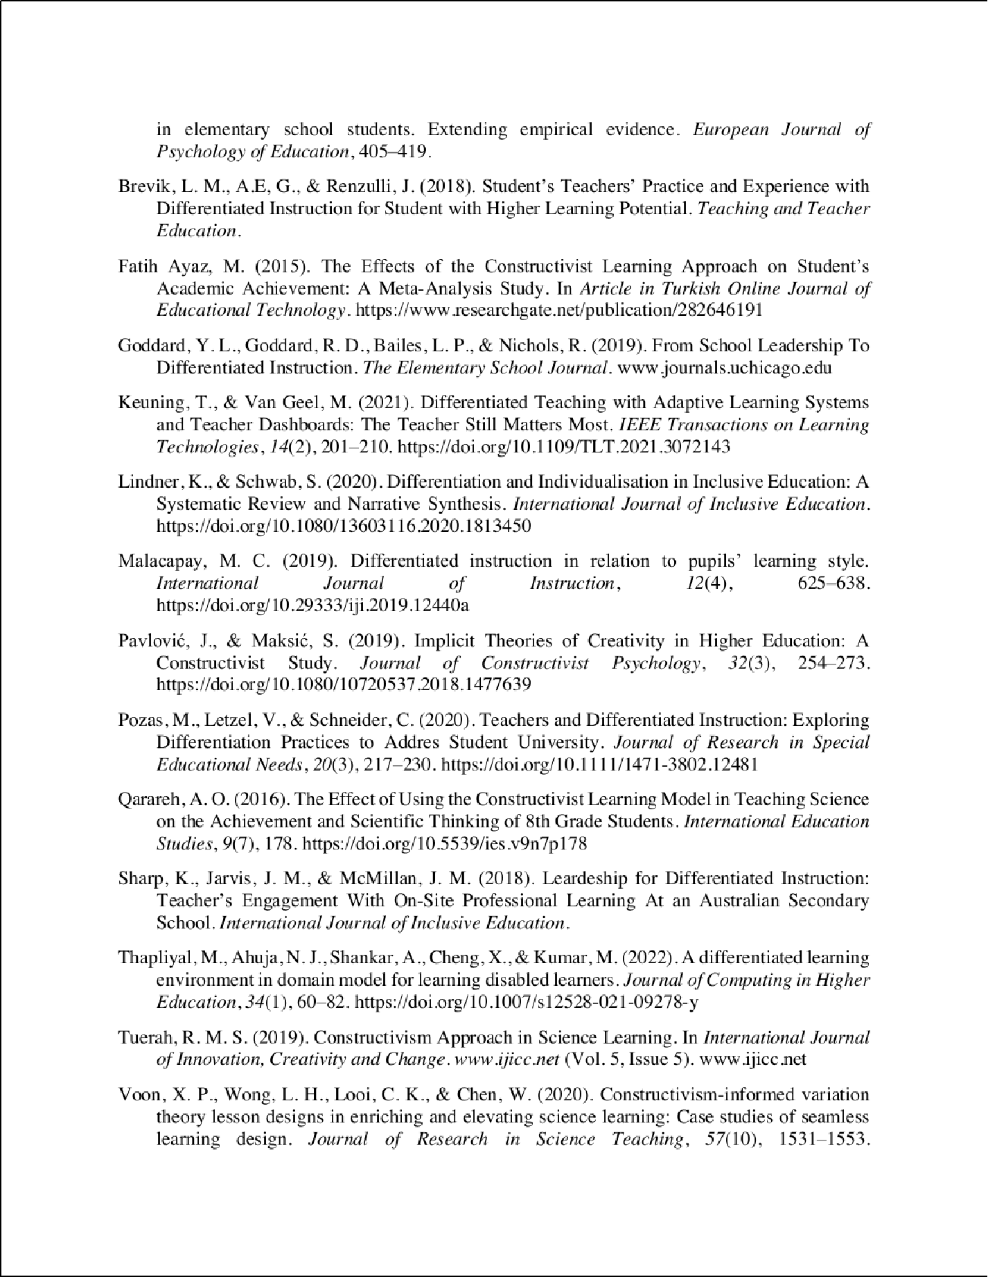

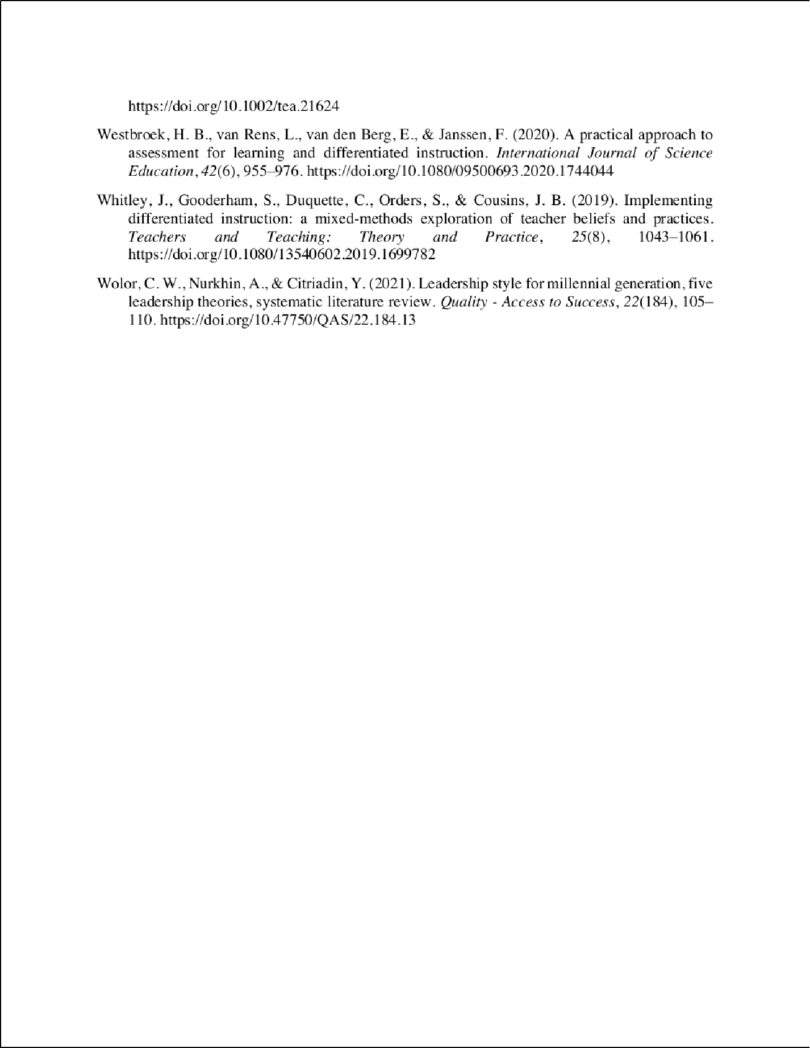

Filsafat

ORIGINALITY REPORT

18

%

SIMILARITY INDEX

11%

INTERNET SOURCES

13%

PUBLICATIONS

3%

STUDENT PAPERS

PRIMARY SOURCES

1 Ahmad, Che Nidzam Che, Wang Chiao Ching, Asmayati Yahaya, and Mohd Faizal Nizam Lee Abdullah. "Relationship between Constructivist Learning Environments and Educational Facility in Science Classrooms", Procedia - Social and Behavioral Sciences, 2015.

Publication

2%

2

admin.calitatea.ro

Internet Source %

2

2%

3 Qarareh, Ahmed O.. "The Eﬀect of Using the Constructivist Learning Model in Teaching Science on the Achievement and Scientiﬁc Thinking of 8th Grade Students", International Education Studies, 2016.

Publication

1%

4 Lisbeth M. Brevik, Ann Elisabeth Gunnulfsen, Joseph S. Renzulli. "Student teachers’ practice and experience with diﬀerentiated instruction for students with higher learning potential", Teaching and Teacher Education, 2018

Publication

5

6

7

8

9

10

11

12

jurnal.fkip.unila.ac.id

Internet Source

e-journal.undikma.ac.id

Internet Source

link.springer.com

Internet Source

Katharina-Theresa Lindner, Susanne Schwab. "Diﬀerentiation and individualisation in inclusive education: a systematic review and narrative synthesis", International Journal of Inclusive Education, 2020

Publication

Jessica Whitley, Suzanne Gooderham, Cheryll Duquette, Shari Orders, J. Bradley Cousins. "Implementing diﬀerentiated instruction: a mixed-methods exploration of teacher beliefs and practices", Teachers and Teaching, 2019

Publication

ijefm.co.in

Internet Source

repository.ung.ac.id

Internet Source

[www.researchgate.net](http://www.researchgate.net/)

Internet Source

1%

1%

1%

1%

1%

1%

1%

<1%

13

14

15

16

17

18

19

20

Wiwin Kobi, Herinda Mardin, M. Iqbal Liayong Pratama. "Implementation of Diﬀerentiated Learning as an Eﬀort to Increase Teacher Capacity at SMA Negeri 1 Tibawa", Mattawang: Jurnal Pengabdian Masyarakat, 2023

Publication

jinav.org

Internet Source

discovery.researcher.life

Internet Source

mail.ijlter.org

Internet Source

scholarworks.waldenu.edu

Internet Source

Submitted to Liberty University

Student Paper

Submitted to cotsu

Student Paper

Duden Saepuzaman, Syakti P. Sriyansyah, Saeful Karim. " Unpacking Pre-service Physics Teachers’ Understanding of the - - Diagram and the Associated Mathematics ", Journal of Physics: Conference Series, 2019

Publication

repository.stkippacitan.ac.id

<1%

<1%

<1%

<1%

<1%

<1%

<1%

<1%

21

22

23

24

25

26

27

28

29

30

Internet Source

Submitted to HCUC

Student Paper

jurnal.unimus.ac.id

Internet Source

Neeves, Erica. "Supporting Teachers through Standardized Testing: Elementary Teachers' Perceptions of Administrator Support", University of South Dakota, 2021

Publication

jlils.ppj.unp.ac.id

Internet Source

[www.krepublishers.com](http://www.krepublishers.com/)

Internet Source

Science Education Research and Practice in Asia, 2016.

Publication

doaj.org

Internet Source

jurnal.ahmar.id

Internet Source

pt.scribd.com

Internet Source

researchspace.ukzn.ac.za

<1%

<1%

<1%

<1%

<1%

<1%

<1%

<1%

<1%

<1%

31

32

33

34

35

36

37

38

Internet Source

[www.pedocs.de](http://www.pedocs.de/)

Internet Source

Huﬀ, Howard Dean. "How Experienced Students See: Perceptions of Engagement with Instructors", The Chicago School of Professional Psychology, 2022

Publication

Mohamed, Debbie. "Comparing Problem- Based Learning to Direct Instruction in 10th Grade Chemistry", Capella University, 2023

Publication

Xin P. Voon, Lung H. Wong, Chee K. Looi, Wenli Chen. "Constructivism‐informed variation theory lesson designs in enriching and elevating science learning: Case studies of seamless learning design", Journal of Research in Science Teaching, 2020

Publication

edepot.wur.nl

Internet Source

ej-edu.org.ejfood.org

Internet Source

listens.online

Internet Source

<1%

<1%

<1%

<1%

<1%

<1%

<1%

<1%

39

40

41

42

43

44

45

stem2020.sites.olt.ubc.ca

Internet Source

tojqih.net

Internet Source

worldwidescience.org

Internet Source

Darnawati Darnawati, Jamiludin Jamiludin, Mursidin Mursidin, La Ili. "Developing online learning guidebook for junior high school level in Kendari City", Journal of Education and Learning (EduLearn), 2021

Publication

Ika Astuti, Achmad Ruslan Afendi. "Implementation of Diﬀerentiated Learning Through Play Activities in Early Childhood", EduLine: Journal of Education and Learning Innovation, 2022

Publication

Monika Thapliyal, Neelu Jyothi Ahuja, Achyut Shankar, Xiaochun Cheng, Manoj Kumar. "A diﬀerentiated learning environment in domain model for learning disabled learners", Journal of Computing in Higher Education, 2021

Publication

jurnal.radenfatah.ac.id

Internet Source

<1%

<1%

<1%

<1%

<1%

<1%

<1%

46

"Eﬀective Teaching Around the World", Springer Science and Business Media LLC, 2023

Publication

<1%

Exclude quotes On Exclude bibliography On

Exclude matches Oﬀ