Development of an Interactive E-Module Based on Blended Learning to Enhance Student Independence and Learning Outcomes on acid-base materials

Novia Andriani, Kusumawati Dwiningsih*
Faculty of Mathematics and Natural Sciences, Surabaya State University.
*Corresponding Author e-mail: kusumawatidwiningsih@unesa.ac.id

Abstract: This study aims to determine the feasibility and effectiveness of interactive e-modules based on blended learning to increase independence and learning outcomes on acid-base materials. The background of this research is the lack of effective learning time in schools, besides that technological innovation in learning is felt to be lacking so that learning outcomes are less satisfying. The method used in this research is borg and gall development which consists of 1) Research and Information collection, 2) Product planning, 3) Product development, 4) Product validation, 5) Product revision, 6) Product trial. Module validity was assessed by 2 chemistry lecturers and 1 chemistry teacher. The validation results are processed using the mode of each statement, the results of content validity get mode 5 with very valid criteria and construct validity get mode 5 with very valid criteria. The results of this study indicate that chemistry learning using interactive e-modules based on blended learning can improve learning independence with an n-gain value of 0.49 in the moderate category and learning outcomes with an average n-gain value of 0.69 in the moderate category. Therefore, the interactive e-module based on blended learning developed is feasible and effective to be used to improve students' independence and learning outcomes on acid-base materials. | Article History  Received: 2  Revised:  Published:.. 2017  Key Words :  Blended learning, Learning Independence, Learning Outcomes, Acid Base
How to Cite: Andriani, Novia., Dwiningsih, Kusumawati. (2024). Development of an Interactive E-Module Based on Blended Learning to Enhance Student Independence and Learning Outcomes on acid-base materials. Jurnal Kependidikan: Jurnal Hasil Penelitian dan Kajian Kepustakaan di Bidang Pendidikan, Pengajaran dan Pembelajaran, vol(no). doi:https://doi.org/10.33394/jk.vxxyyi
 https://doi.org/10.33394/jk.vxxyyi | This is an open-access article under the CC-BY-SA License.


Introduction
Education plays an important role in life because it is a human need in life. The purpose of education cannot be separated from the curriculum. The independent curriculum is a curriculum change that provides new ideas to take advantage of technological developments to utilize the knowledge needed (Manalu et al., 2022)
One of the technological developments in education is the development of interactive e-modules. Interactive e-modules can be used flexibly without any space and time constraints. The use of E-Modules can be used anywhere and anytime, this allows students to access without being connected to the teacher (Wulandari et al., 2021)
Interactive E-Modules are a means of developing technology to improve the quality of learning to be more effective and can increase knowledge and skills for educators and students in the learning process both when in the classroom (indoor) and outside the classroom (outdoor) (Firmandani, 2020). In addition to the use of interactive e-modules, the use of learning methods is also very important to realize smart and skilled student outcomes. One of them is the utilization of blended learning, which is learning that combines e-learning and face-to-face learning (Zakaria, 2022). Blended Learning has advantages over conventional models because it can facilitate students' different learning styles and help students to understand concepts (Elvianasti et al., 2022). This is also in line with research conducted by (Rahman et al., 2020) that blended learning can significantly improve student motivation and learning outcomes.
However, in reality, the implementation of innovative technology-based learning has not been implemented. This is in line with research conducted by (Fajrin et al., 2020) which states that student difficulties in acid-base material with a difficulty level of 47% with the greatest difficulty is in calculating the pH of acid-base solutions with a difficulty level of 88%. Acid-base material is chemistry material taught in class XI SMA. Acid-base material contains factual, conceptual and procedural knowledge (Setiadi & Zainul, 2019). Difficulties in acid-base material can affect other materials because acid-base material is a prerequisite material to continue to the next material such as buffer and salt hydrolysis (Fajrin et al., 2020). This needs student independence to improve learning outcomes, especially on acid-base materials.
In accordance with the independent curriculum or independent curriculum which is defined as a learning design that provides opportunities for students to learn in a fun, comfortable, calm, pressure-free, and stress-free manner. Learning independence is important for students to form principles and concepts that are being learnt (Yuliati & Saputra, 2020). Learning independence can create student confidence and student ability to understand learning materials that can increase so that better student character can be formed (Perwitasari, n.d.). Learning independence can be seen from students' expertise in carrying out learning independently. Learning independence according to is the ability that students have in an effort to be independent in finding learning information in addition to learning resources from teachers (Nuritha & Tsurayya, 2021). Learning independence can improve student learning outcomes in accordance with research conducted by (Khasanah & Lestari, 2021) that students who have high learning outcomes can achieve high learning outcomes and vice versa. In line with research by (Novia & F, 2019) that good learning independence will have a high level of learning outcomes. If the problem of student learning independence is left unchecked, it will have a negative impact on students, they tend to have no targets because they do not have a sense of responsibility, decreased motivation and loss of interest in learning (Rahmawati et al., 2022).
Therefore, a learning media is needed that can increase students' learning independence. One of them is learning media that can support students to increase independence and learning outcomes that allow students to learn flexibly anywhere and anytime
Research Method
This type of research is development research (R&D). Research and development aims to produce a product and test the effectiveness of the product (Sugiyono, 2016). The research method used refers to the development model (Borg & Gall, 2003) which consists of 10 stages of research and development. However, in this study it was modified according to the needs, namely 1) Research and Information collection, 2) Product planning, 3) Product development, 4) Product validation, 5) Product revision, 6) Product trial.
Figure 1 Flowchart Research and Development Borg and Gall
Trial and Research Subjects
The test subjects in this study were students of SMA Negeri 1 Krembung Sidoarjo who took chemistry specialization. The subjects of this study were instrument validators, namely 2 chemistry lecturers and chemistry teachers as well as students of SMA Negeri 1 Krembung Sidoarjo who took chemistry specialization.
Research Instrument and Technique of Analysis
The instruments used were review and validation sheets, learning independence questionnaires, response questionnaires and learning outcomes test sheets. The analysis technique at the validation stage was carried out by 2 chemistry lecturers and 1 chemistry teacher. The validation of the e-module is assessed in the form of construct and content validation which includes the appearance, presentation, language and content of the e-module. This assessment uses a Likert scale of 1 to 5 which includes value 5 is very valid, value 4 is valid, value 3 is quite valid, value 2 is less valid, and value 1 is invalid (Riduwan, 2015). Data from the results of this study were analyzed for each indicator using the mode value. After getting the validation value from the validator, the interactive e-module based on blended learning is declared valid with a mode value of 5.
The next stage is the trial stage which is carried out using a questionnaire of learning independence and pretest and posttest questions to determine the improvement of learning outcomes. The learning independence questionnaire contains statements related to five indicators of learning independence consisting of positive statements and negative statements. The independence questionnaire is filled in before and after learning at each meeting. This assessment uses a Likert scale from 1 to 4. Positive statements, score 4 means Always (SL), score 3 means Often (SR), score 2 means Rarely (J), score 1 means Never (TP). Conversely for negative statements. This learning independence was analysed using the formula


Then for the increase in student learning independence can be calculated using the Ngain analysis method with the following formula.
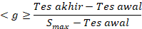
Description:
<g> = gain value
Final test = final test score
Initial test = initial test score
Smax = maximum score

Students' learning outcomes can also be analysed using the Ngain analysis method with the same formula to determine the improvement of learning outcomes.
Result and Discussion
- Preliminary description of Interactive E-Module Based on Bended learning
Based on the results of needs analysis through observations and interviews with 3 chemistry teachers and 31 students at SMA Negeri 1 Krembung about learning media that are often used by teachers in teaching and learning activities. The media still use printed books and LKPD whose contents are less interesting for students. This statement is proven based on the results of the interview questionnaire as 83.9% of students stated that the media that is often used is LKPD while the rest answered notes from the teacher. So that 58.1% of students feel less interested in learning independently using LKPD/printed books. This is in line with research by who stated that textbooks have weaknesses, namely not being able to visualize a phenomenon, less interactive (Ricu Sidiq & Najuah, 2020). Interactive e-books can be one of the best alternatives to improve reading comprehension and reading interest (Winatha, 2018).
In addition, teachers feel that they need learning media that are effectively used offline or online because learning hours at school are limited for teachers, while the material that must be given does not match the availability of learning hours at school. From the results of these interviews, teachers and students feel the need for learning media that is interesting, effective, and can increase student independence and learning outcomes.
- Development of Interactive E-Modules Based on Blended learning
Based on the problems that have been described, it is very necessary to develop learning media that is easily accessible online and offline that can increase student independence and learning outcomes which are expected to overcome these problems. This is in accordance with research conducted by (Herawati & Muhtadi, 2018) which states that interactive e-modules can increase students' interest in learning so that it can improve learning outcomes. Therefore, interactive e-modules are effectively used for online learning activities (Rahmatsyah & Dwiningsih, 2021).
Blended learning model is chosen as the model for developing interactive e-modules to facilitate the learning process. Using the Blended learning model is an efficient solution for online and offline learning (Irsalina, 2018). One of these innovations is blended learning with the flip classroom model. The blended learning model used is flip classroom. Students are given material to study at home which can be studied flexibly in their respective homes (Rahmayani, 2020). The advantages of this flipped classroom are that it takes time to interact with students more effectively, can help with learning difficulties, and help to understand the concept of material (Mirlanda et al., 2020). The overall development of interactive e-modules based on blended learning is as shown in the following figure
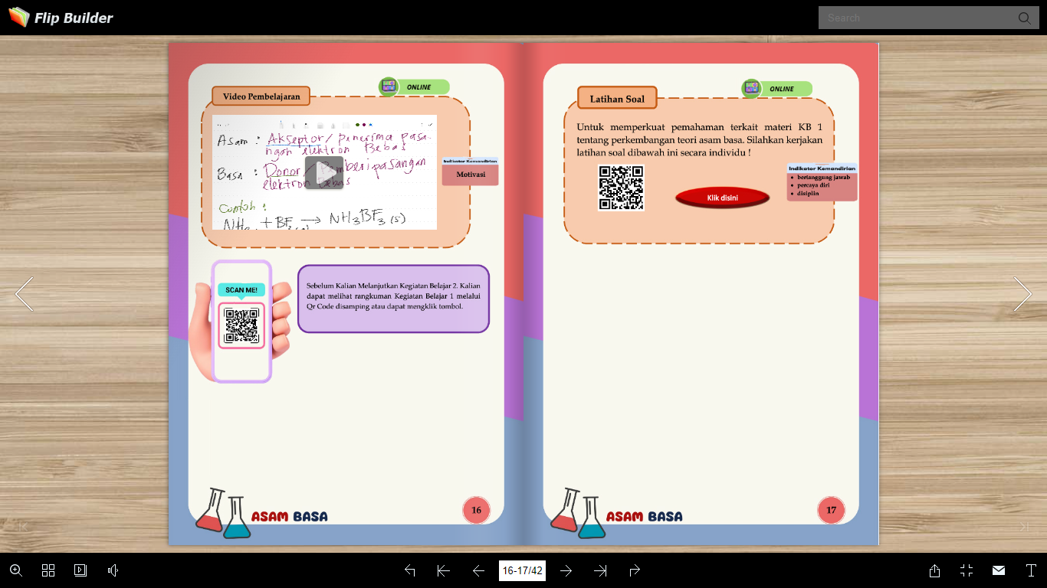
Figure 2 Illustration of Interactive E-Module based on blended learning when online
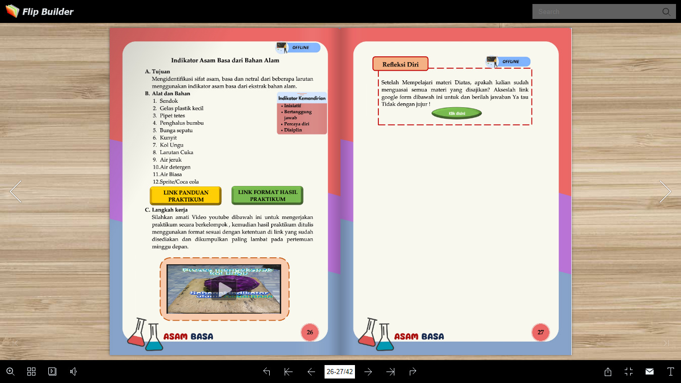
Figure 3 Illustration of Interactive E-Module based on blended learning when offline
Blended learning can encourage students to be involved in the learning process so that students can build their knowledge, this will affect students' independence and learning outcomes (Baidowi et al., 2021). Blended learning can eliminate student boredom in learning so that learning feels more interactive, this can have a positive impact because it can increase student understanding. Thus, the blended learning method can encourage students to improve their learning outcomes (Firmansyah, 2019).
To make it easier for teachers to know student independence, independence indicators are included in each lesson. There are 5 indicators of independence used according to (Mudjiman, 2006) said that student indicators can be said to have learning independence if they have confidence, initiative, discipline, responsibility and motivation. Meanwhile, according to (Astuti, 2016) Learning independence has indicators to believe in yourself, have a sense of responsibility, have your own initiative.
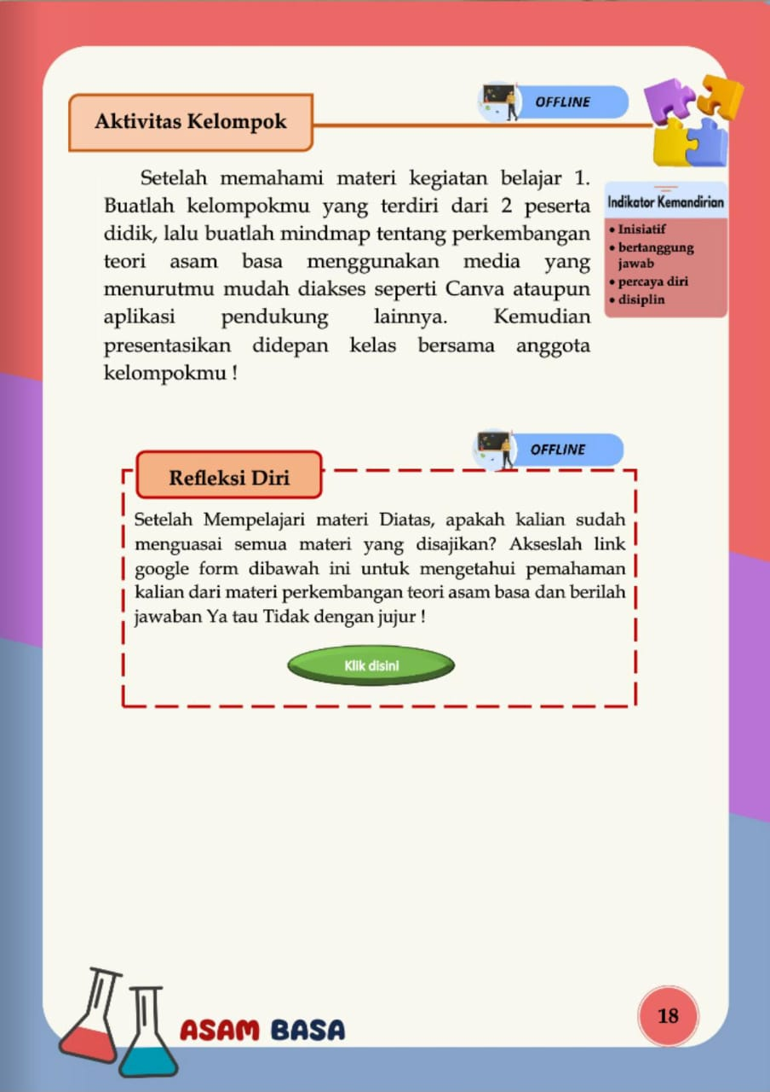
Figure 4 Illustration of student learning independence indicators
In this interactive e-module based on blended learning, 5 indicators of independence are used, namely self-confidence, initiative, motivation, responsibility and discipline. Independence indicators will appear in each activity on the e-module according to the activities that will be carried out by students.
- Feasibility of Interactive E-Modules Based on Blended learning
Learning media that is suitable for use must go through a validation test stage in the form of content and construct validity. The validity test is carried out to determine the level of validity of the media developed in the study and can be said to be valid if it is able to measure and reveal data from the variables studied appropriately (Sanaky, 2021)
The following are the validation results of the interactive e-module based on Blended learning.
- Content Validation Results

Content validity is seen from the feasibility of a learning media (Dzikro & Dwiningsih, 2021). There are 10 aspects of content validation assessed by validators based on the content in the interactive e-module based on blended learning. Of the 10 aspects, 6 of them got a mode value of 5 with the assessment criteria being very valid while 4 of them got a mode value of 4 with the assessment criteria being valid. Based on this assessment, it shows that the interactive e-module based on blended learning is valid for use and fulfills the criteria of content validity according to the Likert scale.
- Construct Validation Results
Construct validation is the validity used to determine the extent to which the impact of measurement results is in accordance with the theoretical construction in the development of an instrument (Pada et al., 2018). Construct validation there are 4 statements related to the appearance of interactive e-modules based on blended learning with 3 of them getting a mode value of 5 with very valid criteria and 1 statement gets a mode value of 4 with valid criteria. Language construct validation there are 3 statements with 2 of them getting a mode value of 5 with very valid criteria and 1 statement gets a mode value of 4 with valid criteria. Finally, the validation of the presentation construct has 3 statements, all of which get a mode value of 4 with valid criteria. Based on these criteria, the interactive e-module based on blended learning in visual design, language and presentation can be said to be valid. Easy-to-understand language can make it easier for students to learn and master the concepts (Wardhana & Hidayah, 2022).
- Effectiveness of Interactive E-Modules based on Blended learning to improve Independence and Learning Outcomes
- Learning Independence Results
After the interactive e-module is said to be valid, the next step is to conduct a trial. The next step is to conduct a trial to find out the effectiveness of a media. Learning can be said to be effective if students are complete in learning (Kurniawan & Hidayah, 2020). In this trial, two instruments were used, namely the independence questionnaire sheet and the pretest-posttest sheet for learning outcomes. This trial was conducted for 3 meetings with the results of learning independence as follows.
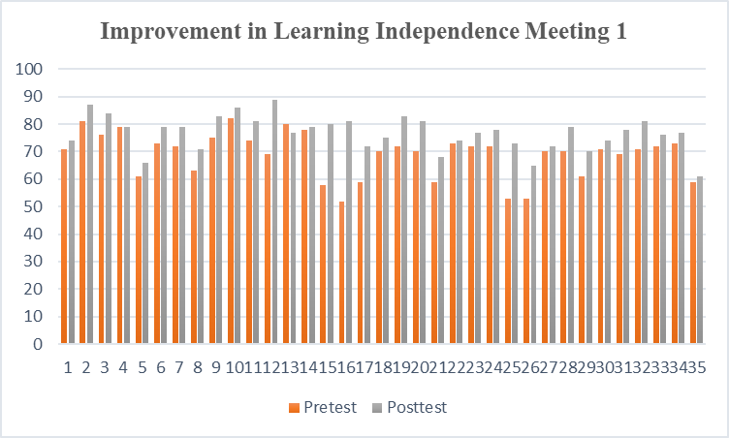
Figure 5 Improvement in Learning Independence Meeting 1
In Figure 1 above, it can be seen that 10 students experienced an increase in independence with an n-gain value of 0.7> g ≥ 0.3 which is included in the moderate category. while 25 of them experienced an increase in independence in the low category..
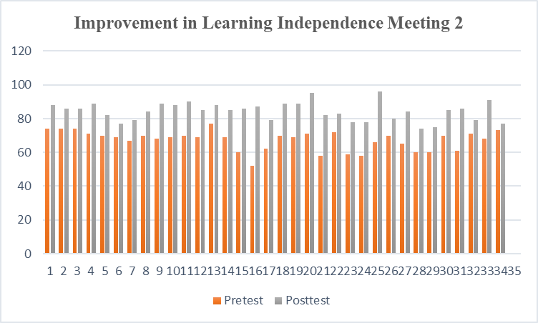
Figure 6 Improvement in Learning Independence Meeting 2
In Figure 2 above, it can be seen that almost all students experienced an increase in learning independence at meeting 2. A total of 29 students experienced an increase in the moderate category with a range of n-gain values of 0.7> g ≥ 0.3, then as many as 4 students experienced an increase in the high category with a range of n-gain values of g ≥ 0.7 and 2 students experienced an increase in independence in the low category with a range of n-gain values g < 0.3.

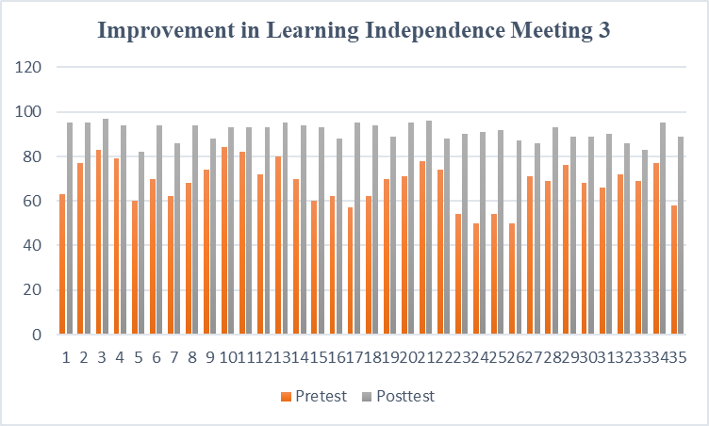
Figure 7 mprovement in Learning Independence Meeting 3
In Figure 3 above, it can be seen that all students experienced an increase in learning independence at meeting 3. A total of 13 students experienced an increase in the moderate category by obtaining an n-gain value with a value range of 0.7> g ≥ 0.3. Then as many as 22 students experienced an increase in the high category with the acquisition of the n-gain value range g < 0.3.

- Cognitive Outcomes
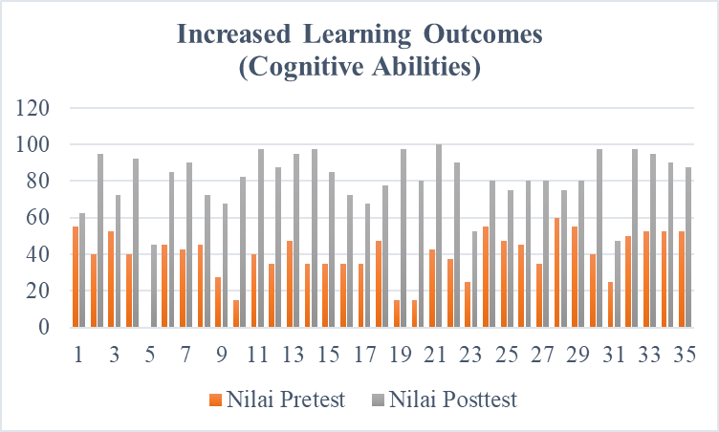
Figure 8 Increased Learning Outcomes
In Figure 3 above, it can be seen that all students experienced an increase in learning independence at meeting 3. A total of 13 students experienced an increase in the moderate category by obtaining an n-gain value with a value range of 0.7> g ≥ 0.3. Then as many as 22 students experienced an increase in the high category with the acquisition of the n-gain value range g < 0.3.
Conclusion
Based on the results of the research that has been done
  - Validation of interactive e-modules based on blended learning in acid-base material obtained a content validity value of 5 with a very valid category and construct validation obtained a value of 4 with a valid category. So it is said that the interactive e-module based on blended learning is feasible to use.
  - The increase in student learning independence obtained an n-gain value range at meeting one of 0.25 with a low category, at meeting two obtained an n-gain value range of 0.51 with a medium category and at meeting three obtained an n-gain value of 0.71 with a high category. So that the average at 3 meetings obtained n-gain of 0.49 with a moderate category. So it is said that interactive e-modules based on blended learning can increase student learning independence.
  - The learning outcomes obtained from the pretest and posttest on acid-base material obtained an average n-gain value of 0.69 with a moderate category. So it can be said that interactive e-modules based on blended learning can improve student learning outcomes.

Recommendation
Some research suggestions that can be used for the future are 1) the development of more innovative learning media that can facilitate teachers and students in developing skills. 2) Development of books or modules that are relevant to the independent curriculum.

References
Astuti, E. (2016). Kemandirian Belajar Matematika Siswa SMP/ MTs di Kecamatan Prembun. Jurnal Pendidikan Surya Edukasi, 2(2), 65–75.
Baidowi, B., Sarjana, K., Novitasari, D., & Kurniawan, E. (2021). Peningkatan Kemandirian dan Hasil Belajar Mahasiswa Pendidikan Matematika dengan Lesson Study melalui Blended Learning. Jurnal Pijar Mipa, 16(3), 366–373. https://doi.org/10.29303/jpm.v16i3.2267
Dzikro, A. Z. T., & Dwiningsih, K. (2021). Kelayakan Media Pembelajaran Berbasis Laboratorium Virtual pada Sub Materi Kimia Unsur Periode Ketiga. Chemistry Education Practice, 4(2), 160–170. https://doi.org/10.29303/cep.v4i2.2389
Elvianasti, M., Festiyed, F., Asrizal, A., Desnita, D., & Ritonga, R. F. (2022). Effect Size of Blended Learning Model in Improving Students’ Science Competence. Jurnal Kependidikan: Jurnal Hasil Penelitian Dan Kajian Kepustakaan Di Bidang Pendidikan, Pengajaran Dan Pembelajaran, 8(1), 162. https://doi.org/10.33394/jk.v8i1.4449
Fajrin, S., Haetami, A., & Marhadi, M. A. (2020). Identifikasi Kesulitan Belajar Kimia Siswa Pada Materi Pokok Larutan Asam Dan Basa Di Kelas Xi Ipa2 Sma Negeri 1 Wolowa Kabupaten Buton. Jurnal Pendidikan Kimia FKIP Universitas Halu Oleo, 5(1), 27. https://doi.org/10.36709/jpkim.v5i1.13106
Firmansyah, R. (2019). Pengaruh Blended Learning Terhadap Hasil Belajar Pai Peserta Didik Kelas X Sman 8 Bandar Lampung Universitas Islam Negeri Raden Intan Lampung Pengaruh Blended Learning Terhadap Hasil Belajar Pai Peserta Didik Kelas X Sman 8 Bandar Lampung Universitas Isla.
Herawati, N. S., & Muhtadi, A. (2018). Pengembangan modul elektronik (e-modul) interaktif pada mata pelajaran Kimia kelas XI SMA. Jurnal Inovasi Teknologi Pendidikan, 5(2), 180–191. https://doi.org/10.21831/jitp.v5i2.15424
Irsalina, A. (2018). Analisis Kepraktisan Pengembangan Lembar Kegiatan Peserta Didik ( Lkpd ) Berorientasi Blended Learning Pada Materi Asam Basa Practicality Analysis Of Developing The Student Worksheet Oriented Blended Learning In Acid Base Material. 3(3), 171–182.
Khasanah, K., & Lestari, A. (2021). The Effect of Quizizz and Learning Independence on Mathematics Learning Outcomes. Tadris: Jurnal Keguruan Dan Ilmu Tarbiyah, 6(1), 63–74. https://doi.org/10.24042/tadris.v6i1.7288
Kurniawan, A. B., & Hidayah, R. (2020). Kepraktisan Permainan Zuper Abase Berbasis Android Sebagai Media Pembelajaran Asam Basa. UNESA Journal of Chemical Education, 9(3), 317–323. https://doi.org/10.26740/ujced.v9n3.p317-323
Manalu, J. B., Sitohang, P., Heriwati, N., & Turnip, H. (2022). Prosiding Pendidikan Dasar Pengembangan Perangkat Pembelajaran Kurikulum Merdeka Belajar. Mahesa Centre Research, 1(1), 80–86. https://doi.org/10.34007/ppd.v1i1.174
Mirlanda, E. P., Nindiasari, H., & Syamsuri, S. (2020). Pengaruh Pembelajaran Flipped Classroom Terhadap Kemampuan Penalaran Matematis Ditinjau Dari Gaya Kognitif Siswa. Prima: Jurnal Pendidikan Matematika, 4(1), 11. https://doi.org/10.31000/prima.v4i1.2081
Mudjiman, H., 2006. Belajar Mandiri. Yogyakarta: Pustaka Belajar.
Novia, H., & F, H. (2019). Hubungan kemandirian terhadap hasil belajar siswa mata pelajaran matematika di kelas X SMK kota cimahi. Journal on Education, 1(02), 1–8. https://media.neliti.com/media/publications/270114-hubungan-kemandirian-terhadap-hasil-bela-b7065fae.pdf
Nuritha, C., & Tsurayya, A. (2021). Pengembangan Video Pembelajaran Berbantuan Geogebra untuk Meningkatkan Kemandirian Belajar Siswa. Jurnal Cendekia : Jurnal Pendidikan Matematika, 5(1), 48–64. https://doi.org/10.31004/cendekia.v5i1.430
Pada, A. U. T., Mustakim, S. S., & Subali, B. (2018). Construct validity of creative thinking skills instrument for biology student teachers in the subject of human physiology. Jurnal Penelitian Dan Evaluasi Pendidikan, 22(2), 119–129. https://doi.org/10.21831/pep.v22i2.22369
Perwitasari, D. (n.d.). Untuk Meningkatkan Kemampuan Komunikasi Matematis Dan Self-Efficacy Siswa Smp. 1–9.
Rahman, Z., Rijanto, T., Basuki, I., & Sumbawati, M. S. (2020). The Implementation of Blended Learning Model on Motivation and Students’ Learning Achievement. International Journal for Educational and Vocational Studies, 2(9), 767–775. https://doi.org/10.29103/ijevs.v2i9.2694
Rahmatsyah, S. W., & Dwiningsih, K. (2021). Development of Interactive E-Module on The Periodic System Materials as an Online Learning Media. Jurnal Penelitian Pendidikan IPA, 7(2), 255. https://doi.org/10.29303/jppipa.v7i2.582
Rahmawati, Y., Supriatna, E., & Yuliani, W. (2022). VALIDITAS DAN RELIABILTAS ANGKET KEMANDIRIAN BELAJAR SISWA SMP Yesi Rahmawati 1 , Ecep Supriatna 2 , Wiwin Yuliani 3 1. 5(3), 254–258. https://doi.org/10.22460/fokus.v5i3.7260
Rahmayani, A. (2020). Pengaruh Model Pembelajaran Flipped Classroom terhadap Hasil Belajar Kognitif Siswa SMA pada Konsep Gerak Parabola. Skripsi, 4. http://repository.uinjkt.ac.id/dspace/handle/123456789/51240
Ricu Sidiq, & Najuah. (2020). Pengembangan E-Modul Interaktif Berbasis Android pada Mata Kuliah Strategi Belajar Mengajar. Jurnal Pendidikan Sejarah, 9(1), 1–14. https://doi.org/10.21009/jps.091.01
Sanaky, M. M. (2021). Analisis Faktor-Faktor Keterlambatan Pada Proyek Pembangunan Gedung Asrama Man 1 Tulehu Maluku Tengah. Jurnal Simetrik, 11(1), 432–439. https://doi.org/10.31959/js.v11i1.615
Setiadi, T., & Zainul, R. (2019). Pengembangan E-Modul Asam Basa Berbasis Discovery Learning Untuk Kelas XI SMA/MA. EduKimia, 1(1), 21–27. https://doi.org/10.24036/ekj.v1i1.104019
Sugiyono, 2016. Metode Penelitian. Bandung: Alfabeta.
Wardhana, S. O., & Hidayah, R. (2022). Interactive Chemical Bond Electronic Module Based on Nature of Science (NoS) to Improve Scientific Literacy Knowledge. Journal of Science Education Research, 6(1), 15–23. https://doi.org/10.21831/jser.v6i1.47575
Winatha, K. R. (2018). Pengembangan E-modul Interaktif Berbasis Proyek Mata Pelajaran Simulasi Digital. Jurnal Pendidikan Teknologi Dan Kejuruan, 15(2), 188–199. https://doi.org/10.23887/jptk-undiksha.v15i2.14021
Wulandari, F., Yogica, R., & Darussyamsu, R. (2021). Analisis Manfaat Penggunaan E-Modul Interaktif Sebagai Media Pembelajaran Jarak Jauh Di Masa Pandemi Covid-19. Khazanah Pendidikan, 15(2), 139. https://doi.org/10.30595/jkp.v15i2.10809
Yuliati, Y., & Saputra, D. S. (2020). Membangun Kemandirian Belajar Mahasiswa Melalui Blended Learning Di Masa Pandemi Covid-19. Jurnal Elementaria Edukasia, 3(1), 142–149. https://doi.org/10.31949/jee.v3i1.2218
Zakaria, M. F. (2022). Pengembangan Blended Learning Pada Mata Kuliah Kapita Selekta Pendidikan Di Prodi Teknologi Pendidikan Fakultas Ilmu Pendidikan Universitas Negeri Makassar Muhammad. Universitas Negeri Yogyakarta. http://eprints.unm.ac.id/23971/1/Jurnal Muhammad Faried Zakaria.pdf

