TITLE:
The Certification Program Evaluation for Students in Vocational Schools Using the CSE UCLA Model

1* Sugeng Priyanto, 2 Siti Sahara, 3 Syahrir, 4 Hari Din Nugraha
¹Department of Manufacturing Engineering, Faculty Engineering, State University of Jakarta, Jakarta, Indonesia
*Corresponding Author e-mail: spriyanto@unj.ac.id

Abstract: This research was conducted to get an overview of the evaluation results and various obstacles faced in the implementation of machining competency test certification in Vocational High Schools (VHS). The evaluation method of this program is a qualitative research approach that uses the analysis of Techniques for Sequence Preference with Ideal Solution Similarity (TOPSIS). This study uses the CSE-UCLA model in designing program evaluation, which consists of five evaluation components: system assessment, program planning, program implementation, program improvement, and certification. Data collection involved subjects who were researched by filling out questionnaires, including school principals, vice principals for curriculum, deputy principals for industrial relations, deputy principals for facilities and infrastructure, heads of machining programs, workshop heads, machining productive teachers, and competency certification institutions/professional certification institutions in schools. Participants involved in collecting information used survey forms in five Vocational High Schools (VHS) in the Province of the Special Capital Region of Jakarta. Purposive Sampling is used to determine the entire subject in the study. The study concluded that the machining competency test certification program has a good level of effectiveness, with certain components assessed as sufficient. Considering the dimension of the system assessment program, the value program planning category needs to be maintained or improved. In the context of program implementation, program improvement, and program certification, efforts are needed to improve the criteria for the better. | Article History  Received: 2  Revised:  Published:..2017  Key Words :  Certification Competency Test, System Assessment, CSE-UCLA Model
How to Cite: Sugeng Priyanto., Siti Sahara., Syahrir., Hari Din Nugraha (2024). The title. Jurnal Kependidikan: Jurnal Hasil Penelitian dan Kajian Kepustakaan di Bidang Pendidikan, Pengajaran dan Pembelajaran, vol(no). doi:https://doi.org/10.33394/jk.vxxyyi
 https://doi.org/10.33394/jk.vxxyyi | This is an open-access article under the CC-BY-SA License.


Introduction
Machining knowledge is widely used in all areas of everyone's life, especially in the field of transportation (Zhu et al. 2020). The average number of companies currently developing new machines to meet human needs is estimated to be 68,000 from 2012 to 2031 (XU & WANG, 2021). Over time, the performance of machining tools continues to improve in terms of higher reliability, longer service life, higher fuel efficiency values, more powerful, cleaner and quieter operating systems, and more advanced materials. This requires a more complex mechanical structure (Wang & Chen, 2023). In addition, the inside of each machine element is manufactured with precision, including free-form surfaces and thin-walled surfaces made of hard-to-cut materials that require dimensional accuracy and high surface quality (Imad et al. 2022). Therefore, the machinery industry needs human resources who are able to keep up with technological developments (CHIBA et al. 2023).
The development of knowledge and technology cannot be separated from the development of education (Vaganova et al., 2020). In the educational process, a person is trained to improve the suitability of the quality of workers and individuals through a systematic process, resulting in changes in behavior, knowledge, and motivation (Stofkova & Sukalova, 2020). Education is an intermediary between the development of knowledge and skills and their application through the curriculum (Yadav et al., 2018). One of them is vocational education, where the learning process is based on the demands of workers in special fields (Fullerton & Leckie, 1999). Vocational training is at the forefront of human resource development in the industry (Ling et al., 2023). The government attaches great importance to the development of vocational education, with the aim of reducing unemployment, especially among the younger generation, alleviating poverty, securing skilled labor, and encouraging the country's economic growth (Li & Pilz, 2023). What's more, the digitalization of automation is now an important part of the industrial process in Industry 4.0, where robots equipped with artificial intelligence can perform all kinds of tasks (Rofiq et al., 2019a). This can be interpreted as the number of jobs that can be done by humans is decreasing and new jobs are created in accordance with the needs of industrial digitalization (Billett, 2000). Hal ini menunjukkan bahwa pelatihan kejuruan harus mampu merespons perubahan kebutuhan profesional di industri (Mahmudah & Santosa, 2021).
Vocational education is based on a practice-based curriculum tailored to industries and skills (Muja et al., 2019). In addition, in some developing countries, particularly Indonesia, there are gaps in practical skills and knowledge among VET students (Abdurrahman et al., 2022). The system and pattern of implementing vocational high schools in Indonesia have not changed from a supply model to a demand model (Antonietti et al., 2022). In addition, vocational school education programs are not flexible to changing job needs (Mason et al., 2018). Based on data from the Central Statistics Agency (BPS) regarding the number of unemployed in Indonesia based on education level in 2022, vocational education graduates are ranked second and contribute the largest number of unemployed with a proportion of 24% (Badan Pusat Statistik, 2020). This means creating programs and policies in the field of vocational education to ensure quality and clarify vocational education priorities through the development of competency test and certification standards for students (Makinde and Bamiro 2023).
Vocational education competency test certification is part of the curriculum to improve students' abilities (Burke et al., 2014). In essence, competency tests are held to measure students' abilities in a certain field well (Nurtanto et al., 2020). This is important because a high level of expertise in one of the industry's investment strategies is included in the desired talent qualification (Finegold & Soskice, 1988). According to the Manpower Law of the Republic of Indonesia, a person's employability is determined by certain factors such as knowledge and skills; work attitude, personal characteristics, knowledge and competence in managing work (Republic of Indonesia Employment Law Number 13 of 2003, n.d.). In addition, the Office of Technology Assessment (OTA) classifies them into four types of competencies: The first type is academic ability represented by reading, writing, and math skills. The other three types are different types of special skills and consist of special skills that are considered based on job-specific skills (Parkinson & Mackay, 2016a). This need requires a special strategy to ensure that vocational school graduates can enter the job market. One of them is to improve the vocational education evaluation system that only focuses on skills, without considering theoretical understanding (literacy) and applied knowledge capabilities, especially in the field of machinery (Majetic & Pellegrino, 2018). Applied knowledge-based competencies, students are expected to be able to use diagrams to interpret and represent physical objects and develop various complex technical ideas (Parkinson & Mackay, 2016b). Therefore, the implementation of competency certification tests requires the development of innovative engagement planning and assessment criteria that are carried out on an ongoing basis (Rodriguez et al., 2020a, 2020b).
Currently, the implementation of the competency certification test only looks at how students complete the work without paying attention to the students' literacy understanding related to each stage in completing the work (Kuntoro et al., 2019b). Penilaian kompetensi adalah proses penilaian seseorang kompeten atau tidak kompeten pada suatu unit kompetensi atau kualifikasi tertentu yang berkaitan dengan suatu proses teknis atau non teknis dengan memberikan bukti terkait unit atau kualifikasi tersebut (Pardjono, Sugiyono, and Budiyono 2015). Given the importance of competency certification for vocational training graduates, it is necessary to evaluate the implementation of the competency certification exam. In the evaluation process, the TOPSIS analysis (Technique for Order Preference by Similarity to Ideal Solution) is refined using the CSE-UCLA evaluation model, with the aim of solving the main objective of the program: using problem-solving. In the Machining Competency Test program based on Applied Knowledge Literacy in Vocational High Schools, the CSE-UCLA evaluation model introduced by Alkin (1969) was selected and classified into five dimensions, namely system assessment, program planning, program implementation, program improvement and program certification (Priyanto et al., 2024). This is because there are 5 stages of evaluation, namely the first evaluation component assessment system which is used to see the initial condition of the program being evaluated, the program planning evaluation component which is used to see various things that may be included to meet the needs of the program, the program implementation evaluation component which is used to see the form of socialization carried out in order to introduce the program to its users, Program Improvement Evaluation component is used to see an overview of the program function and Program Certification Evaluation component is used to see an overview of the usefulness and value of the program.

Research Method
It is vital to assess the competency certification exam's implementation given the significance of the certification for graduates of vocational training. CSE UCLA model consists of: System assessment, Program planning, Program implementation, Program improvement, and Program certification. The expected research period is July–September 2023. Purposive sampling is the research's objective method, and it was conducted at five vocational high schools in Jakarta's Special Capital Region Province. This qualitative research methodology focuses an important priority on understanding the procedure used to collect data from respondents to interviewers' surveys and questionnaires. Combining clustering, optimal matching, and multidimensional scaling techniques is a way to display and summarize recorded data. Therefore, this method to inform adaptive surveys helps outlier data in improving survey data. The selected sample is the principal, vice principal for curriculum, vice principal for industrial relations, vice principal for infrastructure, head of machining program, head of workshop, productive teacher of machining. The questionnaire was created using the weighting of the criteria of the Likert scale model for the following answer choices:
Classification | Score
5 | Perfect Fit
4 | Appropriate
3 | Less Suitable
2 | Not Suitable
1 | Very inappropriate

In addition, qualitative research was analyzed based on questionnaire data collected using the Technique For Others Reference by Similarity to Ideal Solution (TOPSIS) approach. (Mehrparvar et al., 2012). The stages are as follows:
1. Matrix of normalized decision criteria (rij), so that a normalized decision matrix is obtained
Equation:
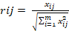 (1)

In this context, rij refers to a matrix element that has been normalized from Object to i based on criterion j.
- Define a normalized decision matrix
Weighted value.
- Determining the positive ideal solution and the negative ideal solution of a matrix. Based on the normalized weight rating, a positive ideal solution (A) and a negative ideal solution (A) can be determined, to identify the ideal solution, it is necessary to first determine whether the analyzed attribute is an advantage or a cost.
A⁺ = (y₁⁺, y₂⁺,........y_{n}⁺)
A⁻ = (y₁⁻, y₂⁻,.............y_{n}⁻) (2)
Here,
y₁⁺ = 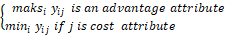

y₁⁻ =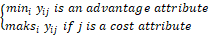
- Calculate the determination of the range between the values of each alternative using a matrix of positive ideal and negative ideal solutions.
= 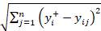 (3)

= 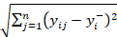 (4)

- Calculate the value determination of each option alternative.
(5)
The effectiveness value of each aspect evaluated is classified based on validity according to Guilford (Uyasa & Kurniawan, 2018). Listed in Table 2.

Table 2. Effectiveness Categories Based on Guilford Validity Classification
Range of effectiveness | Category
0,80 – 1,00 | Excellent
0,60 – 0,79 | Good
0,40 - 0,59 | Enough
0,20 – 0,39 | Less
0,0 – 0,190 | Very Less

Edgar Rodríguez argues that interviews as an analytical instrument show the importance of emphasizing complex narratives, rather than simply presenting a comprehensive understanding of the experiences of the individuals involved (Rodríguez-Dorans & Jacobs, 2020). Edwards stated that a series of activities that take place in a certain context are needed (Edwards & Holland, 2020). The dimensions and components of the questions applied in this study are:
- System Assessment which contains material, a). Urgency of Competency Test b). Benefits of conducting competency tests c). The need for support for competency test management personnel d) Support for all educators of the Educational Laboratory Institution and school educators for the preparation of equipment, materials, testers, supporting components of the Expertise Competency Test.
- Planning Program Includes material, a) Planning the organizational structure of the Competency Test management b) Planning of the competency test program and human resource development c) Planning of activities to prepare students in using workshop services d) Planning the preparation of supporting facilities for the organizers of the Competency Test.
- Implementation Program contains material, a) Socialization of special characteristics of competency test workshops b) Cooperation with certification bodies c) Socialization of measurement devices required by Competency Test workshops.
- Improvement Program Includes material, a) Increasing the understanding of the concept of applied knowledge on tasks/jobshet on the worksheet as the basis for procedural work considerations b) Improving facilities and infrastructure for the benefit of competency test certification workshops. c) Improvement of continuous training programs in aspects of machining knowledge and practices for the improvement of Human Resources.
- Certification Program includes material a) Quality of Competency Test according to the standard of the machining mechanic expertise program package. b) Conformity of the expertise package with the standard of the machining mechanic expertise program package

Result and Discussion
- System Assessment
The level of effectiveness in the System Assessment dimension data shows that there are components that need to be improved in order to improve and maintain the effectiveness of the implementation of Competency Test Certification in the Machining Mechanics Program at VHS, in accordance with the categories listed in Table 2. In this study, there are five Vocational High Schools that are evaluated based on twelve alternative questions. The first stage calculation can be seen in Table 3 based on the Equation. (1). Table 3 shows that the data obtained has been normalized to obtain standardized results from the collection of data Based on the results of the calculation, the normalized value is included in the matrix. The second stage is to input the data contained in Table 3 into Equation (2). The results of these calculations can be presented in Table 4.
Table 3.
The data is normalized into the matrix.
0,2874 | 0,3075 | 0,2835 | 0,3008 | 0,3099
0,2993 | 0,3075 | 0,2959 | 0,2883 | 0,2971
0,2754 | 0,3075 | 0,2835 | 0,3008 | 0,2841
0,2754 | 0,2936 | 0,2835 | 0,2883 | 0,2971
0,2754 | 0,3215 | 0,2835 | 0,3008 | 0,2712
0,2754 | 0,3075 | 0,2959 | 0,2883 | 0,2712
0,2993 | 0,3494 | 0,3082 | 0,3133 | 0,1938
0,2993 | 0,1399 | 0,3082 | 0,3133 | 0,3229
0,2993 | 0,2097 | 0,3082 | 0,2507 | 0,3229
0,2894 | 0,2796 | 0,2568 | 0,282 | 0,2583
0,2993 | 0,2912 | 0,2774 | 0,2716 | 0,3013
0,2894 | 0,2912 | 0,2774 | 0,2611 | 0,3121
Table 4.
() Matrix elements with weighted rating
0,1294 | 0,077 | 0,0427 | 0,0303 | 0,0157
0,1348 | 0,077 | 0,0445 | 0,029 | 0,015
0,124 | 0,077 | 0,0427 | 0,0303 | 0,0144
0,124 | 0,0735 | 0,0427 | 0,029 | 0,015
0,124 | 0,0805 | 0,0427 | 0,0303 | 0,0138
0,124 | 0,077 | 0,0445 | 0,029 | 0,0138
0,1348 | 0,0875 | 0,0464 | 0,0315 | 0,0099
0,1348 | 0,0351 | 0,0464 | 0,0315 | 0,0163
0,1348 | 0,0526 | 0,0464 | 0,0252 | 0,0163
0,1303 | 0,07 | 0,0387 | 0,0284 | 0,0131
0,1348 | 0,073 | 0,0418 | 0,0273 | 0,0153
0,1303 | 0,073 | 0,0418 | 0,0263 | 0,0158

The third stage can be seen in Table 5, which displays the determination of the value of the positive ideal solution and the negative ideal solution using Equations (3) and (4). Next, the value is calculated and uses Equations (5) and (6). Once the and values are obtained, the next step is to identify the value of preference so that it can be ranked based on its value.
Table 5.
Value preference based on a defined rating
y₁⁺ | 0,124 | y₁⁻ | 0,1348
y₂⁺ | 0,0875 | y₂⁻ | 0,0351
y₃⁺ | 0,0387 | y₃⁻ | 0,0464
y₄⁺ | 0,0315 | y₄⁻ | 0,0252
y5⁺ | 0,0099 | y5⁻ | 0,0099

D₁⁺ | 0,014 | D₁⁻ | 0,0433 | V₁ | 0,8578
D₂⁺ | 0,0173 | D₂⁻ | 0,0426 | V₂ | 0,8128
D₃⁺ | 0,0124 | D₃⁻ | 0,0441 | V₃ | 0,8835
D₄⁺ | 0,0158 | D₄⁻ | 0,0408 | V₄ | 0,8222
D₅⁺ | 0,0092 | D₅⁻ | 0,0474 | V₅ | 0,9398
D₆⁺ | 0,0131 | D₆⁻ | 0,0438 | V₆ | 0,8727
D₇⁺ | 0,0134 | D₇⁻ | 0,053 | V₇ | 0,8996
D₈⁺ | 0,0546 | D₈⁻ | 0,0092 | V₈ | 0,2421
D₉⁺ | 0,0386 | D₉⁻ | 0,0188 | V₉ | 0,4266
D₁₀⁺ | 0,0193 | D1₀⁻ | 0,0365 | V₁₀ | 0,7556
D₁₁⁺ | 0,0198 | D₁₁⁻ | 0,0388 | V₁₁ | 0,7633
D₁₂⁺ | 0,0199 | D₁₂⁻ | 0,0393 | V₁₂ | 0,7833

Based on the data information contained in Table 5, the results will be presented in Figure 1.
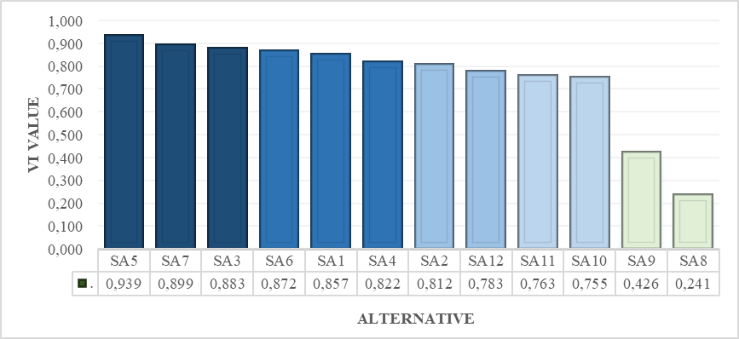
Figure 1. Preference for Each Alternative in the Assessment System Dimension. Based on the results of the calculation of the preference value for each alternative in the Assessment System dimension, it was obtained that the lowest V value indicates the components that need to be improved to increase the effectiveness of the implementation of the Competency Test Certification, which is shown in Figure 1. Indicates that the determination value or determinant for each alternative indicates the results that need to be improved so as to achieve an excellent standard of conformity on the SA12, SA11, and SA10 question components. In addition, the standard score needs to be improved in the SA9 and SA8 question components which have a determination standard value or determinant as an alternative to the standard value of the less category. This shows that the Average Assessment System program of all components of the standard score questions in the Good category. In addition, components related to the infrastructure needs of participants and the implementation team from the Business and Industry World also need to be improved. Fullerton stated that the development of vocational education is based on the demands of professionals (Fullerton & Leckie, 1999). This is reinforced by Mahmudah who stated that vocational education today needs to be able to adapt to the changing demands in this field (Mahmudah & Santosa, 2021).
- Planning Program
The level of effectiveness of the planning dimension in five Vocational High Schools was assessed based on twelve questions. The calculation of the first stage can be seen in Table 6 based on Eq. (1). The normalized values are fed into the . matrix based on the calculation results. Next, entering the data from Table 6 into Equation (2) is the second step. Table 7 shows the calculation results.
Table 6.
The matrix is created from normalized data.
0,2915 | 0,2809 | 0,3018 | 0,2988 | 0,2928
0,3068 | 0,3072 | 0,3102 | 0,2988 | 0,3272
0,2991 | 0,2984 | 0,3018 | 0,3074 | 0,3272
0,3227 | 0,2984 | 0,2683 | 0,2391 | 0,2411
0,2608 | 0,2458 | 0,2516 | 0,2391 | 0,2756
0,3201 | 0,2458 | 0,2516 | 0,2391 | 0,2411
0,3068 | 0,2809 | 0,2683 | 0,2732 | 0,2756
0,3068 | 0,2809 | 0,2683 | 0,2732 | 0,2756
0,5263 | 0,2809 | 0,2683 | 0,3415 | 0,2756
0,2863 | 0,3277 | 0,3353 | 0,296 | 0,2985
0,2863 | 0,3043 | 0,313 | 0,3187 | 0,2985
0,2863 | 0,3043 | 0,313 | 0,3187 | 0,3215

Table 7.
() Matrix elements with weighted rating
0,2915 | 0,2809 | 0,3018 | 0,2988 | 0,2928
0,3068 | 0,3072 | 0,3102 | 0,2988 | 0,3272
0,2991 | 0,2984 | 0,3018 | 0,3074 | 0,3272
0,3227 | 0,2984 | 0,2683 | 0,2391 | 0,2411
0,2608 | 0,2458 | 0,2516 | 0,2391 | 0,2756
0,3201 | 0,2458 | 0,2516 | 0,2391 | 0,2411
0,3068 | 0,2809 | 0,2683 | 0,2732 | 0,2756
0,3068 | 0,2809 | 0,2683 | 0,2732 | 0,2756
0,5263 | 0,2809 | 0,2683 | 0,3415 | 0,2756
0,2863 | 0,3277 | 0,3353 | 0,296 | 0,2985
0,2863 | 0,3043 | 0,313 | 0,3187 | 0,2985
0,2863 | 0,3043 | 0,313 | 0,3187 | 0,3215
Table 8 shows the third stage, where the value of the positive ideal solution and the
negative ideal solution are found using Equation (3) and Equation (4). Furthermore, Equation (5) and Equation (6) are used to calculate the values of and Once the values () and () are found, the preference value () is searched, which can be sorted by value.

Table 8.
Value preference based on a defined rating

 | y₁⁺ |  | 0,1175 |  |  | y₁⁻ | 0,2369
 | y₂⁺ |  | 0,0821 |  |  | y₂⁻ | 0,0616
 | y₃⁺ |  | 0,0379 |  |  | y₃⁻ | 0,0505
 | y₄⁺ |  | 0,0343 |  |  | y₄⁻ | 0,0241
 | y5⁺ |  | 0,0122 |  |  | y5⁻ | 0,0122
D₁⁺ |  | 0,0204 |  | D₁⁻ | 0,1065 |  |  | V₁ | 0,9404
D₂⁺ |  | 0,024 |  | D₂⁻ | 0,1005 |  |  | V₂ | 0,9071
D₃⁺ |  | 0,0211 |  | D₃⁻ | 0,1037 |  |  | V₃ | 0,9310
D₄⁺ |  | 0,0309 |  | D₄⁻ | 0,0933 |  |  | V₄ | 0,8522
D₅⁺ |  | 0,0231 |  | D₅⁻ | 0,1203 |  |  | V₅ | 0,9398
D₆⁺ |  | 0,0354 |  | D₆⁻ | 0,0938 |  |  | V₆ | 0,8272
D₇⁺ |  | 0,0251 |  | D₇⁻ | 0,0999 |  |  | V₇ | 0,9003
D₈⁺ |  | 0,0251 |  | D₈⁻ | 0,0999 |  |  | V₈ | 0,9003
D₉⁺ |  | 0,1203 |  | D₉⁻ | 0,0171 |  |  | V₉ | 0,2236
D₁₀⁺ |  | 0,0181 |  | D1₀⁻ | 0,1103 |  |  | V₁₀ | 0,9606
D₁₁⁺ |  | 0,0165 |  | D₁₁⁻ | 0,1095 |  |  | V₁₁ | 0,9707
D₁₂⁺ |  | 0,018 |  | D₁₂⁻ | 0,0388 |  |  | V₁₂ | 0,9683
Table 8 shows the determination of the values of the positive ideal solution (yj+) and the negative ideal solution (yj-), followed by the calculation of the values (Di+) and (Di-). After finding the values (Di+) and (Di-), the preference value (Vn) is searched, and the ranking can be performed.
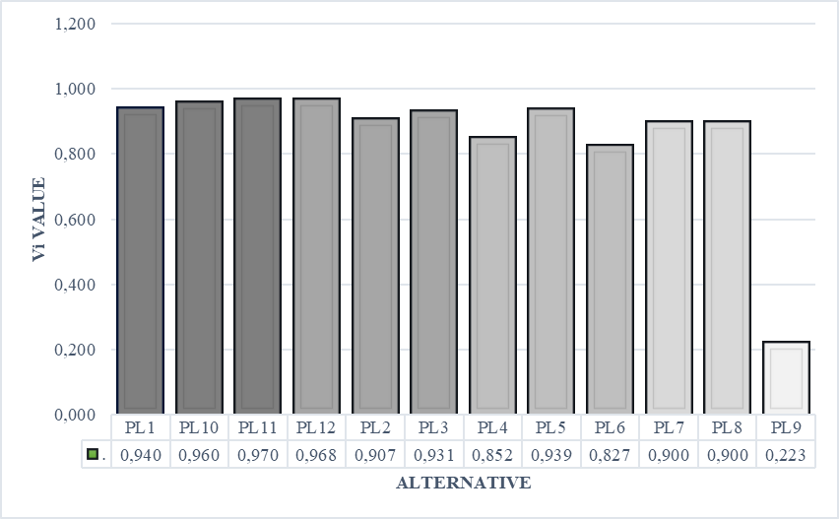
Figure 2. Assess the preferences of each alternative dimension of the planning program. Based on the results of the calculation of the preference value for each alternative dimension of the Planning Program, the component with the lowest V value must be improved to increase the effectiveness of the implementation of the Machining Mechanics Program Competency Test Certification in VHS. Dimensions of the planning program average value d. Alternative grades are excellent for the PL4 and PL6 question components, which need to be upgraded to a standard grade. In addition, the PL9 question component that uses the determinant value standard as an alternative to the category standard value is very lacking, so in the future the category standard must be upgraded to the minimum conformity category standard. In the component aspect, building learning and training to understand applied knowledge in theory and related to the application of work practices in workshops in the Very Low value category. Therefore, Kuntoro stated that organizational assessment planning and engagement standards must be implemented on an ongoing basis to ensure that programs are met. In addition, Arnita stated that planning activities need to design in their approach to purpose-based programming (Arnita & Chrisna, 2022).

- Implementation Program
The problem in the implementation dimension of the program is a component that needs to be improved to increase the effectiveness of the implementation of the Competency Test Certification in the Machining Mechanics Program in five VSS based on 9 questions.
Based on Eq. (1), the first stage of calculation can be seen in Table 9. Table 9 shows the normalization results from data collection to R_{ij}, which based on the calculation results are included in the matrix R_{ij}. The second stage is to incorporate the data found in Table 9 into Equation (2). The results of this stage can be seen in Table 10.
Table 9.
The matrix is created from normalized data.
0,3541 | 0,3564 | 0,3652 | 0,3846 | 0,3986
0,2952 | 0,297 | 0,3044 | 0,3045 | 0,3157
0,3541 | 0,3564 | 0,3044 | 0,3045 | 0,3157
0,3689 | 0,3712 | 0,3804 | 0,3205 | 0,3322
0,3689 | 0,3712 | 0,3804 | 0,3205 | 0,3322
0,3689 | 0,3712 | 0,3804 | 0,4006 | 0,3322
0,3504 | 0,3341 | 0,3424 | 0,3806 | 0,3945
0,2583 | 0,26 | 0,2664 | 0,3005 | 0,27
0,2583 | 0,26 | 0,2474 | 0,2605 | 0,2908

() Matrix elements with weighted rating
0,1596 | 0,0894 | 0,0551 | 0,0388 | 0,0203
0,133 | 0,0746 | 0,046 | 0,0308 | 0,0162
0,1596 | 0,0894 | 0,046 | 0,0308 | 0,0162
0,1662 | 0,0931 | 0,0574 | 0,0324 | 0,017
0,1662 | 0,0931 | 0,0574 | 0,0324 | 0,017
0,1662 | 0,0931 | 0,0574 | 0,0404 | 0,017
0,1579 | 0,0838 | 0,0517 | 0,0384 | 0,0201
0,1165 | 0,0653 | 0,0403 | 0,0304 | 0,0139
0,1165 | 0,0653 | 0,0375 | 0,0264 | 0,0149
Table 11 shows the third stage, where equations (3) and (4) are used to find the value of the positive ideal solution and the negative ideal solution , as well as equations (5) and (6) to find the values of and After finding the values and , the preference value () is searched, which can then be sorted by its value.
Table 11.
Value preference based on a defined rating
y₁⁺ | 0,1165 | y₁⁻ | 0,1662
y₂⁺ | 0,0931 | y₂⁻ | 0,0653
y₃⁺ | 0,0375 | y₃⁻ | 0,0574
y₄⁺ | 0,0404 | y₄⁻ | 0,0264
y5⁺ | 0,0139 | y5⁻ | 0,0139

D₁⁺ | 0,0476 | D₁⁻ | 0,0291 | V₁ | 0,4783
D₂⁺ | 0,0285 | D₂⁻ | 0,037 | V₂ | 0,6658
D₃⁺ | 0,0456 | D₃⁻ | 0,0283 | V₃ | 0,4818
D₄⁺ | 0,0547 | D₄⁻ | 0,029 | V₄ | 0,4452
D₅⁺ | 0,0547 | D₅⁻ | 0,029 | V₅ | 0,4452
D₆⁺ | 0,0541 | D₆⁻ | 0,0317 | V₆ | 0,4682
D₇⁺ | 0,0457 | D₇⁻ | 0,0255 | V₇ | 0,4562
D₈⁺ | 0,0301 | D₈⁻ | 0,0532 | V₈ | 0,7399
D₉⁺ | 0,0316 | D₉⁻ | 0,054 | V₉ | 0,7324

Table 11 data, the results will be shown in Figure 3.
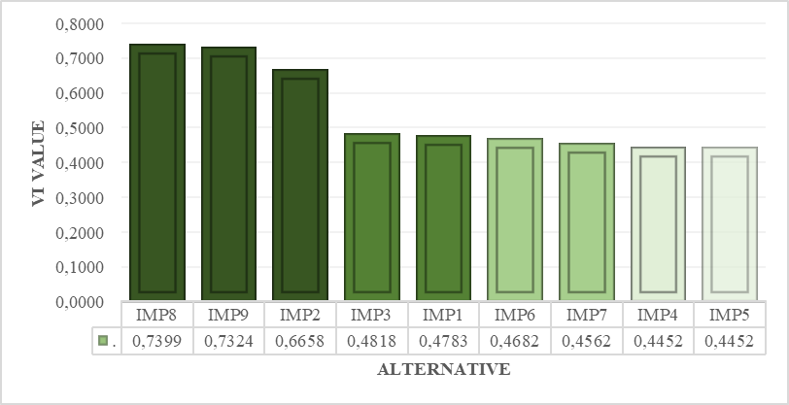

Figure 3. Assess preferences for each alternative dimension of Program Implementation. Based on the results of the calculation of the preference value for each alternative dimension of Program Implementation, the component with the lowest V value must be improved to increase the effectiveness of the implementation of the Competency Test Certification in the VHS Machining Mechanics Program. Figure 3. Showing according to the ranking of alternative scores obtained in the question components that need to be upgraded to the Excellent category in the IMP8, IMP9 question components. The question component of the value category is sufficient and needs to be increased to the Good value category for future programs in the IMP2 question component. In addition, the category of less grades according to the ranking in the IMP3, IMP1, IMP6, IMP7, IMP4 question components. This requires an increase in the value category in future programs to become a standard for the category of suitability for Sufficient or Good scores. Program dimension Implementation of the average score of all question components of the Sufficient value category. This requires an increase in value categories in every aspect of the implementation program dimension. According to Suharno, the main purpose of competency test certification is to improve links and matches, and the secondary goal is to improve the quality of knowledge and skills. Thus, competency-based certification programs expect graduates to be able to use existing certificates in the future (Suharno et al., 2020). In line with Aryani, science will play an important role in technology, tools, and products that will make human life and work easier (Ariyani et al., 2021)
- Improvement Program
In the Improvement Program dimension data, the problem to be found is what components need to be improved to increase the effectiveness of the implementation of the Vocational Machining Mechanics Program Competency Test Certification. In this case, five Vocational High Schools were evaluated based on 9 alternative questions. Table 12 shows the calculation of the first stage based on Eq. (1). It shows the normalization results of data collection to . The calculation results show that the normalized values have been entered into the matrix . Entering the data from Table 12 into Equation (2) is the second step. Table 13 shows the calculation results.
Table 12.
The matrix is created from normalized data.
0,3294 | 0,36 | 0,343 | 0,314 | 0,3463
0,3294 | 0,3222 | 0,343 | 0,351 | 0,3463
0,3294 | 0,3411 | 0,343 | 0,314 | 0,3645
0,3121 | 0,36 | 0,3621 | 0,351 | 0,3281
0,3467 | 0,3411 | 0,3049 | 0,351 | 0,3645
0,3121 | 0,36 | 0,3811 | 0,351 | 0,3645
0,3467 | 0,3032 | 0,3049 | 0,2956 | 0,2916
0,3467 | 0,3032 | 0,3049 | 0,2956 | 0,2916
0,3467 | 0,3032 | 0,3049 | 0,3694 | 0,2916

Table 13.
() Matrix elements with weighted rating
0,1483 | 0,0902 | 0,0516 | 0,0316 | 0,0175
0,1483 | 0,0807 | 0,0516 | 0,0353 | 0,0175
0,1483 | 0,0854 | 0,0516 | 0,0316 | 0,0184
0,1405 | 0,0902 | 0,0545 | 0,0353 | 0,0166
0,1561 | 0,0854 | 0,0459 | 0,0353 | 0,0184
0,1405 | 0,0902 | 0,0573 | 0,0353 | 0,0184
0,1561 | 0,076 | 0,0459 | 0,0297 | 0,0148
0,1561 | 0,076 | 0,0459 | 0,0297 | 0,0148
0,1561 | 0,076 | 0,0459 | 0,0371 | 0,0148

In the third stage, Equations (3) and (4) are used to find the value of the positive ideal solution and the negative ideal solution , and Equations (5) and (6) are used to find the values of and . After finding the values (and , the preference value () is searched, which can then be sorted by its value.
Table 14.
Value preference based on a defined rating
y₁⁺ | 0,1405 | y₁⁻ | 0,1561
y₂⁺ | 0,0902 | y₂⁻ | 0,076
y₃⁺ | 0,0459 | y₃⁻ | 0,0573
y₄⁺ | 0,0371 | y₄⁻ | 0,0297
y₅⁺ | 0,0148 | y₅⁻ | 0,0148

D₁⁺ | 0,0117 | D₁⁻ | 0,0177 | V₁ | 0,7040
D₂⁺ | 0,0141 | D₂⁻ | 0,0126 | V₂ | 0,5712
D₃⁺ | 0,0128 | D₃⁻ | 0,0143 | V₃ | 0,6279
D₄⁺ | 0,0092 | D₄⁻ | 0,0223 | V₄ | 0,8114
D₅⁺ | 0,017 | D₅⁻ | 0,0165 | V₅ | 0,5917
D₆⁺ | 0,0123 | D₆⁻ | 0,0223 | V₆ | 0,7456
D₇⁺ | 0,0225 | D₇⁻ | 0,0116 | V₇ | 0,4383
D₈⁺ | 0,0225 | D₈⁻ | 0,0116 | V₈ | 0,4383
D₉⁺ | 0,0213 | D₉⁻ | 0,0138 | V₉ | 0,4921

The data in Table 14, the results will be shown in Figure 4.
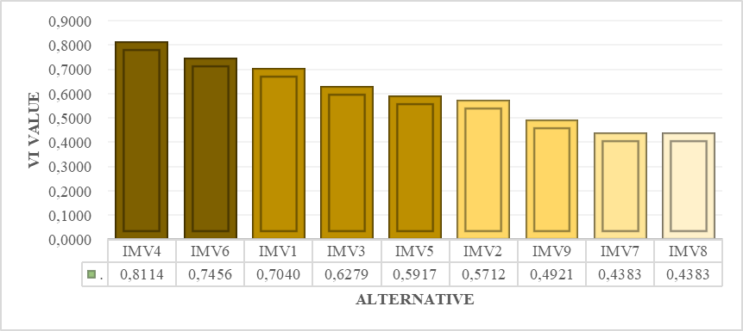
Figure 4 shows the preference values for each of the enhancement dimension alternatives. Based on the results of the calculation of the preference value, the component that gets the lowest V value is the one that must be improved to increase the effectiveness of the implementation of the Competency Test Certification in the Vocational High School Machining Mechanics Program. The results of the alternative ranking of the Good value category in the IMV4, IMV6, IMV1 question components. The Sufficient value category in the IMV3, IMV5, IMV2 question components needs to be upgraded to a Good or Very Good value category in future programs. In addition, the category of Less values in the IMV9, IMV7, IMV8 question components. Therefore, it is necessary to increase the value category of Enough or Good on the question component. The improvment program had an average score of all question components obtained in the category of Sufficient. This needs to be improved from every component of the Improvement program. In line with Elakas stated that the supervisor of training in the productive field and the implementation of real work competency tests using external assessors who evaluate students (Elakas et al., 2023). In addition, Yildiz stated that the industry needs to be considered to meet the needs of increasing the knowledge and skills of prospective workers in the industry (Yildiz & Yildirim, 2023). Therefore, Dirim stated that the competency test certification procedures have been implemented, but the quality, theory, and practice need to be improved to be in accordance with the curriculum and to meet the needs with industry partners (Dirim et al., 2023).
- Certification Program
Certification dimension data shows problems that need to be fixed to make competency test certification on machining mechanics programs in vocational high schools more efficient. In this case, five Vocational High Schools were assessed based on six alternative questions. Table 15 shows the calculation of the first stage based on Equation (1). Table 15 shows the results of normalizing the data to . Based on the calculation results, the normalized values are included in the matrix . Next, the data found in Table 15 is incorporated into Equation (2). Table 16 shows the calculation results.
Table 15.
The matrix is created from normalized data.
0,4000 | 0,3954 | 0,3957 | 0,443 | 0,4028
0,4000 | 0,3954 | 0,3957 | 0,4253 | 0,4028
0,4167 | 0,433 | 0,4333 | 0,4076 | 0,4196
0,4167 | 0,3766 | 0,4145 | 0,3544 | 0,4028
0,4167 | 0,433 | 0,4145 | 0,4076 | 0,4196
0,4000 | 0,4142 | 0,3957 | 0,4076 | 0,4028

Table 16.
() Matrix elements with weighted rating
0,1801 | 0,099 | 0,0595 | 0,0445 | 0,0203
0,1801 | 0,099 | 0,0595 | 0,0427 | 0,0203
0,1876 | 0,1084 | 0,0652 | 0,0409 | 0,0212
0,1876 | 0,0943 | 0,0623 | 0,0356 | 0,0203
0,1876 | 0,1084 | 0,0623 | 0,0409 | 0,0212
0,1801 | 0,1037 | 0,0595 | 0,0409 | 0,0203

In the third stage, Equations (3) and (4) are used to find the value of the positive ideal solution and the negative ideal solution and Equations (5) and (6) are used to find the values of and . After finding the values () and , the preference value () is searched, which can then be sorted by its value.
Table 17.
Value preference based on a defined rating
y₁⁺ | 0,1801 | y₁⁻ | 0,1876
y₂⁺ | 0,1084 | y₂⁻ | 0,0943
y₃⁺ | 0,0595 | y₃⁻ | 0,0652
y₄⁺ | 0,0445 | y₄⁻ | 0,0356
y₅⁺ | 0,0203 | y₅⁻ | 0,0203

D₁⁺ | 0,0096 | D₁⁻ | 0,0139 | V₁ | 0,6935
D₂⁺ | 0,0098 | D₂⁻ | 0,0129 | V₂ | 0,6695
D₃⁺ | 0,0103 | D₃⁻ | 0,0153 | V₃ | 0,7000
D₄⁺ | 0,0187 | D₄⁻ | 0,003 | V₄ | 0,2325
D₅⁺ | 0,009 | D₅⁻ | 0,0156 | V₅ | 0,7359
D₆⁺ | 0,0061 | D₆⁻ | 0,0145 | V₆ | 0,8085

Figure 5 shows the results from Table 16.
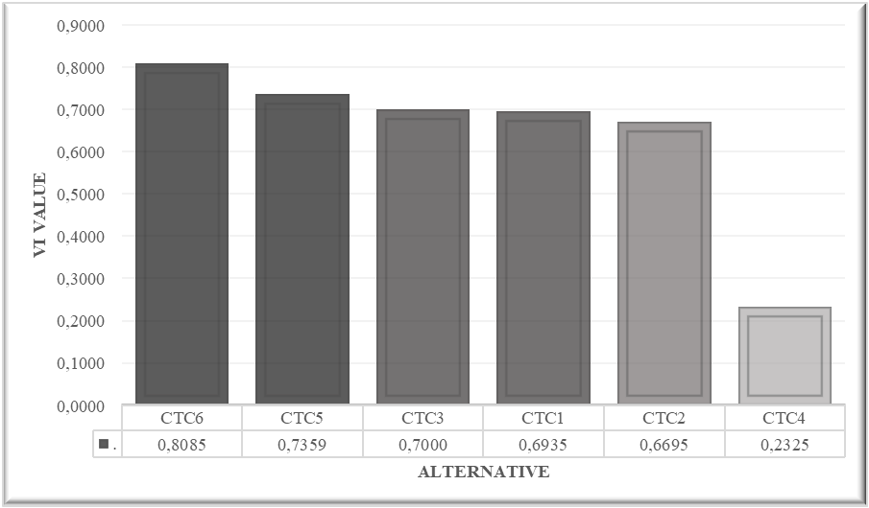

Figure 5. Assess the preference for each alternate certification dimension. Based on the results of the calculation of the preference value for each alternative dimension of certification, the component with the lowest V value must be improved to increase the effectiveness of the implementation of Competency Test Certification in the VHS Machining Mechanics Program. Figure 5. Showing according to the value of the alternative ranking of the Good value category in the CTC6, CTC5, CTC3 question components. This needs to be maintained and improved to Very Good in the Certification program in the future. The value category is sufficient in the CTC1 question component, CTC2 needs to increase the Good value category for the implementation of the program in the future. In addition, the Poor value category in the CTC4 question component needs to be increased to Sufficient or Good in preparation for future program implementation. The average score certification program from all question components was obtained by the Sufficient score criterion. This needs to be improved from every component of the question in the certification program. In line with Huang's opinion, stating that the infrastructure, equipment, and materials of the test takers are all inadequate for the implementation procedure. In addition, the psychomotor test-participant component performed worse than other components due to the lack of theoretical mastery of the certification material for the competency test (Huang et al., 2023). In addition, Knippa stated that in ensuring the influence of the competency test certification program on the performance of students who graduate, a graduate performance tracing was developed

Conclusion
The competency test program in the certification of machining expertise that has been implemented needs to be strengthened in terms of applied knowledge. Therefore, competency exams involve and lead to various aspects in vocational education programs.
To produce graduates who have a good understanding of applied knowledge and skills, competency improvement programs that are usually carried out must be strengthened with an applied understanding that covers various aspects of program management. Qualitative research has been carried out using the CSE-UCLA model in each dimension to assess criteria and alternatives. Therefore, these findings can be used as additional information and as an improvement for the machining engineering competency certification program that is commonly carried out in vocational education.

Recommendation
It is important for the competency test management team to establish the right policies to improve output performance, outcomes, and impact. Information for productive subject teachers about the evaluation of performance competency test programs based on applied scientific knowledge in the application of competency tests. It is expected that vocational education researchers will benefit from a framework of further research on similar research areas. Very few researchers have relevant and relevant competency test certification graduate data with certificates from the five available schools.

Acknowledgment
Thank you, Mechanical Engineering Education Study Program, Faculty of Engineering, State University of Jakarta. Teachers from various Vocational High Schools who have provided support and assisted in the implementation of instruments and activities related to the competency test certification implementation program.

References
Abdullah, M. N., Ahmad, A., & Gani, H. A. (2022). Development of Learning by doing Governance Model Industry based on Vocational Middle School in Makassar. Asian Journal of Applied Sciences, 10(1). https://doi.org/10.24203/ajas.v10i1.6850
Abdurrahman, Parmin, & Muryanto, S. (2022). Evaluation on the automotive skill competency test through ‘discontinuity’ model and the competency test management of vocational education school in Central Java, Indonesia. Heliyon, 8(2). https://doi.org/10.1016/j.heliyon.2022.e08872
Abusamra, A. (2022). The Role of Community Colleges in Developing Creativity and Innovation Skills of Vocational Students (The University College of Applied Science as a Case Study). Dirasat: Human and Social Sciences, 49(2), 583–597. https://doi.org/10.35516/hum.v49i2.1817
Antonietti, C., Cattaneo, A., & Amenduni, F. (2022). Can teachers’ digital competence influence technology acceptance in vocational education? Computers in Human Behavior, 132. https://doi.org/10.1016/j.chb.2022.107266
Ariyani, L. F., Widjaja, S. U. M., Wahyono, H., Haryono, A., Rusdi, J. F., & Pratama, C. B. A. (2021). Vocational education phenomena research method. MethodsX, 8. https://doi.org/10.1016/j.mex.2021.101537
Arnita, V., & Chrisna, H. (2022). Accountings Students Following Test Certification Accounting Yunior Test In Indonesia. Economics, Business and Management Science Journal, 2(2). https://doi.org/10.34007/ebmsj.v2i2.289
Badan Pusat Statistik. (2020). Pengangguran Terbuka Menurut Pendidikan Tertinggi yang Ditamatkan 1986 - 2020. Badan Pusat Statistik.
Badan Pusat Statistik Indonesia. (2023, January 16). Proportion of Workforce in Manufacturing Sector (Percent), 2022. https://www.bps.go.id/id/statistics-table/2/MTIxNyMy/proporsi-tenaga-kerja-pada-sektor-industri-manufaktur--persen-.html
Billett, S. (2000). Defining the demand side of vocational education and training: Industry, enterprises, individuals and regions. Journal of Vocational Education and Training, 52(1), 5–31. https://doi.org/10.1080/13636820000200104
Burke, A. E., Benson, B., Englander, R., Carraccio, C., & Hicks, P. J. (2014). Domain of competence: Practice-based learning and improvement. Academic Pediatrics, 14(2 SUPPL.). https://doi.org/10.1016/j.acap.2013.11.018
CHIBA, Y., KOBAYASHI, R., OSHIDA, J., & ICHIKAWA, H. (2023). Analysis of Human Resource Development Issues in the Machining Industry. Journal of JSEE, 71(2). https://doi.org/10.4307/jsee.71.2_89
Dirim, Ş., Özener, O. Ö., & Sözer, H. (2023). Prioritization and parallel execution of test cases for certification testing of embedded systems. Software Quality Journal, 31(2). https://doi.org/10.1007/s11219-022-09594-1
Edwards, R., & Holland, J. (2020). Reviewing challenges and the future for qualitative interviewing. International Journal of Social Research Methodology, 23(5), 581–592. https://doi.org/10.1080/13645579.2020.1766767
Elakas, A., Tarlan, O., Safak, I., Kalkan, K., & Sozer, H. (2023). Towards Test Automation for Certification Tests in the Banking Domain. UBMK 2023 - Proceedings: 8th International Conference on Computer Science and Engineering. https://doi.org/10.1109/UBMK59864.2023.10286638
Finegold, D., & Soskice, D. (1988). The failure of training in Britain: Analysis and prescription. Oxford Review of Economic Policy, 4(3), 21–53. https://doi.org/10.1093/oxrep/4.3.21
Fullerton, A., & Leckie, G. (1999). Information literacy in science and engineering undergraduate education: faculty attitudes and pedagogical practices. College and Research Libraries, January 1999, 9–29.
Gaviria-Marin, M., Merigó, J. M., & Baier-Fuentes, H. (2019). Knowledge Management: A Global Examination Based On Bibliometric Analysis. Technological Forecasting and Social Change, 140, 1–27. https://doi.org/10.1016/j.techfore.2018.07.006
Huang, F., Huang, B., Wang, Y., & Wang, Y. (2023). A Taxonomy of Software Defect Forms for Certification Tests in Aviation Industry. Lecture Notes in Computer Science (Including Subseries Lecture Notes in Artificial Intelligence and Lecture Notes in Bioinformatics), 14181 LNCS. https://doi.org/10.1007/978-3-031-40923-3_5
Imad, M., Hopkins, C., Hosseini, A., Yussefian, N. Z., & Kishawy, H. A. (2022). Intelligent machining: a review of trends, achievements and current progress. International Journal of Computer Integrated Manufacturing, 35(4–5), 359–387. https://doi.org/10.1080/0951192X.2021.1891573
Knippa, S., Thompson-Brazill, K. A., Roller, A., & Mullen, J. (2023). Certification Test Prep: Professional Caring. In Critical Care Nurse (Vol. 43, Issue 5). https://doi.org/10.4037/ccn2023394
Kuntoro, T., Sudana, I. M., & Anis, S. (2019a). Journal of Vocational Career Education The Implementation of Competency Certification Test for Vocational Students of Light Vehicle Engineering Program by LSP-P3 in Banyumas. Journal of Vocational Career Education, 4(1).
Kuntoro, T., Sudana, I. M., & Anis, S. (2019b). The Implementation of Competency Certification Test for Vocational Students of Light Vehicle Engineering Program by LSP-P3 in Banyumas. Journal of Vocational Career Education, 4(1), 74–82. https://doi.org/https://doi.org/10.15294/jvce.v4i2.23053
Li, J., & Pilz, M. (2023). International transfer of vocational education and training: a literature review. Journal of Vocational Education and Training, 75(2). https://doi.org/10.1080/13636820.2020.1847566
Ling, Y., Chung, S. J., & Wang, L. (2023). Research on the reform of management system of higher vocational education in China based on personality standard. Current Psychology, 42(2). https://doi.org/10.1007/s12144-021-01480-6
Magulod, G. C. (2019). Learning Styles, Study Habits And Academic Performance Of Filipino University Students In Applied Science Courses: Implications For Instruction. Journal of Technology and Science Education, 9(2), 184–198. https://doi.org/10.3926/jotse.504
Mahmudah, F. N., & Santosa, B. (2021). Vocational School Alignment Based-on Industry Needs. 4(1), 36–45.
Majetic, C., & Pellegrino, C. (2018). Building Information Literacy Skills Using Science News Media. Journal of College Science Teaching, 48(1).
Makinde, W. A., & Bamiro, T. O. (2023). Service Quality of Teaching Vocational Education and Training (TVET) and Student’s Satisfaction in Nigeria. Journal of Pedagogy and Education Science, 2(01), 10–25. https://doi.org/10.56741/jpes.v2i01.157
Margaryan, A. (2021). On The Issue Of The Relationship Between Basic And Applied Knowledge. Methodological Aspect. Wisdo, 17(1), 35–43. https://doi.org/10.24234/wisdom.v17i1.426
Marsidi, S. R. (2021). Identification Of Stress, Anxiety, And Depression Levels Of Students In Preparation For The Exit Exam Competency Test. Journal of Vocational Health Studies, 5(2), 87–93. https://doi.org/10.20473/jvhs.v5.i2.2021.87-93
Mason, R. B., Mbambo, S. N., & Pillay, M. A. (2018). Service quality at technical and vocational education and training colleges: Perception according to demographic factors. Journal of Technical Education and Training, 10(1), 15–29. https://doi.org/10.30880/jtet.2018.10.01.002
Matos, F., & Vairinhos, V. M. (2017). Intellectual Capital Management as a Driver of Competitiveness and Sustainability. In Journal of Intellectual Capital (Vol. 18, Issue 3). https://doi.org/10.1108/JIC-04-2017-0060
McDonald, K. (2015). Re-envisioning Libraries for Training and Literacy Development. Procedia - Social and Behavioral Sciences, 176, 504–508. https://doi.org/10.1016/j.sbspro.2015.01.503
Mehrparvar, E., Shahin, A., & Shirouyehzad, H. (2012). Prioritizing internal service quality dimensions using TOPSIS Technique (With a case study in Isfahan Steel Mill Co.). International Journal of Business and Social Science, 3(2), 210–217.
Muja, A., Blommaert, L., Gesthuizen, M., & Wolbers, M. H. J. (2019). The vocational impact of educational programs on youth labor market integration. Research in Social Stratification and Mobility, 64. https://doi.org/10.1016/j.rssm.2019.100437
Nurtanto, M., Sofyan, H., Pardjono, P., & Suyitno, S. (2020). Development model for competency improvement and national vocational qualification support frames in automotive technology. International Journal of Evaluation and Research in Education, 9(1). https://doi.org/10.11591/ijere.v9i1.20447
Pamungkas, S. F., Widiastuti, I., & Suharno. (2020). 21st century learning: Experiential learning to enhance critical thinking in vocational education. In Universal Journal of Educational Research (Vol. 8, Issue 4). https://doi.org/10.13189/ujer.2020.080427
Pardjono, P., Sugiyono, S., & Budiyono, A. (2015). Developing A Model Of Competency And Expertise Certification Tests For Vocational High School Students. REID (Research and Evaluation in Education), 1(2). https://doi.org/10.21831/reid.v1i2.6517
Parkinson, J., & Mackay, J. (2016a). The literacy practices of vocational training in Carpentry and Automotive Technology. Journal of Vocational Education and Training, 68(1). https://doi.org/10.1080/13636820.2015.1104714
Parkinson, J., & Mackay, J. (2016b). The literacy practices of vocational training in Carpentry and Automotive Technology. Journal of Vocational Education and Training, 68(1), 33–50. https://doi.org/10.1080/13636820.2015.1104714
Priyanto, S., Soeprijanto, Badrujaman, A., & Sahara, S. (2024). Evaluation Approach Of The Mechanical Engineering Competency Test Certification Using The Assessment Evaluability And Performance Monitoring Model. Decision Science Letters, 13(1). https://doi.org/10.5267/j.dsl.2023.9.002
Republic of Indonesia Employment Law Number 13 of 2003. (n.d.).
Rodriguez, R., Svensson, G., & Wood, G. (2020a). Assessing corporate planning of future sustainability initiatives in private healthcare organizations. Evaluation and Program Planning, 83(August). https://doi.org/10.1016/j.evalprogplan.2020.101869
Rodriguez, R., Svensson, G., & Wood, G. (2020b). Assessing corporate planning of future sustainability initiatives in private healthcare organizations. Evaluation and Program Planning, 83. https://doi.org/10.1016/j.evalprogplan.2020.101869
Rodríguez-Dorans, E., & Jacobs, P. (2020). ‘Making narrative portraits: a methodological approach to analysing qualitative data.’ International Journal of Social Research Methodology, 23(6), 611–623. https://doi.org/10.1080/13645579.2020.1719609
Rofiq, Z., Surono, S., Bruri Triyono, M., & Setiyo Hari Purwoko, B. (2019a). Developing the Standard Competencies for Vocational Teacher Candidates of Mechanical Engineering. Journal of Physics: Conference Series, 1273(1). https://doi.org/10.1088/1742-6596/1273/1/012032
Rofiq, Z., Surono, S., Bruri Triyono, M., & Setiyo Hari Purwoko, B. (2019b). Developing the Standard Competencies for Vocational Teacher Candidates of Mechanical Engineering. Journal of Physics: Conference Series, 1273(1). https://doi.org/10.1088/1742-6596/1273/1/012032
Rosenbaum, E., Klopfer, E., & Perry, J. (2020). On location learning: Authentic applied science with networked augmented realities. Journal of Science Education and Technology, 16(1). https://doi.org/10.1007/s10956-006-9036-0
Said, A. (2018). Vocational teaching-learning through the eyes of undergraduate vocational students in Malta: A qualitative exploratory study. International Journal for Research in Vocational Education and Training, 5(1). https://doi.org/10.13152/IJRVET.5.1.3
Santosa, B., & Dwi, S. (2018). Work-based assessment at vocational high school in Indonesia. International Journal of Research Studies in Education, 8(1). https://doi.org/10.5861/ijrse.2018.3011
Santosa, B., & Kamin, Y. Bin. (2018). CBT in the workplace in Indonesian vocational high school. Journal of Vocational Education Studies, 1(2). https://doi.org/10.12928/joves.v1i2.700
Shaw, J. (2022). Revisiting the Basic/Applied Science Distinction: The Significance of Urgent Science for Science Funding Policy. Journal for General Philosophy of Science, 53(4). https://doi.org/10.1007/s10838-021-09575-1
Stanković, N., & Micić, Ž. (2018). Innovating And Management Of The Knowledge Base On The Example Of IT Applications. Telematics and Informatics, 35(5), 1–23. https://doi.org/10.1016/j.tele.2018.02.010
Stofkova, Z., & Sukalova, V. (2020). Sustainable Development of Human Resources in Globalization Period. Sustainabiliity Journal, 7681(12), 1–14. https://doi.org/https://doi.org/10.3390/su12187681
Suharno, Pambudi, N. A., & Harjanto, B. (2020). Vocational education in Indonesia: History, development, opportunities, and challenges. In Children and Youth Services Review (Vol. 115). https://doi.org/10.1016/j.childyouth.2020.105092
Tang, F., O’Grady, A., & Clapham, A. (2017). Entering the testing and certification industry: A review of job and competency requirements. IEEE International Conference on Industrial Engineering and Engineering Management, 2017-December. https://doi.org/10.1109/IEEM.2017.8289871
Taruno, D. L. B., & Ramadani, W. (2019). Development of Assessment Tools Certification Competency Test in Higher Education. Proceedings of the International Conference on Online and Blended Learning, 222–225. https://doi.org/10.2991/assehr.k.200521.049
Ubaidah, S., Trisnamansyah, S., Insan, H. S., & Harahap, N. (2021). Partnership Management Between Vocational Schools with the World of Business and Industry to Improve the Quality of Graduates Who Are Ready to Work. International Journal of Nusantara Islam, 9(1). https://doi.org/10.15575/ijni.v9i1.11818
Uyasa, PS. W. A., & Kurniawan, P. S. (2018). Pemberdayaan Model CSE-UCLA Dalam Pelaksanaan Evaluasi Program Blended Learning di SMA Negeri 1 Ubud. WACANA AKADEMIKA: Majalah Ilmiah Kependidikan, 2(2), 137. https://doi.org/10.30738/wa.v2i2.2627
Vaganova, O. I., Bakharev, N. P., Kulagina, J. A., Lapshova, A. V., & Kirillova, I. K. (2020). Multimedia technologies in vocational education. Revista Amazonia Investiga, 9(26), 391–398. https://doi.org/10.34069/ai/2020.26.02.45
Wang, H., & Chen, S. (2023). Insights into the Application of Machine Learning in Reservoir Engineering: Current Developments and Future Trends. Energies, 16(3). https://doi.org/10.3390/en16031392
Wilkesmann, M., & Wilkesmann, U. (2018). Industry 4.0 – Organizing Routines Or Innovations? VINE Journal of Information and Knowledge Management Systems, 48(2), 238–254. https://doi.org/10.1108/VJIKMS-04-2017-0019
XU, Z., & WANG, Y. (2021). Electrochemical machining of complex components of aero-engines: Developments, trends, and technological advances. In Chinese Journal of Aeronautics (Vol. 34, Issue 2, pp. 28–53). https://doi.org/10.1016/j.cja.2019.09.016
Yadav, N., Gupta, K., & Khetrapal, V. (2018). Next Education: Technology Transforming Education. South Asian Journal of Business and Management Cases, 7(1). https://doi.org/10.1177/2277977918754443
Yildiz, F., & Yildirim, E. (2023). Important insect pests in winter vegetables grown in Beydere Seed Certification Test Directorate. Plant Protection Bulletin (Turkey), 63(3). https://doi.org/10.16955/bitkorb.1274312
Zhu, D., Feng, X., Xu, X., Yang, Z., Li, W., Yan, S., & Ding, H. (2020). Robotic grinding of complex components: A step towards efficient and intelligent machining – challenges, solutions, and applications. Robotics and Computer-Integrated Manufacturing, 65. https://doi.org/10.1016/j.rcim.2019.101908

