DEVELOPMENT OF CIRCLE TIME E-MODULE THROUGH LINKTREE TO IMPROVE STUDENTS NARRATIVE TEXT CONTENT SPEAKING SKILLS
1 Dwi Maryani Devi Rohmawati, 2 Nugraheti Sismulyasih SB, 3 Panca Dewi Purwati
Elementary School Teacher Education, Faculty of Education and Psychology,
Universitas Negeri Semarang
E-mail: devirohmawati504@students.unnes.ac.id, nugraheti@mail.unnes.ac.id, pancadewi@mail.unnes.ac.id
Abstract: The limitations of teaching materials, especially technology-based ones, make students passive so that they feel bored and lack interest in learning. This results in low language skills and student learning outcomes. This study aims to develop and test the feasibility, practicality, and effectiveness of the Circle Time E-module through Linktree in grade IV Indonesian language subjects on narrative text material. This research uses the Research and Development (R&D) method with the Borg and Gall development model. The data collection techniques used are tests (pretest and posttest questions) and non-tests (observation, interviews, documentation data, and questionnaires). The results of the feasibility test obtained a percentage of the assessment, namely from the media expert validator of 90.8% and the material expert of 90% so that the average was 90.4% with a very feasible category. The effectiveness of the Circle Time E-module through Linktree is proven through a t-test which shows a significance value <0.05 which means there is a significant difference between speaking skills before and after treatment with an N-gain test value of 0.662 on a small scale and 0.642 on a large scale which shows a medium category. Practicality is demonstrated by the positive response of 96% of teachers and 96.5% of students with very positive criteria. From these results, it can be concluded that the Circle Time E-module through Linktree is effective, feasible, and practical for improving narrative text speaking skills in Indonesian language learning for grade IV elementary school students. | Article History  Received: 2  Revised:  Published:.. 2017  Key Words:  Circel Time, E-module, Indonesian language, Linktree, Speaking skill
How to Cite: First author., Second author., Third author, etc.. (20xx). The title. Jurnal Kependidikan: Jurnal Hasil Penelitian dan Kajian Kepustakaan di Bidang Pendidikan, Pengajaran dan Pembelajaran, vol(no). doi:https://doi.org/10.33394/jk.vxxyyi
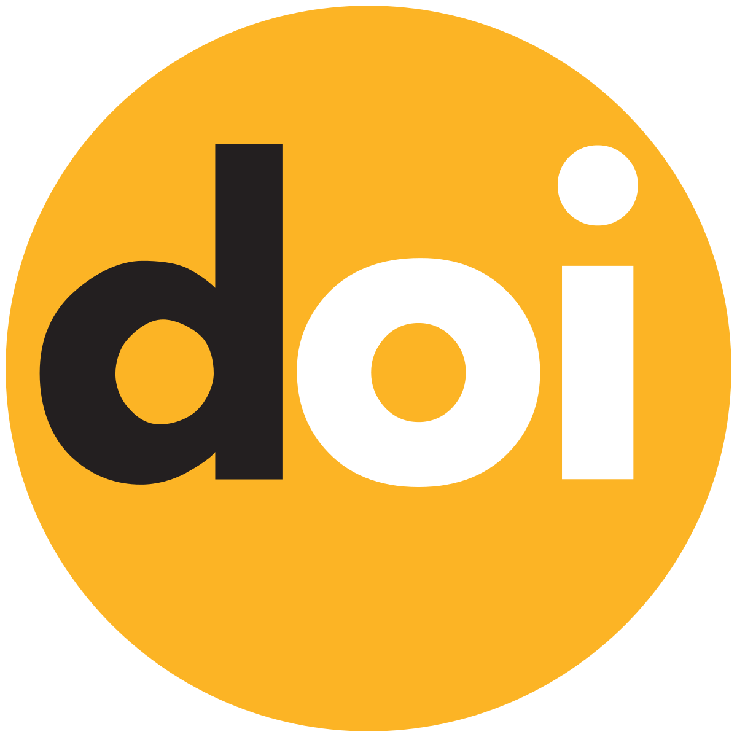 https://doi.org/10.33394/jk.vxxyyi | This is an open-access article under the CC-BY-SA License.


Introduction
Education plays an important role in producing the next generation of quality nations, as well as developing skills according to the potential of each individual. Education functions to help a person develop in aspects of knowledge, skills, and personality through various recognized learning methods (Herawati & Muhtadi, 2020). This is in line with the Regulation of the Minister of Education, Culture, Research, and Technology of the Republic of Indonesia Number 16 of 2022, which stipulates that Process Standards serve as guidelines in the implementation of effective and efficient learning, to optimally develop students' abilities, initiatives, skills, and independence. Effective, efficient, and independent learning processes are also applied in learning at the elementary school level (Arwanda et al., 2020; Firmadani, 2020).
Learning at the elementary school level certainly cannot be separated from Indonesian language subjects. Indonesian language learning at this level serves as a means to develop students' ability to use language as the main communication tool, in accordance with its function (Padmawati et al., 2019). Thus, the purpose of learning Indonesian in elementary school is not only limited to teaching language skills but also to prepare students to interact with the surrounding environment effectively.
Indonesian language education has a very important role in ensuring that all Indonesian citizens can master good communication skills and understand the correct use of the national language. Indonesian language education begins at an early age with an emphasis on developing basic skills such as speaking, reading, writing, and listening. Language skills are the main capital for every individual, so it is hoped that everyone can master language skills by linguistic rules (Magdalena, 2021). Language skills include four aspects, namely writing, reading, speaking, and listening, which are interrelated with each other. In this study, the main focus is on speaking skills. Although the new curriculum has been implemented, the implementation of Indonesian language learning in elementary schools is still faced with various problems.
Problems that arise in the implementation of Indonesian language learning in elementary schools include teachers still applying cooperative learning models supported by discussion, assignment, lecture, and question-and-answer methods. This makes students passive in learning activities and tend to feel bored easily (Tiyas et al., 2020; Zakirman et al., 2022). Indonesian language learning is also considered difficult by students because there is too much memorization. In addition, there are limited teaching materials used in delivering the material (Made Sri Dewi & Nyoman Ayu Lestari, 2020). Many teachers have difficulty in developing and operating technology-based teaching materials (Trinaldi et al., 2022; Yudha et al., 2022). To improve the quality of learning, one of the steps that can be taken is technology innovation, especially through the development of teaching materials or learning media so that learning remains relevant to the development of the world of education (Bayu & Wibawa, 2021; Sintya Devi & Wira Bayu, 2020). The right teaching materials can have a positive impact, such as motivating students, increasing interest in learning, maintaining focus, making learning more interesting, and strengthening students' memory of the material taught.
This research was focused on SD Negeri 2 Ketaon, chosen because it faced a special problem that was worthy of study, namely the lack of learning tools used by teachers. Based on observations made by researchers, it was found that there are already technological tools that can help teachers in the learning process. However, teachers have not utilized it properly. With the innovation of technology-based teaching materials offered, it can help students and teachers to achieve maximum learning goals. Fourth-grade students of SD Negeri 2 Ketaon experience problems in retelling the contents of narrative text. The narrative text itself contains stories that are arranged chronologically or a structured series of events based on the character's experience (Maslakhah et al., 2024; Najuah et al., 2022; Rohmawati et al., 2022; Alimah & Indihadi, 2022; Astutik, 2021; Sistiara et al., 2022; Tarigan et al., 2022). This type of text aims to describe human behavior in an event, arrange the story sequentially, and provide entertainment through an interesting narrative.
The learning outcomes of grade IV students of SD Negeri 2 Ketaon in the Indonesian language subject indicate that “students can retell information read or heard from narrative texts about interesting things in the surrounding environment”. In class IV consisting of 30 students (17 boys and 13 girls), the results of daily test scores show that only 14 students (47%) scored above the KKTP, while the remaining 16 students (53%) scored below the KKTP. These results show that the learning process in achieving the goal of students being able to use their language in retelling the contents of narrative texts that have been heard has not gone well. Most students have not met the expected learning outcomes, so improvements are needed in the teaching and learning process.
In Indonesian language subjects, achieving learning objectives requires interesting teaching materials. Therefore, an E-Module is needed that can help students better understand the material. E-Modules are technology-based teaching materials that are structured to facilitate the learning process (Alti et al., 2022; Indah & Dafit, 2022; Ulfa & Sucahyo, 2022). E-Modules are digital teaching materials that are effective and efficient, and prioritize student independence in learning activities (Kustini et al., 2022; Triwahyuningtyas et al., 2020). The selection of e-modules must also be adjusted to the learning model that will be used. Circle time is one of the appropriate learning models used to develop speaking skills in elementary school students.
The Circle Time learning model is an approach to learning that places social interaction and collaboration among students as the main focus. In this model, students sit in a circle to discuss and share ideas, experiences, or other information. A challenging and fun learning model is the center or circle time learning model because it involves elements of playing, moving, singing, and learning (Fitriah, 2020). This model can increase students' activeness in speaking so as to encourage students to express their ideas. Circle Time is packaged into fun classroom activities without any barriers that limit students. So that students can express their ideas and ideas widely.
Previous research shows that the use of E-Module can improve students' speaking skills in the learning process (Setyawan & Nawangsari, 2021). In this study, researchers focused on the Circle Time E-Module through Linktree for Indonesian language subjects on narrative text material. Linktree is a platform that allows the incorporation of various links in one web page so that it can be accessed flexibly anytime and anywhere (Anggraini & Rozi, 2022; Afriyose et al., 2022; Syafii et al., 2023). In contrast to the e-module developed by researchers, this e-module contains grade IV narrative text material to improve speaking skills packaged using the Linktree website. This e-module is also equipped with a suitable learning model to develop students' speaking skills, namely the circle time model. The e-module developed contains presence, e-module, LKPD, and evaluation questions. So it can be concluded that this research has diversity in terms of material and output produced. The use of Circle Time E-Modules through Linktree makes it easy for students to access materials anywhere and anytime and can support the smooth learning process for both students and teachers.
Based on this background, the researcher will develop a Circle Time E-Module through Linktree to Improve Speaking Skills for Narrative Text Content in Grade IV SD. The researcher identified the lack of innovation in teaching materials used by teachers as the main problem. The presence of Circle Time E-Module through Linktree is expected to make it easier for students to understand learning materials and increase the effectiveness of the learning process in the classroom. In addition, this E-Module is also expected to increase student motivation and learning outcomes.

Research Method
Research Design
The type of research used is research and development (R&D) which will produce Circle Time E-Modules through Linktree on narrative text material for grade IV SD Negeri 2 Ketaon, Boyolali Regency. In this e-module research and development, researchers carried out the development by the procedures developed by Borg and Gall (Sugiyono, 2019) which consisted of 10 steps, but researchers only limited it to step 8, namely the trial use due to limited time and cost. So the steps in this study are: (1) problems and potential; (2) data collection; (3) product design; (4) design validation; (5) design revision and product development; (6) product testing; (7) product revision; and (8) implementation/trial use.
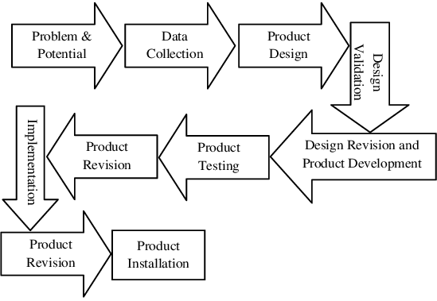
Figure 1. Borg and Gall Development Model
In the problem and potential stage, researchers conducted observations, and interviews, and documented the learning outcomes and language skills of fourth-grade students of SD Negeri 2 Ketaon, Boyolali Regency to find out the potential problems that exist in schools. The data collection stage, is the stage after researchers know the problems and potential by collecting data and information to plan the product to be developed using student and teacher questionnaires. In the product design stage, researchers design products to be developed starting from the design, material, and language to be used. The product design is adjusted to the learning outcomes (CP) of the Indonesian Language as stated in the decision in phase B, namely, students can retell information read or heard from the narrative text about interesting things in the surrounding environment. The design validation stage, after the product is designed, is then validated by experts who are competent in their fields, namely media experts and material experts by filling out the validation sheet prepared by the researcher using a Likert scale.
In the design revision stage, products that have been assessed by media expert validators and material experts are then revised based on suggestions or input provided by expert validators. In the product tasting stage, product trials to students on a small scale in class IV consisting of 12 students, using purposive sampling techniques based on different levels of cognitive ability. At the product trial stage, learning was carried out using the Circle Time E-Module through Linktree. After carrying out the learning, teachers and students were asked to fill out a response questionnaire regarding the Circle Time E-Module through Linktree. The product revision stage, the results of the response questionnaire that has been filled in by teachers and students will be analyzed, and if there is input it can be used as material for revising products that have been tested. The use trial stage, testing the developed product on a larger scale. Researchers conducted trials of its use to all fourth-grade students of SD Negeri 2 Ketaon, Boyolali Regency, totaling 30 people to determine the effectiveness of the products developed based on the results of students' speaking skills.
Research Participants or Population and Sample
The population of this study were all students of SD Negeri 2 Ketaon, Boyolali Regency, totaling 178 students. The research sample was taken using a purposive sampling technique with grade 4 students as research subjects. The selection of grade 4 students was based on the consideration that these students were studying narrative text material, so it was considered most relevant to the variable under study, namely the skill of speaking the content of narrative text.
Instruments
The type of data used in this research is primary data. Primary data is data obtained directly when conducting research, namely qualitative and quantitative data. Qualitative data in this study was obtained from the results of observations, questionnaires, and teacher interviews conducted at SD Negeri 2 Ketaon, Boyolali Regency. Quantitative data in this study were obtained from the results of speaking skills of fourth-grade students of SD Negeri 2 Ketaon, Boyolali Regency on narrative text material in Indonesian language subjects as well as the results of pretest and posttest assessments.
Data Analysis
The research design used is a pre-experimental design with a one group pretest-posttest design model, namely a pretest before treatment and a posttest after research. It aims to determine the results of the treatment more precisely because it can compare the conditions before and after treatment by using E-Modules with Circle Time content through Linktree narrative text material (Sugiyono, 2019). Data collection techniques use test and non-test techniques. The test technique is in the form of 4 description questions, while the non-test technique is in the form of observation, questionnaire, interview results, and documentation data. To determine the feasibility of the product developed, data analysis was carried out in the form of an assessment by material and media expert validators using a Likert scale. To determine the practicality of the product, a student and teacher response questionnaire was used after the product was developed using a Guttman scale. Then to determine the effectiveness of the product, data analysis was carried out in the form of a gain test based on students' pretest and posttest scores on a large-scale trial.

Result and Discussion
Result
Based on the results of pre-research, several problems were found such as the lack of learning tools, limited learning resources for students, and the lack of development of learning teaching materials, especially those based on technology. The limitations in the development of learning teaching materials have an impact on students' lack of interest in learning, especially in subjects such as Indonesian because students have to memorize and deeply understand the material provided by using monotonous learning methods from teachers with lectures. This makes students less interested, easily bored, and have difficulty understanding the material provided. In addition, it can be seen that the data on learning outcomes and speaking skills for Indonesian language subjects are still low and have not met the minimum criteria for achieving learning objectives (KKTP). The KKTP value set is 75, but out of 30 students only 14 students (46%) have completed KKTP while the remaining 16 students (54%) have not completed KKTP. Meanwhile, for speaking skills out of 30 students, only 11 students (36%) already have speaking skills and the remaining 19 (64%) students do not have speaking skills.
Data collection was carried out by researchers using a questionnaire regarding the needs of teachers and students for the desired learning tools. Based on the results of data collection, teaching materials such as student books, teacher books, and reference books are still minimal, and many are even damaged. This lack of varied teaching materials causes students to be less enthusiastic in participating in learning and makes it difficult for students to understand the material presented. In addition, the utilization of technology-based teaching materials is still very limited which has an impact on the lack of student interest in learning, especially subjects such as Indonesian. This makes students less interested and bored, as well as difficulties in understanding the material provided. Therefore, teachers need additional teaching materials to increase knowledge and improve students' language skills in narrative text material. It is necessary to develop attractive technology-based teaching materials with the selection of designs, images, and animations to increase students' interest in learning. In addition, teachers must also have a more interesting learning model or approach and include all students in the learning process.
Students need teaching materials that can be accessed anywhere and anytime. The teaching materials are tailored to students' abilities and language and are equipped with animations and images to improve speaking skills and understanding of the material presented. Technology-based teaching materials that are suitable for use are e-modules because they are easy to use. E-modules are made as attractive as possible and can be accessed without going through a separate application so that students play an active role in learning and are more motivated to learn independently. This e-module is also adapted to learning models that can improve speaking skills, one of which is the circle time model. Students agree and are happy when using e-modules that can contain materials, LKPD, and evaluation questions.
The design of e-modules is adjusted to the learning outcomes (CP) and learning objectives (TP) to be achieved. Teaching materials are developed with an attractive design consisting of text, images, and animations that are to the characteristics of students. The design of teaching materials is made in the Canva application. Then, the finished teaching materials will be included in the Linktree website which can be accessed without having to download the application. Circle Time E-Module through Linktree contains narrative text material, LKPD, and evaluation questions that can be used to improve speaking skills of narrative text content. Circle Time E-Module through Linktree consists of several parts as follows.
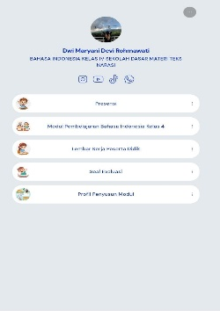  E-Module display via Linktree | 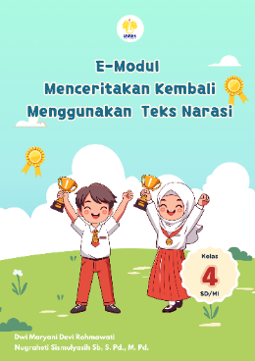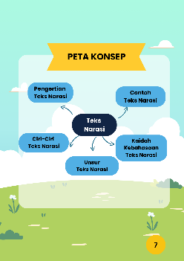  E-Module display, this page explains the narrative text material that can help students to better understand the material being taught. | 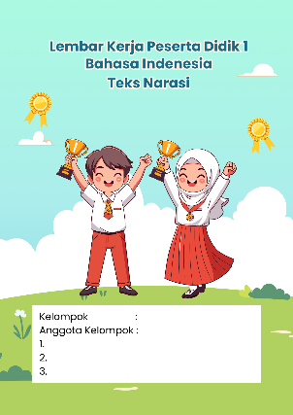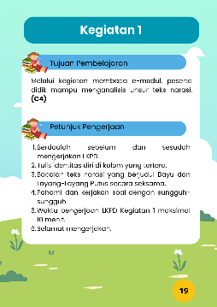  LKPD display, this page has questions that are done individually and in groups and can help students improve their speaking skills.
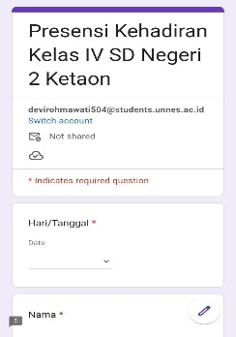  Presence display, this page helps teachers to recap student attendance. | 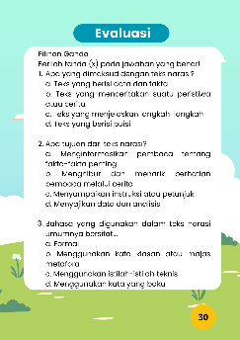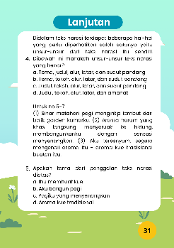  Evaluation display, this page contains questions that are used to measure students' speaking skills after participating in the learning process. | 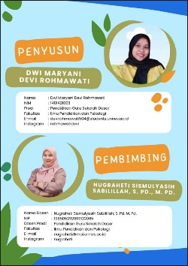  Developer profile display.

The product design stage carried out by researchers includes preparing materials, formats, and layouts for customized designs. The second stage is the manufacture of product designs that have been developed. The last stage is the application of making technology-based e-modules with a website into a link.
At this stage, the researcher validates the product to competent media expert validators, namely lecturers of learning media courses in the Elementary School Teacher Education study program and material experts, namely lecturers of Indonesian Language courses in the Elementary School Teacher Education study program to test the feasibility of products developed by researchers. After being assessed by expert validators, there will be input on the products developed so that researchers can make revisions to the products developed.

Table 1. Results of Expert Validator Assessment of Circle Time E-Modules through Linktree

No | Aspect | Value | % | Description
1. | Material expert | 90 | 90 | Very feasible
2. | Media expert | 90,8 | 90.8 | Very feasible

Table 1 above shows that the validation given by the media expert validator of 90.8% is in the very feasible category, and the material validation by the material expert is 90%. The average validation value obtained is 90.4%. So it is categorized as valid because obtaining a value above 70% is included in the feasible criteria. Circle Time E-Module through Linktree declared valid overall both from content or material, appearance or media, and language and ready to be tested. This is in line with research conducted by (Fariha et al., 2024) which obtained a value of more than 70% so that it is feasible and can be used as an additional alternative teaching material in the Indonesian language learning process in elementary schools.
The small-scale trial was applied to fourth-grade students of SD Negeri 2 Ketaon, Boyolali Regency, totaling 12 students. The selection of students was carried out by purposive sampling, which is a technique of taking samples with certain considerations. Students were selected based on their rank in the class, namely, 4 top-ranked students, 4 middle-ranked students, and 4 lower-ranked students. The purpose of choosing these samples is so that the Circle Time E-Module through Linktree can be used by students who are at the three levels of academic achievement, namely upper, middle, and lower ranks. After carrying out the learning, students, and teachers were given an answer sheet containing 15 Likert scale questions, which must be filled in based on the experience of using the product that has been developed. The questionnaire has assessment criteria: (1) assessment with very feasible criteria if the value is 76%-100%; (2) feasible criteria if the value is 51%-75%; (3) inappropriate criteria if the value is 26%-50%; and (4) very inappropriate criteria if the value is 0%-25%. The calculation to measure the percentage of teacher response questionnaire answers is as follows (formula 1).
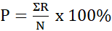
In testing the practicality of the Circle Time E-Module through Linktree, teacher and student response questionnaires were distributed which had three technical qualities, namely appearance, presentation of material content, and language. The three aspects are then described in 6 indicators, namely the appearance of the media, instructions for use, presentation of material, presentation of exercise questions, use of language in the media, and display of images, text, and colors.

Table 2. Results of Teacher and Student Response to Circle Time E-Modules through Linktree Small Scale
No | Respondent | Value | % | Description
1. | Teacher | 31 | 96 | Very positive
2. | Students | 374 | 97 | Very positive
Table 2 shows that teachers' and students' responses to the Circle Time E-Module through Linktree were very positive because they scored above 85%. So, it can be concluded that the Circle Time E-Module through Linktree is practical for learning activities. The Circle Time E-Module through Linktree was declared very positive and practical based on 15 questions on a Likert scale. So the Circle Time E-Module through Linktree has no product revisions in the small-scale trial.
Table 3. Results of Teacher and Student Response to Circle Time E-Modules through Linktree Large Scale
No | Respondent | Value | % | Description
1. | Teacher | 31 | 96 | Very positive
2. | Students | 928 | 96 | Very positive
Table 3 shows that teachers' and students' responses to the Circle Time E-Module through Linktree were very positive as they scored above 85%. Based on 15 questions on a Likert scale, almost all of them scored 4. This shows that the Circle Time E-Module through Linktree gets a very positive and practical response. This is in line with the research that has been conducted, which explains that the teacher and student response questionnaires to Linktree-assisted e-learning obtained a score above 85%, thus indicating a very positive value, which means that Linktree-assisted e-learning is practical to use in learning activities (Syafii et al., 2023).
Discussion
Large-scale trials using Circle Time E-Modules through Linktree in Indonesian language subjects on narrative text material were conducted to determine the effectiveness of the product based on student learning outcomes. The design used is a pre-experiment design with a one-group pretest-posttest design model, namely a pretest before treatment and a posttest after the study.
Table 4. Student Pretest and Posttest Results on the Small-Scale Product Use Trial
No | Type | Average Value | % | Students above KKTP
1. | Pretest | 62,25 | 33 | 4
2. | Posttest | 84,58 | 100 | 12

Table 5. Student Pretest and Posttest Results on the Large-Scale Product Use Trial
No | Type | Average Value | % | Students above KKTP
1. | Pretest | 62,40 | 40 | 12
2. | Posttest | 85,83 | 100 | 30

Based on Table 4, it is known that the average student learning outcomes showed an increase of 22.33 in the small-scale product trial. Meanwhile in the large-scale trial, there was an increase of 23.43. The data in the table shows that there are differences in student learning outcomes in the Indonesian language subject of grade IV narrative text material at SD Negeri 2 Ketaon before and after using the Circle Time E-Module through Linktree. It can be seen that there is an increase in the average results of students' speaking skills after using the Circle Time E-Module through Linktree.
The effectiveness test is followed by a normality test and then tested using the t-test and N-gain test.
Table 6. Normality Test in Small Group
No | Type | Statistic | Df | Sig.
1. | Pretest | .872 | 12 | .070
2. | Posttest | .884 | 12 | .099

Table 7. Normality Test in Large Group
No | Type | Statistic | Df | Sig.
1. | Pretest | .935 | 30 | .069
2. | Posttest | .937 | 30 | .075

Analysis of the results of the normality test using the Komlogorov-Smirnov type with 12 respondents on a small scale and 30 people on a large scale. Data is said to be normally distributed if Sig. > 0,05. Based on the normality test table, the pretest and posttest normality test results on a small scale were 0.070 and 0.099. While the results of the pretest and posttest normality test on a large scale were 0.069 and 0.075 which indicated that the speaking skills data were normally distributed.
After the normality test, the homogeneity test was conducted using a t-test. The results of the t-test on both the small scale and large scale obtained a sig value of 0.00 <0.05 which means that there is a significant difference between the speaking skills before and after the treatment. This is in line with research that has been conducted, which shows the sig value of the t-test on Linktree-assisted E-learning is 0.00 < 0.05 (Nera Afriyose et al., 2022; Winarno & Bukhori, 2024).
Table 8. Small Scale N-Gain Test Results
No | Difference | Mean | N | Description
1. | 22,33 | .662 | 12 | Medium

Table 9. Large Scale N-Gain Test Results
No | Difference | Mean | N | Description
1. | 23,43 | .642 | 30 | Medium
Based on Tables 8 and 9, it is known that the difference in the average pretest and posttest scores was 23.43 in the large-scale trial. This shows that the value of grade VI students of SD Negeri 2 Ketaon has increased by 0.642 which is included in the medium criteria. This increase shows that the use of Circle Time E-Modules through Linktree in Indonesian language subjects on narrative text material has succeeded in improving students' speaking skills. Therefore, the use of the Circle Time E-Module through Linktree has a positive influence on students' speaking skills (Rahayu & Pahlevi, 2021).
The use of Circle Time E-Module through Linktree can encourage students' learning motivation, so that they can learn independently by utilizing teaching materials that suit students' needs (Nur et al., 2022; Ulfah Nurkhaeroni & Ripaiyah, 2022). The Circle Time E-Module through Linktree is able to build a more active learning atmosphere, not boring and not monotonous so that students are actively involved during learning (Ratnawati & Werdiningsih, 2020). Based on this, it can be concluded that the Circle Time E-Module through Linktree is feasible and effective for learning because it can improve students' speaking skills.

Conclusion
Based on the results of the research that has been conducted, it can be concluded that the Circle Time E-Module through Linktree can motivate and improve students' speaking skills in Indonesian language subjects on narrative text material. This is evidenced by the results of the product validation evaluation by experts, the t-test, the N-Gain test, and the results of teacher and student responses. The results of the feasibility test obtained a percentage of the assessment, namely from the media expert validator of 90.8% and the material expert of 90% so that the average was 90.4% with a very feasible category. The effectiveness of the Circle Time E-module through Linktree is proven through a t-test which shows a significance value <0.05 which means there is a significant difference between speaking skills before and after treatment with an N-gain test value of 0.662 on a small scale and 0.642 on a large scale which shows a moderate category. Practicality is demonstrated by the positive response of 96% of teachers and 96.5% of students with very positive criteria. From these results, it can be concluded that the Circle Time E-module through Linktree is effective, feasible, and practical for improving narrative text speaking skills in Indonesian language learning for grade IV elementary school students.

Recommendation
Researchers and teachers will implement Indonesian language learning in grade IV using of circle time e-module through linktree to improve students narrative text content speaking skills. With this e-module, students can develop themselves through the speaking skills that have been acquired. In this learning process, there are still obstacles, namely the lack of facilities to access the circle time e-module through linktree.

Acknowledgment
Thanks to the supervisors who have guided the research process and writing of this article to completion. Thank you to SD Negeri 2 Ketaon, Boyolali Regency for helping and making this research possible. Thanks to Mandalika University of Education for facilitating the preparation of this article and to the editors who have reviewed and studied this article. Thanks to myself, parents, siblings, and friends for their prayers and support.

References
Alimah, M., & Indihadi, D. (2022). Analisis teks narasi implementasi strategi mind map peserta didik di Sekolah Dasar. Edukatif: Jurnal Ilmu Pendidikan, 4(4), 5512–5519. https://doi.org/https://doi.org/10.31 004/edukatif.v4i4.3245
Alti, RM, Anasi, PT, Silalahi, DE, Fitriyah, LA, Hasanah, H., Akbar, MR, Arifianto, T., Kamaruddin, I., Malahayati, EN, Hapsari, S., Jubaidah, W., Yanuarto, WN, Agustianti, R., & Kurniawan, A. (2022). Media Pembelajaran. Sumatera Barat: PT Global Eksekutif Teknologi.
Anggraini, N., & Rozi, F. (2022). Pengembangan media pembelajaran video animasi berbasis linktree interaktif pada tema 3 subtema 2 keberagaman makhluk hidup kelas IV SDN 106158 Pematang Johar. EJoES (Educational Journal of Elementary School), 4(3), 78–89. https://doi.org/https://doi.org/10.30 596/ejoes.v4i3.16856
Arwanda, P., Irianto, S., & Andriani, A. (2020). Pengembangan Media Pembelajaran Articulate Storyline Kurikulum 2013 Berbasis Kompetensi Siswa Abad 21 Tema 7 Kelas IV Sekolah Dasar. Al-Madrasah: Jurnal Pendidikan Madrasah Ibtidaiyah, 4 (2), 193. https://doi.org/10.35931/am.v4i2.331
Astutik, P. (2021). Peningkatan kemampuan menggali informasi penting dengan teknik 5w + 1h berbantuan video pada siswa kelas VI. Jurnal Pendidikan, 7(4), 1647–Tahun 1652. https://doi.org/10.31949/educatio.v 7i4.1557
Bayu, I. M. K., & Wibawa, I. M. C. (2021). Belajar Siklus Air Melalui Video Demonstrasi dengan Media Konkret. Mimbar PGSD Undiksha, 9(2), 248–257.

