DIDACTIC TRANSPOSITION IN READING MATERIAL: LINKING KNOWLEDGE TO BE TAUGHT AND ASSEMENT FOR LEARNING
*¹Hikmah Maulani, ²Isop Syafei, ³Nur Muthmainah
¹³Universitas Pendidikan Indonesia, Indonesia
²Universitas Islam Negeri Gunung Djati, Indonesia
*Corresponding Author e-mail: hikmahmaulani@upi.edu
Abstract: This study aims to elaborate on the assessment of instructional planning (lesson plan), particularly how planning emerges from the teacher's internal didactic transposition. It focuses on the diffusion of knowledge by teachers from the curriculum and textbooks into the form of teaching modules or lesson plans. A phenomenological approach through qualitative research was employed in this study. The data sources include the Arabic language teaching module for Grade 3 Madrasah Ibtidaiyah and Arabic language teachers as participants. Data collection techniques consisted of document analysis and in-depth interviews, followed by a praxeological review as an analytical tool. The assessment results identified learning barriers faced by students in the Qiraah (reading) skill material. In this context, internal didactic transpositiondefined as the transformation of theoretical material into teaching practice plays a crucial role in aligning instructional content with students’ needs and learning objectives. The process of internal transposition in Qiraah instruction positively impacts students’ reading skills, especially when teaching materials are adapted contextually and made relevant to the students’ proficiency levels. Within the framework of deep learning-based instruction, the focus extends beyond superficial comprehension of texts to include the internalization of meaning, critical analysis, and the development of deep thinking toward the reading content. | Article History  Received: 2  Revised:  Published:.. 2017  Key Words :  Arabic Language, Didactics, Phenomenology, Reading, Transposition.
How to Cite: First author., Second author., Third author, etc.. (20xx). The title. Jurnal Kependidikan: Jurnal Hasil Penelitian dan Kajian Kepustakaan di Bidang Pendidikan, Pengajaran dan Pembelajaran, vol(no). doi:https://doi.org/10.33394/jk.vxxyyi
 https://doi.org/10.33394/jk.vxxyyi | This is an open-access article under the CC-BY-SA License.


Introduction
Reading ability (Qiraah) in Arabic language learning is one of the essential competencies that students need to master (Ghani et al., 2012). However, Qiraah instruction often faces significant challenges, including materials that are not aligned with students' proficiency levels (Rohma & Fawaid, 2023), monotonous teaching methods (Asse et al., 1894), and a lack of cognitive engagement from students in deeply understanding the meaning of texts [zurqoni]. Most Qiraah learning still focuses on literal text comprehension and memorization, which tends to result in shallow and limited understanding(Al Farisi et al., 2024).
In this context, the concept of internal transposition the transformation of teaching materials from theoretical forms into effective instructional practice plays a crucial role in aligning learning content with learners’ needs (Totohasina et al., 2024). This process enables teachers to develop materials that are more relevant and accessible to students (Fitrianto, 2024). However, successful implementation of internal transposition requires an approach that fosters students’ critical, analytical, and reflective thinking abilities, which are the essence of deep learning-based education. Chevallard (Strømskag & Chevallard , 2024) was the first to introduce the theory of didactic transposition in mathematics education, classifying mathematics as both a scholarly body of knowledge and as a subject to be taught and learned. He later defined didactic transposition as a transformational process of knowledge involving four types: scholarly knowledge, knowledge to be taught, taught knowledge, and learned knowledge (Chevallard, 1989). his concept has since been adapted into the context of Arabic language instruction.
The skill of Qiraah (reading proficiency) in Arabic language learning encompasses a variety of cognitive aspects (Huda et al., 2021), requiring students not only to recognize linguistic symbols but also to comprehend the meanings embedded within them. The type of knowledge that plays a major role in mastering this skill is propositional knowledge, which refers to knowledge of factual statements or conceptual understandings that can be deemed true or false. This includes vocabulary mastery, understanding the context of word usage, and grammatical competence.
Previous studies conducted by Jamilah et al. (2020) explored didactic transposition from scholarly knowledge in mathematics (Jamilah et al., 2020). In 2021, research by Martini et al. focused on pre-service teachers’ representations of content concepts (Martini et al., 2021), and in 2024, Nicolás and Gascón investigated the limits and transforming power of didactics (Nicolás & Gascón, 2024), In the same year, a study by Herizal and Priatna (2024) examined learned knowledge in the didactic transposition process (Herizal & Priatna, 2024). ese studies demonstrate that most research on transposition of teaching materials has been conducted in the context of science and mathematics education.
However, other studies in different domains also exist. For instance, in 2011, curriculum analysis was conducted during the pandemic, focusing on students' English language proficiency levels in Colombia (Wilson & Hernández, 2021). In the same year, research was also carried out on didactic transposition in the context of grammar in digital English learning.
In the field of Arabic language education, a praxeological study was conducted on textbook (Syihabuddin et al., 2024). However, as of 2024, no specific study has been found that focuses on didactic transposition within the context of Arabic language skills or components of the Arabic language.
A search using Google Scholar through Publish or Perish with the keywords Arabic, Assessment, Transposition, Didactic over the past ten years revealed 100 studies, with a noticeable increase in publications between 2022 and 2023 (as shown in Figure 1). This indicates growing scholarly interest in the study of transposition within the field of language education.
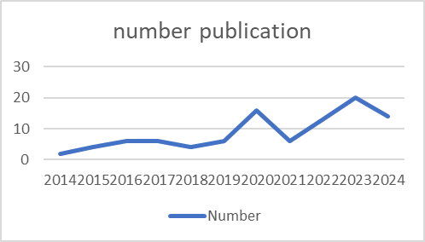
Figure 1. Publication graph of the last ten years (source: author own work)
In addition, through the bibliometric Vosviewer, 2 clusters were also found (see Figure 2) that the topic of this study in the scope of language studies is still small and is an interesting thing to research..

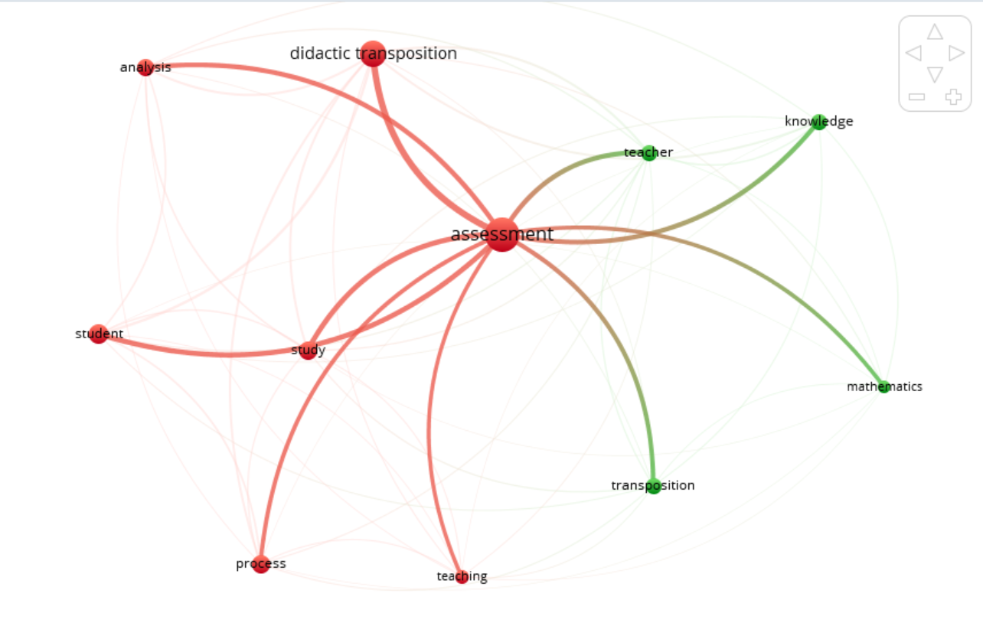
Figure 2. Network visualization bibliometric (source: author own work)
Based on the findings of previous research, Publish or Perish and Bibliometric, and Research Gap, novelty was found in this study, namely the assessment of learning planning, how the planning results from the internal transposition of teachers in the study of Arabic language proficiency with a focus on Qiraah Proficiency.
Research Method
This study adopts a phenomenological approach. It is a qualitative study and encompasses various methodologies developed across different academic fields, each affiliated with distinct epistemological frameworks such as focus groups (emancipatory), intrinsic and instrumental case studies, theory-based approaches, ethnography, autoethnography, and phenomenological approaches (Weir, 2005; Filipović, 2019).
The phenomenological approach is used to understand and explore subjective experiences and the meaning individuals assign to a particular phenomenon (Khan, 2014). In the context of educational research, such as in Qiraah (reading proficiency) material, phenomenology serves as an effective method for revealing how teachers and students experience and interpret the learning process.

Data Source
The data sources in this study include curriculum documents and Arabic language textbooks for Grade 3 of Madrasah Ibtidaiyah (MI), published by the Directorate General of the Ministry of Religious Affairs of the Republic of Indonesia, as well as teaching modules. In addition, the study involves participants consisting of Arabic language teachers and students at the MI level.

Data Collection and Analysis
This study focuses specifically on the topic of Qiraah proficiency, with a particular emphasis on the theme of Riyadhah (sport). he investigation into the Qiraah material on Riyadhah to be taught is conducted through two main sources: the teaching module or lesson plan (RPP) prepared by the teacher (analyzed using a phenomenological approach) and the Arabic language textbook. The aim of this analysis is to determine the position or role of the Riyadhah material as presented in both documents.
Specifically, the textbook analysis is conducted using the theory of praxeologies (Roth et al., 2017). This approach is considered effective for evaluating human knowledge and action in this case, those of the textbook authors through representations in the form of text or images presented in the book (Wijayanti & Aufa, 2020; HastiYunianta et al., 2023; Hendriyanto et al., 2023). This is based on the assumption that textbooks are a product of their authors’ thinking (Allail et al., 2025). Therefore, the goal of this analysis is to identify the authors’ ideas and how the material is presented, including the problems or tasks related to the concepts introduced.
In addition, this analysis also aims to assess whether the material arrangement in the book could potentially create learning obstacles for students (Cesaria & Herman, 2019). The textbook review employs the components of praxeology, namely the praxis block (T = type of task, and 𝝉 = techniques) and the logos block (𝜽 = technology, dan 𝜣 = theory) (de Oliveira & Barbosa, 2023). Each section of the material, including conceptual tasks, examples, and exercises, is evaluated according to the sequence in which it is presented in the Arabic textbook.

Result and Discussion
This section presents the main findings from the analysis of two key documents: the teaching module/lesson plan prepared by the teacher and the Arabic language textbook, both of which contain Qiraah material on the theme of Riyadhah (sports). The analysis was conducted to identify how the material is positioned, structured, and developed within each document.
In the teaching module, a phenomenological approach was used to explore the teacher's experiences and considerations in designing the learning process. Meanwhile, for the textbook, the theory of praxeologies was applied to examine the material structure based on the components of praxis and logos. The findings outlined in this section provide a comprehensive picture of the form, depth, and potential learning challenges related to the Riyadhah topic within the context of Arabic language instruction.

Initial Competencies in the Teaching Module
Initial competencies represent a crucial component in learning design, as stated in the teaching module (Maryani et al., 2017). This component serves as a foundation for identifying students' readiness before engaging with the core material. In the context of Qiraah or reading in Arabic, initial competencies play a role in mapping students’ basic abilities, both in reading Arabic text and in understanding its embedded meanings. The following are the initial competencies listed in the module (see Figure 3).
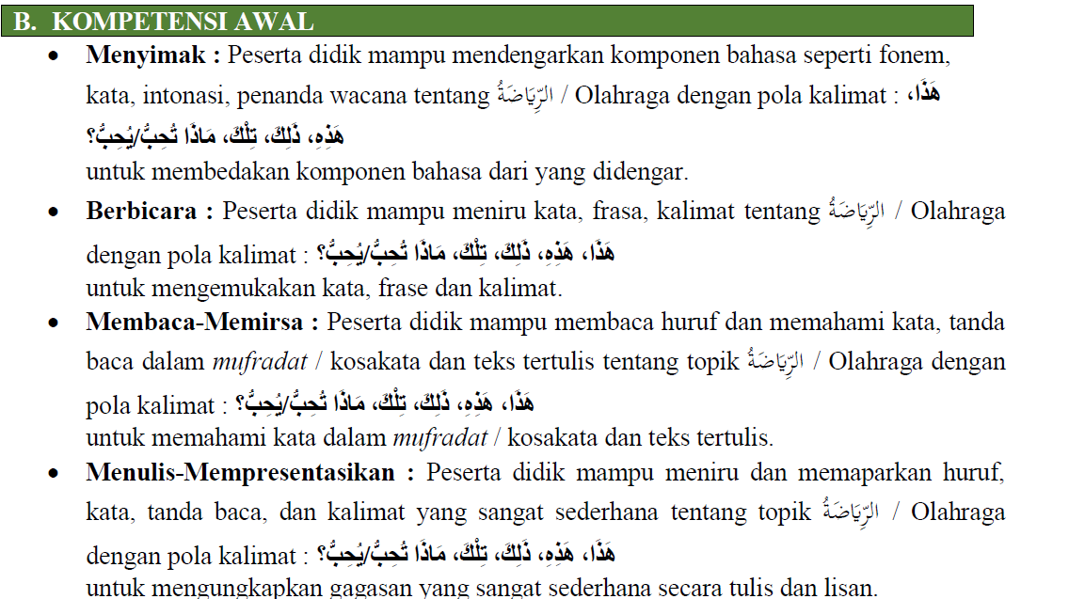
Figure 1 3. Initial Competencies (source: teaching module/ lesson plan for Arabic language teachers for grade 3 MI)
Understanding initial competencies in Qiraah or reading skills emphasizes two main aspects: the ability to read Arabic texts fluently and to comprehend the meanings contained within them. The key phrase “able to read and understand” reflects the expectation that students are not merely pronouncing Arabic words or sentences phonetically, but are also able to grasp the content, semantic structure, and context of the text being read.
Practically, this expectation includes several indicators of ability, namely: First, Recognizing letters, words, and sentence structures in Arabic texts fluently. Second, Understanding basic vocabulary and common expressions related to the reading theme. Third, Identifying main ideas and key information from paragraphs or short discourses. Fourth, Relating the reading content to cultural context or personal experience, especially when the text contains elements of Islamic values or culture. Fifth, Answering questions based on the reading content, both explicitly (direct information) and implicitly (implied meaning).
Praxeological Analysis of Qiraah Material on the Theme of Riyadhah
There are two sections of material related to Riyadhah (ٱلرِيَاضَةُ), presented in the form of simple discourse. The following are the findings from the analysis (see Table 1 and Table 2).

Table1. Praxeological Analysis 1
Practical Blok |  | Theoretical Blok
Type of Task (T₁) | Techniques (𝝉) | Technology (𝜽) | Theory (𝜣)
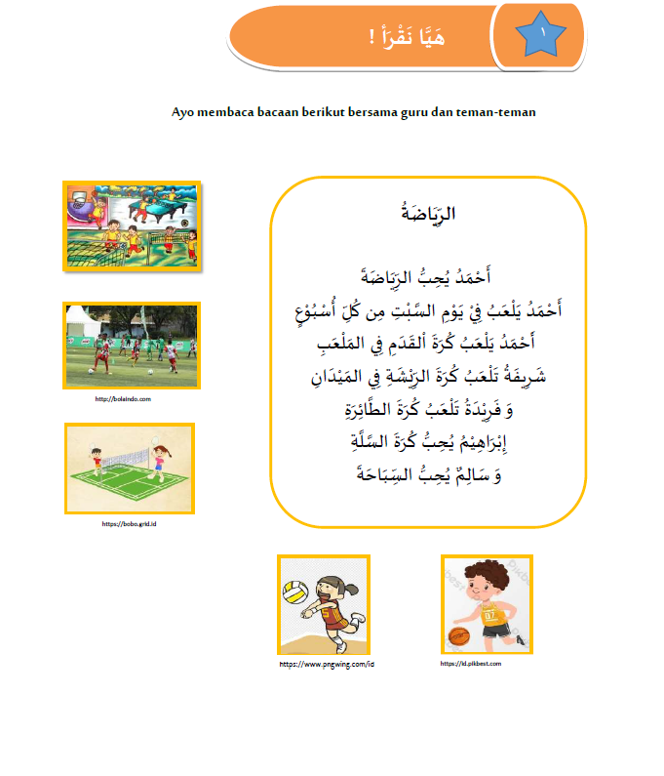  Reading text about Riyadhah الرياضة | Reading readings with teachers and friends | - Students read aloud together in class guided by the teacher  - Researchers assume that students listen to the teacher's words and then repeat them | Short discourse construction in the context of Riyadhah الرياضة
(source: author own work)
In the first type of task (T₁), this task refers to the core activity expected from students, which is reading a text with the theme of Riyadhah or sports. This task is a form of Qiraah activity focused on strengthening students' receptive skills in reading Arabic.
The researcher analyzes the didactic difficulties in the first design of this material presented in images, where students face challenges in understanding abstract concepts to comprehend the discourse of the text without an Indonesian translation. Based on interviews with the teacher regarding the acquisition of students' knowledge about prior vocabulary understanding, it was found that despite the curriculum for 2nd-grade MI including similar competencies, students demonstrated a lack of mastery of Arabic vocabulary.
Furthermore, the researcher assumed that children could imitate the teacher’s pronunciation of the provided reading correctly. However, the command “let's read the following passage together with your friends” in T1 becomes irrelevant, because the technique used by students was not repetition, but simply reading together. Therefore, students' reading skills should already be fulfilled. According to the teacher's explanation on addressing this issue, the teacher uses a learning strategy involving the repetition of reading.
Next, the second analysis regarding Qiraah competence is conducted in the second section (T2) (see Table 2).
Table 2. Praxeological Analysis 2
Practical Blok |  | Theoretical Blok
Type of Task (T₂) | Techniques (𝝉) | Technology (𝜽) | Theory (𝜣)
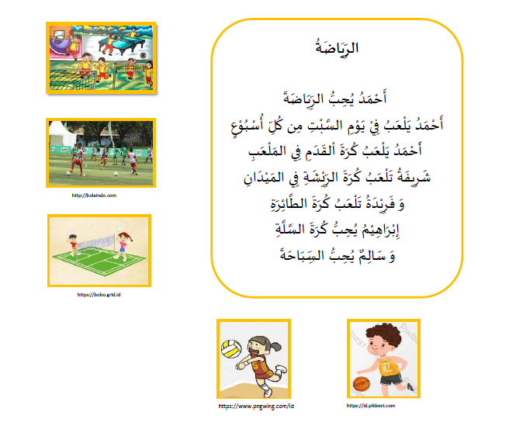  There are five pictures (no captions) | Students see pictures | - Students interpret words by guessing the pictures  - Researchers assume that the pictures can help students remember | Single Vocabulary Construction about the types of Riyadhah الرياضة
(source: author own work)
Type of Task (T₂) is a non-verbal, visually-based task in which students are presented with five images representing different types of sports (riyadhah) without any text labels. The primary goal of this task is to encourage students to associate the images with relevant Arabic vocabulary, which makes this activity highly supportive in forming initial meaning connections during the language acquisition process.
The researcher analyzed the didactic difficulties in the design of the second material presented in images, where students encountered challenges in understanding abstract concepts in order to grasp the meaning of vocabulary through visuals. The researcher assumed that this activity reflects the integration of visual, linguistic, and cognitive aspects in the qiraah learning process. By using images without accompanying text, students are encouraged to think actively and associate visual experiences with linguistic knowledge. This is not only part of the comprehension process but also an initial step in building meaningful reading skills.
To support this assumption, students must be able to acquire the language in terms of prior vocabulary mastery. In relation to this, the teacher believes that (see Figure 4)
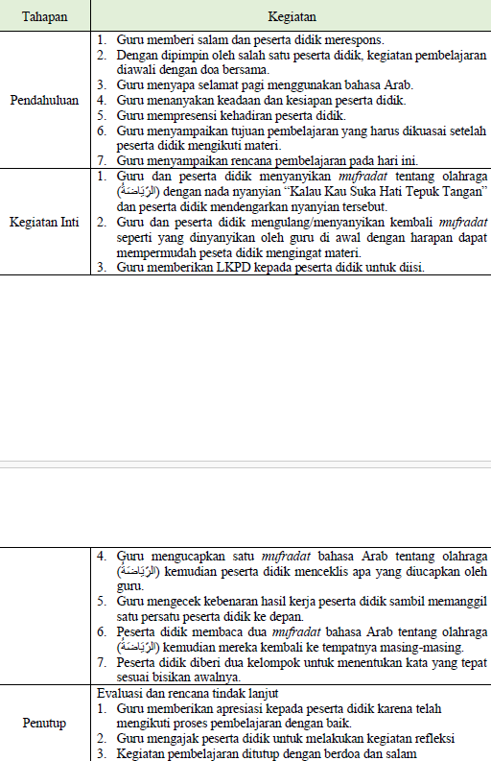
Figure 4. Learning stages (source: Arabic language teaching module for class 3 MI)
The teacher carries out the transfer from scholarly knowledge to knowledge to be taught by designing a lesson plan and instructional strategies. Based on previous data indicating that students faced difficulties in acquiring prior linguistic knowledge, the teacher sought an alternative approach suited to the students’ age.
Based on Figure 4 and verification through teacher interviews, the details of the lesson plan are as follows:
The learning activities begin with the introduction of vocabulary (mufradat) related to the theme of sports (الريَاضَة) using a musical method. The teacher and students sing the vocabulary together using the melody of a widely known children’s song, "If You’re Happy and You Know It, Clap Your Hands." This song is used to create an enjoyable learning atmosphere and to facilitate vocabulary memorization through repetition and familiar musical patterns (Bestandani, 2024).
Next, the teacher invites the students to repeat and sing the vocabulary (mufradat) they have learned. This repetition is intended to strengthen the students’ memory and help them pronounce the vocabulary correctly, following the example provided by the teacher.
After the repetition session, the teacher distributes Student Worksheets (Lembar Kerja Peserta Didik or LKPD) containing a list of sports-themed vocabulary. Students are instructed to complete the worksheet based on a listening activity that will follow.
The teacher then reads each vocabulary word in Arabic that was previously introduced. Students are asked to mark (check off) the vocabulary words they hear on their respective worksheets.
After all the vocabulary has been read aloud, the teacher continues the activity by calling students one by one to the front of the class to verify their work. Each student is asked to read two vocabulary words they checked as part of a formative assessment of their reading and pronunciation skills.
To conclude the lesson, the teacher divides the students into two groups to participate in a language game activity. In this game, each group is tasked with identifying the correct vocabulary word based on a whispered clue provided by the teacher. The aim of this activity is to train the students' memory, accuracy, and collaboration (Le et al., 2018) in the context of actively and participatively learning Arabic vocabulary.

Discussion
The concept of knowledge to be taught refers to knowledge that is explicitly designed to be taught (Jamilah et al., 2020), including content, skills, and cognitive strategies that students need to master. In the context of the Riyadhah (الرياضة) material, the content presented in the form of text without translation or images does not explicitly facilitate students' initial understanding of the concepts and meanings in the text. When students lack a strong vocabulary foundation, the knowledge intended to be taught becomes inaccessible to them independently. In other words, the knowledge to be taught (i.e., linguistic knowledge and text meaning) fails to be effectively delivered.
To address this, when designing knowledge to be taught, teachers can provide scaffolding (Taber, 2018) such as visual glossaries (Lee & Lee, 2015), contextual illustration (Jubhari et al., 2022), or explicit cues (Yang & Wang, 2015) so that students can gradually construct meaning that is not presented in the textbook. The researcher refers to this as a didactic difficulty (Pauji et al., 2023), eaning an obstacle that arises not from students’ shortcomings, but from the way the material is designed and presented, which does not sufficiently support student understanding.
The types of tasks presented in the research findings can be associated with Assessment for Learning (AfL) (Taras, 2010; Schellekens et al., 2021), an assessment approach focused on student development through constructive feedback during the learning process. The instruction to "read together with friends" does not effectively direct students toward phonological practice, such as mimicking the teacher or individually re-reading the text. The teacher carries an additional responsibility: bridging the material presented in the textbook. Within the AfL framework, teachers can observe how students read, evaluate the effectiveness of the strategy, and adjust instructions to truly support learning objectives this is reflected in the learning stages planned by the teacher.
In the context of knowledge to be taught for this material, which involves images representing types of sports without textual labels, AfL plays a vital role in helping students build connections between visual experiences and linguistic knowledge—provided that students already possess relevant visual experiences and linguistic vocabulary knowledge.
First, AfL encourages teachers to observe how students think (Mumm et al., 2016) and tackle the challenge of understanding abstract concepts, thereby helping to prevent learning obstacles. Here, assessment focuses on students’ thought processes, not just their final answers. Teachers can provide feedback that helps students understand how to strengthen associations between images and vocabulary. The material is adapted to the students’ cognitive and linguistic development, for instance, by providing support such as contextual translation, illustrations, or teacher explanations to break down abstract concepts. The step of understanding vocabulary through singing becomes a strategic learning method given the cognitive development of third-grade MI students, who are typically 9–10 years old memorizing vocabulary is not perceived as a burden but instead enjoyed by students.
Second, AfL provides continuous feedback throughout the learning process, which helps students identify their strengths and weaknesses in associating images with vocabulary. This type of assessment does not focus solely on final outcomes, but on progress made throughout the task, enabling students to improve their understanding of the Arabic vocabulary being learned.
Based on the results and discussion, this research has practical implications: instructional guidance, such as "read together," needs to be more explicit and technical, for example, "slowly mimic the teacher’s reading" or "reread individually with phonetic correction." These findings open opportunities for further exploration into how teacher-student verbal interactions and instructional strategies affect vocabulary understanding and reading techniques in Arabic text-based learning. Theoretically, in the context of knowledge to be taught, instructional design must accommodate students’ cultural and linguistic contexts and avoid the assumption that all students can derive meaning solely from texts in the target language.

Conclusion
The riyadhah material, structured in textual and visual forms, inherently contains rich linguistic meaning. However, the transposition process from academic knowledge (Arabic language content) to knowledge to be taught has not fully considered the linguistic and cognitive readiness of third-grade students. The presentation of text without translation and visuals without labels results in a gap in meaning-making, especially in understanding abstract concepts and new vocabulary. The findings indicate didactic difficulties in two main areas: first, in the design of text-based material that lacks adequate contextual support; second, in the implementation of learning tasks where instructional commands are not aligned with the strategies employed by students. This highlights the crucial role of teachers in guiding meaning-making through appropriate teaching techniques, such as oral repetition, the use of contextual visual media, and pronunciation modeling.
The didactic transposition process is not only intended to simplify material for teaching purposes but also serves as a framework for implementing Assessment for Learning (AfL). Teachers can use transposition as a tool to identify how well the material is understood by students and how they respond to the forms of knowledge representation provided. Adjusting teaching strategies based on observation and interaction is a concrete form of AfL in practice.

Recommendation
This study offers recommendations for the design of instructional materials and contextual assessment strategies for theme-based content (such as riyadhah and other themes found in textbooks). It emphasizes the development of materials that take into account competency mapping, contextual relevance, and students' learning difficulties. Lastly, it advocates for the refinement of instructional document design, moving beyond administrative compliance toward a clearly defined epistemological framework.

Acknowledgment
The researcher extends sincere appreciation to the Institute for Research and Community Service at Universitas Pendidikan, as well as to the participants of this study, who have provided valuable insights and meaningful contributions to the completion of this research.

References
Al Farisi, M. Z., Maulani, H., Hardoyo, A. B., Khalid, S. M., & Saleh, N. (2024). Investigating Arabic language teaching materials based on Indonesian folklore: an ethnographic study on the folktale of “Bandung.” Asian Education and Development Studies, 13(2), 134–149. https://doi.org/10.1108/AEDS-07-2023-0082
Allail, C. A., Sopian, A., Saleh, N., Maulani, H., & Indonesia, U. P. (2025). Praxeology Analysis of The Arabic Language Textbook for Madrasah Ibtidaiyah. 2(2). https://doi.org/10.32332/ijalt.v7i01.10066
Asse, A., Jabir, M., Idhan, M., & Harun, U. (1894). Al-Intiqaiyyah Method to Improve Maharah Al-Qira ’ ah Skills in Arabic Language Learning.
Bestandani, I. (2024). Irene Bestandani 1) , Syamsurrijal 2). 3(2), 229–238.
Cesaria, A., & Herman, T. (2019). Learning obstacle in geometry. Journal of Engineering Science and Technology, 14(3), 1271–1280.
Chevallard, Y. (1989). On didatic transposition theory: some introductory notes. Lnternational Symposium on Selected Domains of Research and Development in Mathematics Education, 1–9. http://yves.chevallard.free.fr/spip/spip/article.php3?id_article=122
de Oliveira, A. P., & Barbosa, N. D. (2023). Tasks About Impossible Random Events: A Pedagogical Game as a Teaching Tool for the Early Years of Elementary School. Acta Scientiae, 25(6), 183–208. https://doi.org/10.17648/acta.scientiae.7654
Filipović, J. (2019). Transdisciplinary qualitative paradigm in applied linguistics: autoethnography, participatory action research and minority language teaching and learning *. International Journal of Qualitative Studies in Education, 32(5), 493–509. https://doi.org/10.1080/09518398.2019.1597209
Fitrianto, I. (2024). Innovation and Technology in Arabic Language Learning in Indonesia : Trends and Implications. 2(3), 134–150.
Ghani, S. A., Ahmad, S. Z. @ H., Hashim, U. H. H., Shaadon, Z., & Mustapa, N. S. (2012). Application of basic Skills in Reading Arabic Text for Teaching and Learning Maharat Al-Qiraah. Procedia - Social and Behavioral Sciences, 59, 26–32. https://doi.org/10.1016/j.sbspro.2012.09.241
HastiYunianta, T. N., Suryadi, D., Dasari, D., & Herman, T. (2023). Textbook praxeological-didactical analysis: Lessons learned from the Indonesian mathematics textbook. Journal on Mathematics Education, 14(3), 503–524. https://doi.org/10.22342/jme.v14i3.pp503-524
Hendriyanto, A., Suryadi, D., Dahlan, J. A., & Juandi, D. (2023). Praxeology review: Comparing Singaporean and Indonesian textbooks in introducing the concept of sets. Eurasia Journal of Mathematics, Science and Technology Education, 19(2), 1–13. https://doi.org/10.29333/ejmste/12953
Herizal, H., & Priatna, N. (2024). The Concept of Angles Formed by a Transversal: A Study of Undergraduate Students’ Learned Knowledge in the Didactic Transposition Process. Proceedings of Malikussaleh International Conference On Education Social Humanities And Innovation (Miceshi), 1(1), 57.
Huda, M. N., Nurrosyid, A. F., & Aji, A. B. (2021). Implementasi Metode Qira’ah dalam Pembelajaran Bahasa Arab di Madrasah Hidayatul Mubtadiin Lirboyo Kediri. Alfakkaar: Jurnal Pendidikan Bahasa Arab, 5(2), 79–93.
Jamilah, J., Suryadi, D., & Priatna, N. (2020). Didactic transposition from scholarly knowledge of mathematics to school mathematics on sets theory. Journal of Physics: Conference Series, 1521(3). https://doi.org/10.1088/1742-6596/1521/3/032093
Jubhari, Y., Sasabone, L., & Nurliah, N. (2022). The Effectiveness of Contextual Teaching and Learning Approach in Enhancing Indonesian EFL Secondary Learners’ Narrative Writing Skill. REiLA : Journal of Research and Innovation in Language, 4(1), 54–66. https://doi.org/10.31849/reila.v4i1.8633
Khan, S. N. (2014). Qualitative research method - Phenomenology. Asian Social Science, 10(21), 298–310. https://doi.org/10.5539/ass.v10n21p298
Le, H., Janssen, J., & Wubbels, T. (2018). Collaborative learning practices: teacher and student perceived obstacles to effective student collaboration. Cambridge Journal of Education, 48(1), 103–122. https://doi.org/10.1080/0305764X.2016.1259389
Lee, H., & Lee, J. H. (2015). The Effects of Electronic Glossing Types on Foreign Language Vocabulary Learning: Different Types of Format and Glossary Information. Asia-Pacific Education Researcher, 24(4), 591–601. https://doi.org/10.1007/s40299-014-0204-3
Martini, B., Michelini, M., Stefanel, A., & Tombolato, M. (2021). Prospective teachers’ representations on the concept of force. Education Sciences, 11(10), 1–26. https://doi.org/10.3390/educsci11100614
Maryani, I., Martaningsih, S. T., & Putra Bhakti, C. (2017). Module Based on Pedagogical Content Knowledge to Increase the Engagement and Skills of the Future Teachers in Designing a Lesson Plan. Journal of Education and Learning (EduLearn), 11(1), 91–102. https://doi.org/10.11591/edulearn.v11i1.5758
Mumm, K., Karm, M., & Remmik, M. (2016). Assessment for learning: Why assessment does not always support student teachers’ learning. Journal of Further and Higher Education, 40(6), 780–803. https://doi.org/10.1080/0309877X.2015.1062847
Nicolás, P., & Gascón, J. (2024). Limits and transforming power of didactics To cite this version : HAL Id : hal-04421179 Limits and transforming power of didactics.
Pauji, I., Suryadi, D., Bin, M. A., Setambah, B., & Hendriyanto, A. (2023). Indonesian Journal of Science and Mathematics Education XX (X) (20XX) X-X mm 20XX Learning Obstacle In The Introduction To Number: A Critical Study Within Didactical Design Research Framework. X. https://doi.org/10.24042/ijsme.v5i1.19792
Rohma, F., & Fawaid, A. (2023). Analysis of Students’ Difficulties In Reading Texts to Increase Reading Comprehension In Islamic Senior High School. Al Qalam: Jurnal Ilmiah Keagamaan Dan Kemasyarakatan, 17(3), 2003. https://doi.org/10.35931/aq.v17i3.2205
Roth, A. W., Lawless, D., Tobin, K., & Roth, W. (2017). Towards a Praxeology of Teaching Published by : Canadian Society for the Study of Education Stable URL : http://www.jstor.org/stable/1585864 Towards a Praxeology of Teaching. 25(1), 1–15.
Schellekens, L. H., Bok, H. G. J., de Jong, L. H., van der Schaaf, M. F., Kremer, W. D. J., & van der Vleuten, C. P. M. (2021). A scoping review on the notions of Assessment as Learning (AaL), Assessment for Learning (AfL), and Assessment of Learning (AoL). Studies in Educational Evaluation, 71(July), 101094. https://doi.org/10.1016/j.stueduc.2021.101094
Strømskag, H., & Chevallard , Y. (2024). Didactic transposition and the knowledge to be taught: towards an archeorganisation for concave/convex functions. International Journal of Mathematical Education in Science and Technology. https://doi.org/10.1080/0020739X.2024.2305879
Syihabuddin, S., Murtadho, N., Baso, Y. S., Maulani, H., & Khalid, S. M. (2024). The acquisition of nominal gender agreement: praxeology analysis of Arabic second language text book “Silsilah Al-Lisaan.” Journal of Applied Research in Higher Education, 16(4), 1055–1068. https://doi.org/10.1108/JARHE-11-2022-0369
Taber, K. S. (2018). Scaffolding learning: Principles for effective teaching and the design of classroom resources. Effective Teaching and Learning: Perspectives, Strategies and Implementation, September 2018, 1–44.
Taras, M. (2010). Assessment for learning: Assessing the theory and evidence. Procedia - Social and Behavioral Sciences, 2(2), 3015–3022. https://doi.org/10.1016/j.sbspro.2010.03.457
Totohasina, A., Masonova, B., & Bemena, S. (2024). Philosophical conception of the answers to the question “ Can one become a good teacher ?” 803–826.
Weir, C. J. (2005). Limitations of the Common European Framework for developing comparable examinations and tests. Language Testing, 22(3), 281–300. https://doi.org/10.1191/0265532205lt309oa
Wijayanti, D., & Aufa, D. N. (2020). Picturing Textbook on Exponent Equations Based on Praxeology Organization. 409(SoRes 2019), 494–498. https://doi.org/10.2991/assehr.k.200225.107
Wilson, J., & Hernández, T. (2021). Research Article Intellectual Challenges For Improving Esl Students ’ Performance During Pandemic. 02(11), 3184–3191.
Yang, P.-L., & Wang, A.-L. (2015). Investigating the Relationship Among Language Learning Strategies, English Self-Efficacy, and Explicit Strategy Instructions. Taiwan Journal of TESOL, 121, 35–62. http://files.eric.ed.gov/fulltext/EJ1078937.pdf

