Analisis Data R-MSPSS

**Hasil Uji Deskriptif**

**Descriptive Statistics**

| **Descriptive Statistics** | | | | | | | | | | | |
| --- | --- | --- | --- | --- | --- | --- | --- | --- | --- | --- | --- |
|  | | **Usia (tahun)** | | **Jenis Kelamin** | | **Suku** | | **Tempat Tinggal** | | **Mengajar di Jenjang** | |
| Valid |  | 285 |  | 285 |  | 285 |  | 285 |  | 285 |  |
| Missing |  | 0 |  | 0 |  | 0 |  | 0 |  | 0 |  |
| Mean |  | 42.007 |  | 1.751 |  | 1.246 |  | 1.421 |  | 2.021 |  |
| Std. Deviation |  | 11.066 |  | 0.433 |  | 0.553 |  | 0.825 |  | 0.787 |  |
| Minimum |  | 20.000 |  | 1.000 |  | 1.000 |  | 1.000 |  | 1.000 |  |
| Maximum |  | 60.000 |  | 2.000 |  | 3.000 |  | 4.000 |  | 3.000 |  |
|  | | | | | | | | | | | |

**Frequency Tables**

| **Frequencies for Jenis Kelamin** | | | | | | | | | |
| --- | --- | --- | --- | --- | --- | --- | --- | --- | --- |
| **Jenis Kelamin** | | **Frequency** | | **Percent** | | **Valid Percent** | | **Cumulative Percent** | |
| Laki-laki |  | 71 |  | 24.912 |  | 24.912 |  | 24.912 |  |
| Perempuan |  | 214 |  | 75.088 |  | 75.088 |  | 100.000 |  |
| Missing |  | 0 |  | 0.000 |  |  |  |  |  |
| Total |  | 285 |  | 100.000 |  |  |  |  |  |
|  | | | | | | | | | |

| **Frequencies for Suku** | | | | | | | | | |
| --- | --- | --- | --- | --- | --- | --- | --- | --- | --- |
| **Suku** | | **Frequency** | | **Percent** | | **Valid Percent** | | **Cumulative Percent** | |
| Sunda |  | 232 |  | 81.404 |  | 81.404 |  | 81.404 |  |
| Jawa |  | 36 |  | 12.632 |  | 12.632 |  | 94.035 |  |
| Lainnya |  | 17 |  | 5.965 |  | 5.965 |  | 100.000 |  |
| Missing |  | 0 |  | 0.000 |  |  |  |  |  |
| Total |  | 285 |  | 100.000 |  |  |  |  |  |
|  | | | | | | | | | |

| **Frequencies for Tempat Tinggal** | | | | | | | | | |
| --- | --- | --- | --- | --- | --- | --- | --- | --- | --- |
| **Tempat Tinggal** | | **Frequency** | | **Percent** | | **Valid Percent** | | **Cumulative Percent** | |
| Kota Bandung |  | 210 |  | 73.684 |  | 73.684 |  | 73.684 |  |
| Kab. Bandung |  | 47 |  | 16.491 |  | 16.491 |  | 90.175 |  |
| Kab. Bandung Barat |  | 11 |  | 3.860 |  | 3.860 |  | 94.035 |  |
| Kota Cimahi |  | 17 |  | 5.965 |  | 5.965 |  | 100.000 |  |
| Missing |  | 0 |  | 0.000 |  |  |  |  |  |
| Total |  | 285 |  | 100.000 |  |  |  |  |  |
|  | | | | | | | | | |

| **Frequencies for Mengajar di Jenjang** | | | | | | | | | |
| --- | --- | --- | --- | --- | --- | --- | --- | --- | --- |
| **Mengajar di Jenjang** | | **Frequency** | | **Percent** | | **Valid Percent** | | **Cumulative Percent** | |
| SD |  | 85 |  | 29.825 |  | 29.825 |  | 29.825 |  |
| SMP |  | 109 |  | 38.246 |  | 38.246 |  | 68.070 |  |
| SMA/SMK |  | 91 |  | 31.930 |  | 31.930 |  | 100.000 |  |
| Missing |  | 0 |  | 0.000 |  |  |  |  |  |
| Total |  | 285 |  | 100.000 |  |  |  |  |  |
|  | | | | | | | | | |

**Descriptive Statistics RMSPSS: tidak normal**

| **Descriptive Statistics** | | | |
| --- | --- | --- | --- |
|  | | **TOTAL_SS** | |
| Valid |  | 285 |  |
| Missing |  | 0 |  |
| Mean |  | 90.042 |  |
| Std. Deviation |  | 12.424 |  |
| Skewness |  | -0.632 |  |
| Std. Error of Skewness |  | 0.144 |  |
| Kurtosis |  | 0.192 |  |
| Std. Error of Kurtosis |  | 0.288 |  |
| Shapiro-Wilk |  | 0.970 |  |
| P-value of Shapiro-Wilk |  | < .001 |  |
| Minimum |  | 47.000 |  |
| Maximum |  | 112.000 |  |
|  | | | |

**Distribution Plots**

**TOTAL_SS**

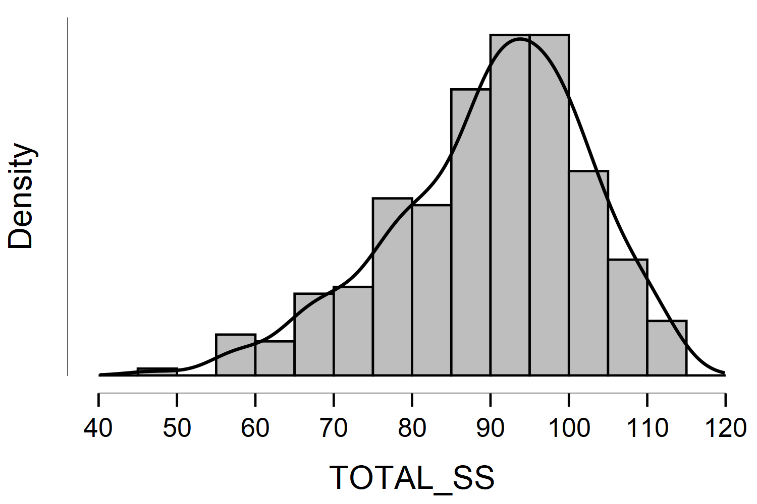

**Boxplots**

**TOTAL_SS**

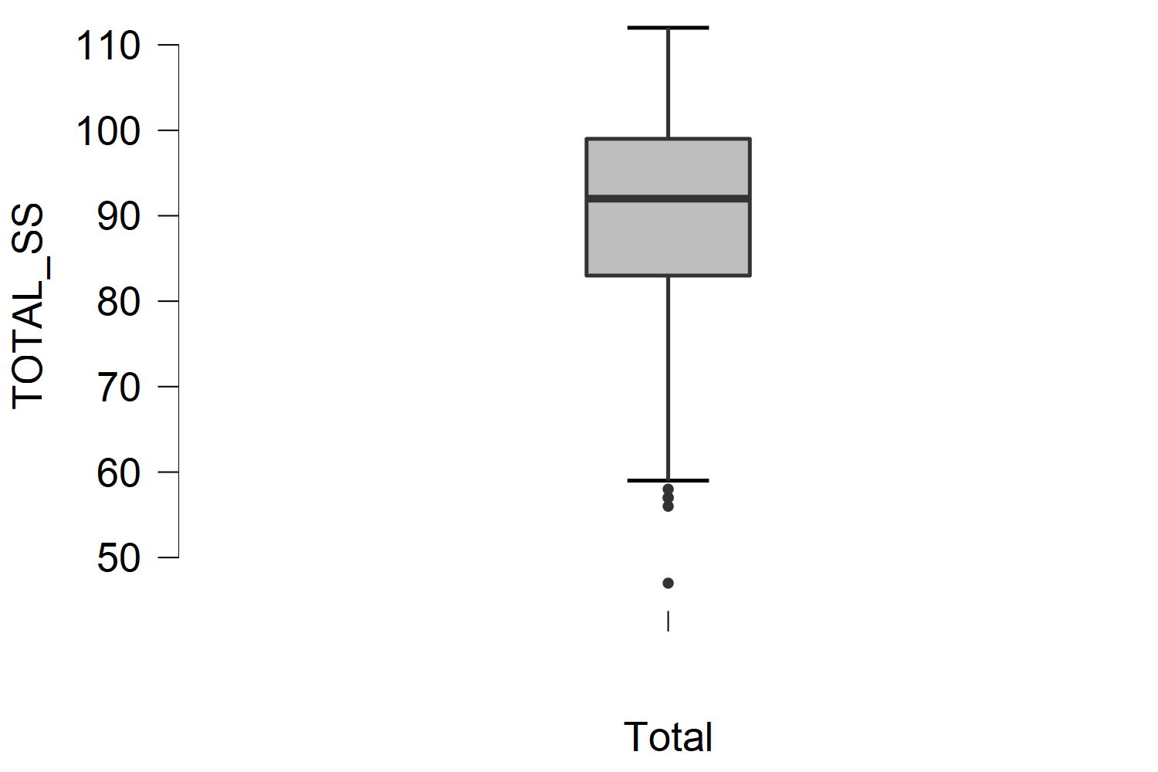

**Q-Q Plot**

**TOTAL_SS**

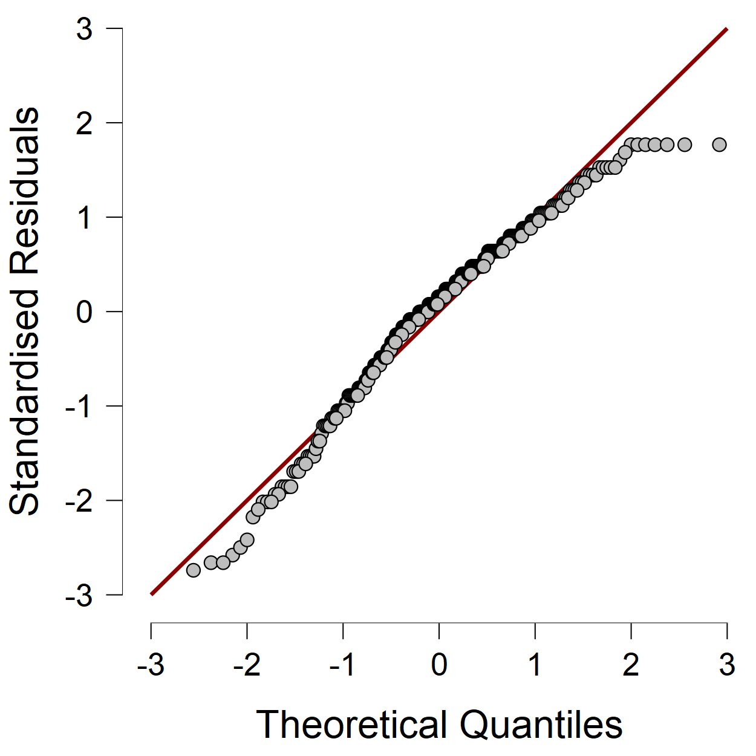

**Reliabilitas**

| **Revised-Multidimensional Scale of Perceived Social Support** | | |
| --- | --- | --- |
|  | | **Cronbach's** | | |
| Total |  | 0.886 | |  |
| Principal |  | 0.825 | |  |
| Coworker |  | 0.718 | |  |
| Family |  | 0.825 | |  |
| Friend |  | 0.818 | |  |
|  | | | | |

| **Frequentist Individual Item Reliability Statistics** | | | | | | | |
| --- | --- | --- | --- | --- | --- | --- | --- |
| **Item** | | **Item-rest correlation** | | **mean** | | **sd** | |
| SS_P1 |  | 0.462 |  | 5.849 |  | 1.130 |  |
| SS_C1 |  | 0.481 |  | 5.782 |  | 1.148 |  |
| SS_P2 |  | 0.629 |  | 4.993 |  | 1.601 |  |
| SS_C2 |  | 0.629 |  | 5.330 |  | 1.457 |  |
| SS_Fa1 |  | 0.591 |  | 6.074 |  | 1.150 |  |
| SS_Fa2 |  | 0.534 |  | 6.260 |  | 1.039 |  |
| SS_P3 |  | 0.541 |  | 6.081 |  | 1.229 |  |
| SS_C3 |  | 0.506 |  | 6.137 |  | 0.903 |  |
| SS_Fr1 |  | 0.594 |  | 5.519 |  | 1.197 |  |
| SS_Fr2 |  | 0.614 |  | 5.228 |  | 1.330 |  |
| SS_Fa3 |  | 0.334 |  | 6.028 |  | 1.147 |  |
| SS_Fr3 |  | 0.562 |  | 5.537 |  | 1.428 |  |
| SS_P4 |  | 0.649 |  | 4.863 |  | 1.554 |  |
| SS_C4 |  | 0.589 |  | 5.186 |  | 1.368 |  |
| SS_Fa4 |  | 0.444 |  | 6.196 |  | 1.005 |  |
| SS_Fr4 |  | 0.432 |  | 4.979 |  | 1.565 |  |
|  | | | | | | | |

**Confirmatory Factor Analysis**

**Model fit**

| **Chi-square test** | | | | | | | |
| --- | --- | --- | --- | --- | --- | --- | --- |
| **Model** | | **Χ²** | | **df** | | **p** | |
| Baseline model |  | 2658.430 |  | 120 |  |  |  |
| Factor model |  | 133.225 |  | 98 |  | 0.010 |  |
|  | | | | | | | |

**Additional fit measures**

| **Fit indices** | | | |
| --- | --- | --- | --- |
| **Index** | | **Value** | |
| Comparative Fit Index (CFI) |  | 0.986 |  |
| Tucker-Lewis Index (TLI) |  | 0.983 |  |
| Bentler-Bonett Non-normed Fit Index (NNFI) |  | 0.983 |  |
| Bentler-Bonett Normed Fit Index (NFI) |  | 0.950 |  |
| Parsimony Normed Fit Index (PNFI) |  | 0.776 |  |
| Bollen's Relative Fit Index (RFI) |  | 0.939 |  |
| Bollen's Incremental Fit Index (IFI) |  | 0.986 |  |
| Relative Noncentrality Index (RNI) |  | 0.986 |  |
|  | | | |

| **Information criteria** | | | |
| --- | --- | --- | --- |
|  | | **Value** | |
| Log-likelihood |  |  |  |
| Number of free parameters |  | 38.000 |  |
| Akaike (AIC) |  |  |  |
| Bayesian (BIC) |  |  |  |
| Sample-size adjusted Bayesian (SSABIC) |  |  |  |
|  | | | |

| **Other fit measures** | | | |
| --- | --- | --- | --- |
| **Metric** | | **Value** | |
| Root mean square error of approximation (RMSEA) |  | 0.036 |  |
| RMSEA 90% CI lower bound |  | 0.018 |  |
| RMSEA 90% CI upper bound |  | 0.050 |  |
| RMSEA p-value |  | 0.950 |  |
| Standardized root mean square residual (SRMR) |  | 0.075 |  |
| Hoelter's critical N (α = .05) |  | 261.301 |  |
| Hoelter's critical N (α = .01) |  | 285.534 |  |
| Goodness of fit index (GFI) |  | 0.969 |  |
| McDonald fit index (MFI) |  | 0.940 |  |
| Expected cross validation index (ECVI) |  | 0.737 |  |
|  | | | |

| **R-Squared** | | | |
| --- | --- | --- | --- |
|  | | **R²** | |
| SS_P1 |  | 0.353 |  |
| SS_P2 |  | 0.665 |  |
| SS_P3 |  | 0.455 |  |
| SS_P4 |  | 0.659 |  |
| SS_C1 |  | 0.311 |  |
| SS_C2 |  | 0.518 |  |
| SS_C3 |  | 0.321 |  |
| SS_C4 |  | 0.400 |  |
| SS_Fa1 |  | 0.860 |  |
| SS_Fa2 |  | 0.710 |  |
| SS_Fa3 |  | 0.235 |  |
| SS_Fa4 |  | 0.435 |  |
| SS_Fr1 |  | 0.646 |  |
| SS_Fr2 |  | 0.686 |  |
| SS_Fr3 |  | 0.528 |  |
| SS_Fr4 |  | 0.286 |  |
|  | | | |

**Parameter estimates**

| **Factor loadings** | | | | | | | | | | | | | | | | | | | |
| --- | --- | --- | --- | --- | --- | --- | --- | --- | --- | --- | --- | --- | --- | --- | --- | --- | --- | --- | --- |
|  | | | | | | | | | | | | | | **95% Confidence Interval** | | | |  | |
| **Factor** | | **Indicator** | | **Symbol** | | **Estimate** | | **Std. Error** | | **z-value** | | **p** | | **Lower** | | **Upper** | | **Std. Est. (all)** | |
| Kepala Sekolah |  | SS_P1 |  | λ11 |  | 0.671 |  | 0.045 |  | 14.888 |  | < .001 |  | 0.583 |  | 0.760 |  | 0.594 |  |
|  |  | SS_P2 |  | λ12 |  | 1.306 |  | 0.070 |  | 18.558 |  | < .001 |  | 1.168 |  | 1.444 |  | 0.816 |  |
|  |  | SS_P3 |  | λ13 |  | 0.830 |  | 0.054 |  | 15.299 |  | < .001 |  | 0.723 |  | 0.936 |  | 0.675 |  |
|  |  | SS_P4 |  | λ14 |  | 1.261 |  | 0.069 |  | 18.410 |  | < .001 |  | 1.127 |  | 1.396 |  | 0.812 |  |
| Rekan Guru |  | SS_C1 |  | λ21 |  | 0.640 |  | 0.041 |  | 15.475 |  | < .001 |  | 0.559 |  | 0.722 |  | 0.558 |  |
|  |  | SS_C2 |  | λ22 |  | 1.049 |  | 0.058 |  | 17.954 |  | < .001 |  | 0.935 |  | 1.164 |  | 0.720 |  |
|  |  | SS_C3 |  | λ23 |  | 0.512 |  | 0.034 |  | 15.177 |  | < .001 |  | 0.446 |  | 0.578 |  | 0.567 |  |
|  |  | SS_C4 |  | λ24 |  | 0.865 |  | 0.055 |  | 15.789 |  | < .001 |  | 0.758 |  | 0.973 |  | 0.633 |  |
| Keluarga |  | SS_Fa1 |  | λ31 |  | 1.066 |  | 0.062 |  | 17.246 |  | < .001 |  | 0.945 |  | 1.188 |  | 0.927 |  |
|  |  | SS_Fa2 |  | λ32 |  | 0.876 |  | 0.057 |  | 15.394 |  | < .001 |  | 0.764 |  | 0.987 |  | 0.843 |  |
|  |  | SS_Fa3 |  | λ33 |  | 0.556 |  | 0.048 |  | 11.589 |  | < .001 |  | 0.462 |  | 0.650 |  | 0.484 |  |
|  |  | SS_Fa4 |  | λ34 |  | 0.663 |  | 0.046 |  | 14.387 |  | < .001 |  | 0.573 |  | 0.754 |  | 0.660 |  |
| Teman |  | SS_Fr1 |  | λ41 |  | 0.962 |  | 0.056 |  | 17.105 |  | < .001 |  | 0.852 |  | 1.072 |  | 0.803 |  |
|  |  | SS_Fr2 |  | λ42 |  | 1.102 |  | 0.062 |  | 17.819 |  | < .001 |  | 0.980 |  | 1.223 |  | 0.828 |  |
|  |  | SS_Fr3 |  | λ43 |  | 1.037 |  | 0.064 |  | 16.232 |  | < .001 |  | 0.912 |  | 1.162 |  | 0.726 |  |
|  |  | SS_Fr4 |  | λ44 |  | 0.838 |  | 0.059 |  | 14.152 |  | < .001 |  | 0.722 |  | 0.954 |  | 0.535 |  |
|  | | | | | | | | | | | | | | | | | | | |

| **Factor variances** | | | | | | | | | | | | | | | |
| --- | --- | --- | --- | --- | --- | --- | --- | --- | --- | --- | --- | --- | --- | --- | --- |
|  | | | | | | | | | | **95% Confidence Interval** | | | |  | |
| **Factor** | | **Estimate** | | **Std. Error** | | **z-value** | | **p** | | **Lower** | | **Upper** | | **Std. Est. (all)** | |
| Kepala Sekolah |  | 1.000 |  | 0.000 |  |  |  |  |  | 1.000 |  | 1.000 |  | 1.000 |  |
| Rekan Guru |  | 1.000 |  | 0.000 |  |  |  |  |  | 1.000 |  | 1.000 |  | 1.000 |  |
| Keluarga |  | 1.000 |  | 0.000 |  |  |  |  |  | 1.000 |  | 1.000 |  | 1.000 |  |
| Teman |  | 1.000 |  | 0.000 |  |  |  |  |  | 1.000 |  | 1.000 |  | 1.000 |  |
|  | | | | | | | | | | | | | | | |

| **Factor Covariances** | | | | | | | | | | | | | | | | | | | |
| --- | --- | --- | --- | --- | --- | --- | --- | --- | --- | --- | --- | --- | --- | --- | --- | --- | --- | --- | --- |
|  | | | | | | | | | | | | | | **95% Confidence Interval** | | | |  | |
|  | |  | |  | | **Estimate** | | **Std. Error** | | **z-value** | | **p** | | **Lower** | | **Upper** | | **Std. Est. (all)** | |
| Kepala Sekolah |  | ↔ |  | Rekan Guru |  | 0.783 |  | 0.054 |  | 14.543 |  | < .001 |  | 0.677 |  | 0.888 |  | 0.783 |  |
| Kepala Sekolah |  | ↔ |  | Keluarga |  | 0.460 |  | 0.039 |  | 11.854 |  | < .001 |  | 0.384 |  | 0.536 |  | 0.460 |  |
| Kepala Sekolah |  | ↔ |  | Teman |  | 0.522 |  | 0.042 |  | 12.553 |  | < .001 |  | 0.441 |  | 0.604 |  | 0.522 |  |
| Rekan Guru |  | ↔ |  | Keluarga |  | 0.571 |  | 0.047 |  | 12.109 |  | < .001 |  | 0.478 |  | 0.663 |  | 0.571 |  |
| Rekan Guru |  | ↔ |  | Teman |  | 0.718 |  | 0.053 |  | 13.614 |  | < .001 |  | 0.614 |  | 0.821 |  | 0.718 |  |
| Keluarga |  | ↔ |  | Teman |  | 0.432 |  | 0.037 |  | 11.691 |  | < .001 |  | 0.360 |  | 0.505 |  | 0.432 |  |
|  | | | | | | | | | | | | | | | | | | | |

| **Residual variances** | | | | | | | | | | | | | | | |
| --- | --- | --- | --- | --- | --- | --- | --- | --- | --- | --- | --- | --- | --- | --- | --- |
|  | | | | | | | | | | **95% Confidence Interval** | | | |  | |
| **Indicator** | | **Estimate** | | **Std. Error** | | **z-value** | | **p** | | **Lower** | | **Upper** | | **Std. Est. (all)** | |
| SS_P1 |  | 0.826 |  | 0.140 |  | 5.913 |  | < .001 |  | 0.552 |  | 1.099 |  | 0.647 |  |
| SS_P2 |  | 0.858 |  | 0.270 |  | 3.178 |  | 0.001 |  | 0.329 |  | 1.387 |  | 0.335 |  |
| SS_P3 |  | 0.823 |  | 0.209 |  | 3.939 |  | < .001 |  | 0.413 |  | 1.232 |  | 0.545 |  |
| SS_P4 |  | 0.823 |  | 0.251 |  | 3.277 |  | 0.001 |  | 0.331 |  | 1.316 |  | 0.341 |  |
| SS_C1 |  | 0.909 |  | 0.145 |  | 6.273 |  | < .001 |  | 0.625 |  | 1.192 |  | 0.689 |  |
| SS_C2 |  | 1.022 |  | 0.231 |  | 4.435 |  | < .001 |  | 0.571 |  | 1.474 |  | 0.482 |  |
| SS_C3 |  | 0.554 |  | 0.100 |  | 5.550 |  | < .001 |  | 0.358 |  | 0.749 |  | 0.679 |  |
| SS_C4 |  | 1.122 |  | 0.201 |  | 5.587 |  | < .001 |  | 0.728 |  | 1.515 |  | 0.600 |  |
| SS_Fa1 |  | 0.185 |  | 0.192 |  | 0.963 |  | 0.336 |  | -0.191 |  | 0.561 |  | 0.140 |  |
| SS_Fa2 |  | 0.313 |  | 0.176 |  | 1.785 |  | 0.074 |  | -0.031 |  | 0.658 |  | 0.290 |  |
| SS_Fa3 |  | 1.007 |  | 0.169 |  | 5.969 |  | < .001 |  | 0.677 |  | 1.338 |  | 0.765 |  |
| SS_Fa4 |  | 0.571 |  | 0.146 |  | 3.915 |  | < .001 |  | 0.285 |  | 0.856 |  | 0.565 |  |
| SS_Fr1 |  | 0.508 |  | 0.185 |  | 2.746 |  | 0.006 |  | 0.145 |  | 0.871 |  | 0.354 |  |
| SS_Fr2 |  | 0.555 |  | 0.207 |  | 2.682 |  | 0.007 |  | 0.149 |  | 0.960 |  | 0.314 |  |
| SS_Fr3 |  | 0.963 |  | 0.257 |  | 3.745 |  | < .001 |  | 0.459 |  | 1.467 |  | 0.472 |  |
| SS_Fr4 |  | 1.748 |  | 0.221 |  | 7.895 |  | < .001 |  | 1.314 |  | 2.182 |  | 0.714 |  |
|  | | | | | | | | | | | | | | | |

| **Implied covariance matrix** | | | | | | | | | | | | | | | | | | | | | | | | | | | | | | | |
| --- | --- | --- | --- | --- | --- | --- | --- | --- | --- | --- | --- | --- | --- | --- | --- | --- | --- | --- | --- | --- | --- | --- | --- | --- | --- | --- | --- | --- | --- | --- | --- |
| **SS_P1** | | **SS_P2** | | **SS_P3** | | **SS_P4** | | **SS_C1** | | **SS_C2** | | **SS_C3** | | **SS_C4** | | **SS_Fa1** | | **SS_Fa2** | | **SS_Fa3** | | **SS_Fa4** | | **SS_Fr1** | | **SS_Fr2** | | **SS_Fr3** | | **SS_Fr4** | |
| 1.276 |  |  |  |  |  |  |  |  |  |  |  |  |  |  |  |  |  |  |  |  |  |  |  |  |  |  |  |  |  |  |  |
| 0.877 |  | 2.563 |  |  |  |  |  |  |  |  |  |  |  |  |  |  |  |  |  |  |  |  |  |  |  |  |  |  |  |  |  |
| 0.557 |  | 1.083 |  | 1.511 |  |  |  |  |  |  |  |  |  |  |  |  |  |  |  |  |  |  |  |  |  |  |  |  |  |  |  |
| 0.847 |  | 1.647 |  | 1.046 |  | 2.414 |  |  |  |  |  |  |  |  |  |  |  |  |  |  |  |  |  |  |  |  |  |  |  |  |  |
| 0.337 |  | 0.655 |  | 0.416 |  | 0.632 |  | 1.319 |  |  |  |  |  |  |  |  |  |  |  |  |  |  |  |  |  |  |  |  |  |  |  |
| 0.551 |  | 1.072 |  | 0.681 |  | 1.036 |  | 0.672 |  | 2.123 |  |  |  |  |  |  |  |  |  |  |  |  |  |  |  |  |  |  |  |  |  |
| 0.269 |  | 0.523 |  | 0.332 |  | 0.506 |  | 0.328 |  | 0.537 |  | 0.816 |  |  |  |  |  |  |  |  |  |  |  |  |  |  |  |  |  |  |  |
| 0.455 |  | 0.884 |  | 0.562 |  | 0.854 |  | 0.554 |  | 0.908 |  | 0.443 |  | 1.870 |  |  |  |  |  |  |  |  |  |  |  |  |  |  |  |  |  |
| 0.329 |  | 0.641 |  | 0.407 |  | 0.619 |  | 0.390 |  | 0.638 |  | 0.312 |  | 0.526 |  | 1.322 |  |  |  |  |  |  |  |  |  |  |  |  |  |  |  |
| 0.270 |  | 0.526 |  | 0.334 |  | 0.508 |  | 0.320 |  | 0.524 |  | 0.256 |  | 0.432 |  | 0.934 |  | 1.080 |  |  |  |  |  |  |  |  |  |  |  |  |  |
| 0.172 |  | 0.334 |  | 0.212 |  | 0.322 |  | 0.203 |  | 0.333 |  | 0.162 |  | 0.274 |  | 0.593 |  | 0.487 |  | 1.316 |  |  |  |  |  |  |  |  |  |  |  |
| 0.205 |  | 0.398 |  | 0.253 |  | 0.385 |  | 0.242 |  | 0.397 |  | 0.194 |  | 0.327 |  | 0.707 |  | 0.581 |  | 0.368 |  | 1.011 |  |  |  |  |  |  |  |  |  |
| 0.337 |  | 0.656 |  | 0.417 |  | 0.634 |  | 0.442 |  | 0.724 |  | 0.354 |  | 0.597 |  | 0.444 |  | 0.364 |  | 0.231 |  | 0.276 |  | 1.434 |  |  |  |  |  |  |  |
| 0.386 |  | 0.751 |  | 0.477 |  | 0.725 |  | 0.506 |  | 0.830 |  | 0.405 |  | 0.684 |  | 0.508 |  | 0.417 |  | 0.265 |  | 0.316 |  | 1.060 |  | 1.768 |  |  |  |  |  |
| 0.363 |  | 0.707 |  | 0.449 |  | 0.683 |  | 0.477 |  | 0.781 |  | 0.381 |  | 0.644 |  | 0.478 |  | 0.393 |  | 0.249 |  | 0.297 |  | 0.998 |  | 1.142 |  | 2.038 |  |  |  |
| 0.294 |  | 0.571 |  | 0.363 |  | 0.552 |  | 0.385 |  | 0.631 |  | 0.308 |  | 0.520 |  | 0.386 |  | 0.317 |  | 0.201 |  | 0.240 |  | 0.806 |  | 0.923 |  | 0.869 |  | 2.450 |  |
|  | | | | | | | | | | | | | | | | | | | | | | | | | | | | | | | |

| **Residual covariance matrix** | | | | | | | | | | | | | | | | | | | | | | | | | | | | | | | |
| --- | --- | --- | --- | --- | --- | --- | --- | --- | --- | --- | --- | --- | --- | --- | --- | --- | --- | --- | --- | --- | --- | --- | --- | --- | --- | --- | --- | --- | --- | --- | --- |
| **SS_P1** | | **SS_P2** | | **SS_P3** | | **SS_P4** | | **SS_C1** | | **SS_C2** | | **SS_C3** | | **SS_C4** | | **SS_Fa1** | | **SS_Fa2** | | **SS_Fa3** | | **SS_Fa4** | | **SS_Fr1** | | **SS_Fr2** | | **SS_Fr3** | | **SS_Fr4** | |
| < .001 |  |  |  |  |  |  |  |  |  |  |  |  |  |  |  |  |  |  |  |  |  |  |  |  |  |  |  |  |  |  |  |
| 0.171 |  | < .001 |  |  |  |  |  |  |  |  |  |  |  |  |  |  |  |  |  |  |  |  |  |  |  |  |  |  |  |  |  |
| 0.167 |  | 0.048 |  | < .001 |  |  |  |  |  |  |  |  |  |  |  |  |  |  |  |  |  |  |  |  |  |  |  |  |  |  |  |
| < .001 |  | < .001 |  | 0.074 |  | < .001 |  |  |  |  |  |  |  |  |  |  |  |  |  |  |  |  |  |  |  |  |  |  |  |  |  |
| 0.356 |  | 0.027 |  | < .001 |  | < .001 |  | < .001 |  |  |  |  |  |  |  |  |  |  |  |  |  |  |  |  |  |  |  |  |  |  |  |
| < .001 |  | 0.335 |  | < .001 |  | < .001 |  | < .001 |  | < .001 |  |  |  |  |  |  |  |  |  |  |  |  |  |  |  |  |  |  |  |  |  |
| 0.040 |  | < .001 |  | 0.255 |  | < .001 |  | 0.117 |  | < .001 |  | < .001 |  |  |  |  |  |  |  |  |  |  |  |  |  |  |  |  |  |  |  |
| < .001 |  | < .001 |  | < .001 |  | 0.446 |  | < .001 |  | 0.122 |  | < .001 |  | < .001 |  |  |  |  |  |  |  |  |  |  |  |  |  |  |  |  |  |
| 0.094 |  | < .001 |  | 0.020 |  | < .001 |  | 0.084 |  | 0.038 |  | 0.020 |  | < .001 |  | < .001 |  |  |  |  |  |  |  |  |  |  |  |  |  |  |  |
| 0.047 |  | 0.015 |  | 0.015 |  | < .001 |  | 0.043 |  | < .001 |  | < .001 |  | < .001 |  | 0.040 |  | < .001 |  |  |  |  |  |  |  |  |  |  |  |  |  |
| < .001 |  | < .001 |  | < .001 |  | 0.090 |  | < .001 |  | < .001 |  | < .001 |  | 0.217 |  | < .001 |  | 0.077 |  | < .001 |  |  |  |  |  |  |  |  |  |  |  |
| < .001 |  | < .001 |  | 0.037 |  | 0.047 |  | < .001 |  | < .001 |  | < .001 |  | 0.066 |  | < .001 |  | < .001 |  | 0.225 |  | < .001 |  |  |  |  |  |  |  |  |  |
| 0.044 |  | 0.024 |  | 0.105 |  | < .001 |  | < .001 |  | 0.019 |  | 0.107 |  | < .001 |  | 0.138 |  | 0.046 |  | < .001 |  | 0.034 |  | < .001 |  |  |  |  |  |  |  |
| < .001 |  | 0.050 |  | < .001 |  | 0.063 |  | < .001 |  | 0.243 |  | < .001 |  | 0.006 |  | 0.032 |  | < .001 |  | < .001 |  | 0.072 |  | 0.068 |  | < .001 |  |  |  |  |  |
| < .001 |  | < .001 |  | 0.110 |  | 0.144 |  | < .001 |  | < .001 |  | < .001 |  | 0.097 |  | < .001 |  | < .001 |  | 0.144 |  | < .001 |  | < .001 |  | < .001 |  | < .001 |  |  |  |
| < .001 |  | < .001 |  | < .001 |  | 0.234 |  | < .001 |  | 0.161 |  | < .001 |  | 0.596 |  | < .001 |  | < .001 |  | 0.127 |  | < .001 |  | < .001 |  | 0.029 |  | 0.460 |  | < .001 |  |
|  | | | | | | | | | | | | | | | | | | | | | | | | | | | | | | | |

**Modification Indices**

| **Cross-loadings** | | | | | | | | | |
| --- | --- | --- | --- | --- | --- | --- | --- | --- | --- |
|  | |  | |  | | **Mod. Ind.** | | **EPC** | |
| Rekan Guru |  | → |  | SS_P4 |  | 5.174 |  | 0.815 |  |
| Teman |  | → |  | SS_C1 |  | 5.011 |  | -0.319 |  |
| Teman |  | → |  | SS_P1 |  | 4.299 |  | -0.212 |  |
|  | | | | | | | | | |

| **Residual covariances** | | | | | | | | | |
| --- | --- | --- | --- | --- | --- | --- | --- | --- | --- |
|  | |  | |  | | **Mod. Ind.** | | **EPC** | |
| SS_P1 |  | ↔ |  | SS_C1 |  | 14.726 |  | 0.398 |  |
| SS_C4 |  | ↔ |  | SS_Fr4 |  | 12.364 |  | 0.653 |  |
| SS_P4 |  | ↔ |  | SS_C4 |  | 8.832 |  | 0.548 |  |
| SS_Fr3 |  | ↔ |  | SS_Fr4 |  | 8.719 |  | 0.585 |  |
| SS_Fa3 |  | ↔ |  | SS_Fa4 |  | 6.776 |  | 0.274 |  |
| SS_P3 |  | ↔ |  | SS_C3 |  | 6.643 |  | 0.280 |  |
| SS_P1 |  | ↔ |  | SS_C4 |  | 6.171 |  | -0.279 |  |
| SS_P3 |  | ↔ |  | SS_C2 |  | 4.755 |  | -0.293 |  |
| SS_P2 |  | ↔ |  | SS_C2 |  | 4.484 |  | 0.428 |  |
| SS_P1 |  | ↔ |  | SS_Fa3 |  | 4.252 |  | -0.166 |  |
| SS_P2 |  | ↔ |  | SS_P4 |  | 4.142 |  | -0.513 |  |
| SS_P1 |  | ↔ |  | SS_Fr4 |  | 3.972 |  | -0.228 |  |
|  | | | | | | | | | |

**Plots**

**Model plot**

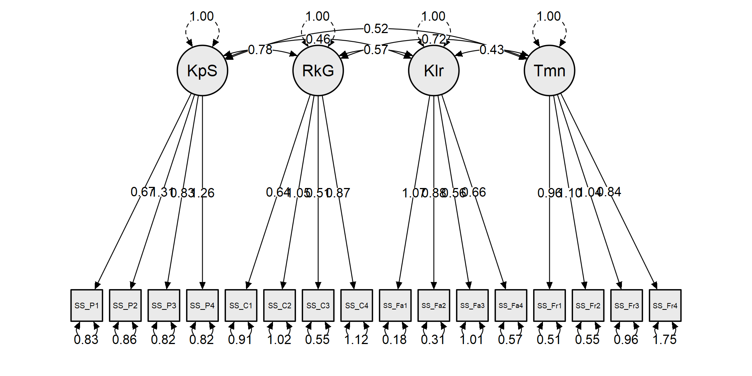

**Plots**

**Model plot**

