HASIL PENGUJIAN ALAT UKUR

Hasil Uji Deskriptif
Mindfulness in Teaching Scale, Teacher Stress Inventory-Revised & Teacher Self-Efficacy Scale-Short
 | MTS | TSI-R | TSES-Short
Valid | 244 | 244 | 244
Missing | 0 | 0 | 0
Mean | 52.135 | 59.791 | 85.984
Std. Deviation | 6.220 | 17.096 | 12.720
Shapiro-Wilk | 0.989 | 0.988 | 0.964
P-value of Shapiro-Wilk | 0.050 | 0.044 | < .001

Mengajar di Jenjang | Frekuensi | Persentase
SD | 58 | 23.770
SMA | 49 | 20.082
SMK | 49 | 20.082
SMP | 88 | 36.066
Total | 244 | 100.000

Hasil Uji Reliabilitas
Teacher Stress Inventory – Revised
 | Cronbach’s Alpha
Total TSI-R | 0.931
Work-Related Stressors | 0.809
Emotional Manifestations | 0.896
Physical Manifestations | 0.865

Mindfulness in Teaching Scale Indonesia
 | Cronbach’s Alpha
Total MTS-I | 0.717
Intrapersonal Mindfulness | 0.792
Interpersonal Mindfulness | 0.580

Teacher Self-Efficacy Scale – Short Form
 | Cronbach’s Alpha
Total TSES-Short | 0.956
Class Management | 0.890
Instructional Strategies | 0.903
Student Engagement | 0.878

Hasil EFA MTS-I

Factor Loadings
 |  | Factor 1 |  | Factor 2 |  | Uniqueness
Intra_1 |  | 0.497 |  |  |  | 0.736
Inter_2 |  |  |  | 0.551 |  | 0.691
Intra_7 |  | 0.477 |  |  |  | 0.751
Intra_5 |  | 0.639 |  |  |  | 0.591
Inter_4 |  |  |  | 0.449 |  | 0.797
Intra_8 |  | 0.641 |  |  |  | 0.582
Intra_6 |  | 0.626 |  |  |  | 0.593
Inter_5 |  |  |  | 0.329 |  | 0.892
Intra_3 |  | 0.682 |  |  |  | 0.524
Intra_9 |  | 0.411 |  |  |  | 0.827
Inter_1 |  |  |  | 0.721 |  | 0.478
Intra_2 |  | 0.464 |  |  |  | 0.784
Intra_4 |  | 0.540 |  |  |  | 0.706
Note. Applied rotation method is varimax.

Path Diagram
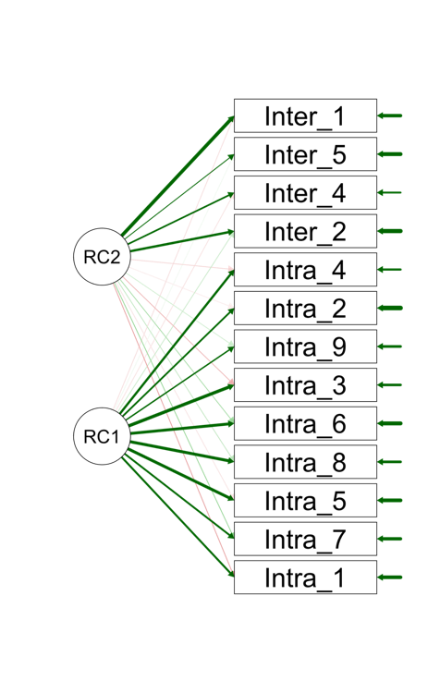

Hasil CFA MTS-I

HASIL CFA SETELAH MODIFIKASI

Additional fit measures
Fit indices
Index |  | Value
Comparative Fit Index (CFI) |  | 0.941
Tucker-Lewis Index (TLI) |  | 0.925
Bentler-Bonett Non-normed Fit Index (NNFI) |  | 0.925
Bentler-Bonett Normed Fit Index (NFI) |  | 0.862
Parsimony Normed Fit Index (PNFI) |  | 0.674
Bollen's Relative Fit Index (RFI) |  | 0.823
Bollen's Incremental Fit Index (IFI) |  | 0.943
Relative Noncentrality Index (RNI) |  | 0.941

Model fit
Chi-square test
Model |  | Χ² |  | df |  | p
Baseline model |  | 709.600 |  | 78
Factor model |  | 98.231 |  | 61 |  | 0.002

Other fit measures
Metric |  | Value
Root mean square error of approximation (RMSEA) |  | 0.050
RMSEA 90% CI lower bound |  | 0.031
RMSEA 90% CI upper bound |  | 0.068
RMSEA p-value |  | 0.479
Standardized root mean square residual (SRMR) |  | 0.052
Goodness of fit index (GFI) |  | 0.941
McDonald fit index (MFI) |  | 0.927
Expected cross validation index (ECVI) |  | 0.648

Parameter estimates
Factor loadings
 |  |  |  |  |  |  |  |  |  |  |  |  |  | 95% Confidence Interval
Factor |  | Indicator |  | Symbol |  | Estimate |  | Std. Error |  | z-value |  | p |  | Lower |  | Upper |  | Std. Est. (all)
Intrapersonal |  | Intra_1 |  | λ11 |  | 0.551 |  | 0.086 |  | 6.430 |  | < .001 |  | 0.383 |  | 0.718 |  | 0.450
 |  | Intra_7 |  | λ12 |  | 0.381 |  | 0.053 |  | 7.159 |  | < .001 |  | 0.276 |  | 0.485 |  | 0.494
 |  | Intra_5 |  | λ13 |  | 0.609 |  | 0.077 |  | 7.940 |  | < .001 |  | 0.459 |  | 0.760 |  | 0.552
 |  | Intra_8 |  | λ14 |  | 0.569 |  | 0.064 |  | 8.932 |  | < .001 |  | 0.444 |  | 0.694 |  | 0.606
 |  | Intra_6 |  | λ15 |  | 0.528 |  | 0.063 |  | 8.322 |  | < .001 |  | 0.403 |  | 0.652 |  | 0.573
 |  | Intra_3 |  | λ16 |  | 0.645 |  | 0.068 |  | 9.526 |  | < .001 |  | 0.513 |  | 0.778 |  | 0.637
 |  | Intra_9 |  | λ17 |  | 0.457 |  | 0.073 |  | 6.240 |  | < .001 |  | 0.313 |  | 0.600 |  | 0.437
 |  | Intra_2 |  | λ18 |  | 0.563 |  | 0.079 |  | 7.166 |  | < .001 |  | 0.409 |  | 0.717 |  | 0.495
 |  | Intra_4 |  | λ19 |  | 0.598 |  | 0.070 |  | 8.518 |  | < .001 |  | 0.460 |  | 0.736 |  | 0.576
Interpersonal |  | Inter_2 |  | λ21 |  | 0.458 |  | 0.066 |  | 6.935 |  | < .001 |  | 0.328 |  | 0.587 |  | 0.569
 |  | Inter_4 |  | λ22 |  | 0.496 |  | 0.085 |  | 5.854 |  | < .001 |  | 0.330 |  | 0.662 |  | 0.461
 |  | Inter_5 |  | λ23 |  | 0.415 |  | 0.092 |  | 4.506 |  | < .001 |  | 0.235 |  | 0.596 |  | 0.355
 |  | Inter_1 |  | λ24 |  | 0.652 |  | 0.083 |  | 7.900 |  | < .001 |  | 0.490 |  | 0.814 |  | 0.693

Modification Indices
Cross-loadings
 |  |  |  |  |  | Mod. Ind. |  | EPC
Interpersonal |  | → |  | Intra_7 |  | 4.127 |  | 0.114

Residual covariances
 |  |  |  |  |  | Mod. Ind. |  | EPC
Intra_1 |  | ↔ |  | Intra_3 |  | 12.085 |  | 0.235
Intra_7 |  | ↔ |  | Intra_8 |  | 10.809 |  | 0.111
Intra_1 |  | ↔ |  | Inter_1 |  | 10.138 |  | -0.177
Intra_3 |  | ↔ |  | Inter_1 |  | 6.806 |  | -0.109
Intra_5 |  | ↔ |  | Inter_1 |  | 5.875 |  | 0.107
Inter_2 |  | ↔ |  | Inter_1 |  | 5.456 |  | 0.269
Inter_4 |  | ↔ |  | Inter_5 |  | 5.432 |  | 0.185
Intra_7 |  | ↔ |  | Intra_3 |  | 4.558 |  | -0.081
Intra_1 |  | ↔ |  | Intra_7 |  | 4.308 |  | -0.101
Intra_9 |  | ↔ |  | Intra_2 |  | 3.996 |  | 0.133
Intra_3 |  | ↔ |  | Inter_2 |  | 3.946 |  | 0.073
Intra_5 |  | ↔ |  | Inter_2 |  | 3.909 |  | -0.076

Model plot
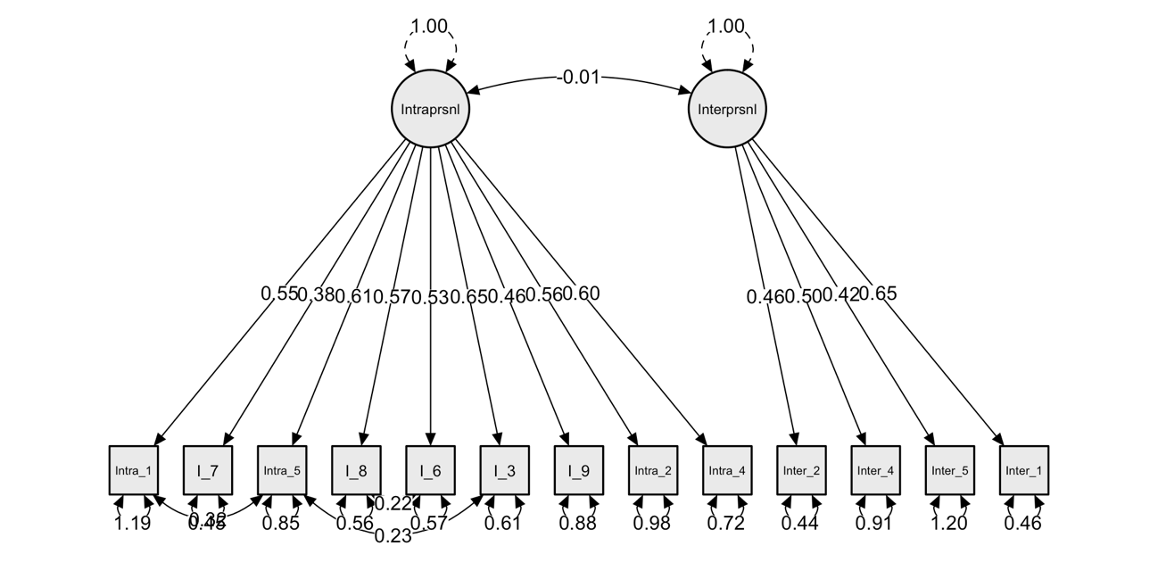

HASIL KORELASI

Korelasi Total MTS-I & Dimensi MTS-I
Pearson's Correlations
Variable |  | TOTAL MTS-I | INTRAPERSONAL | INTERPERSONAL
1. TOTAL MTS-I | Pearson's r | —
 | p-value | —
2. INTRAPERSONAL | Pearson's r | 0.867 | —
 | p-value | < .001 | —
3. INTERPERSONAL | Pearson's r | 0.588 | 0.187 | —
 | p-value | < .001 | 0.003 | —

Korelasi antar Alat Ukur (Total Item)
Pearson's Correlations
Variable |  | TOTAL MTS-I | TOTAL_TSI | TOTAL_TSES
1. TOTAL MTS-I | Pearson's r | —
 | p-value | —
2. TOTAL_TSI | Pearson's r | -0.295 | —
 | p-value | < .001 | —
3. TOTAL_TSES | Pearson's r | 0.256 | -0.207 | —
 | p-value | < .001 | 0.001 | —

Korelasi Antar Dimensi
Variable |  | INTRAPERSONAL | INTERPERSONAL
1. INTRAPERSONAL | Pearson's r | —
 | p-value | —
2. INTERPERSONAL | Pearson's r | 0.187** | —
 | p-value | 0.003 | —
3. WR | Pearson's r | -0.400*** | -0.018
 | p-value | < .001 | 0.778
4. EM | Pearson's r | -0.378*** | 0.018
 | p-value | < .001 | 0.782
5. PM | Pearson's r | -0.358*** | 0.039
 | p-value | < .001 | 0.542
6. CM | Pearson's r | 0.222*** | 0.303***
 | p-value | < .001 | < .001
7. SE | Pearson's r | 0.111 | 0.277***
 | p-value | 0.082 | < .001
8. IS | Pearson's r | 0.160* | 0.292***
 | p-value | 0.013 | < .001
9. TOTAL_TSI | Pearson's r | -0.423*** | 0.015
 | p-value | < .001 | 0.812
10. TOTAL_TSES | Pearson's r | 0.175** | 0.308***
 | p-value | 0.006 | < .001

