Development of Camera and Lens Recognition Learning Media Based on Augmented Reality (AR)
Elsa Sabrina^{1*}, Dony Novaliandry², Muhammad Adri³
¹Technology and Vocational Education, Faculty of Engineering, Universitas Negeri Padang
²Electronic Engineering, Faculty of Engineering, Universitas Negeri Padang
³Electronic Engineering, Faculty of Engineering, Universitas Negeri Padang
*Corresponding Author. Email: elsasabrina40@gmail.com

Abstract  The purpose of this research is to first create learning media for introducing cameras and lenses into the subject of photography. Then use augmented reality technology to create learning media. Third, create a learning media application that can be run from your smartphone using the Android platform. As a research method, we have adopted a research and development method using the ADDIE development model, which consists of five stages: analysis, design, development, implementation, and evaluation. In this study, the stages are limited to the development stage. When designing this photo learning media, the application is created using the Unity software Blender, and for database management it is created using Vuforia. The final result of this study is an Android-based photo learning media. | Article History  Received: …..J  Reviewed: ……  Published:……..  Key Words  Learning Media, Augmented Reality, Android, ADDIE.
Abstrak  Tujuan penelitian ini adalah Pertama, Menghasilkan media pembelajaran pengenalan kamera dan lensa pada mata pelajaran Fotografi. Kedua, Menghasilkan media pembelajaran menggunakan teknologi Augmented Reality. Ketiga, menghasilkan Aplikasi media pembelajaran yang dapat dijalankan melalui smartphone dengan platform android. Metode penelitian yang digunakan adalah metode research & development dengan model pengembangan ADDIE dimana model pengembangan ini terdiri dari lima tahap yaitu tahap analisis, desain, development, implementasi dan evaluasi. Pada penelitian ini tahapan nya dibatasi sampai tahapan development. Dalam perancangan media pembelajaran fotografi ini pembuatan aplikasi nya menggunakan software unity, blender dan untuk manajemen databasenya mnggunakan vuforia. Hasil akhir penelitian ini yaitu berupa media pembelajaran fotografi berbasis Android.  . | Sejarah Artikel  Diterima: …..  Direview: …..  Disetujui: ……. 7  Kata Kunci  Media Pembelajaran, Augmented Reality, Android, ADDIE.
How to Cite: First author., Second author., Third author, etc. (20xx). The title. Jurnal Kependidikan: Jurnal Hasil Penelitian dan Kajian Kepustakaan di Bidang Pendidikan, Pengajaran dan Pembelajaran, vol(no). doi:https://doi.org/10.33394/jk.vxxyyi
 https://doi.org/10.33394/jk.vxxyyi | This is an open-access article under the CC-BY-SA License.

INTRODUCTION
Covid19 is still established in Indonesia, where the disease is spreading rapidly. Not only Indonesia, but the world is now devastated by the health crisis caused by Covid19 (Buliali 2021). Initially, the spread of Covid 19 only affected the start of economic activity. As reported by the Daily Compass (2020), the government has also restricted road closure policies to residents who want to enter and leave areas of all regions. Also known as lockdown. (Fadhilaturrahmi, Ananda and Yolanda 2021; Wafa and Fahmi 2020). Today, the world of education is also affected by this disease (Mandasari, Subandowo, Gunawan2021).
In order for education to continue to function properly, the President has instructed you to stay at home, study at home, work at home, and worship at home. The Minister of Education, Culture, Sports, Science and Technology (Mendikubud) said in 2020 Circular (SE) No. if Covid19 needs to be disseminated. Announced that it will implement educational guidelines. I followed this guide in 4. This means learning from home through online / distance learning. It provides students with a new learning experience and enables them to provide all curriculum services without the hassle required for both class progress and graduation. (Pakpahan and Fitriani 2020; Nistrina 2021; Wibowo and Saepuloh 2020; Mandasari, Subandowo and Gunawan 2021). Augmented reality-based learning media have been developed as distance learning tools to support learning in a way that is performed correctly and continues to be communicated.
AUGMENTED REALITY
Augmented reality is an application that combines the real and virtual worlds in the form of 2D or 3D projections in the real world (Hakim 2018; Ramadhan, Putra and Surahman 2021). The existence of the concept of augmented reality applications seems to be a solution for teachers to overcome the limitations of online learning for vocational high school students in order to overcome the learning barriers to be practiced. (Krishna Pillaietal. 2021; Wibowo and Saepuloh 2020; Kurniawan 2017). Another advantage is that using augmented reality technology makes the learning media used more sophisticated and eliminates the need for students to purchase relatively expensive tools that they cannot afford to study at home. (Haida Dafitri, Arief Budiman, Fakhrana Nadhila 2020; Hakim 2018)
Figure 1. AR Work Diagram
RESEARCH METHODS
Researchers use augmented reality technology by describing different types of objects on electronic media in real time. The information displayed by the virtual objects helps students perform their actual activities. Audio media will be added later in the application to make the learning media more interesting. The system the researchers are trying to build uses an Android operating system with augmented reality technology. The steps for the ADDIE development model are as follows: (Nugrahaetal. 2021; Cahyadi 2019).

1. The analysis phase (analysis) performs analysis of the current system, analysis of problems and solutions, and analysis of the proposed system according to the conditions of SMK Negeri 2 Pariaman.
2. Design stage, which is the stage of creating learning media
3. Development phase, d. H. The process of implementing a design created during the design phase.
4. The implementation phase is the phase to test the student's learning media.
5. Evaluation Phase In this phase, the learning media is evaluated to determine the quality of the feasibility of the developed learning media.
DATA COLLECTION TECHNIQUE
The techniques used in collecting data in this study were 1) Observations were made to students regarding the conditions of smartphone use, 2) Interviews were conducted to collect data about the learning process in the classroom, and 3) Questionnaires to collect data to be used in technical data analysis.(Wibowo and Saepuloh 2020; Nugraha et al. 2021).
DATA ANALYSIS TECHNIQUE
The data used in the form of qualitative data and quantitative data to determine the quality of learning media product data (Sari, Rifki, and Karmila 2020). Quantitative data from this medium are in the form of scores of 4 (fully agree), 3 (agree), 2 (disagree) and 1 (disagree). Qualitative data of learning media SS (very agree), S (I agree), KS (I don't agree), TS (I don't agree). To determine the criteria for media quality, the total points for each respondent (media expert, material expert, student) who responded to the survey are calculated and calculated using the following formula:
𝐾 = 𝐹 𝑁 × 𝐼 × 𝑅

Description :
K : Qualified rate
F : Total number of responses from respondents
N : Highest Score in the questionnaire
I : Number of questions in the questionnaire
R : Number of respondents

After knowing the eligibility percentage, the interpretation is performed according to the table below.
Table 1. Feasibility Presentation
Percentage | Criteria
0%≤ K ≤20% | Very Inappropriate
20%<𝐾 ≤40% | Less Worthy
40%<𝐾 ≤60% | Enough
60%<𝐾 ≤80% | Worthy
80%<𝐾 ≤100% | Very Worthy
A learning media is considered appropriate if the feasibility rate of the learning media exceeds 60%. With appropriate standards.

RESEARCH RESULTS AND DISCUSSION
This application is one of the most interactive and communicative learning media. This learning medium is intended to help students in class XISMK understand the introduction of cameras and lenses in schools. This learning medium can be used anytime, anywhere with the appearance of 3D image objects that students can see directly.
A. Analysis phase
1. Perform a system analysis
Running system analysis is performed by analyzing the objects needed to design a system that need to focus on the functionality of the running system, not the process flow of the system.
2. Problem analysis and solution
Problem and solution analysis is an analysis of problems that occur in the field and the solutions that are provided to solve those problems.
3. Proposed system analysis
After analyzing the current system and analyzing the problems and solutions, the next step is to design the proposed system. In this phase, augmented reality technology is used to develop learning media for introducing camera and lens types to the subject.
B. Design stage
In this phase, the textbook is designed as a marker of application execution. The first preparation for this textbook is to determine the materials from which the media will be made. Evaluation equipment or quizzes are also held so that students can evaluate their skills at the end of the meeting.
C. Development stage (development)
This development phase is the phase in which learning media developers perform a media creation process aimed at creating interactive learning media based on augmented reality. The development of these media combines textbook learning media with augmented reality technology to enable indirect recognition of the introduction of materials in the form of objects through shape and function.
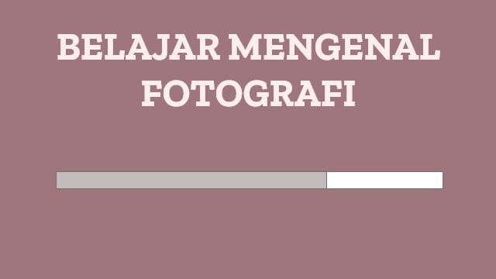
Figure 2. Loading Page Interface Display

Next go to the menu page.
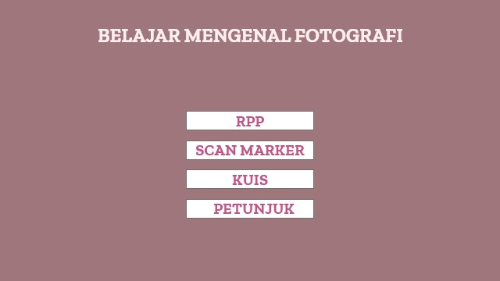
Figure 3. Menu Page Display
Then go to the Scan Marker display page.
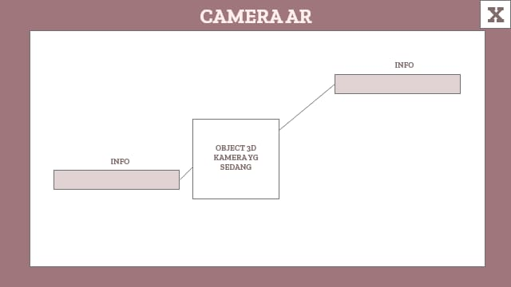
Figure 4. Interface Scan Marker
Quiz interface page.

Figure 5. Quiz Interface Display
Application Rpp interface page.

Figure 6. Interface Rpp Application
Application Guide interface page.
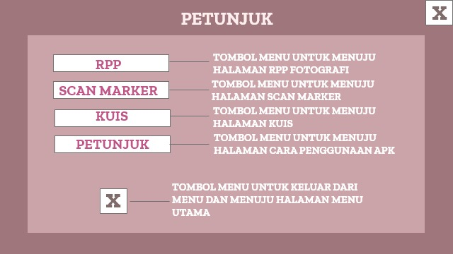
Figure 7. Application Instruction Interface Display
It is based on the verification results of augmented reality-based learning media by two validators. You can see that the results of the validator's evaluation, with an average share of 84.47% for both values, are classified as "very valid" based on the media validation category table.
The results of material validation of augmented reality-based learning media with two validators are known to receive a value that the average percentage of the values ​​of the two validators is 90.88% and the category is "very valid". increase. Category table for media verification. Based on the results of user tests by several students working on photography, the average rating, calculated as a percentage, scored 90.63%, which the media classified as "very effective" for its practicality. I understand this. .. Media category table used as learning media. Submitted application media and material ads show 90% in the category "Very effective", and in software ads, 92.33% in the category "Very effective" and in the category "Very effective" "Category". It is 92.33%. About profit index. Therefore, the results of student responses show that students are interested in using augmented reality-based learning media.
CONCLUSION
This research has succeeded in developing learning media based on augmented reality on the introduction of lenses and cameras for class XI students using the ADDIE model. In accordance with the ADDIE procedure, this development has carried out all the existing stages. Based on the assessment by media experts, material experts and questionnaires on small and large class student trials, it can be concluded that the learning media that the researchers have developed are in the very feasible category to use.
Buliali, Joko Lianto. 2021. “Andriyani , Joko Lianto Buliali PENGEMBANGAN MEDIA PEMBELAJARAN LINGKARAN MENGGUNAKAN AUGMENTED REALITY BERBASIS ANDROID BAGI SISWA TUNARUNGU DEVELOPMENT LEARNING MEDIA OF CIRCLE USING ANDROID-BASED Math Didactic : Jurnal Pendidikan Matematika Pengembanga.” 7(2): 170–85.

Cahyadi, Rahmat Arofah Hari. 2019. “Pengembangan Bahan Ajar Berbasis Addie Model.” Halaqa: Islamic Education Journal 3(1): 35–42.

Fadhilaturrahmi, Fadhilaturrahmi, Rizki Ananda, and Sisi Yolanda. 2021. “Persepsi Guru Sekolah Dasar Terhadap Pembelajaran Jarak Jauh Di Masa Pandemi Covid 19.” Jurnal Basicedu 5(3): 1683–88.

Haida Dafitri, Arief Budiman, and Fakhrana Nadhila. 2020. “Peranan Teknologi Augmented Reality Sebagai Media Pembelajaran.” Jurnal Sistem Informasi 04(02): 1–10.

Hakim, Lukman. 2018. “Pengembangan Media Pembelajaran Pai Berbasis Augmented Reality.” Lentera Pendidikan : Jurnal Ilmu Tarbiyah dan Keguruan 21(1): 59–72.

Krishna Pillai, Salini et al. 2021. “Kemudahan Penggunaan Augmented Reality Sebagai Alat Bantu Pembelajaran Online Bagi Meningkatkan Kinerja Dan Prestasi Siswa Dalam Seni Ukiran Kayu.” Journal of Engineering, Technology, and Applied Science 3(2): 48–57.

Kurniawan, Nanang. 2017. “Pengembangan Augmented Reality Sebagai Media Pembelajaran Pengenalan Komponen Pneumatik Di Smk.” Jurnal Pendidikan Teknologi dan Kejuruan 14(2): 136–44.

Mandasari, Yayuk Dian, M Subandowo, and Wawan Gunawan. 2021. “Pengembangan Media Pembelajaran Interaktif Konfigurasi Elektron Elektronik Otomatis Mata Pelajaran IPA Di Masa Pandemi Covid-19.” JKTP: Jurnal Kajian Teknologi Pendidikan 4(3): 309–18.

Nistrina, Khilda. 2021. “Penerapan Augmented Reality Dalam Media Pembelajaran.” Jurnal Sistem Informasi, J-SIKA 03(01).

Nugraha, Ariadie Chandra et al. 2021. “Rancang Bangun Media Pembelajaran Berbasis Augmented Reality Untuk Pembelajaran Tematik Kelas 5 Sekolah Dasar.” 05(2): 138–47.
Pakpahan, Roida, and Yuni Fitriani. 2020. “Analisa Pemafaatan Teknologi Informasi Dalam Pemeblajaran Jarak Jauh Di Tengah Pandemi Virus Corona Covid-19.” JISAMAR (Journal of Information System, Applied, Management, Accounting and Researh) 4(2): 30–36.

Ramadhan, Aditya Fajar, Ade Dwi Putra, and Ade Surahman. 2021. “Aplikasi Pengenalan Perangkat Keras Komputer Berbasis Android Menggunakan Augmented Reality (Ar).” Jurnal Teknologi dan Sistem Informasi 2(2): 24–31.

Sari, Widya, Andi Muhammad Rifki, and Mila Karmila. 2020. “Pembelajaran Jarak Jauh Pada Masa Darurat Covid 19.” Jurnal MAPPESONA (1): 12.

Wafa, A K A, and Syariful Fahmi. 2020. “Pengembangan Media Pembelajaran Berbasis Android Pada Materi Bangun Ruang Sisi Datar.” UrbanGreen Conference Proceeding Library2(2):50–57. https://urbangreen.co.id/proceeding/index.php/library/article/view/3.

Wibowo, R Ichsan Andi, and Luthpi Saepuloh. 2020. “PENGEMBANGAN MEDIA PEMBELAJARAN AUGMENTED REALITY PADA SIMULASI KOMUNIKASI DIGITAL DI SMK MUHAMMADIYA 1 SUKABUMI Pendidikan Tidak Dapat Dipisahkan Dari Kehidupan Manusia , Karena Selama Mendewasakan Upaya Pengajaran Dan Pelatihan ”. Menurut U.” Jurnal Utile VI: 160–67.

