Implementation of Predict Observe Explain Learning Model in Improving Critical Thinking Ability and Student Learning Outcomes

Rina Gustina¹, Intan Dwi Hastuti^{2*}, Muhammad Nizaar³, Syaharuddin⁴
^{1,2,3} Elementary School Teacher Education, Universitas Muhammadiyah Mataram, NTB
⁴ Mathematics Education, Universitas Muhammadiyah Mataram, NTB
*Corresponding Author e-mail: intandwihastuti23@gmail.com
Abstract: The effect of the application of the POE learning model has not been studied for its level of influence in improving students' critical thinking skills and learning outcomes, which includes its overall influence at each level of education and material field. So this study aims to examine the level of influence, using the meta-analysis method (quantitative) on the journal indexer database for the last 10 years. And from the results of the JASP calculation, it was found that the level of influence of the application of the POE learning model on critical thinking and student learning outcomes was 60% with a moderate category. Then based on the level of education, the influence of the POE learning model is very large at the high school level with an I2 value of 94.227. Then the POE model is very influential in the field of mathematics by 67% with a moderate category. Meanwhile, from the results of the moderator variable test, the influence of the POE model is very low in 2018-2022 at 47% (Low). This is most likely due to the covid-19 virus in 2020. | Article History  Received: 2  Revised:  Published:.. 2017  Key Words :  Predict Observe Explain, critical thinking skills, learning outcome, Mathematics, Natural sciences
How to Cite: First author., Second author., Third author, etc.. (20xx). The title. Jurnal Kependidikan: Jurnal Hasil Penelitian dan Kajian Kepustakaan di Bidang Pendidikan, Pengajaran dan Pembelajaran, vol(no). doi:https://doi.org/10.33394/jk.vxxyyi
 https://doi.org/10.33394/jk.vxxyyi | This is an open-access article under the CC-BY-SA License.


Introduction
The learning model is a pattern that has been carefully planned and guides the implementation of learning starting from the opening, core, and closing activities as well as learning assessments that are arranged in such a way as to achieve learning objectives (Salsabila et al., 2022). The learning model describes the broadest level of learning practice and contains a learning philosophy orientation, which is used to select and arrange teaching strategies, methods, skills, and learning activities to emphasize one part of learning (Nasrun et al., 2018). So it can be said that the learning model is very important to be applied during the learning process to achieve effectiveness and success in the learning process.
When the learning process is carried out, it is still found that many teachers or educators have not properly placed the learning model based on the conditions that occur. As a result, it causes problems that affect students' critical thinking skills and the achievement of learning objectives, this is because the learning activities carried out are still teacher-centered so that students tend to be passive (Ratnawati et al., 2020), (Dari & Ahmad, 2020). Critical thinking that students want is a way of thinking where the student can draw rational conclusions about something that is considered the truth (Lusiana & Tuti Zubaidah, 2020), as well as critical thinking skills that use a decision-making technique to solve problems for reasoned and reflective thinking (Amaliyah & Nasrudin, 2019). In the sense that students not only look for answers, but more than that such as asking questions about answers, facts, or existing information (Delita et al., 2022). To achieve this critical thinking ability, in general, there are 5 indicators of critical thinking skills that must be considered by the teacher, namely: (1) providing simple explanations (elementary clarification); (2) building basic skills (basic support); (3) making inferences (inferring); (4) making further explanations (advanced clarification); (5) organizing strategies and tactics (Islamiyah et al., 2019).
Based on these indicators, a teacher must be able to invite students to predict a phenomenon, make observations with demonstrations, and be able to explain the results of their previous demonstrations and predictions so that the teacher can make students' thinking power sharper. Therefore, a teacher must apply an effective learning model such as the predict, explain, observe (POE) learning model which can be used as an alternative so that students can understand the learning delivered by the teacher and students can think critically.
The POE learning model was first developed by White and Gunstone (Rini et al., 2018), (Larasati et al., 2018) which aims to reveal students' ability to make predictions (Nur Hayati et al., n.d.), (Ikhfa et al., 2020). The POE model comes from the words Predict, Observe, and Explain (Khilyatin Ula et al., 2022), (Putra Erawan et al., 2022). POE is a learning model that involves students directly in the learning process by conducting experiments so that the knowledge gained becomes more meaningful (Ulya Ulpa et al., 2019), (Nurfadilah et al., 2022). The POE learning model is a learning model that adheres to the theory of constructivism (Amaliyah & Nasrudin, 2019), (Abdillah & Surya Anggara, 2021) and involves students to think critically in understanding the material to be learned (Ika Inayah et al., n.d.)(Lantik et al., n.d.).
The results of the above research state that using the predict, observe and explain learning model can improve students' critical thinking skills both at the elementary, junior high, and senior high school levels. Other research findings also say that the application of the POE learning model can improve students' critical thinking skills in science and mathematics material areas. It's just that in previous studies there has been no study of the effect of applying the POE learning model in improving students' critical thinking skills which includes the overall effect at each level of education and material field. So this research aims to examine the level of influence and this research also aims to draw a common understanding from previous research so that this research can be used as a reference by future researchers related to the implementation of the POE learning model in improving students' critical thinking skills.
Research Method
This research uses meta-analysis. Meta-analysis is a type of research conducted by researchers by summarizing research data, then reviewing and analyzing research data from several previous research results (Hardina Aldira, siti et al., 2021), (Wahyuni et al., 2022). The data is collected by searching for articles in international and national journals online through the database on Google Scholar. The keywords used in searching such as: (1) The dependent variable is "POE learning model", (2) The independent variable used is "Critical thinking", “learning outcome”. The steps are taken in this study according to the opinion (Wahyuni et al., 2022) in Figure 1 below:
Searching Journal and Repository Database: Google Scholar (Inclusion and exclusion), (last ten year data).

Data Encoding & Tabulation: Name, year of publication, level of education, subject area, r, F, t or classical value.

JASP Software Inputs: effect size (ES), standard error (SE), publication bias.

Data Analysis : JASP Sofware.

Interpretation & Conclusion: JASP output, moderator variable.

Figure 1. Research Flow Diagram
Data Collection
First, researchers collected data from the "Google Scholar" indexer database based on inclusion and exclusion criteria. The inclusion criteria included (1) search keywords, namely "POE learning model" and "Critical thinking", “Learning outcome”; (2) articles published in 2013-2022; and (3) articles using Indonesian or English. While the exclusion criteria include (1) there is the amount of data (N); (2) education level; (3) material field; (4) there is a correlation coefficient value (r), fisher value (F), t-test value (t) and classical value (k).
Data Tabulation
The second stage, analyzing data in the form of (1) labeling or numbering articles related to the topic (2) writing the name of the researcher, the level of education, and the field of education, (3) writing the correlation test value (r), writing the proportional test value (class), and the number of research subjects (N), (4) calculating the effect size (ES) and standard error (SE), (5) conducting data analysis using JASP software (6) analyzing the results found from the articles that become data references (7) writing moderator variables, (8) drawing conclusions and suggestions.
Data Analysis
The third stage, calculating the effect size (ES) and standard error (SE) values using the formula from (Mansurah et al., 2021) as follows:
- Correlation research results (r), fisher (F), and t-test (t)
F = (1)
t = (2)

r = 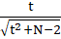 (3)

p = ES = 0,5 x ln (4)

SE = 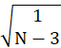 (5)

- Classical Research Results (k)
p = ES = (6)

SE = 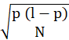 (7)
Drawing Conclusions
In the fifth stage, the criteria for concluding according to the category of influence level is determined by the Effect Size (ES) and Standard Error (SE) values. ES value categories according to Table 1 below:
Table 1. Criteria Effect size (Cohen’s, 1988)
Effect Size (ES) | Category
0.00 ≤ ES < 0.20 | Very low
0.20 ≤ ES < 0.50 | Low
0.50 ≤ ES < 0.80 | Medium
0.80 ≤ ES < 1.30 | High
1.30 ≤ ES | Very High
The last stage, drawing conclusions from the JASP output results and testing moderator variables to see the level of influence of several other variables such as year of publication, and a number of participan sciencents.
Result and Discussion
The search results from the indexer database obtained data as many as 110 publication data based on the last 10 years of research (2013-2022). From this data, complete and incomplete data were obtained. Complete data consists of 70 data and incomplete data consists of 40 data, with 28 data not having the number of participant (N), and 12 data not having test values (t, F, r, or k). From the 70 complete data, the results of the calculation of ES and SE values are as follows.
Table 2. Calculation of ES and SE values
Name | Variable | Level | Field | ES | SE | Category
Study 1 | Critical Thinking | Junior High School | Mathematics | 0,79 | 0,17 | Medium
Study 2 | Critical Thinking | Junior High School | Natural Science | 0,33 | 0,17 | Law
Study 3 | Critical Thinking | Senior High School | Natural Science | 0,13 | 0,18 | Law
Study 4 | Critical Thinking | Senior High School | Natural Science | 0,66 | 0,17 | Medium
Study 5 | Critical Thinking | Junior High School | Mathematics | 1,15 | 0,21 | High
Study 6 | Critical Thinking | Junior High School | Natural Science | 0,24 | 0,13 | Law
Study 7 | Critical Thinking | Senior High School | Natural Science | 0,53 | 0,1 | Medium
Study 8 | Critical Thinking | Senior High School | Natural Science | 0,19 | 0,22 | Law
Study 9 | Critical Thinking | Elementary School | Thematic | 0,5 | 0,13 | Medium
Study 10 | Critical Thinking | Elementary School | Mathematics | 0,44 | 0,13 | Law
Study 11 | Critical Thinking | Elementary School | Mathematics | 0,23 | 0,21 | Law
Study 12 | Critical Thinking | Senior High School | Natural Science | 0,41 | 0,12 | Law
Study 13 | Critical Thinking | Elementary School | Mathematics | 0,85 | 0,2 | High
Study 14 | Critical Thinking | Elementary School | Natural Science | 0,5 | 0,12 | Medium
Study 15 | Critical Thinking | Junior High School | Natural Science | 0,71 | 0,23 | Medium
Study 16 | Critical Thinking | Elementary School | Thematic | 0,56 | 0,13 | Medium
Study 17 | Critical Thinking | Senior High School | Natural Science | 0,39 | 0,12 | Law
Study 18 | Critical Thinking | Senior High School | Natural Science | 0,23 | 0,28 | Law
Study 19 | Critical Thinking | Elementary School | Natural Science | 0,48 | 0,16 | Law
Study 20 | Critical Thinking | Senior High School | Natural Science | 0,66 | 0,13 | Medium
Study 21 | Critical Thinking | Senior High School | Natural Science | 0,37 | 0,13 | Law
Study 22 | Critical Thinking | Junior High School | Natural Science | 0,14 | 0,12 | Very Law
Study 23 | Critical Thinking | Elementary School | Natural Science | 0,41 | 0,15 | Law
Study 24 | Critical Thinking | Senior High School | Natural Science | 0,98 | 0,22 | High
Study 25 | Critical Thinking | Senior High School | Mathematics | 0,15 | 0,18 | Very Law
Study 26 | Critical Thinking | Elementary School | Mathematics | 0,82 | 0,21 | High
Study 27 | Critical Thinking | Elementary School | Mathematics | 0,63 | 0,16 | High
Study 28 | Critical Thinking | Junior High School | Mathematics | 1,15 | 0,21 | High
Study 29 | Critical Thinking | Elementary School | Natural Science | 0,27 | 0,07 | Law
Study 30 | Critical Thinking | Junior High School | Natural Science | 0,54 | 0,17 | Medium
Study 31 | Critical Thinking | Senior High School | Natural Science | 0,9 | 0,13 | High
Study 32 | Critical Thinking | Senior High School | Natural Science | 0,33 | 0,13 | Law
Study 33 | Critical Thinking | Junior High School | Natural Science | 0,64 | 0,12 | Medium
Study 34 | Learning Outcome | Elementary School | Mathematics | 0,98 | 0,2 | High
Study 35 | Learning Outcome | Junior High School | Natural Science | 1,31 | 0,33 | Very High
Study 36 | Learning Outcome | Senior High School | Natural Science | 0,33 | 0,18 | Law
Study 37 | Learning Outcome | Senior High School | Mathematics | 0,31 | 0,2 | Law
Study 38 | Learning Outcome | Elementary School | Natural Science | 0,13 | 0,24 | Very Law
Study 39 | Learning Outcome | Senior High School | Natural Science | 0,36 | 0,14 | Law
Study 40 | Learning Outcome | Elementary School | Mathematics | 0,26 | 0,2 | Law
Study 41 | Learning Outcome | Junior High School | Natural Science | 0,33 | 0,2 | Law
Study 42 | Learning Outcome | Senior High School | Natural Science | 2,26 | 0,13 | Very High
Study 43 | Learning Outcome | Junior High School | Natural Science | 0,88 | 0,14 | High
Study 44 | Learning Outcome | Junior High School | Natural Science | 0,38 | 0,12 | Law
Study 45 | Learning Outcome | Senior High School | Natural Science | 0,5 | 0,13 | Medium
Study 46 | Learning Outcome | Senior High School | Natural Science | 0,59 | 0,18 | Medium
Study 47 | Learning Outcome | Senior High School | Natural Science | 0,14 | 0,37 | Very Law
Study 48 | Learning Outcome | Senior High School | Natural Science | 1,64 | 0,13 | Very High
Study 49 | Learning Outcome | Junior High School | Natural Science | 0,84 | 0,16 | High
Study 50 | Learning Outcome | Senior High School | Natural Science | 0,82 | 0,19 | High
Study 51 | Learning Outcome | Elementary School | Natural Science | 0,72 | 0,21 | High
Study 52 | Learning Outcome | Junior High School | Natural Science | 0,87 | 0,19 | High
Study 53 | Learning Outcome | Junior High School | Natural Science | 0,48 | 0,12 | Law
Study 54 | Learning Outcome | Senior High School | Natural Science | 1,59 | 0,15 | Very High
Study 55 | Learning Outcome | Elementary School | Natural Science | 0,93 | 0,33 | High
Study 56 | Learning Outcome | Senior High School | Natural Science | 0,32 | 0,16 | Law
Study 57 | Hasil belajar | Senior High School | Natural Science | 0,91 | 0,13 | High
Study 58 | Hasil belajar | Senior High School | Natural Science | 0,24 | 0,11 | Law
Study 59 | Hasil belajar | Senior High School | Natural Science | 0,33 | 0,13 | Law
Study 60 | Hasil belajar | Elementary School | Natural Science | 0,49 | 0,13 | Law
Study 61 | Learning Outcome | Senior High School | Natural Science | 0,12 | 0,17 | Very Law
Study 62 | Learning Outcome | Senior High School | Natural Science | 0,25 | 0,11 | Law
Study 63 | Learning Outcome | Senior High School | Natural Science | 0,26 | 0,13 | Law
Study 64 | Learning Outcome | Junior High School | Natural Science | 0,15 | 0,16 | Very Law
Study 65 | Learning Outcome | Elementary School | Natural Science | 0,53 | 0,2 | Medium
Study 66 | Learning Outcome | Senior High School | Natural Science | 0,29 | 0,14 | Law
Study 67 | Learning Outcome | Elementary School | Natural Science | 0,68 | 0,07 | Medium
Study 68 | Learning Outcome | Senior High School | Natural Science | 0,33 | 0,13 | Law
Study 69 | Learning Outcome | Senior High School | Natural Science | 2,51 | 0,12 | Very High
Study 70 | Learning Outcome | Senior High School | Natural Science | 0,36 | 0,16 | Law
RE MODEL |  |  |  | 0.60 (0.49, 0.70)
Table 2. The results showed that the application of the POE learning model in the teaching and learning process had a considerable influence on students' critical thinking skills and learning outcomes with the acquisition of a RE value of 60% in the moderate category. Furthermore, the researcher will calculate the effect by using the hypothesis test and publication bias test on the data that has been obtained as follows.
Table 3. Hypothesis test
Coefficients
 |  | Estimate |  |  | Standard Error |  | z |  | p
intercept |  |  | 0.595 |  | 0.056 |  | 10.700 |  |  | < .001
Note. Wald test.
Table 3. above, it can be seen that there is no publication bias as indicated by the p-value <001. The value of the funnel plot model according to the following Figure 2 :

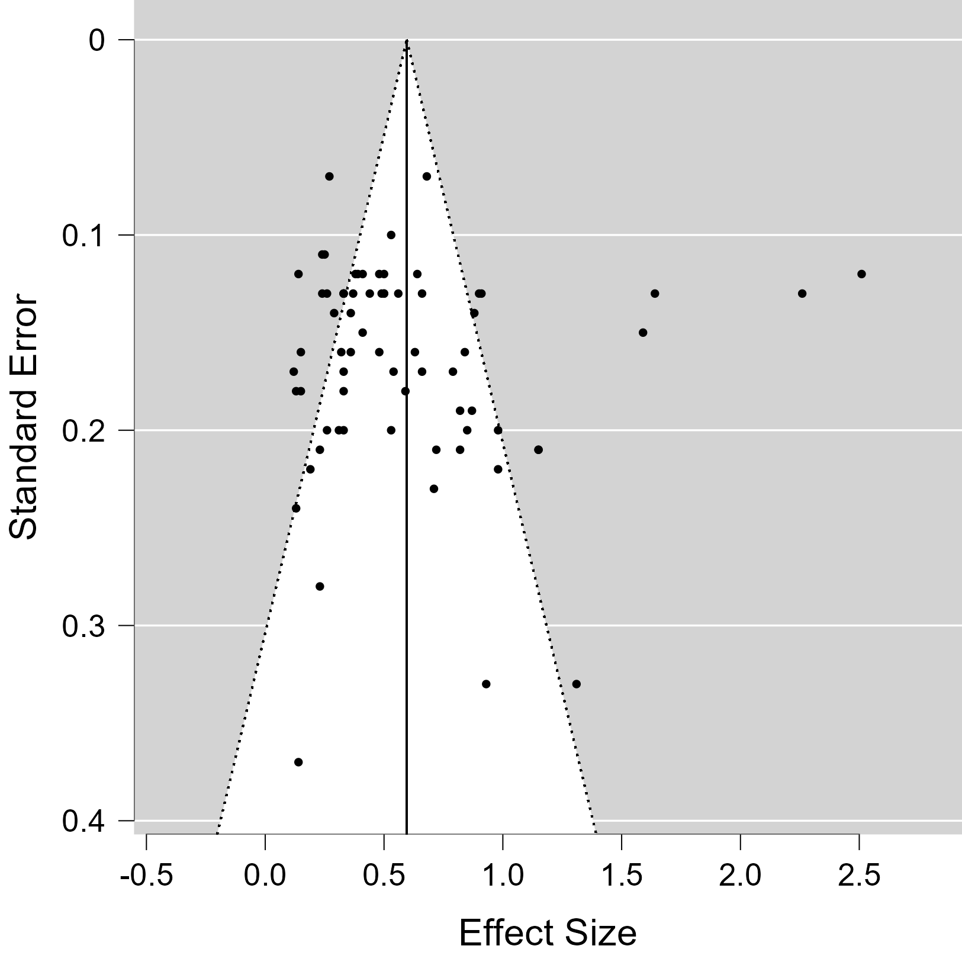

Figure 2. Funnel Plot Standard Error

From Figure 2. It can be seen that the shape of the funnel plot is symmetrical, which means that there is no publication bias and the points are above the curve, which means that the ES estimate is accurate, then the overall picture above shows that the points are around the curve, it can be concluded that there is no missing research data.
Table 4. Effect of POE Learning Model based on Variables
Indikator | N | Q- Heterogen | I² (%) | P - Value | RE
Critical Thinking | 34 | 88.364 | 65.083 | <.001 | 0.51(0.42,0.60)
Learning Outcome | 18 | 621.712 | 93.414 | <.001 | 0.66 (0.48, 0.85)
Table 4. shows the effect of the application of the POE learning model has a greater effect on student Learning Outcomes than the Critical Thinking ability of students. This can be seen from the RE value of the effect of the POE learning model on Learning Outcome of 66% versus 1% greater than its effect on student Critical Thinking of 51%.

Effect of POE Learning Model on Students' Critical Thinking Ability based on Education Level
Table 2. The effect of applying the POE model on students' critical thinking based on their education level is obtained as follows:
Table 5. Data by education level
Level | N | Q- Heterogeneous | I²(%) | p-Rank Test | P - Value
Elementary School | 19 | 38.236 | 46.359 | 0.723 | <.001
Junior High School | 17 | 65.173 | 77.205 | 0.033 | <.001
Senior High School | 49 | 628.695 | 94.227 | 0.727 | <.001
Table 5. shows that the effect of POE learning model on Critical Thinking and Learning Outcome of students based on the level obtained a very large effect at the senior high school level and a very small effect at the elementary school level.
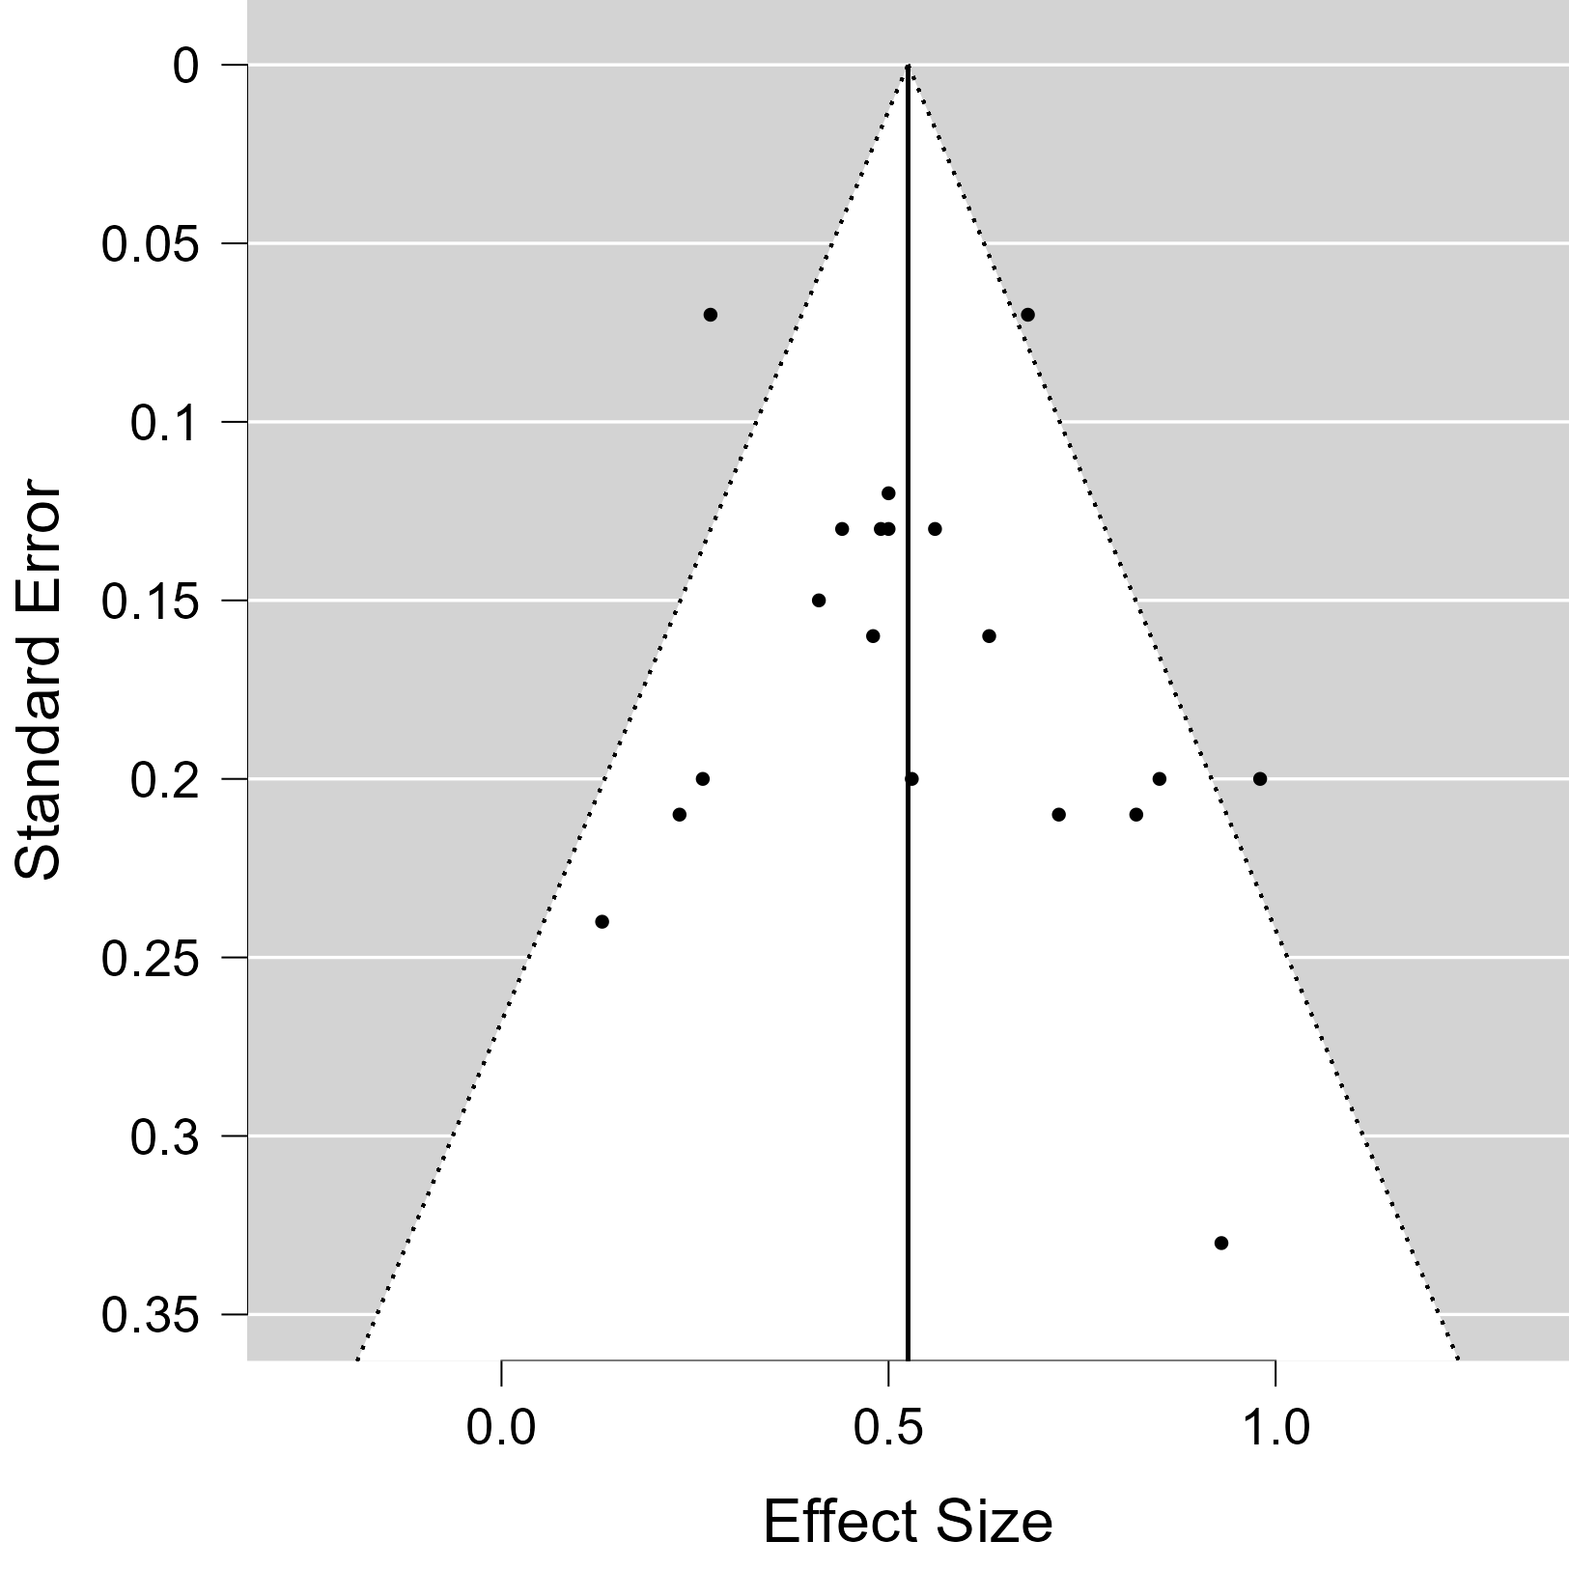
Figure 3. Funnel plot of elementary school level data
From Figure 3. It can be seen that the shape of the funnel plot is symmetrical, which means that there is no publication bias and the points are above the curve, which means that the ES estimate is accurate, then the overall picture above shows that the points are around the curve, it can be concluded that there is no missing research data.
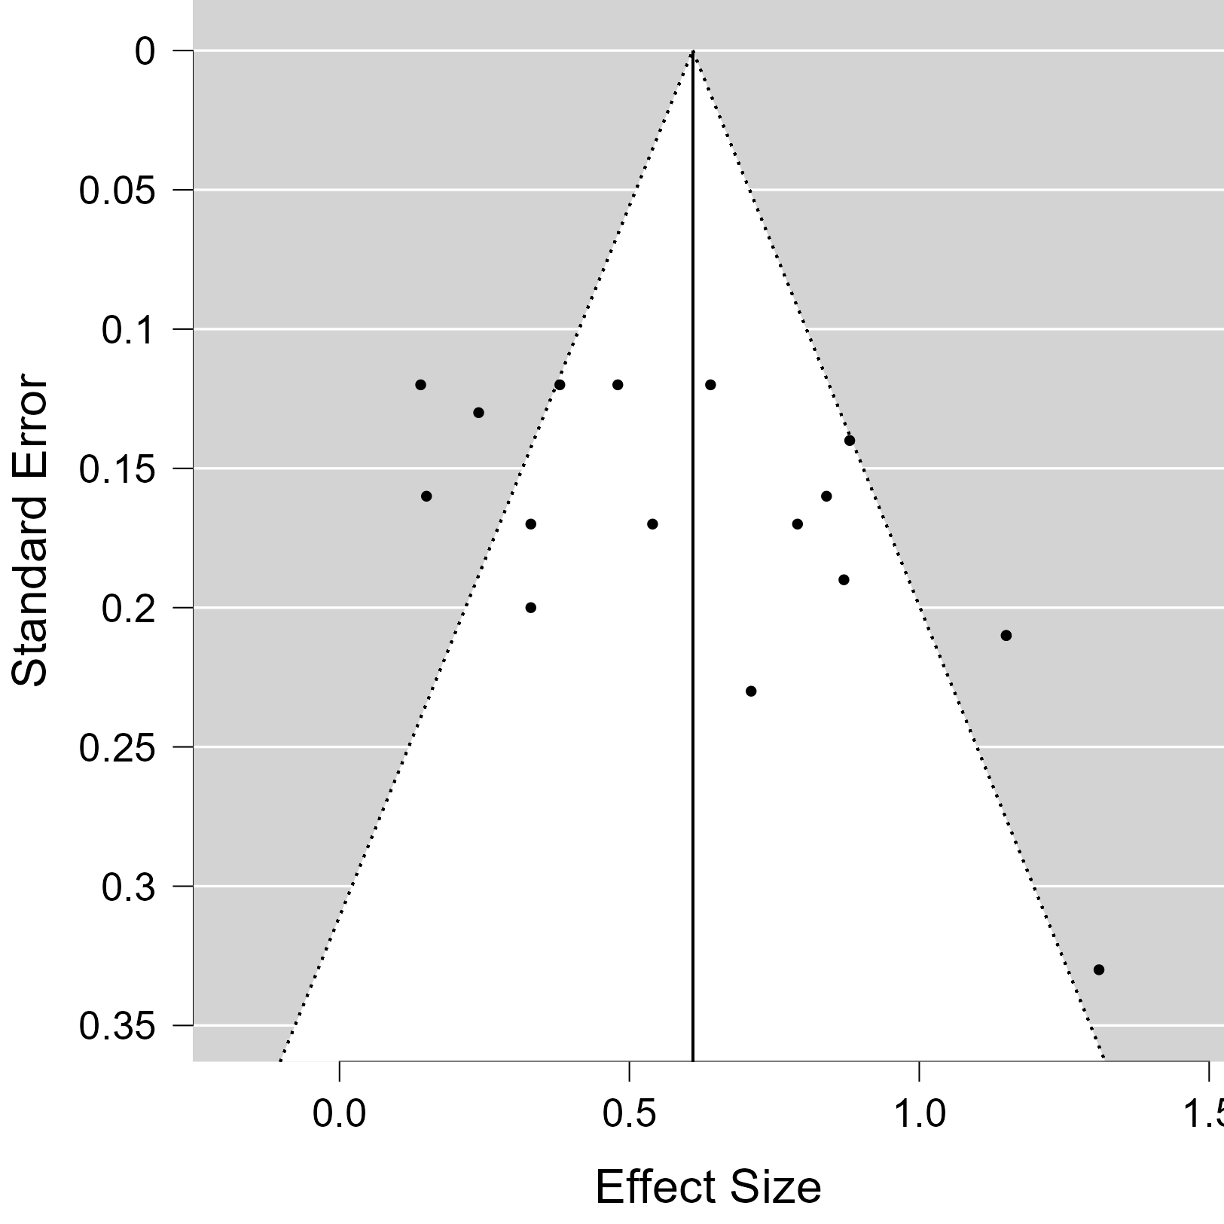
Figure 4. Funnel plot of junior high school data

From Figure 4. It can be seen that the shape of the funnel plot is symmetrical, which means that there is no publication bias and the points are above the curve, which means that the ES estimate is accurate, then the overall picture above shows that the points are around the curve, it can be concluded that there is no missing research data.
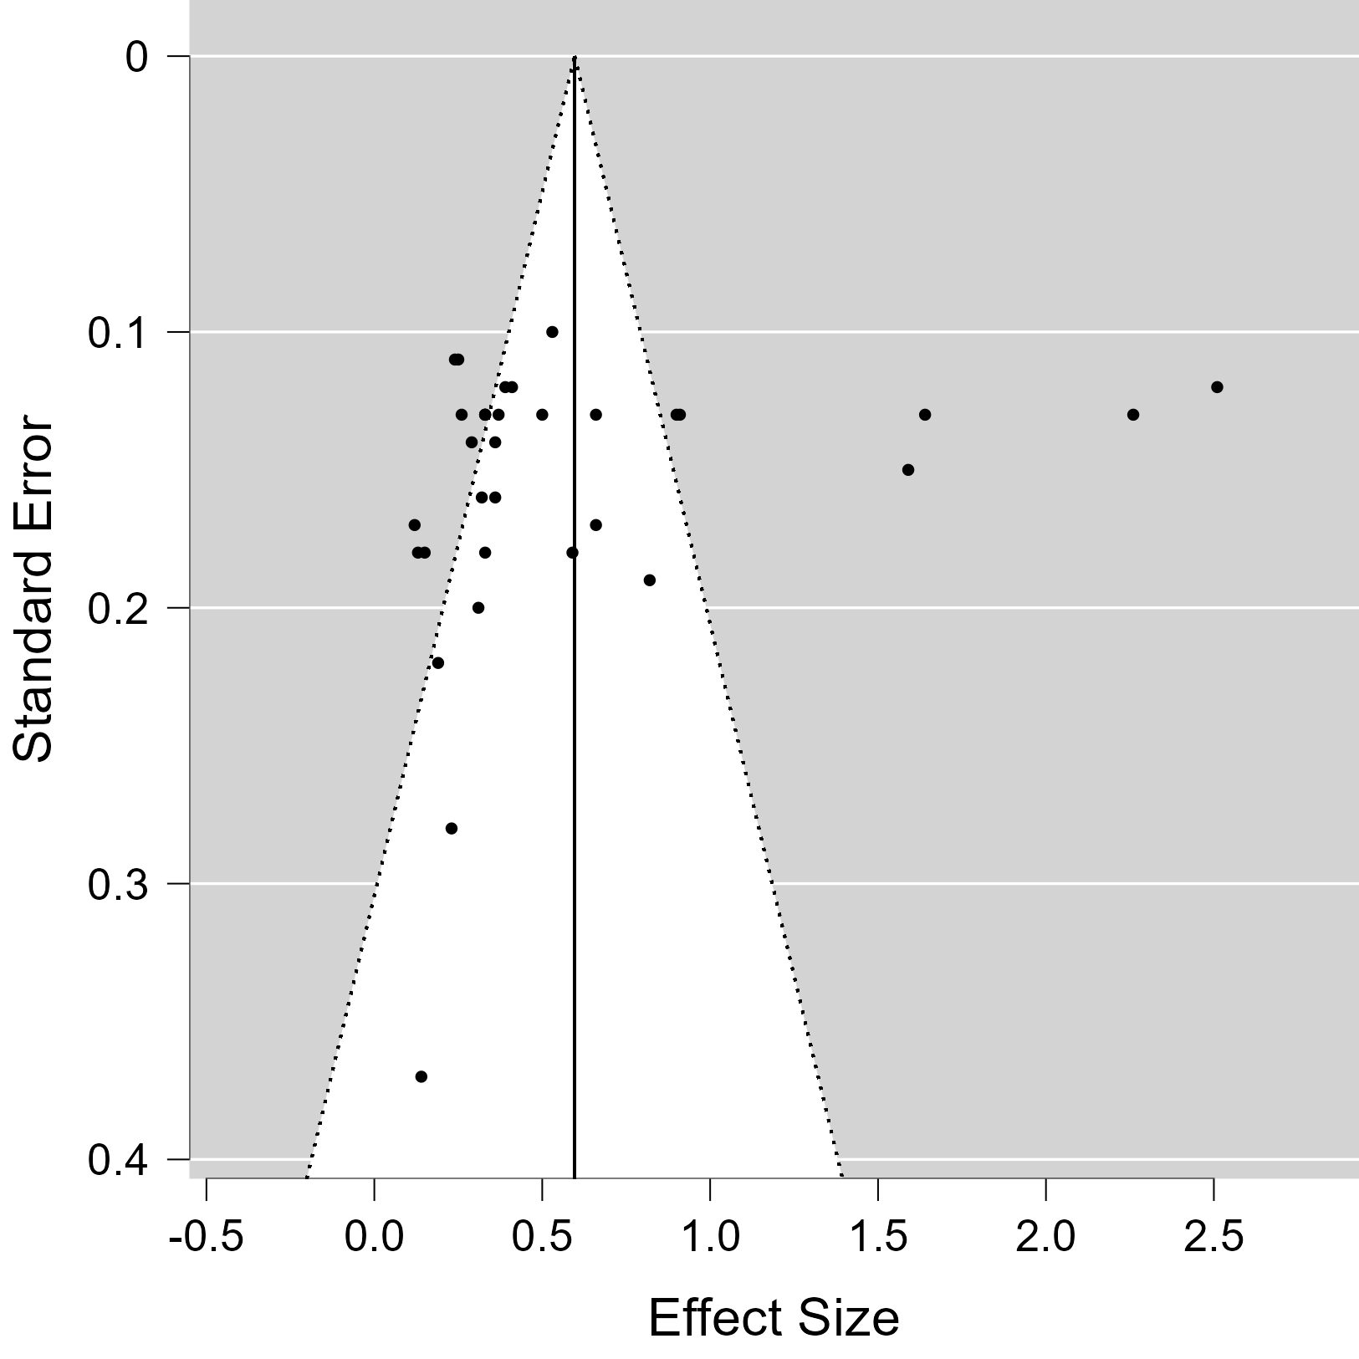
Figure 5. Funnel plot of senior high school data

From Figure 5. It can be seen that the shape of the funnel plot is symmetrical, which means that there is no publication bias and the points are above the curve, which means that the ES estimate is accurate, then the overall picture above shows that the points are around the curve, it can be concluded that there is no missing research data.

The Effect of the POE Learning Model on Students' Critical Thinking Skills based on Material Areas
Table 2. The effect of applying the POE model on students' critical thinking and learning outcome based on the material field is obtained as follows:
Table 7. Data by material field
Field | N | Kendall,s | I²(%) | P - Value | RE
Natural science | 74 | 0.033 | 93.606 | 0.475 | 0.53 (0.42, 0.63)
Math | 8 | 0.074 | 91.697 | 0.690 | 0.67 (0.40, 0.94)
Table 7. shows that the effect of POE learning model on Critical Thinking and Learning Outcome of students is greater in the field of mathematics material with RE value of 67%.
Based on Moderator Variable
Moderator variable analysis is needed to see the classification, year of publication, and amount of data. The results of data analysis using JASP are shown in Table 8 below.
Table 8. Variable Moderator
Variable | Distribution | Estimate | p-Rank Test | RE | Category
Data | < 50  > 50 | 0.572  0.519 | 0.387  0.286 | 0.57 (0.47, 0.68)  0.53 (0.36, 0.68) | Medium  Medium
Year | 2013 - 2017  2018 - 2022 | 0.688  0.469 | 0.290  0.552 | 0.69 (0.49, 0.88)  0.47 (0.37, 0.56) | Medium  Low
Table 8. shows a very drastic decrease in the effect of the POE model on Critical Thinking and Learning Outcome of students, namely in 2018-2022 with a RE value of 47% smaller than the previous year.
Conclusion
The results of the above research show that the application of the POE learning model has a greater effect on student Learning Outcome than student Critical Thinking with an effect of 66%. Then based on the level of education, the influence of the POE model on Critical Thinking and student Learning Outcome is greater at the senior high school level and based on the material field, the POE model has a greater influence on the mathematics material field. Then the moderator variable shows a very drastic decrease in the effect of the POE model on Critical Thinking and Learning Outcome of students in 2018-2022 with a RE value of 47% smaller than the previous year. This could be due to the emergence of covid-19 in 2020 where teaching and learning activities are carried out online so that the POE model is not applied optimally.

Recommendation
The suggestions presented from the results of this study should be able to make the POE learning model a learning model that can foster critical thinking skills and improve student learning outcomes. Then the teachers should be able to use this POE learning model in the learning process to be able to improve the quality of learning and improve the student learning process. POE learning needs to be applied in schools, this is because the steps in the POE learning model are suitable for training students' critical thinking skills and students learn actively in acquiring knowledge. For further research will conduct research in this field, it is hoped that this research can be an illustration, information, and input about the use of the POE learning model in further learning to include more articles and thesis results. This aims to make the data obtained more, broader and can be seen more deeply in the results of the research.
Acknowledgment
We would like to thank the supervisors of the Research Class Program of the Faculty of Teacher Training and Education, Universitas Muhammadiyah Mataram for their support during the research process.

References

