Uji Normalitas gambar

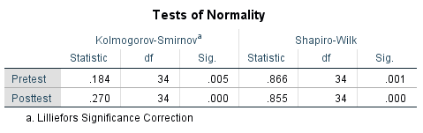

Tabel Jelas :

|  |  |  |  |  |  |  |
| --- | --- | --- | --- | --- | --- | --- |
| **Tests of Normality** | | | | | | |
|  | Kolmogorov-Smirnovaa | | | Shapiro-Wilk | | |
| Statistic | df | Sig. | Statistic | df | Sig. |
| Pretest | .184 | 34 | .005 | .866 | 34 | .001 |
| Posttest | .270 | 34 | .000 | .855 | 34 | .000 |

a Lilliefors Significance Correction

Wilcoxon gambar

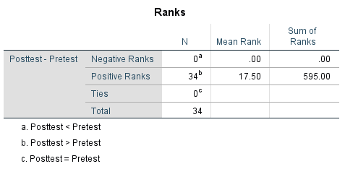

Tabel Jelas : **Ranks**

|  |  |  |  |  |  |
| --- | --- | --- | --- | --- | --- |
|  |  | | N | Mean Rank | Sum of Ranks |
| Posttest-Pretest | | Negative Ranks | 0a | .00 | .00 |
| Positive Ranks | 34b | 17.50 | 595.00 |
| Ties | 0c |  |  |
| Total | 34 |  |  |

a. Posttest < Pretest

b. Posttest > Pretest

c. Posttest = Pretest

Wilcoxon

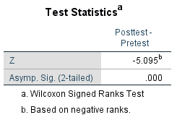

**Tabel** Hasil N-Gain Pretest dan Posttest

| **No.** | **Peserta Didik** | **Nilai *pretest*** | **Nilai *Posttest*** | **N-Gain** | **Kategori** |
| --- | --- | --- | --- | --- | --- |
| 1. | PD 1 | 33 | 86 | 0,79 | Tinggi |
| 2. | PD 2 | 26 | 86 | 0,81 | Tinggi |
| 3. | PD 3 | 33 | 80 | 0,70 | Tinggi |
| 4. | PD 4 | 46 | 100 | 1 | Tinggi |
| 5. | PD 5 | 46 | 86 | 0,74 | Tinggi |
| 6. | PD 6 | 20 | 80 | 0,75 | Tinggi |
| 7. | PD 7 | 20 | 86 | 0,82 | Tinggi |
| 8. | PD 8 | 26 | 93 | 0,90 | Tinggi |
| 9. | PD 9 | 46 | 93 | 0,87 | Tinggi |
| 10. | PD 10 | 26 | 86 | 0,81 | Tinggi |
| 11. | PD 11 | 40 | 80 | 0,66 | Sedang |
| 12. | PD 12 | 46 | 100 | 1 | Tinggi |
| 13. | PD 13 | 26 | 93 | 0,90 | Tinggi |
| 14. | PD 14 | 46 | 93 | 0,87 | Tinggi |
| 15. | PD 15 | 0 | 86 | 0,86 | Tinggi |
| 16. | PD 16 | 33 | 86 | 0,79 | Tinggi |
| 17. | PD 17 | 26 | 86 | 0,81 | Tinggi |
| 18. | PD 18 | 20 | 100 | 1 | Tinggi |
| 19. | PD 19 | 0 | 80 | 0,80 | Tinggi |
| 20. | PD 20 | 20 | 86 | 0,82 | Tinggi |
| 21. | PD 21 | 26 | 80 | 0,72 | Tinggi |
| 22. | PD 22 | 46 | 93 | 0,87 | Tinggi |
| 23. | PD 23 | 33 | 86 | 0,79 | Tinggi |
| 24. | PD 24 | 46 | 80 | 0,62 | Sedang |
| 25. | PD 25 | 33 | 80 | 0,70 | Tinggi |
| 26. | PD 26 | 46 | 100 | 1 | Tinggi |
| 27. | PD 27 | 46 | 93 | 0,87 | Tinggi |
| 28. | PD 28 | 0 | 86 | 0,86 | Tinggi |
| 29. | PD 29 | 20 | 86 | 0,82 | Tinggi |
| 30. | PD 30 | 33 | 86 | 0,79 | Tinggi |
| 31. | PD 31 | 46 | 100 | 1 | Tinggi |
| 32. | PD 32 | 33 | 86 | 0,79 | Tinggi |
| 33. | PD 33 | 46 | 80 | 0,62 | Sedang |
| 34. | PD 34 | 20 | 93 | 0,91 | Tinggi |