Virtual Reality Media for Introducing Gender Wayang Instruments Based on Tri Hita Karana

**Gde Indra Ananta Wijaya, I Nyoman Sukajaya, Dewa Gede Hendra Divayana**

Computer Science Pascasarjana Program, Ganesha University of Education, Buleleng, Indonesia

**\*Corresponding Author e-mail: gde.indra@undiksha.ac.id**

|  |  |
| --- | --- |
| **Abstract:** This research aims to develop a virtual reality gender wayang application that can increase students understanding and appreciation of Balinese culture, especially gender wayang. This research focuses on the challenges of preserving traditional Balinese art in the digital era, where virtual reality technology is used as a tool to create a more interactive and fun learning experience. The method used in this research is the ADDIE model. The results showed that the developed virtual reality gender wayang application obtained a very high level of validity, with an average Aiken's V of 0.900 from experts. The results of a questionnaire filled out by 20 students showed an average score of 2.98 on the indicators of interest, loyalty, concern, and appreciation for local culture, indicating that this application is effective in fostering students' interest and concern for gender wayang and the preservation of Balinese culture. This research also shows that virtual reality can enrich students' learning experience with a more interactive and fun visual approach, and can strengthen students' connection to cultural heritage with the Tri hita karana philosophy. | **Article History**  Received: 2  Revised:  Published:.. 2017  **Key Words :**  Virtual Reality, Gender Wayang, Tri Hita Karana, Balinese Culture, ADDIE |

**How to Cite:** First author., Second author., &amp; Third author. (20xx). The title. Jurnal Paedagogy: Jurnal Penelitian dan Pengembangan Pendidikan, vol(no). doi:https://doi.org/10.33394/jp.vxxyyi

|  |  |
| --- | --- |
| C:\Users\IKIP\Pictures\1200px-DOI_logo.svg.png https://doi.org/10.33394/jp.vxxyyi | This is an open-access article under the [CC-BY-SA License.](http://creativecommons.org/licenses/by/4.0/) |

C:\Users\IKIP\Pictures\CC_BY-SA_3.0.png

**Introduction**

In the current digital era, it is very difficult to pass on traditional arts to the next generation, which shows how challenging it is to protect cultural heritage, especially in Bali. However, in Bali, the preservation of traditional arts such as music and dance, which are part of Bali's cultural identity, is increasingly threatened by global cultural influences. An interactive and fun learning experience becomes very important because traditional teaching methods often fail to engage the younger generation. Technology can facilitate the creation of an interactive and fun learning environment. One of the technologies that can be used is XR (extended reality) technology, which includes augmented reality, virtual reality, and mixed reality (Alnagrat et al., 2022). XR is a technology that connects the physical world with the virtual world. In this research, the technology used is virtual reality, which is a technology that creates a digital environment completely separate from the physical world, allowing users to interact and immerse themselves in the digital world (Lin et al., 2020). To use virtual reality technology, users need a virtual reality headset. This allows users to fully immerse themselves in the digital world. There are various types of virtual reality headsets, such as mobile virtual reality, tethered virtual reality, and standalone virtual reality. Mobile virtual reality uses a smartphone as a screen and computer, tethered virtual reality, on the other hand, requires a cable to connect to a computer or game console, and standalone virtual reality operates independently, without the need for additional devices like a phone, PC, or game console.

The use of virtual reality, especially in Bali, is a great way to make learning more interactive and enjoyable. The younger generation can directly interact with digital elements using virtual reality. This is an effective new way to integrate traditional Balinese values, making it easier for the younger generation to connect with Balinese culture. Gender wayang is one of the traditional Balinese cultures that is nearly extinct. Gender wayang is an important part of Balinese music and is one of the older types of gamelan (Hartini & Haryati, 2023). Gender wayang consists of four sets of gender instruments played in a single ensemble (Muflyhudin et al., 2022). The preservation of gender wayang faces many challenges, such as the limited number of studios that own gender wayang instruments, which has led to a decline in interest among the younger generation. Due to these issues, there is a need for virtual reality technology to help the younger generation learn about the form of gender wayang and how to play it. With virtual reality technology, users can directly interact with gender wayang and learn about its form and structure. By combining virtual reality technology with Balinese culture, specifically gender wayang, it provides an interactive and enjoyable way for users to learn about and appreciate the richness of local Balinese traditions.

Using virtual reality to learn about gender wayang, in line with the concept of Tri Hita Karana, is a new way to make people more interested in and understand Balinese culture, especially in terms of gender wayang. The Tri Hita Karana principle emphasizes the importance of maintaining a harmonious interaction between humans, nature, and the divine (Mayoni et al., 2023). In the context of VR, this interactive experience allows users to feel this harmony virtually, giving them a deeper understanding of the cultural relationship between Balinese gender wayang, nature, and spirituality. Along with cultural factors, the use of virtual reality has many benefits for teaching and learning. Virtual reality makes learning more interactive and enjoyable by engaging the younger generation more, encouraging them to actively participate in the learning process rather than just being observers. People can better understand the form of gender wayang when they interact with real-life visual experiences. Using virtual reality enhances the younger generation's ability to think critically, solve problems, and be creative (Hwang & Chang, 2022). People actively explore learning sources through virtual reality. Using virtual reality-based learning media can help people understand how culture and technology are interconnected, providing relevant and profound learning experiences. Creating virtual reality-based learning tools for gender wayang is not only a way to learn, but also to attract the younger generation to preserve the sustainability of gender wayang. This technology allows anyone to learn about gender wayang from various perspectives, including its form, function, and philosophical implications.

(Indrawan et al., 2025) research shows that the application of Tri Hita Karana in the educational environment can increase the concentration and interest of its users. This method may increasingly be used with Virtual Reality (VR) technology, making learning about Balinese culture, especially gender wayang, more interactive and enjoyable. With VR, learning is not only passive, but also encourages users to actively interact with the elements of Balinese culture they are studying. Virtual reality allows people to learn by interacting with things they can see and touch. Tri Hita Karana is a philosophy that teaches the importance of harmonious relationships between humans, nature, and supernatural elements. With VR, this experience can be realized by allowing users to interact with elements of Balinese culture that reflect these relationships, such as gender wayang instruments connected to nature and Balinese spirituality. This can easily be incorporated into VR applications, giving users the opportunity not only to understand but also to feel the essence of this idea in the context of Balinese culture. This VR experience is meant to make people more interested in Balinese culture. By using interactive features in the VR software, users can not only see gender wayang instruments but also try to play them, feel their musical flow, and understand the philosophy behind them. The VR software from this study will have many interactive features that will help users learn more about Balinese arts and culture, specifically gender wayang. This VR software will have several important features, such as allowing users to interact with gender wayang instruments and their mallets. This characteristic helps people better understand gender wayang, making exploration more enjoyable.

This software was developed using the ADDIE method (Analysis, Design, Development, Implementation, Evaluation), which allows for the structured and planned development of the application with a focus on user needs. This method ensures that each phase of the application development is monitored and improved based on user feedback, which is crucial for creating an effective application in teaching Balinese culture. The application is evaluated using a questionnaire method to determine the level of acceptance of the application when used. This questionnaire assesses various aspects of the application, including how effective the application is in helping users understand gender wayang, how interactive the application is, and to what extent the application creates an enjoyable and immersive learning experience. This application is designed to help people understand not only the physical form of gender in wayang but also the cultural background that accompanies it, such as the values of Tri Hita Karana that are important for every part of the art. This VR application is a way to teach people while preserving and sharing the rich Balinese culture with future generations who are more proficient with digital technology. With this application, users not only learn about gender wayang instruments but also gain an interactive experience that reflects the values of harmony between humans, nature, and spirituality contained in Tri Hita Karana.

**Research Method**

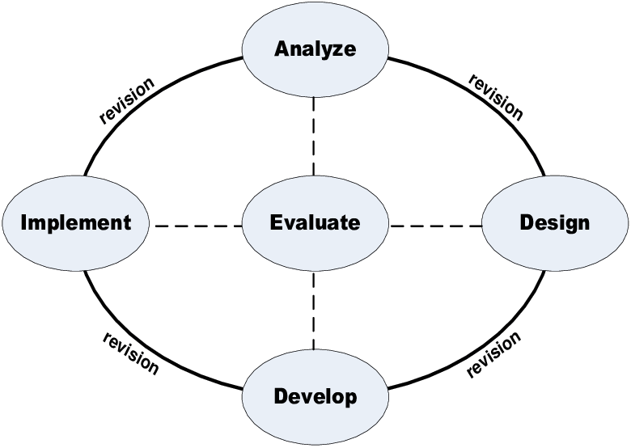

This study uses the ADDIE model (Analysis, Design, Development, Implementation, Evaluation) (Spatioti et al., 2022) to develop a virtual reality application as a learning tool for gender wayang. The ADDIE method consists of five stages, namely:

1. Analysis: In the analysis stage, the focus is on identifying the problems faced in gender wayang learning, such as the lack of access to gender wayang instruments. Data collection was conducted through interviews with instructors and students at the Dewi Ratih Batu Bulan art studio. This stage aims to determine the educational needs and issues that must be addressed through the virtual reality gender wayang application.
2. Design: The design stage involves creating the framework for the virtual reality gender wayang application, which integrates gender wayang learning with interactive and enjoyable elements. The focus of this design process is to create an experience that allows users to understand the form, structure, and philosophy of gender wayang through an easy-to-use interface. The design of the virtual reality gender wayang application also includes visual elements that reflect Balinese culture.
3. Development: In the development stage, the design outcomes are implemented into the form of the virtual reality gender wayang application. During this development process, the virtual reality gender wayang application also collaborates with gamelan and gender wayang experts to ensure that the content and visuals incorporated into the application are authentic and align with the values of Balinese culture. The virtual reality technology used in this study includes various interactive features that allow users to directly interact with gender wayang instruments and learn about their form.
4. Implementation: In the implementation stage, the virtual reality gender wayang application was tested with 20 students from the Dewi Ratih Batu Bulan art studio, consisting of young people actively learning Balinese art. The implementation involves initial training on how to use the application and direct observation of its use by students. Each student was given the opportunity to explore the application freely, and their interactions and experiences were recorded.
5. Evaluation: In the evaluation stage, feedback was collected from students using questionnaires and interviews. This questionnaire assessed various aspects of the application, including how effective the application was in improving participants' understanding of gender wayang, how interactive the application was, and to what extent the application created an interactive and enjoyable learning experience. The results of this evaluation will be used to make improvements and updates to the application if necessary.

The research method used in this study allows for the design, testing, and continuous improvement of the application based on user feedback, ensuring that the resulting virtual reality gender wayang application can become an effective tool in teaching traditional Balinese arts, particularly gender wayang. This technique is highly suitable for the interactive and enjoyable characteristics needed to teach Balinese cultural concepts in greater depth. The data used in this study includes two main types of data: material validation data obtained from gamelan and gender wayang experts, which is used to ensure the feasibility of the material taught in the virtual reality gender wayang application, and user input data, which assesses whether the gender wayang application is accepted and effective in aiding the learning process of gender wayang recognition. The virtual reality gender wayang application is designed with the concept of Tri Hita Karana, which teaches the values of harmony between humans, nature, and spiritual elements. Data on user interest in local culture was also collected through a questionnaire to assess the level of interest of the younger generation in preserving Balinese culture, particularly in terms of gender wayang.

The research instrument used for data collection is a questionnaire designed to evaluate the developed virtual reality application (Kamińska et al., 2022). This questionnaire covers several aspects, such as user satisfaction, the effectiveness of the application in facilitating learning, and user perceptions of Balinese culture after using the application. Expert assessments were conducted to evaluate the feasibility of the teaching materials in supporting technology-based virtual reality learning. In the evaluation phase, data from the expert testing aims to determine whether the developed materials and the virtual reality gender wayang application meet the expected standards or require improvements (Hidayat et al., 2021). If there are shortcomings or suggestions for improvement from the experts, the researcher will revise the materials and the application based on that feedback.

The data analysis technique used in this study combines both quantitative and qualitative approaches to ensure the accuracy and depth of the results (Hands, 2022). Quantitative data were analyzed using descriptive statistics, such as mean and standard deviation, to assess the effectiveness of the developed learning media, including its impact on improving students' knowledge and skills. The validity of the materials was tested using the Aiken's V method, which is employed to evaluate the suitability of the materials based on expert assessments, ensuring that the materials used in the application are relevant and meet the expected learning standards (Wahyuni, 2023).

Qualitative data were obtained through questionnaires completed by users and were then analyzed using data reduction techniques, data presentation, and conclusion drawing. This process aimed to gain deeper insights into users' experiences, the challenges they faced, and feedback regarding the use of the virtual reality gender wayang application. Data triangulation was also used to ensure the validity of the research findings by comparing results from various data sources (user questionnaires, expert opinions, and observations) and different research methods (quantitative and qualitative) (Vera Nurfajriani et al., 2024). Additionally, reflective analysis was conducted to assess the effectiveness of implementing Virtual Reality (VR)-based learning in teaching gender wayang. The results of this analysis serve as the basis for the further development of the application, ensuring that the applied learning model can optimize user interest in gender wayang and support the preservation of local culture within the educational context. Through this analysis, it is expected that the VR application will continue to be refined to become more effective in enhancing young people's understanding of Balinese culture.

**Result and Discussion**

**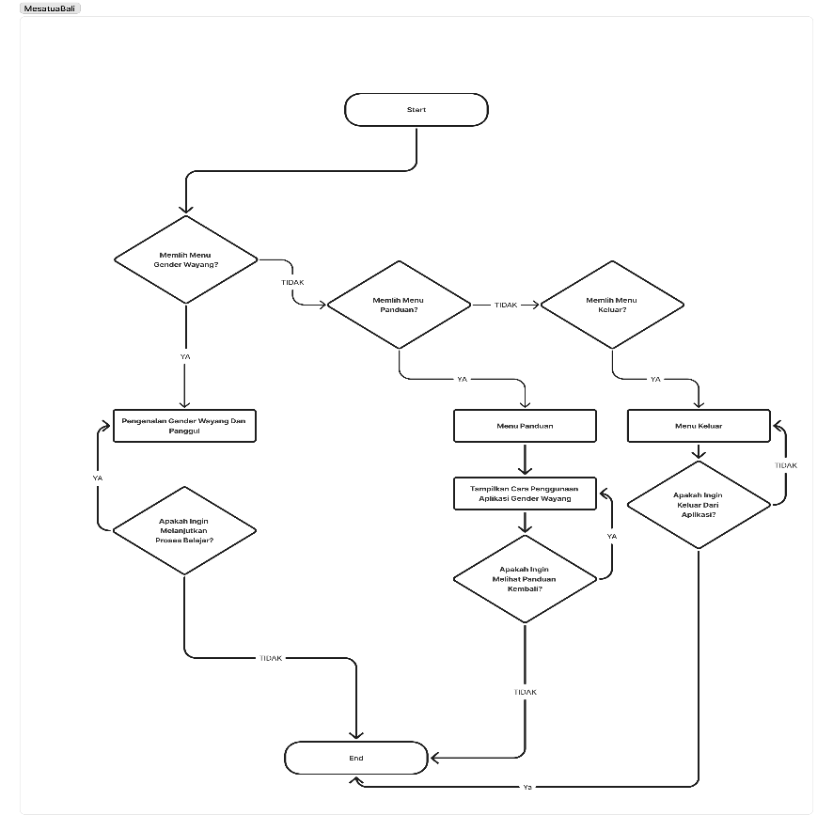**

**Figure 2. Flowchart of the Tri Hita Karana-Based VR Gender Wayang Application Program**

Figure 2 shows the flowchart of the virtual reality gender wayang application. The application has three main menus: the gender wayang menu, the guide menu, and the exit menu. The gender wayang menu is used to enter the process of training on the form of gender wayang and the mallet. The guide menu is used to view instructions on how to use the application, and the exit menu is used to exit the application.

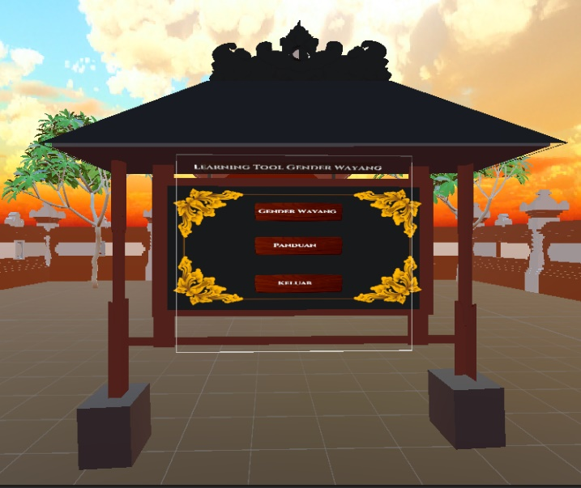

**Figure 3. Interface Display of the Tri Hita Karana-Based Virtual Reality (VR) Gender Wayang Application**

Figure 3 shows the menu interface of the Tri Hita Karana-based virtual reality gender wayang application. This application harmoniously integrates visual and interactive elements, which can be easily accessed virtually through a virtual reality device. In this application, users can explore various features, learn about the form of gender wayang, play some basic notes of gender wayang, and gain information about the Tri Hita Karana philosophy. The main menu of the application is designed to be user-friendly, with clear buttons and visual cues to guide the virtual gender wayang learning experience.

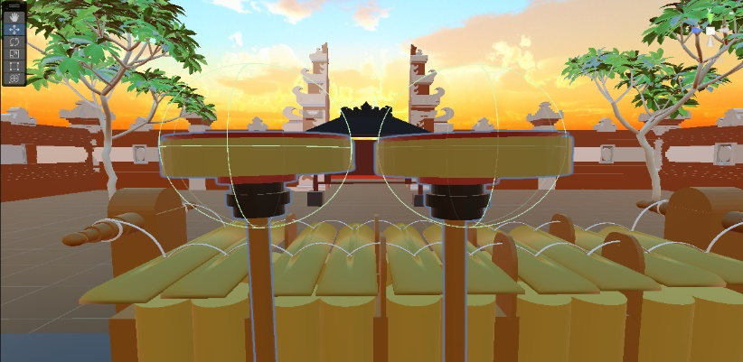

**Figure 4. Live Visual Display of the Tri Hita Karana-Based Virtual Reality (VR) Gender Wayang Application**

Figure 4 shows the Tri Hita Karana-based virtual reality gender wayang application, displaying the integration of technology with local culture in an interactive and enjoyable form. In this visualization, gender wayang is displayed digitally with accurate details, allowing users to explore the elements of the instrument virtually. By using virtual reality, this application provides an immersive experience that not only introduces Balinese instruments but also supports the understanding of the philosophy of sustainability and harmony within Balinese culture. Users can better understand how gender wayang relates to the concept of Tri Hita Karana, which includes harmony between humans, nature, and spirituality in Balinese culture.

The success of the virtual reality gender wayang application was evaluated through material validity testing by experts using the Aiken’s V index. This assessment involved two experts who evaluated the validity of the materials within the application. Based on the formula developed by Aiken, the Aiken's V index is used to calculate the validity coefficient based on the experts' evaluation of the extent to which each item represents the construct being measured (Alamsyah Mansur & Manaf, 2023). Data analysis of the validity test was conducted by applying the Aiken's V formula, to ensure that the virtual reality gender wayang application is suitable for use in teaching.

**Table 1. Expert Validation Validity Criteria**

| **Average Score** | **Validity Level** |
| --- | --- |
| 0.8 < V ≤ 1.0 | Very Valid |
| 0.4 < V ≤ 0.8 | Valid Enough |
| 0 < V ≤ 0.4 | Invalid |

The table above shows the data validity categories based on the average score obtained, using a three-level scale. Data with scores ranging from 0.8 to 1.0 (0.8 < V ≤ 1.0) are categorized as "Very Valid," meaning they are highly valid and reliable. Data with scores between 0.4 and 0.8 (0.4 < V ≤ 0.8) fall into the "Valid Enough" category, indicating that the data is sufficiently valid, although there are minor shortcomings. Meanwhile, data with scores from 0 to 0.4 (0 < V ≤ 0.4) are considered "Invalid," meaning they are not suitable for further analysis (Sabila et al., 2024).

Several aspects evaluated by the experts include content, presentation, characteristics, interactivity, and usability (Lacoche et al., 2022). Content assesses the quality and accuracy of the materials within the application, ensuring that the information provided aligns with the learning objectives and is relevant to Balinese culture, particularly gender wayang. Presentation evaluates how the material is presented to users, including aspects of design and aesthetics such as visuals, layout, and the method of conveying information. Characteristics measure the features of the application that support the learning process, such as interaction with virtual elements and additional features that enhance the learning experience. Interactivity examines how actively users are engaged in learning, assessing how much users can interact with the application to deepen their understanding. Usability evaluates the ease of use of the application for all users, regardless of their technological experience, including how easily the application can be navigated and operated by users with various technical backgrounds.

**Table 2. Media Validator Assessment of Tri Hita Karana-Based VR Gender Wayang**

| **Aspect** | **Aiken's V (Validator 1)** | **Aiken's V (Validator 2)** | **Average Aiken's V** | **Category** |
| --- | --- | --- | --- | --- |
| Content | 1.0 | 1.0 | 1.0 | Very Valid |
| Presentation | 0.666 | 1.0 | 0.833 | Valid Enough |
| Characteristics | 1.0 | 0.666 | 0.833 | Valid Enough |
| Interactivity | 1.0 | 1.0 | 1.0 | Very Valid |
| Usability | 1.0 | 0.666 | 0.833 | Valid Enough |
| Average | | | 0.900 | Valid Enough |

Table 2 shows the results of the validation of the virtual reality gender wayang application, evaluated by two experts using Aiken's V to measure content validity. The content received a score of 1.0 from both validators, indicating that it is very valid. Presentation received an average score of 0.833, showing a good level of validity but with room for improvement, especially in visual elements and the interface. Characteristics also had an average score of 0.833, meaning it is generally valid, but improvements are needed in the interactive features. Interactivity was rated as very valid with a score of 1.0 from both validators, indicating that the interactive features function well. Usability received an average score of 0.833, indicating good ease of use, although some interface elements still need improvement. Overall, the average Aiken’s V for this application is 0.900, which places the virtual reality gender wayang application in the "Valid Enough" category, with most aspects meeting high validity standards, especially in terms of Content and Interactivity.

**Table 4. Questionnaire Results on Students' Attitudes Towards Local Culture Learning with the VR Gender Wayang Application**

| **Indicator** | **Average Score** | **Category** |
| --- | --- | --- |
| Interest | 2.95 | Good |
| Loyalty | 3.0 | Good |
| Concern | 3.0 | Good |
| Appreciation | 3.0 | Good |
| Average | 2.98 | Good |

Based on the results of the questionnaires completed by 20 students, it can be concluded that the virtual reality gender wayang application successfully fostered students' interest and concern for Balinese culture. The average scores for each indicator fall within the "Good" category, with the highest scores on the indicators of Loyalty, Concern, and Appreciation, all of which received an average score of 3.0. Meanwhile, Interest received an average score of 2.95, which is still within the "Good" category but slightly lower, indicating that although students showed a fairly high level of interest in learning about gender wayang using this application, there is room to further increase their engagement. This suggests that aspects of interactivity or more engaging features in the application may be further enhanced to motivate students and increase their interest in learning about Balinese culture overall.

The results of this study indicate that the development of virtual reality gender wayang media is highly effective in enhancing students' interest, particularly in understanding and appreciating gender wayang as part of local Balinese culture. Based on expert validation using the Aiken's V method, the developed virtual reality media achieved a very high validity level, with an average score of 0.900, indicating that the content, presentation, and characteristics of the application are very suitable for use in learning. The student questionnaire results also show a high level of interest, with an average score of 2.98 across the indicators of interest, loyalty, concern, and appreciation for local culture. These findings support previous research by (Indrawan et al., 2025), which emphasized that VR technology in education significantly enhances conceptual understanding and student engagement, while demonstrated that VR enriches learning experiences with a more engaging visual approach, strengthening students' connection with their cultural heritage. In conclusion, this research shows that the integration of interactive technology with local culture can serve as an innovative solution, emphasizing the need for further teacher training to effectively adopt and implement VR. Further development of the VR gender wayang application could include gamification features and artificial intelligence for adaptive feedback, making it more responsive to students' needs and increasingly contributing to cultural preservation in the rapidly advancing digital era.

**Conclusion**

Based on the results of the study, the development of Tri Hita Karana-based Virtual Reality (VR) gender wayang has proven to be effective in enhancing students' interset and fostering a love for local Balinese culture. Validation conducted by experts showed that this media has a very high validity level, with an average Aiken's V score of 0.900, indicating that the content, presentation, and characteristics of the application are highly suitable for learning. Additionally, the results of the student questionnaire show that they have a high level of interest in using the VR gender wayang application, with an average score of 2.98 in the aspects of interest, loyalty, concern, and appreciation for local culture. The integration of VR into culture-based learning not only helps students understand the concepts of Balinese culture, specifically gender wayang, but also introduces them to the philosophy of Tri Hita Karana, which emphasizes the balance of relationships with God, others, and nature. With its interactive design and innovative learning experience, VR gender wayang becomes a relevant learning solution in the digital era while contributing to the preservation of local culture.

**Recommendation**

For further development, the virtual reality gender wayang application can be enhanced by adding more complex interactive features, such as more realistic three-dimensional, and a application control can provide adaptive feedback to users based on their level of understanding. Further research on the effectiveness of this application at various educational levels is also needed to ensure that this technology can be optimally applied. With continuous innovation, VR gender wayang has the potential to become an increasingly effective and engaging interactive learning tool for students.

Teachers are also encouraged to integrate Virtual Reality (VR) technology into the learning process to enhance students' creativity and understanding of the concepts being taught. Intensive training on the use of VR should be provided to ensure that teachers can utilize this technology optimally. Additionally, teachers can adapt local wisdom-based learning methods, such as Tri Hita Karana, to enrich students' learning experiences.

**Acknowledgment**

We would like to express our gratitude to all parties who have contributed to the development of the virtual reality gender wayang application, especially to the expert validators and students of sanggar who have provided valuable input to this project with full dedication.

**References**

Alamsyah Mansur, F., & Manaf, A. (2023). Analysis of The Aiken Index to Measure The Content Validity of The Wolio Language and Culture Preservation Model Instrument. *ELS Journal on Interdisciplinary Studies in Humanities*, *6*, 2023. https://doi.org/10.34050/elsjish.v6i3.29667

Alnagrat, A., Che Ismail, R., Syed Idrus, S. Z., & Abdulhafith Alfaqi, R. M. (2022). A Review of Extended Reality (XR) Technologies in the Future of Human Education: Current Trend and Future Opportunity. *Journal of Human Centered Technology*, *1*(2), 81–96. https://doi.org/10.11113/humentech.v1n2.27

Hands, A. S. (2022). Integrating quantitative and qualitative data in mixed methods research: An illustration. *The Canadian Journal of Information and Library Science*, *45*(1), 1–20. https://doi.org/10.5206/cjilsrcsib.v45i1.10645

Hartini, N. P., & Haryati, N. M. (2023). Estetika Pertunjukan Gender Wayang secara Virtual. *Tamumatra : Jurnal Seni Pertunjukan*, *5*(2). https://doi.org/10.29408/tmmt.v5i2.12256

Hwang, G.-J., & Chang, C.-Y. (2022). A reflective cycle-based virtual reality approach to promoting students’ learning achievement, sense of presence, and higher-order thinking in professional training. *Interactive Learning Environments*, 1–16. https://doi.org/10.1080/10494820.2022.2147959

Indrawan, I. P. E., Parmithi, N. N., & Anggreni, N. L. P. Y. (2025). Developing Tri Hita Karana-Based Balinese Klakat Tradition Augmented Reality Media to Enhance Creativity of Elementary School Students. *Jurnal Paedagogy*, *12*(2), 294. https://doi.org/10.33394/jp.v12i2.14830

Kamińska, D., Zwoliński, G., & Laska-Leśniewicz, A. (2022). Usability Testing of Virtual Reality Applications—The Pilot Study. *Sensors*, *22*(4), 1342. https://doi.org/10.3390/s22041342

Lacoche, J., Villain, E., & Foulonneau, A. (2022). Evaluating Usability and User Experience of AR Applications in VR Simulation. *Frontiers in Virtual Reality*, *3*. https://doi.org/10.3389/frvir.2022.881318

Lin, X., Mahmud, S., Jones, E., Shaker, A., Miskinis, A., Kanan, S., & Kim, J. H. (2020). Virtual Reality-Based Musical Therapy for Mental Health Management. *2020 10th Annual Computing and Communication Workshop and Conference, CCWC 2020*, 948–952. https://doi.org/10.1109/CCWC47524.2020.9031157

Mayoni, K., Hayu Widhiyaningsih, I., Yesi Dharnendri, L., Komang Semaranatha, I., Teguh Wiryasanjaya, M., Negeri, S., Negeri, S., & Negeri Nusabali, S. (2023). *Implementasi Ajaran Tri Hita Karana Dalam Pembangunan Masyarakat Bali*. 90–95. https://doi.org/10.59435/gjmi.v1i5.865

Muflyhudin, D., Eka, G., Koriawan, H., Ketut Sudita, I., Bahasa, F., Program, S., Pendidikan, S., & Rupa, S. (2022). PEMANFAATAN LIMBAH BESI UNTUK DIJADIKAN GAMELAN GENDER OLEH BAPAK I WAYAN SUKARTA DI BANJAR DINAS TULAMBEN KARANGASEM. *Jurnal Pendidikan Seni Rupa Undiksha*, *12*(1), 15–22. https://ejournal.undiksha.ac.id/index.php/JJPSP/index

Sabila, A. Z., Nana, N., & Mahmudah, I. R. (2024). Development of interactive learning multimedia based on Somatic, Auditory, Visual, Intellectual (SAVI) approach assisted by Articulate Storyline 3 on circular motion material. *Jurnal Riset Dan Kajian Pendidikan Fisika*, *11*(1), 11–20. https://doi.org/10.12928/jrkpf.v11i1.717

Spatioti, A. G., Kazanidis, I., & Pange, J. (2022). A Comparative Study of the ADDIE Instructional Design Model in Distance Education. In *Information (Switzerland)* (Vol. 13, Issue 9). MDPI. https://doi.org/10.3390/info13090402

Vera Nurfajriani, W., Ilhami, M. W., Mahendra, A., Sirodj, R. A., Afgani, W., Negeri, U. I., Fatah, R., & Abstract, P. (2024). Triangulasi Data Dalam Analisis Data Kualitatif. *Jurnal Ilmiah Wahana Pendidikan*, *10*(17), 826–833. https://doi.org/10.5281/zenodo.13929272

Wahyuni, V. (2023). Aiken Index Analysis to Determine The Contents Validity of Project Assessment Instrument in Learning Islamic Religion and Character in the Independent Curriculum. *Sustainable Jurnal Kajian Mutu Pendidikan*, *6*(2), 565–569. https://doi.org/10.32923/kjmp.v6i2.4043