The Level of Critical Thinking Skills and Communication of Grade VIII SMP Students in Science Education

1* Salvi Dwi Fani, 2 Indrawati, 3 Sri Astutik
Master of Science Education, Faculty of Teacher Training and Education, Jember University.
*Corresponding Author e-mail: salvidwif@gmail.com

Abstract: The importance of critical thinking and communication skills in education for preparation for the world of work there is still a significant gap in these two skills. The purpose of this study was to determine the level of students' critical thinking and communication skills. The method used in this study is descriptive quantitative using test instruments and questionnaires. The results obtained in this study for critical thinking skills, each indicator is providing simple explanations (65%) in the medium category, building basic skills (51%) in the low category, concluding (45%) in the low category, providing advanced explanations (41%) in the low category, and organizing strategies and tactics (28%) in the very low category. And for communication skills, each indicator is Expressing 45% (low), Evaluating 42% (low), Responding 59% (medium), Negotiating 49% (low). | Article History  Received: 2  Revised:  Published:.. 2017  Key Words :  Critical Thinking, Communication, Students.
How to Cite: First author., Second author., &amp; Third author. (20xx). The title. Jurnal Paedagogy: Jurnal Penelitian dan Pengembangan Pendidikan, vol(no). doi:https://doi.org/10.33394/jp.vxxyyi
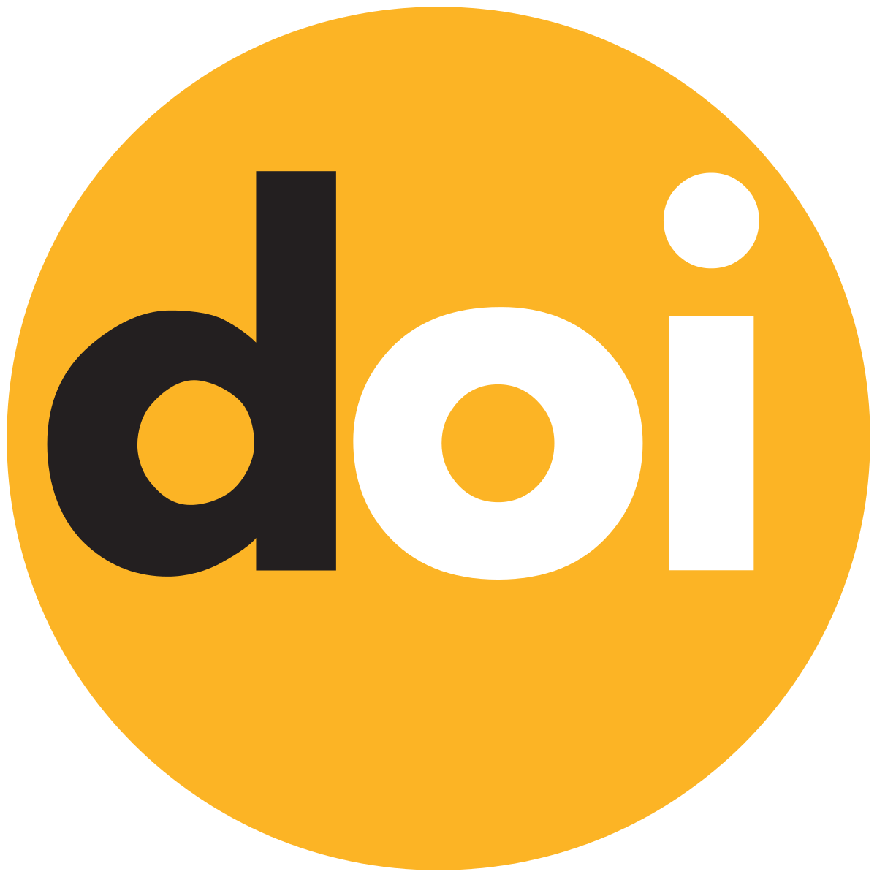 https://doi.org/10.33394/jp.vxxyyi | This is an open-access article under the CC-BY-SA License.
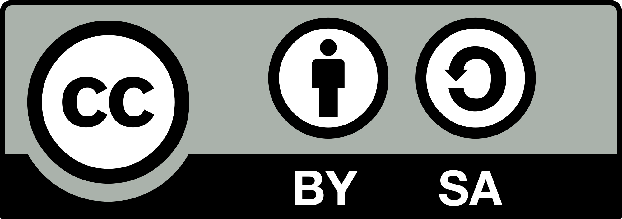
Introduction
The development of education in the 21st century has experienced rapid changes along with the development of science, technology and globalization. Education in the 21st century demands significant transformation in preparing students to face complex and ongoing global challenges (Mardhiyah et al., 2021). The challenges of the modern world require students to not only control knowledge academic, but also have 21st century skills that include critical thinking skills, communication, collaboration, and creativity (Suryani et al., 2025). There needs to be student readiness in facing global competition.
Facing increasingly tight global competition, the government has prepared an independent curriculum by improving 21st century skills. Critical thinking skills are one of the important skills that students need to have to problem solving and make decisions in the real world (Ariadila et al., 2023). Critical thinking skills are not just rote learning, but require skills to question assumptions, assess evidence, and formulate reasoned conclusions (Sari, 2023). For students, developing critical thinking skills is not only an academic need but also a life skill that fosters independence and adaptability.
Students' preparation for their future is not only having critical thinking skills but also other skills, one of which is communication skills to complement it. Communication skills play a role in establishing effective relationships in everyday life (Suleman, 2024). Communication skills are aimed at conveying ideas clearly, listening actively, and understanding other people's perspectives can improve understanding of scientific knowledge (Wardhani et al., 2024). Therefore, developing communication skills is a crucial step to support student success in learning at school.
The development of communication skills in schools is very important because it is the basis for students to interact effectively in various situations. Through natural science learning that encourages discussion, presentation, and group work, students can learn to convey ideas clearly, listen well, and respect the opinions of others (Wakhudin et al., 2024). Communication skills are not only useful in the school environment, but also become valuable provisions in social life and the world of work in the future (Stellarosa & Ikhsano, 2021). In addition, good communication skills can increase students' self-confidence and critical thinking skills (Septia et al., 2021). Therefore, schools need to actively create a learning environment that supports the development of communication skills from an early age.
The development of critical thinking skill and communication during Junior High School (SMP) is very important. At this stage, students are transitioning from concrete operational thinking typical of younger children, to more abstract formal operational thinking (N. D. Anggraeni et al., 2024). This cognitive change allows them to handle more complex tasks that involve reasoning, reflection, and applying learned knowledge to new situations (Maulana, 2024). Therefore, the junior high school period is an important window for cultivating critical thinking and communication skills that will prepare students for the demands of higher education and their future professional lives.
However, although the importance of critical thinking skill and communication in education has been recognized, there is still a significant gap in understanding how well junior high school students develop these two skills, especially in the context of natural science subjects. Existing research often focuses on higher education or specific disciplines such as research conducted by Hasanah et al., the study was on improving critical thinking and communication skills of students at universities with a field of entrepreneurship, in addition to other research conducted by Louto et al. on improving critical thinking and communication skills in high school students (Hasanah & Malik, 2020; Louto et al., 2025). However, there is little empirical data on students' critical thinking and communication skills at the junior high school level. In addition, there is a lack of studies that measure these skills to assess the extent to which students' critical thinking and communication skills are aligned with educational benchmarks.
This study aims to determine the level of critical thinking skill and communication in junior high school students when they are involved in natural science learning. Thus, this study will explain how well students are able to apply critical thinking and communication skills to solve scientific problems, whether they are performing basic tasks such as providing simple explanations or engaging in more complex activities such as determining strategies and tactics for experiments.

Research Method
This study will use a descriptive research design that is very appropriate to assess the current state of critical thinking and communication skills in a particular population. Descriptive research is a research method that attempts to describe the object or subject being studied according to what it is (Syahrizal & Jailani, 2023). By adopting this design, this study aims to provide an accurate picture of the critical thinking skill and communication of junior high school (SMP) students as they interact with science learning (IPA). This is important to gain an authentic understanding of how students develop and use their critical thinking skill and communication in science educational.
This study was conducted in three junior high schools (SMP) in Tuban Regency, East Java. By involving 73 students from grade VIII to work on critical thinking skills tests and questionnaires on student communication.
The main data collection instruments for this study include the Critical Thinking Skills Test and Questionnaire. These tools were chosen to comprehensively assess students' critical thinking and communication skills, using both quantitative and qualitative methods. Critical Thinking Skills Test: A standardized test specifically designed to measure critical thinking skills in the context of science learning on the circulatory system will be given to all participating students. This test will include items that assess the five indicators outlined by Ennis, namely providing simple explanations, building basic skills, concluding, providing advanced explanations, and organizing strategies and tactics (Ennis, 2011). The critical thinking skills test consists of five questions with one question for each indicator of critical thinking skills. This assessment will provide quantitative data on students' levels of critical thinking, allowing researchers to categorize participants based on their skills. Questionnaire: a questionnaire instrument will be used, namely a self-assessment questionnaire to collect data on students' communication during science lessons. With indicators of communication skills by Por Chang, namely Expressing, Evaluating, Responding, Negotiating (Chang et al., 2011). This self-assessment questionnaire data will help provide insight into students' communication skills in learning situations.
Furthermore, the test and questionnaire data were analyzed using percentages to determine each indicator of critical thinking and communication skills using the formula (Nuraini, 2017):
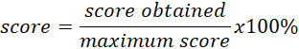
Then the values ​​obtained are converted using the critical thinking skill and communication categories (Nuraini, 2017):
Tabel 1. Critical Thinking Skill and Communication Category
Percentage | Category
85,00% – 100% | Very high
70,00% – 84,99% | High
55,00% – 69,99% | Medium
40,00% – 54,99% | Low
0% – 39,99% | Very low

Result and Discussion
Result
The assessment of critical thinking skills in junior high school students in natural science learning produced interesting findings. Data collected through the Critical Thinking Skills Test showed varying levels of ability on the five indicators defined by Ennis. Overall, these findings indicate that although students have a sufficient understanding of critical thinking skills, there are significant areas that need improvement. The percentage of students who met expectations for each indicator is as follows: providing simple explanations (65%) in the medium category, building basic skills (51%) in the low category, concluding (45%) in the low category, providing advanced explanations (41%) in the low category, and organizing strategies and tactics (28%) in the very low category (Figure 1).
Figure 1. Percentage of students' critical thinking skills test
The findings on students' communication skills through the five-indicator self-assessment questionnaire described by Por Chang vary widely. The percentage of achievement for each communication skill indicator is Expressing 45% (Low), Evaluating 42% (Low), Responding 59% (Medium), Negotiating 49% (Low) (Figure 2).
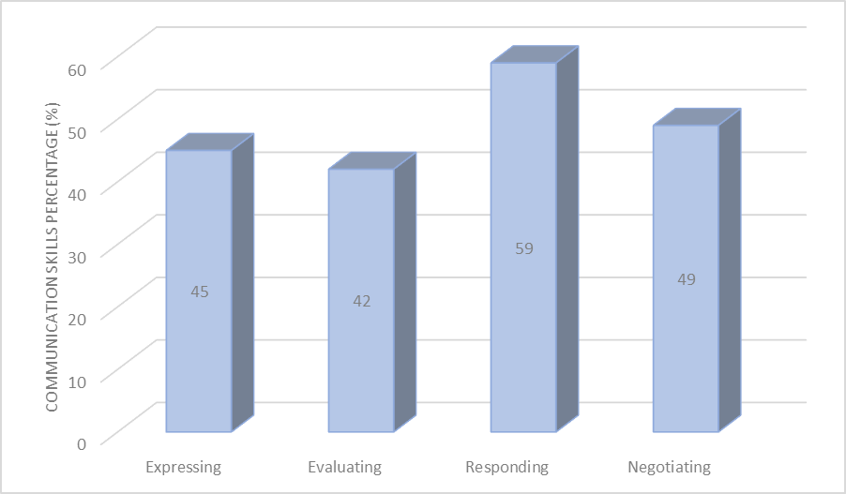
Figure 2. Communication Skills Percentage

Discussion
The results of this study provide a clear picture of the critical thinking and communication skills possessed by junior high school students in the context of natural science learning (IPA). The data show that students have varying levels of proficiency in the five critical thinking indicators set by Ennis. Communication skills according to the data obtained have almost the same value for the four indicators according to Por Chang.
- Critical Thinking Skills
The first indicator is providing simple explanation. Students' critical thinking skills develop gradually through habitual practice, such as answering questions that require explanation (Purwanti, 2023). This first indicator obtained results of 65% of students who were able to provide a simple explanation which was classified as a moderate category. In this indicator, 48 out of 73 students were able to answer the questions asked correctly. It can be seen that some students are able to explain the basic concept of the questions given where students are asked to provide an explanation of the diseases that arise due to hypertension. However, there are still some students who only mention the disease without providing an explanation. This indicator of providing a simple explanation reflects students' dependence on memorizing and providing short answers rather than deeper understanding and critical analysis of students (Suhendra & Wahyuningtyas, 2024).
The second indicator builds basic skills. The characteristics of a person who has critical thinking skills in this indicator by utilizing relevant information to find a solution to a problem (Astari & Sumarni, 2020). The data obtained for the indicator of building basic skills shows that 51% of students can consider the information provided. The third indicator is that students are in the low category, as many as 37 students can answer the questions given. Students are given data on the amount of hemoglobin based on different genders and age, students can absorb information and see the truth of the information provided according to what they have learned. The need for students to process information sources is very important in critical thinking (Ariadila et al., 2023).
The third indicator concludes. Students can make conclusions by providing correct and complete answers (Rosmalinda et al., 2021). This indicator obtained 45% of students in concluding with a low category. as many as 33 students were able to conclude correctly while 40 other students were unable to conclude. Students were given data on 10 diseases related to the circulatory system in Indonesia, students were asked to conclude the data based on the identification of the causes of the disease. Students have not been able to conclude from the data presented. Students need to be accustomed to identifying data so that students can conclude data.
The fourth indicator is providing advanced explanation. Defining terms to provide more detailed explanations is a support for critical thinking skills in problem solving (Amarila, 2021). The results obtained from the data are that 41% of students can provide more detailed definitions of terms. This indicator is included in the low category, more than half of the students have not been able to define terms in detail. Students are given terms for circulatory system disease, many students are still unfamiliar with these terms. Teachers need to provide scientific reading to students so that students have broader insights to define more detailed terms (Adawiyyah & Irvani, 2022).
The fifth indicator is organizing strategies and tactics. Critical thinking skills highlight the importance of setting strategies and tactics in providing concrete solutions. In this fifth indicator, data was obtained that 28% of students could set strategies and tactics, but the indicator had the lowest level compared to the other indicators. Where students who can set strategies and tactics are 21 students out of 73 students. This indicator is in the very low category. where students are presented with data on normal red blood cells that humans have in the body and those that are not normal, students are asked to set strategies to normalize abnormal red blood cells. Students still cannot set strategies in providing solutions in carrying out the actions to be taken (Ridho et al., 2020).
- Communication Skills
The first indicator of communication skills is expressing. The data obtained was 45% in the moderate category. 45% of students stated that they often use graphs or mathematical symbols to explain the contents of the data. However, some students are still unable to express data in the form of graphs or mathematical symbols. The expression of the data shown will bring new experiences for students in improving their communication skills (Rambe et al., 2022).
The second indicator is evaluating. Evaluation is an indicator of communication skills where students can judge other people's opinions correctly based on facts from data. The data obtained was 42% of students could judge other people's opinions. This indicator is in the moderate category where 31 students can judge other people's opinions. However, there needs to be a habit of students in judging other people's opinions based on the facts and knowledge they have learned. The importance of students in judging other people's opinions based on facts, so that students can filter the information obtained (N. Anggraeni et al., 2022).
The third indicator is responding. Responding is an indicator of responding to a question or statement from a friend. From the data obtained, 59% of students can respond to questions or statements from teachers or other students. This indicator is in the moderate category. However, there are still many students who are not willing to give their opinions in responding to statements from teachers or other friends. Even though it is in the moderate category, students need to get used to communicating to respond to a problem. Students are less brave in expressing their opinions or responding to questions or statements from teachers or other students (Ramadina & Rosdiana, 2021).
The fourth indicator is negotiating. Negotiating is being able to accept opinions from other friends or from teachers. This indicator obtained 49% with a moderate category. Students can accept opinions from others well and discuss opinions received from others well, but there are some students who are less able to accept other people's opinions by defending their opinions. Differences of opinion during discussions are common, but many cannot accept these differences of opinion (AL Fazri et al., 2021). There needs to be a habit of open discussion to accommodate other people's opinions so that students can accept opinions from others.

Conclusion
In conclusion, the results of this study indicate that the level of critical thinking and communication skills of junior high school students has a significant gap in science learning. Critical thinking skills that have five indicators with critical thinking skills test results with an average in the low category. The percentage associated with each of the five indicators indicates the need for training in critical thinking skills questions related to students' daily lives so that students not only memorize but can face the challenges of the future world of work. Students' communication skills with four indicators with an average have a low category. The percentage associated with each of the four indicators indicates the need for good and correct communication training in accordance with the existing facts, so that students gain confidence in facing the future world of work.
Recommendation
There are still many shortcomings in this study, the recommendation this research so further research is needed to improve students' critical thinking and communication skills. There needs to be training in critical thinking questions and good communication habits. Addition of the use of supporting learning models, strategies and methods.

References
Adawiyyah, Y., & Irvani, A. I. (2022). Analisis Pembelajaran Dengan Desain Didaktik Sharing Task dan Jumping Task pada Materi Persilangan Monohibrid. Jurnal Pendidikan UNIGA, 16(2), 592. https://doi.org/10.52434/jpu.v16i2.1797
AL Fazri, M., Putri, I. A., & Suhairi, S. (2021). Keterampilan Interpersonal Dalam Berkomunikasi Tatap Muka. Da’watuna: Journal of Communication and Islamic Broadcasting, 2(1), 46–58. https://doi.org/10.47467/dawatuna.v2i1.510
Amarila, R. S. (2021). Analisis Kemampuan Berpikir Kritis Siswa Pada Pembelajaran Ipa Terpadu Tema Lingkungan Universitas Negeri Semarang 3 Universitas Negeri Semarang PENDAHULUAN Pembelajaran IPA Ramdani et al ., ( 2019 ) menjelaskan beberapa permasalahan yang terjadi terkait. Jurnal Ilmiah Untuk Peningkatan Mutu Penddikan, 8(1), 82–91.
Anggraeni, N. D., Kumala Dwi Alviana, W., Fitriya Wahyuni, D., Kusuma Ainurrosyidah, L. D., Mahardika, I. ketut, Sutarto, S., & Wicaksono, I. (2024). Analisis Perkembangan Peserta Didik Menurut Teori Jean Piaget Dan Pengimplementasianya Pada Pembelajaran Ipa Smp. EDUSAINTEK: Jurnal Pendidikan, Sains Dan Teknologi, 11(3), 1503–1519. https://doi.org/10.47668/edusaintek.v11i3.1252
Anggraeni, N., Rustini, T., & Wahyuningsih, Y. (2022). Keterampilan Berpikir Kritis Siswa Sekolah Dasar Pada Mata Pelajaran Ips Di Kelas Tinggi. Jurnal Review Pendidikan Dasar : Jurnal Kajian Pendidikan Dan Hasil Penelitian, 8(1), 84–90. https://doi.org/10.26740/jrpd.v8n1.p84-90
Ariadila, S. N., Silalahi, Y. F. N., Fadiyah, F. H., Jamaluddin, U., & Setiawan, S. (2023). Analisis Pentingnya Keterampilan Berpikir Kritis TerhadapPembelajaran Bagi Siswa. Jurnal Ilmiah Wahana Pendidikan, 9(20), 664–669.
Astari, J. I. R., & Sumarni, W. (2020). Pengembangan Lembar Kerja Peserta Didik Bermuatan Etnosains Gunameningkatkan Kemampuan Berpikir Kritis. CiE, 9(2), 1–9. http://journal.unnes.ac.id/sju/index.php/chemined
Chang, H. P., Chen, C. C., Guo, G. J., Cheng, Y. J., Lin, C. Y., & Jen, T. H. (2011). The development of a competence scale for learning science: Inquiry and communication. International Journal of Science and Mathematics Education, 9(5), 1213–1233. https://doi.org/10.1007/s10763-010-9256-x
Ennis, R. (2011). Critical Thinking: Reflection and Perspective. The Journal of Critical Analysis, 26(2), 5–19.
Hasanah, H., & Malik, M. N. (2020). Blended learning in improving students’ critical thinking and communication skills at University. Cypriot Journal of Educational Sciences, 15(5), 1295–1306.
Louto, F. F., Jamhari, M., & Ramadhan, A. (2025). Problem-Based Learning through Reading , Questioning , and Answering ( PBLRQA ): A Teaching Module to Improve Critical Thinking and Science Communication Skills in High School Students. 9(1), 186–196.
Mardhiyah, R. H., Aldriani, S. N. F., Chitta, F., & Zulfikar, M. R. (2021). Pentingnya Keterampilan Belajar di Abad 21 sebagai Tuntutan dalam Pengembangan Sumber Daya Manusia. Lectura: Jurnal Pendidikan, 12, 29–40.
Maulana, A. (2024). Teori Perkembangan Kognitif Piaget Pada Tahap Operasional Formal. 1(1), 12–22.
Nuraini, N. (2017). Critical Thinking Profile of Student of Biological Teacher Candidate as Efforts to Prepare 21 st Century Generation. Jurnal Penelitian Pendidikan Biologi, 1(2), 89–96.
Purwanti, E. (2023). Analisis Keterampilan Berpikir Kritis Siswa SMP pada Materi Sistem Kehidupan Tumbuhan. Bioscientist : Jurnal Ilmiah Biologi, 11(1), 864. https://doi.org/10.33394/bioscientist.v11i1.8541
Ramadina, A., & Rosdiana, L. (2021). Keterampilan Komunikasi Siswa Setelah Diterapkan Strategi Active Knowledge Sharing Ketika Pembelajaran Daring. Pensa E-Jurnal : Pendidikan Sains, 9(2), 247–251.
Rambe, S. D. S., Manurung, P., & Syarqawi, A. (2022). Faktor Pendukung Dalam Mengembangkan Keterampilan Komunikasi Siswa Di Smp It Bunayya Padangsidimpuan. Jurnal Ikatan Alumni Bimbingan Konseling Islam, 4(juni), 7–8.
Ridho, S., Ruwiyatun, R., Subali, B., & Marwoto, P. (2020). Analisis Kemampuan Berpikir Kritis Siswa Pokok Bahasan Klasifikasi Materi dan Perubahannya. Jurnal Penelitian Pendidikan IPA, 6(1), 10–15. https://doi.org/10.29303/jppipa.v6i1.194
Rosmalinda, N., Syahbana, A., & Nopriyanti, T. D. (2021). Analisis Kemampuan Berpikir Kritis Siswa Smp Dalam Menyelesaikan Soal-Soal Tipe Pisa. Transformasi : Jurnal Pendidikan Matematika Dan Matematika, 5(1), 483–496. https://doi.org/10.36526/tr.v5i1.1185
Sari, Y. (2023). Problem Oriented Project Based Learning Meningkatkan Hasil Belajar dan Kemampuan Berpikir Kritis Siswa. BIOMA: Jurnal Biologi Dan Pembelajaran Biologi, 8(1), 61–75. https://doi.org/10.32528/bioma.v8i1.361
Septia, S., Sumantri, M. S., & Hasanah, U. (2021). HUBUNGAN KEPERCAYAAN DIRI DENGAN KEMAMPUAN KOMUNIKASI SISWA KELAS V SEKOLAH DASAR. Edustream: Jurnal Pendidikan Dasar, V(2), 152–159.
Stellarosa, Y., & Ikhsano, A. (2021). Pengembangan Keterampilan Komunikasi Melalui Pelatihan Komunikasi Efektif di Sekolah Menengah Kejuruan. Journal of Servite, 3(1), 19. https://doi.org/10.37535/102003120212
Suhendra, D., & Wahyuningtyas, N. (2024). Penerapan Tutor Sebaya dan Model Snowball Throwing untuk Meningkatkan Kemampuan Berpikir Kritis Siswa SMP. Journal of Innovation and Teacher Professionalism, 2(3), 263–272. https://doi.org/10.17977/um084v2i32024p263-272
Suleman, M. A. (2024). Meningkatkan Keterampilan Komunikasi Siswa melalui Penerapan Experiential Learning. Ideguru: Jurnal Karya Ilmiah Guru, 9(3), 1530–1538. https://doi.org/10.51169/ideguru.v9i3.1101
Suryani, A. W., Larasati, I. P., Harliansyah, P., Putra, N., Novia, S. S., & Malang, U. N. (2025). Developing 4C skills through scientific writing for labor readiness. 10(3), 757–773.
Syahrizal, H., & Jailani, M. S. (2023). Jenis-Jenis Penelitian Dalam Penelitian Kuantitatif dan Kualitatif. Jurnal QOSIM Jurnal Pendidikan Sosial & Humaniora, 1(1), 13–23. https://doi.org/10.61104/jq.v1i1.49
Wakhudin, Barir, B., Rukhmana, T., Ikhlas, A., Sartika, D., & Muarif, S. (2024). Model Pembelajaran Investigasion Based Scientific Collaborative ( IBSC ). Indonesian Research Journal on Education, 4, 496–503.
Wardhani, N. K., Variani, D., & Aini, L. N. (2024). Inovasi dalam Pelatihan Keterampilan Komunikasi : Mengoptimalkan Pengalaman Magang Mahasiswa. Prima Abdika: Jurnal Pengabdian Masyarakat, 4(4), 679–687.

