Development of Inquiry-Based Teaching Materials on Environmental Pollution To Improve High School Students' Environmental Literacy Skills

Muhammad Vikram^{1*}, Riandi^{2*}, Rini Solihat^{2*}
Biology Education Department, Faculty of Mathematics and Natural science, Indonesia University of Education.
*Corresponding Author e-mail: muhammadvikram007@gmail.com

Abstract:  The primary goal of this study is to create inquiry-based online teaching resources for class X environmental contamination topics. (2) To assess the reliability of inquiry-based online teaching resources. (3) to ascertain how using inquiry-based e-learning materials affects students' ability to develop their environmental literacy. Development research, which uses the ADDIE development model, is what this kind of study is. This study was carried out in a senior high school in Cimahi. The focus of this study is on inquiry-based online teaching resources. While the e-teaching materials trial was conducted in two classes, with the experimental class using e-teaching materials and the control class serving as a comparison using traditional school textbooks. Validation analysis is the data analysis method employed, and the t test and N-gain are utilized to examine the effectiveness of the instructional materials. The study's findings demonstrate that the generated e-teaching materials satisfy legal requirements and are appropriate for use. According to the outcomes of employing inquiry-based e-teaching resources to enhance environmental literacy abilities, the experimental class's N-gain value was higher than the average n-gain value for the control class. Therefore, it can be said that inquiry-based online teaching resources are practical to use and effective at enhancing students' environmental literacy abilities. | Article History  Received: 2  Revised:  Published:.. 2017  Key Words :  Development, inquiry, environmental literacy, e-teaching resources.

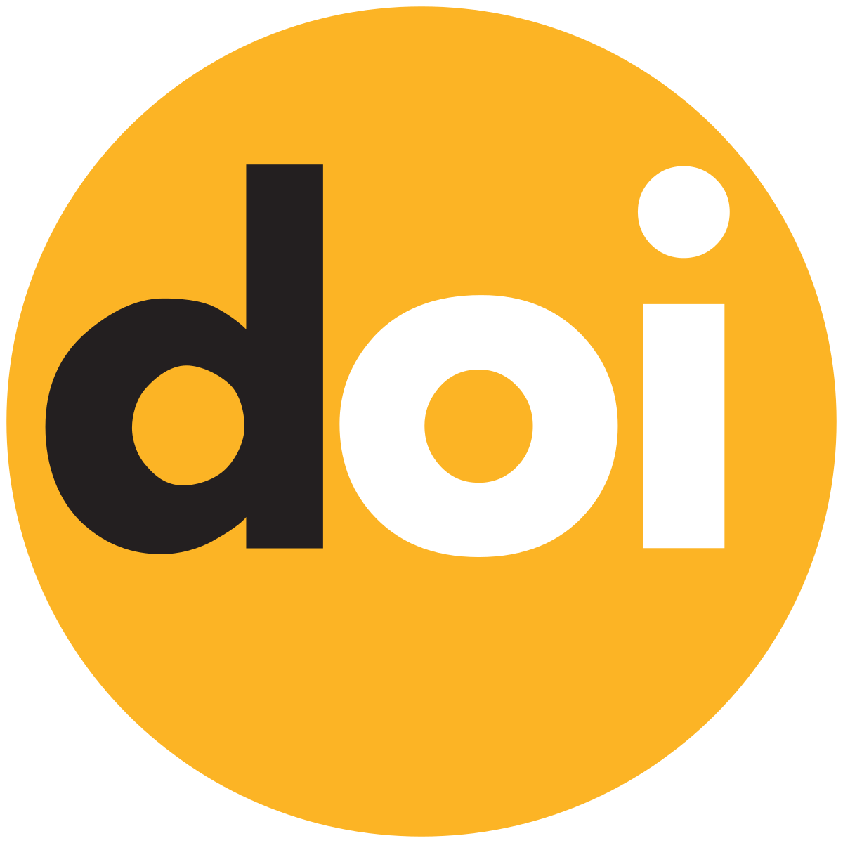 https://doi.org/10.33394/jp.vxxyyi | This is an open-access article under the CC-BY-SA License.

Introduction
Environmental literacy is a conscious attitude to maintain environmental balance (Kusumaningrum, 2018). This conscious attitude is called environmental awareness. In a sense, not only knowledge about the environment but also attitude to perceive and be able to offer solutions to environmental problems. Environmental literacy is personal knowledge and understanding of the construction of environmental aspects, principles that are applied in the environment, and the ability to act to maintain environmental quality that is applied in the environment in the surrounding environment (Komariah et al, 2017). Environmental literacy education must be instilled in students, especially in formal education environments. Environmental literacy in order to instill character in the student environment, the personality of students who are environmentally minded which aims to prepare them in environmental awareness so they can overcome the problems around them. Environmental literacy is the awareness and skills needed to develop knowledge and concepts about the environment in everyday life (Fidan and Ay, 2016). Someone with extensive environmental knowledge will be able to solve existing environmental problems (Sari et al, 2021).
Learning is needed for efforts to increase students' environmental literacy. Learning is a collaborative process including teachers, students, and instructional materials. To provide learning resources that can support student learning activities, the learning process must be implemented (Windyarinani, 2016). Environments that can be used by teachers as a source of information are referred to as teaching resources. The environment in issue consists of all messages, resources, methods, procedures, backgrounds, and people that students can use as a source for learning activities and can enhance the standard of their education (Abdullah, 2012). Learning resources are crucial instruments that can assist students in obtaining knowledge throughout educational activities.
Teaching materials are one of the learning resources that are urgent and have a big impact on learning (Permatasari et al., 2019). To speed up the learning process, instructional materials are used as manuals (Nengsi and Afriani, 2019). Learning should be made more exciting so that students can comprehend the topic being taught, and teaching materials are tools used to deliver correct and real information to students (Daryanto, 2014).
Based on the preliminary study's findings, the researcher discovered that students felt the existing teaching materials were insufficient to help them find information during the learning process, and that the lack of creativity in the process of creating teaching materials led to a more passive learning environment. This is consistent with studies by Agustina (2014) and Ardan (2016) that found that the choice of instructional materials and the creativity with which they were created had an impact on the quality of learning. Therefore, it is the responsibility of educators to create instructional materials that support the desired learning outcomes. According to the findings of teacher interviews conducted at the school, textbooks were the only resources used by teachers to convey the learning material. According to Yusliani et al. (2019), the majority of textbooks currently in use do not satisfy the requirements of the current curriculum and not all of them adhere to the standards set by the curriculum.
Teaching materials should facilitate students in exploring information in the learning process and help educators convey information in the learning process. Learning refers to the 2013 curriculum in order to produce people who are productive, creative, innovative, skilled and have integrated knowledge. Therefore, to strengthen this, an appropriate learning model is needed, namely inquiry-based learning (Komalasari et al, 2019), one of which is using inquiry-based materials. Inquiry means a statement or investigation, inquiry can be interpreted as a process carried out by humans to find and understand information. Inquiry learning is a learning process that begins with the activities of formulating problems, submitting hypotheses, collecting evidence, testing hypotheses, drawing temporary conclusions, and testing these temporary conclusions to arrive at conclusions that are believed to be true (Nurdyansyah and Fariyatul, 2016). The inquiry model is a model that will teach students directly, where the role of the teacher is to control the entire process of interaction and procedures carried out by students. Students will learn when they are actively involved in the learning process. Permatasari et al (2019) and Hanif et al (2016) in their research results suggested that the use of inquiry-based teaching materials is effective for improving student learning outcomes.
Teaching materials that are developed systematically follow learning steps based on an inquiry learning model, then the teaching materials are packaged in electronic form that can be accessed using smartphones, laptops, or computers. This is a form of effort in utilizing technology which is one of the demands of the 21st century, namely the digital century. In addition to this, the use of e-learning materials is also flexible and helps students to read and study the material anywhere and anytime. Based on this background, the purpose of this research is to produce inquiry-based e-teaching materials on environmental pollution to improve students' literacy skills in terms of validity, effectiveness, and practicality.

Research Method
This research was conducted at a high school in the Cimahi area. This type of research is development research. The purpose of this research is to produce inquiry-based teaching materials that are valid and suitable for use in learning to improve environmental literacy skills. The instrument used in this research is a validation questionnaire sheet. This questionnaire sheet is used to determine the eligibility/validity that refers to the National Education Standards Agency (BSNP, 2008) and the Ministry of National Education (Depdiknas, 2012). This research step refers to development research procedures (Sugiyono, 2017), with stages starting from potential problems, gathering information, designing teaching materials, validating teaching materials, revising, testing, revising again, trying again, so as to produce teaching material products that are ready to use. The teaching materials that have been designed will then be validated by a validator consisting of 3 validators, which aims to determine the validity of the teaching materials. The validity of a product is determined by the findings of a percentage-based questionnaire study, followed by comprehension of the questionnaire. To ascertain the degree of eligibility, this is done. The eligibility requirements are shown in table 1.
Tabel 1. Eligibility criteria according to Ridwan and Akdon (2013)
Value Scale | Category | Percentage (%)
1 | Very Valid | 81-100
2 | Valid | 61-80
3 | Enough | 41-70
4 | Invalid | 21-40
5 | Totally invalid | 0-20

The validated e-teaching materials will then be tested to determine the effect of increasing environmental literacy skills. questions to measure environmental literacy skills refer to the National Environmental Literacy Assessment (NELA, 2008). The sample of this research is 2 class. 1 experimental class of 35 students and 1 control class of 35 students. The data obtained will then be analyzed descriptively quantitatively with the Likert scale as the reference. Based on the data obtained from the validation sheet, then the percentage validity of teaching materials will be calculated using a Likert scale. for data on increasing environmental literacy skills seen from the N-Gain value and the t test
Result and Discussion
These development study findings include inquiry-based e-teaching tools on environmental pollution, validity or viability of such materials, and results of using such materials to improve students' environmental literacy. The ADDIE approach, which has five stages analysis, design, development, implementation, and evaluation is used in this development research. Figure 1 displays the products of e-learning materials.
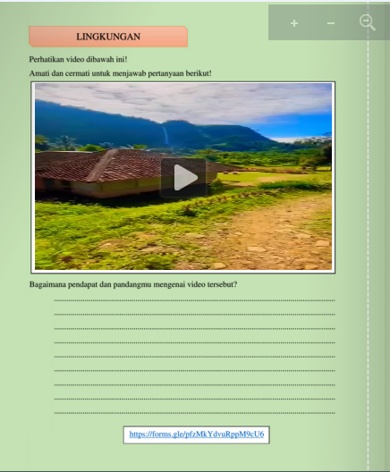
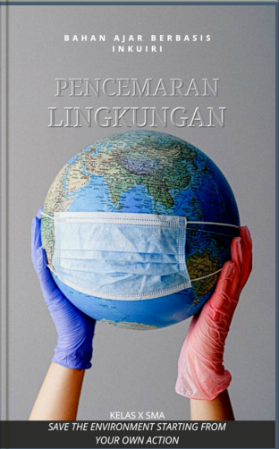

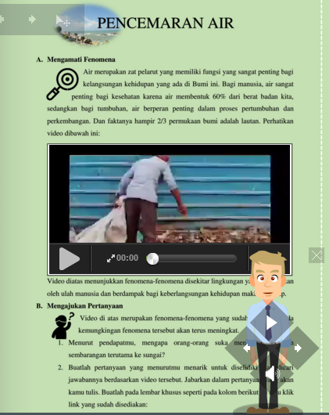
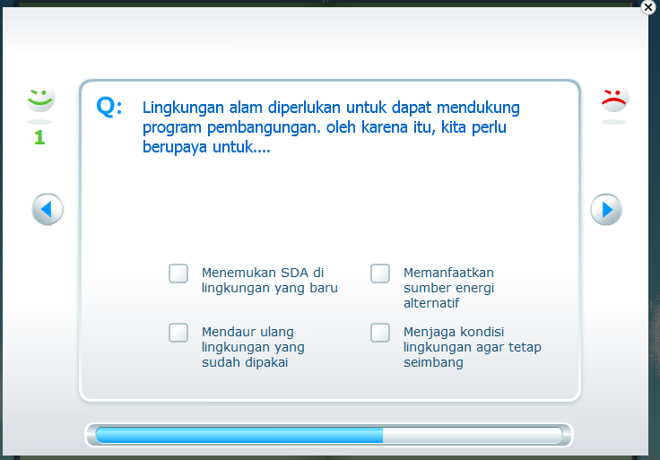

Figure 1. Appearance of inquiry-based e-learning materials
Data obtained from the validation results of inquiry-based e-teaching materials on environmental pollution material carried out by 3 validators and 2 supervisors who provided input and suggestions. presented in the following Table 1

Tabel 2. The Supervisor Appears
Component | The Supervisor Appears
Material | The content of the instructional materials is excellent and complies with the curriculum's requirements.
Media | 1. Since this is an electronic-based system, you must employ a variety of functions like video, audio, search, and electronic-based work. rather of converting the book to electronic  2. To make it simpler for students to find something in teaching materials, use logos and hyperlinks.
Language | 1. Be mindful of your language choices; you need to modify it for high school students.  2. Be careful when writing to avoid typing errors
Based on table 2, experts have concluded that e-teaching materials are effective and can be used with only modest adjustments. after which it was updated based on feedback from the supervisor and was prepared for validation. To collect suggestions for improvement, this validation was only conducted with 3 biology professors. BNSP is referred to in the instrument used to validate e-teaching materials. Table 2 displays the findings of the validation of instructional materials.
Tabel 3. Validation Results
No | Assessment Aspects | Score Average | Persentase
1 | Content Eligibility | 3,66 | 91,5 %
2 | Eligibility of Presentation | 3,62 | 90,6%
3 | Feasibility of Contextual Assessment | 3,0 | 75%
4 | Language | 3,27 | 81,75 %

Based on table 3, the validator's data on the feasibility element of the content was 91.5%, according to the results. This demonstrates how highly feasible the content of teaching materials is. The findings obtained in terms of presenting feasibility were 90.6%. This further demonstrates how feasible it is to present educational materials. possible aspects Results of the contextual assessment are 75%. This demonstrates the viability of the contestual eligibility. Considering linguistic factors, the scores were 81.75%. This demonstrates how viable the terminology employed in this electronic resource is. According to the findings of the research, the development of the inquiry-based e-teaching materials has complied with the accepted standards by professionals.
Then, once the instructional materials are current and usable. The electronic content is used in educational activities. the use of this online learning content to raise pupils' environmental literacy levels. the results of the implementation of inquiry-based e-teaching materials are presented in table 4

Table 4 Environmental Literacy Ability Data Recapitulation
Data | Kelas Kontrol |  | Kelas Eksperimen
Data | Pretest | Posttest | Pretest | Posttest
Jumlah Siswa (N) | 35
Skor Minimun | 25 | 50 | 20 | 55
Skor Maksimum | 70 | 90 | 80 | 90
Rata-rata | 48,4 | 66,8 | 54,5 | 72,4
Standar Deviasi | 11,991 | 10,152 | 13,415 | 10,316
Uji Normalitas (Pretest) | 0,203 (Normal)
Uji Homogenitas (Pretest) | 0,720 (Homogen)
Uji Paired Sample T-test (Pretest) | 0,032 (Berbeda Signifikan)
The average pretest scores of pupils in the control class and experimental class are low, as shown in Table 4.3. The normality test findings show that the pretest data is normally distributed based on the results of the prerequisite test. The data variant is homogeneous, according to the findings of the homogeneity test. The paired sample T-test will be used because the data fits the criteria, namely that it is homogeneous and normally distributed. The paired sample T-test findings showed a significant value of 0.032 for the pretest data. Therefore, it may be stated that there is a significant difference in the average student value because the P-value is less than the value 0.05.
A test will then be conducted to determine the impact of the application of inquiry-based E-teaching materials on environmental pollution, which is seen based on the N-gain presented in Table 5, in light of the fact that there are differences in students' initial knowledge between the control class and the experimental class.
Table 5 Environmental Literacy Ability N-gain
Class | N-gain | Interpretasi
Control | 0,36 | Currently
Eksperiment | 0,43 | Currently

Based on table 5, Students in the experimental class had an average n-gain that is higher than those in the control class. This is so that students are engaged and active participants in the learning process, which is the goal of inquiry-based e-learning materials. Rusyadi (2021) argues that inquiry-based learning helps pupils build knowledge, a comprehension of the world's scientific ideas, and higher-order thinking abilities. Education will be able to educate kids and will be immediately improved by learning that is intended to train students in higher order thinking. Uswatun and Rohaeti (2015) claim that using inquiry-based learning tools can help students develop their critical-thinking abilities and attitudes. This demonstrates that adopting inquiry-based e-learning materials helps students achieve good learning results.
This is so that students may best master the subject that has been taught since learning utilizing inquiry-based teaching materials will encourage students to think methodically so that knowledge of the concepts learnt can be minimized. Additionally, the challenges in inquiry-based teaching materials include local environmental issues or environmental issues that are currently trending, which makes learning more active and encourages student participation. By asking questions and seeking out solutions based on their curiosity, children can improve intellectual discipline and thinking abilities through inquiry-based learning, according to Sanjaya (2008). In accordance with the findings of research by Komalasari (2019) and Hanif et al. (2016), who found that the use of inquiry-based teaching materials was successful in the learning process and may enhance students' conceptual comprehension abilities. As a result, learning will be more pleasurable and meaningful. Students will get meaningful learning experiences if the learning process is enjoyable. Since students will essentially return to their home environments, this learning experience affects not only the learning outcomes but also the environment. If what is learned is put to use in daily life, the advantages of good learning will become apparent. According to the findings of the research presented by Yuliyanti, inquiry-based learning has an impact on student character.
The use of electronic media also contributes to the knowledge of students. E-teaching materials have a number of characteristics that will aid students in their learning and make it more active and interactive. In keeping with Ashyfah and Rasmi's research (2023), which claims that electronic media significantly enhances student learning outcomes and is very beneficial to the learning process. Due to these findings, the experimental class's outcomes utilizing inquiry-based e-learning materials outperformed the control group's performance using common textbooks.

Conclusion
Based on the results and discussion obtained, inquiry-based teaching materials on environmental pollution material are declared valid and suitable for use in the biology learning process. And students' environmental literacy skills increased significantly after the implementation of inquiry-based e-learning materials.

Recommendation
Students must bring a smartphone or laptop to use the e-learning material because it is based on the Android operating system. It is possible to gauge pupils' critical thinking abilities through future research.

Acknowledgment
First, I would like to thank my parents for funding this research. Second, thanks to the lecturers who have guided the research writing process. Third, thanks to the biology teachers and high school students in Cimahi who have helped with the research process. Fourth, thanks to all parties involved in this research.

References
Abdullah, Ramli. (2012). "Pembelajaran berbasis pemanfaatan sumber belajar." Jurnal Ilmiah Didaktika: Media Ilmiah Pendidikan dan Pengajaran
Agustina, P., Al Muhdhar, M. H. I., & Amin, M. (2014). Pengembangan Modul Inkuiri Berorientasi Life Skills pada Materi Pencemaran Lingkungan untuk Siswa Kelas X Sekolah Menengah Atas (SMA). In Proceeding Biology Education Conference: Biology, Science, Enviromental, and Learning (Vol. 11, No. 1, pp. 771-779).
Akdon, dan Riduwan. 2013. Rumus dan Data Dalam Analisis Statistika. Bandung: Alfabeta
Ardan, A. S. (2016). The Development of Biology Teaching Material Based on the Local Wisdom of Timorese to Improve Students Knowledge and Attitude of Environment in Caring the Preservation of Environment. International Journal of Higher Education, 5(3), 190-200.
Ashyfah, U., & Rasmi, D. A. C. (2023). Efektivitas Modul Elektronik terhadap Hasil Belajar Biologi Peserta Didik Tingkat Sekolah Menengah Atas Kelas X. Journal of Classroom Action Research, 5(2), 270-276.
Daryanto. (2013). Menyusun Modul: E-bahan ajar untuk Persiapan Guru dalam Mengajar.Yogyakarta: Gava Media.
Fidan, Nuray Kurtdede, and Tugba Selanik Ay. "Acquisition of Operational Environmental Literacy in Social Studies Course." International Journal of Environmental and Science Education 11.13 (2016): 5951-5968.
Hanif, H., Ibrohim, I., & Rohman, F. (2016). Pengembangan perangkat pembelajaran biologi materi plantae berbasis inkuiri terbimbing terintegrasi nilai islam untuk meningkatkan pemahaman konsep siswa sma. Jurnal Pendidikan: Teori, Penelitian, dan Pengembangan, 1(11), 2163-2171.
Komalasari, B. S., Jufri, A. W., & Santoso, D. (2019). Pengembangan E-bahan ajar IPA Berbasis Inkuiri Terbimbing untuk Meningkatkan Literasi Sains. Jurnal Penelitian Pendidikan IPA, 5(2), 219-227.
Komariah, N., Yusup, P. M., Saepudin, E., & Rodiah, S. (2017). Pendidikan literasi lingkungan sebagai penunjang desa wisata agro kecamatan padaherang kabupaten pangandaran. Dharmakarya, 6(2).
Kusumaningrum, D. (2018). Literasi lingkungan dalam kurikulum 2013 dan pembelajaran ipa di sd. Indonesian Journal of Natural Science Education (IJNSE), 1(2), 57-64.
Nengsih, S., & Afriani, W. (2019). Pengembangan LKS Biologi Berbasis Inkuiri Terbimbing Materi Sistem Regulasi. BIOEDUSAINS: Jurnal Pendidikan Biologi Dan Sains, 2(1), 50-59.
Nurdyansyah, N., & Fahyuni, E. F. (2016). Inovasi model pembelajaran sesuai kurikulum 2013.
Permatasari, I., Ramdani, A., & Syukur, A. (2019). Pengembangan E-bahan ajar IPA Berbasis Inkuiri Terintegrasi Sets (Science, Environment, Technology And Society) pada Materi Sistem Reproduksi Manusia. Jurnal Pijar Mipa, 14(2), 74-78.
Sari, Fransiska Faberta Kencana, and Idam Ragil Widianto Atmojo. "Analisis Kebutuhan Bahan Ajar Digital Berbasis Flipbook untuk Memberdayakan Keterampilan Abad 21 Peserta Didik pada Pembelajaran IPA Sekolah Dasar." Jurnal Basicedu 5.6 (2021): 6079-6085.
Sanjaya, W. (2008). Perencanaan & desain sistem pembelajaran.
Sugiyono. (2017). Metode Penelitian Kuantitatif, Kualitatif, dan R&D. Bandung : Alfabeta,
CV.
Uswatun, D. A., & Rohaeti, E. (2015). Perangkat pembelajaran IPA berbasis inkuiri untuk meningkatkan critical thinking skills dan scientific attitude siswa. Jurnal Inovasi Pendidikan IPA, 1(2), 138-152.
Windyariani, Sistiana, and Astri Sutisnawati. "Pengembangan bahan ajar berbasis konteks dan kreativitas untuk melatihkan literasi sains siswa sekolah dasar." Jurnal Bioedukatika 4.2 (2016): 19-25.
Yusliani, Erlina, Hanana Laila Burhan, and Nurul Zakiatin Nafsih. "Analisis integrasi keterampilan abad Ke-21 dalam sajian buku teks fisika SMA Kelas XII Semester 1." Jurnal Eksakta Pendidikan (JEP) 3.2 (2019): 184-191.

