Development of 'Smart Egg Puzzle' Media with the ADDIE Model in Introducing Numbers to Early Childhood

Rizka Febrilia Inkasari¹, Indah Kharismawati^{2*}, Selasi Priatiningsih³
^{1,2*,3}Universitas PGRI Argopuro Jember
*Corresponding Author e-mail: iendah.kharismawati@gmail.com

Abstract: This study aimed to develop a ‘smart egg puzzle’ as a learning tool to introduce numbers to 5-6-year-old children at TK Lab.School IKIP PGRI Jember. The development process followed the ADDIE Model, which includes Analysis, Design, Development, Implementation, and Evaluation stages. After validation by media and material experts, the ‘smart egg puzzle’ was found to be highly valid, with an 88.75% validation rate from media experts and an 83.92% validation rate from material experts. Additionally, practicality assessments by teachers indicated that the learning media was very practical, with an average score of 90.38%. The effectiveness of the ‘smart egg puzzle’ was tested with pretests and posttests, showing a significant improvement in students' number recognition skills. The development of the ‘smart egg puzzle’ was found to be effective and met the criteria for validity, practicality, and effectiveness, making it a suitable learning tool for students at TK Lab.School IKIP PGRI Jember. | Article History  Received: 2  Revised:  Published:.. 2017  Key Words :  Smart egg puzzle, ADDIE model, Early Childhood.
How to Cite: First author., Second author., &amp; Third author. (20xx). The title. Jurnal Paedagogy: Jurnal Penelitian dan Pengembangan Pendidikan, vol(no). doi:https://doi.org/10.33394/jp.vxxyyi
 https://doi.org/10.33394/jp.vxxyyi | This is an open-access article under the CC-BY-SA License.

The importance of learning number recognition for children from an early age will greatly affect the intelligence of mathematical logic in each child or individual, because counting in mathematics is often encountered or used in everyday life. Thus, it is necessary to introduce numbers from an early age, so that each child or individual has the ability and readiness to recognize numbers for counting (Mufarizuddin, 2017). Cognitive ability is closely related to the level of intelligence (intelligence) possessed in each individual who characterizes a person with various interests, especially those aimed at ideas and interest in learning. Cognitive is a thought process, which is the ability possessed in each individual to be able to assess, consider and connect an event or event (Setyani et al., 2023).
The low ability of early childhood in recognizing number symbols often assumes that learning related to numbers or numbers is a very difficult subject to understand. In various ways that have been done by educators to teach basic mathematics learning materials for early childhood related to numbers, counts, numbers and others, starting with conventional learning methods where the learning process uses the lecture method, namely oral delivery between teachers and students and uses tools in the form of learning media to be able to attract children's attention during the learning process in the classroom so that they can be easily understood (Utami & Sriwijaya, 2021)(Björklund et al., 2020).
Based on the results of observations and interviews conducted by researchers on June 08, 2023 at TK Lab.School IKIP PGRI Jember in children aged 5-6 years, with a total of 16 children and developmental achievements in recognizing number symbols by observing learning activities at school. The learning process at TK Lab.School IKIP PGRI Jember uses a conventional learning process which is a learning process using the lecture method as a means of oral communication between the teacher and students during the learning process in the classroom. So that researchers want to increase children's interest in learning in the classroom and improve children's ability to recognize numbers using number puzzle learning media.
About 60% of children are less able to correctly mention number symbols in sequence, use number symbols to count, match numbers with number symbols, and make sequences of numbers 1-20 correctly. In addition, the lack of use of learning media as a tool during the learning process, so that children still seem to find it difficult to understand what is conveyed by the teacher in the classroom during the learning process. In addition, children's participation and activeness in the classroom is very low due to their low ability to recognize numbers and the lack of supporting learning media in the classroom. Thus children do not have the confidence to answer questions given by the teacher in the classroom related to numbers. This is because the child's understanding of recognizing numbers is still low (Khumaeroh & dkk, 2018). In delivering the material used to learn children, namely in the form of blackboards, magazines and paper cutouts. So that it causes children's learning boredom. While the problem in language skills is that most group b children aged 5-6 years do not have the ability to language, namely narrating about the pictures they make and asking questions. Puzzle education games are expected to develop cognitive and language skills, and reduce the level of boredom in children's learning. This is in line with the research of (Hermawan et al., 2017) in his journal stated as a Puzzle game based on conditions that are easy to understand and can trigger math skills.
Several studies on media development have been conducted including (Sintia, 2020)(Fitriyah et al., 2021)(Pertiwi et al., 2022)(Kirana et al., 2022). Learning media development is one of the efforts to improve the quality of learning. In developing learning media, it should also be noted that the learning media developed must be able to support independent learning by students without being accompanied by a teacher, and can be accessed easily by students (Sintia, 2020)(Friwahyuni et al., 2022). In addition, the learning media developed must be developed on material whose phenomena are actually easily observed by students in everyday life (Rahmatia et al., 2021). In the development of learning media, it is necessary to analyze student needs, design learning media that suits their needs, develop learning media by material validation experts and media experts, and test learning media on students (Hartati, 2018)(Saurina, 2016).
Learning media that is interesting and interactive can help early childhood in understanding basic concepts such as numbers. One of the learning media that can be used is Smart Egg Puzzle. In this study, the development of Learning Media 'Smart Egg Puzzle' uses the ADDIE Model (Analysis, design, development, implementation, evaluation). The goal of this research is to develop a 'Smart Egg Puzzle' to introduce numbers to children aged 5-6 years in kindergarten Lab.School IKIP PGRI Jember.

Research Method
The research method used in the development of Learning Media 'Smart Egg Puzzle' with the ADDIE Model involves a series of stages consisting of Analysis, Design, Development, Implementation, and Evaluation.
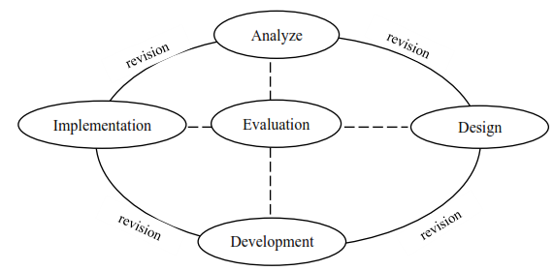
Figure 1. ADDIE Model

The stages of the ADDIE model in this 'smart egg puzzle' Learning Media Development research in introducing numbers to Early Childhood are as follows:
- Analysis
The stages of analysis in this research are: 1) Identification of learning problems in students at TK Lab.School IKIP PGRI Jember. 2) Evaluate students' learning needs, learning preferences, and obstacles they may face. 3) Analysis of available learning media, such as learning media to introduce numbers in early childhood as support.
- Design
The stages of design in this research are: 1) Determine specific learning objectives: Introducing numbers and basic math concepts. 2) Designing the structure of the 'smart egg puzzle' learning media. 3) Selecting the type of materials and colors in the media to be developed that are in accordance with the character of early childhood. 4) Designing expert validation sheets and observation sheets to measure number comprehension.
- Development
The stages of development in this research are: 1) Making learning media 'smart egg puzzle' that has been designed. 2) Validating media experts and material experts on the media that has been made.
- Implementation
The stages of implementation in this study are: 1) Test the learning media 'smart egg puzzle' that has been made to students aged 5-6 years at TK Lab.School IKIP PGRI Jember. 2) Ensuring the use of media in real learning situations. 3) Observation of students' responses and their interaction with the 'smart egg puzzle' learning media that has been made.
- Evaluation
This stage of evaluation in this research exists at each stage of the ADDIE model. Analyze the data to measure the achievement of learning objectives that have been set at the implementation stage. use the evaluation results to refine and improve the learning media if needed.
This ADDIE model scheme provides a systematic step-by-step guide to develop 'smart egg puzzle' learning media and ensure that this media is effective in introducing numbers to early childhood.
The data analysis techniques used in this research are qualitative and quantitative analysis techniques. Qualitative data in this study were obtained from validator input at the validation stage including material experts and media experts. While quantitative is data that describes the results of product development in the form of a 'smart egg puzzle' to improve number recognition in children at TK Lab.School IKIP PGRI Jember. The results of data analysis are used as a basis for revising the products developed. The data that has been obtained by researchers is then analyzed to determine the feasibility of the product developed. The response questionnaire is quantitative data can be processed by presenting the percentage using a Likert scale as a measuring scale.

Table 1. Criteria for product eligibility
Percentage Score (%) | Criteria
0-25 | Invalid
26-50 | Less valid
51-75 | Valid
76-100 | Very valid

Table 1. is a criterion for the feasibility of a product, that product development, namely learning media, will be said to be feasible when the assessment score of this learning media has met the eligibility requirements with the level of material suitability and media feasibility in media development, which is> 51% or included in the valid and very valid criteria.

Table 2. Response questionnaire criteria
Percentage Practicality score (%) | Criteria
0 ≤ P < 55 | Not practical
55 ≤ P < 60 | Less practical
60 ≤ P < 75 | Practical enough
75 ≤ P < 85 | Practical
85 ≤ P < 100 | Very Practical

Table 2. are the criteria for the response questionnaire, that the 'smart egg puzzle' media developed is said to be practical if it gets a good response from students and teachers, namely ≥ 60% or quite practical, practical, and very practical.
Table 3. Score Interpretation
Interval | Score | Criteria
85 ≤ Score < 100 | A | Very effective
65 ≤ Score < 85 | B | Effective
55 ≤ Score < 65 | C | Moderately effective
45 ≤ Score < 55 | D | Less effective
0 ≤ Score < 45 | E | Not effective

Table 3. Is an interpretation of the value for the effectiveness test of the product developed, that the development of the 'smart egg puzzle' media is said to be effective if it meets 3 conditions, namely the posttest value on the criteria ≥ 65 or good, the average posttest value above the pretest value, and if the average posttest value ≥ 75 according to the KKM.

Result and Discussion
The results of this 'Smart Egg Puzzle' learning media development research through the stages of the ADDIE model, which consists of:
- Analysis
The needs analysis conducted on students at the IKIP PGRI Jember Lab.School Kindergarten is the unavailability of game media to attract children to play and learn. The only media available are posters and other learning books. Therefore, the 'Smart Egg Puzzle' media is very useful for children to help develop number recognition in early childhood. The needs analysis conducted by researchers aims to identify the availability and state of learning media used and the result is the unavailability of learning media such as those developed by researchers.
Analysis of the characteristics of different children is used as a consideration for developing learning media to be used. The level of number recognition ability in children at Lab.School IKIP PGRI Jember Kindergarten is different. Researchers developed learning media in the form of 'Smart Egg Puzzle' games that are tailored to children's abilities and can be used by all children in Lab.School IKIP PGRI Jember Kindergarten. Based on unstructured interviews with teachers at the Lab.School IKIP PGRI Jember Kindergarten, the ability to recognize numbers in children varies, causing learning activities to be less well implemented. Based on the results of the following analysis, learning media in the form of 'Smart Egg Puzzle' media is expected to be able to improve the ability of number recognition in TK Lab.School IKIP PGRI Jember.
The curriculum analysis used by TK Lab.School IKIP PGRI Jember is an independent curriculum. This curriculum analysis aims to find out the curriculum used at the school to be adjusted to the learning media developed by the researcher. Curriculum analysis is used to determine teaching materials for children. teaching materials used are adjusted to the level of developmental achievement and indicators in the curriculum. Indicators of learning implementation are used as a reference for making learning objectives. The learning objectives to be achieved in this learning activity are that children have the ability to recognize numbers, train children's physical motor skills and are able to socialize with peers well.

- Design
At the design stage that has been carried out in this study, it has compiled an instrument for assessing the quality of the product developed in the form of a checklist questionnaire for media experts and material experts. At this stage begins with the preparation of a questionnaire lattice and the preparation of a questionnaire, the results of this stage have obtained a validation questionnaire that will be given by media experts and material experts. To determine the feasibility of the 'Smart Egg Puzzle' media that has been developed, then the practicality test by the teacher, and also conducted a small group trial and a large group trial.
This 'Smart Egg Puzzle' media is designed to be as interesting as possible, which initially the puzzle game was just a game to put together broken pieces to form a predetermined image or writing, where the game only sat arranging puzzle pieces. So at this design stage the researchers redesigned starting from maintaining materials that are safe and resistant to children, interesting puzzle shapes, with colorful origami colors that attract children's attention, and added numbers from the pieces of the 'smart egg puzzle'. Then the 'Smart Egg Puzzle' media that has been developed is validated by media experts and material experts to determine the feasibility of the product, and after validation the 'Smart Egg Puzzle' media that has been developed is declared feasible to be tested on children aged 5-6 years at TK Lab.School IKIP PGRI Jember.

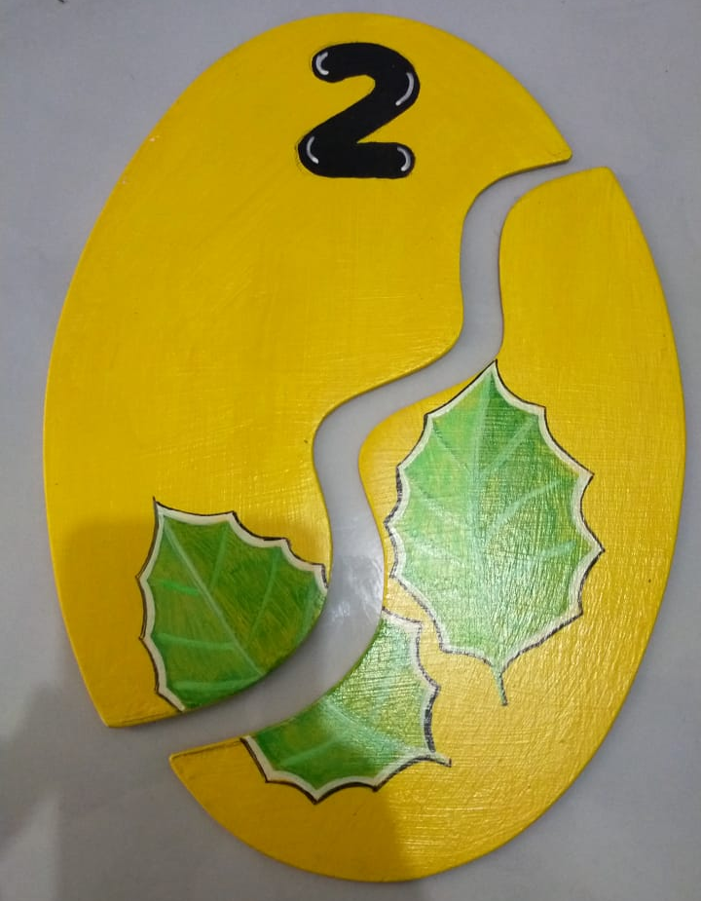
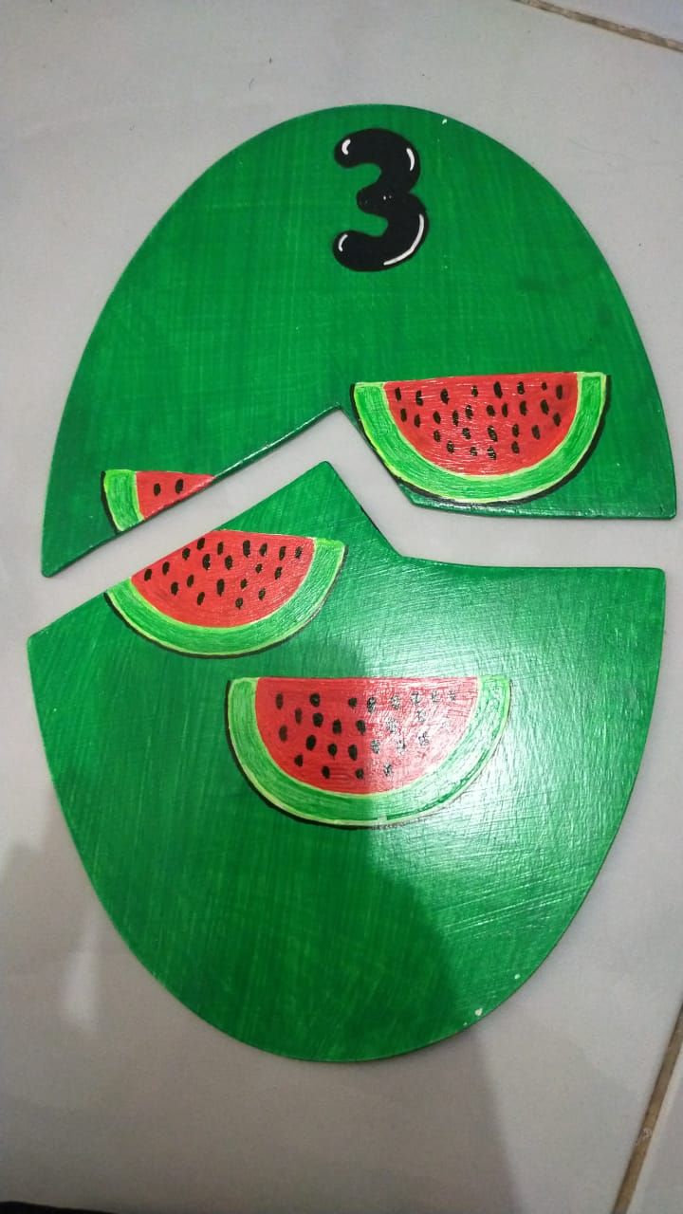
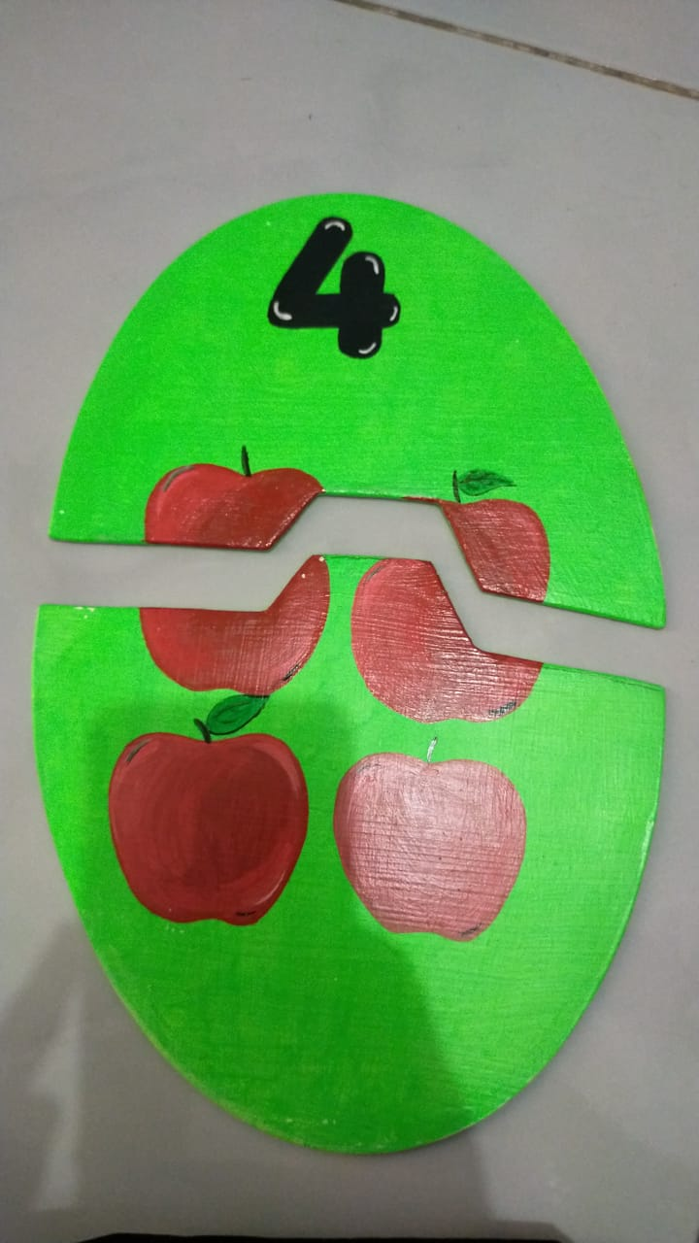
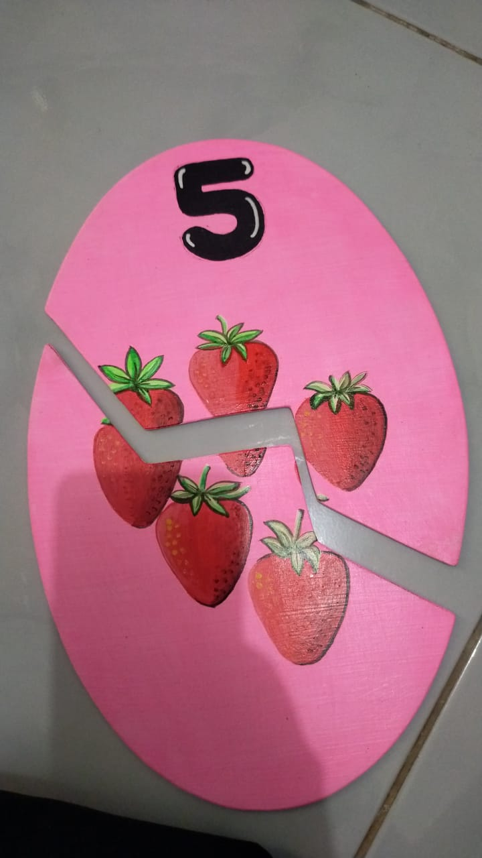

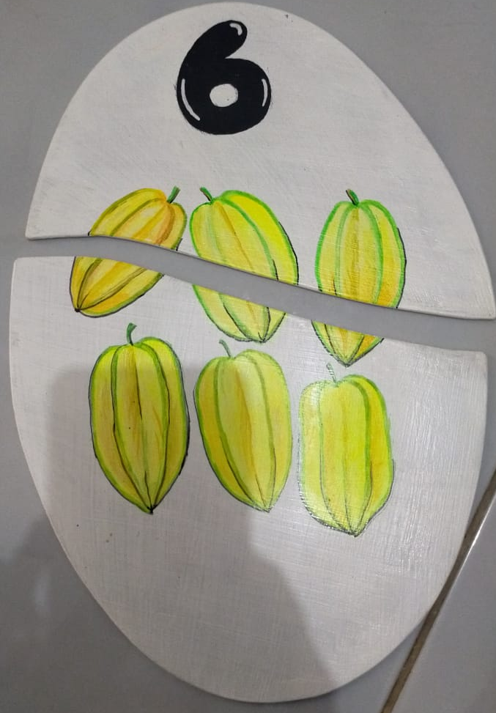
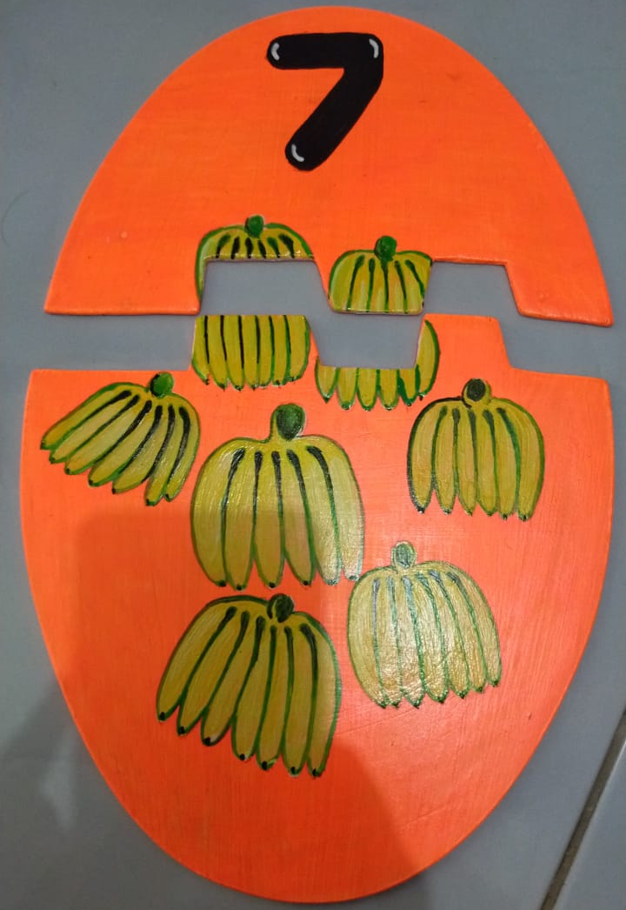
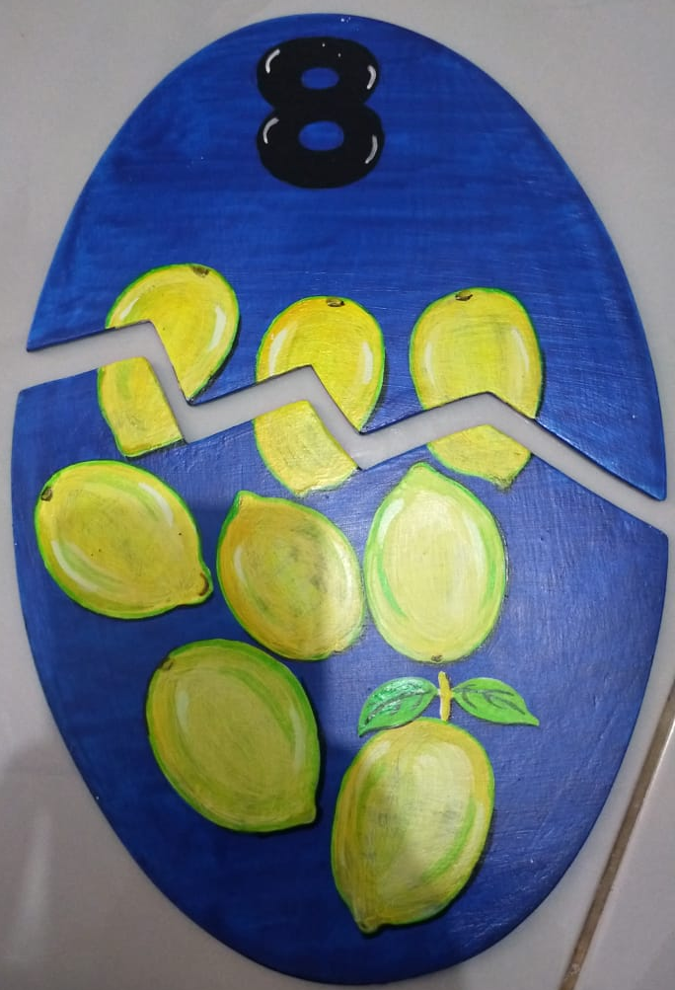
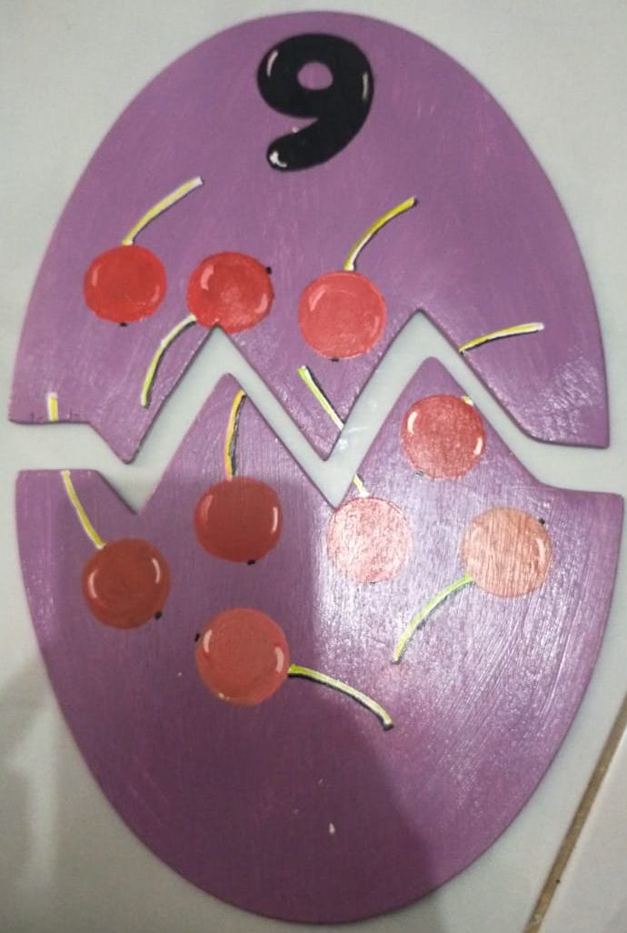
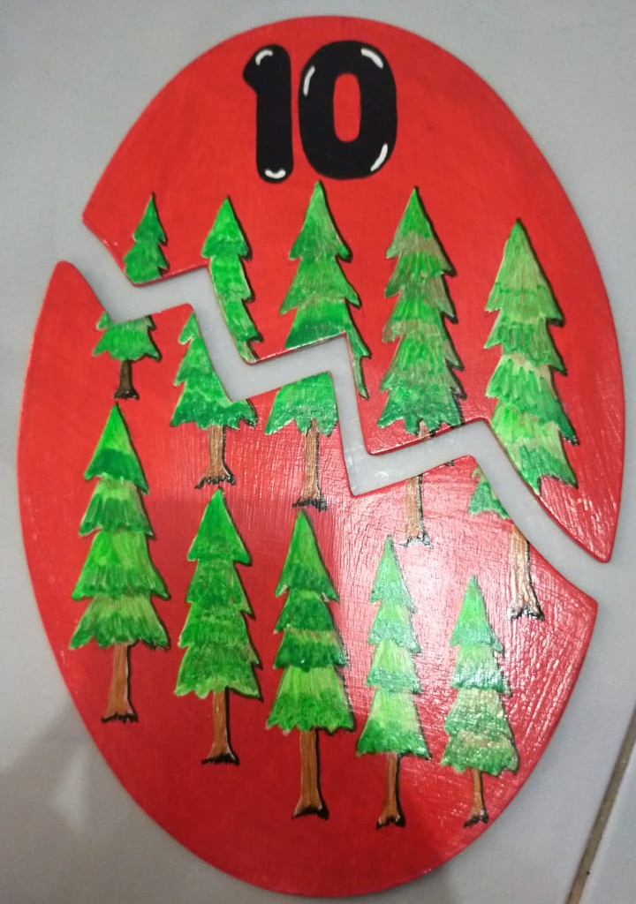

Figure 2. ‘Smart egg puzzle’ media that has been designed and developed

Figure 2. is the 'smart egg puzzle' media that the researchers have developed based on the indicators of number recognition development, the researchers made several changes that make this game interesting, one of which is the 'Smart Egg Puzzle' game steps which are not just like sitting still arranging puzzle pieces, with this 'Smart Egg Puzzle' the researchers made unique and interesting game steps, of course, attracting children to play while learning to recognize numbers, thus the 'Smart Egg Puzzle' method that the researchers developed is expected to increase the enthusiasm and interest in learning children, especially in the TK Lab.School IKIP PGRI Jember.

- Development
Media expert validation has been carried out to fill out an assessment questionnaire sheet on each aspect of the assessment consisting of 3 aspects which have 20 questions, all of which have been filled in by the media expert. Validators of media experts are lecturers who have a concentration on learning media. Media expert assessment on the learning media 'smart egg puzzle' can be seen in Table 4.

Table 4. The results of learning media expert validation
Aspects | Score | Maximum score | Percentage (%) | Criteria
Clarity of media display | 3 | 4 | 75 | Valid
Pattern design of 'smart egg puzzle' media | 10 | 12 | 83,33 | Very valid
Use of 'smart egg puzzle' media | 58 | 64 | 90,63 | Very valid
Total number of scores | 71 | 80
Percentage | 88,75%
Criteria | Very valid
In table 4. the results of the validation test by learning media experts obtained a total of 71 out of a maximum score of 80 with a percentage of 88.75% and stated in very valid criteria.
Material expert validation has been carried out by filling out an assessment questionnaire sheet on each aspect of the assessment consisting of 2 aspects which have 14 questions all filled in by the material expert. The results of the material expert assessment on the 'smart egg puzzle' learning media can be seen in Table 5.

Table 5. Material expert validation results
Aspects | Score | Maximum score | Percentage (%) | Criteria
Content feasibility | 34 | 40 | 85 | Very valid
Presentation | 13 | 16 | 81,25 | Very valid
Total score | 47 | 56
Percentage | 83,92%
Criteria | Very valid
In table 5. The results of the validation test by material experts obtained a percentage of 83.92% with a total of 47 out of a maximum score of 56 and stated in very valid criteria.
- Implementation
At the implementation stage, an assessment of the level of practicality and effectiveness of the 'smart egg puzzle' learning media that has been developed has been carried out. The practicality test stage has been carried out a field trial, with a total of 11 students and 1 teacher of TK Lab.School IKIP PGRI Jember. The effectiveness test that has been carried out aims to determine the extent to which the product made can make students meet the KKM provisions. Data on the effectiveness of learning media 'smart egg puzzle' seen from the ability to recognize the numbers of students increased.
Practicality test by kindergarten teachers Lab.School IKIP PGRI Jember which has been calculated in the teacher's practicality questionnaire as an assessment of the developed media. Covering aspects of instructions, aspects of attractiveness, aspects of the process and ease of use, benefits and efficiency of learning time. The complete assessment results can be seen in Table 6.

Table 6. Practicality test by teacher
Aspects | Score value of each aspect | Maximum score | Percentage (%) | Criteria
Attractiveness | 14 | 16 | 87,5 | Very practical
Process and ease of use | 22 | 24 | 91,6 | Very practical
Benefits of | 7 | 8 | 87,5 | Very practical
Efficiency of learning time | 4 | 4 | 100 | Very practical
Total score | 47 | 52
Percentage | 90,38%
Criteria | Very practical

The effectiveness test has been carried out by testing the ability twice, namely the first test (pretest) or before using the 'smart egg puzzle' media, and the second test (posttest) after using the 'smart egg puzzle' media. The following are the results of the first test (pretest) and the results of the second test (posttest) after using the 'smart egg puzzle' media can be seen in Table 7.
Table 7. Results of pretest and posttest in the 'smart egg puzzle' media effectiveness test
Name | Pretest Score  (before using 'smart egg puzzle' media) | Posttest Score  (after using 'smart egg puzzle' media)
Learner 1 | 40 | 80
Learner 2 | 40 | 80
Learner 3 | 30 | 60
Learner 4 | 40 | 60
Learner 5 | 50 | 90
Learner 6 | 80 | 90
Learner 7 | 80 | 100
Learner 8 | 20 | 70
Learner 9 | 60 | 90
Learner 10 | 60 | 80
Learner 11 | 40 | 80
Average score | 49,09 | 80

After developing the learning media 'smart egg puzzle' and testing it on students at TK Lab.School IKIP PGRI Jember, it can be seen that each stage has increased, although there are some students who are still in the unfinished category. Based on the results of the posttest scores, it is known that there are still 2 students who have scores below the KKM that have not been declared complete and there are 9 students who get scores above the KKM. The average obtained from the posttest scores of 11 students is 80 in the good criteria. Overall, from the posttest results, students' problem solving skills are good and have improved.
- Evaluation
At this stage, the second evaluation of data is carried out in the form of suggestions obtained from media experts and material experts as well as children's posttest and pretest observation sheets from the implementation stage which are used to determine children's number recognition abilities. The results of the above research indicate that the use of 'Smart Egg Puzzle' media is feasible, practical and able to improve the ability of number recognition in early childhood at TK Lab.School IKIP PGRI Jember. Children are able to recognize numbers and apply them in everyday life this is because 'Smart Egg Puzzle' can be used in a relaxed manner in the form of interesting and unique games so as to increase children's learning motivation.

Discussion
Based on the detailed results and descriptions of the research results described above, a learning media in the form of 'smart egg puzzle' media is obtained to improve children's number recognition. learning media is developed with the ADDIE research and development model (Analysis, Design, Develop, Implement, Evaluation) (Sugihartini & Yudiana, 2018).
The first stage of the ADDIE development model is the analysis stage. The analysis stage is divided into needs analysis, student characteristics analysis, and curriculum analysis. Needs analysis is conducted to identify the availability of pre-existing learning tools. From the results of teacher interviews, it was found that the learning tools to be developed did not exist and had never been applied at the TK Lab.School IKIP PGRI Jember. Analysis of student characteristics is carried out to identify the abilities of children to be studied. From the results of analyzing children's characteristics, it is obtained that children's abilities vary. Curriculum analysis is used to identify the curriculum applied and as a reference for making learning tools that are in accordance with the core competencies and basic competencies in the curriculum.
After the analysis stage is carried out, the researchers carry out the next stage, namely the design stage at the design stage, designing the appropriate 'smart egg puzzle' media based on the data obtained from the initial research stage based on the needs analysis. At this design stage, the 'smart egg puzzle' media that will be developed starting from the selection of media materials, media colors, media displays, images and media sizes must be in accordance with the characteristics of children aged 5-6 years.
Media 'smart egg puzzle' is shaped like an egg made of plywood, played in a unique way unlike the usual puzzle game that just sits quietly arranging puzzle pieces. This 'smart egg puzzle' media is played in a way that is determined by steps that have been designed by researchers that are interesting and unique to stimulate children's interest in playing and not boring. This 'smart egg puzzle' media is made to develop number recognition to early childhood to be applied in everyday life. So that the resulting 'smart egg puzzle' media becomes truly suitable media to support learning, especially number recognition in children.
Then at the development stage that has been carried out this is the initial stage in making the 'smart egg puzzle' media which will become a complete unit and validation by experts, the purpose of validation by these experts is to obtain input, criticism and suggestions for improvement and perfection of the 'smart egg puzzle' media developed. At the implementation stage, the 'smart egg puzzle' media has been tested on students aged 5-6 years at the Lab.School IKIP PGRI Jember Kindergarten and has not undergone revision, this can be seen from the students as the test subjects being able to use and play the 'smart egg puzzle' media developed in number recognition so that students have an increase in number recognition as evidenced by the results of the pretest and posttest. So, by using this 'smart egg puzzle' media can facilitate children in number recognition, the use of 'smart egg puzzle' media in the teaching and learning process can increase the desire and interest in learning for children. In addition, the ability of children's number recognition in TK Lab.School IKIP PGRI Jember increased because in essence children need concrete and fun media such as the 'smart egg puzzle' media.
After the development of the 'smart egg puzzle' media at TK Lab.School IKIP PGRI Jember, it can be seen that each stage has increased, although there are some students who are still in the unfinished category. Based on the results of the posttest scores, it is known that there are still 2 students who have scores below the KKM that have not been declared complete and there are 9 students who get scores above the KKM. Overall, from the posttest results, the number recognition ability of students is good. Based on the results that have been obtained, it can be concluded that the development of the 'smart egg puzzle' media to improve number recognition skills in kindergarten Lab.School IKIP PGRI Jember is declared effective and has met 3 requirements, namely the posttest score with a score of 80 in good criteria, the average posttest score is above the pretest score, and the average posttest score is above 75 or according to the KKM.
According to (Nari et al., 2020) in their research stated that providing educational tools in the form of Puzzle games can improve children's cognitive. Puzzle games are one of the game learning methods that can develop cognitive abilities. Apart from being used for cognitive development, puzzles can also be used for language development. This is in line with (Trimantara et al., 2019) which concluded that children's language development can be developed through educational games in the form of puzzles. According to research (Sunarti & Dalle, 2017) in his journal states that the right language settings in puzzles can be used to logically determine the nature of objects. The results of (Zusanti et al., 2022) discuss six logic puzzles that are available in smartphone applications, namely thermometer puzzles, color puzzles, infinite circles, sliders and free flow. Of the six games used to introduce math concepts. Which is part of cognitive development. In research conducted by (Ningrum et al., 2022)(Made & Asri, 2020), the development of Smart Egg Puzzle learning media with the ADDIE model has proven effective in introducing numbers to early childhood. In the study, Smart Egg Puzzle was used as a learning media for early childhood in kindergarten. The results showed that the use of Smart Egg Puzzle can improve children's ability to recognize numbers.
The use of 'smart egg puzzle' media that has been developed makes it easier for students to learn and recognize numbers so that students are able to apply them in everyday life. In addition, the ability of students in TK Lab.School IKIP PGRI Jember in terms of number recognition really needs concrete media that is fun like this 'smart egg puzzle' media. So, with the application of the 'smart egg puzzle' media developed in the introduction of numbers, especially for children aged 5-6 years in kindergarten Lab.School IKIP PGRI Jember can increase.
The development of the 'smart egg puzzle' learning media that has been made has several advantages as a learning media, especially in terms of improving early childhood number recognition, namely as follows; 1) The 'smart egg puzzle' media can improve children's number recognition, this is evidenced by the results of the validation of material experts and media experts, and has been tested for practicality and pretest and posttest tests. 2) Media 'smart egg puzzle' can be used as a fun learning media, when children use Media 'smart egg puzzle' all children are enthusiastic and they look very happy. 3) The 'smart egg puzzle' media uses interesting designs and game steps so that it can attract attention and make it easier for children to understand what they want to convey.

Conclusion
Based on the results of the validation of 2 experts, namely media experts, and material experts to test the feasibility of developing learning media 'smart egg puzzles' to introduce numbers, it is declared very valid for use with a percentage value of 88.75% in the media expert validation test and 83.92% in the material expert validation test, so the learning media 'smart egg puzzle' in introducing numbers that have been developed are said to be very valid.
The results of the practicality assessment conducted by the teacher, where the results on the teacher's practicality questionnaire sheet gave an average score of 90.38% on the practicality test of the developed 'smart egg puzzle' learning media can be categorized as very practical.
The effectiveness test of the development of 'smart egg puzzle' media in introducing numbers in TK Lab.School IKIP PGRI Jember was carried out using pretest and posttest. the first test before using the 'smart egg puzzle' media (pretest) and the second test after using the 'smart egg puzzle' media (posttest). At this stage the effectiveness test amounted to 11 students. Based on the results of the second test value (posttest) there was an increase in the recognition of numbers in students, namely the average pretest score of 49.09 was in the criteria less while the average posttest score of 80 was in the criteria good. So, the development of the 'smart egg puzzle' media to introduce numbers in TK Lab.School IKIP PGRI Jember can be declared effective and has fulfilled 3 conditions, namely the posttest score with a score of 80 in good criteria, the average posttest score is above the pretest score, and the average posttest score is above 75 or according to KKM.
Based on the results of the validity, practicality and effectiveness tests, the development of the 'smart egg puzzle' media to improve number recognition skills has met the valid, practical and effective criteria for use as a learning medium for students at the TK Lab.School IKIP PGRI Jember.

Recommendation
Future research should be learning media 'smart egg puzzle' this should be more in neatness, especially materials so that early childhood is not dangerous in doing a game. Early childhood is very wary because early childhood does not know which ones are dangerous and harmless, so before making the media, it must be considered first. It is hoped that it can be more creative in developing this learning media in order to increase effectiveness in the teaching and learning process. And can-do better development that can be used as teaching materials into learning activities by using different themes and preparing materials in accordance with the game media used as teaching materials.

References
Björklund, C., van den Heuvel-Panhuizen, M., & Kullberg, A. (2020). Research on early childhood mathematics teaching and learning. ZDM - Mathematics Education, 52(4), 607–619. https://doi.org/10.1007/s11858-020-01177-3
Fitriyah, I., Wiyokusumo, I., & Leksono, I. P. (2021). Pengembangan media pembelajaran Prezi dengan model ADDIE simulasi dan komunikasi digital. Jurnal Inovasi Teknologi Pendidikan, 8(1), 84–97. https://doi.org/https://doi.org/10.21831/jitp.v8i1.42221
Friwahyuni, D., Hasanah, H., & Kharismawati, I. (2022). Pengembangan Media Ular Tangga Edukatif dalam Menanamkan Nilai Nasionalisme pada Anak Usia 5-6 Tahun. JECIE (Journal of Early Childhood and Inclusive Education), 6(1), 53–60. https://doi.org/https://doi.org/10.31537/jecie.v6i1.716
Hartati, U. (2018). The Development of Interactive Learning Media “Bedah Beruang” to Introduce the Concept of A Substraction in Kindergarten. Pendidikan Guru PAUD S-1, 5(6), 621–634. https://journal.student.uny.ac.id/index.php/pgpaud/article/view/2776
Hermawan, D. P., Herumurti, D., & Kuswardayan, I. (2017). Efektivitas Penggunaan Game Edukasi Berjenis Puzzle, RPG dan Puzzle RPG Sebagai Sarana Belajar Matematika. JUTI: Jurnal Ilmiah Teknologi Informasi, 15(2), 195. https://doi.org/10.12962/j24068535.v15i2.a663
Khumaeroh, S., & dkk. (2018). Penggunaan Puzzle Sebagai Alat Permainan Edukatif dan ImplementasiTerhadap Aspek Motorik Halus Anak Usia 4-6 Tahun. Journal Of Early Childhood Islamic Education, 5(2), 229–241.
Kirana, S. N., Kharismawati, I., Hariyanto, H., & Gerhani, F. (2022). Pengembangan Media Pembelajaran Busy Book pada Materi Pokok Mengenal Tanaman Buah untuk Anak Usia 4-5 Tahun. JECIE (Journal of Early Childhood and Inclusive Education), 6(1), 33–39. https://doi.org/https://doi.org/10.31537/jecie.v6i1.713
Made, N., & Asri, I. (2020). Pengembangan Media Pembelajaran Puzzle Angka untuk Meningkatkan Kemampuan Mengenal Lambang Bilangan. 3(October), 416–426. https://doi.org/http://dx.doi.org/10.23887/jippg.v3i3
Mufarizuddin, M. (2017). Peningkatan Kecerdasaan Logika Matematika Anak melalui Bermain Kartu Angka Kelompok B di TK Pembina Bangkinang Kota. Jurnal Obsesi : Jurnal Pendidikan Anak Usia Dini, 1(1), 62. https://doi.org/10.31004/obsesi.v1i1.32
Nari, N., Akmay, D. Y., Sasmita, D., Tarbiyah, F., Agama, I., Negeri, I., & Batusangkar, I. (2020). Penerapan permainan puzzle untuk meningkatkan kemampuan membilang. 7(1), 44–52.
Ningrum, S. U., Leksono, I. P., & Rohman, U. (2022). Pengembangan Media Ajar E-Book Berbasis Sains Model Addie Di Taman Kanak-Kanak. JIPI (Jurnal Ilmiah Penelitian Dan Pembelajaran Informatika), 7(3), 958–968. https://doi.org/10.29100/jipi.v7i3.3154
Pertiwi, P. I., Hasanah, H., & Kharismawati, I. (2022). Pengembangan Media Permainan Kotak Ajaib dalam Mengenal Bacaan Huruf Satu Suku Kata pada Aspek Bahasa Anak Usia 5-6 Tahun. JECIE (Journal of Early Childhood and Inclusive Education), 5(2), 50–54. https://doi.org/10.31537/jecie.v5i2.701
Rahmatia, R., Pajarianto, H., Kadir, A., Ulpi, W., & Yusuf, M. (2021). Pengembangan Model Bermain Konstruktif dengan Media Balok untuk Meningkatkan Visual-Spasial Anak. Jurnal Obsesi : Jurnal Pendidikan Anak Usia Dini, 6(1), 47–57. https://doi.org/10.31004/obsesi.v6i1.1185
Saurina, N. (2016). Pengembangan Media Pembelajaran Untuk Anak Usia Dini Menggunakan Augmented Reality. Jurnal IPTEK, 20(1), 95. https://doi.org/10.31284/j.iptek.2016.v20i1.27
Setyani, N. H., Handayani, A., & Rahmawati, D. (2023). Pengembangan Keterampilan Numerasi Dan Kemampuan Kognitif Pada Anak Usia Dini Melalui Media Pembelajaran Menggunakan Bahan Alam. Jurnal Insan Pendidikan Dan Sosial Humaniora, 1(3), 55–73.
Sintia, M. D. (2020). Pengembangan Media Pembelajaran Big Puzzle untuk Meningkatkan Kemampuan Kerjasama pada Anak. Journal for Lesson and Learning Studies, 3(3), 454–460. https://ejournal.undiksha.ac.id/index.php/JLLS/article/view/29409
Sugihartini, N., & Yudiana, K. (2018). ADDIE SEBAGAI MODEL PENGEMBANGAN MEDIA INSTRUKSIONAL EDUKATIF (MIE) MATA KULIAH KURIKULUM DAN PENGAJARAN. Jurnal Pendidikan Teknologi Dan Kejuruan (JPTK), 15(2), 277–286. https://doi.org/https://doi.org/10.23887/jptk-undiksha.v15i2.14892
Sunarti, & Dalle, A. (2017). Keefektifan penggunaan media gambar puzzle dalam keterampilan menulis kalimat sederhana bahasa jerman siswa kelas xi man 1 makassar. 1(1).
Trimantara, H., Mulya, N., & Liyana, U. (2019). MENGEMBANGKAN BAHASA ANAK USIA 4-5 TAHUN MELALUI ALAT PERMAINAN EDUKATIF PUZZLE. 2(1), 25–34. https://doi.org/http://dx.doi.org/10.24042/ajipaud.v2i1.4553
Utami, F., & Sriwijaya, U. (2021). Indonesian Journal of Early Childhood Education Studies The Introduction for Number Symbols in Children Aged 4-5 Years through Mathematics Play Activities. Indonesian Journal of Early Childhood Education Studies, 10(2), 96–102. http://journal.unnes.ac.id/sju/index.php/ijeces
Zusanti, M., Masitoh, S., & Setyowati, S. (2022). PENGARUH MEDIA PUZZLE EDUCATION GAME TERHADAP PERKEMBANGAN KOGNITIF DAN BAHASA ANAK TK. JOEAI (Journal of Education and Instruction), 5(1), 52–64. https://doi.org/https://doi.org/10.31539/joeai.v5i1.3307

