**Lampiran 1 Validitas dan Realibilitas Instrumen Penelitian**

1. **Validitas dan Realibilitas Angket Kegiatan Ekstrakurikuler**
2. **Validitas**

|  |  |  |  |  |
| --- | --- | --- | --- | --- |
| Butir Angket | r-hitung | r-tabel | N | Kesimpulan |
| 1 | 0,458 | 0,367 | 29 | Valid |
| 2 | 0,401 | 0,367 | 29 | Valid |
| 3 | 0,434 | 0,367 | 29 | Valid |
| 4 | -0,083 | 0,367 | 29 | Tidak Valid |
| 5 | -0,047 | 0,367 | 29 | Tidak Valid |
| 6 | 0,507 | 0,367 | 29 | Valid |
| 7 | -0,050 | 0,367 | 29 | Tidak Valid |
| 8 | 0,219 | 0,367 | 29 | Tidak Valid |
| 9 | 0,504 | 0,367 | 29 | Valid |
| 10 | 0,220 | 0,367 | 29 | Tidak Valid |
| 11 | 0,403 | 0,367 | 29 | Valid |
| 12 | 0,493 | 0,367 | 29 | Valid |
| 13 | 0,029 | 0,367 | 29 | Tidak Valid |
| 14 | 0,490 | 0,367 | 29 | Valid |
| 15 | 0,225 | 0,367 | 29 | Tidak Valid |
| 16 | 0,074 | 0,367 | 29 | Tidak Valid |
| 17 | 0,436 | 0,367 | 29 | Valid |
| 18 | 0,468 | 0,367 | 29 | Valid |
| 19 | 0,435 | 0,367 | 29 | Valid |
| 20 | 0,202 | 0,367 | 29 | Tidak Valid |
| 21 | 0,441 | 0,367 | 29 | Valid |
| 22 | 0,440 | 0,367 | 29 | Valid |
| 23 | 0,446 | 0,367 | 29 | Valid |
| 24 | 0,395 | 0,367 | 29 | Valid |
| 25 | 0,410 | 0,367 | 29 | Valid |
| 26 | 0,610 | 0,367 | 29 | Valid |
| 27 | 0,413 | 0,367 | 29 | Valid |
| 28 | 0,382 | 0,367 | 29 | Valid |
| 29 | 0,456 | 0,367 | 29 | Valid |
| 30 | 0,432 | 0,367 | 29 | Valid |
| 31 | 0,101 | 0,367 | 29 | Tidak Valid |
| 32 | 0,377 | 0,367 | 29 | Valid |
| 33 | 0,371 | 0,367 | 29 | Valid |
| 34 | 0,232 | 0,367 | 29 | Tidak Valid |
| 35 | 0,405 | 0,367 | 29 | Valid |
| 36 | 0,420 | 0,367 | 29 | Valid |
| 37 | 0,413 | 0,367 | 29 | Valid |
| 38 | 0,381 | 0,367 | 29 | Valid |
| 39 | -0,023 | 0,367 | 29 | Tidak Valid |
| 40 | 0,406 | 0,367 | 29 | Valid |
| 41 | 0,405 | 0,367 | 29 | Valid |

1. **Reliabilitas**

|  |  |
| --- | --- |
| Reliablity Statistics | |
| Cronbach’s Alpha | N of Items |
| .947 | 41 |

|  |  |  |
| --- | --- | --- |
| **KRITERIA PENGAMBILAN KEPUTUSAN** | | |
| **Nilai Acuan** | **Nilai Cronbach’s Alpha** | **Kesimpulan** |
| 0.6 | 0.947 | Reliabel |

1. **Validitas dan Realibilitas Angket Motivasi Belajar**
2. **Validitas**

|  |  |  |  |  |
| --- | --- | --- | --- | --- |
| Butir Angket | r-hitung | r-tabel | N | Kesimpulan |
| 1 | 0,544 | 0,367 | 29 | Valid |
| 2 | 0,154 | 0,367 | 29 | Tidak Valid |
| 3 | 0,408 | 0,367 | 29 | Valid |
| 4 | 0,561 | 0,367 | 29 | Valid |
| 5 | 0,561 | 0,367 | 29 | Valid |
| 6 | 0,003 | 0,367 | 29 | Tidak Valid |
| 7 | 0,471 | 0,367 | 29 | Valid |
| 8 | 0,262 | 0,367 | 29 | Tidak Valid |
| 9 | 0,615 | 0,367 | 29 | Valid |
| 10 | 0,397 | 0,367 | 29 | Valid |
| 11 | 0,441 | 0,367 | 29 | Valid |
| 12 | 0,541 | 0,367 | 29 | Valid |
| 13 | 0,282 | 0,367 | 29 | Tidak Valid |
| 14 | 0,459 | 0,367 | 29 | Valid |
| 15 | 0,417 | 0,367 | 29 | Valid |
| 16 | 0,378 | 0,367 | 29 | Valid |
| 17 | 0,442 | 0,367 | 29 | Valid |
| 18 | 0,370 | 0,367 | 29 | Valid |
| 19 | 0,301 | 0,367 | 29 | Tidak Valid |
| 20 | 0,405 | 0,367 | 29 | Valid |
| 21 | 0,457 | 0,367 | 29 | Valid |
| 22 | 0,492 | 0,367 | 29 | Valid |
| 23 | 0,435 | 0,367 | 29 | Valid |
| 24 | 0,478 | 0,367 | 29 | Valid |
| 25 | 0,301 | 0,367 | 29 | Tidak Valid |
| 26 | 0,430 | 0,367 | 29 | Valid |
| 27 | 0,659 | 0,367 | 29 | Valid |
| 28 | 0,424 | 0,367 | 29 | Valid |
| 29 | 0,386 | 0,367 | 29 | Valid |
| 30 | 0,404 | 0,367 | 29 | Valid |

1. **Reliabilitas**

|  |  |
| --- | --- |
| Reliablity Statistics | |
| Cronbach’s Alpha | N of Items |
| .867 | 30 |

|  |  |  |
| --- | --- | --- |
| **KRITERIA PENGAMBILAN KEPUTUSAN** | | |
| **Nilai Acuan** | **Nilai Cronbach’s Alpha** | **Kesimpulan** |
| 0.6 | 0.867 | Reliabel |

1. **Lembar Validasi Instrumen Ahli**

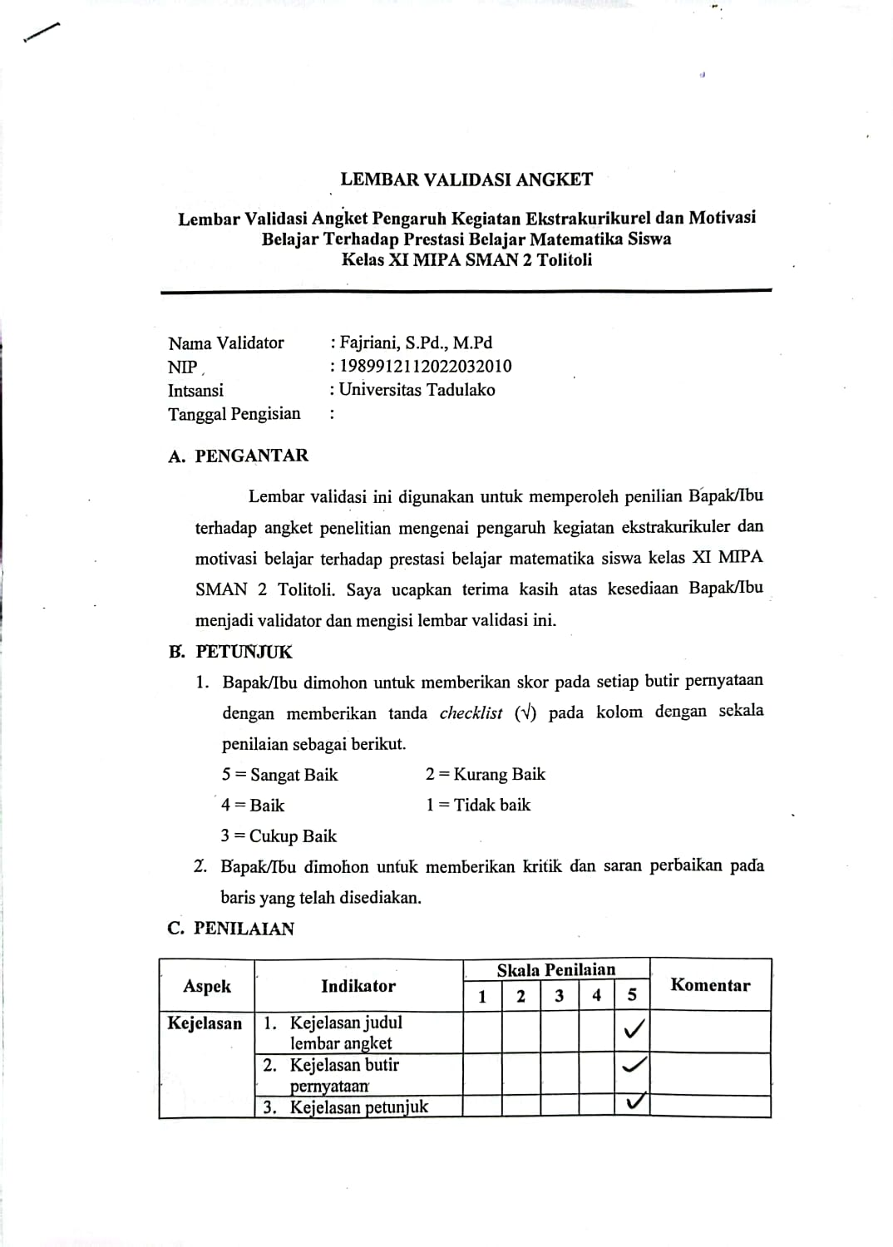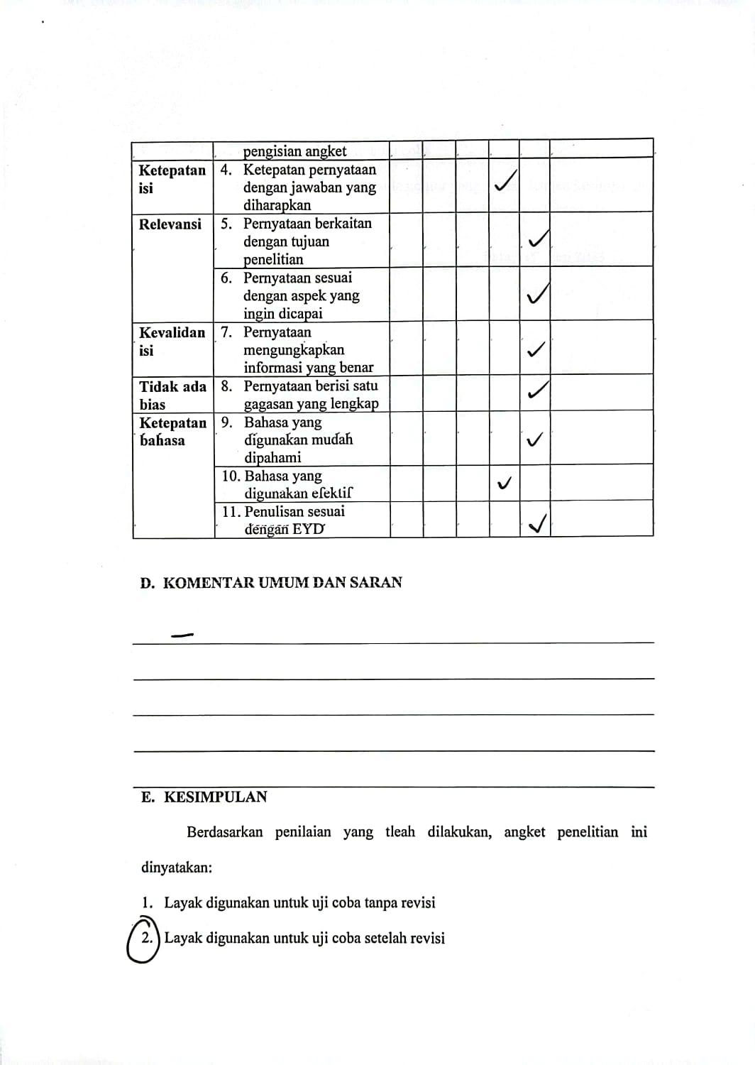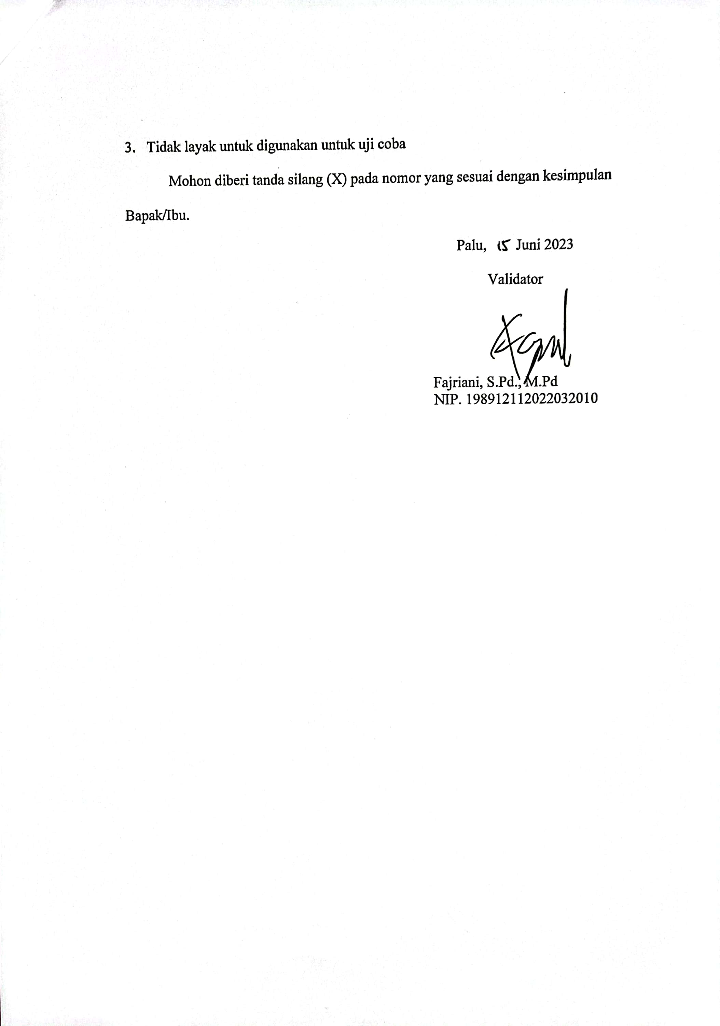

1. **Instrumen Penelitian**

**Angket Kegiatan Ekstrakurikuler**

Nama : …………………………………………………….

Kelas : …………………………………………………….

Ekstrakurikuler yang diikuti : …………………………………………………….

Sekolah : SMAN 2 Tolitoli

Tahun : 2023/2024

1. Pengantar

Angket ini bertujuan untuk mengetahui kegiatan ekstrakurikuler dalam belajar matematika. Anda diharapkan mengisi angket ini sesuai dengan kuisioner yang dibahas. Jawaban yang Anda berikan sangat rahasia, dan tidak berpengaruh terhadap nilai matematika Anda.

1. Petunjuk Pengisian

Berilah tanda *checklist* (√) untuk setiap pernyataan yang terdapat pada kolom yang telah disediakan dengan ketentuan sebagai berikut:

SL = Selalu KK = Kadang-kadang

SR = Sering TP = Tidak Pernah

|  |  |  |  |  |  |
| --- | --- | --- | --- | --- | --- |
| No. | Pernyataan | Alternatif Jawaban | | | |
| SL | SR | KK | TP |
| 1 | Saya sangat senang mengikuti kegiatan ekstrakurikuler di sekolah. |  |  |  |  |
| 2 | Saya aktif dalam kegiatan ekstrakurikuler berdasarkan keinginan sendiri. |  |  |  |  |
| 3 | Kegiatan belajar saya terganggu karena mengikuti kegiatan ekstrakurikuler |  |  |  |  |
| 4 | Menurut saya mengikuti kegiatan ekstrakurikuler meningkatkan prestasi belajar di kelas |  |  |  |  |
| 5 | Dalam kegiatan ekstrakurikuler, kakak pembimbing masa bodoh dan tidak memberikan arahan. |  |  |  |  |
| 6 | Mengikuti kegiatan ekstrakurikuler membuat saya semakin rajin belajar |  |  |  |  |
| 7 | Saya diberikan teguran ketika tidak mematuhi aturan dalam kegiatan ekstrakurikuler |  |  |  |  |
| 8 | Saya aktif mengikuti kegiatan ekstrakurikuler di sekolah |  |  |  |  |
| 9 | Saya mengikuti kegiatan ekstrakurikuler karena ingin mendapatkan nilai dari guru |  |  |  |  |
| 10 | Kegiatan ekstrakurikuler yang saya ikuti dilakukan diluar waktu belajar. |  |  |  |  |
| 11 | Pembibing ekstrakurikuler di sekolah membiarkan saya bercanda dalam kegiatan. |  |  |  |  |
| 12 | Pengetahuan yang saya peroleh dalam kegiatan ekstrakurikuler dapat menunjang pelajaran di kelas. |  |  |  |  |
| 13 | Pengetahuan saya bertambah setelah mengikuti kegiatan ekstrakurikuler |  |  |  |  |
| 14 | Siswa yang lalai dalam kegiatan ekstrakurikuler diberikan sanksi |  |  |  |  |
| 15 | Pembimbing mengarahkan kegiatan ekstrakurikuler sehingga berjalan dengan baik |  |  |  |  |
| 16 | Menurut saya materi yang disampaikan dalam kegiatan ekstrakurikuler tidak menarik. |  |  |  |  |
| 17 | Setelah mengikuti kegiatan ekstrakurikuler, bakat yang saya miliki mulai berkembang |  |  |  |  |
| 18 | Saya tidak aktif mengikuti kegiatan ekstrakurikuler di sekolah |  |  |  |  |
| 19 | Mengikuti kegiatan ekstrakurikuler di sekolah membuat saya malas untuk belajar dirumah. |  |  |  |  |
| 20 | Pembimbing ekstrakurikuler memberi motivasi agar giat berlatih |  |  |  |  |
| 21 | Pembimbing ekstrakurikuler memberi tahu kesalahan dalam kegiatan dengan kasar (membentak-bentak) |  |  |  |  |
| 22 | Siswa mendapatkan nilai yang lebih baik |  |  |  |  |
| 23 | Saya menjadi pemecah masalah yang baik |  |  |  |  |
| 24 | Saya dapat mengontrol lebih baik semua hal dalam hidup saya |  |  |  |  |
| 25 | Ekstrakurikuler memberikan dampak positif terhadap hasil belajar |  |  |  |  |
| 26 | Saya menikmati kegiatan ekstrakurikuler di sekolah saya |  |  |  |  |
| 27 | Orang tua saya mendorong saya untuk berpartisipasi dalam program ekstrakurikuler di sekolah saya |  |  |  |  |
| 28 | Saya mengikuti kegiatan ekstrakurikuler atas kemauan sendiri tanpa paksaan orang lain |  |  |  |  |
| 29 | Saya tidak menaati peraturan dalam mengikuti kegiatan ekstrakurikuler di sekolah |  |  |  |  |

**Angket Motivasi Belajar Siswa**

1. Pengantar

Angket ini bertujuan untuk mengetahui motivasi belajar dalam belajar matematika. Anda diharapkan mengisi angket ini sesuai dengan kuisioner yang dibahas. Jawaban yang Anda berikan sangat rahasia, dan tidak berpengaruh terhadap nilai matematika Anda.

1. Petunjuk Pengisian

Berilah tanda *checklist* (√) untuk setiap pernyataan yang terdapat pada kolom yang telah disediakan dengan ketentuan sebagai berikut:

TP = Tidak Pernah SR = Sering

J = Jarang SL = Selalu

KK = Kadng-kadang

|  |  |  |  |  |  |  |
| --- | --- | --- | --- | --- | --- | --- |
| No | Pernyataan | Jawaban Alternatif | | | | |
| TP | J | KD | SR | SL |
| 1 | Saya senang belajar matematika |  |  |  |  |  |
| 2 | Menurut saya belajar matematika itu menarik |  |  |  |  |  |
| 3 | Saya suka matematika yang menantang saya |  |  |  |  |  |
| 4 | Memahami matematika memberi saya rasa pencapaian |  |  |  |  |  |
| 5 | Mendapatkan nilai matematika yang bagus penting bagi saya |  |  |  |  |  |
| 6 | Jika saya kesulitan belajar matematika, saya mencoba mencari tahu alasannya |  |  |  |  |  |
| 7 | Saya cukup berusaha untuk belajar matematika |  |  |  |  |  |
| 8 | Saya menggunakan strategi yang memastikan saya belajar matematika dengan baik |  |  |  |  |  |
| 9 | Ini adalah kesalahan saya jika saya tidak mengerti matematika |  |  |  |  |  |
| 10 | Saya berharap untuk melakukan sebaik atau lebih baik dari siswa lain dalam kursus matematika |  |  |  |  |  |
| 11 | Saya yakin saya akan mengerjakan tugas dan proyek matematika dengan baik |  |  |  |  |  |
| 12 | Saya percaya saya dapat menguasai pengetahuan dan keterampilan dalam mata pelajaran matematika |  |  |  |  |  |
| 13 | Saya percaya diri saya akan melakukannya dengan baik pada tes matematik |  |  |  |  |  |
| 14 | Saya percaya saya bisa mendapatkan nilai "A" dalam kursus matematika |  |  |  |  |  |
| 15 | Saya berpikir tentang bagaimana belajar matematika dapat membantu saya mendapatkan pekerjaan yang baik |  |  |  |  |  |
| 16 | Saya berpikir tentang bagaimana matematika yang saya pelajari akan membantu saya |  |  |  |  |  |
| 17 | Saya berpikir tentang bagaimana belajar matematika dapat membantu karir saya |  |  |  |  |  |
| 18 | Saya berpikir tentang bagaimana saya akan menggunakan matematika yang saya pelajari |  |  |  |  |  |
| 19 | Matematika yang saya pelajari relevan dengan kehidupan saya |  |  |  |  |  |
| 20 | Saya gugup tentang bagaimana saya akan melakukannya pada tes matematika |  |  |  |  |  |
| 21 | Saya menjadi cemas ketika tiba waktunya untuk mengerjakan ulangan matematika |  |  |  |  |  |
| 22 | Saya khawatir gagal dalam ujian matematika |  |  |  |  |  |
| 23 | Saya khawatir bahwa siswa lain lebih baik dalam matematika |  |  |  |  |  |
| 24 | Aku benci mengambil tes matematika |  |  |  |  |  |

1. **Tabulasi Data Penelitian**

|  |  |  |  |  |  |  |  |  |  |  |  |  |  |  |  |  |  |  |  |  |  |  |  |  |  |  |  |  |  |  |
| --- | --- | --- | --- | --- | --- | --- | --- | --- | --- | --- | --- | --- | --- | --- | --- | --- | --- | --- | --- | --- | --- | --- | --- | --- | --- | --- | --- | --- | --- | --- |
| **Tabulasi Data Penelitian Angket Kegiatan Ekstrakurikuler** | | | | | | | | | | | | | | | | | | | | | | | | | | | | | | **Jumlah** |
| **No** | **Item Pernyataan** | | | | | | | | | | | | | | | | | | | | | | | | | | | | |
| **1** | **2** | **3** | **4** | **5** | **6** | **7** | **8** | **9** | **10** | **11** | **12** | **13** | **14** | **15** | **16** | **17** | **18** | **19** | **20** | **21** | **22** | **23** | **24** | **25** | **26** | **27** | **28** | **29** |
| **1** | 4 | 4 | 4 | 1 | 4 | 2 | 1 | 4 | 4 | 2 | 3 | 1 | 4 | 2 | 4 | 4 | 3 | 4 | 4 | 2 | 4 | 3 | 2 | 4 | 1 | 4 | 4 | 4 | 4 | 91 |
| **2** | 4 | 3 | 3 | 4 | 1 | 2 | 1 | 4 | 4 | 4 | 2 | 3 | 3 | 1 | 2 | 4 | 2 | 3 | 1 | 2 | 4 | 4 | 2 | 4 | 4 | 2 | 2 | 3 | 3 | 81 |
| **3** | 4 | 3 | 4 | 3 | 4 | 2 | 3 | 4 | 4 | 4 | 4 | 3 | 3 | 1 | 4 | 4 | 3 | 4 | 4 | 3 | 4 | 3 | 3 | 3 | 4 | 4 | 4 | 4 | 4 | 101 |
| **4** | 4 | 4 | 4 | 4 | 4 | 4 | 4 | 4 | 4 | 1 | 4 | 4 | 4 | 3 | 4 | 4 | 4 | 4 | 4 | 4 | 4 | 1 | 2 | 4 | 4 | 4 | 4 | 4 | 4 | 107 |
| **5** | 4 | 4 | 1 | 4 | 4 | 4 | 4 | 4 | 1 | 4 | 3 | 4 | 4 | 1 | 4 | 4 | 4 | 4 | 4 | 4 | 4 | 4 | 4 | 4 | 4 | 4 | 4 | 4 | 4 | 106 |
| **6** | 1 | 1 | 1 | 2 | 3 | 1 | 2 | 2 | 4 | 2 | 3 | 1 | 1 | 4 | 2 | 3 | 2 | 4 | 4 | 1 | 4 | 1 | 1 | 1 | 2 | 2 | 2 | 1 | 4 | 62 |
| **7** | 2 | 3 | 4 | 3 | 4 | 2 | 4 | 3 | 3 | 2 | 3 | 3 | 3 | 4 | 1 | 4 | 3 | 3 | 3 | 2 | 3 | 1 | 2 | 2 | 4 | 2 | 4 | 1 | 1 | 79 |
| **8** | 3 | 3 | 2 | 3 | 4 | 4 | 3 | 3 | 2 | 4 | 2 | 3 | 4 | 2 | 4 | 2 | 3 | 1 | 2 | 4 | 2 | 3 | 3 | 3 | 3 | 3 | 3 | 3 | 2 | 83 |
| **9** | 2 | 1 | 4 | 4 | 4 | 4 | 3 | 1 | 4 | 1 | 4 | 4 | 4 | 3 | 4 | 4 | 1 | 1 | 4 | 3 | 2 | 2 | 2 | 4 | 1 | 2 | 4 | 1 | 3 | 81 |
| **10** | 4 | 2 | 4 | 4 | 4 | 4 | 2 | 4 | 1 | 4 | 4 | 4 | 4 | 2 | 4 | 4 | 4 | 4 | 4 | 3 | 4 | 4 | 4 | 4 | 4 | 3 | 4 | 4 | 1 | 102 |
| **11** | 1 | 1 | 4 | 4 | 3 | 3 | 2 | 2 | 2 | 2 | 4 | 3 | 4 | 2 | 2 | 4 | 3 | 4 | 3 | 3 | 1 | 3 | 4 | 2 | 3 | 1 | 4 | 3 | 3 | 80 |
| **12** | 3 | 2 | 4 | 3 | 4 | 3 | 2 | 4 | 3 | 4 | 3 | 2 | 4 | 1 | 4 | 4 | 3 | 3 | 4 | 4 | 4 | 3 | 2 | 3 | 4 | 4 | 4 | 4 | 4 | 96 |
| **13** | 1 | 1 | 4 | 1 | 4 | 1 | 1 | 1 | 4 | 1 | 4 | 1 | 1 | 4 | 1 | 4 | 1 | 4 | 4 | 1 | 4 | 3 | 1 | 1 | 1 | 1 | 1 | 1 | 4 | 61 |
| **14** | 4 | 3 | 3 | 3 | 3 | 1 | 4 | 4 | 3 | 3 | 3 | 4 | 1 | 1 | 2 | 2 | 1 | 1 | 2 | 2 | 4 | 3 | 2 | 4 | 3 | 2 | 4 | 2 | 4 | 78 |
| **15** | 2 | 3 | 4 | 3 | 4 | 2 | 2 | 2 | 3 | 4 | 3 | 4 | 4 | 3 | 3 | 4 | 2 | 3 | 4 | 3 | 4 | 3 | 2 | 3 | 3 | 3 | 3 | 3 | 4 | 90 |
| **16** | 2 | 2 | 4 | 2 | 4 | 3 | 3 | 2 | 4 | 2 | 4 | 2 | 3 | 1 | 3 | 3 | 2 | 3 | 4 | 3 | 4 | 3 | 2 | 2 | 3 | 3 | 2 | 2 | 4 | 81 |
| **17** | 2 | 2 | 4 | 3 | 3 | 2 | 1 | 3 | 4 | 4 | 3 | 2 | 2 | 4 | 3 | 3 | 1 | 1 | 4 | 4 | 4 | 2 | 2 | 4 | 3 | 3 | 4 | 4 | 1 | 82 |
| **18** | 4 | 3 | 4 | 3 | 4 | 2 | 3 | 4 | 4 | 4 | 4 | 3 | 3 | 1 | 4 | 4 | 3 | 4 | 4 | 3 | 4 | 3 | 3 | 4 | 4 | 4 | 4 | 4 | 4 | 102 |
| **19** | 2 | 2 | 3 | 2 | 4 | 2 | 2 | 2 | 3 | 3 | 3 | 2 | 2 | 3 | 2 | 3 | 2 | 3 | 3 | 2 | 3 | 2 | 2 | 2 | 2 | 2 | 2 | 3 | 2 | 70 |
| **20** | 2 | 2 | 3 | 1 | 4 | 2 | 2 | 2 | 1 | 3 | 3 | 3 | 3 | 2 | 3 | 4 | 2 | 3 | 4 | 4 | 4 | 3 | 2 | 2 | 4 | 3 | 3 | 4 | 4 | 82 |
| **21** | 4 | 4 | 4 | 3 | 4 | 4 | 4 | 4 | 4 | 4 | 4 | 3 | 4 | 3 | 4 | 4 | 4 | 4 | 4 | 4 | 4 | 3 | 2 | 4 | 4 | 4 | 4 | 4 | 4 | 110 |
| **22** | 1 | 1 | 1 | 1 | 4 | 1 | 1 | 1 | 4 | 1 | 4 | 1 | 1 | 4 | 1 | 4 | 1 | 4 | 4 | 1 | 4 | 4 | 1 | 1 | 1 | 1 | 1 | 1 | 4 | 59 |
| **23** | 4 | 4 | 4 | 3 | 4 | 3 | 4 | 4 | 3 | 4 | 4 | 3 | 4 | 1 | 4 | 4 | 4 | 4 | 4 | 3 | 2 | 1 | 3 | 2 | 2 | 4 | 4 | 4 | 4 | 98 |
| **24** | 4 | 2 | 4 | 2 | 3 | 2 | 1 | 4 | 1 | 3 | 4 | 3 | 4 | 3 | 4 | 3 | 1 | 4 | 4 | 4 | 4 | 2 | 2 | 3 | 4 | 4 | 1 | 1 | 4 | 85 |
| **25** | 4 | 2 | 4 | 2 | 3 | 4 | 4 | 4 | 3 | 2 | 4 | 4 | 4 | 1 | 4 | 4 | 4 | 4 | 4 | 4 | 4 | 4 | 2 | 4 | 2 | 4 | 2 | 4 | 4 | 99 |
| **26** | 4 | 3 | 4 | 3 | 4 | 3 | 2 | 3 | 4 | 4 | 3 | 2 | 3 | 3 | 3 | 4 | 3 | 4 | 4 | 3 | 3 | 2 | 1 | 3 | 2 | 4 | 3 | 4 | 4 | 92 |
| **27** | 4 | 4 | 4 | 4 | 4 | 4 | 3 | 4 | 1 | 4 | 4 | 4 | 4 | 2 | 3 | 4 | 4 | 4 | 4 | 4 | 2 | 4 | 2 | 2 | 3 | 4 | 2 | 4 | 4 | 100 |
| **28** | 2 | 2 | 4 | 3 | 4 | 3 | 2 | 2 | 3 | 4 | 4 | 4 | 3 | 1 | 4 | 4 | 2 | 3 | 4 | 4 | 4 | 3 | 1 | 4 | 4 | 3 | 3 | 4 | 2 | 90 |
| **29** | 4 | 3 | 4 | 4 | 4 | 3 | 2 | 4 | 2 | 4 | 3 | 4 | 4 | 2 | 4 | 4 | 3 | 4 | 4 | 3 | 4 | 3 | 2 | 3 | 4 | 4 | 3 | 4 | 4 | 100 |
| **30** | 2 | 2 | 4 | 2 | 4 | 3 | 4 | 3 | 3 | 4 | 2 | 2 | 3 | 1 | 4 | 4 | 2 | 3 | 4 | 4 | 1 | 4 | 1 | 4 | 4 | 3 | 2 | 4 | 4 | 87 |
| **31** | 4 | 2 | 4 | 4 | 4 | 4 | 2 | 2 | 4 | 1 | 3 | 2 | 4 | 3 | 4 | 4 | 4 | 3 | 4 | 4 | 4 | 3 | 2 | 3 | 4 | 4 | 4 | 4 | 4 | 98 |
| **32** | 4 | 2 | 4 | 4 | 4 | 4 | 2 | 2 | 4 | 1 | 3 | 2 | 4 | 3 | 4 | 4 | 4 | 3 | 4 | 4 | 4 | 3 | 2 | 3 | 4 | 4 | 4 | 4 | 4 | 98 |
| **33** | 4 | 4 | 4 | 1 | 4 | 2 | 1 | 4 | 4 | 2 | 3 | 1 | 4 | 2 | 4 | 4 | 4 | 4 | 4 | 2 | 4 | 3 | 2 | 4 | 1 | 4 | 4 | 4 | 4 | 92 |
| **34** | 2 | 2 | 4 | 2 | 4 | 3 | 4 | 3 | 1 | 4 | 3 | 3 | 3 | 1 | 4 | 4 | 3 | 1 | 4 | 4 | 4 | 3 | 2 | 3 | 4 | 3 | 4 | 3 | 4 | 89 |
| **35** | 3 | 2 | 4 | 4 | 3 | 1 | 3 | 4 | 3 | 4 | 4 | 2 | 4 | 3 | 4 | 2 | 1 | 2 | 4 | 1 | 4 | 1 | 4 | 4 | 2 | 3 | 2 | 4 | 2 | 84 |
| **36** | 4 | 3 | 4 | 3 | 4 | 3 | 1 | 4 | 1 | 1 | 1 | 3 | 4 | 1 | 4 | 4 | 3 | 4 | 4 | 3 | 4 | 3 | 3 | 3 | 4 | 4 | 4 | 4 | 4 | 92 |
| **37** | 4 | 4 | 4 | 4 | 4 | 4 | 3 | 4 | 4 | 2 | 3 | 3 | 2 | 4 | 2 | 4 | 4 | 4 | 4 | 4 | 4 | 4 | 3 | 2 | 4 | 4 | 4 | 3 | 4 | 103 |
| **38** | 2 | 2 | 4 | 1 | 4 | 2 | 2 | 3 | 4 | 4 | 4 | 2 | 3 | 3 | 4 | 4 | 2 | 4 | 4 | 2 | 4 | 2 | 2 | 2 | 3 | 3 | 2 | 4 | 4 | 86 |
| **39** | 2 | 3 | 2 | 3 | 4 | 4 | 4 | 4 | 1 | 4 | 3 | 2 | 3 | 4 | 4 | 3 | 4 | 3 | 4 | 1 | 3 | 2 | 2 | 2 | 3 | 2 | 3 | 4 | 3 | 86 |
| **40** | 2 | 2 | 3 | 1 | 4 | 2 | 2 | 2 | 2 | 4 | 3 | 1 | 3 | 1 | 4 | 2 | 1 | 3 | 3 | 4 | 4 | 3 | 2 | 2 | 3 | 3 | 4 | 3 | 4 | 77 |
| **41** | 2 | 2 | 4 | 3 | 4 | 3 | 3 | 3 | 1 | 3 | 3 | 3 | 3 | 1 | 3 | 4 | 3 | 3 | 4 | 3 | 3 | 3 | 2 | 3 | 4 | 3 | 4 | 4 | 3 | 87 |
| **42** | 2 | 2 | 3 | 1 | 4 | 2 | 2 | 2 | 2 | 4 | 3 | 1 | 3 | 1 | 4 | 3 | 1 | 3 | 3 | 4 | 4 | 3 | 1 | 4 | 2 | 3 | 4 | 4 | 4 | 79 |
| **43** | 4 | 4 | 4 | 2 | 4 | 2 | 2 | 4 | 4 | 3 | 3 | 2 | 4 | 2 | 3 | 4 | 2 | 4 | 3 | 4 | 4 | 2 | 2 | 2 | 2 | 4 | 1 | 2 | 4 | 87 |
| **44** | 2 | 2 | 4 | 3 | 4 | 3 | 2 | 3 | 1 | 4 | 4 | 4 | 4 | 1 | 4 | 4 | 2 | 3 | 3 | 4 | 4 | 3 | 1 | 2 | 2 | 3 | 4 | 1 | 3 | 84 |
| **45** | 2 | 2 | 4 | 4 | 4 | 1 | 1 | 1 | 4 | 1 | 4 | 1 | 1 | 1 | 3 | 4 | 1 | 4 | 2 | 1 | 4 | 1 | 1 | 1 | 1 | 1 | 1 | 1 | 4 | 61 |
| **46** | 4 | 4 | 1 | 4 | 3 | 4 | 4 | 3 | 1 | 1 | 1 | 4 | 4 | 1 | 4 | 4 | 4 | 4 | 4 | 4 | 3 | 3 | 3 | 4 | 4 | 4 | 4 | 4 | 4 | 96 |
| **47** | 4 | 4 | 4 | 4 | 4 | 2 | 1 | 4 | 4 | 4 | 4 | 2 | 4 | 3 | 4 | 4 | 4 | 4 | 4 | 4 | 3 | 3 | 3 | 4 | 4 | 4 | 4 | 4 | 4 | 105 |
| **48** | 4 | 4 | 4 | 4 | 4 | 4 | 4 | 4 | 4 | 4 | 4 | 3 | 4 | 1 | 4 | 4 | 4 | 4 | 4 | 4 | 4 | 4 | 4 | 4 | 4 | 4 | 4 | 4 | 4 | 112 |
| **49** | 4 | 4 | 4 | 4 | 4 | 4 | 2 | 4 | 1 | 4 | 1 | 3 | 3 | 1 | 4 | 4 | 4 | 4 | 4 | 4 | 4 | 4 | 4 | 4 | 3 | 4 | 4 | 4 | 4 | 102 |
| **50** | 2 | 2 | 2 | 4 | 3 | 2 | 3 | 2 | 3 | 3 | 4 | 3 | 2 | 4 | 2 | 2 | 2 | 4 | 2 | 2 | 2 | 3 | 2 | 3 | 4 | 2 | 4 | 3 | 2 | 78 |
| **51** | 4 | 4 | 4 | 4 | 3 | 4 | 4 | 4 | 2 | 4 | 1 | 4 | 4 | 1 | 4 | 4 | 4 | 4 | 4 | 4 | 4 | 4 | 4 | 4 | 4 | 4 | 4 | 4 | 4 | 107 |
| **52** | 3 | 2 | 4 | 1 | 3 | 1 | 2 | 4 | 4 | 4 | 3 | 1 | 3 | 1 | 2 | 3 | 3 | 3 | 4 | 2 | 3 | 3 | 1 | 4 | 3 | 3 | 3 | 4 | 3 | 80 |
| **53** | 2 | 2 | 4 | 3 | 4 | 3 | 2 | 3 | 1 | 4 | 3 | 2 | 4 | 2 | 3 | 4 | 3 | 3 | 4 | 3 | 4 | 3 | 4 | 4 | 4 | 3 | 3 | 4 | 3 | 91 |
| **54** | 2 | 2 | 4 | 2 | 4 | 2 | 1 | 2 | 3 | 4 | 4 | 2 | 4 | 2 | 4 | 4 | 2 | 3 | 4 | 4 | 3 | 2 | 2 | 4 | 4 | 4 | 2 | 4 | 4 | 88 |
| **55** | 3 | 4 | 3 | 3 | 3 | 4 | 3 | 3 | 2 | 3 | 3 | 2 | 3 | 2 | 3 | 3 | 3 | 2 | 3 | 3 | 3 | 3 | 3 | 3 | 3 | 3 | 3 | 3 | 3 | 85 |
| **56** | 1 | 1 | 4 | 1 | 4 | 1 | 1 | 1 | 4 | 4 | 1 | 3 | 4 | 4 | 3 | 4 | 4 | 2 | 3 | 3 | 4 | 3 | 1 | 4 | 3 | 1 | 4 | 3 | 4 | 80 |
| **57** | 3 | 2 | 4 | 2 | 4 | 2 | 4 | 24 | 3 | 4 | 1 | 3 | 1 | 4 | 4 | 2 | 3 | 4 | 3 | 4 | 3 | 2 | 2 | 2 | 4 | 2 | 4 | 4 | 4 | 108 |
| **58** | 2 | 2 | 4 | 1 | 4 | 1 | 2 | 1 | 2 | 3 | 3 | 3 | 3 | 3 | 3 | 3 | 2 | 3 | 4 | 2 | 3 | 2 | 2 | 2 | 3 | 2 | 2 | 2 | 3 | 72 |
| **59** | 3 | 2 | 4 | 4 | 3 | 3 | 4 | 2 | 1 | 4 | 3 | 3 | 4 | 2 | 4 | 4 | 3 | 2 | 4 | 3 | 4 | 3 | 2 | 2 | 3 | 4 | 2 | 3 | 4 | 89 |

|  |  |  |  |  |  |  |  |  |  |  |  |  |  |  |  |  |  |  |  |  |  |  |  |  |  |
| --- | --- | --- | --- | --- | --- | --- | --- | --- | --- | --- | --- | --- | --- | --- | --- | --- | --- | --- | --- | --- | --- | --- | --- | --- | --- |
| **Tabulasi Data Penelitian Angket Kegiatan Ekstrakurikuler** | | | | | | | | | | | | | | | | | | | | | | | | | **Jumlah** |
| **No** | **Item Pernyataan** | | | | | | | | | | | | | | | | | | | | | | | |
| **1** | **2** | **3** | **4** | **5** | **6** | **7** | **8** | **9** | **10** | **11** | **12** | **13** | **14** | **15** | **16** | **17** | **18** | **19** | **20** | **21** | **22** | **23** | **24** |
| **1** | 3 | 3 | 4 | 3 | 5 | 5 | 5 | 5 | 3 | 5 | 5 | 3 | 5 | 2 | 5 | 5 | 5 | 5 | 3 | 4 | 1 | 1 | 1 | 5 | 91 |
| **2** | 3 | 3 | 3 | 4 | 4 | 4 | 4 | 5 | 2 | 2 | 3 | 1 | 1 | 1 | 3 | 3 | 1 | 3 | 1 | 4 | 3 | 1 | 3 | 5 | 67 |
| **3** | 4 | 4 | 4 | 4 | 3 | 5 | 5 | 4 | 4 | 3 | 3 | 3 | 4 | 3 | 4 | 4 | 4 | 4 | 4 | 2 | 3 | 2 | 3 | 4 | 87 |
| **4** | 4 | 4 | 4 | 5 | 5 | 5 | 5 | 5 | 3 | 5 | 5 | 5 | 5 | 3 | 5 | 1 | 5 | 3 | 5 | 1 | 5 | 1 | 5 | 5 | 99 |
| **5** | 5 | 5 | 5 | 5 | 5 | 5 | 5 | 5 | 5 | 5 | 5 | 5 | 5 | 5 | 5 | 5 | 5 | 5 | 5 | 5 | 5 | 5 | 5 | 5 | 120 |
| **6** | 2 | 3 | 3 | 3 | 2 | 2 | 3 | 2 | 2 | 3 | 3 | 2 | 3 | 3 | 2 | 3 | 2 | 2 | 2 | 3 | 3 | 4 | 3 | 4 | 64 |
| **7** | 1 | 1 | 1 | 3 | 3 | 2 | 4 | 2 | 4 | 5 | 3 | 3 | 3 | 3 | 5 | 5 | 2 | 2 | 3 | 3 | 4 | 4 | 4 | 1 | 71 |
| **8** | 5 | 5 | 5 | 5 | 5 | 5 | 5 | 5 | 5 | 5 | 5 | 5 | 5 | 5 | 5 | 5 | 5 | 5 | 5 | 1 | 1 | 1 | 1 | 1 | 100 |
| **9** | 5 | 3 | 1 | 1 | 5 | 3 | 5 | 5 | 5 | 3 | 5 | 3 | 5 | 4 | 3 | 4 | 2 | 4 | 5 | 4 | 4 | 5 | 2 | 5 | 91 |
| **10** | 5 | 5 | 5 | 5 | 5 | 5 | 5 | 5 | 5 | 5 | 5 | 5 | 5 | 5 | 5 | 5 | 5 | 5 | 5 | 1 | 1 | 1 | 1 | 1 | 100 |
| **11** | 1 | 1 | 1 | 4 | 5 | 5 | 3 | 1 | 5 | 5 | 2 | 2 | 4 | 2 | 2 | 4 | 1 | 2 | 3 | 2 | 4 | 5 | 3 | 4 | 71 |
| **12** | 3 | 3 | 2 | 3 | 4 | 4 | 5 | 5 | 4 | 4 | 3 | 3 | 4 | 5 | 4 | 4 | 5 | 5 | 4 | 3 | 2 | 4 | 3 | 3 | 89 |
| **13** | 2 | 3 | 1 | 4 | 2 | 2 | 4 | 1 | 5 | 1 | 2 | 1 | 2 | 1 | 4 | 5 | 4 | 5 | 1 | 3 | 3 | 2 | 5 | 1 | 64 |
| **14** | 3 | 2 | 2 | 3 | 3 | 3 | 4 | 2 | 4 | 2 | 3 | 1 | 2 | 2 | 2 | 2 | 2 | 5 | 2 | 4 | 4 | 1 | 3 | 4 | 65 |
| **15** | 3 | 3 | 3 | 4 | 3 | 3 | 3 | 3 | 3 | 3 | 3 | 3 | 3 | 3 | 2 | 4 | 2 | 3 | 2 | 2 | 3 | 2 | 3 | 4 | 70 |
| **16** | 3 | 3 | 3 | 4 | 5 | 4 | 5 | 4 | 4 | 5 | 4 | 4 | 3 | 3 | 3 | 4 | 3 | 3 | 3 | 2 | 1 | 1 | 1 | 3 | 78 |
| **17** | 3 | 3 | 3 | 2 | 5 | 3 | 4 | 3 | 5 | 3 | 4 | 3 | 3 | 3 | 5 | 3 | 1 | 1 | 1 | 3 | 1 | 1 | 3 | 2 | 68 |
| **18** | 5 | 5 | 4 | 4 | 4 | 3 | 5 | 3 | 4 | 5 | 4 | 3 | 4 | 3 | 4 | 4 | 4 | 3 | 5 | 4 | 3 | 3 | 4 | 4 | 94 |
| **19** | 3 | 3 | 2 | 3 | 3 | 3 | 3 | 3 | 4 | 2 | 3 | 1 | 2 | 2 | 3 | 3 | 3 | 3 | 3 | 3 | 2 | 1 | 3 | 4 | 65 |
| **20** | 3 | 3 | 3 | 4 | 5 | 4 | 4 | 3 | 4 | 3 | 4 | 4 | 3 | 3 | 3 | 3 | 4 | 3 | 3 | 2 | 2 | 2 | 2 | 3 | 77 |
| **21** | 5 | 5 | 5 | 5 | 5 | 4 | 5 | 5 | 5 | 3 | 5 | 3 | 5 | 5 | 5 | 2 | 5 | 4 | 5 | 1 | 5 | 2 | 5 | 5 | 104 |
| **22** | 2 | 5 | 4 | 4 | 4 | 4 | 4 | 4 | 4 | 4 | 4 | 4 | 4 | 3 | 4 | 4 | 1 | 4 | 1 | 2 | 2 | 2 | 5 | 5 | 84 |
| **23** | 3 | 3 | 2 | 3 | 2 | 4 | 5 | 4 | 5 | 5 | 4 | 3 | 4 | 1 | 2 | 4 | 2 | 5 | 3 | 5 | 5 | 5 | 5 | 3 | 87 |
| **24** | 3 | 3 | 2 | 3 | 4 | 5 | 5 | 5 | 5 | 5 | 1 | 5 | 3 | 3 | 5 | 5 | 2 | 1 | 1 | 1 | 1 | 1 | 2 | 5 | 76 |
| **25** | 3 | 1 | 1 | 1 | 4 | 5 | 5 | 5 | 5 | 5 | 1 | 5 | 3 | 3 | 5 | 5 | 5 | 2 | 1 | 2 | 1 | 1 | 1 | 5 | 75 |
| **26** | 3 | 3 | 3 | 4 | 5 | 4 | 4 | 4 | 3 | 3 | 4 | 3 | 3 | 4 | 4 | 3 | 3 | 3 | 3 | 3 | 4 | 4 | 3 | 5 | 85 |
| **27** | 3 | 5 | 3 | 4 | 5 | 4 | 3 | 3 | 5 | 5 | 3 | 4 | 3 | 1 | 5 | 5 | 5 | 4 | 3 | 2 | 1 | 1 | 1 | 4 | 82 |
| **28** | 3 | 5 | 4 | 4 | 5 | 4 | 5 | 4 | 4 | 4 | 3 | 4 | 3 | 1 | 5 | 4 | 4 | 5 | 3 | 2 | 1 | 1 | 1 | 5 | 84 |
| **29** | 3 | 4 | 3 | 5 | 4 | 5 | 5 | 4 | 5 | 4 | 5 | 4 | 4 | 4 | 4 | 4 | 5 | 4 | 4 | 3 | 3 | 3 | 4 | 4 | 97 |
| **30** | 3 | 5 | 3 | 4 | 4 | 3 | 5 | 4 | 3 | 2 | 4 | 4 | 2 | 2 | 3 | 1 | 2 | 3 | 2 | 2 | 1 | 1 | 4 | 5 | 72 |
| **31** | 3 | 3 | 3 | 3 | 5 | 5 | 5 | 4 | 4 | 4 | 3 | 3 | 4 | 3 | 4 | 3 | 3 | 3 | 3 | 3 | 3 | 3 | 2 | 5 | 84 |
| **32** | 3 | 3 | 3 | 3 | 5 | 5 | 5 | 4 | 3 | 5 | 4 | 4 | 4 | 4 | 5 | 5 | 5 | 5 | 4 | 1 | 1 | 1 | 1 | 2 | 85 |
| **33** | 3 | 3 | 4 | 3 | 5 | 5 | 5 | 5 | 3 | 5 | 5 | 3 | 5 | 2 | 5 | 5 | 5 | 5 | 3 | 4 | 1 | 1 | 1 | 5 | 91 |
| **34** | 3 | 4 | 4 | 4 | 5 | 4 | 5 | 4 | 5 | 5 | 5 | 4 | 4 | 5 | 3 | 3 | 3 | 4 | 3 | 1 | 1 | 1 | 1 | 5 | 86 |
| **35** | 5 | 5 | 5 | 5 | 5 | 5 | 5 | 5 | 5 | 5 | 5 | 5 | 5 | 5 | 5 | 5 | 4 | 4 | 4 | 2 | 2 | 2 | 2 | 2 | 102 |
| **36** | 3 | 5 | 3 | 5 | 3 | 5 | 5 | 3 | 3 | 3 | 4 | 5 | 5 | 3 | 3 | 5 | 3 | 5 | 3 | 4 | 3 | 2 | 3 | 5 | 91 |
| **37** | 3 | 4 | 3 | 4 | 5 | 3 | 4 | 3 | 3 | 5 | 4 | 4 | 4 | 3 | 3 | 3 | 3 | 3 | 1 | 2 | 1 | 3 | 2 | 4 | 77 |
| **38** | 3 | 3 | 2 | 3 | 4 | 3 | 4 | 3 | 5 | 4 | 3 | 3 | 3 | 2 | 3 | 4 | 3 | 3 | 1 | 3 | 3 | 2 | 3 | 5 | 75 |
| **39** | 3 | 3 | 2 | 5 | 5 | 4 | 4 | 4 | 3 | 4 | 3 | 3 | 4 | 4 | 3 | 4 | 3 | 3 | 5 | 3 | 3 | 3 | 3 | 5 | 86 |
| **40** | 3 | 3 | 3 | 3 | 4 | 3 | 4 | 3 | 2 | 4 | 3 | 3 | 4 | 3 | 3 | 3 | 3 | 3 | 2 | 4 | 4 | 3 | 3 | 5 | 78 |
| **41** | 3 | 3 | 2 | 4 | 5 | 3 | 4 | 3 | 5 | 4 | 4 | 5 | 4 | 3 | 5 | 4 | 4 | 4 | 4 | 2 | 2 | 2 | 2 | 3 | 84 |
| **42** | 3 | 3 | 1 | 3 | 5 | 2 | 3 | 3 | 1 | 1 | 3 | 2 | 2 | 2 | 1 | 3 | 1 | 3 | 3 | 4 | 1 | 1 | 3 | 1 | 55 |
| **43** | 2 | 3 | 3 | 1 | 3 | 3 | 5 | 2 | 3 | 3 | 3 | 3 | 2 | 2 | 3 | 3 | 3 | 3 | 3 | 4 | 3 | 4 | 4 | 3 | 71 |
| **44** | 3 | 3 | 2 | 4 | 5 | 3 | 5 | 5 | 5 | 5 | 4 | 5 | 4 | 3 | 5 | 3 | 5 | 4 | 4 | 2 | 2 | 2 | 2 | 4 | 89 |
| **45** | 3 | 3 | 1 | 3 | 5 | 5 | 4 | 4 | 1 | 1 | 5 | 5 | 4 | 4 | 4 | 5 | 4 | 4 | 5 | 2 | 1 | 2 | 1 | 5 | 81 |
| **46** | 4 | 4 | 4 | 4 | 4 | 3 | 3 | 3 | 2 | 4 | 4 | 4 | 4 | 4 | 4 | 4 | 4 | 4 | 4 | 4 | 4 | 4 | 4 | 5 | 92 |
| **47** | 4 | 4 | 4 | 4 | 4 | 4 | 4 | 4 | 2 | 4 | 4 | 4 | 4 | 4 | 4 | 4 | 4 | 4 | 4 | 4 | 4 | 4 | 4 | 5 | 95 |
| **48** | 5 | 5 | 5 | 5 | 5 | 5 | 5 | 5 | 5 | 4 | 4 | 5 | 5 | 4 | 3 | 4 | 3 | 4 | 4 | 2 | 3 | 3 | 2 | 5 | 100 |
| **49** | 5 | 4 | 3 | 4 | 5 | 5 | 5 | 5 | 4 | 4 | 4 | 3 | 4 | 4 | 5 | 5 | 4 | 4 | 3 | 3 | 1 | 1 | 1 | 3 | 89 |
| **50** | 3 | 3 | 5 | 3 | 3 | 3 | 1 | 5 | 2 | 4 | 3 | 3 | 3 | 3 | 3 | 3 | 3 | 3 | 3 | 1 | 3 | 3 | 3 | 3 | 72 |
| **51** | 2 | 2 | 1 | 1 | 2 | 4 | 2 | 1 | 2 | 3 | 5 | 5 | 5 | 5 | 5 | 5 | 5 | 5 | 1 | 1 | 1 | 5 | 1 | 1 | 70 |
| **52** | 2 | 3 | 1 | 1 | 4 | 4 | 5 | 4 | 1 | 4 | 4 | 1 | 1 | 1 | 1 | 1 | 1 | 1 | 1 | 1 | 1 | 1 | 2 | 1 | 47 |
| **53** | 3 | 3 | 4 | 4 | 3 | 5 | 2 | 4 | 5 | 4 | 4 | 4 | 4 | 3 | 5 | 5 | 5 | 5 | 5 | 1 | 2 | 2 | 3 | 3 | 88 |
| **54** | 3 | 3 | 3 | 5 | 5 | 4 | 5 | 4 | 5 | 3 | 3 | 3 | 3 | 3 | 3 | 3 | 3 | 4 | 3 | 2 | 2 | 2 | 2 | 4 | 80 |
| **55** | 2 | 4 | 4 | 4 | 4 | 4 | 4 | 5 | 3 | 3 | 4 | 4 | 3 | 4 | 4 | 5 | 4 | 4 | 5 | 2 | 3 | 2 | 2 | 3 | 86 |
| **56** | 2 | 3 | 4 | 3 | 2 | 2 | 3 | 3 | 2 | 1 | 3 | 2 | 2 | 1 | 2 | 3 | 4 | 4 | 2 | 4 | 3 | 1 | 3 | 3 | 62 |
| **57** | 3 | 3 | 3 | 3 | 2 | 3 | 3 | 3 | 2 | 2 | 3 | 2 | 3 | 3 | 3 | 3 | 3 | 3 | 1 | 3 | 3 | 3 | 3 | 5 | 68 |
| **58** | 2 | 4 | 3 | 2 | 3 | 3 | 2 | 2 | 5 | 3 | 2 | 2 | 1 | 1 | 1 | 2 | 1 | 3 | 1 | 2 | 2 | 2 | 3 | 3 | 55 |
| **59** | 3 | 4 | 3 | 4 | 4 | 4 | 3 | 3 | 5 | 3 | 3 | 3 | 4 | 3 | 3 | 4 | 2 | 3 | 2 | 2 | 2 | 2 | 2 | 5 | 76 |

|  |  |  |  |
| --- | --- | --- | --- |
| Tabulasi Data Pokok Hasil Penelitian | | | |
| No. | X1 | X2 | Y |
| 1 | 91 | 91 | 83 |
| 2 | 81 | 67 | 63 |
| 3 | 101 | 87 | 80 |
| 4 | 107 | 99 | 84 |
| 5 | 106 | 120 | 88 |
| 6 | 62 | 64 | 57 |
| 7 | 79 | 71 | 58 |
| 8 | 83 | 100 | 82 |
| 9 | 81 | 91 | 74 |
| 10 | 102 | 100 | 83 |
| 11 | 80 | 71 | 67 |
| 12 | 96 | 89 | 81 |
| 13 | 61 | 64 | 58 |
| 14 | 78 | 65 | 68 |
| 15 | 90 | 70 | 75 |
| 16 | 81 | 78 | 73 |
| 17 | 82 | 68 | 77 |
| 18 | 102 | 94 | 84 |
| 19 | 70 | 65 | 67 |
| 20 | 82 | 77 | 74 |
| 21 | 110 | 104 | 91 |
| 22 | 59 | 84 | 70 |
| 23 | 98 | 87 | 82 |
| 24 | 85 | 76 | 78 |
| 25 | 99 | 75 | 85 |
| 26 | 92 | 85 | 86 |
| 27 | 100 | 82 | 87 |
| 28 | 90 | 84 | 81 |
| 29 | 100 | 97 | 88 |
| 30 | 87 | 72 | 77 |
| 31 | 98 | 84 | 78 |
| 32 | 98 | 85 | 82 |
| 33 | 92 | 91 | 83 |
| 34 | 89 | 86 | 81 |
| 35 | 84 | 102 | 86 |
| 36 | 92 | 91 | 86 |
| 37 | 103 | 77 | 80 |
| 38 | 86 | 75 | 73 |
| 39 | 86 | 86 | 79 |
| 40 | 77 | 78 | 75 |
| 41 | 87 | 84 | 85 |
| 42 | 79 | 55 | 69 |
| 43 | 87 | 71 | 68 |
| 44 | 84 | 89 | 78 |
| 45 | 61 | 81 | 69 |
| 46 | 96 | 92 | 83 |
| 47 | 105 | 95 | 85 |
| 48 | 112 | 100 | 90 |
| 49 | 102 | 89 | 84 |
| 50 | 78 | 72 | 73 |
| 51 | 107 | 70 | 80 |
| 52 | 80 | 47 | 64 |
| 53 | 91 | 88 | 82 |
| 54 | 88 | 80 | 75 |
| 55 | 85 | 86 | 82 |
| 56 | 80 | 62 | 68 |
| 57 | 108 | 68 | 68 |
| 58 | 72 | 55 | 65 |
| 59 | 89 | 76 | 71 |

1. **Tabel Distribusi**

**DISTRIBUSI F­tabel**

|  |  |  |  |  |  |  |  |  |
| --- | --- | --- | --- | --- | --- | --- | --- | --- |
| e | df1=(k-1) | | | | | | | |
| df2=(n-k- 1) | 1 | 2 | 3 | 4 | 5 | 6 | 7 | 8 |
| 1 | 161.448 | 199.500 | 215.707 | 224.583 | 230.162 | 233.986 | 236.768 | 238.883 |
| 2 | 18.513 | 19.000 | 19.164 | 19.247 | 19.296 | 19.330 | 19.353 | 19.371 |
| 3 | 10.128 | 9.552 | 9.277 | 9.117 | 9.013 | 8.941 | 8.887 | 8.845 |
| 4 | 7.709 | 6.944 | 6.591 | 6.388 | 6.256 | 6.163 | 6.094 | 6.041 |
| 5 | 6.608 | 5.786 | 5.409 | 5.192 | 5.050 | 4.950 | 4.876 | 4.818 |
| 6 | 5.987 | 5.143 | 4.757 | 4.534 | 4.387 | 4.284 | 4.207 | 4.147 |
| 7 | 5.591 | 4.737 | 4.347 | 4.120 | 3.972 | 3.866 | 3.787 | 3.726 |
| 8 | 5.318 | 4.459 | 4.066 | 3.838 | 3.687 | 3.581 | 3.500 | 3.438 |
| 9 | 5.117 | 4.256 | 3.863 | 3.633 | 3.482 | 3.374 | 3.293 | 3.230 |
| 10 | 4.965 | 4.103 | 3.708 | 3.478 | 3.326 | 3.217 | 3.135 | 3.072 |
| 11 | 4.844 | 3.982 | 3.587 | 3.357 | 3.204 | 3.095 | 3.012 | 2.948 |
| 12 | 4.747 | 3.885 | 3.490 | 3.259 | 3.106 | 2.996 | 2.913 | 2.849 |
| 13 | 4.667 | 3.806 | 3.411 | 3.179 | 3.025 | 2.915 | 2.832 | 2.767 |
| 14 | 4.600 | 3.739 | 3.344 | 3.112 | 2.958 | 2.848 | 2.764 | 2.699 |
| 15 | 4.543 | 3.682 | 3.287 | 3.056 | 2.901 | 2.790 | 2.707 | 2.641 |
| 16 | 4.494 | 3.634 | 3.239 | 3.007 | 2.852 | 2.741 | 2.657 | 2.591 |
| 17 | 4.451 | 3.592 | 3.197 | 2.965 | 2.810 | 2.699 | 2.614 | 2.548 |
| 18 | 4.414 | 3.555 | 3.160 | 2.928 | 2.773 | 2.661 | 2.577 | 2.510 |
| 19 | 4.381 | 3.522 | 3.127 | 2.895 | 2.740 | 2.628 | 2.544 | 2.477 |
| 20 | 4.351 | 3.493 | 3.098 | 2.866 | 2.711 | 2.599 | 2.514 | 2.447 |
| 21 | 4.325 | 3.467 | 3.072 | 2.840 | 2.685 | 2.573 | 2.488 | 2.420 |
| 22 | 4.301 | 3.443 | 3.049 | 2.817 | 2.661 | 2.549 | 2.464 | 2.397 |
| 23 | 4.279 | 3.422 | 3.028 | 2.796 | 2.640 | 2.528 | 2.442 | 2.375 |
| 24 | 4.260 | 3.403 | 3.009 | 2.776 | 2.621 | 2.508 | 2.423 | 2.355 |
| 25 | 4.242 | 3.385 | 2.991 | 2.759 | 2.603 | 2.490 | 2.405 | 2.337 |
| 26 | 4.225 | 3.369 | 2.975 | 2.743 | 2.587 | 2.474 | 2.388 | 2.321 |
| 27 | 4.210 | 3.354 | 2.960 | 2.728 | 2.572 | 2.459 | 2.373 | 2.305 |
| 28 | 4.196 | 3.340 | 2.947 | 2.714 | 2.558 | 2.445 | 2.359 | 2.291 |
| 29 | 4.183 | 3.328 | 2.934 | 2.701 | 2.545 | 2.432 | 2.346 | 2.278 |
| 30 | 4.171 | 3.316 | 2.922 | 2.690 | 2.534 | 2.421 | 2.334 | 2.266 |
| 31 | 4.160 | 3.305 | 2.911 | 2.679 | 2.523 | 2.409 | 2.323 | 2.255 |
| 32 | 4.149 | 3.295 | 2.901 | 2.668 | 2.512 | 2.399 | 2.313 | 2.244 |
| 33 | 4.139 | 3.285 | 2.892 | 2.659 | 2.503 | 2.389 | 2.303 | 2.235 |
| 34 | 4.130 | 3.276 | 2.883 | 2.650 | 2.494 | 2.380 | 2.294 | 2.225 |
| 35 | 4.121 | 3.267 | 2.874 | 2.641 | 2.485 | 2.372 | 2.285 | 2.217 |
| 36 | 4.113 | 3.259 | 2.866 | 2.634 | 2.477 | 2.364 | 2.277 | 2.209 |
| 37 | 4.105 | 3.252 | 2.859 | 2.626 | 2.470 | 2.356 | 2.270 | 2.201 |
| 38 | 4.098 | 3.245 | 2.852 | 2.619 | 2.463 | 2.349 | 2.262 | 2.194 |
| 39 | 4.091 | 3.238 | 2.845 | 2.612 | 2.456 | 2.342 | 2.255 | 2.187 |
| 40 | 4.085 | 3.232 | 2.839 | 2.606 | 2.449 | 2.336 | 2.249 | 2.180 |
| 41 | 4.079 | 3.226 | 2.833 | 2.600 | 2.443 | 2.330 | 2.243 | 2.174 |
| 42 | 4.073 | 3.220 | 2.827 | 2.594 | 2.438 | 2.324 | 2.237 | 2.168 |
| 43 | 4.067 | 3.214 | 2.822 | 2.589 | 2.432 | 2.318 | 2.232 | 2.163 |
| 44 | 4.062 | 3.209 | 2.816 | 2.584 | 2.427 | 2.313 | 2.226 | 2.157 |
| 45 | 4.057 | 3.204 | 2.812 | 2.579 | 2.422 | 2.308 | 2.221 | 2.152 |
| 46 | 4.052 | 3.200 | 2.807 | 2.574 | 2.417 | 2.304 | 2.216 | 2.147 |
| 47 | 4.047 | 3.195 | 2.802 | 2.570 | 2.413 | 2.299 | 2.212 | 2.143 |
| 48 | 4.043 | 3.191 | 2.798 | 2.565 | 2.409 | 2.295 | 2.207 | 2.138 |
| 49 | 4.038 | 3.187 | 2.794 | 2.561 | 2.404 | 2.290 | 2.203 | 2.134 |
| 50 | 4.034 | 3.183 | 2.790 | 2.557 | 2.400 | 2.286 | 2.199 | 2.130 |
| 51 | 4.030 | 3.179 | 2.786 | 2.553 | 2.397 | 2.283 | 2.195 | 2.126 |
| 52 | 4.027 | 3.175 | 2.783 | 2.550 | 2.393 | 2.279 | 2.192 | 2.122 |
| 53 | 4.023 | 3.172 | 2.779 | 2.546 | 2.389 | 2.275 | 2.188 | 2.119 |
| 54 | 4.020 | 3.168 | 2.776 | 2.543 | 2.386 | 2.272 | 2.185 | 2.115 |
| 55 | 4.016 | 3.165 | 2.773 | 2.540 | 2.383 | 2.269 | 2.181 | 2.112 |
| 56 | 4.013 | 3.162 | 2.769 | 2.537 | 2.380 | 2.266 | 2.178 | 2.109 |
| 57 | 4.010 | **3.159** | 2.766 | 2.534 | 2.377 | 2.263 | 2.175 | 2.106 |
| 58 | **4.007** | 3.156 | 2.764 | 2.531 | 2.374 | 2.260 | 2.172 | 2.103 |
| 59 | 4.004 | 3.153 | 2.761 | 2.528 | 2.371 | 2.257 | 2.169 | 2.100 |
| 60 | 4.001 | 3.150 | 2.758 | 2.525 | 2.368 | 2.254 | 2.167 | 2.097 |
| 61 | 3.998 | 3.148 | 2.755 | 2.523 | 2.366 | 2.251 | 2.164 | 2.094 |
| 62 | 3.996 | 3.145 | 2.753 | 2.520 | 2.363 | 2.249 | 2.161 | 2.092 |
| 63 | 3.993 | 3.143 | 2.751 | 2.518 | 2.361 | 2.246 | 2.159 | 2.089 |
| 64 | 3.991 | 3.140 | 2.748 | 2.515 | 2.358 | 2.244 | 2.156 | 2.087 |
| 65 | 3.989 | 3.138 | 2.746 | 2.513 | 2.356 | 2.242 | 2.154 | 2.084 |
| 66 | 3.986 | 3.136 | 2.744 | 2.511 | 2.354 | 2.239 | 2.152 | 2.082 |
| 67 | 3.984 | 3.134 | 2.742 | 2.509 | 2.352 | 2.237 | 2.150 | 2.080 |
| 68 | 3.982 | 3.132 | 2.740 | 2.507 | 2.350 | 2.235 | 2.148 | 2.078 |
| 69 | 3.980 | 3.130 | 2.737 | 2.505 | 2.348 | 2.233 | 2.145 | 2.076 |
| 70 | 3.978 | 3.128 | 2.736 | 2.503 | 2.346 | 2.231 | 2.143 | 2.074 |
| 71 | 3.976 | 3.126 | 2.734 | 2.501 | 2.344 | 2.229 | 2.142 | 2.072 |
| 72 | 3.974 | 3.124 | 2.732 | 2.499 | 2.342 | 2.227 | 2.140 | 2.070 |
| 73 | 3.972 | 3.122 | 2.730 | 2.497 | 2.340 | 2.226 | 2.138 | 2.068 |
| 74 | 3.970 | 3.120 | 2.728 | 2.495 | 2.338 | 2.224 | 2.136 | 2.066 |
| 75 | 3.968 | 3.119 | 2.727 | 2.494 | 2.337 | 2.222 | 2.134 | 2.064 |
| 76 | 3.967 | 3.117 | 2.725 | 2.492 | 2.335 | 2.220 | 2.133 | 2.063 |
| 77 | 3.965 | 3.115 | 2.723 | 2.490 | 2.333 | 2.219 | 2.131 | 2.061 |
| 78 | 3.963 | 3.114 | 2.722 | 2.489 | 2.332 | 2.217 | 2.129 | 2.059 |
| 79 | 3.962 | 3.112 | 2.720 | 2.487 | 2.330 | 2.216 | 2.128 | 2.058 |
| 80 | 3.960 | 3.111 | 2.719 | 2.486 | 2.329 | 2.214 | 2.126 | 2.056 |
| 81 | 3.959 | 3.109 | 2.717 | 2.484 | 2.327 | 2.213 | 2.125 | 2.055 |
| 82 | 3.957 | 3.108 | 2.716 | 2.483 | 2.326 | 2.211 | 2.123 | 2.053 |
| 83 | 3.956 | 3.107 | 2.715 | 2.482 | 2.324 | 2.210 | 2.122 | 2.052 |
| 84 | 3.955 | 3.105 | 2.713 | 2.480 | 2.323 | 2.209 | 2.121 | 2.051 |
| 85 | 3.953 | 3.104 | 2.712 | 2.479 | 2.322 | 2.207 | 2.119 | 2.049 |
| 86 | 3.952 | 3.103 | 2.711 | 2.478 | 2.321 | 2.206 | 2.118 | 2.048 |
| 87 | 3.951 | 3.101 | 2.709 | 2.476 | 2.319 | 2.205 | 2.117 | 2.047 |
| 88 | 3.949 | 3.100 | 2.708 | 2.475 | 2.318 | 2.203 | 2.115 | 2.045 |
| 89 | 3.948 | 3.099 | 2.707 | 2.474 | 2.317 | 2.202 | 2.114 | 2.044 |
| 90 | 3.947 | 3.098 | 2.706 | 2.473 | 2.316 | 2.201 | 2.113 | 2.043 |
| 91 | 3.946 | 3.097 | 2.705 | 2.472 | 2.315 | 2.200 | 2.112 | 2.042 |
| 92 | 3.945 | 3.095 | 2.704 | 2.471 | 2.313 | 2.199 | 2.111 | 2.041 |
| 93 | 3.943 | 3.094 | 2.703 | 2.470 | 2.312 | 2.198 | 2.110 | 2.040 |
| 94 | 3.942 | 3.093 | 2.701 | 2.469 | 2.311 | 2.197 | 2.109 | 2.038 |
| 95 | 3.941 | 3.092 | 2.700 | 2.467 | 2.310 | 2.196 | 2.108 | 2.037 |
| 96 | 3.940 | 3.091 | 2.699 | 2.466 | 2.309 | 2.195 | 2.106 | 2.036 |
| 97 | 3.939 | 3.090 | 2.698 | 2.465 | 2.308 | 2.194 | 2.105 | 2.035 |
| 98 | 3.938 | 3.089 | 2.697 | 2.465 | 2.307 | 2.193 | 2.104 | 2.034 |
| 99 | 3.937 | 3.088 | 2.696 | 2.464 | 2.306 | 2.192 | 2.103 | 2.033 |
| 100 | 3.936 | 3.087 | 2.696 | 2.463 | 2.305 | 2.191 | 2.103 | 2.032 |

**DISTRIBUSI Rtabel**

|  |  |  |  |  |  |  |  |  |
| --- | --- | --- | --- | --- | --- | --- | --- | --- |
| N | Taraf Signif | | N | Taraf Signif | | N | Taraf Signif | |
| 5% | 10% |  | 5% | 10% |  | 5% | 10% |
| 3 | 0,997 | 0,999 | 27 | 0,381 | 0,487 | 55 | 0,266 | 0,345 |
| 4 | 0,950 | 0,990 | 28 | 0,374 | 0,478 | 60 | 0,254 | 0,330 |
| 5 | 0,878 | 0,959 | 29 | 0,367 | 0,470 | 65 | 0,244 | 0,317 |
| 6 | 0,811 | 0,917 | 30 | 0,361 | 0,463 | 70 | 0,235 | 0,306 |
| 7 | 0,754 | 0,874 | 31 | 0,355 | 0,456 | 75 | 0,227 | 0,296 |
| 8 | 0,707 | 0,834 | 32 | 0,349 | 0,449 | 80 | 0,220 | 0,286 |
| 9 | 0,666 | 0,798 | 33 | 0,344 | 0,442 | 85 | 0,213 | 0,278 |
| 10 | 0,632 | 0,765 | 34 | 0,339 | 0,436 | 90 | 0,207 | 0,270 |
| 11 | 0,602 | 0,735 | 35 | 0,334 | 0,430 | 95 | 0,202 | 0,263 |
| 12 | 0,576 | 0,708 | 36 | 0,329 | 0,424 | 100 | 0,195 | 0,256 |
| 13 | 0,553 | 0,684 | 37 | 0,325 | 0,418 | 125 | 0,176 | 0,230 |
| 14 | 0,532 | 0,661 | 38 | 0,320 | 0,413 | 150 | 0,159 | 0,210 |
| 15 | 0,514 | 0,641 | 39 | 0,316 | 0,408 | 175 | 0,148 | 0,194 |
| 16 | 0,497 | 0,623 | 40 | 0,312 | 0,403 | 200 | 0,138 | 0,181 |
| 17 | 0,482 | 0,606 | 41 | 0,308 | 0,398 | 300 | 0,113 | 0,148 |
| 18 | 0,468 | 0,590 | 42 | 0,304 | 0,393 | 400 | 0,098 | 0,128 |
| 19 | 0,456 | 0,575 | 43 | 0,301 | 0,389 | 500 | 0,088 | 0,115 |
| 20 | 0,444 | 0,561 | 44 | 0,297 | 0,384 | 600 | 0,080 | 0,105 |
| 21 | 0,433 | 0,549 | 45 | 0,294 | 0,380 | 700 | 0,074 | 0,097 |
| 22 | 0,423 | 0,537 | 46 | 0,291 | 0,376 | 800 | 0,070 | 0,091 |
| 23 | 0,413 | 0,526 | 47 | 0,288 | 0,372 | 900 | 0,065 | 0,086 |
| 24 | 0,404 | 0,515 | 48 | 0,284 | 0,368 | 1000 | 0,062 | 0,081 |
| 25 | 0,396 | 0,505 | 49 | 0,281 | 0,364 |  |  |  |
| 26 | 0,388 | 0,496 | 50 | 0,279 | 0,361 |  |  |  |

**Lampiran 2**

**Hasil Uji Prasyarat**

1. **Uji Deskriptif**

|  |  |  |
| --- | --- | --- |
| **Statistics** | | |
| Kegiatan Ekstrakurikuler | | |
| N | Valid | 59 |
| Missing | 24 |
| Mean | | 88.66 |
| Median | | 88.00 |
| Mode | | 80a |
| Std. Deviation | | 12.594 |
| Variance | | 158.607 |
| Range | | 53 |
| Minimum | | 59 |
| Maximum | | 112 |
| Sum | | 5231 |

|  |  |  |
| --- | --- | --- |
| **Statistics** | | |
| Motivasi Belajar | | |
| N | Valid | 59 |
| Missing | 24 |
| Mean | | 81.22 |
| Median | | 84.00 |
| Mode | | 84a |
| Std. Deviation | | 13.686 |
| Variance | | 187.313 |
| Range | | 73 |
| Minimum | | 47 |
| Maximum | | 120 |
| Sum | | 4792 |

|  |  |  |
| --- | --- | --- |
| **Statistics** | | |
| Prestasi Belajar Matematika | | |
| N | Valid | 83 |
| Missing | 0 |
| Mean | | 76.53 |
| Median | | 78.00 |
| Mode | | 82 |
| Std. Deviation | | 8.526 |
| Variance | | 72.691 |
| Range | | 34 |
| Minimum | | 57 |
| Maximum | | 91 |
| Sum | | 6352 |

1. **Uji Normalitas Kolmogorov-Smirnov**

|  |  |  |
| --- | --- | --- |
| **One-Sample Kolmogorov-Smirnov Test** | | |
|  | | Unstandardized Residual |
| N | | 59 |
| Normal Parametersa,b | Mean | .0000000 |
| Std. Deviation | 8.22233930 |
| Most Extreme Differences | Absolute | .104 |
| Positive | .055 |
| Negative | -.104 |
| Test Statistic | | .104 |
| Asymp. Sig. (2-tailed) | | .173c |
| a. Test distribution is Normal. | | |
| b. Calculated from data. | | |
| c. Lilliefors Significance Correction. | | |

1. **Uji Linearitas**

|  |  |  |  |  |  |  |  |  |
| --- | --- | --- | --- | --- | --- | --- | --- | --- |
| **ANOVA Table** | | | | | | | | |
|  | | | | Sum of Squares | df | Mean Square | F | Sig. |
| Prestasi Belajar Matematika* Kegiatan Ekstrakurikuler | Between Groups | (Combined) | 2666.201 | | 33 | 80.794 | 1.006 | .501 |
| Linearity | 676.801 | | 1 | 676.801 | 8.427 | .008 |
| Deviation from Linearity | 1989.400 | | 32 | 62.169 | .774 | .755 |
| Within Groups | | 2007.833 | | 25 | 80.313 |  |  |
| Total | | 4674.034 | | 58 |  |  |  |

|  |  |  |  |  |  |  |  |
| --- | --- | --- | --- | --- | --- | --- | --- |
| **ANOVA Table** | | | | | | | |
|  | | | Sum of Squares | df | Mean Square | F | Sig. |
| Prestasi Belajar Matematika * Motivasi Belajar | Between Groups | (Combined) | 3158.951 | 32 | 98.717 | 1.694 | .086 |
| Linearity | 464.769 | 1 | 464.769 | 7.976 | .009 |
| Deviation from Linearity | 2694.182 | 31 | 86.909 | 1.491 | .151 |
| Within Groups | | 1515.083 | 26 | 58.272 |  |  |
| Total | | 4674.034 | 58 |  |  |  |

**Lampiran 3**

**Hasil Uji Asumsi Klasik**

1. **Uji Multikolinearitas**

|  |  |  |  |  |  |  |  |  |
| --- | --- | --- | --- | --- | --- | --- | --- | --- |
| **Coefficientsa** | | | | | | | | |
| Model | | Unstandardized Coefficients | | Standardized Coefficients | t | Sig. | Collinearity Statistics | |
| B | Std. Error | Beta |  |  | Tolerance | VIF |
| 1 | (Constant) | 23.455 | 4.073 |  | 5.759 | .000 |  |  |
| Kegiatan Ekstrakurikuler | .291 | .051 | .437 | 5.673 | .000 | .699 | 1.430 |
| Motivasi Belajar | .341 | .047 | .556 | 7.218 | .000 | .699 | 1.430 |
| a. Dependent Variable: Prestasi Belajar Matematika | | | | | | | | |

1. **Uji Heterokedastisitas**

|  |  |  |  |  |  |  |
| --- | --- | --- | --- | --- | --- | --- |
| **Coefficientsa** | | | | | | |
| Model | | Unstandardized Coefficients | | Standardized Coefficients | t | Sig. |
| B | Std. Error | Beta |
| 1 | (Constant) | 15.346 | 5.132 |  | 2.990 | .004 |
| Kegiatan Ekstrakurikuler | -.013 | .065 | -.031 | -.205 | .839 |
| Motivasi Belajar | -.098 | .060 | -.252 | -1.641 | .106 |
| a. Dependent Variable: RES2 | | | | | | |

1. **Uji Autokorelasi**

|  |  |
| --- | --- |
| **Runs Test** | |
|  | Unstandardized Residual |
| Test Valuea | .91230 |
| Cases < Test Value | 29 |
| Cases >= Test Value | 30 |
| Total Cases | 59 |
| Number of Runs | 31 |
| Z | .134 |
| Asymp. Sig. (2-tailed) | .894 |
| a. Median | |

**Lampiran 4**

**Hasil Uji Hipotesis**

1. **Analisis Regresi Linear Sederhana**

|  |  |  |  |  |  |  |
| --- | --- | --- | --- | --- | --- | --- |
| **Coefficientsa** | | | | | | |
| Model | | Unstandardized Coefficients | | Standardized Coefficients | t | Sig. |
| B | Std. Error | Beta |
| 1 | (Constant) | 52.562 | 7.817 |  | 6.724 | .000 |
| Kegiatan Ekstrakurikuler | .271 | .087 | .381 | 3.107 | .003 |
| a. Dependent Variable: Prestasi Belajar Matematika | | | | | | |

|  |  |  |  |  |  |  |
| --- | --- | --- | --- | --- | --- | --- |
| **Coefficientsa** | | | | | | |
| Model | | Unstandardized Coefficients | | Standardized Coefficients | t | Sig. |
| B | Std. Error | Beta |
| 1 | (Constant) | 59.811 | 6.789 |  | 8.810 | .000 |
| Motivasi Belajar | .207 | .082 | .315 | 2.509 | .015 |
| a. Dependent Variable: Prestasi Belajar Matematika | | | | | | |

1. **Analisis Regresi Linear Berganda**

|  |  |  |  |  |  |  |
| --- | --- | --- | --- | --- | --- | --- |
| **Coefficientsa** | | | | | | |
| Model | | Unstandardized Coefficients | | Standardized Coefficients | t | Sig. |
| B | Std. Error | Beta |
| 1 | (Constant) | 49.722 | 8.273 |  | 6.010 | .000 |
| Kegiatan Ekstrakurikuler | .212 | .104 | .297 | 2.028 | .047 |
| Motivasi Belajar | .100 | .096 | .153 | 1.042 | .302 |
| a. Dependent Variable: Y | | | | | | |

1. **Uji Hipotesis**
2. **Hipotesis 1**

|  |  |  |  |  |  |  |
| --- | --- | --- | --- | --- | --- | --- |
| **ANOVAa** | | | | | | |
| Model | | Sum of Squares | df | Mean Square | F | Sig. |
| 1 | Regression | 676.801 | 1 | 676.801 | 9.651 | .003b |
| Residual | 3997.233 | 57 | 70.127 |  |  |
| Total | 4674.034 | 58 |  |  |  |
| a. Dependent Variable: Prestasi Belajar Matematika | | | | | | |
| b. Predictors: (Constant), Kegiatan Ekstrakurikuler | | | | | | |

1. **Hipotesis 2**

|  |  |  |  |  |  |  |
| --- | --- | --- | --- | --- | --- | --- |
| **ANOVAa** | | | | | | |
| Model | | Sum of Squares | df | Mean Square | F | Sig. |
| 1 | Regression | 464.769 | 1 | 464.769 | 6.294 | .015b |
| Residual | 4209.265 | 57 | 73.847 |  |  |
| Total | 4674.034 | 58 |  |  |  |
| a. Dependent Variable: Prestasi Belajar Matematika | | | | | | |
| b. Predictors: (Constant), Motivasi Belajar | | | | | | |

1. **Hipotesis 3**

|  |  |  |  |  |  |  |
| --- | --- | --- | --- | --- | --- | --- |
| **ANOVAa** | | | | | | |
| Model | | Sum of Squares | df | Mean Square | F | Sig. |
| 1 | Regression | 752.836 | 2 | 376.418 | 5.376 | .007b |
| Residual | 3921.198 | 56 | 70.021 |  |  |
| Total | 4674.034 | 58 |  |  |  |
| a. Dependent Variable: Prestasi Belajar Matematika | | | | | | |
| b. Predictors: (Constant), Kegiatan Ekstrakurikuler, Motivasi Belajar | | | | | | |

1. **Koefisien Determinasi**

|  |  |  |  |  |
| --- | --- | --- | --- | --- |
| **Model Summary** | | | | |
| Model | R | R Square | Adjusted R Square | Std. Error of the Estimate |
| 1 | .381a | .145 | .130 | 8.374 |
| a. Predictors: (Constant), Kegiatan Ekstrakurikuler | | | | |

|  |  |  |  |  |
| --- | --- | --- | --- | --- |
| **Model Summary** | | | | |
| Model | R | R Square | Adjusted R Square | Std. Error of the Estimate |
| 1 | .315a | .099 | .084 | 8.593 |
| a. Predictors: (Constant), Motivasi Belajar | | | | |

|  |  |  |  |  |
| --- | --- | --- | --- | --- |
| **Model Summary** | | | | |
| Model | R | R Square | Adjusted R Square | Std. Error of the Estimate |
| 1 | .401a | .161 | .131 | 8.368 |
| a. Predictors: (Constant), Kegiatan Ekstrakurikuler, Motivasi Belajar | | | | |

**Lampiran 5 Surat-Surat dan Dokumentasi**

1. **Surat Izin Penelitian**

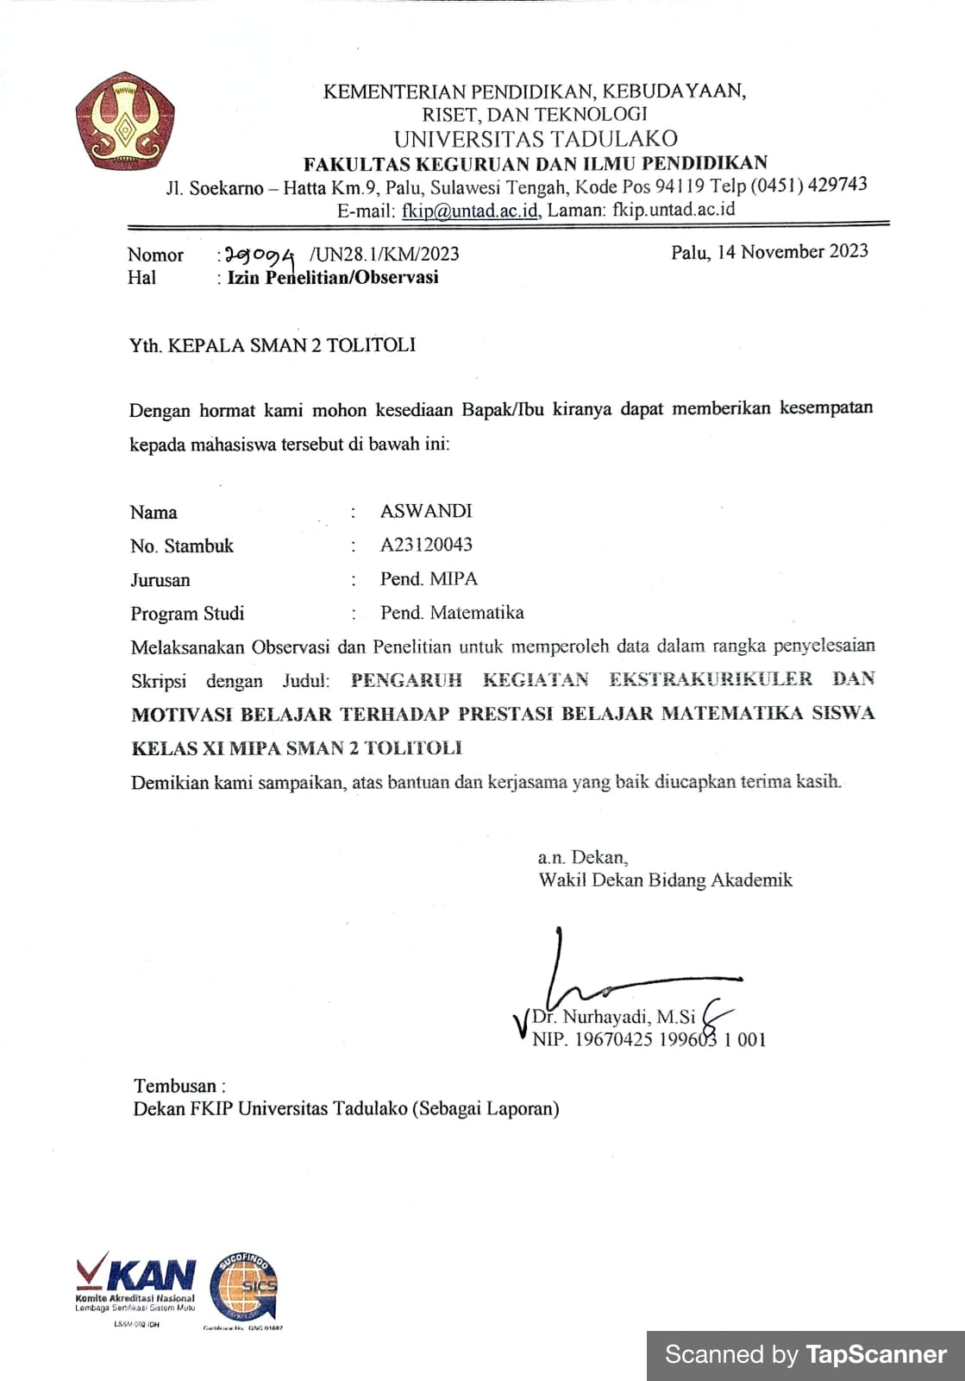

1. **Surat Pernyataan Telah Melakukan Penelitian**

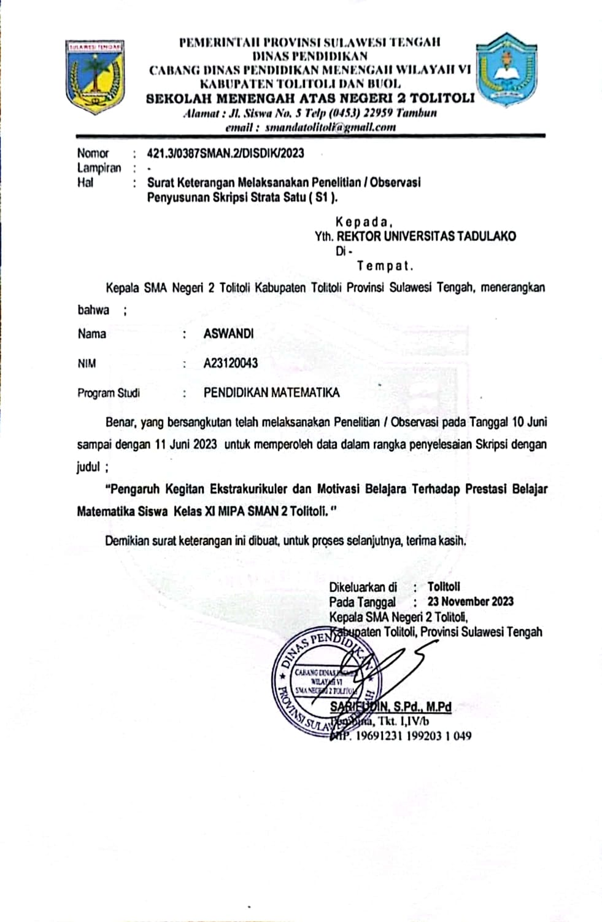

1. **SK Pembimbing**

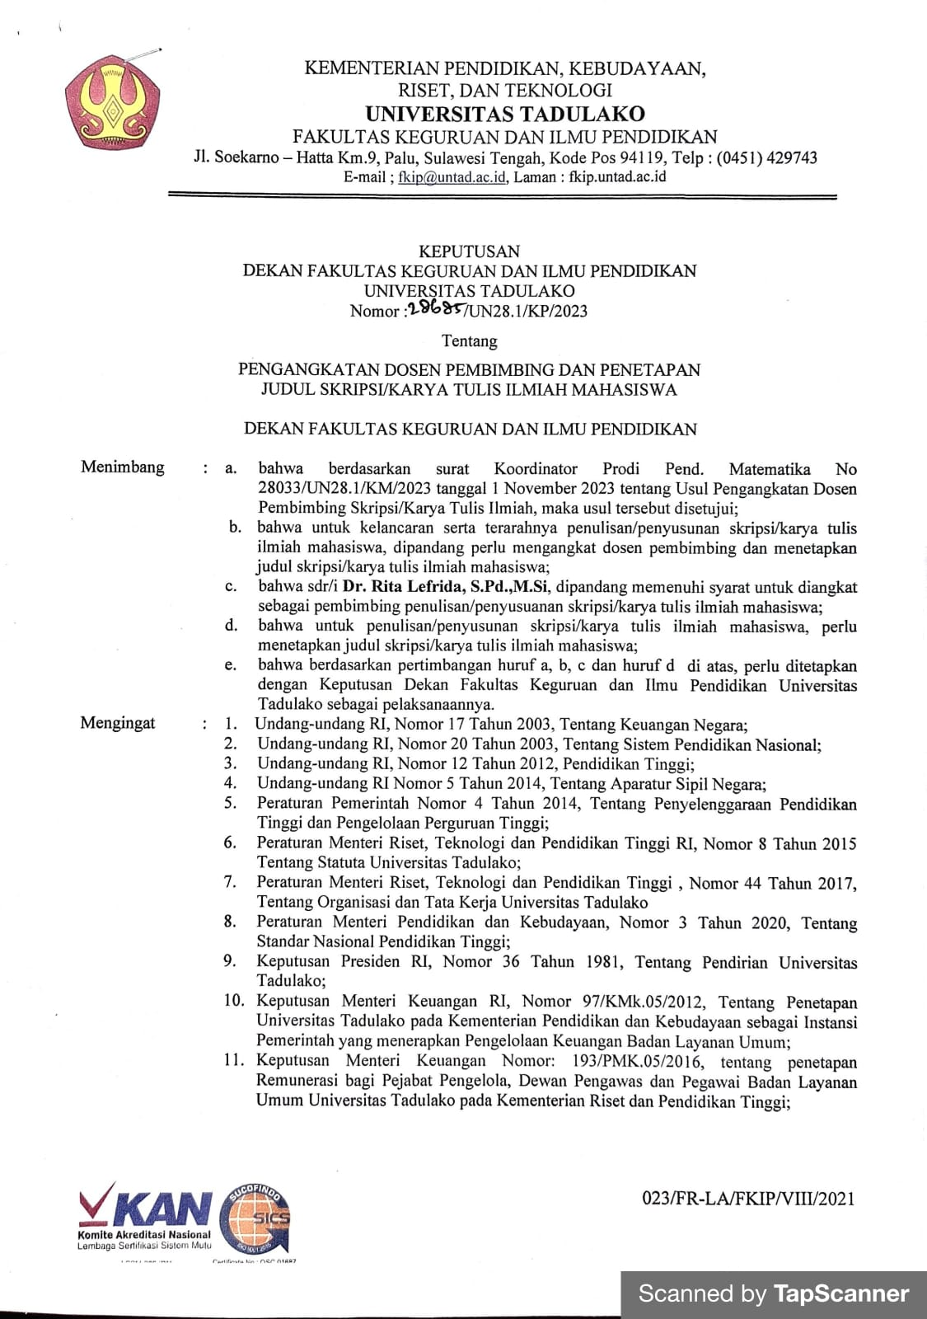

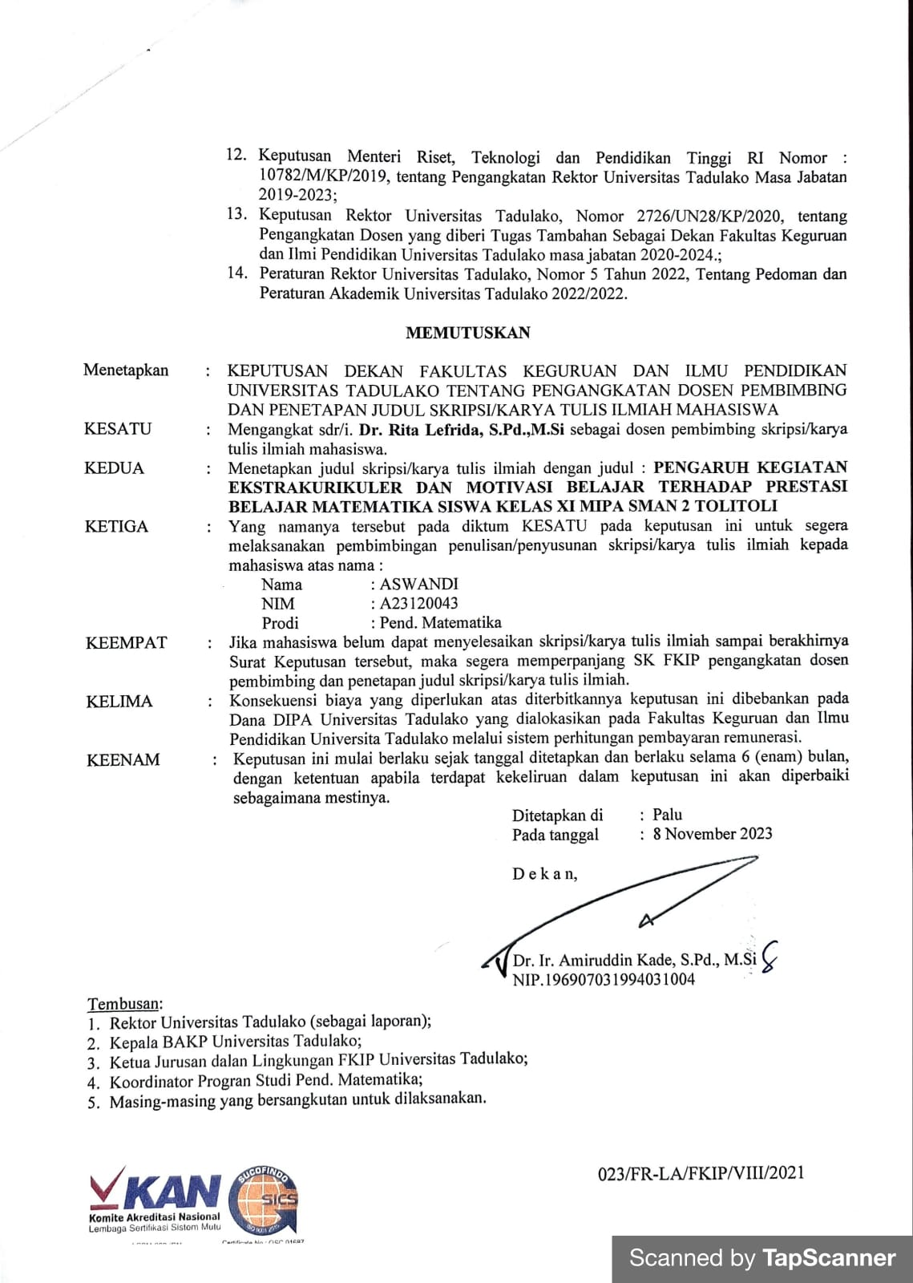

1. **Dokumentasi Penelitian**

**XI MIPA 1**

|  |  |
| --- | --- |
|  |  |
|  |  |
|  | |

**XI MIPA 2**

|  |  |
| --- | --- |
|  |  |
|  |  |
|  | |