Development of Student Worksheets on Spatial Structure Material Based on Candi Penataran to Support Student Learning Outcomes

¹Anisah Salsabila, ^{2*}Asfira Zakiatun Nisa, ³Erni Anggraini, ⁴Marhayati
Departement of Mathematics Education, Faculty of Learning Education, Universitas Islam Negeri Malang. Jl. Gajayana No. 50, Dinoyo, Lowokwaru, Malang, Indonesia. Postal code: 65144
*Corresponding Author e-mail: anisahslsbl@gmail.com

Received:…………..; Revised:…………; Published: …………..
Abstract
This research aims to develop Student Worksheets (LKPD) based on the Spatial Structure Material with a foundation in Penataran Temple to support students' learning outcomes. The study also aims to assess the validity of the LKPD and measure the improvement in students' learning outcomes after using the LKPD. The research follows the development model proposed by Richey and Klein, which consists of three stages: planning, production, and evaluation. The planning stage involves needs analysis, concept development, and planning for the implementation of the LKPD. The researcher conducts an initial study regarding the challenges in teaching spatial geometry to junior high school students and devises strategies to enhance their learning outcomes. Additionally, needs analysis for the development of worksheets based on Penataran Temple and spatial structure is carried out during the planning stage. The production stage includes the creation and development of LKPD based on the concepts and objectives designed during the planning phase. The researcher develops LKPD that focuses on the Penataran Temple and spatial structure concepts. The results of the pre-test and post-test analyses indicate a significant improvement in the average scores of students. The average pre-test score is 29.86, while the average post-test score is 64.93. These results also reflect an increase in the number of students who have reached the minimum passing grade (KKM) across various schools with varying KKM standards.
Keywords: Student Worksheet, Penataran Temple, Flat Surface Spatial Geometry, Learning Outcomes
How to Cite: Anisah Salsabila.,Asfira Zakiatun Nisa., Erni Anggaraini & Marhayati. (2024). The title. Prisma Sains: Jurnal Pengkajian Ilmu dan Pembelajaran Matematika dan IPA IKIP Mataram, vol(no), xx-yy. doi:https://doi.org/10.33394/j-ps.vxxiyy

https://doi.org/10.33394/j-ps.vxxiyy | Copyright© 2019, First author et al  This is an open-access article under the CC-BY License.

INTRODUCTION (12pt, Times New Roman)
Learning outcomes can be characterized by changes in knowledge or skills. Changes in knowledge can occur due to experiences gained during the teaching and learning process(A. Chandra & Hidayati, 2023). To achieve optimal student learning outcomes, meaningful learning processes are necessary. Meaningful learning can be ensured by considering students' prior knowledge to yield optimal results (Wati, 2020).
Success in learning can be attributed to the support of each learning component. One of these components is teaching materials. Teaching materials are fundamental in education as they provide guidance that helps teachers convey information more effectively and aids students in understanding the learning materials (Luthfi & Rakhmawati, 2022). In achieving educational goals and meeting competency standards, teaching resources play a significant role. Teaching materials are considered a collection of learning materials and supplementary information from various sources with the aim of creating enjoyable learning experiences (Kuswari & Choiruddin, 2021). One compelling tool to engage students in independent learning and promote effective teacher-student interaction is student worksheets (Teo & Goh, 2019).
The use of worksheets in teaching can improve student learning outcomes (Oktarina et al., 2019). Additionally, student worksheets are employed not only to enhance learning outcomes but also to improve students' mathematical reasoning abilities (Handayani & Mandasari, 2018) and critical thinking skills (Suanto et al., 2022). Therefore, when creating student worksheets, it is essential to include well-structured content and tasks related to the material.
Based on observations and interviews conducted with teachers at MTs Nurul Huda NgadirejoBlitar, it was revealed that teachers had already created worksheets, but these worksheets consisted mainly of content and questions. The existing worksheets did not incorporate images related to local culture or objects encountered by students in their daily lives. Observations in MTs Nurul Huda NgadirejoBlitar, grade VIII, showed that students faced difficulties in learning flat surface spatial geometry materials. In interviews with teachers at SDN 1 Blimbing, it was found that teachers used government-provided textbooks in their teaching.
Flat surface spatial geometry is an abstract branch of geometry. Therefore, it requires a teaching approach that can relate geometry to everyday life to make it more relevant for students. One approach that can be used in teaching is the Realistic Mathematics Approach. This approach provides students with the opportunity to construct mathematical concepts based on their everyday experiences (Guarino et al., 2022).
More meaningful mathematics education can capture the relationship between learning experiences and the local cultural environment. The introduction of culture can be integrated into teaching by utilizing the local environment in instructional materials (Salafudin et al., 2022). The connection between mathematics and daily life or culture is known as ethnomathematics (D’Ambrosio, 1985). One cultural element that can be linked to flat surface spatial geometry, particularly, is temples. In East Java, specifically in Blitar, there is a Majapahit Kingdom heritage temple called Candi Penataran. The temple's architecture, constituent stones, and ornaments contain geometric concepts (Chandra, 2021; Munthahana & Budiarto, 2020). Geometric concepts found in the architecture of Candi Penataran include cubes, rectangular prisms, arbitrary triangular prisms, isosceles triangular prisms, frustum of rectangular pyramids, rhombus-based prisms, and cylinders The study byMunthahana & Budiarto (2020)also identified mathematical concepts present in Candi Penataran, such as spatial structure and geometric transformations.
Currently, several researchers have developed flat surface spatial geometry worksheets based on culture (Astuti et al., 2021; Noveno & Putra, 2022; Oktarina et al., 2019; Septiani & Hidayah, 2022). The cultural context used in the development of worksheets is adapted to the local culture of each researcher. Astuti et al. (2021) used the context of regional dishes from Medan.Noveno & Putra (2022) used the cultural context of traditional market snacks from Pontianak. Oktarina et al. (2019) used the cultural context of traditional houses from South Sumatra. Septiani & Hidayah (2022) incorporated the historical building LawangSewu into their teaching materials.
Based on the above explanations, to address the difficulties faced by students in understanding flat surface spatial geometry materials, worksheets will be developed. These student worksheets will be based on the local culture of Candi Penataran. The student worksheets on flat surface spatial geometry integrated with the culture of Candi Penataran will be developed for three educational levels: Elementary School (SD), Junior High School (SMP), and High School (SMA). Therefore, this research is titled "Development of Student Worksheets on Flat Surface Spatial Geometry Material Based on Candi Penataran to Support Student Learning Outcomes."

METHOD
This research is a development study (R&D). The research model follows the steps of Richey and Klein with three main stages: planning, production, and evaluation. The study was conducted at An-Nurriyah Islamic Junior High School, Sukun District, Malang City. The first stage of the research is planning, which aims to determine the research objectives, identify learning problems, and the needs of students in understanding flat surface spatial geometry material based on the culture of Candi Penataran in student learning. It also involves formulating strategies for developing student worksheets. The production stage is carried out to design and develop student worksheets based on the culture of Candi Penataran that align with the learning needs and objectives. The evaluation stage is conducted to assess the quality and effectiveness of the student worksheets based on the culture of Candi Penataran in supporting the learning outcomes of junior high school students.
This study involved 18 students in the learning process, utilizing student worksheets on flat surface spatial geometry material based on Candi Penataran. The research provided data collection instruments, including validation sheets for the student worksheets by experts and a set of evaluations (pre-test and post-test). The pre-test and post-test were designed in the form of essay questions tailored to the research needs, consisting of five questions related to flat surface spatial geometry. A subject matter expert reviewed these test questions before they were officially administered to the students. The validity of the student worksheets was determined by calculating the score percentage on the questionnaire through statistical analysis as part of the quantitative data analysis process.
Meanwhile, to measure the learning outcomes of students regarding flat surface spatial geometry material, a comparison was made using the results of the pre-test and post-test, assessed based on the achievement of learning outcome indicators. To assess the effectiveness of the student worksheets in supporting student learning outcomes, the pre-test and post-test data were analyzed using a paired sample t-test and normalized gain test. However, before conducting the t-test analysis, prerequisites were examined, including tests for normality and homogeneity.

RESULTS AND DISCUSSION
The results of the development of culturally-based student worksheets for junior high school students in mathematics education will be explained as follows:
a. Planning Phase
The first stage is planning, also known as needs analysis. The goal of this stage is to determine and define the requirements for mathematics education at the junior high school level. Determining and defining these requirements begins with an analysis of the objectives. The results of the definition phase are as follows:
1) Problem Analysis
The problem analysis aims to understand the initial conditions at MTs Nurul Huda Ngajum Malang, especially in grade IX. What needs to be analyzed is the teaching methods and techniques used by mathematics teachers. The mathematics teachers mentioned to the researcher that the basic mathematical understanding of grade IX students is somewhat lacking. This is reinforced by the daily test score data, which averages below the minimum passing grade (KKM), particularly in geometry. When the researcher asked the mathematics teachers about the reasons for the students' low understanding of basic mathematics, the teachers explained that one of the factors is the students' perception that mathematics is a difficult subject and is not related to everyday life. The researcher continued to inquire about the reasons behind the students' perception that mathematics is difficult, and the teachers explained that the developed student worksheets (LKPD) had not been able to accommodate the academic and emotional needs of the students. Until now, mathematics teaching had been carried out using textbooks provided by the Ministry of Education. The teachers had already made efforts to actively involve the students in the teaching and learning process. With the development of culture-based geometry LKPD, it is expected to change the students' perception of mathematics, which initially considered it difficult and unrelated to daily life, into something easy and highly relevant to their daily lives. The teaching process begins with the distribution of LKPD to students. The students listen to the material explained by the teacher, referring to the mathematics textbook, followed by question and answer sessions related to the material and concluding with exercises. This affects the students' engagement in the subject, leading to the perception that mathematics and local wisdom are separate entities, with mathematics not addressing cultural aspects, and vice versa.
Similar to MTs Nurul Huda Ngajum Malang, the teaching of basic mathematics for grade IX students at SMP Islam Annuriyah is also inadequate. This is evidenced by the daily test score data, which averages below the minimum passing grade (KKM), especially in geometry. When the researcher asked the mathematics teachers about the reasons for the students' low understanding of basic mathematics, the teachers explained that one of the factors is the students' background in a pesantren environment, where mathematics is seen as unrelated to everyday life. Additionally, students lack motivation because they find mathematics difficult as santri (students in a pesantren). Furthermore, at SMP Islam Annuriyah, only the provided Student Worksheets (LKS) from the school are used, so innovative learning resources are less accessible to students.
2) Curriculum Analysis
Curriculum analysis is crucial in the planning stage of developing culture-based geometry student worksheets. Teachers must be able to determine the appropriate materials to be taught using the developed student worksheets. Components related to the curriculum, particularly subject matter and competencies to be achieved, are considered based on the 2013 curriculum and independent learning curriculum. The characteristics of the independent learning curriculum are implemented to prepare Indonesian generations who have faith, productivity, creativity, innovation, and affective qualities, capable of contributing to community life, the nation, and global civilization. Based on this description, one way to respond to issues in line with the demands and challenges of the independent learning curriculum is to develop culture-based geometry student worksheets aimed at enhancing cognitive and affective abilities in junior high school students.
3) Student Worksheet Needs Analysis
The step of analyzing and organizing the needs of student worksheets determines the quantity or number of student worksheets required. In this stage, the sequence of student worksheets is determined so that they can be used effectively, systematically, and constructively. Curriculum analysis is carried out by analyzing the curriculum used, namely the independent learning curriculum initiated by the Ministry of Education and published by BSNP (National Center for Education Standards). This is done to ensure that the developed student worksheets can be beneficial to various schools and are not tied to a specific school's curriculum. The aspects analyzed in the curriculum include the expected basic competencies and indicators that students must achieve regarding the topics of flat surface spatial geometry. Once the curriculum analysis has been conducted, the creation of a student worksheet needs map becomes more straightforward. Additionally, in the creation of the student worksheet needs map, an analysis of learning resources to be used in teaching is included.
4) Student Analysis
In this stage, the researcher conducted observations and discussions with mathematics teachers. Based on the observations, it was found that the basic knowledge of students at MTs Nurul Huda Ngajum Malang was quite good. However, many students still considered mathematics to be a difficult and irrelevant subject, as they felt it had no connection to their religion and culture. Students also had a tendency to become easily bored with teaching and learning activities and were less active in seeking various information related to the material being taught. Often, teachers had to repeat the material to ensure that students remembered what they had learned, and the intellectual abilities of the students were quite diverse or heterogeneous due to students at MTs Nurul Huda Ngajum Malang coming from different formal education backgrounds.
Not much different from MTs Nurul Huda Ngajum, students at SMP Islam Annuriyah also had a tendency to become bored with learning activities. They lacked enthusiasm in participating in lessons. One of the factors contributing to this was that students in the pesantren environment had activities from morning until ten at night. Therefore, there was a need for innovation in learning, especially in mathematics, which could be related to culture to improve student learning outcomes. Additionally, students in pesantren environments, with limited opportunities to leave the pesantren, were not fully aware of the cultural aspects related to mathematics in Indonesia.
5) Learning Material Analysis
The analysis of learning material involves selecting and systematically detailing relevant teaching materials to be used. The teaching material used in this research is geometry, specifically, flat surface spatial geometry, including cubes, rectangular prisms, prisms, and pyramids. Once the main concept of the material has been analyzed, an outline of the material to be included in the student worksheet is developed. After the material outline is established, indicators and learning objectives for geometry in the eighth grade are formulated.

b. Production Phase
Based on the findings of the preliminary study, a design for teaching materials in the form of culture-based geometry student worksheets (LKPD) was developed. The goal of this phase is to prepare a prototype of culture-based geometry LKPD to facilitate student understanding of mathematics in the learning process. This phase includes the following steps:
1) Selection of Appropriate Media
Educational media serves as a tool to effectively transfer material to students so they can understand, receive, and master the material clearly and easily. Media used in the LKPD are aligned with the core competencies, indicators, and main topics. The images presented are adjusted to the characteristics of students' daily lives and Indonesian culture, ensuring that the learning objectives are achieved according to the indicators.
2) Format Selection
Format selection is done by examining various RME-based student worksheet formats that support student learning outcomes in mathematics education. The LKPD culture-based geometry background includes font size 14 for the body text, main titles in Chewy font size 57, sub-chapter titles in Chewy font size 70, images of temples, mathematical illustrations related to students' daily lives associated with Candi Penataran, and other designs to enhance the appearance of the LKPD.
3) Initial LKPD Plan
In this design stage, the researcher has already created an initial product (prototype) or product design. This stage is conducted to create the culture-based geometry LKPD, focusing on Candi Penataran, and to simulate the use of the model and geometry LKPD in a small-scale setting. After aligning the core competencies with the indicators in the previous stage, the LKPD design is carried out. The structure of the LKPD development in this research is based on Prastowo (2011) and includes the following components:
- Introduction
- Title: Development of Student Worksheets on Flat Surface Spatial Geometry Based on Candi Penataran to Support Student Learning Outcomes
- List of Competency Objectives: Includes Core Competencies, Basic Competencies, Indicators, and Learning Objectives.
- Core
The core section of this development model consists of several elements, including:
- Motivation
Before getting into the core material, the LKPD provides literacy about Candi PenataranBlitar.
- Material Description
The material description provides introductory material for each learning activity. After presenting the introductory material in the culture-based geometry LKPD, constructive mathematical learning steps are presented, starting with presenting a problem where the problem presented is a flat surface spatial geometry problem.
- Learning Activities
The learning activities in the culture-based geometry student worksheets integrated into Islamic mathematics education are directed toward RME-based learning. The main learning activities ask students to solve real-life problems from their daily lives.
c) Conclusion
The concluding section in this development model includes a final test. The final test is used to assess student learning outcomes using the culture-based geometry student worksheets. The test consists of questions that cover all learning outcome indicators.
d) Validation Section
The development phase aims to produce LKPD that has been revised based on feedback from expert validators in the fields of content, construction, and language. This stage consists of two parts: 1) Validation conducted by experts on the developed product, and 2) development testing conducted with eighth-grade students at MTs Surya Buana Malang. The steps are as follows:
- Validation by Experts
Validation is conducted to assess the suitability of a research instrument. In this research, the research instrument being validated includes the content, language, design, teaching approach, Islamic aspects, practicality, and the test instrument itself. The LKPD is validated by one content expert, Dr. PatmaSopamena, M.Pd.I, M.Pd.; one teaching expert, Dr. PatmaSopamena, M.Pd.I, M.Pd.; one design expert, Ibrahim Sani Ali Manggala, M.Pd.; one Islamic expert, Budi PrasetyoMargono, M.Pd.; one language expert, Mohammad KhikamZahidi, M.Pd.; and one practitioner, Faizal Chanda, S.Pd. Additionally, the test instrument in this research is validated by Prof. Dr. H. Turmudi, M.Si, Ph.D. The goal of this step is to receive feedback and evaluation from experts on the LKPD that has been designed. Subsequently, the feedback and suggestions from the validators are used to revise the first prototype. Improvements to the first prototype are based on the feedback and guidance of the validators, leading to the creation of the second prototype. The evaluation of the LKPD involves providing the LKPD materials that have been developed, along with a LKPD feasibility assessment sheet. The evaluation of the LKPD, including the first prototype and the second prototype, is conducted in two stages.
Table 1. Validation Results of Student Worksheets and Instruments
Assessment Aspect | Assessment Results | Category
Content | 77,94% | Very Valid
Teaching | 97,2% | Very Valid
Language | 88,63% | Very Valid
Design | 82,5% | Very Valid
Islamic Aspect | 100% | Very Valid
Practitioner | 93,75% | Very Valid
Test Instruments | 78,57% | Very Valid
Based on the data above, in Stage 1, the average assessment score falls into the "good" category. However, based on feedback from the validator, some improvements are needed in certain parts of the student worksheets. The improvements made to the student worksheets based on the Stage 1 assessment can be seen in Table 2. After these improvements, a Stage 2 assessment was conducted on the prepared student worksheets, resulting in an average assessment score categorized as "very good." Therefore, it can be concluded that the developed student worksheets for Flat-Sided Space Construction based on Candi Penataran meet the criteria for being highly valid. There is no further need for revisions, and limited testing can proceed. The appearance of the student worksheets before and after the revisions can be seen in Table 2.
Table 2. Student Worksheet
Before Revision | After Revision
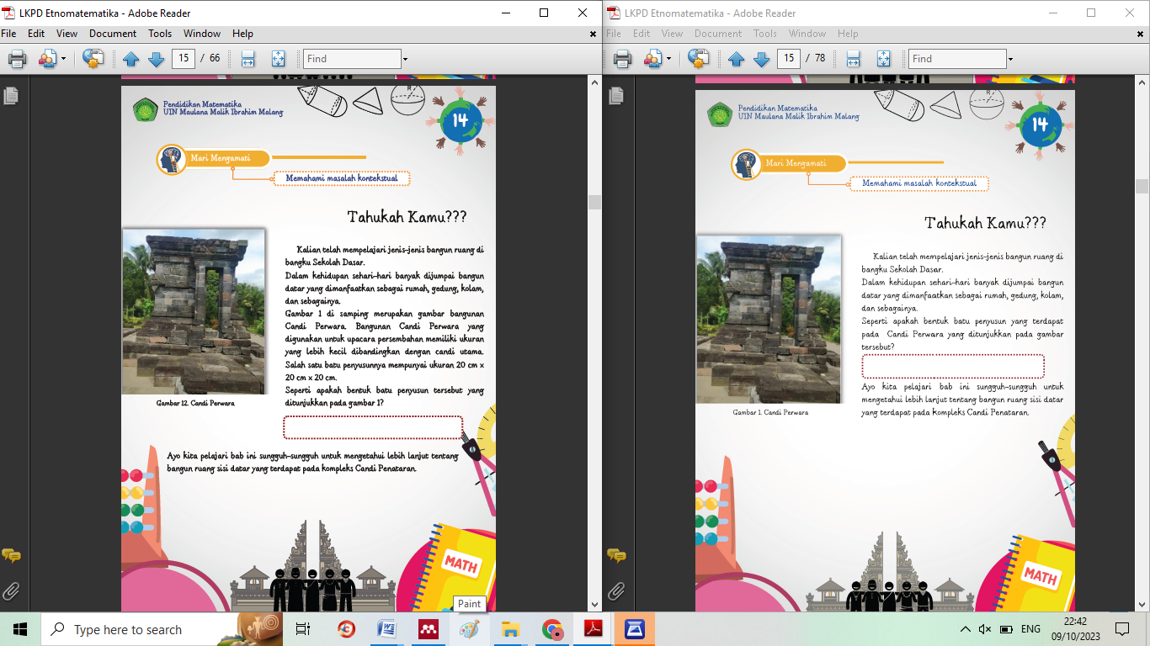 | 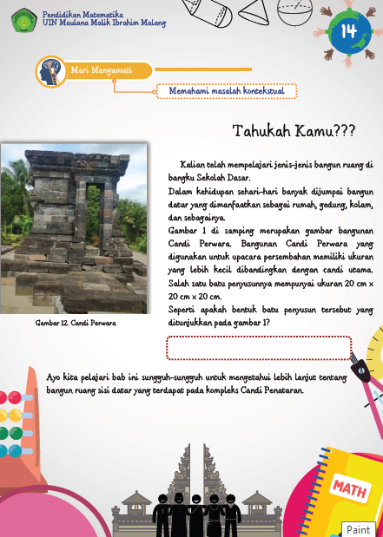
Clarifying the issues used in conveying concepts to students
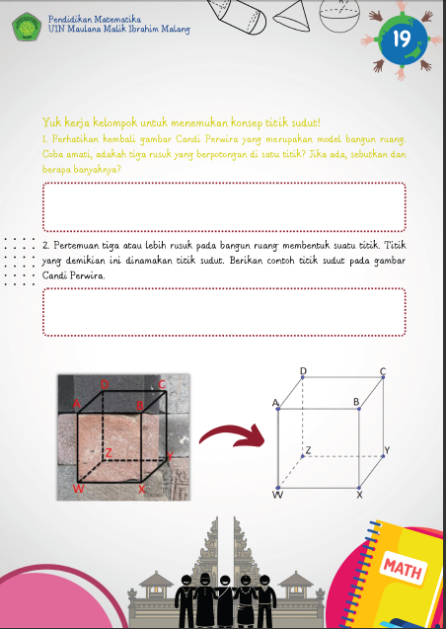 | 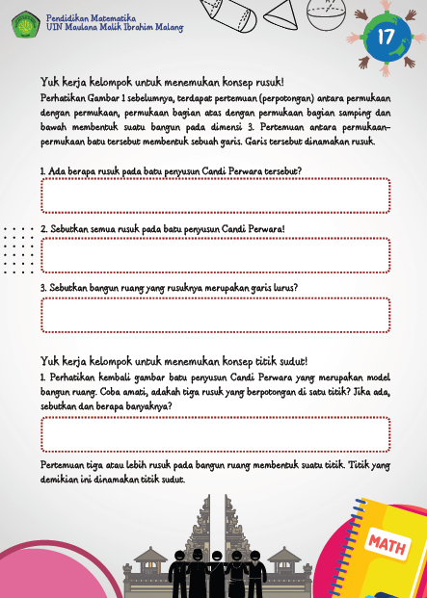
Eliminating repetitive parts to avoid redundancy in conveying the material as well as images (illustrations).
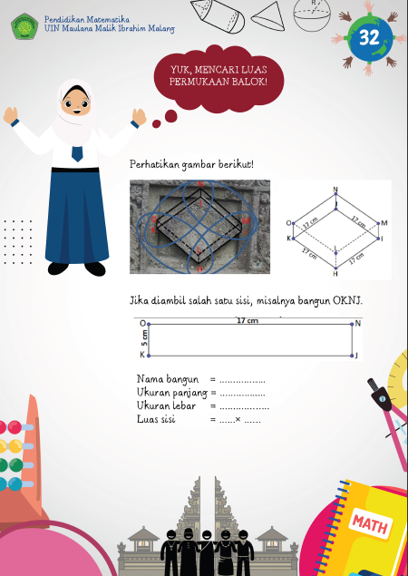 | 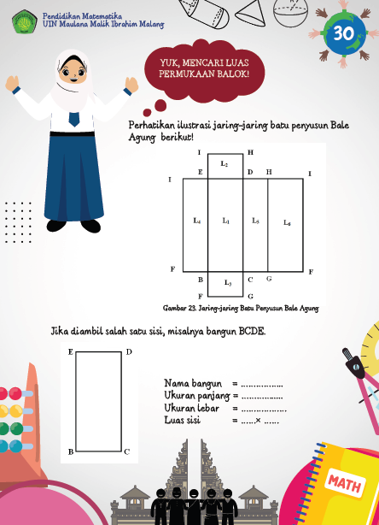
The mesh diagrams in the surface area of the rectangular prism material are replaced with the same mesh diagrams as the previous image (the stone structure of Bale Agung).
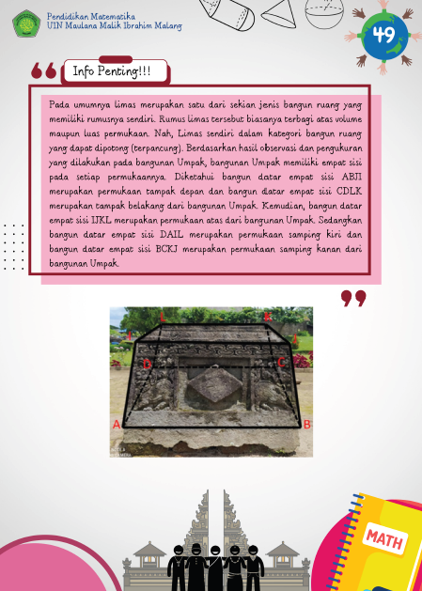 | 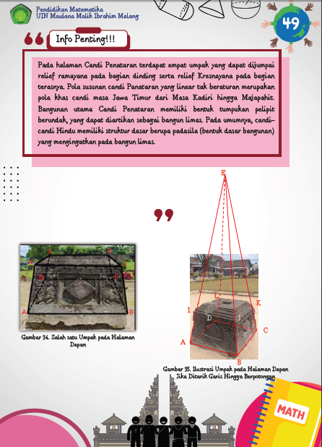
Adding illustrations for the complete form of a truncated pyramid (a pointed pyramid) on the 'Umpak’

c. Evaluation Phase
The validation process has been completed, revised, and deemed suitable for testing with students at SMP Islam Annuriyah Malang who have studied the topic of "Two-Dimensional Shapes" in grade IX. Before conducting the trial, students were given a pre-test to assess their initial abilities before using the culturally-based Candi Penataran-themed worksheet (LKPD). The results of the pre-test can be found in the appendix attached to this report. This trial aims to determine the effectiveness and attractiveness of the developed product and whether it can be used as a reference for student learning, as assessed through a questionnaire filled out by the students.
The trial of the developed and improved culturally-based Candi Penataran-themed LKPD took place following the validation process's conclusions. The final validation stage involved implementing the Candi Penataran-themed LKPD in Class IX A at SMP Islam Annuriyah Malang. This activity represents the last step in determining the suitability of the developed LKPD.
Each student received the LKPD for their learning, and they were then asked to complete the activities and exercises within the LKPD. Subsequently, students were given a test to assess their learning outcomes. The results of this assessment will serve as criteria for the effectiveness of the developed LKPD.
The evaluations conducted by subject matter experts, educators, designers, language experts, Islamic scholars, and practitioners, as well as the student test results, indicate that the "Two-Dimensional Shapes" LKPD meets the criteria for validity. Therefore, the LKPD can be utilized in mathematics education, with the hope that it will assist students in enhancing their learning outcomes.
Below are the results of the pre-test and post-test for the students.
Table 3. Student Pre-test and Post-test Results
No. | Name | Pre-Test | Post Test
1 | S 1 | 0 | 86
2 | S 2 | 0 | 61
3 | S 3 | 33 | 64
4 | S 4 | 59 | 63
5 | S 5 | 59 | 63
6 | S 6 | 15 | 46
7 | S 7 | 59 | 41
8 | S 8 | 18 | 81
9 | S 9 | 27 | 84
10 | S 10 | 0 | 84
11 | S 11 | 39 | 64
12 | S 12 | 59 | 86
13 | S 13 | 9 | 86
14 | S14 | 41 | 0

**Table 3** shows significant variations in student achievement between the Pre-test and Post-test. Some students experienced remarkable improvements in their understanding of the material, such as Subject 1, who initially scored 0 on the Pre-Test and increased to 86 on the Post-Test. Additionally, Subject 8 also demonstrated significant improvement, with a Pre-Test score of 18 and a Post-Test score of 81. On the other hand, there were some students who recorded a decline in their results, such as Subject 7, who decreased from a Pre-Test score of 59 to 41 on the Post-Test. Furthermore, some students achieved stagnant scores, like Subject 14, who maintained a score of 41 on both tests. Further analysis of this data can provide deeper insights into the use of LKPD in supporting students' learning outcomes in the topic of Two-Dimensional Shapes.
Table 4. Results of Students' Religious Moderation Questionnaire
No. | Name | Meet-1 | Meet-2
1 | S 1 | 37 | 43
2 | S 2 | 50 | 50
3 | S 3 | 37 | 38
4 | S 4 | 30 | 27
5 | S 5 | 48 | 54
6 | S 6 | 57 | 56
7 | S 7 | 25 | 27
8 | S 8 | 20 | 35
9 | S 9 | 37 | 43
10 | S 10 | 30 | 27
11 | S 11 | 20 | 27
12 | S 12 | 23 | 27
13 | S 13 | 42 | 42
14 | S14 | 40 | 41

The research results indicate significant variation in the development of the research subjects between the first and second meetings. Several subjects experienced a rather noticeable improvement in their understanding of the material, as reflected in the increase in scores between the first and second meetings. For example, Subject 5 showed a substantial improvement from a score of 48 in the first meeting to 54 in the second meeting, demonstrating a significant improvement in understanding the material. Subject 6 showed positive development, with a first-meeting score of 57 that increased to 56 in the second meeting. However, there were also subjects who experienced a decrease in their understanding, such as Subject 4, who initially scored 30 in the first meeting and dropped to 27 in the second meeting. Subject 8 also experienced a decrease, with a score of 20 in the first meeting rising to 35 in the second meeting.
Furthermore, some other subjects showed stagnant changes between the two meetings, like Subject 2, who scored 50 in both meetings, and Subject 13, who maintained a score of 42 in both meetings. These results provide a complex picture of the development of the research subjects' understanding during the meeting period.
Discussion
The stages used in this development process utilize three phases developed by Richey and Klein: planning, production, and evaluation. During the analysis phase conducted before the research, it was identified that students faced difficulties in solving problems related to flat geometry materials. Therefore, the researcher chose to develop a culture-based Student Worksheet (LKPD) on the subject of flat-sided spatial geometry to assist students in understanding mathematics through cultural integration.
The design phase involved the development of a framework and ideas for creating culture-based LKPD on flat-sided spatial geometry. Designing was performed to provide an understanding of the appearance and content of the LKPD to be created and developed. The instrument design aimed to create a validation questionnaire for experts, including experts in the subject matter, experts in instructional media, design experts, language experts, Islamic experts, practitioners, as well as pre-test and post-test instruments.
The production phase involved the creation of the instructional media. Once the product was completed and developed, the next step was to validate it with the experts. The validation aimed to identify the strengths and weaknesses of the LKPD and obtain feedback or suggestions for improving the developed LKPD. Validation also determined whether the LKPD was suitable for use in the learning process based on the assessments of the experts. The results of the expert evaluations showed that the LKPD was highly valid, with subject matter experts rating it at 77.94%, instructional experts at 97.2%, design experts at 82.5%, language experts at 90%, Islamic experts at 88%, and practitioners at 87%. Additionally, the validation results for the pre-test and post-test instruments were 90%, indicating "very valid."
The evaluation phase involved assessing the product that had been created and developed. The purpose of this evaluation phase was to determine whether the culture-based LKPD on spatial geometry was suitable and engaging for use in learning. The results of the assessments by subject matter experts, instructional media experts, design experts, language experts, Islamic experts, and practitioners led to the conclusion that the culture-based geometry LKPD was valid for use in learning and could support student learning outcomes.

CONCLUSION
The conclusion describes the answer to the hypothesis and / or the purpose of the research or scientific findings obtained. Conclusions do not contain repetitions of the results and discussion, but rather summarize the findings as expected in the objectives or hypotheses.
The development of this Student Worksheet (LKPD) has resulted in the creation of the "Flat-Sided Spatial Geometry Student Worksheet" based on Candi Penataran as a companion book for mathematics, covering flat geometry topics for middle school students (grade VIII). It introduces one of Indonesia's cultural treasures, Candi Penataran. The development of this culture-based LKPD for flat-sided spatial geometry in middle school students received a valid rating from experts. The scores given by experts in instruction, content, media, Islamic integration, language, design, and practitioners were 77.94%, 97.2%, 88.63%, 82.5%, 100%, 93.75%, and 78.57%, respectively. Thus, the LKPD is considered highly valid, with an average score of 88.37%.
The results of this development can contribute to the diversity of mathematics companion books and serve as a reference for both teachers and students in the eighth-grade classroom. For future research, it is hoped that the developed media will not be limited to flat geometry topics alone (cubes, rectangular prisms, prisms, and pyramids) but will explore more complex subjects to facilitate students in developing their mathematical understanding and moderating their diversity.

RECOMMENDATION
This research is only limited to developing student worksheets on flat-sided geometric figures for class 9 of junior high school. Apart from that, this research is limited to the context of the Blitar upgrading temple only. So the researcher recommends other researchers to continue research in the field of ethnomathematics for other cultures, be it temples, games, artifacts, dances, and so on which can be used for mathematics learning, especially in improving students' understanding of mathematics.

REFERENCES
Astuti, A., Zulfah, Z., & Rian, D. (2021). Pengembangan Lembar Kerja Peserta Didik (LKPD) Berbasis Etnomatematika pada Materi Bangun Ruang Sisi Datar Kelas VIII SMP Negeri 11 Tapung. Jurnal Pendidikan Tambusai, 5(3), 9222–9231. https://doi.org/10.31004/jptam.v5i3.2452
Chandra, A., & Hidayati, A. (2023). Pengembangan LKPD Berbasis Pendekatan Realistic Mathematics Education. Jurnal Ilmiah Pendidikan Matematika), 11(2), 280–292. https://doi.org/10.25273/jipm.v11i2.14336
Chandra, F. (2021). Eksplorasi bangun datar dan bangun ruang pada bangunan Candi Penataran di Kabupaten Blitar. Skripsi.
D’Ambrosio, U. (1985). Ethnomathematics and Its Place in the History and Pedagogy of Mathematics. For the Learning of Mathematics, 5(February 1985), 44-48 (in 'Classics').
Guarino, K. F., Wakefield, E. M., Morrison, R. G., & Richland, L. E. (2022). NC-ND license Why do children struggle on analogical reasoning tasks? Considering the role of problem format by measuring visual attention ☆. Acta Psychologica, 224. https://doi.org/10.17605/OSF.IO/YPRA8
Handayani, S., & Mandasari, N. (2018). Pengembangan Lembar Kerja Siswa (LKS) Berbasis Problem Based Learning untuk Meningkatkan Kemampuan Penalaran Matematika. Jurnal Pendidikan Matematika (JUDIKA EDUCATION), 1(2), 144–151. https://doi.org/10.31539/judika.v1i2.412
Kuswari, R. I., & Choiruddin, C. (2021). the Development of Student Worksheet Based on Higher Order Thinking Skills in Improving Mathematics Learning Outcomes. JMIE (Journal of Madrasah Ibtidaiyah Education), 5(2), 200. https://doi.org/10.32934/jmie.v5i2.333
Luthfi, H., & Rakhmawati, F. (2022). Pengembangan Lembar Kerja Peserta Didik (LKPD) Berbasis Etnomatematika pada Materi Bangun Ruang Sisi Lengkung Kelas IX. Jurnal Cendekia : Jurnal Pendidikan Matematika, 7(1), 98–109. https://doi.org/10.31004/cendekia.v7i1.1877
Munthahana, J., & Budiarto, M. T. (2020). Ethnomathematics Exploration in Panataran Temple and Its Implementation in Learning. Indonesian Journal of Science and Mathematics Education, 3(2), 196–209. https://doi.org/10.24042/ijsme.v3i2.6718
Noveno, C., & Putra, A. (2022). Pengembangan Lembar Kerja Siswa Etnomatematika Jajanan Pasar Tradisional Kota Pontianak Pada Materi Bangun Ruang Sisi Datar. 1(2), 144–152.
Oktarina, A., Luthfiana, M., & Refianti, R. (2019). Pengembangan Lembar Kerja Siswa (LKS) Etnomatematika Berbasis Penemuan Terbimbing pada Materi Bangun Ruang Sisi Datar. Jurnal Pendidikan Matematika (JUDIKA EDUCATION), 2(2), 91–101. https://doi.org/10.31539/judika.v2i2.887
Salafudin, Sholehuddin, M. S., Sholikhah, A., & Sari, N. H. M. (2022). Ethnomathematics in Elementary School Pengembangan LKS dengan Pembelajaran Matematika Realistik. Jurnal Phenomenon, 12(1), 77–89.
Septiani, N., & Hidayah, N. (2022). Pengembangan LKPD dengan Pendekatan PMRI pada Materi Bangun Ruang Sisi Datar Konteks Bangunan Bersejarah Lawang Sewu. Konferensi Ilmiah Pendidikan, 3, 87–100.
Suanto, E., Khainingsih, F. G., & Hutapea, N. M. (2022). Pengembangan Lkpd-El Berbasis Problem Based Learning Berkonteks Budaya Melayu Untuk Meningkatkan Kemampuan Berpikir Kritis Matematis. AKSIOMA: Jurnal Program Studi Pendidikan Matematika, 11(3), 1805. https://doi.org/10.24127/ajpm.v11i3.5659
Teo, T. W., & Goh, W. P. J. (2019). Assessing lower track students’ learning in science inference skills in Singapore. Asia-Pacific Science Education, 5(1), 1–19. https://doi.org/10.1186/s41029-019-0033-z
Wati, J. (2020). Tahap Preliminary Research Pengembangan LKPD Berbasis PBL Materi Peluang Kejadian Majemuk. INOMATIKA, 2(2), 106–116.

