**Mathematical Literacy through PBL-Team Teaching with Educaplay: A Case Study Based on Students’ Learning Styles**

**1Rhaesa Fadillah Rahmadani, 2Nilam Pusparani, 3*Muchamad Subali Noto, 4Mohammad Dadan Sundawan**

Department of Mathematics Education, Faculty of Education and Science, Swadaya Gunung Jati University. Jl. Perjuangan No. 1, Cirebon, West Java, Indonesia. Postal Code: 45131

*Corresponding Author e-mail: [msnoto@ugj.ac.id](mailto:msnoto@ugj.ac.id)

Received:…………..; Revised:…………; Published: …………..

**Abstract**

*This study aims to describe the mathematical literacy skills of junior high school students on the geometry of tubes and cones by applying the Problem-Based Learning (PBL) model with a team teaching strategy assisted by Educaplay digital media in terms of student learning styles. The research used a descriptive qualitative approach with a case study type. The subjects were three students with visual, auditory, and kinesthetic dominant learning styles selected based on a questionnaire. The research instruments included the learning style questionnaire, a mathematical literacy test based on local cultural contexts, and semi-structured interviews. The results indicated that visual learners tended to excel in interpreting visual contexts but struggled with abstract mathematical formulation. Auditory learners demonstrated understanding through verbal explanations but showed weaknesses in procedural aspects, while kinesthetic learners exhibited strong spatial reasoning through hands-on experiences. Integrating PBL, team teaching, and Educaplay proved effective in fostering mathematical literacy that is adaptive to diverse learning styles and culturally relevant. This study highlights the importance of responsive instructional approaches that acknowledge and accommodate students’ varied characteristics.*

***Keywords:*** *Educaplay, Learning Styles, Mathematical Literacy, Problem-Based Learning, Team Teaching.*

***How to Cite:*** First author., Second author., & Third author. (20xx). The title. *Prisma Sains: Jurnal Pengkajian Ilmu dan Pembelajaran Matematika dan IPA IKIP Mataram, vol*(no), xx-yy. doi:<https://doi.org/10.33394/j-ps.vxxiyy>

|  |  |
| --- | --- |
| <https://doi.org/10.33394/j-ps.vxxiyy> | Copyright*©* 2019, First author et al  This is an open-access article under the [CC-BY License](http://creativecommons.org/licenses/by/4.0/).  [Creative Commons License](http://creativecommons.org/licenses/by/4.0/) |

**INTRODUCTION**

Mathematical literacy is a critical competency that students must develop to navigate the challenges of the 21st century. It extends beyond basic arithmetic skills to include the ability to formulate contextual problems into mathematical representations, apply mathematical concepts and procedures, and interpret results across real-world situations (Afni & Hartono, 2020; Poernomo et al., 2021). In this sense, mathematical literacy is understood as the capacity to comprehend, utilise, and evaluate mathematics in various life contexts, enabling students to recognise the role of mathematics in their daily lives (Almarashdi & Jarrah, 2023). Despite its importance, numerous national and international studies, including findings from the Programme for International Student Assessment (PISA), indicate that Indonesian students’ mathematical literacy remains below the global average (Harisman et al., 2023). This highlights a persistent gap between the expected ideal competencies and students’ abilities (Kusmaryono & Kusumaningsih, 2023). One key contributing factor is the dominance of procedural teaching approaches that fail to connect mathematical concepts with real-life contexts relevant to students’ experiences.

Various studies have shown that conventional learning centred on memorisation and procedural learning tends to inhibit students from thinking critically and applying concepts meaningfully in everyday life situations (Ichda et al., 2023). Therefore, mathematics teaching should develop students’ ability to think critically, logically, and creatively, enabling them to integrate mathematical concepts into everyday problem solving (Sundawan et al., 2019). Problem-based learning (PBL) is a very suitable learning model to improve students’ mathematical literacy, because this model emphasises solving real-world problems in a meaningful context (Khairunnisah & Rasyidah, 2024). This model has been shown to enhance student engagement and deepen conceptual understanding (Smith et al., 2022), while encouraging higher-order thinking skills through problem-solving tasks grounded in everyday life (Suastra et al., 2019). A team teaching strategy can be employed to further optimise the implementation of PBL. This collaborative approach among teachers aims to broaden instructional facilitation and make learning more adaptive to the diverse needs of students.

On the other hand, integrating technology into instruction has become a crucial factor in enhancing students’ motivation and participation. One effective form of educational technology innovation is using digital game-based learning platforms such as Educaplay, which offers interactive educational activities, including puzzles, quizzes, matching games, and contextual simulations (Purbawati et al., 2024). The use of interactive educational games not only makes learning more enjoyable but also fosters meaningful learning experiences aligned with the characteristics of 21st-century education (Pramuditya et al., 2018). However, the effectiveness of learning is not only determined by the model and media used but also greatly influenced by students' individual characteristics, one of which is learning style. Learning style refers to an individual's tendency to receive, process, and store information optimally (Djara et al., 2023). Each student exhibits unique learning tendencies, commonly classified into three primary styles: visual, auditory, and kinesthetic (Ishartono et al., 2021).

In addition, linking mathematics content to local cultural contexts is believed to enhance the meaningfulness of learning. In geometry topics such as cylinders and cones, contextualisation can be achieved through cultural objects such as the *Tifa* musical instrument from Papua, which resembles a cylinder; the *Mbaru Niang* traditional house from Wae Rebo, which is shaped like a cone; and the *Honai* house from Papua, which combines cylindrical and conical forms. This culturally responsive instructional approach has the potential to help students construct knowledge in more creative and relevant ways while simultaneously integrating cultural values into the learning process (Noto et al., 2018). Although several previous studies have discussed the effectiveness of the Problem-Based Learning (PBL) model, the use of interactive digital media, and learning styles separately, research that combines these three elements thoroughly in the context of Indonesian local culture is still minimal. Studies that examine students’ mathematical literacy by applying the PBL model combined with a team teaching strategy, supported by Educaplay media, and viewed from various learning styles in a cultural context are still rarely found. The novelty of this research lies in integrating the PBL learning model, team teaching strategy, and Educaplay digital media adapted to the local cultural context while considering the diversity of student learning styles in learning mathematics, especially tube and cone material.

Thus, this study aims to describe the mathematical literacy skills of junior high school students in geometry material, especially on the topic of tubes and cones, through the application of the Problem-Based Learning (PBL) model combined with a team teaching strategy and supported by Educaplay interactive digital media, and seen from the perspective of various student learning styles.

**METHOD**

This research used a descriptive qualitative approach with a case study design. The purpose is to describe and analyse students’ mathematical literacy based on their learning styles after participating in learning that applies the Problem-Based Learning (PBL) model combined with a team teaching strategy assisted by Educaplay interactive media. The study was conducted for one week, from April 14 to 17, 2025, in a junior high school in Cirebon, Indonesia. The research subjects consisted of 30 eighth-grade students who had completed learning activities on the geometry topics of cylinders and cones, taught through a culturally contextualised approach using traditional Indonesian objects: the *Tifa* musical instrument, the *Mbaru Niang* house, and the *Honai* house. Before the literacy test, all students completed a learning style questionnaire to identify their dominant learning preferences. Based on the questionnaire results, three students with the highest scores in each category, visual, auditory, and kinesthetic, were selected as the primary case study subjects, representing distinctly different dominant learning styles.

The instruments used in this study consisted of (1) a questionnaire to identify learning styles, (2) a mathematics literacy test adapted to the local cultural context, and (3) a semi-structured interview guide. The 30-item learning style questionnaire was divided into three sections with 10 items each for visual, auditory, and kinesthetic learning styles, using a four-point Likert scale, as described in Table 1.

**Table 1.** Likert Scale for the Learning Style Questionnaire

|  |  |
| --- | --- |
| **Likert Scale Categories** | |
| **Score** | **Criteria** |
| **4** | Strongly Agree |
| **3** | Agree |
| **2** | Disagree |
| **1** | Strongly Disagree |

Based on Table 1, the final score for each learning style category is calculated by summing the scores from 10 statements in each category. Students with the highest score in a particular category are considered to have a dominant learning style. Two expert lecturers in mathematics education validated the questionnaire to ensure content appropriateness, readability, and relevance to the characteristics of junior high school students. Four open-ended questions based on local cultural contexts were developed to assess mathematical literacy skills, referring to the PISA framework (OECD, 2019). Each question was designed to represent one mathematical literacy indicator, as shown in Table 2.

**Table 2.** Questions and Mathematical Literacy Indicators

|  |  |
| --- | --- |
| **Mathematical Problems** | **Indicator/Deskription** |
| **Read about the Traditional Musical Instrument Tifa!**    **Making the Tifa Instrument** Source: <https://images.app.goo.gl/vMtXawfrtgAXuMbi9>  In a village in Papua, there is a traditional musical instrument craftsman named Mr. Budi. He is an expert in making the Tifa, a traditional Papua drum-shaped instrument used in various cultural ceremonies and art performances. Mr. Budi wants to teach the village youth how to make the Tifa to preserve the local culture. In the making process, Mr. Budi selects high-quality wood and carves it into a cylindrical shape. The top of the cylinder is covered with stretched animal skin to produce a resonant sound. To ensure the Tifa produces a good sound, Mr. Budi must consider the wood’s diameter, height, and thickness to optimise the sound resonance. After the Tifa is completed, the youth try to play it in an art performance. They realise that Tifa’s size affects the sound’s pitch and volume. Therefore, Mr. Budi invites them to understand the mathematical aspects of making the Tifa to create a high-quality musical instrument.   1. Mr. Budi wants to make the Tifa produce a louder sound without changing the diameter of the cylinder. What factors can be adjusted to achieve this goal? Explain mathematically how these changes will affect the sound resonance! | **Formulate:** Identifying and formulating situations into mathematical terms. |
| **Traditional House Mbaru Niang, East Nusa Tenggara** Source: <https://images.app.goo.gl/KVsvm5x2YEqpNt5N9>   1. The traditional house Mbaru Niang has a circular base with a diameter of 14 meters. If the home is constructed in the shape of a cone, determine the area of the cone’s base. Then, calculate the amount of materials needed to cover the house’s base, considering that every square meter requires five bamboo sheets. Is the estimated amount of bamboo sufficient to cover the entire base of the house? | **Employ:** Using mathematical concepts, procedures, and facts in problem-solving. |
| 1. The Honai traditional house is designed to reduce the impact of extreme weather in Papua. How does the conical roof of the Honai help channel rainwater efficiently? Analyse and provide a simple mathematical calculation to support your answer. | **Interpret:** Interpreting mathematical results and relating them to the original context. |
| 1. If an artisan wants to send 5 Tifa drums out of town in a rectangular box measuring 16 cm × 9 cm × 10 cm, can all the Tifas fit inside the box? | **Evaluate:** Evaluating and reflecting on the solution and the problem-solving process. |

In addition to written tests, data were also collected through in-depth interviews using a semi-structured interview guide with the three main subjects after the test was conducted. These interviews aimed to obtain deeper information about the thinking processes, problem-solving methods, and how learning styles influence the understanding and resolution of mathematical problems in relevant contexts. The data from the tests and interviews were then analysed using the Miles and Huberman framework, which includes three main stages: data reduction, data display, and conclusion drawing. The analysis focused on the test results and interview transcripts to identify students’ answer patterns, their relation to mathematical literacy indicators, and the relationship between learning styles and students’ mathematical literacy abilities. An overview of the research process is presented in Figure 1.

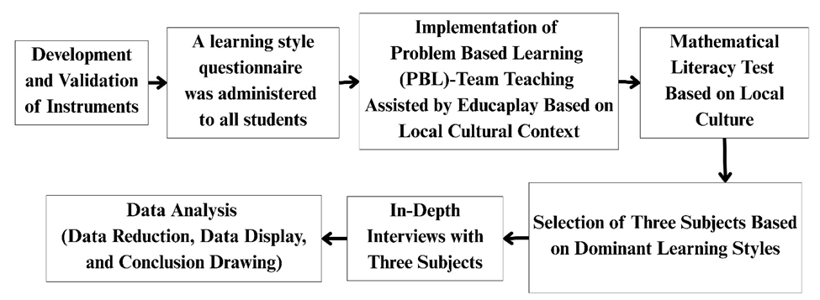

**Figure 1.** Research Flowchart

Figure 1 depicts the systematic stages of the research process, spanning from initial planning to the conclusion.

**RESULTS AND DISCUSSION**

The analysis results of the learning styles questionnaire completed by 30 eighth-grade students are presented in Figure 2 below.

**Figure 2.** Percentage of Learning Styles Questionnaire Results

Figure 2 presents the distribution of students’ learning styles as follows: 14 students (46%) demonstrated a dominant visual learning style, five students (17%) were auditory learners, and 11 students (37%) showed a kinesthetic learning preference. These findings reflect the diversity of students’ learning styles, in line with the study by (Magdalena & Amanda, 2020), which asserts that each student possesses a unique approach to receiving and processing information. The predominance of visual learners suggests the importance of visually delivering instructional content, such as through images and diagrams, to enhance students’ comprehension of mathematical concepts. This aligns with the study's outcomes (Sheromova et al., 2020), which state that visual learners achieve better learning outcomes when engaging with visualisation-based media. Additionally, (Cimermanová, 2018) emphasised that selecting instructional models and media should consider students’ dominant learning styles to maximise learning effectiveness. This variation necessitates a flexible and differentiated instructional approach, which is accommodated through integrating the Problem-Based Learning (PBL) model with a team teaching strategy supported by Educaplay media. This approach fosters interactive and contextually meaningful learning experiences.

Following the classification of students’ learning styles, a mathematical literacy test was administered to assess their abilities to formulate, employ, and interpret mathematical concepts related to cylinders and cones. The test, given to 30 students, revealed variations in performance aligned with their respective learning styles. For an in-depth analysis, three representative students were selected: S1 (visual learner), S2 (auditory learner), and S3 (kinesthetic learner). The data from the mathematics test and follow-up interviews are summarised as follows.

1. **Mathematical Literacy Ability of Student with Visual Learning Style (S1)**

After administering the learning style questionnaire, one student with the highest score in the visual learning style category was selected from 14 students identified as visual learners. This student was chosen as a subject for further analysis of their responses to the mathematics literacy test. The student’s answers, representing the mathematical literacy ability of a visual learner, are presented in Figure 2 below.

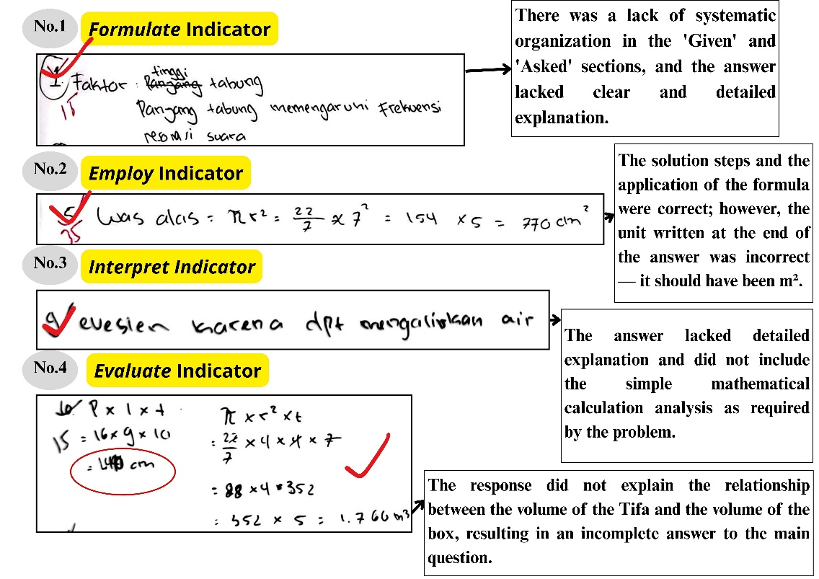

**Figure 2.** Results of Written Tests: Students with Visual Learning Style

Figure 2 shows that students with a visual learning style successfully solved all problems in accordance with the mathematical literacy indicators. The following section provides a detailed analysis of each problem.

1. **Problem 1 (Formulate)**

Student S1 demonstrated the ability to identify the relationship between the length of the cylindrical shape of the Tifa musical instrument and the frequency of sound it produces. However, the student did not explicitly include mathematical representations, such as using resonance formulas or complete computational steps. This indicates that the student’s understanding remains conceptual, based on visual observation, and has not yet developed into formulating an abstract mathematical model. This finding is consistent with the conclusions of (Montenegro et al., 2018), which indicates that learners with a visual learning preference frequently require additional visual scaffolding to effectively bridge concrete contexts and abstract mathematical representations. An excerpt from the interview with Student 1 (S1) is presented below:

Interviewer : Mr. Budi wants to make a Tifa that produces a louder sound without changing the diameter of the tube. What factor can be adjusted?

Student (S1) : The length of the tube. If it is shorter, the sound becomes higher and louder. I saw in the picture that the sound waves become more compact.

Interviewer : What helped you understand this question?

Student (S1) : The illustration or image. If it were only a formula, I would be confused, but with the image, I understood it right away.

1. **Problem 2 (Employ)**

Student S1 successfully calculated the base area of the conical traditional house *Mbaru Niang* using the formula $L=πr^{2}$ Multiply it by the number of bamboo pieces needed. Although there was a unit conversion error, the student demonstrated procedural understanding and the ability to apply mathematical concepts in a culturally contextualised task. This finding supports the study of (Mainali, 2021), which emphasises the importance of visual media in helping students comprehend spatial concepts.

1. **Problem 3 (Interpret)**

Student S1 explained that the conical roof of the Honai house “makes it easier for water to flow”, but did not include any mathematical analysis, such as calculating the angle of inclination or the slant surface area. This response indicates a practical understanding of the problem, yet reveals a limitation in connecting geometric concepts to physical phenomena through mathematical reasoning. Such a result is in agreement with (Mailani et al., 2024), who point out that the ability to visualise geometry is pivotal in students’ interpretation of mathematical ideas. An excerpt from the interview with Student 1 (S1) is presented below:

Interviewer : How does the conical roof of the Honai house help rainwater flow efficiently?

Student (S1) : The sloped roof in all directions helps the water run off quickly.

Interviewer : Can you explain that mathematically, with a simple calculation?

Student (S1) : Formulas can be challenging to explain. It is easier for me to understand if there is a picture to help visualise the concept.

1. **Problem 4 (Evaluate)**

Student S1 could accurately calculate the box’s volume and the five Tifa drums. However, the student failed to draw a valid conclusion regarding the feasibility of fitting all the items into the box and overlooked the spatial arrangement required. This indicates a limitation in evaluating realistic constraints despite the student’s visual learning preference, which has the potential to develop further through the use of diagrams or 3D models (Alfianti & Nalurita, 2025). The following is an excerpt from the interview with the subject:

Interviewer : A craftsman wants to send 5 Tifa drums in a box measuring

$16 cm × 9 cm ×10 cm$. Do you think all the Tifa can fit inside the box?

Student (S1) : I calculated the volume to be enough. But I’m still unsure how to arrange them so they fit, and I’m not confident they will all fit.

1. **Mathematical Literacy Ability of Students with Auditory Learning Style (S2)**

From the four students identified as having an auditory learning style through the administered questionnaire, one student (S2) was selected for in-depth analysis based on obtaining the highest score in this category. According to the written assessment results, S2 was able to correctly solve two out of the four problems, specifically those aligned with the interpret (Problem 3) and evaluate (Problem 4) indicators, as presented in Figure 3.

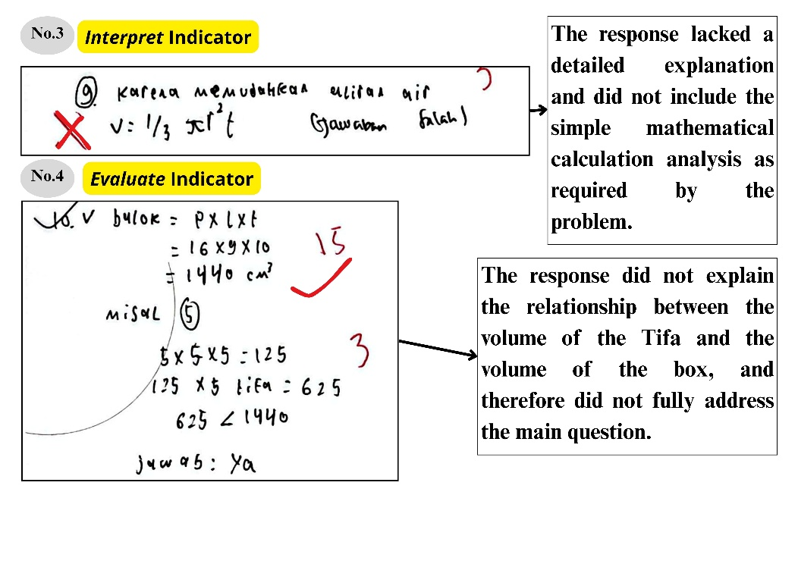

**Figure 3.** Results of Written Tests: Students with Auditory Learning Style

Based on Figure 3, the following is the analysis for each problem.

1. **Problem 3 (Interpret)**

S2 stated that the conical roof of the Honai house facilitates rainwater drainage but did not relate this to geometric concepts such as angles or the area of the slanted surface. This supports the findings by (Wulandari & Wardhani, 2024) This indicates that auditory learners understand better through structured verbal explanations that bridge abstract concepts. Below is an excerpt from the interview with S2:

Interviewer : How does the Honai house’s conical roof help channel rainwater?

Student (S2) : The water flows immediately without pooling because it is pointed and sloped.

Interviewer : How do you find it easier to understand questions like this?

Student (S2) : Through verbal explanations. If it is only pictures or formulas, I often get confused.

1. **Problem 4 (Evaluate)**

S2 accurately calculated the volume of the box and five Tifas, but did not conclude on the feasibility of storing all Tifas inside. This lack of spatial evaluation reflects limitations in contextual reasoning, consistent with findings by (Setiana & Purwoko, 2020), which asserts that auditory learners require repeated verbal guidance to independently develop evaluative skills. The following excerpt is from the interview with S2:

Interviewer : Can five Tifas fit into a $16 × 9 × 10 cm$ Box?

Student (S2) : My calculations show they fit, but I am not confident. I need repeated verbal explanations to fully understand.

1. **Mathematical Literacy Ability of Students with Kinesthetic Learning Style (S3)**

Following the administration of the learning style questionnaire, one student was selected from a group of 11 identified as having a kinesthetic learning style to serve as the subject of further analysis. This student’s responses to the mathematical literacy test were examined in detail. Based on the study, the kinesthetic learner (S3) successfully solved Problem 3, corresponding to the interpret indicator, and Problem 4, corresponding to the evaluate indicator. The results of this student’s mathematical literacy test responses are presented in Figure 4 below.

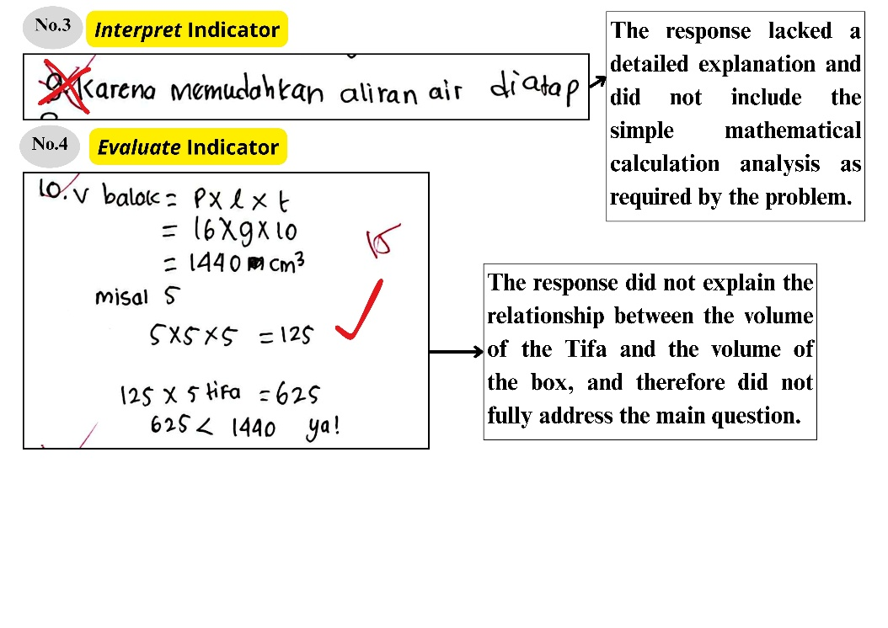

**Figure 4.** Results of Written Tests: Students with Kinesthetic Learning Style

Based on Figure 4, the following is an analysis of each problem.

1. **Problem 3 (Interpret**)

S3 explained that the conical roof of the Honai house “helps rainwater flow down quickly." However, it did not provide a mathematical analysis of the angle of inclination or the surface area of the slant. The explanation was based on concrete experience and spatial visualisation. This reflects the kinesthetic learner’s tendency to understand concepts through physical exploration and interaction with tangible models. This finding aligns with (Alfianti & Nalurita, 2025), who emphasised that physical representations can enhance spatial understanding for kinesthetic students. Presented below is an excerpt from the interview:

Interviewer : How does the conical roof of the Honai house help rainwater flow efficiently?

Student (S3) : When I hold the model and pour water on it, it flows right down. Because it is pointed and sloped in all directions, water does not pool.

Interviewer : How do you find it easier to understand this problem?

Student (S3) : I understand better through hands-on practice.

1. **Problem 4 (Evaluate)**

S3 correctly calculated the volume of the box and the five Tifa drums, while also considering the arrangement to fit them inside the box. This demonstrates an integration of calculation and spatial imagination, consistent with (Magdalena & Amanda, 2020) Findings that kinesthetic learners excel in contextual evaluation through direct physical experience. Presented below is an excerpt from the interview:

Interviewer : How did you think about arranging the Tifa drums so they would fit in the box?

Student (S3) : I imagined that the Tifa drums should be neatly arranged, maybe standing upright or tilted to fit. I once tried arranging objects similar to Tifa in a small box during practice, so I know the importance of positioning so that everything fits.

This study demonstrates that implementing the Problem-Based Learning (PBL) model combined with a team teaching strategy, supported by Educaplay interactive media, positively influences enhancing students’ mathematical literacy. Nevertheless, the levels of mathematical literacy achievement varied depending on the student’s learning style characteristics, specifically visual, auditory, and kinesthetic modalities. Visual learners tend to better understand contexts through illustrations and visual representations, but still face challenges translating contextual information into formal mathematical models. Auditory learners show strong comprehension through oral explanations, particularly in interpretation and evaluation, although they require additional procedural skills and modelling support. Meanwhile, kinesthetic learners exhibit the most comprehensive understanding through concrete activities, especially in linking mathematical calculations with realistic spatial representations.

These findings directly address the research objective, describing students’ mathematical literacy abilities based on their learning styles in implementing the PBL model with a team teaching strategy supported by Educaplay. Integrating the learning model, interactive media, and students’ learning style characteristics has proven effective in creating more meaningful, adaptive, and contextually relevant learning experiences. These findings correspond with the study conducted by (Saputra et al., 2024), which underscores the efficacy of contextual inquiry-based learning in advancing science literacy. Both studies highlight the importance of connecting learning to real-world contexts and the necessity of instructional design considering learner characteristics. Therefore, this study provides an empirical contribution to developing mathematical literacy grounded in local cultural contexts.

**CONCLUSION**

This study shows that students’ mathematical literacy abilities in culturally oriented geometry instruction are influenced by their learning styles. Each of the three learning styles—visual, auditory, and kinesthetic—shows unique strengths and limitations in different areas of mathematical literacy when the Problem-Based Learning (PBL) model is used with a team teaching approach backed by interactive media, Educaplay. These results support the study’s goals by demonstrating that a flexible teaching strategy considering different learning preferences can successfully promote contextual and meaningful mathematical literacy.

**RECOMMENDATION**

Based on the findings of this study, it is recommended that subsequent research focus on developing a more adaptable Problem-Based Learning (PBL) model by integrating a wider array of interactive media and expanding the diversity of team teaching strategies to more effectively address the varied learning styles of students. Furthermore, follow-up studies should involve larger and more geographically diverse samples to enhance the generalizability of the results across different cultural contexts. Researchers should also address several challenges identified in this study, such as limited instructional time affecting the model’s effectiveness, teaching strategies, and variations in students’ technological proficiency that may impact the use of interactive media. Therefore, subsequent research is advised to employ a more flexible research design and provide adequate technological training support for students and teachers to overcome these obstacles.

**REFERENCES**

Afni, N., & Hartono. (2020). Contextual Teaching and Learning (CTL) as a Strategy to Improve Students Mathematical Literacy. *Journal of Physics: Conference Series*, *1581*(1). <https://doi.org/10.1088/1742-6596/1581/1/012043>

Alfianti, N., & Nalurita, I. V. (2025). Analisis Kemampuan Spasial Siswa Ditinjau dari Gaya Belajar. *Math Didactic: Jurnal Pendidikan Matematika*, *11*(1), 45–57. <https://doi.org/https://doi.org/10.33654/math.v11i1.76>

Almarashdi, H. S., & Jarrah, A. M. (2023). Assessing Tenth-Grade Students’ Mathematical Literacy Skills in Solving PISA Problems. *Social Sciences*, *12*(1). <https://doi.org/10.3390/socsci12010033>

Cimermanová, I. (2018). The Effect of Learning Styles on Academic Achievement in Different Forms of Teaching. *International Journal of Instruction*, *11*(3), 219–232. <https://doi.org/10.12973/iji.2018.11316a>

Djara, J. I., Imaniar, M., Sae, E., & Anin, S. (2023). Pengaruh Gaya Belajar Terhadap Hasil Belajar Siswa. *Jurnal Pendidikan Dan Kebudayaan* , *3*(2), 226–233. <https://doi.org/10.55606/jurdikbud.v3i2>

Harisman, Y., Mayani, D. E., Armiati, Syaputra, H., & Amiruddin, M. H. (2023). Analysis of Student’s Ability Solve Mathematical Literacy Problems in Junior High Schools in The City Area. *Infinity: Journal of Mathematics Education*, *12*(1), 55–68. <https://doi.org/10.22460/infinity.v12i1.p55-68>

Ichda, M. A., Alfan Muhammad, & Kuncoro, T. (2023). Literacy Studies: Implementation of Problem-based Learning Models to Improve Critical Thinking Skills in Elementary School Students. *KnE Social Sciences*, *8*(10), 222–233. <https://doi.org/10.18502/kss.v8i10.13449>

Ishartono, N., Faiziyah, N., Sutarni, S., Putri, A. B., Fatmasari, L. W. S., Sayuti, M., Rahmaniati, R., & Yunus, M. M. (2021). Visual, Auditory, and Kinesthetic Students: How They Solve PISA-Oriented Mathematics Problems? *Journal of Physics: Conference Series*, *1720*(1), 1–7. <https://doi.org/10.1088/1742-6596/1720/1/012012>

Khairunnisah, T., & Rasyidah. (2024). The Effect of the Problem-Based Learning Model Assisted by the Kahoot Application on the Understanding of Concepts Related to the Nervous System in High School Students. *Prisma Sains: Jurnal Pengkajian Ilmu Dan Pembelajaran Matematika Dan IPA IKIP Mataram*, *12*(3), 500–508. <https://doi.org/10.33394/j-ps.v12i3.12153>

Kusmaryono, I., & Kusumaningsih, W. (2023). Evaluating the Results of PISA Assessment: Are There Gaps Between the Teaching of Mathematical Literacy at Schools and in PISA Assessment? *European Journal of Educational Research*, *12*(3), 1479–1493. <https://doi.org/10.12973/eu-jer.12.3.1479>

Magdalena, I., & Amanda, N. A. (2020). Identifikasi Gaya Belajar Siswa (Visual, Auditorial, Kinestetik). In *PENSA : Jurnal Pendidikan dan Ilmu Sosial* (Vol. 2, Issue 1). <https://doi.org/https://doi.org/10.36088/pensa.v2i1.599>

Mailani, E., Rarastika, N., Butar-Butar, A., Purba, J. E., & Purba, D. S. (2024). Pendekatan Etnomatematika dalam Pembelajaran Geometri Menggunakan Pola Lantai Rumah Adat Nusantara. *Journal Educational Research and Development*, *01*(02), 179–184. https://doi.org/https://doi.org/10.62379/jerd.v1i2.121

Mainali, B. (2021). Representation in teaching and learning mathematics. *International Journal of Education in Mathematics, Science and Technology*, *9*(1), 1–21. <https://doi.org/10.46328/ijemst.1111>

Montenegro, P., Costa, C., & Lopes, B. (2018). Transformations in the Visual Representation of a Figural Pattern. *Mathematical Thinking and Learning*, *20*(2), 91–107. <https://doi.org/10.1080/10986065.2018.1441599>

Noto, M. S., Firmasari, S., & Fatchurrohman, M. (2018). Etnomatematika pada Sumur Purbakala Desa Kaliwadas Cirebon dan Kaitannya dengan Pembelajaran Matematika di Sekolah. *Jurnal Riset Pendidikan Matematika*, *5*(2), 201–210. <https://doi.org/10.21831/jrpm.v5i2.15714>

OECD. (2019). PISA 2018 Assessment and Analytical Framework. Paris: OECD Publishing.

Poernomo, E., Kurniawati, L., & Atiqoh, K. S. N. (2021). Studi Literasi Matematis. *ALGORITMA: Journal of Mathematics Education*, *3*(1), 83–100. <https://doi.org/10.15408/ajme.v3i1.20479>

Pramuditya, S. A., Noto, S., & Purwono, H. (2018). Desain Game Edukasi Berbasis Android pada Materi Logika Matematika. *JNPM (Jurnal Nasional Pendidikan Matematika)*, *2*(2), 165–179. <https://doi.org/https://doi.org/10.33603/jnpm.v2i2.919>

Purbawati, S. Y., Haryani, S., Andrijati, N., Sudarmin, Wardani, S., & Lestari, W. (2024). Desain Educaplay pada Materi Pecahan dalam Meningkatkan Kemampuan Pemecahan Masalah Matematis Siswa Sekolah Dasar. *Cakrawala Jurnal Pendidikan*, *18*(2), 89–95. <https://doi.org/https://doi.org/10.24905/cakrawala.v18i2.482>

Saputra, W. T., Rochintaniawati, D., & Agustin, R. R. (2024). The Role of Learning Models in Enhancing Scientific Literacy: A Critical Review Evaluation. *Prisma Sains: Jurnal Pengkajian Ilmu Dan Pembelajaran Matematika Dan IPA IKIP Mataram*, *12*(3), 462–476. <https://doi.org/10.33394/j-ps.v12i3.10827>

Setiana, D. S., & Purwoko, R. Y. (2020). Analisis kemampuan berpikir kritis ditinjau dari gaya belajar matematika siswa. *Jurnal Riset Pendidikan Matematika*, *7*(2), 163–177. <https://doi.org/10.21831/jrpm.v7i2.34290>

Sheromova, T. S., Khuziakhmetov, A. N., Kazinets, V. A., Sizova, Z. M., Buslaev, S. I., & Borodianskaia, E. A. (2020). Learning Styles and Development of Cognitive Skills in Mathematics Learning. *Eurasia Journal of Mathematics, Science and Technology Education*, *16*(11), 1–13. <https://doi.org/10.29333/EJMSTE/8538>

Smith, K., Maynard, N., Berry, A., Stephenson, T., Spiteri, T., Corrigan, D., Mansfield, J., Ellerton, P., & Smith, T. (2022). Principles of Problem-Based Learning (PBL) in STEM Education: Using Expert Wisdom and Research to Frame Educational Practice. *Education Sciences*, *12*(10), 1–20. <https://doi.org/10.3390/educsci12100728>

Suastra, I. W., Suarni, N. K., & Dharma, K. S. (2019). The Effect of Problem Based Learning (PBL) Model on Elementary School Students’ Science Higher Order Thinking Skill and Learning Autonomy. *Journal of Physics: Conference Series*, *1318*(1), 1–7. <https://doi.org/10.1088/1742-6596/1318/1/012084>

Sundawan, M. D., Irmawan, W., & Sulaiman, H. (2019). Kemampuan Berpikir Relasional Abstrak Calon Guru Matematika dalam Menyelesaikan Soal-Soal Non-Rutin pada Topik Geometri Non-Euclid. *Mosharafa: Jurnal Pendidikan Matematika* , *8*(2), 319–330. <https://doi.org/https://doi.org/10.31980/mosharafa.v8i2.565>

Wulandari, O. A., & Wardhani, I. S. (2024). Media dan Gaya Belajar Siswa: Strategi dalam Pembelajaran Efektif. *Jurnal Media Akademik*, *2*(11), 3031–5220. <https://doi.org/10.62281>