**DEVELOPMENT OF SCIENCE MODULE BASED ON THE MEANING OF TEMPERATURE AND HEAT MEANING LEARNING MODEL**

**1Fauziyah Khoirin Nisyah, 2 Dinar Maftukh Fajar, 3 Binar Kurnia Prahani, 4 Andi Suhardi**

Department of Natural Sciences, Faculty of Tarbiyah and Teacher Training, UIN Khas Jember. Jl. Mataram No. 1, Jember, Indonesia. Postal code: 68136

* Corresponding Author e-mail:fauziyah250796@gmail.com

Received:…………..; Revised:…………; Published: …………..

**Abstract**

*This research is motivated by the rampant degradationvalues, attitudes, and character of students, especially junior high school students; In addition, there is also the lack of science learning resources owned by students that contain character education. Based on the results of research and development (Reseach and Development / R & D) with the ADDIE approach, namely: Analysis, Design, Development, Implementation, Evaluation. Data analysis was carried out by qualitative analysis and quantitative analysis. The data analysis carried out is numerical (quantitative) and descriptive (qualitative) data. Numerical data (quantitative) in the form of numbers obtained from validators and student response questionnaires. While descriptive data (qualitative) in the form of suggestions/comments given by the validator during the validation process and students during the small-scale and large-scale test processes both written and unwritten. The results obtained from research that has been carried out in MTs are as follows. First, the level of validity of the science module based on the meaning learning model of 5 expert validators, namely 2 material experts 86.58%, 2 education experts 83.77%, and 1 science teacher 78.04%, an average of 82.79% in the very category. valid/usable without revision. Second, the response of students to the science module based on the meaning learning model with the results of the small group trial getting an average of 76.8% with the attractive/agree category with the number of students 5, then in the large group trial it got an average of 77,84% with the attractive/agree category with the number of students 30.*

***Keywords:****Character (moral values),Meaning learning model, Science Module*

***How to Cite:***Nisyah, F., Fajar, D., Prahani, B.,Suhardi, A.(2022).Development of Science Modules Based on Learning Models on the Meaning of Temperature and Heat Materials for Class VII SMP/MTs. Prisma Sains: Journal of the Study of Science and Mathematics Learning*and IPA IKIP Mataram, vol*(no), xx-yy.two:<https://doi.org/10.33394/j-ps.vxxiyy>

|  |  |
| --- | --- |
| <https://doi.org/10.33394/j-ps.vxxiyy> | Copyright© 2019, First author et al  This is an open-access article under the[CC-BY License](http://creativecommons.org/licenses/by/4.0/).  [Creative Commons License](http://creativecommons.org/licenses/by/4.0/) |

**INTRODUCTION**

Learning is the process of changing human behavior from not knowing to knowing, from being unskilled to being skilled, from being polite to being impolite, systematically and intentionally. (Muslimin: 2014) Learning can be done anywhere and anytime, just as students can gain knowledge from nature or from social events. The process of changing a person's behavior based on certain experiences and the results of their interactions with the surrounding environment, either intentionally or unintentionally. In essence, learning aims to gain wisdom, learn, lesson learned. (Suyono: 2014)

The development of science and technology that can change the mindset of humans to be more advanced and developing, encourages educators to prepare the next generation that is able to adapt to current scientific advances. But on the other hand there is a shift in the values, attitudes, and character of students. Some negative phenomena such as fights, cheating, lack of manners towards others, skipping school are the effects of weakening the character of students. This phenomenon is contrary to the ideals of national education in shaping Indonesian people who have personality and noble character. (Hamid: 2015)

Education is closely related to the learning and learning process, but the teaching and learning process has not been implemented as expected. Good learning is learning that is able to transmit behavior, positive attitudes and contains wisdom. (Suyono: 2014) In this regard, the author has the initiative to develop student learning resources by using a model of meaning, where this learning resource is used not only oriented to intelligence. only academic, but can also be used to teach and internalize the positive character of students.

Each subject has its own values ​​that will be instilled in students. One of them is through the subjects of Natural Sciences (IPA). Science is a science that studies natural phenomena through observation and analysis activities with a series of experiments in the laboratory to strengthen a comprehensive understanding. This science is definite or exact because the observed phenomena are relatively real and measurable. In addition, IPA strives to preserve nature and use it for human welfare in improving living standards, efficiency, and work effectiveness. Nature is a source of knowledge that will never run out from time to time. (Wonoharjo: 2011)

The meaning learning model is a learning model through examples and examples of related events, symptoms or phenomena that can potentially be used as models in learning that aims to teach positive attitudes, noble character, and character in addition to the academic aspects. In relation to this model, meaning is an example of how to show the consequences of the behavior performed. The meaning is carried out in various ways to touch the hearts of students that what is done by someone deserves to be imitated or otherwise should be avoided, then analogized to a negative phenomenon, and motivates students to avoid it. In other words, the phenomena in science can be interpreted to portray models of attitudes, characters and manners as visual analogies. (Ibrahim: 2014)

Based on the results of an interview with one of the MTs science teachers. ASHRI which is used to identify the obstacles that occur in the learning process, namely, one of which is that student learning resources in the form of textbooks are very minimal, then it results in students falling behind in receiving the material, some students when given assignments some cheat and some cheat. who don't work.

One alternative is in the form of teaching materials used to load modules on temperature and heat material, because this material has a potential to display the main points of meaning learning models in science material and can help support meaning learning models in the learning process in the classroom.

**METHOD**

**Research Design**

The product produced in the R & D research is in the form of a science module on temperature and heat material based on a meaning learning model that will be implemented at MTs Ashri.

The stages used in this study were quoted from Robert Maribe Branch (2009), namely Instructional Design with the ADDIE approach (Analysis, Design, Development, Implementation, Evaluation). The stages of the ADDIE approach can be seen in the image below, adapted to the ADDIE model. (Sugiyono: 2016)

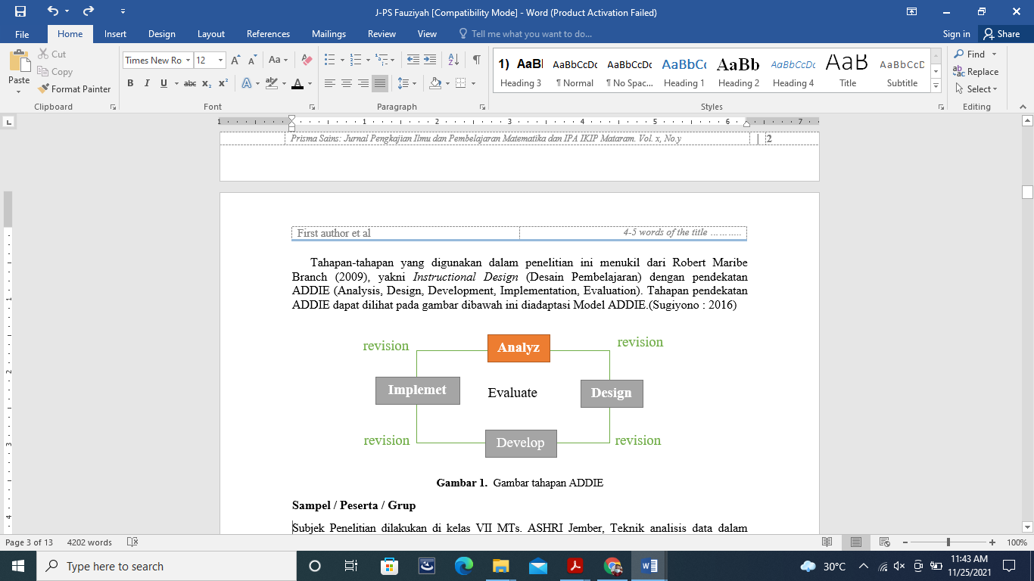

**Image 1.**ADDIE stage pictures

**Samples / Participants / Groups**

Subjects The research was conducted in class VII MTs. ASHRI Jember,The data analysis technique in this research isnumerical (quantitative) and descriptive (qualitative) data. Numerical data (quantitative) in the form of numbers obtained from validators and student response questionnaires. While descriptive data (qualitative) in the form of suggestions/comments given by the validator during the validation process and students during the small-scale and large-scale test processes both written and unwritten.

**Instruments and Procedures**

The trial was conducted in class VII MTs. ASHRI Jember,The data analysis technique in this research isnumerical (quantitative) and descriptive (qualitative) data. Numerical data (quantitative) in the form of numbers obtained from validators and student response questionnaires. While descriptive data (qualitative) in the form of suggestions/comments given by the validator during the validation process and students during the small-scale and large-scale test processes both written and unwritten.

**Data analysis**

1. **Stage of Analysis (Analysis)**

Stages of analysis are carried out to determine the obstacles experienced, namely, from the results of interviews and observations carried out as pre-research which is used to identify obstacles in the learning process in MTs. ASHRI, namely, one of which is that the learning resources of students in the form of textbooks are very minimal, then it results in students falling behind in receiving the material, some students when given assignments some cheat and some don't.

The researcher analyzed the curriculum used and needed at MTs ASHRI. Researchers create teaching resources that can help students and educators in the learning process, then analyze Core Competencies (KI) and Basic Competencies (KD) in class VII MTs. ASHRI which is described as follows:

**Table 1**

**Core Competencies and Basic Competencies**

|  |  |
| --- | --- |
| **Core Competencies** | **Basic competencies** |
| 1. Living and practicing the teachings of the religion he adheres to | 1.2 His faith increases by realizing the relationship between the order and complexity of nature and the universe to the greatness of God who created it |
| 2. Appreciate and live honest behavior, discipline, responsibility, caring (tolerance, mutual cooperation), polite, confident, in interacting effectively with the social and natural environment within the reach of the association and its existence | 2.3 Demonstrate honest and responsible behavior as a form of implementation of honesty in reporting observational data |
| 3. Understanding knowledge (factual,  conceptual, and procedural)  based on curiosity  about science, technology,  art, culture related phenomena and  visible events. | 3.4 Analyzing the concepts of temperature, expansion, heat, heat transfer, and their application in everyday life, including the mechanism for maintaining a stable body temperature in humans and animals. |
| 4. Trying to manage and present the concrete realm (using, parsing, assembling, modifying, and creating) and abstract realm (writing, reading, counting, drawing, and composing) according to what is learned in school and other sources that are the same in point of view or theory. | 4.4 Conduct experiments to investigate the effect of heat on the temperature and shape of objects as well as heat transfer |

1. **Stage of Design / Design (Design)**

The design stages of this module are designed to be able to support the meaning learning model, in which the module will show examples, linkages of events, symptoms or phenomena that have the potential to be used as models to teach positive attitudes, noble character, and character. In other words, this module shows the consequences of behavior that is done or not done. This design is also inseparable from the analysis that has been carried out according to KI and KD, here are some examples of learning models contained in the module.

**Table 2. Learning Model Analysis**

|  |  |
| --- | --- |
| **Model** | **Target** |
| One quantity has various measuring tools and scales. For example: a measure of length has a measuring instrument in the form of a ruler, meter, caliper, and so on. | * Humans are taught to assess and measure based on their competence. * By knowing the various scales, humans are taught to be humble. |
| The railroad connection is given space for expansion. Too tight or too far apart are both dangerous. | Disproportionate attention / affection, both excessive and insufficient, are equally detrimental. |
| The increase in length of a metal due to expansion is influenced by the initial length, the coefficient of long expansion, and the temperature range. | Learning motivation for students: if students have more initial knowledge, it will be easier to understand the material being taught. |
| Changes in state occur because water accepts or loses heat. Water only changes form, does not change chemically. | The message that no matter what position we are in, we are still human. Position and sustenance only entrusted to Allah SWT |
| Heat is absorbed in the white and black cloth. Black color is good at absorbing heat. White is good at reflecting heat. | Black and white clothes become an analogy for a dirty and clean heart. A black/dirty liver is prone to liver disease. This is clearly different from a clean heart. |

The module format consists of three parts, namely the beginning, the content, and the end, which are adapted from the Ministry of National Education. The formats developed are:

1. Beginning section: Cover, introduction, table of contents, list of tables, list of pictures, instructions for using concept maps, and keywords.

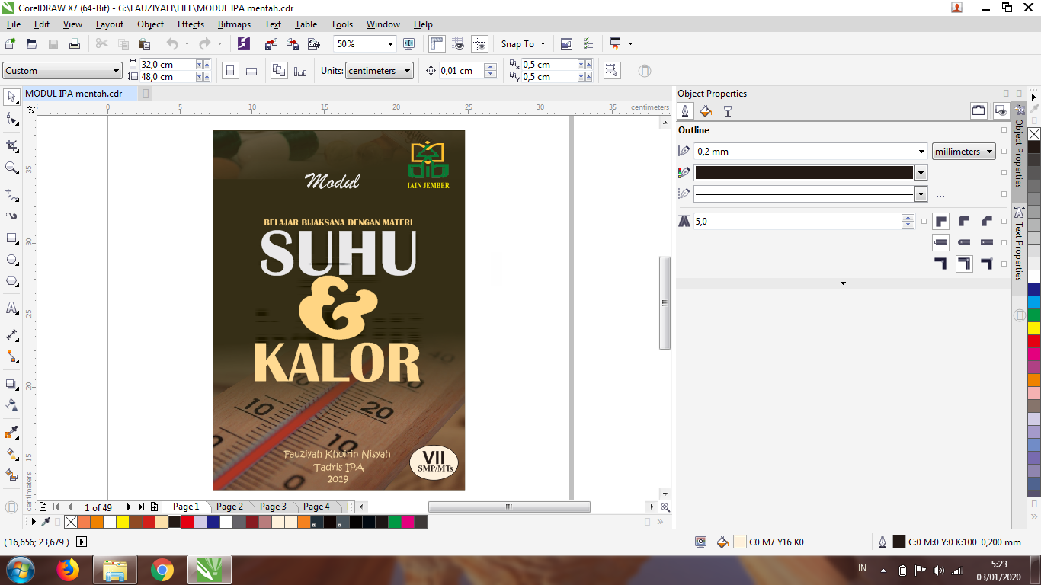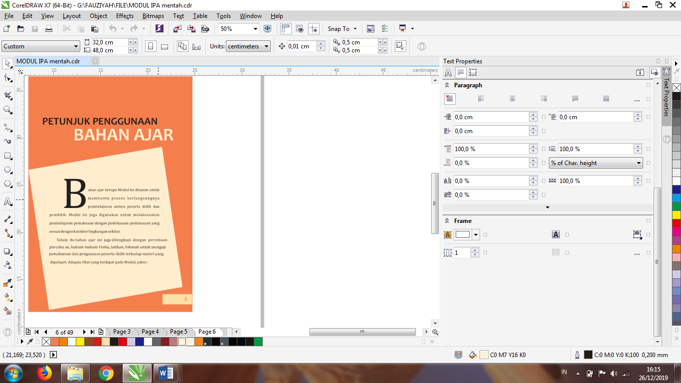

**Figure 2 The Beginning of the Module**

1. Contents section: Core Competencies (KI) and Basic Competencies (KD), introduction, description of material content, reflection corners, group assignments, sample questions, physics news (beta), memory column (comet), discussion of competency tests, practicum.

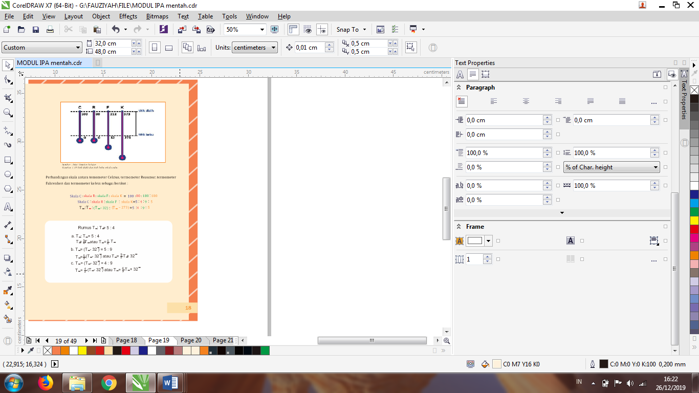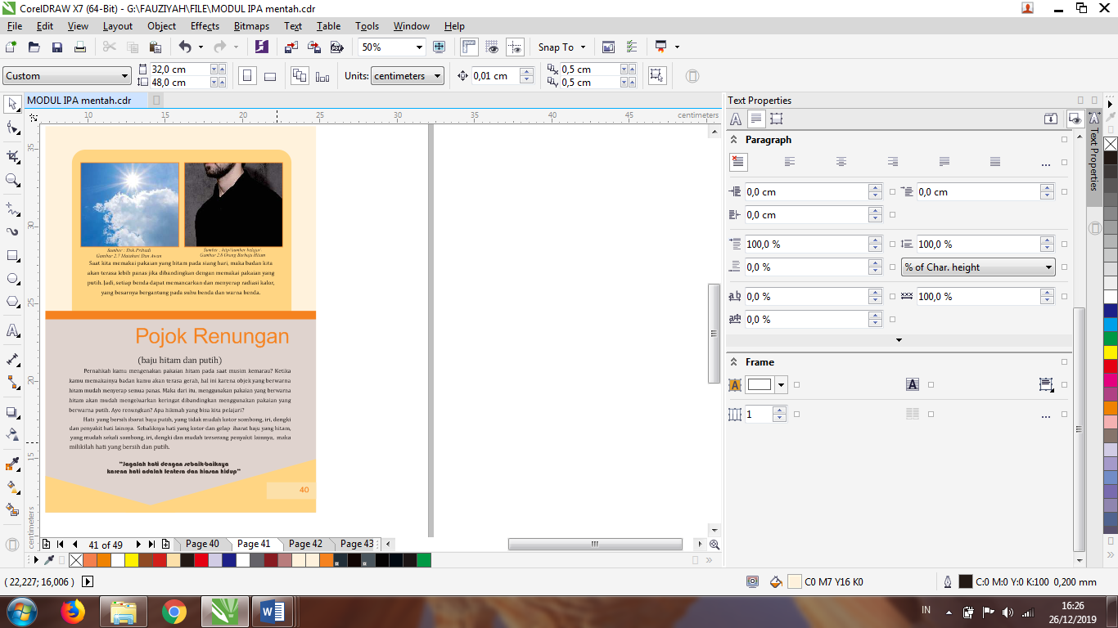

**Figure 3 Module Core Parts**

Final section: summary, glossary, bibliography and author biography

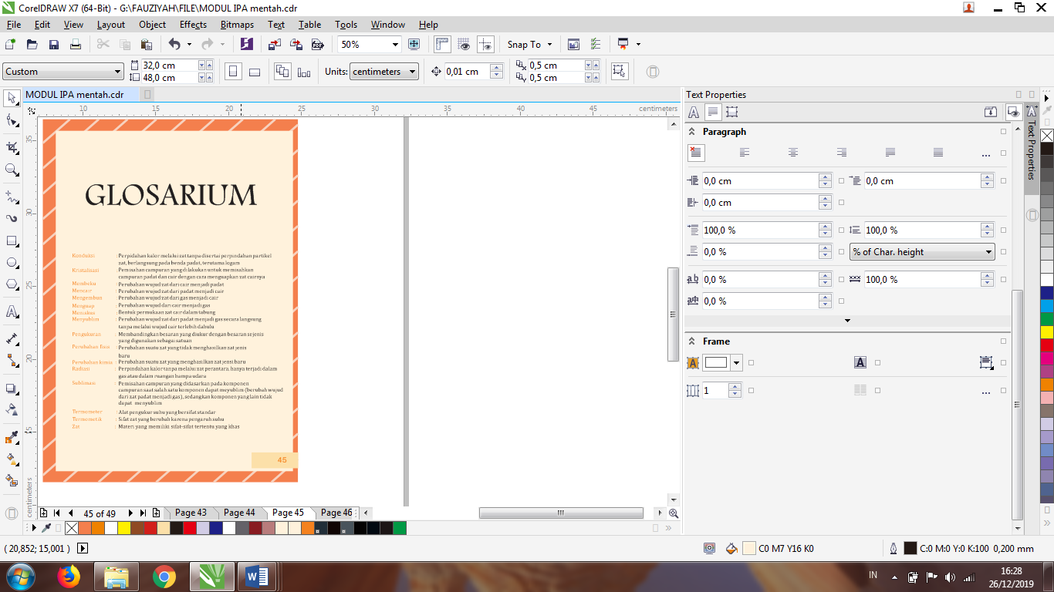 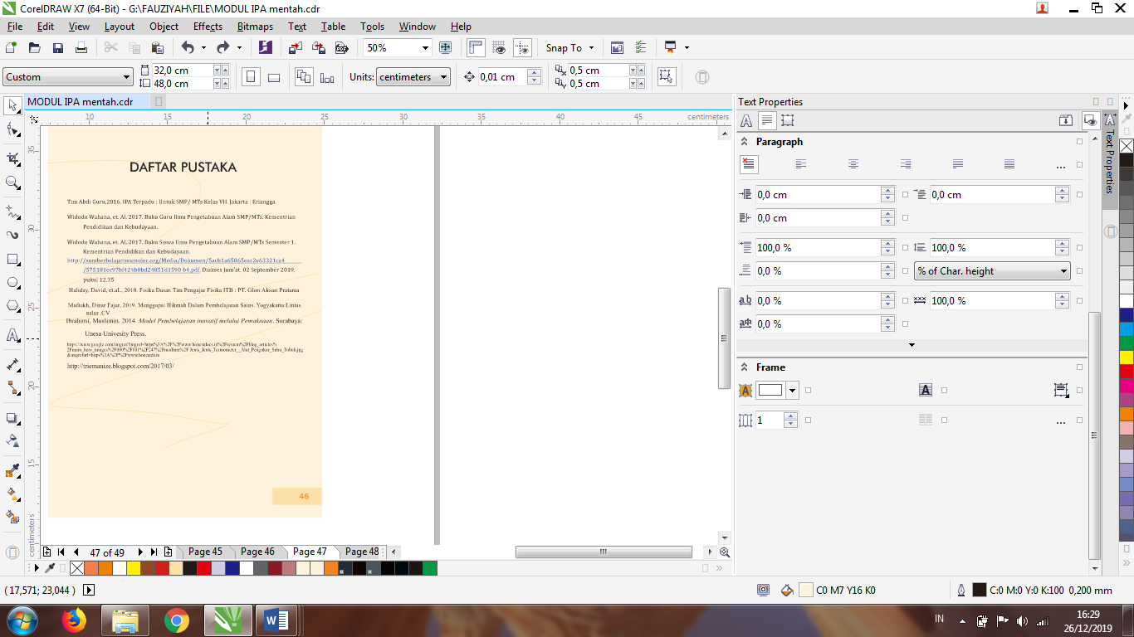

**Figure 4 The Final Part of the Module**

1. **Development Phase (Development)**

This development stage is carried out to determine the feasibility of the module that has been made. Kemudin is validated by experts and revised so that it can be tested on a small scale and large scale products on students. The results of the module validation that have been carried out by 5 expert validators consisting of 4 lecturers and 1 science subject teacher, include 2 material experts, 2 education experts, 1 science teacher.

Data analysis of the validation test results aims to determine the level of validity of the developed student module. The data analysis technique used is the percentage calculation technique and the qualitative descriptive technique, namely, with the following formula. (Akbar, 2013)

$$P=\frac{Xi}{X}X 100\%$$

Information:

*P*: percentage value

*Xi*: The number of scores given by the validator for each aspect

*X*: maximum score for each criterion.

There are module validity test criteria which can be seen in the table below. (Akbar, 2013)

**Table 3.**

**Validation Criteria**

|  |  |
| --- | --- |
| **Percentage (%)** | **Criteria** |
| 81% - 100% | Very valid, or can be used without revision |
| 61% - 80% | Valid, or usable but need minor revision |
| 41% - 60% | Less valid, it is recommended not to use it because it needs major revision. |
| 21% - 40% | Invalid, or should not be used. |
| 0% - 20% | Totally invalid,-shouldn't be used. |

1. **Implementation**

At this stage the product will be tested on a small group of 5 people and tested on a large group of 30 people. At this stage, a questionnaire will also be distributed to measure and find out the opinions/responses of students regarding the Science Module based on the meaning learning model.If necessary, revisions are made based on input and suggestions from students.

Student response data was obtained by providing student response questionnaires after knowing the contents of the integrated science module teaching materials based on the meaning learning model. The student response questionnaire was given to class VII B MTs students. Ashri who has taken temperature and heat material, then has not used the module in learning. The data analysis techniques used are percentage calculation techniques and qualitative descriptive techniques, namely with the following formula.

$$V-au=\frac{Tse}{Tsh}X 100\%$$

Information:

*V-au*: percentage value

*Tse*: total empirical score obtained from student responses

*Tsh*: total expected score

There are criteria for the results of student responses to the module which can be seen in the table below. (Akbar, 2013)

**Table 4.**

**Criteria for Student Response Results**

|  |  |
| --- | --- |
| **Percentage (%)** | **Criteria** |
| 81% - 100% | Very interesting/strongly agree |
| 61% - 80% | Interesting / agree |
| 41% - 60% | Interesting enough / quite agree |
| 21% - 40% | Not interesting / disagree |
| 0% - 20% | Very unattractive/strongly disagree |

1. **Stages of evaluation (Evaluation)**

At this stage is an evaluation that is comparing the results obtained at the trial stage. In addition to comparing the results obtained from the validator, the researcher also analyzed the data obtained from the students to find out the opinions/responses regarding the products that had been made.

In this interesting category, it shows that the science module of the meaning learning model has a positive response, in which the development of teaching materials in the form of modules is expected to be able to provide wisdom in learning, so that learning becomes meaningful.

**RESULTS AND DISCUSSION**

The results of expert validation are the results of validation of the integrated science module teaching materials on temperature and heat material for MTs class VII B carried out by 5 expert validators. Quantitative data are in the form of assessment sheets on aspects of content feasibility, presentation feasibility aspects and language feasibility aspects. Qualitative data in the form of suggestions/comments from validators as well as through validation instruments.

**Table 5.**Expert Validation Results

**Teaching Materials for Integrated Science Modules Based on Meaningful Learning Models**

|  |  |  |  |  |
| --- | --- | --- | --- | --- |
| **Validator** | **Aspect** | **Rating result** | **Average (%)** | **Category** |
| **1** | **2** | **3** | **4** | **5** |
| 2 Material experts | 1. Content eligibility 2. Serving eligibility 3. Language Eligibility | 355 | 86.58% | Very valid |
| 2 Education Expert | 1. Content eligibility 2. Serving eligibility 3. Language Eligibility | 341 | 83.77% | Very valid |
| science teacher | 1. Content eligibility 2. Serving eligibility 3. Language Eligibility | 160 | 78.04% | Valid |
| **Average IPA Module validation results** | | | 82.79% | Very valid |

The results of comments and suggestions given by the validator can be seen in the following table

**Table 6 Results of Suggestions/Comments from Validators**

|  |  |  |
| --- | --- | --- |
| **No** | **Validator** | **Suggestions/ Comments** |
| **1** | **2** | **3** |
| 1. | Material Expert | Page placement |
| * + - 1. Lack of units in the formula in the module       2. Spelling and words changed |
| 2. | Education Expert | 1. Distance of writing on page 3 2. Some features are not available while on the next page there are 3. Addition of KI and KD 4. And 4.4 4. Differentiation of tools and materials on page 10 5. Numbering pictures and tables in each figure and table available in the module 6. On each formula font, size and point outside 7. The cover in the writing module must not overlap |
| 1. On pages 1 & 2 are given pictures 2. Given the source and number on the image in each image available in the module 3. On page 30 is given the unit 4. References are added to the bibliography |
| 3. | science teacher | 1. Page 15 includes a comparison scale formula to make it easier for students 2. Added more material |

After being validated by the validator, then the student response questionnaire was tested on 5 class VII B students of MTs Ashri who had taken temperature and heat material, then had not used the module in learning.

**Table 7 Small-Scale Response Results**

**Teaching Materials for Integrated Science Modules Based on Meaningful Learning Models**

|  |  |  |  |  |
| --- | --- | --- | --- | --- |
| **No** | **Rated aspect** | **Average**  **Aspect Result (100%)** | **Average**  **Rating result**  **Aspect**  **(100%)** | **Category** |
| **1** | **2** | **3** | **4** | **5** |
|  | The cover of the module is very interesting | 80% | 76.8% | Interesting |
|  | Modules use easy-to-understand language | 84% |
|  | Instructions for using the Module are clear, making it easier for me to carry out all activities | 88% |
|  | The choice of font, size and space used makes it easier for me to read the module | 84% |
|  | At the beginning of learning this Module, there is something interesting | 64% |
|  | The presentation style of this module is interesting | 80% |
|  | On every page there are words or sentences that I don't understand | 64% |
|  | In this module the meaning used contains wisdom for me | 72% |
|  | I am so contemplative with the reflection corner that is presented | 64% |
|  | The material fits perfectly with the analogies that have been presented in the reflection corner | 92% |
|  | I can relate science material in daily life | 68% |
|  | I feel helped by this module | 72% |
|  | As I learn to use this Module, I believe that I can understand its contents well | 68% |
|  | I can get information from this Module | 80% |
|  | After studying temperature and heat using this module, it makes it easier for me to understand science subjects | 84% |
|  | This module is very useful for me | 76% |
|  | There is no material in this Module that I understand | 84% |
|  | I feel happy learning science, especially the material Temperature and heat | 76% |
|  | This module tells you what to avoid and what to do | 80% |
|  | The contents of this module are according to my interests | 76% |

Based on the results of small-scale responses to science module teaching materials based on meaning learning models, it can be seen that the average aspect assessment results are 76.8% with interesting categories. based on the meaning learning model.

**Table 7. Results of Small-Scale Response Suggestions/ Comments**

|  |  |  |
| --- | --- | --- |
| **No** | **Respondent** | **Suggestions and Comments** |
| **1** | **2** | **3** |
|  | Five Students | 1. Very good I like 2. The content of this module is good but not interesting 3. This module is easy to understand 4. In the content of the module there are letters that are missing 5. Very well made module |

The results of student responses on a large scale can be seen in Table 8

**Table 8 Results of Large-Scale Responses**

**Teaching Materials for Integrated Science Modules Based on Meaningful Learning Models**

|  |  |  |  |  |
| --- | --- | --- | --- | --- |
| **No** | **Rated aspect** | **Average**  **Aspect Result (100%)** | **Average**  **Rating result**  **Aspect**  **(100%)** | **Category** |
| **1** | **2** | **3** | **4** | **5** |
|  | The cover of the module is very interesting | 78.6% | **77.84%** | **Interesting** |
|  | Modules use easy-to-understand language | 80% |
|  | Instructions for using the Module are clear, making it easier for me to carry out all activities | 73.3% |
|  | The choice of font, size and space used makes it easier for me to read the module | 89.3% |
|  | At the beginning of learning this Module, there is something interesting | 78.6% |
|  | The presentation style of this module is interesting | 83.5% |
|  | On every page there are words or sentences that I don't understand | 56.6% |
|  | In this module the meaning used contains wisdom for me | 74.6% |
|  | I am so contemplative with the reflection corner that is presented | 75.3% |
|  | The material fits perfectly with the analogies that have been presented in the reflection corner | 78.6% |
|  | I can relate science material in daily life | 82.6% |
|  | I feel helped by this module | 83.5% |
|  | As I learn to use this Module, I believe that I can understand its contents well | 80.6% |
|  | I can get information from this Module | 82.6% |
|  | After studying temperature and heat using this module, it makes it easier for me to understand science subjects | 80.6% |
|  | This module is very useful for me | 86% |
|  | There is no material in this Module that I understand | 70% |
|  | I feel happy learning science, especially the material Temperature and heat | 70.6% |
|  | This module tells you what to avoid and what to do | 79.3% |
|  | The contents of this module are according to my interests | 72.6% |

Based on the results of student responses on a large scale, it can be seen that the average student response assessment results are 77.84% with an interesting category. Based on the results of student responses on a large scale, they also provide suggestions / comments on the science module based on the meaning learning model.

**Table 9 Results of Large-Scale Response Suggestions/ Comments**

|  |  |  |
| --- | --- | --- |
| **No** | **Respondent** | **Suggestions and Comments** |
| **1** | **2** | **3** |
|  | 30 Students | 1. The content of the material in this module makes it easier to understand the material of temperature and heat 2. The writing is correct and the letters that are missing are also already 3. This module is very good 4. Modules can be developed again 5. This module is very simple so students like it 6. Nice cover |

.

**CONCLUSION**

Based on the results of the analysis that has been carried out by the author, the research conducted is in accordance with development research using the ADDIE approach quoted from Robert Maribe Branch (2009). Research that develops a learning model of meaning using this module's teaching materials has a validity test with a result of 82.79% with a very valid category / can be used without revision, then on a positive response from students through a small group test 76.8% with an interesting category and 77.84% large group test with interesting category.

**RECOMMENDATION**

This research is in accordance with the research adapted by Prof. Muslimin Ibrahim who uses the meaning learning model in science learning conducted in elementary, junior high, high school shows an increase in the mastery of learning objectives. All meaning-oriented research conducted showed consistent results.

**ACKNOWLEDGMENT**

This research is the final project in the Tadris IPA study from the State Islamic University of Kyai Haji Ahmad Shiddiq Jember. The author would like to thank profusely to the supervisors and parties involved in this research.

**REFERENCES**

1. Qari'ah, Al., Habiba, Habibi., & Yudianti, Rini., 2016. Effectiveness of Learning in Science Learning on Character Building of Students at MTsN Terate Pandian Sumenep. Lens (Science Lantern), 6(1), 253.https://doi.org/10.24929/lensa.v6i1.253
2. Akbar, Sa'dun, 2016. Learning Instrument Instruments. Bandung: PT. Rosdakarya Youth.
3. Budi Septi, Sartika, 2011. Development of Learning Devices Oriented Physics Learning Model Meaning to Improve Student Learning Outcomes. Journal of Education, Vol 1, No 1. https://doi.org/10.21070/pedagogia.v1i1.33
4. Budimah, et. Al. 2014. Development of Character-Based Science Learning Modules for Class VII Junior High School Heat Materials in Bandar Lampung. *Journal of Science and Education 1 (1), 1-8.*https://scholar.google.co.id/citations?user=5JuQ198AAAAJ&hl=en
5. Durorin Inca, Nabilah. The Effectiveness of Learning Model Devices on the Digestive System Material at SMPN 28 Surabaya. Pensa : E-Journal of Science Education, 6 (01). https://ejournal.unesa.ac.id/index.php/pensa/article/view/22802
6. Dewi, Kurnia Rusdiana Putri, Muhlis Muhlis, & Ramdani Agus. 2021.The Validity of Android-Based Biology Teaching Materials to Improve Students' Concept Mastery.*Journal of the Study of Science and Mathematics and Science Learning at IKIP Mataram,*Vol. 9, No. 2. https://doi.org/10.33394/j-ps.v9i2.4202
7. Ministry of Education. 2008. Guidelines for the Development of Teaching Materials. Jakarta: Ministry of National Education.
8. Goninala Alfikry, Pikola Masrid, & La kilo Akram, 2019. Validity of Learning Devices for Chemical Bonds Based on Meaningful Learning Models to Train High School Students' Moral Sensitivity. *Journal of Postgraduate Science Education, State University of Surabaya. Vol. 1, No. 2:8*. https://doi.org/10.34312/jjec.v1i1.2067
9. Habibi, 2021. Development of Meaning-Oriented Biology Learning to Teach Academic Ability and Moral Sensitivity.LENS*(Science Lantern): Journal of Science Education*. 1, 2, 9-17.https://doi.org/10.24929/lensa.v1i2.139
10. Hamid Abdul, & Sudiyono. 2015. Development of Learning Devices for Meaning Models on Wave and Sound Materials to Practice Moral Sensitivity for Junior High School Students. Journal of Science Education Research, Vol. 5 No.1. https://doi.org/10.26740/jpps.v5n1.p811-821
11. Ibrahim, Muslim. 2014. Innovative Learning Models through Meaning. Surabaya : Unesa University Press.
12. Ibrahim, Muslim. et.Al. 2018.Cultivating characters (moral value) through internalization strategy in science classroom.[*IOP Conference Series: Materials Science and Engineering*](https://iopscience.iop.org/journal/1757-899X)*, Vol 296.*https://iopscience.iop.org/article/10.1088/1757-899X/296/1/012047
13. Putra, IrwanSyah, & Ibarahim, Muslimin, et.al. 2014.Development of Biology Science Learning Devices Based on Innovative Learning Models Through Meaning in Science Learning and Growth of Moral Sensitivity. JPPS (Journal of Science Education Research) Vol. 3 No. 2.https://doi.org/10.26740/jpps.v3n2.p340-345
14. Maftukh, Dawn Dinar.2019. Appreciating Wisdom in Science Learning. Yogyakarta: Cross Reason.
15. Markiah, Dewi, Rudiana Agustini, & Toeti Koestiari, (2015). Innovative learning model through meaning in the material of the organizational system of life to improve learning outcomes and grow the character of junior high school students. JPPS (Journal of Science Education Research) Vol. 4 No. 2.http://dx.doi.org/10.26740/jpps.v4n2.p591-605
16. Mashinta, Anggraini. 2015. Development of an Integrated Science Module for Middle/Mts with a Problem Based Learning Model with the Theme of Healthy Water.,*Journal of Inquiry: Science Education*, Vol IV. No. Eleven March University.http://lib.unnes.ac.id/23144/1/4001410008.pdf
17. Nana, Permana Ahmad., Surahman, ending., & Fitriani, Rita.., 2020. Learning Models of Meaning to Improve Learning Outcomes of Class X Mathematics and Natural Sciences Students on the Concept of Biodiversity. Journal of Biology and Learning Vol. 15 No. 1. http://dx.doi.org/10.30870/biodidaktika.v15i1.7824
18. Prastowo, Andi. 2015. Creative Guide to Making Innovative Teaching Materials. Yogyakarta: DIVA Press.
19. Pratiwi, Aci, Darmiany Darmiany, & Setiawan, Heri. 2021.Character education values: is the learning process in elementary school implement it?.*Prisma Sains: Journal of the Study of Science and Mathematics and Science Learning at IKIP Mataram,*Vol. 9, No. 2.https://doi.org/10.33394/j-ps.v9i2.4374
20. Pertiwiningrum Agustina, & Ibrahim Muslimin. 2013. Implementation of Character Learning Tools. JPPS (Journal of Science Education Research) Vol. 2 No. 2.http://dx.doi.org/10.26740/jpps.v2n2.p240-249
21. Riski, Miftakhur. 2018. Implementation of the Meaningful Learning Model in Improving Creative Thinking Skills of PGMI STIT Muhammadiyah Bojonegoro Students. Inventa : Journal of Elementary School Teacher Education,Vol. 2 No. 2.https://doi.org/10.36456/inventa.2.2.a1653
22. Sudjana, Nana, et.al. 2009. Teaching Technology, Bandung: Cet. VI Sinar Baru Algensindo.
23. Sahlan, 2015. Learning Evaluation: A Practical Guide for Educators and Prospective Educators. Jember: Stain Press.
24. Sugiyono, 2016. Research & Development Methods Research and Development. Bandung : Alphabeta.
25. Suharli., Made I Gusti., Sentajaya, & I Made. 2021. Profile of Cultural Intelligence of Students in Sumbawa District. Prisma Sains: Journal of the Study of Science and Mathematics and Science Learning at IKIP Mataram, Vol. 9, No. 2. https://doi.org/10.33394/j-ps.v9i2.4214
26. Sumarni, Tukiran, & Yuanita, Leny. 2017. Application of the Learning Model for the Meaning of Acid Base Titration to Develop the Character of Class XI High School Students.*JPPS (Journal of Science Education Research)*Vol. 1 No. 2.https://doi.org/10.26740/jpps.v1n2.p85-89
27. Suyono, 2014. Learning and Learning; Basic Theories and Concepts. Bandung: PT. Rosdakarya Youth.
28. Suwar, Wasis, & Koestiari, Toeti, 2014. Development of Science Learning Tools Based on Meaning Models to Practice Science Process Skills and Instill Character.*JPPS (Journal of Science Education Research)*Vol. 3 No. 2.https://doi.org/10.26740/jpps.v3n2.p387-397
29. Syamsudin, 2019. Development of Science Learning Tools Oriented Meaning Learning Model to Improve Student Motivation and Learning Outcomes PDF Wustha. Journal of Science Education Research, Vol 3 No.2. https://doi.org/10.26740/jppipa.v3n2.p50-57
30. Wonorahardjo, & Surjani. 2011. Fundamentals of Science: Creating a Science Aware Society. Jakarta : PT. Index.
31. Lailatul, Nita Fauzia, & Budi, Septi. 2020.The Moral Sensitivity of Students Through The Meaningfull Learning Model on Natural Science Subjects in Secondary School Sensitivity. *Proceedings of the National Seminar* *Educational and Psychological Conference in the 4.0 era* Volume 8.https://doi.org/10.21070/icecrs2020488
32. [Trianto.2011.*Integrated Learning Model: Concept, Strategy, and Its Implementation in Education Unit Level Curriculum*.Jakarta: Earth Literacy](http://repository.unej.ac.id/).
33. Yuliani, Nuri,. Engraving., & Yuanita, Leny. 2012.The Application of the Meaningful Learning Model in Chemistry Learning on Character Development in Vocational High School Students.*JPPS (Journal of Science Education Research)*Vol. 1 No. 2.https://journal.unesa.ac.id/index.php/jpps/article/download/395/245