**THE CORRELATION BETWEEN PROJECT LEARNING MODELS AND STUDENT ACTIVITIES IN ONLINE LEARNING**

**FOR INNOVATIVE LEARNING MODEL COURSES**

**1*Oktaffi Arinna Manasikana, 2Noer Af’idah**

Natural Science Education Department, Faculty of Science Education, UNHASY Jombang.

Jl. Irian Jaya No. 55, Tebuireng, Jombang Indonesia. Postal code: 61471

*Corresponding Author e-mail: oktaffimanasikana@unhasy.ac.id

Received:…………..; Revised:…………; Published: …………..

**Abstract**

Based-project learning system provides many opportunities to access material as much as possible, so the learning can be optimum. The innovative learning model course is a compulsory basic course for prospective teachers, that requires students to be active in learning the material. This study aims to determine the effectiveness of project learning on student activity in innovative learning models course. The research conducted was used the experimental method. The results showed that the activeness of students in the activity was included in the successful category, the result is 72.7% and student activity in understanding the innovative learning model was included in the successful category, it is 63.6%. Student responses to project learning are included in the very successful category 81.8%. Mastery of student concepts has increased from 45.8 to 85.8. The results of statistical research using partial regression correlation analysis techniques and multiple correlations show a significant positive relationship between project learning and learning effectiveness with a correlation coefficient (ry1) = 0.201 and there is a significant positive relationship between student activities in innovative learning models and learning effectiveness with correlation coefficient (ry2) = 0.759, and there is a significant positive relationship between project learning and student activities together with learning effectiveness with correlation coefficient (ry12) = 0.769. Based on the results of these studies, it can be concluded that the effectiveness of learning can be increased through project learning and student activities.

***Keywords:*** *project learning, effectiveness, activeness****.***

***How to Cite:*** Manasikana, Oktaffi Arinna., Noer Af’idah. (2023). *The Correlation Between Project Learning Models And Student Activities In Online Learning For Innovative Learning Model Courses*. *Prisma Sains: Jurnal Pengkajian Ilmu dan Pembelajaran Matematika dan IPA IKIP Mataram, vol*(no), xx-yy. doi:<https://doi.org/10.33394/j-ps.vxxiyy>

|  |  |
| --- | --- |
| <https://doi.org/10.33394/j-ps.vxxiyy> | Copyright*©* 2019, First author et al  This is an open-access article under the [CC-BY License](http://creativecommons.org/licenses/by/4.0/).  [Creative Commons License](http://creativecommons.org/licenses/by/4.0/) |

**INTRODUCTION**

The Industrial Revolution 4.0 is a state of the 21st century industry where massive changes in various fields through a combination of technology reduce the barriers between the physical, digital and scientific worlds. Regarding the impact of the Industrial Revolution 4.0, namely with the digitalization of the system, it requires educators and students to be able to quickly adapt to recent changes. The pandemic in the world due to Covid-19 also requires all aspects of life to quickly evolve, including in education. The learning system, which was conducted in the classroom directly, has adapted into an integrated learning system through the internet or online (in a network). Online learning connects learners (students) with their learning resources (databases, experts/instructors, libraries) who are physically separated or even far apart but can communicate, interact or collaborate directly/synchronously and indirectly/asynchronously (Molinda, 2005) . Online learning will certainly be less meaningful without the synergy of appropriate learning strategies and methods. One of the implementations which can integrate online learning is project learning. The main component of project learning is asking questions or problems to compose and initiate activities that emphasize a number of projects in order to get final result in the form of a product as a series of individual communication activities or the various task results from answering some questions. Through learning project learning provides opportunities for students to learn concepts deeply and also to increase their learning outcomes. As Adit (2020) state, project-based learning is a deep investigation of a topic from the real world. A well-designed project makes students tackle or solve the real problems and important issues that occur in the daily life, especially in the learning process. Thus, the projects built by students are based on observations of real-problems around them that will provide meaningful for them.

The Innovative learning model course is a compulsory basic course for prospective teachers who learn about the characteristics of innovative learning models and the selection of appropriate innovative learning models. This course requires students to be active in learning the material and it can be practiced when they become teachers. From the results of interviews with Science Education students who have taken offline course in Innovative Learning Model in the previous learning year, it was stated that 96% of them liked that this learning was carried out by teaching practice in the classroom so that the application of the selection of this learning model could be conducted correctly. By teaching practice, student activity can be seen in the mastery of competencies. Activity is an activity that is both physical and mental, namely doing and thinking as a series that cannot be separated (Chasanah, 2016). In this research, the project would be carried out by students was making teaching practice videos by applying one of the innovative learning models adapted to the characteristics of the material and students then the other students analyze the video.

This study aimed to implement project learning in Innovative Learning Model courses and determine the effectiveness of project learning on student activity. Noor (2017) stated that effective learning is learning that provides students with the opportunity to learn on their own or carry out the widest possible activities for students to learn. To achieve an effective and efficient learning concept needs to be a reciprocal relationship between students and lecturers to achieve a goal, besides; it must also be adapted to the current pandemic learning conditions.

**METHOD**

This research is a quantitative research using experimental methods. While the research design used was a control group pretest-posttest design. The use of this type of research aims to be able to control all external variables that can affect the experiment. The target of this research was semester 4 students in 2021 who were taking online courses on Innovative Learning Models.

The data obtained in this study included the student activeness during learning in the form of activeness when participating in project model activities, activeness in understanding innovative learning model material, and data of student responses. Data on students' mastery of concepts was obtained by comparing the pretest and posttest scores of students in Innovative Learning Model course materials.

The activity data was analyzed by using percentage as Made Wena stated (2009) bellow:

**P = $\frac{f}{N}$ x 100 %**

Note: P = percentage of activity f = the frequency of activeness, N = sum of the students

To know the learning activities was showed in the table, Wena (2009) gave some criterion on the table below:

Tabel 1 The criterion of activity success

|  |  |  |
| --- | --- | --- |
| Criterion | Success | Percentage (%) |
| Very poor | Failed | 0-25 |
| Poor | Less failed | 26-50 |
| High | Successful | 51-75 |
| Very high | Very successful | 76-100 |

This research is a quantitative research with a correlational approach which consists of two independent variables, namely project learning (X1) and student activities (X2), and one dependent variable, namely learning effectiveness (Y).

**RESULTS AND DISCUSSION (12pt, Times New Roman)**

Project Learning according to Made Wena (2009:144) is a learning method that provides opportunities for teachers to manage classroom learning by involving project work that contains complex tasks based on the questions and problems given. The concept and characteristics of project learning is an innovative learning model or approach which emphasizes contextual learning through complex activities. This approach allows students to work independently in shaping their learning, and to accumulate it in real products. The steps/syntax in implementing the project method used showed in table 2:

Table 2. Steps of Project Method

|  |  |  |
| --- | --- | --- |
| Steps | Teacher Activities | Student Activities |
| 1. Teacher propose the problem | Propose some actual research problems completed by the explanation | Studying or learning the prefer and interesting topic or tittle to choose |
| 1. Students make a small groups and decide steps of solving | Let the students to decide a research group consisting 2 people in each group | Decide a friend to be in a group |
| 1. Students find the related sources | Facilitate students need as like coordinating to the laboratory and library staffs to get information related to the student need in conducting the research | Find the source based on the teacher instruction or students need and know |
| 1. Students conduct the observation | Guiding the students on conducting the research | On the certain time, students are on the research location |
| 1. Students make a report | Decide framework of the report   1. Introduction 2. Material and method 3. Experiment 4. Result and discussion | Write the framework of the report |

(Source: Made Wena 2009, Inovatif Kontemporer)

The topic of the problem that became the theme of the project was teaching practice with two learning models, one is free and the other is mandatory. In the free theme, students choose their own learning model that is practiced but keep regarding on suitability of the characteristics of the material, students, time and facilities. And the obligation theme is that students must apply the blended learning model. These two teaching practice projects were then recorded and uploaded on social media. The final step was that students made reports and presented them in online classes.

The practice of teaching with a free theme through offline learning has some advantages of showing how students are able to carry the syntax out in the chosen learning model. And it also shows class mastery of the teacher in teaching. The following is a picture of teaching practice with a free theme to the students:

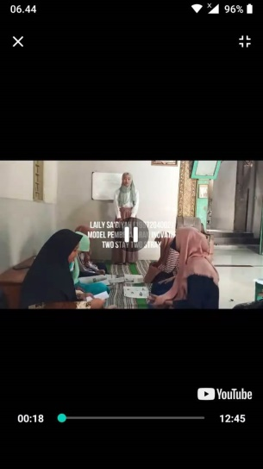

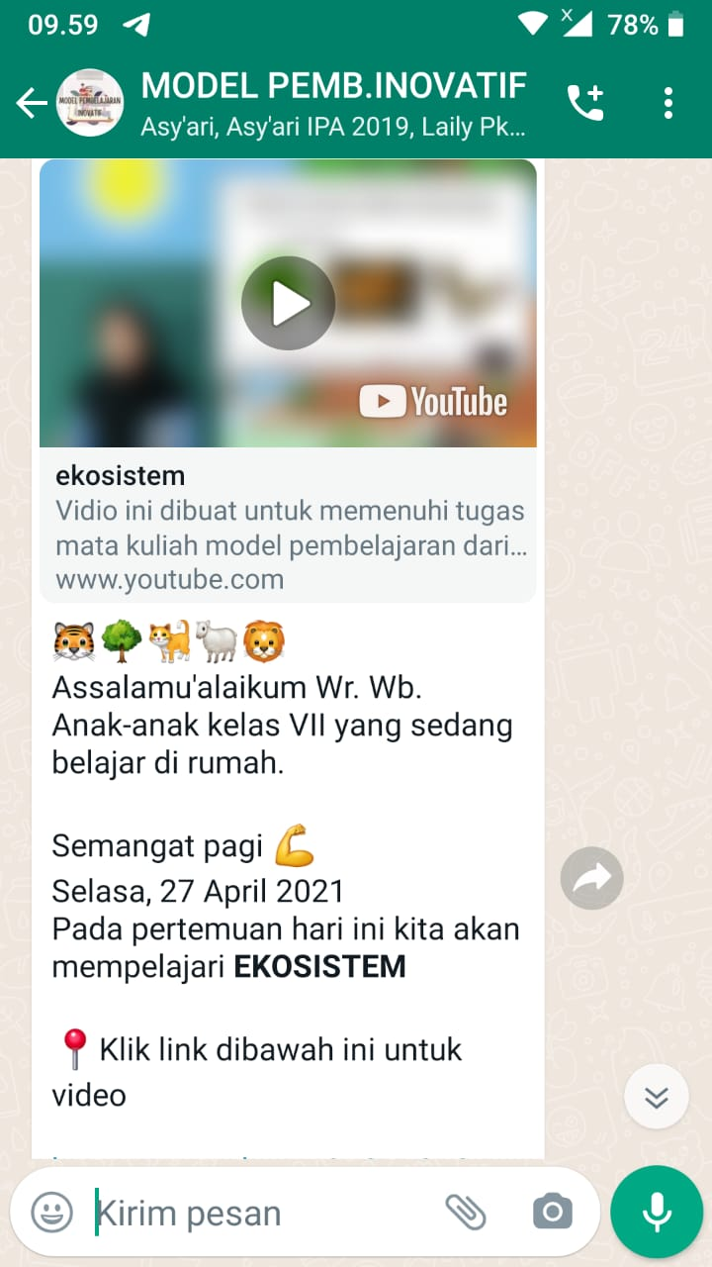**Figure 1. Practice of teaching and learning (https://youtu.be/T4DtcVxPH34 )**

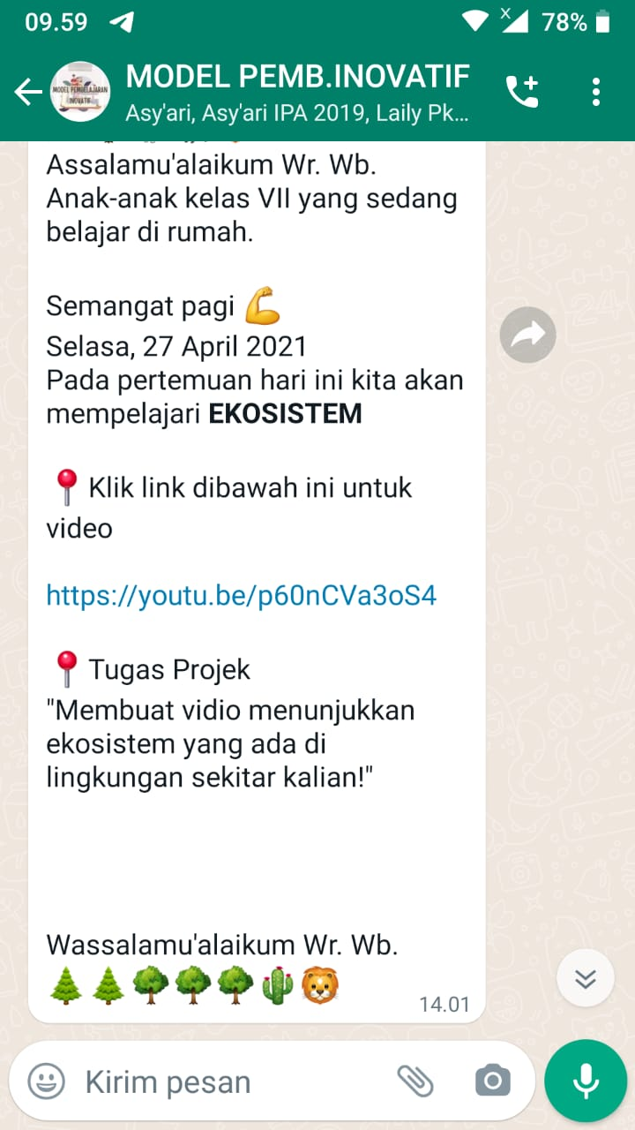

**Figure 2. teaching practice (https://youtu.be/p60nCVa3oS4)**

To find out student responses to the implementation of learning projects, it was done by giving questionnaires to the students’ participation in the Innovative Learning Model course. The questionnaire consists of positive statements and negative statements. The questionnaire has 5 alternative answers that respondents can choose. Aspects of the statement can be seen in table 2 below :

Table 2. The questionnaire criterion of student response toward learning project

|  |  |  |  |
| --- | --- | --- | --- |
| No | Criteria item of questionnaire | Number of questions | |
| Statement (+) | Statement (-) |
| 1. | Students perception toward innovative learning model course | 1 | 2 |
| 2. | Students motivation toward innovative learning model course | 3 | 4 |
| 3. | Students comprehension toward *innovative learning model* course | 5 | 6 |
| 4. | Students activity on project model | 7 | 8 |
| 5. | Students impression toward project learning | 9 | 10 |

The results showed that student activity in project activities was included in the successful category; it is 72.7% as follows in figure 3:

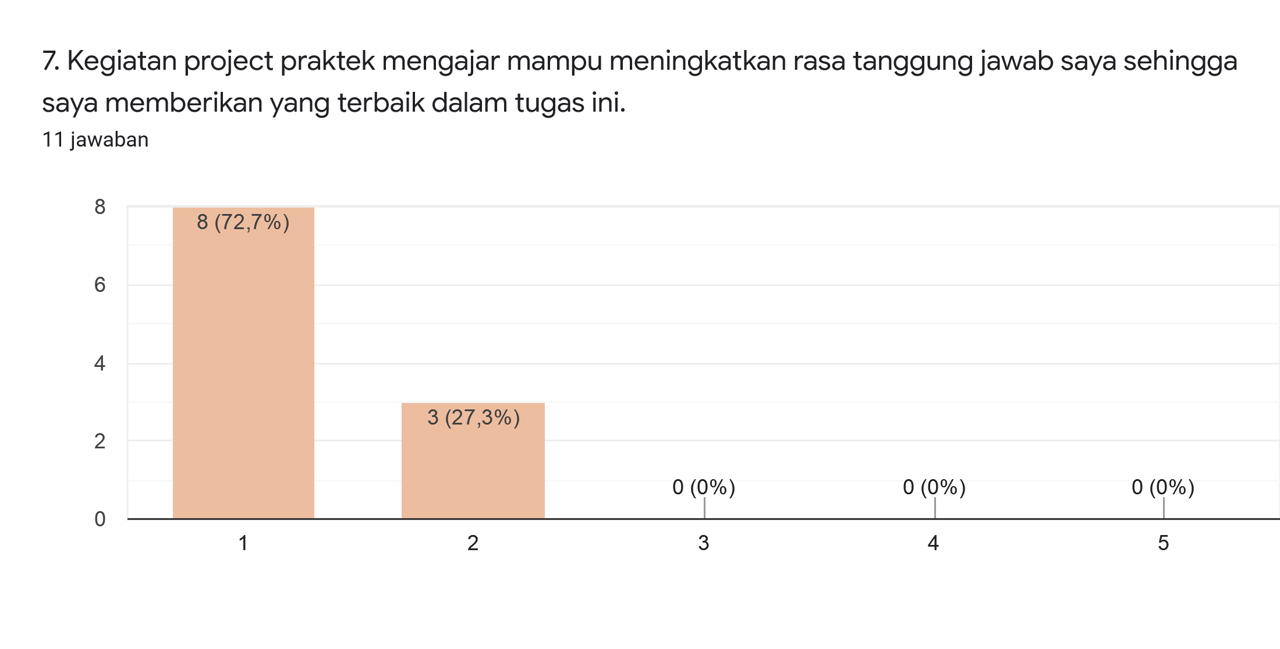

**Figure 3. Students’ activness in project**

At the students’ activeness in comprehending the learning innovative learning model course was successful category, it is 6% as graphic bellow in figure 4:

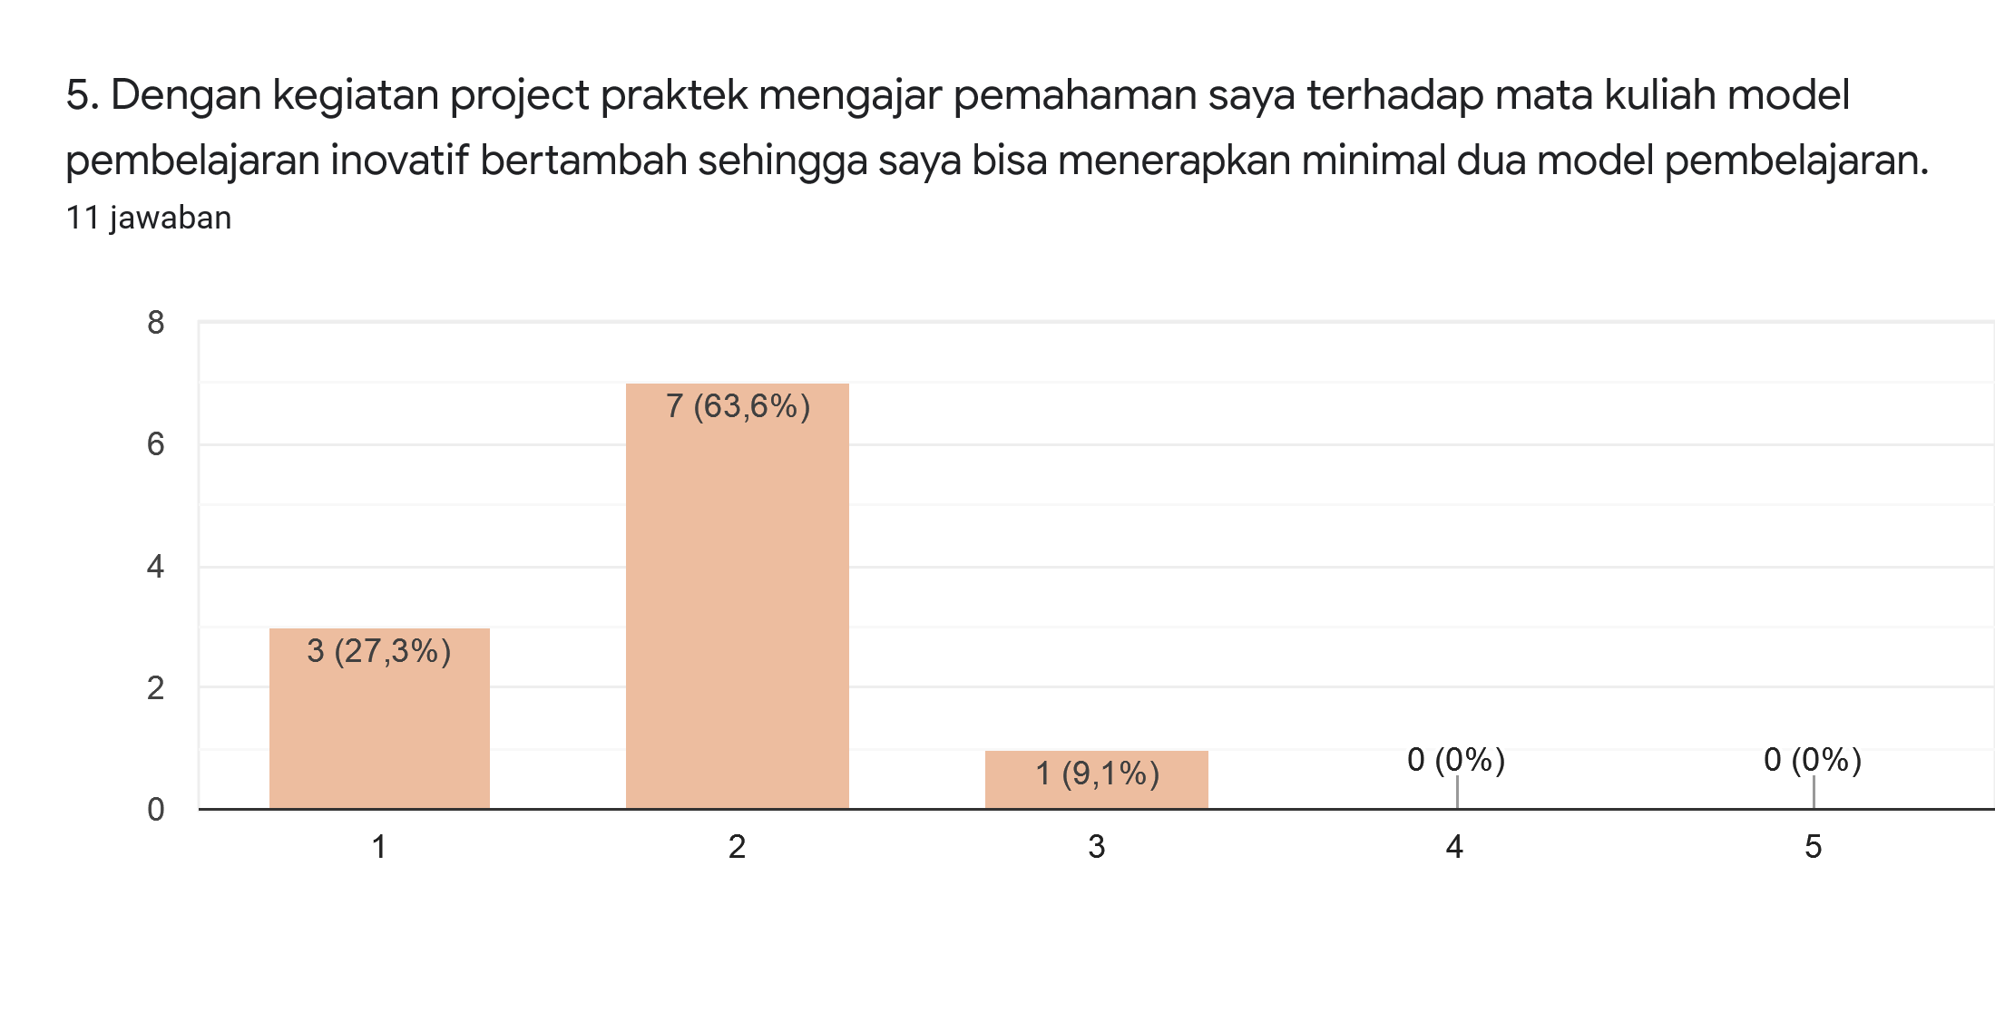

**Figure 4. Table of student activity in innovative learning model lectures**

Student activities during lectures became more active in each meeting; it was proved by the increasing the student’s number who asked some questions, objections, discussions and responses one another during the presentations. The increase of the student activities cannot be separated from the principle of project learning, namely relating the real concepts to the activities experienced in the field. Those caused students understanding what needed to be done in the field from planning toward implementing teaching practices so that the project implementation is successful.

Project learning also trains the students to be responsible, cooperative, and tough. There are various difficulties in implementing teaching practices such as classroom management, teacher creativity in planning, assessment and understanding in the IT field to make videos in designing blended learning. Various difficulties faced during project learning did not decrease the students' intention and enthusiasm to complete the assignments. Those are proved from the student's responses to project learning, it was very successful category 81.8% as shown in the following figure 5:

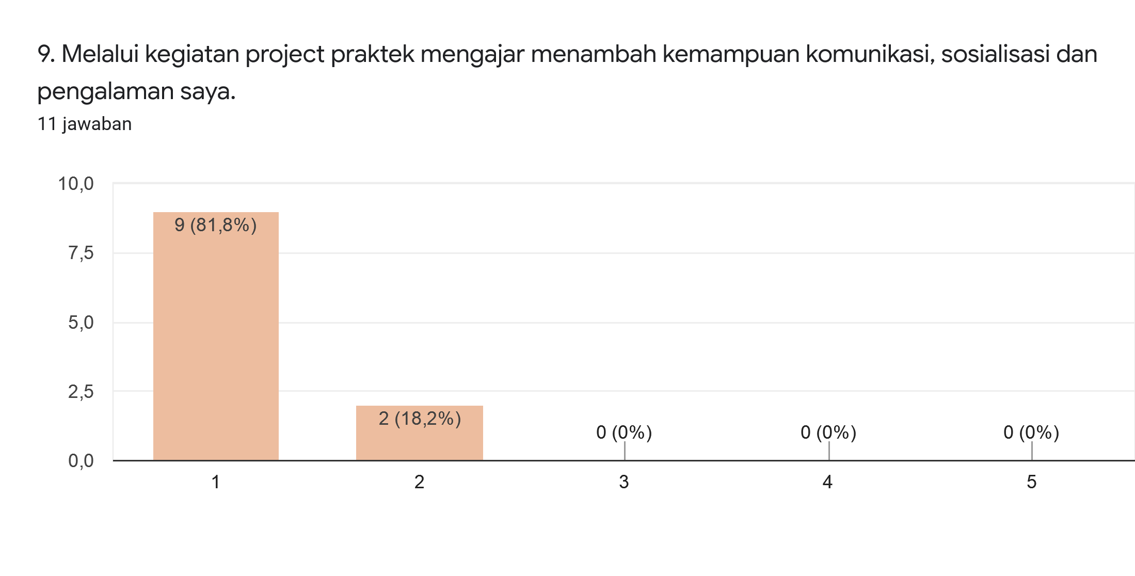

**figure 5. Table of students responses on the project**

Noor, et al. (2017) revealed that e-learning in project-based learning is significantly effective in achievement of spiritual attitudes, social attitudes, projects, product and student learning completeness. Based on the various research results described above, project-based online learning can be a solution in optimizing learning, especially in the midst of the Covid-19 pandemic. Through project-based online learning, students can go through meaningful learning so that the knowledge and science gained has meaning which can be used as a provision for them to become problem solvers of the problems they face. It can be seen from the mastery of the students' concepts increases from the pretest result 45.8 to the post-test result 85.8.

Online learning synergized with the right learning base will provide more optimal learning effect. One of the learning approaches that can improve the students’ competence from various researches that have been carried out is project-based learning. An interaction can occur effectively in project-based learning utilizing the inquiry process by guiding the students to create or develop applicative and related product to the daily life.

Specifically, project-based learning consists of inquiry-based tasks that help learners develop the technological, social and core importance of the curriculum (Sahin, 2013). Several research results showed the effectiveness of project-based learning, Adit (2020) revealed that project-based learning models can improve students' life skills. This increase occurred in all aspects of life skills; personal skills, social skills, academic skills, and vocational skills.

The project-based learning model is an alternative learning model that can be implemented to foster student life skills in college or students at school, especially in learning related to science. The research results’ Chasanah et al. (2014) found that learning with project based learning models was more effective than conventional learning models in improving learning outcomes in the form of students' creative thinking skills and science process skills.

The results of the correlation test show that the correlation coefficient between project learning and learning effectiveness (ry1) is 0.201. The probability value is 0.029 < 0.05 which indicates the correlation coefficient is significant. Thus, this study states that there is a significant positive relationship between the effectiveness of learning and project learning. The contribution of project learning to learning effectiveness (r2y1) is 0.040 so it can be stated that 4% of the diversity in learning effectiveness is explained by project learning. Based on the results, it is known that the correlation coefficient between student activities and learning effectiveness (ry2) is 0.759. The probability value is 0.000 < 0.05 and 0.01 which indicates the correlation coefficient is significant. Thus, this study confirms that there is a significant positive relationship between effectiveness learning and student activities. The contribution of teamwork to learning effectiveness (r2y2) is 0.575 so it can be stated that 57% of the diversity in learning effectiveness is explained by student activities. From the results it can be seen that the correlation coefficient of the relationship between project learning and student activities with learning effectiveness (ry12) is 0.769. Thus, this study confirms that there is a significant positive relationship between the three variables. The contribution between project learning and student activities with learning effectiveness (ry12) is 0.591 so that it can be stated that 59.1% diversity in learning effectiveness can be explained by project learning and student activities together. While the remaining 41.9% is explained by other variables not examined.

**CONCLUSION (12pt, Times New Roman)**

Based on the results of the research, students’ activity in project activities is successful category 72.7% and student activity in understanding the learning of innovative learning models is successful category 63.6%. Student responses to project learning are very successful category 81.8%. Mastery of student concepts has increased from 45.8 to 85.8. The results of statistical research using partial regression correlation analysis techniques and multiple correlations show a significant positive relationship between project learning and learning effectiveness with a correlation coefficient (ry1) = 0.201 and there is a significant positive relationship between student activities in innovative learning models and learning effectiveness with correlation coefficient (ry2) = 0.759, and there is a significant positive relationship between project learning and student activities together with learning effectiveness with correlation coefficient (ry12) = 0.769. Based on the results of these studies, it can be concluded that the effectiveness of learning can be increased through project learning and student activities.

**REFERENCES**

Adit, A. (2020). *12 Aplikasi Pembelajaran Daring Kerjasama Kemendikbud, Gratis!*. [https://edukasi.kompas.com/read/2020/03/22/123204571/12-aplikasi-pembelajaran-](https://edukasi.kompas.com/read/2020/03/22/123204571/12-aplikasi-pembelajaran-daring-kerjasama-kemendikbud-gratis?page=all) [daring-kerjasama-kemendikbud-gratis?page=all](https://edukasi.kompas.com/read/2020/03/22/123204571/12-aplikasi-pembelajaran-daring-kerjasama-kemendikbud-gratis?page=all) Diakses 28 April 2020

Budiansyah, A. (2020). *Internet Digratiskan Selama Wabah Corona di RI, Setuju?* [https://www.cnbcindonesia.com/tech/20200407180620-37-150401/internet-](https://www.cnbcindonesia.com/tech/20200407180620-37-150401/internet-digratiskan-selama-wabah-corona-di-ri-setuju) [digratiskan-selama-wabah-corona-di-ri-](https://www.cnbcindonesia.com/tech/20200407180620-37-150401/internet-digratiskan-selama-wabah-corona-di-ri-setuju) [setuju.](https://www.cnbcindonesia.com/tech/20200407180620-37-150401/internet-digratiskan-selama-wabah-corona-di-ri-setuju) Diakses 27 April 2020

Chasanah, ARU, Khoiri,N. & Nuroso, H. (2016). Efektivitas Model Project Based Learning terhadap Keterampilan Proses Sains dan Kemampuan Berpikir Kreatif Siswa pada Pokok Bahasan Kalor Kelas X SMAN 1 Wonosegoro Tahun Pelajaran 2014/2015. *Jurnal Penelitian Pembelajaran Fisika. 7 (1), 19-24.* [http://journal.upgris.ac.id/index.php/JP2F/](http://journal.upgris.ac.id/index.php/JP2F/article/view/1149) [article/view/1149](http://journal.upgris.ac.id/index.php/JP2F/article/view/1149) DOI: <http://dx.doi.org/10.26877/jp2f.v7i1.1149>

Gunawan, Suranti, NMY. & Fathoroni (2020). Variations of Models and Learning Platforms for Prospective Teachers During the COVID-19 Pandemic Period. *Indonesian Journal of Teacher Education.1 (2), 61-70*[https://journal.publication-](https://journal.publication-center.com/index.php/ijte/article/view/95/48) [center.com/index.php/ijte/article/view/95/48](https://journal.publication-center.com/index.php/ijte/article/view/95/48)

Hermann, M., Pentek, T. & Otto, B. (2016). *Design Principles for Industrie 4.0 Scenarios.* Presented at the 49th Hawaiian International Conference on Systems Science. [https://pdfs.semanticscholar.org/069c/d10](https://pdfs.semanticscholar.org/069c/d102faebef48fbb7b531311e0127652d926e.pdf) [2faebef48fbb7b531311e0127652d926e.pd](https://pdfs.semanticscholar.org/069c/d102faebef48fbb7b531311e0127652d926e.pdf)f

Kagermann, H., Lukas, W.D. & Wahlster, W. (2013). *Final report: Recommendations for implementing the strategic initiative INDUSTRIE 4.0.* Industrie 4.0 Working Group. [https://www.din.de/blob/76902/e8cac883f42bf28536e7e8165993f1fd/recommendati](https://www.din.de/blob/76902/e8cac883f42bf28536e7e8165993f1fd/recommendations-for-implementing-industry-4-0-data.pdf) [ons-for-implementing-industry-4-0-](https://www.din.de/blob/76902/e8cac883f42bf28536e7e8165993f1fd/recommendations-for-implementing-industry-4-0-data.pdf) [data.pdf](https://www.din.de/blob/76902/e8cac883f42bf28536e7e8165993f1fd/recommendations-for-implementing-industry-4-0-data.pdf) <https://ojs.unm.ac.id/semnaslemlit/article/view/8256>

Made Wena. 2009. Strategi Pembelajaran Inovatif Komtemporer Suatu Tinjauan Konseptual Operasional.Malang : Bumi Aksara

Noor, ME., Hardyanto, W & Wibawanto, H. (2017). Penggunaan E-Learning dalam Pembelajaran Berbasis Proyek di SMA Negeri 1 Jepara. *Innovative Journal of Curriculum and Educational Technology 6 (1), 17-26.* [https://journal.unnes.ac.id/sju/index.php/u](https://journal.unnes.ac.id/sju/index.php/ujet/article/view/15572) [jet/article/view/15572](https://journal.unnes.ac.id/sju/index.php/ujet/article/view/15572)

Sahin, A. (2013). *STEM Project-Based Learning.*Boston, USA: SensePublisher