Lampiran

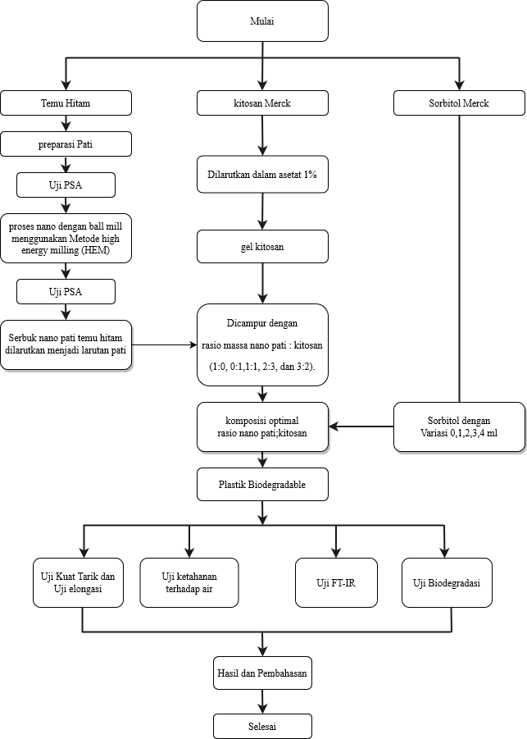

Gambar 3.1 Diagram alir penelitian

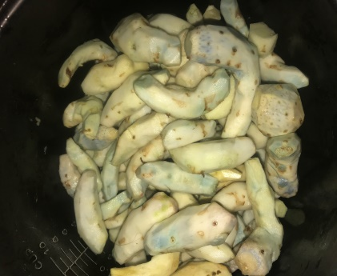 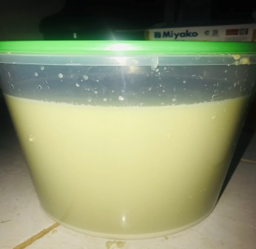

(1) (2)

Gambar 4.1 Temu hitam yang sudah dikupas dan endapan temu hitam

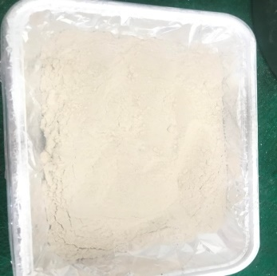

Gambar 4.2 Serbuk pati temu hitam

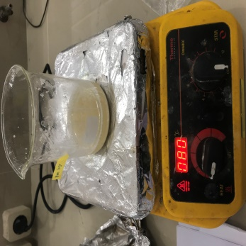 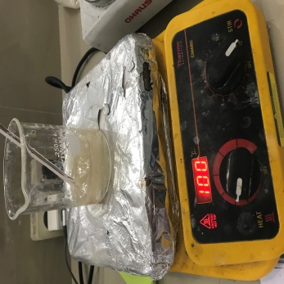

(1) (2)

Gambar 4.3 proses pemanasan pati dan proses pemanasan kitosan

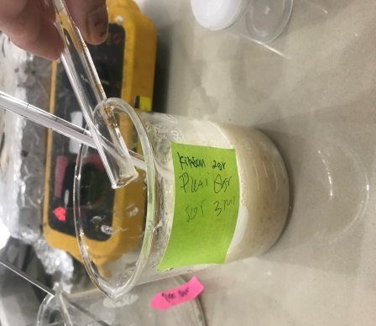 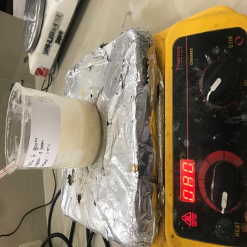

(1) (2)

Gambar 4.4 penambahan sorbitol dan proses pemanasan bahan

plastik biodegradable

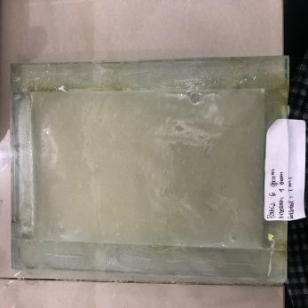 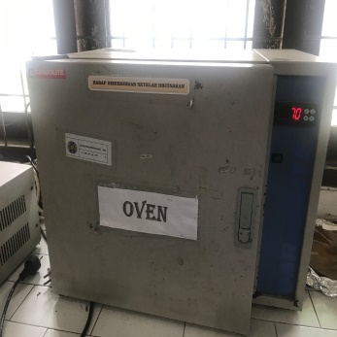

(1) (2)

Gambar 4.5 proses pencetakan dan pengeringan plastik biodegradable

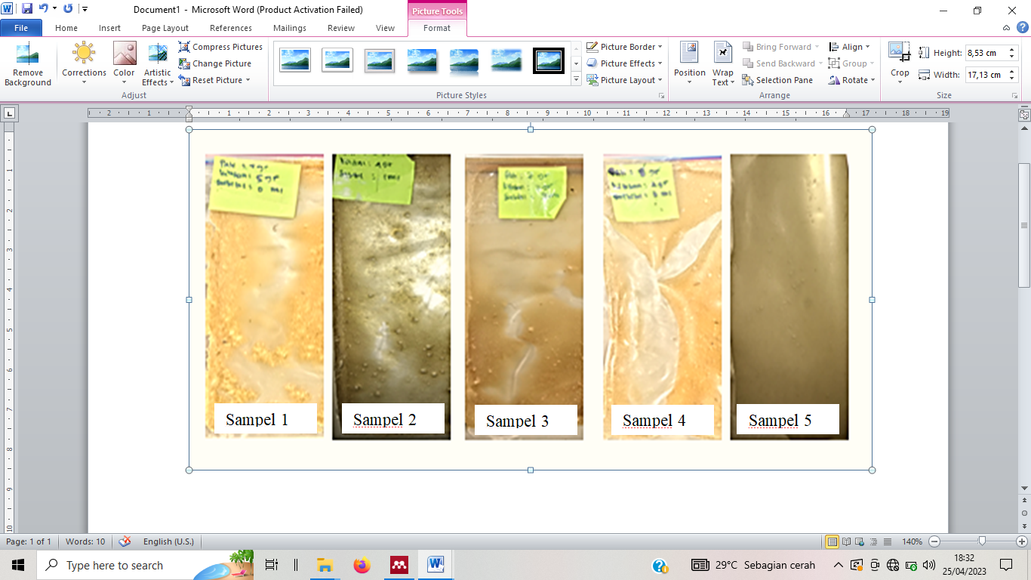

Gambar 4.6 Penampakan Visual plastik biodegradable

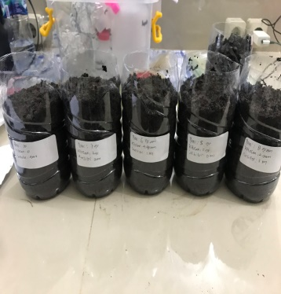 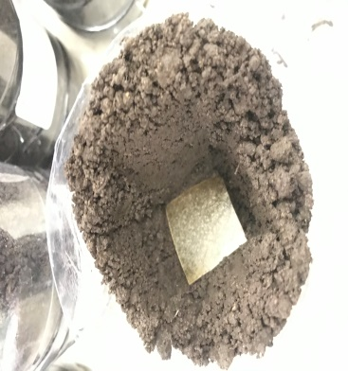 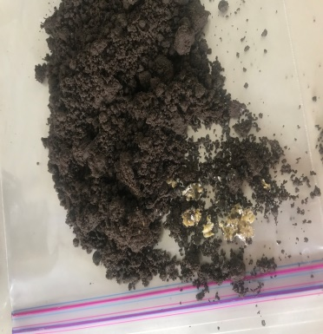

Gambar 4.7Pengujian Degradasi Plastik biodegradable

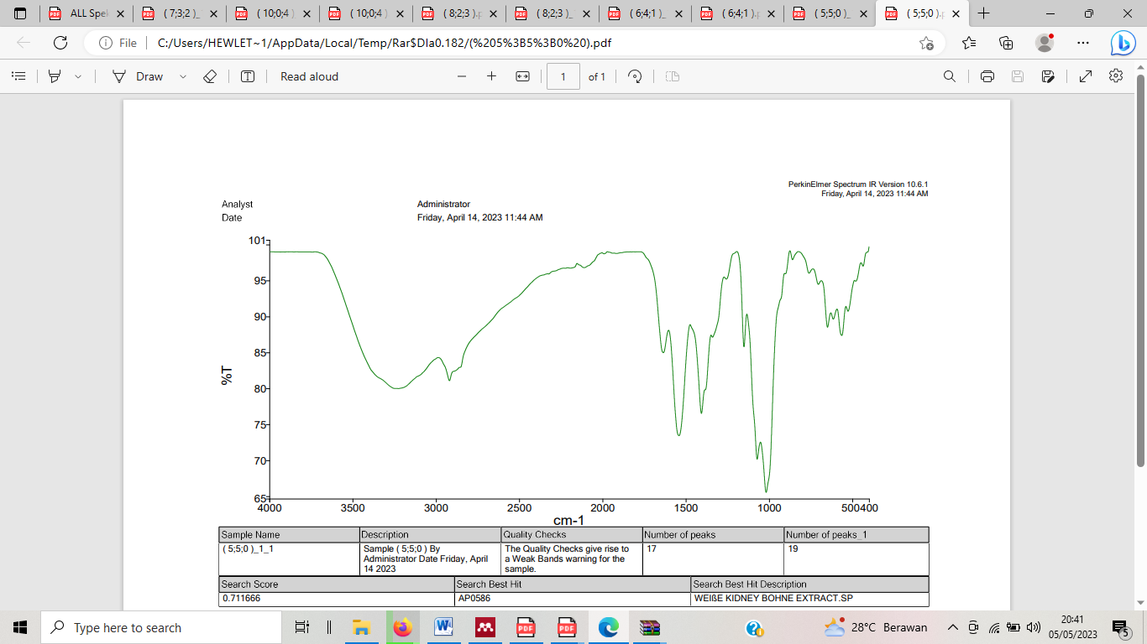

(1) sampel P1

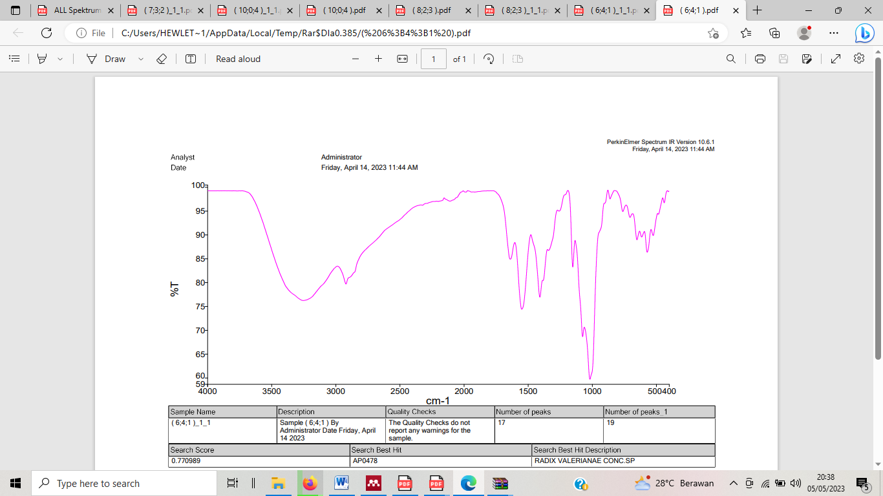

(2) sampel P2

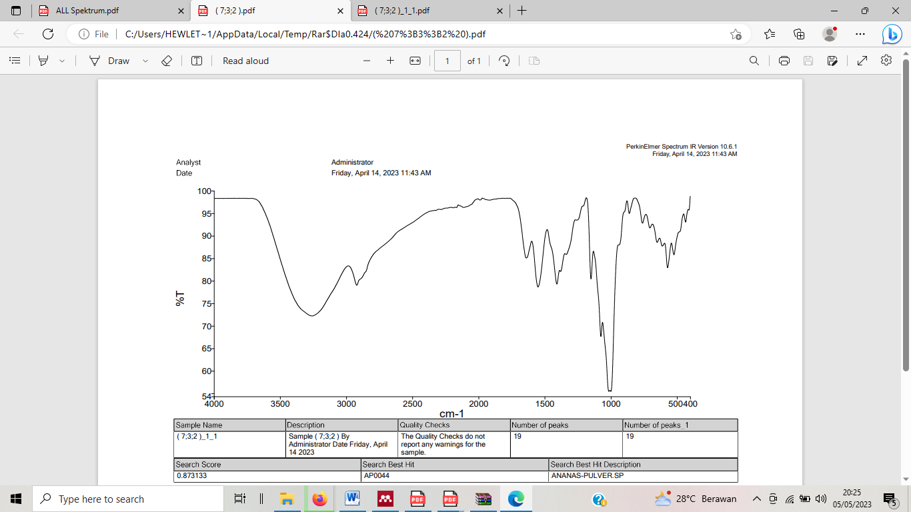

(3) sampel P3

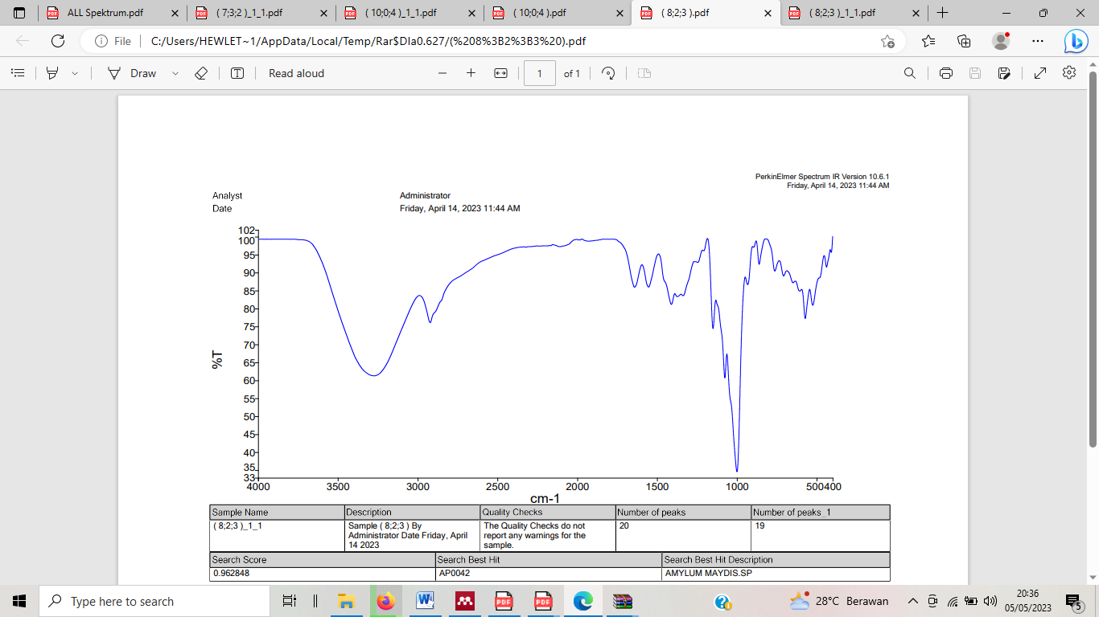

(4) sampel P4

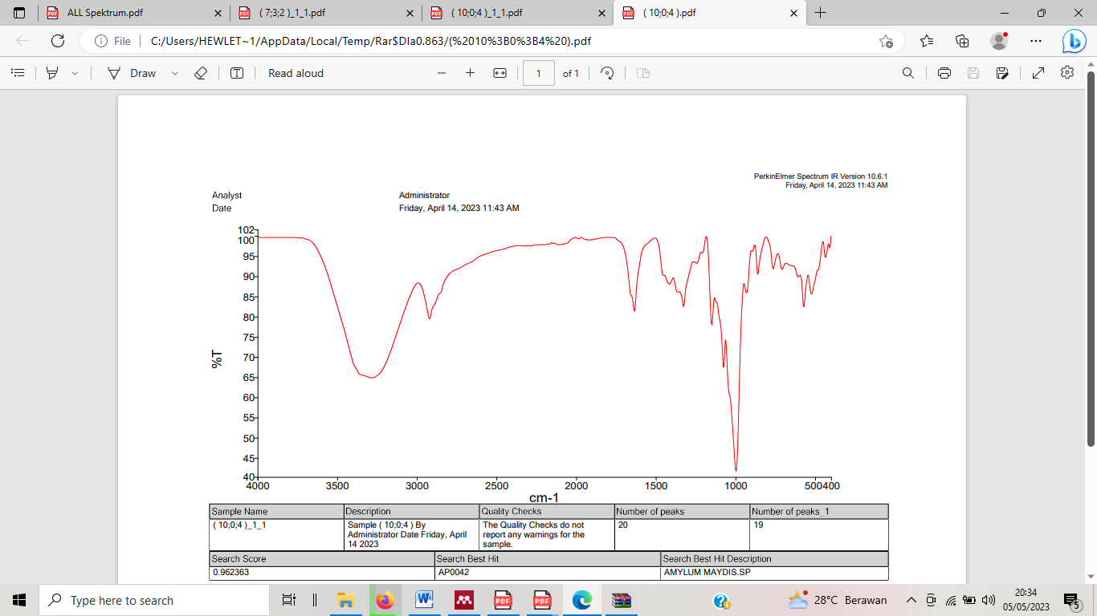

(5) sampel P5

Gambar 4.12 Hasil Pengujian Gugus Fungsi plastik Bioderadable

Tabel 4.4 Gugus fungsi sampel P1 yang terbaca pada sektrum IR

|  |  |  |
| --- | --- | --- |
| Sampel | Wave number (cm-1) | Gugus fungsi |
| Sampel P1 | 3228.78 | O-H senyawa hidroksil |
| 2921.93 | Alkane C-H |
| 2113.09 | Alkuna C≡C |
| 1636.04 | Alkena C=C |
| 1542.24 | Aromatic C=C |
| 1407.18 | Alkane C-H |
| 1151.34 | alkohol, asam karboksilat, ester C-O |
| 1072.15 | alkohol, asam karboksilat, ester C-O |

Tabel 4.5 Gugus fungsi sampel P2

|  |  |  |
| --- | --- | --- |
| Sampel | Wave number | Kelompok |
| Sampel P2 | 3256.09 | O-H senyawa hidroksil |
| 2922.12 | Alkane C-H |
| 2111.11 | Alkuna C≡C |
| 1639.39 | Alkena C=C |
| 1549.58 | Aromatic C=C |
| 1408.10 | Alkane C-H |
| 1151.00 | Amina, amida C-O |
| 1074.32 | Alkhol, eter, asam karboksilat, ester C-O |

Tabel 4.6 Gugus fungsi sampel P3

|  |  |  |
| --- | --- | --- |
| Sampel | Wave number | Kelompok |
| Sampel P3 | 3261.50 | O-H senyawa hidroksil |
| 2923.39 | Alkane C-H |
| 2114.77 | Alkuna C≡C |
| 1916.37 | C=C |
| 1640.12 | Alkena C=C |
| 1551.85 | Aromatic C=C |
| 1409.20 | Alkane C-H |
| 1150.70 | Alkhol, eter, asam karboksilat, ester C-O |
| 1075.73 | Alkhol, eter, asam karboksilat, ester C-O |

Tabel 4.7 Gugus fungsi sampel P4

|  |  |  |
| --- | --- | --- |
| Sampel | Wave number | Kelompok |
| Sampel P4 | 3274.09 | O-H senyawa hidrogen |
| 2924.93 | Alkana C-H |
| 1643.05 | Alkena C=C |
| 1554.32 | Aromatic C=C |
| 1411.72 | Alkana C=H |
| 1374.54 | Alkana C=H |
| 1338.10 | Amina, amida C-N |
| 1150.37 | Alkhol, eter, asam karboksilat, ester C-O |
| 1076.19 | Alkhol, eter, asam karboksilat, ester C-O |

Tabel 4.8 Gugus fungsi sampel P5

|  |  |  |
| --- | --- | --- |
| Sampel | Wave number (cm-1) | Kelompok |
| Sampel P5 | 3289.84 | O-H senyawa hidroksil |
| 2924.10 | Alkana C-H |
| 2111.94 | Alkuna C≡C |
| 1913.08 | C≡C |
| 1635.80 | Alkena C=C |
| 1416.61 | alkana C=H |
| 1327.27 | Amina,amida C-N |
| 1244.50 | Alkhol, eter, asam karboksilat, ester C-O |
| 1150.06 | Alkhol, eter, asam karboksilat, ester C-O |
| 1075.91 | Alkhol, eter, asam karboksilat, ester C-O |