**STUDY AND CHARACTERIZATION OF TRIBOFILM BASED ON ACTIVATED CARBON-NANOCHITOSAN MODIFIED WITH SILICONE OIL FOR APPLICATION OF SELF-HEALING COATINGS ON METAL SURFACES**

# Sarah Mutiara Sembiring, *Syahrul Humaidi, Martha Riana

Department of Physics, Faculty of Mathematics and Natural Science, University of Sumatera Utara, Jl. Dr. T. Mansur No 9I, Padang Bulan, Kec. Medan Baru, Medan, Sumatera Utara Indonesia, Postal Code : 20222

*Corresponding Author e-mail: [syahrul1@usu.ac.id](mailto:syahrul1@usu.ac.id)

***ABSTRACT***

*A tribofilm material based on activated carbon and nanochitosan modified with silicone oil has been prepared using the sol gel method with variations in the composition of activated carbon at a mass ratio of 40% wt – 60% wt at 5% wt intervals. Sampling was carried out in two stages. The first stage of the synthesis of activated carbon from palm shells using activation of 7% H3PO4 and nanochitosan derived from shrimp shells using the ionic gelation method. The second stage was mixing the tribofilm material of activated carbon, nanochitosan and silicone oil using the sol gel method to produce a film-forming solution which was then characterized including: physical, chemical, mechanical and thermal properties. The characterization results showed that the most optimum composition was the tribofilm material of activated carbon/nanochitosan/silicone oil in S1 with a mass ratio of 40%wt activated carbon which produced a density of 0.94 x 103 kg/m3, a viscosity of 28.42 cP, and a liquid surface tension of 63.5 mN/m. While the performance characteristics of the metal surface coating produce a surface roughness of 0.162 µm for aluminum metal and 0.156 µm for copper metal, friction coefficient 0.024, wear rate 0.19 mm, thermal conductivity 0.092 W/m.K, corrosion properties 1a (slight tarnish), rate corrosion rate of 2.34 mm/yr in 3.5% NaCl medium, 4.33 mm/yr in seawater medium and 11,476 mm/yr in 3% H2SO4 medium and has good self-healing properties for 3 days on carbon steel metal surfaces with corrosion scratch treatment on 3.5% NaCl media, namely almost all the scratches/cracks covered due to frictional force from galvanic corrosion with active carboxyl, amine and hydroxyl groups with the healing agent aminopropyl siloxane (NH2-R-NH-Si-O-R) which reacts with metal ion particles (M-OH) in the formation of polymer chains for new network layers.*

***Keywords****:* *Metal Surface Protector, Nanochitosan, Palm Shell Activated Carbon, Self-Healing Coating, Tribofilm Material*

**1. INTRODUCTION**

In the era of revolution 4.0, human civilization is growing and advancing which has an impact on the human need for new machine-based technologies to help and reduce human mechanical motion in carrying out strenuous activities, one of which is machines on robotic equipment. based on data *International Federation of Robotics* (2013), world robot sales in 2012 reached 159,346 units with an increase of 25% per year such as agricultural robots, space exploration, nursing robots, military robots, food packaging robots, arm robots and so on. The sophistication of the robot lies in the control and sensor systems that make movement flexible, but complex movements can actually reduce robot performance due to friction which is the main cause of robot energy loss of 0.099% with a workload of 150-250 kg which reduces friction will help achieve carbon neutrality in a global energy audit (Wang, C 2018). Lubricant is a chemical substance which is generally in the form of a liquid, which is given between two moving objects with the aim of reducing frictional forces made of (70-90)% base lubricating oil mixture and added with additives to improve its properties such as increasing engine efficiency, reducing the rate of wear due to friction and heat removal (cooling) on ​​the two contacting areas to prevent hot defects that cause defects in the metal besides that around 3-4% fuel consumption savings contributed from lubrication. However, lubricants are an environmental problem that generates high levels of toxic waste (Yang, H 2019).

Therefore, an effort is needed to make a lubricant layer in terms of overcoming tribological problems in metal materials, especially engines. Potential materials that can be used as raw materials for colloidal nanocapsules in polymers *Polydimethylsiloxane* (PDMS) a type of silicone oil derived from organic materials in the form of palm shells which are derived into activated carbon and chitosan from chitin derivatives which have the privilege of being renewable and readily available raw materials. Tribofilm based lubricant from PMDS type silicone oil inserted by activated carbon and chitosan nanoparticles (n-Chit) as a coating*self-healing* which can mobilize metal surfaces using dynamic networks based on nanocolloid capsules with its advantageswhich can reduce the responsive voltage of electricity / acid, control the movement of sliding droplets and is non-toxic. The feasibility of silicone oil as a lubricant is due to its density of 965 kg/m3, viscosity 4.8 x 10-2 Pa.s, the glass transition temperature is 127oC, the surface tension of the liquid is 2.08 x 10-2 N/m and a dielectric constant of 2.72 – 2.75 so that it has the property of neutralizing acids and transferring heat due to friction evenly by utilizing the polarization bonds of the Si-O groups (Huneault, 2018). Then activated carbon as a nanocolloid capsule for self-healing fluids has an amorphous structure with a porosity of (40-90)% which is able to store and precipitate lubricating materials in the form of microcapsules, has a density of (0.4-2) g/cm3 and specific surface area (500-2000) m2/g. As well as nanochitosan which can bind Zn, Cd, Pb, Cu and Hg ions by the active group NH2- in a chelating manner (Berman, 2018 and Salinas, 2021).

A mixture of silicon oil with activated carbon and nanochitosan using the sol gel method is expected to produce a self-healing friction and corrosion protective material that has good physical, chemical, mechanical and thermal properties that can restore engine condition and extend engine life.

**2. METHOD**

In this study, silicone oil was obtained from Inosol with a viscosity of 1000 cps. Activated carbon was synthesized from the palm shells of the Adolina PTPN IV North Sumatra palm oil mill physically by using activation of a 7% H3PO4 solution and nbanochitosan from shrimp shells was synthesized using the ionic gelation method using acetic acid solvent

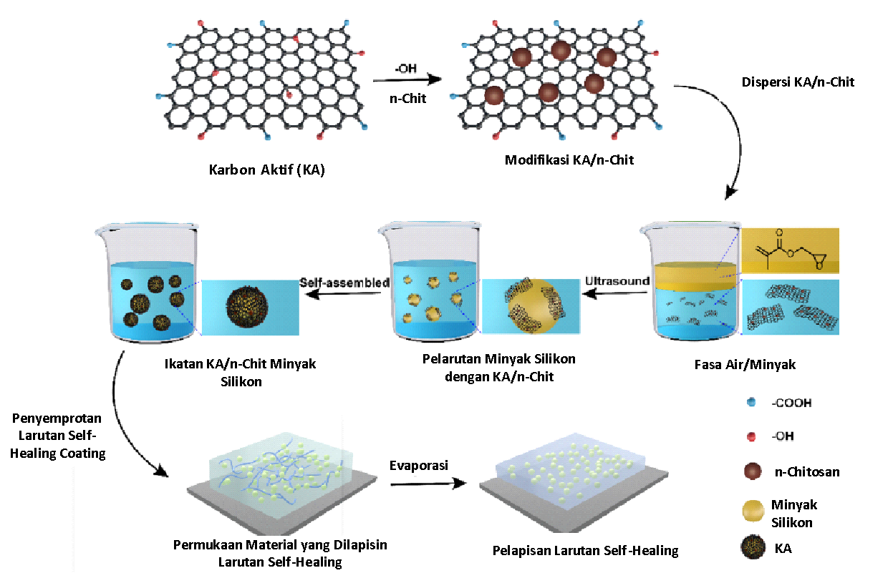

**Figure 1.** Schematic of Formation of Activated Carbon/Nanochitosan/Silicon Oil Tribofilm Solution

**2.1 Preparation of Palm Shell Activated Carbon**

The process of synthesizing activated carbon from palm shells was adopted based on Zurairah's research, 2020 in which 300 g of oil palm shells obtained were cleaned, then placed in a container and put in the oven for 2 hours at 110oC to remove the existing water content. Then the palm shells are carbonized at a temperature of 400oC for 2 hours in the furnace, where the time is calculated when the temperature has reached 400oC. After the carbonization process. After the carbonization process, the charcoal formed is activated by adding 7% H3PO4 at a ratio of 1:10 (w/w). Then stirred for 30 minutes and soaked for 24 hours. The results of the marinade are filtered, then dried in the oven at 120oC for 24 hours. The dried charcoal is then heated at 600oC for 2 hours in the furnace, where the time is calculated when the temperature reaches 600oC. After the heating process, the activated carbon obtained was then washed with 5N HCl several times to remove chloride elements, then washed using hot distilled water (temperature 100oC) to pH 6.8-7, and washed using cold distilled water (temperature 4oC) to remove the phosphorus content. The activated carbon is dried in an oven at 120oC, then crushed and blended. After the activated carbon is smooth, then it is filtered using a 400 mesh filter.

**2.2 Synthesis of Nanochitosan**

Synthesis of nanochitosan using the ionic gelation method, modifying the research steps from Isna (2022). Chitosan powder weighing 0.05% was dissolved in 100 mL acetic acid 1% (w/v). Then stir using *magnetic stirrer* for 1 hour. Chitosan solution was then added NaTPP 0.1% (w/v) and twen 80 0.1% (v/v) withratio of 5:1:0.05 while stirring. The solution is stirred constantly with *magnetic stirrer* for 2 hours at room temperature.

**2.3 Fabrication of Lubricants *Self-Healing***

Lubricant manufacturing process*self-healing* using the sol gel method by dissolving activated carbon and nanochitosan with 100 mL of silicone oil on a hotplate stirrer at 25OC with a stirring speed of 600 rpm until evenly mixed for 24 hours after which tests were carried out (density, viscosity, surface tension and liquid), chemical properties (corrosion type and corrosion rate), mechanical properties (surface roughness, wear rate and coefficient of friction) and performance properties (self-healing process based on optical microscopy visualization)

**2.4 Lubricant Performance Testing *Self-Healing***

Provided metal plate material type Al and Cu size 5 cm x 5 cm then sprayed with lubrication *self-healing* on a metal surface and allowed to stand for 24 hours after which performance testing was carried out such as ability *self-healing*, corrosion type, corrosion rate, surface roughness, coefficient of friction, *wear loss* (wear rate), and thermal conductivity.

**3. RESULT AND DISCUSSION**

Several tests were carried out to see the performance of the sample as a self-healing coating application in which these parameters influenced the self-healing process, namely the tribological properties including the surface roughness of the metal, the coefficient of friction, the wear rate, and corrosion rate so that the characteristics of the metal being coated would greatly play a role in the self-healing properties in forming a layer of tribofilm to recover after an external force such as friction causes a scratch.

Fig.2 showed the optimum surface roughness for Al and Cu metals coated by tribofilm on an active carbon composition of 40% wt where the surface roughness before coating was 0.348 µm for Al and 0.309 µm for Cu whereas after coating it became 0.152 µm for Cu and 0.162 µm for Al. While the roughness results were less than optimum on the composition of activated carbon 60% wt with surface roughness for Al of 0.248 µm and for Cu 0.216 µm. There is a decrease in the surface roughness of the metal after being coated with tribofilm material, this is due to the functional groups contained in the microcapsules present in the tribofilm coating including carbonyl groups (-C=O), hydroxyl groups (-OH), amine groups (-NH2) and a sulfonate group (-S(=O)2-O-) which has an electron affinity for the metal surface to form an ionic or covalently coordinated interface bond with positive metal ions in the form of a protective layer (*thin film*) in inhibiting direct contact which can cause an increase in the surface roughness value of the metal.

**Figure 2.** Analysis of Metal Surface Roughness Curve Against Activated Carbon

**Figure 3.** Analysis of the Coefficient of Friction Curve for Activated Carbon Variations

Optimum conditions obtained a low coefficient of friction at a composition of 40% wt activated carbon 0.024. This shows that the composition of activated carbon which has a small amount of activated carbon has a very low coefficient of friction because the number of heavy fractions for the silicone oil matrix is ​​very high so that the binding force to bind the activated carbon and nanochitosan particles is very strong and not easily released when forming a molecular layer that can stabilize heat. due to frictional forces that cause abrasion and scratches by utilizing ion transport *chemisorption* (Wang, L 2019). While the less optimum conditions on the composition of 60% wt activated carbon with a friction coefficient of 0.047.

**Figure 4.** Analysis of the Wear Rate Curve for Activated Carbon Variations

Optimum conditions obtained a low wear rate value on a composition of 40% wt activated carbon with a wear rate value of 0.19 mm. This shows that the composition of the microcapsule composed of activated carbon and nanochitosan modified with silicon oil has a small amount so that the silanol (Si-O) active group is more optimal in binding the active groups that make up the microcapsule with the nanochitosan binding agent. If the metal surface that has been coated with tribofilm material is subjected to frictional forces, a process of breaking down the microcapsules occurs in which the microcapsules release additional lubricants or protective agents in the formation of a network of new film layers on the metal surface so as to reduce the wear rate *physisorption* (Liu, 2020).

**Figure 5.** Corrosion Rate Curve Analysis of Activated Carbon Variations

The composition of 40% wt activated carbon on tribofilm material produces an optimal corrosion rate of 2.34 mm/yr in 3.5% NaCl media, 4.33 mm/yr in seawater media and 11,476 mm/yr in 3% H2SO4 media. This is due to the nature of the constituent material of the tribofilm material in the form of activated carbon which has a porous surface that can absorb several compounds from the environment such as CO2 and bicarbonate ions (HCO3-) so that a passive and stable carbonate layer is formed which functions to protect the metal from corrosion by reducing metal reactivity and stabilizing the pH around the metal surface. The following is the reaction for the formation of the carbonate protective layer produced by the tribofilm material: (Wang, Q 2020)

* Reaction of carbon dioxide with water:

CO2 + H2O⇌ H2CO3 (carbonic acid)

* Reaction of carbonates with ferrous ions in metals:

Fe + 2HCO3- ⇌ Fe(HCO3)2 +2e- (reduction reaction)

* Carbonate layer formation:

Fe(HCO3)2 + CaCO3 ⇌ FeCO3 + Ca(HCO3)2

In addition to activated carbon, nanochitosan in tribofilm materials also plays an important role in inhibiting and reducing the corrosion rate of metals because nanochitosan has a positively charged amine functional group (-NH2) which can be interacted with*ion exchange* against negative ions (corrosive ions) such as SO42- and Cl- by binding or absorbing them. While the less optimum composition is 60% wt activated carbon with a corrosion rate of 19,014 mm/yr for 3% H2SO4 media, 12,802 mm/yr for seawater media and 8,662 mm/yr for 3.5% NaCl media.

* 1. ***Self-Healing* with an Optical Microscope**

The self-healing of the tribofilm material when etched was carried out in 3.5% NaCl media using 3 variations of active carbon composition between 40% wt, 50% wt and 60% wt. Following are the results of digital image testing of ferrous metal surfaces before and after being coated with tribofilm material

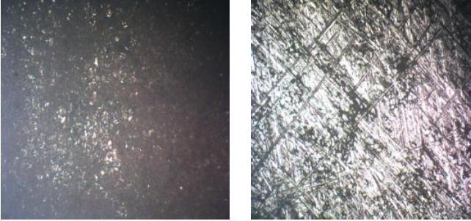

**Figure 6.** Visual Analysis of Carbon Steel Metal Sections Before Coating and Soaking in 3.5% NaCl Media

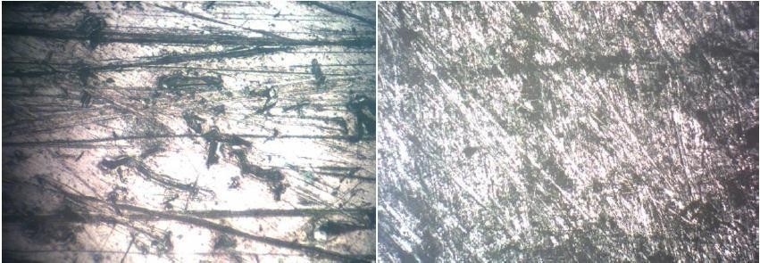

**Figure 7.** Visual Analysis of the Condition of Carbon Steel Metal Coated with Tribofilm Material with 60%wt Activated Carbon Variations Soaked in 3.5% NaCl Ocean Media

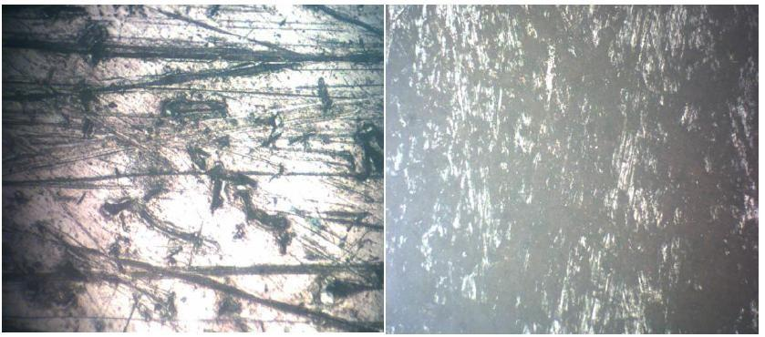

**Figure 8.** Visual Analysis of Carbon Steel Metal Sections After being Coated with Tribofim Material with 40% wt Activated Carbon Variation Soaked in 3.5% NaCl Solution Media

Fig.7 shows the shape of the visual image of the surface of the carbon steel metal before being given electrochemical scratch treatment using a 3.5% NaCl electrolyte solution which looks smooth and has no scratches due to decomposition caused by galvanic corrosion reactions. Meanwhile on Fig.8 and Fig.9 the formation of white streaks due to the NaCl solution oxidizes the Fe content (black area) on the carbon steel plate by releasing positive ions (Fe2+ or Fe3+) causing degradation. However, tribofilm materials as applications *self-healing* contains microcapsules with healing agents *aminopropyl siloxane* (NH2-R-NH-Si-O-R) which can quickly flow into the etched area, followed by particle re-structuring to rebuild new tissue for 3 days.

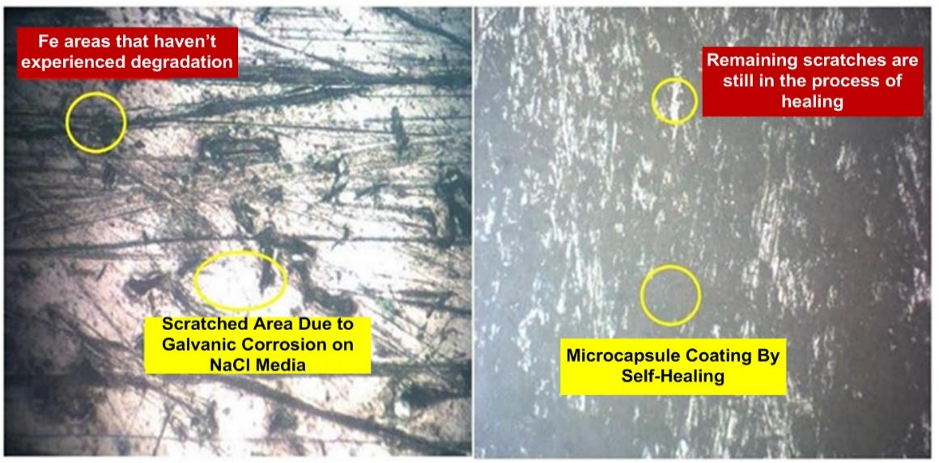

**Figure 9.** Formation of Self-Healing Areas in the Process of Covering Scratches Due to Corrosion for 3 Days

Fig.9 shows the process of self-healing of carbon steel metal material after experiencing scratches due to frictional forces in the galvanic corrosion process by NaCl solution utilizing a combination reaction *chemisorption* and *physisorption* which in the process of degradation of Fe ions due to the corrosion reaction forms a scratch layer, causing a small part of the metal structure of carbon steel to be exposed. The resulting localized corrosion triggered a solution-induced surge of electrolyte NaCl which rapidly dissipated within seconds, indicating that the coating had self-healed to restore its protective barrier properties. The mechanism of action is that when a scratch from the effects of corrosion arises it will cause the process of breaking down the metal surface structure so that an immobilization process occurs by forming a lightweight colloidal capsule-based dynamic network which in the dynamic part of the particle network nearby both on the right and left sides of the oil layer is thick and creep resistant. However, the viscoelasticity of the oil is very low so that the breakdown of the activated carbon/nanochitosan microcapsules with healing agents occurs. *Aminopropyl siloxane* and flows out photochemically and thermochemically in which the silicone oil liquid carrying microcapsules of active carbon/chitosan is viscoelastic which begins to flow into the open area and brings new particles to rebuild tissue damaged by repeated scratches for 3 days (Aumrung, 2023). The following illustrates the self-healing process:

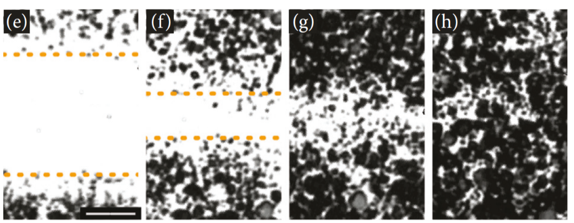

**Figure 11.** (a) Illustration of Silicone Oil Polymer Chain in Carrying Microcapsules to Form New Networks in the Self-Healing Process of Scratches

**4. CONCLUSION**

Obtained visual process properties *self-healing* good CA/nanochitosan/silicone oil tribofilm material for 3 days based on optical microscopy on a carbon steel metal surface with scratch corrosion treatment on 3.5% NaCl media, namely almost all scratches/cracks covered due to frictional forces from galvanic corrosion with active carboxyl groups, amines and hydroxyl with healing agents *aminopropyl siloxane* (NH2-R-NH-Si-O-R) which reacts with metal ion particles (M-OH) in the formation of polymer chains for new network layers.

**5. ACKNOWLEDGMENT**

The authors would like to thank the Organic Chemistry Laboratory (USU), Lhoksumawe State Polytechnic (Chemical Engineering Laboratory), Medan Harapan University (Mechanical Engineering Laboratory), UPT LIDA USU Biology Laboratory, USU Integrated Laboratory, and PTKI Materials Test Laboratory and who those involved for their scientific and technical support. The authors hope that this paper can contribute to the development of tribofilm.

**6. REFERENCES**

Aumrung, K and Daniel, C 2023.Self-healing and anticorrosion coatings based on responsive polymers with metal coordination bonds, *Chemical Engineering Journal* 452(1):1-10 doi: https://doi.org/10.1016/j.cej.2022.139055

D. Berman, B. Narayanan, M.J. Cherukara, S.K.R.S. Sankaranarayanan, A. Erdemir, A. Zinovev, A.V Sumant, Operando tribochemical formation of onion-like-carbon leads to macroscale superlubricity, *Nat. Commun*. 9:1164. doi: https://doi.org/10.1038/s41467-018-03549-6

Huneault, J., Kamil, J., Higgins, A., & Plant, D. (2018). Dynamic tensile strength of silicone oils. *AIP Conference Proceedings 1979*, 070016(2018):1-6. doi:10.1063/1.5044825

Liu, X Zhiwei, L Jun’an. Z Bo, L[Yan, C](https://www.sciencedirect.com/author/55263949000/yan-cao) and Xueming. Q 2020. The self-lubricating behavior and evolution mechanisms of the surface microporous friction interface of M50-(Sn-Ag-Cu) material. Journal of Materials Research and Technology, 9(4):8207-8220. Doi: https://doi.org/10.1016/j.jmrt.2020.05.095

Samiee, R., Ramezanzadeh, B., Mahdavian, M., & Alibakhshi, E. 2019.Assessment of the smart self-healing corrosion protection properties of a water-base hybrid organo-silane film combined with non-toxic organic/inorganic environmentally friendly corrosion inhibitors on mild steel. *Journal of Cleaner Production,* 220(2019):340-356. Doi: 10.1016/j.jclepro.2019.02.149

V.R. Salinas Ruiz, T. Kuwahara, J. Galipaud, K. Masenelli-Varlot, M. Ben Hassine, C. H´eau, M. Stoll, L. Mayrhofer, G. Moras, J.M. Martin, M. Moseler, M.-I. de Barros Bouchet, 2021. Interplay of mechanics and chemistry governs wear of diamond-like carbon coatings interacting with ZDDP-additivated lubricants, *Nat. Commun*. 12:4550. Doi:10.1038/s41467-021-24766-6

Wang, C Jianjun, Z Kai, L Yuqi, N Xiaoming, G Qinglun, C Shunsheng, X Yuzhen, L and Weimin, L 2023. Effect of Substrate Roughness and Contact Scale on the Tribological Performance of MoS2 Coatings. Lubricants, 11(5):191-202. Doi: https://doi.org/10.3390/lubricants11050191

Wang, K., Zhou, Z., Zhang, J., Tang, J., Wu, P., Wang, Y., … Leng, Y. (2020). Electrical and Thermal and Self-Healing Properties of Graphene-Thermopolyurethane Flexible Conductive Films. *Nanomaterials,* 10(4), 753. doi: 10.3390/nano10040753

Wang, L., Yang, Y., Qin, Y., Yang, G., Qin, Y., & Wu, M. (2019). Self-repairing mechanism and surface characterization of compressor vanes lubricated with oil added with magnesium silicate hydroxide nanorods. *Manufacturing Review, 6(26)*:1-10. Doi: 10.1051/mfreview/2019025

Wang, Q., Cao, J., Liu, X., Yang, S., & Jiang, M. (2020). Self-healing coatings for inhibiting corrosion of ferrous metals exposed to preservative-treated bamboo*. Journal of Wood Science, 66(1)*:1-10*.*Doi: https://doi.org/10.1186/s10086-020-01865-4

Yang, H., Mo, Q., Li, W., & Gu, F. (2019). Preparation and Properties of Self-Healing and Self-Lubricating Epoxy Coatings with Polyurethane Microcapsules Containing Bifunctional Linseed Oil*. Polymers,* 11(10), 1578:1-17*.* doi:10.3390/polym11101578

Yu, H., Feng, Y., Gao, L., Chen, C., Zhang, Z., & Feng, W. (2020). Self-Healing High Strength and Thermal Conductivity of 3D Graphene/PDMS Composites by the Optimization of Multiple Molecular Interactions*. Macromolecules*, 1(1):1-10. Doi: https://doi.org/10.1021/acs.macromol.9b02544