**Ethnomathematics-Based Pancasila Student Profile Strengthening Project Module in the Merdeka Curriculum Phase A in Elementary Schools**

**1 Midya Yuli Amreta, 2* Giati Anisah**

Nahdlatul Ulama University Sunan Giri Bojonegoro

Jl. Ahmad Yani No.10, Jambean, Sukorejo, Kec. Bojonegoro, Bojonegoro Regency

East Java Indonesia, Postal code: 62115

[Corresponding](mailto:midyaamreta2@gmail.com) Author e-mail : [midyaamreta2@gmail.com](mailto:midyaamreta2@gmail.com)

Received :…………..; Revised:…………; Published: …………..

**Abstract**

The transformation of education in Indonesia after Covid-19 has experienced quite significant changes, namely the latest Merdeka Belajar curriculum. The Merdeka Curriculum develops learning according to interests, learning styles and abilities that are connected to the competence of teachers and students. The independent curriculum is implemented through a project to strengthen the profile of Pancasila students. There are six competencies in Pancasila students formulated as key dimensions that are interrelated and strengthen each other, namely 1) faith, devotion to God Almighty and noble character, 2) global diversity, 3) mutual cooperation, 4) independence, 5) critical reasoning , and 6) creative. These dimensions are important and must be embedded in students in learning, so they are important in developing modules. The module developed is based on ethnomathematics which is used as an integration of curriculum, pedagogy and mathematics. The use of local wisdom as an integrated module for the project to strengthen the profile of Pancasila students makes students trained and able to explore mathematical concepts that exist in their cultural environment. Local wisdom will make it easier for students to learn because this culture exists in the student's environment. In this research, the context is local wisdom in Tuban Regency, East Java. This research aims to produce a product, namely a project module to strengthen the profile of Pancasila students which contains ethnomathematics. The product is obtained from research results using Research And Development (R&D) research with a 4D model. The 4D model design consists of four paths, namely Define, Design, Develop, and Desseminase. The validation results from design validation were 88%, language validators were 94%, and material validators were 90%. Thus the percentage of the average value of 90.6%. The average pretest result of trial 1 was 62.75 then in trial 2 was 63.75. The posttest results from trial 1 were continued, namely 90.33 and trial 2, namely 91.58. After carrying out the pre-test and post-test at the trial stage, the researcher calculated the N-Gain Score value, namely N-Gain trial 1, namely getting a score of 0.76 which means high and getting an interpretation of N-Gain effectiveness of 76.78% which means effective. Then the students filled out a student response questionnaire, and obtained a presentation of 85% in the very satisfied category.

***Keywords:*** *Module Development; Project Module; Pancasila Student Profile; Ethnomathematics; Independent Curriculum*

***How to Cite:*** First author., Second author., & Third author . (20xx). The title . *Prisma Sains: Journal of the Study of Science and Learning Mathematics and Science IKIP Mataram, vol* ( no ), xx-yy . doi: [https://doi.org/10.33394/j-ps.v xx i yy](https://doi.org/10.33394/j-ps.vxxiyy)

|  |  |
| --- | --- |
| [https://doi.org/10.33394/j-ps.v xx i yy](https://doi.org/10.33394/j-ps.vxxiyy) | Copyright *©* 2019, First author et al  This is an open-access article under the [CC-BY License](http://creativecommons.org/licenses/by/4.0/) .  [Creative Commons License](http://creativecommons.org/licenses/by/4.0/) |

**INTRODUCTION**

The teaching and learning process that occurs in education takes place effectively and efficiently. Urgency education is a very important element in the dignity of social and state life [1] [2]. When the Covid-19 pandemic took place there were many problems in education [3] [4] especially the process of teaching and learning activities in schools, so teachers used online and offline learning systems [5] [6] [7]. The transformation of education in Indonesia after Covid-19 has experienced quite significant changes. The change that occurs is that there is a new curriculum, namely the Merdeka Belajar curriculum [8].

The Independent Curriculum develops learning according to the interests, learning styles and abilities of students which are connected to the competence of teachers and students [9]. In this period, the Minister of Education applied the independent curriculum at all levels of schools/educational units. There are 3 phases of the independent curriculum in elementary schools, namely Phase A, Phase, and Phase C. The application of the curriculum in elementary schools will bring a changing effect for teachers, education staff, learning administration, learning strategies, learning methods, and learning evaluation [10] . Curriculum changes occur with the aim of improving the quality of education. The independent curriculum in addition to improving the quality of education is also to produce human resources [11]. The independent curriculum applies to primary and secondary education. In the independent curriculum that is applied is project learning to strengthen the profile of Pancasila students [12] [13].

The urgency of the project to strengthen the Pancasila student profile is cross-disciplinary learning to observe and solve surrounding problems. There are six competencies in Pancasila students formulated as key dimensions that are interrelated and mutually reinforcing, namely 1) having faith, fearing God Almighty and having noble character, 2) global diversity, 3) working together, 4) independent, 5) critical thinking , and 6) creative [14]. These dimensions are important and must be embedded in students in learning, so they are important in developing modules. The chart of these competencies can be seen as follows:

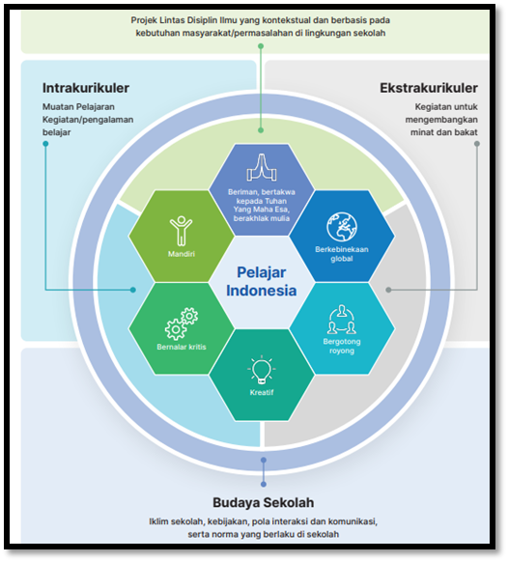

**Figure 1.** Interrelated key dimension competencies

This research focuses on developing a project module to strengthen the profile of Pancasila students based on ethnomathematics in the independent curriculum phase A in elementary schools. Ethnomatematics is used as an integration of curriculum, pedagogy, and mathematics [15]. The use of local wisdom as an integration project module to strengthen the profile of Pancasila students makes students trained and able to explore mathematical concepts that exist in their cultural environment [16] [17]. Local wisdom will make it easier for students to learn because this culture exists in the students' environment [18] [19] [20]. In this research, the context is local wisdom in Tuban Regency, East Java. The use of modules in learning has a major effect on student achievement [21] [22], especially in dealing with an independent curriculum, new teachers and students must develop independent learning [23]. This means learning naturally to achieve independence. In essence, modules are needed to explore the greatest potential of teachers and students to innovate and improve the quality of independent learning.

Previous research that has been carried out regarding the project module for strengthening the profile of Pancasila students was carried out with variables that are still common, namely, it has produced research results including regarding student character [24], strengthening strategies [25], Pancasila character [26], emerging values. [27], as well as its application in the profile of Pancasila students [28]. However, it has not added ethnomathematics. This is important because students are trained and able to explore mathematical concepts that exist in their cultural environment. This makes it easier for them to learn because the culture exists in the students' environment. Mathematics is a science related to the study of abstract structural forms [29]. The learning developed meets the effective criteria in developing the Ethomathematics module [30]. Mathematics learning is important in developing an independent learning curriculum .

**METHOD**

1. Development Model

This research is Research and Development (R&D). Development is carried out using a 4-D model with the Define, Design, Develop, and Desseminase stages [33] [34].

a. Define Stage (Definition)

The define stage is carried out by field observation with curriculum analysis, student analysis, task analysis, concept analysis, and learning objectives.

b . Design Stage (Designing)

The design stage is carried out by selecting the design and format of the project module for strengthening the profile of Pancasila students based on ethnomathematics which is prepared based on curriculum references with the coverage in it of the title, objectives, material presented in the form of a module that matches the students' experience in comics, evaluation. The comic teaching materials themselves contain characters, characters, subject matter, conversation balloons, ethnomathematics storylines that suit the students' experiences, as well as colors that the students like.

c . Development Stage (Development)

This development stage aims to find a product, namely a project module for strengthening the profile of Pancasila students based on ethnomathematics which has been revised and improved based on input from experts, colleagues, and the results of trial 1 (limited) and trial 2 (field) for students.

d . Dessiminase Stage (Dissemination)

This dissemination stage aims to disseminate the final research product. Products developed and tested for use by others.

The research development procedure is as follows:

**Table. 1** 4D Research Flow

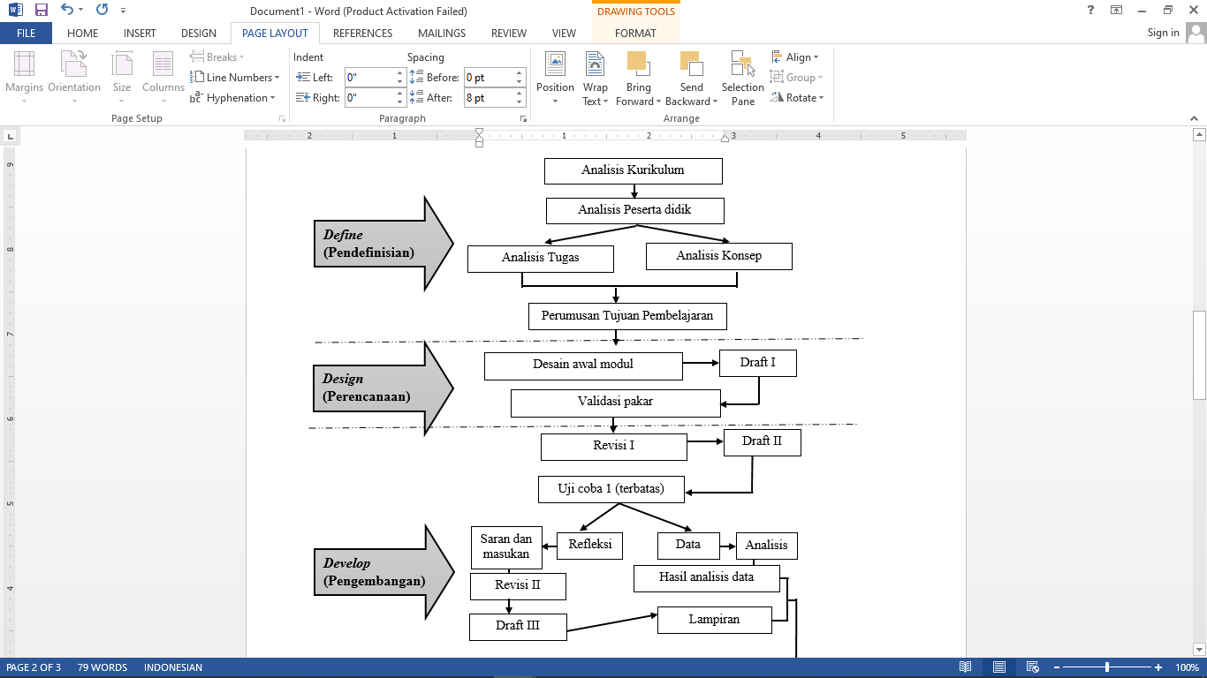

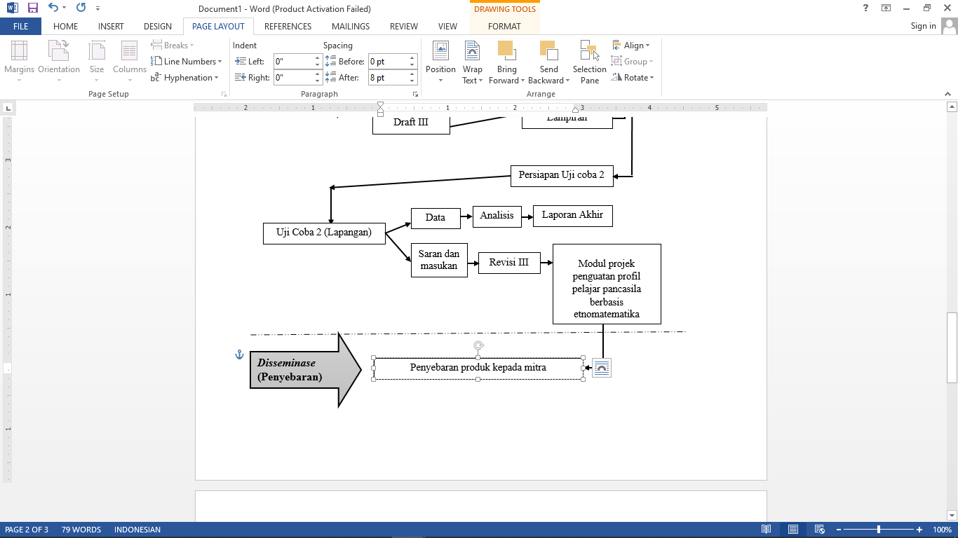

2. Data and Data Sources

The data in this research is divided into two, namely qualitative and quantitative data. Qualitative data in the form of suggestions for improvement, criticism, comments provided by material experts, design experts, language/module readability experts, students and teachers, both written in questionnaires and expressed during interviews. Quantitative data is data obtained from questionnaires filled out by material experts, design experts, language/module readability experts. In addition, quantitative data is also data derived from students' scores when taking cognitive learning outcomes tests .

3. Data Collection Techniques and Instruments

Data collection was carried out in three ways , namely questionnaires, interviews, and tests. Questionnaires are used to collect data regarding the validity and practicality of the instrument. The questionnaire was addressed to materials, design experts, linguists/student module readability experts and teachers. Interviews were conducted with materials, design experts, language/module readability experts, and teachers to obtain data regarding validity and practicality. The test was used during trial 1 and trial 2 to obtain data which was then analyzed.

4. Data Analysis

The qualitative data obtained was analyzed through three stages, namely data condensation, data presentation, and data conclusion [31]. Conclusions regarding suggestions for improvement, criticism and comments are then applied in follow-up module improvements. Quantitative data from the use of the module is analyzed using test theory where the percentage of feasibility is obtained from the following formula:

**Percentage = $\frac{(Nilai yang dicapai)}{(Jumlah seluruh nilai yang harus dicapai)}$ x 100%**

After that, the average score is calculated using the following formula:

**Completeness = $\frac{(Nilai yang dicapai)}{(Jumlah seluruh nilai yang harus dicapai)}$ x Maximum score**

The validation eligibility criteria can be seen in the following table:

**Table 1** . Validation Eligibility Criteria

|  |  |
| --- | --- |
| **Classification** | **Information** |
| 7 6 – 100 % | Valid / Eligible |
| 51 – 75 % | Enough Valid / Decent Enough |
| 26 – 50 % | Less Valid / Less Appropriate |
| 0 – 25 % | Invalid / Ineligible |

The division of categories for the acquisition of N-Gain values is as follows:

**Table 2** . Validation Eligibility Criteria

|  |  |
| --- | --- |
| **N-Gain Value** | **Category** |
| G > 0.7 | Tall |
| 0.3 < G < 0.7 | Currently |
| G < 0.3 | Low |

Then the category of obtaining the interpretation of the effectiveness of N-Gain in percent (%) is as follows:

**Table 3** . Validation Eligibility Criteria

|  |  |
| --- | --- |
| **Percentage (%)** | **Category** |
| < 40 | Ineffective |
| 40 – 55 | Less effective |
| 56–75 | Effective enough |
| > 76 | Effective |

Then the categories of acquisition of student response questionnaires are as follows:

**Table 4** . Student Response Questionnaire

|  |  |
| --- | --- |
| **Classification** | **Information** |
| 7 6 – 100 % | Satisfied |
| 51 – 75 % | Enough Satisfied |
| 26 – 50 % | Less satisfied |
| 0 – 25 % | Dissatisfied _ |

**RESULTS AND DISCUSSION**

The product was obtained with validation results from design validation of 88%, language validator of 94%, and material validator of 90%. Thus , the average percentage value of 90.6% can be seen in the table as follows:

**Table 5** . Validation Results

|  |  |
| --- | --- |
| **Validators** | **Results** |
| Design Validator | 88 % |
| Language Validator | 94 % |
| Material Validators | 90 % |
| **Average** | **90.6 %** |

The average pretest result of trial 1 was 62.75 then in trial 2 was 63.75. The posttest results from trial 1 were continued, namely 90.33 and trial 2, namely 91.58. The following are the results of the trial phase:

**Chart 1.** Pretest and Posttest Results

After carrying out the pretest and posttest at the trial stage, the researcher calculated the N-Gain Score, namely the N-Gain trial 1, namely obtaining a score of 0.76 which means high and obtaining an interpretation of the effectiveness of N-Gain 76.78% which means effective. This can be seen in the following table:

**Table 6.** N-Gain Score (Trial 1)

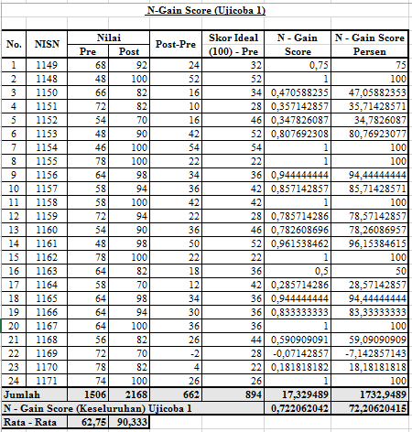

**Table 7 .** N-Gain Score (Trial 2)

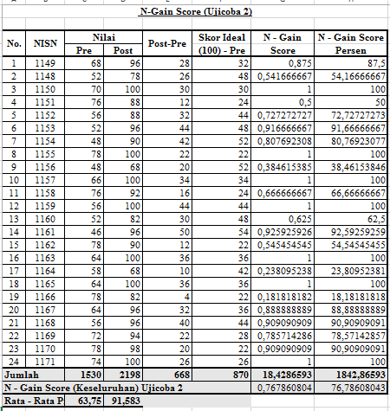

Then students filled out the student response questionnaire, and obtained presentation results of 85% in the very satisfied category as follows:

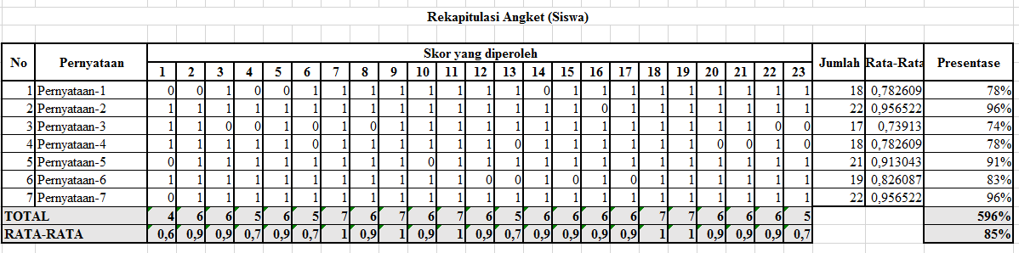

**CONCLUSION**

In this research, there were obstacles experienced in implementing the research process. This obstacle is the adjustment of hours in activities carried out at school, because it happens to be held in August where schools hold many activities to commemorate the independence day of the Republic of Indonesia. However, this can be handled well by arranging the right time and schedule. Then another obstacle is the need for a definite understanding regarding the understanding of the chosen theme in project learning and this can be overcome well.

**RECOMMENDATIONS**

Suggestions from researchers to all stakeholders to ensure that project learning in the independent curriculum is very important, especially regarding ethnomathematics with the aim of forming a Pancasila student profile. In addition , all school members must cultivate and familiarize positive behavior in realizing learning goals.

**REFERENCES**

1. Numeration and Characteristics of Critical Thinking of Elementary School Students Based on Ethnomatematics. Cent Educ J. 2022;3(01):50–61.
2. Krisna D, Gunarhadi G, Winarno W. Development of Educational Comic with Local Wisdom to Foster Morality of Elementary School Students: A Need Analysis. Int J Educ Methodol. 2020;6(2):337–43.
3. Nur Z. Effectiveness of Learning After the Covid-19 Pandemic at MTs Negeri 1 Makassar. Educandum [Internet]. 2022;8(1):121–8. Available from: <http://jurnal.stkipalmaksum.ac.id/index.php/Sintaksis/article/view/183/183>.
4. Parid M, Julrissani J. The Impact of the Covid-19 Pandemic on the Learning Process of Elementary School Students. VOX EDUCATION J Ilm Educator Science. 2021;12(1):114–21.
5. Maula LH. Mathematics Learning During the Pandemic in Elementary Schools. J Basicedu. 2022;6(5):7872–8.
6. Mutia A, Wulandari I, Afifah NR, Itsar PA, Nur Y, Sari F. Effectiveness of Offline and Online Mathematics Learning Models During the Covid-19 Pandemic. Orig Res. 2022;(58):95–102.
7. Ramadani MR. Online Mathematics Learning During the Covid-19 Pandemic at Mts Negeri 1 Banyumas Class Ix a. J Educator Mat Undiksha. 2022;12(2):55–62.
8. Maulinda U. Development of Independent Curriculum-Based Teaching Modules. Tarbawi. 2022;5(2):130–8.
9. Merta Sari N Komang Lina, Widiratini NK, Anggendari MD. Development of Embroidery Teaching Materials Based on Merdeka Learning Campus Merdeka. J BOSAPARIS Welfare Educator Kel. 2022;13(1):28–36.
10. Rahimah. Improving the Capacity of Tebingtinggi City 10 Public Middle School Teachers in Developing Independent Curriculum Teaching Modules through Assistance Activities for the 2021/2022 Academic Year. J ansiru PAI [Internet]. 2022;6(1):92–106. Available from: <http://jurnal.uinsu.ac.id/index.php/ansiru/article/view/12537/5670>.
11. Nurohmah AN, Kartini D, Rustini T. Relevance of Independent Curriculum Policy to 21st Century Education in Social Studies Learning in Elementary Schools. J Ilm Education Forum, February [Internet]. 2023;9(3):24–35. Available from: <https://doi.org/10.5281/zenodo.7594483>.
12. Shofa NA. Strengthening the profile of Pancasila students through Project-Based Learning in learning History. 12th Int Conf Lesson Study. 2021;8(1):187–97.
13. Hadian T, Mulyana R, Mulyana N, Tejawiani I. Implementation of Project Based Learning to Strengthen Pancasila Student Profiles at Sman 1 Sukabumi City. Prim J Primary School Teacher Educator. 2022;11(6):1659.
14. Alanur SN, Nawing K, Septiwiharti D, Syuaib D, Jamaludin J. Development of PPKn Teaching Materials Containing Pancasila Student Profile Values as Strengthening Students' Civic Character. J Citizenship Educator. 2022;12(2):107.
15. Islam U, Rahmat R. DEVELOPMENT OF AKM QUESTIONS CONTAINING ETHNOMATHEMATICS USING CANVA MEDIA TO MEASURE NUMERATION LITERACY CAPABILITY Raden Rahmat Islamic University Malang, Indonesia E-mail: Abstract. 2023;(March).
16. Irawan A, Lestari M, Rahayu W, Wulan R. Ethnomathematics batik design Bali island. J Phys Conf Ser. 2019;1338(1).
17. Widiantari NKK, Suparta IN, Sariyasa S. Improving Numeracy Literacy and Character Education with E-Modules Containing Ethnomathematics in the Era of the COVID-19 Pandemic. JIPM (Educator Science Journal Mat. 2022;10(2):331.
18. Suciawati V, Jatisunda MG, Kania N. How a Traditional Homemaker Predicts: An Ethnographic Study. Malikussaleh J Math Learn. 2021;4(1):41.
19. Ditasona C. Ethnomathematics Exploration of the Toba Community: Elements of Geometry Transformation Contained in Gorga (Ornament on Bataks House). IOP Conf Ser Mater Sci Eng. 2018;335(1).
20. Oktiningrum W, Wardhani DAP. Developing Hot Mathematics Task with Indonesian Heritage as Context to Assess Mathematical Literacy of Students in Primary Schools. Int J Educ Vocat Stud. 2020;1(8):69.
21. Andi Achmad. The Relationship between the Development of Teaching Materials and Learning Media with Student Learning Outcomes in Islamic Religious Education Subjects at Public Elementary Schools in Sungai Kunjang District. Shamil. 2017;5(1):59–73.
22. Khairiyah EA. DEVELOPMENT OF ETHNOMATHEMATICS-BASED TEACHING MATERIALS IN SQUARE AND TRIANGLE MATERIALS FOR GRADE VII SMP/MTs. RepositoryUinjktAcId [Internet]. 2019; Available from: https://repository.uinjkt.ac.id/dspace/handle/123456789/61562%0Ahttps://repository.uinjkt.ac.id/dspace/bitstream/123456789/61562/1/11170170000016 EVA AFIFAH KHAIRIYAH % 28watermark%29.pdf
23. Sulastri S, Syahril S, Adi N, Ermita E. Strengthening character education through Pancasila student profiles for teachers in elementary schools. JRTI (Indonesian Action Research Journal. 2022;7(3):583.
24. Kurniawaty I, Faiz A, Purwati P. Strategies for Strengthening Pancasila Student Profiles in Elementary Schools. Educative J Science Educator. 2022;4(4):5170–5.
25. Jamaludin J, Alanur S SNAS, Amus S, Hasdin H. Implementation of Pancasila Student Profile Values Through Campus Teaching Activities in Elementary Schools. J Cakrawala Pendas. 2022;8(3):698–709.
26. Lubaba MN, Alfiansyah I. Analysis of the Application of the Pancasila Student Profile in Forming Student Character in Elementary Schools. Science and Technology. 2022;9(3):2022–687.
27. Traditional P, Student B, Negeri SD, Kepanjen D, Oktiningrum W, Zuhroh L, et al. Corresponding author: Wuli Oktiningrum Raden Rahmat Islamic University Malang. 2023;2(1):29–36.
28. Permatasari KT, Apriyani E, Fitriyana ZN, Studi P, Mathematics P, Mathematics F, et al. Development of Mathematics Learning Media in the Form of Corner Clock Teaching Tools. J Mat And Science Educator [Internet]. 2021;9(2):83–8. Available from: <http://journal.uny.ac.id/index.php/jpm>.
29. Syahputri N. Designing Class 1 Elementary School Mathematics Learning Media Using the Demonstration Method. J Sist Inf Kaputama. 2018;2(1):89–95.
30. Widiyasari R, Astriyani A, Irawan KV. Development of Mathematics Learning Devices with the Help of Thatquiz Evaluation Media. FIBONACCI J Educators Mat and Mat. 2020;6(2):131.
31. Yang X, Kaiser G. The impact of mathematics teachers' professional competence on instructional quality and students' mathematics learning outcomes. Curr Opin Behav Sci [Internet]. 2022 ;48:101225 . Available from: <https://doi.org/10.1016/j.cobeha.2022.101225>
32. Donovan D. Mental health nursing is stretched to breaking point. Nurs Stand. 2016;30(25):33.